Supplementary Information
Bioinspired multifunctional self-sensing actuated gradient hydrogel for soft-hard robot remote interaction
He Liu¹, Haoxiang Chu¹, Hailiang Yuan¹, Deliang Li¹, Weisi Deng¹, Zhiwei Fu¹, Ruonan Liu¹, Yiying Liu¹, Yixuan Han¹, Yanpeng Wang¹, Yue Zhao¹, Xiaoyu Cui^{1, *}, Ye Tian^{1, 2, *}
¹College of Medicine and Biological Information Engineering, Northeastern University, Shenyang 110169, China
²Foshan Graduate School of Northeastern University, Foshan, 528300, China
Corresponding author:
Dr. Xiaoyu Cui, E-mail: cuixy@bmie.neu.edu.cn
Dr. Ye Tian, E-mail: tianye@bmie.neu.edu.cn

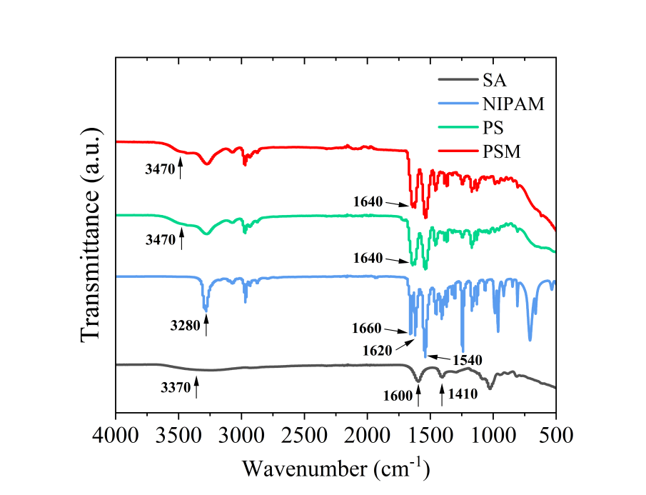
Fig. S1 FTIR spectra of SA, NIPAM, PS hydrogel and PSM hydrogel

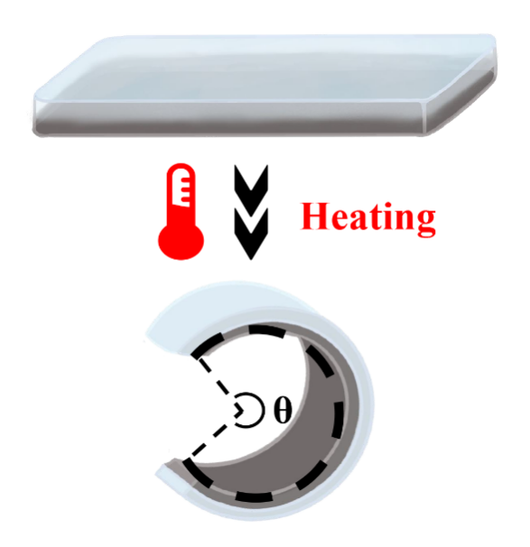
Fig. S2 Scheme of measuring the bending angle (θ) of the hydrogel actuator

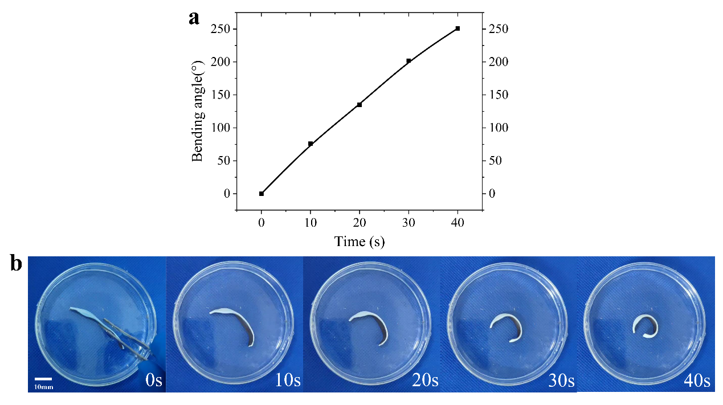
Fig. S3 Thermo-responsive actuation a angle change curve, b physical diagram of the hydrogel without CaCl₂ soaking in water at 50 °C

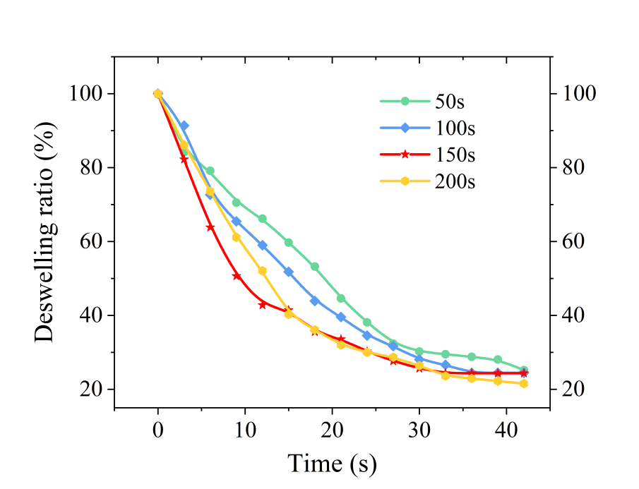
Fig. S4 The deswelling ratio of PSM hydrogels soaked in CaCl₂ for 50 s, 100 s, 150 s and 200 s

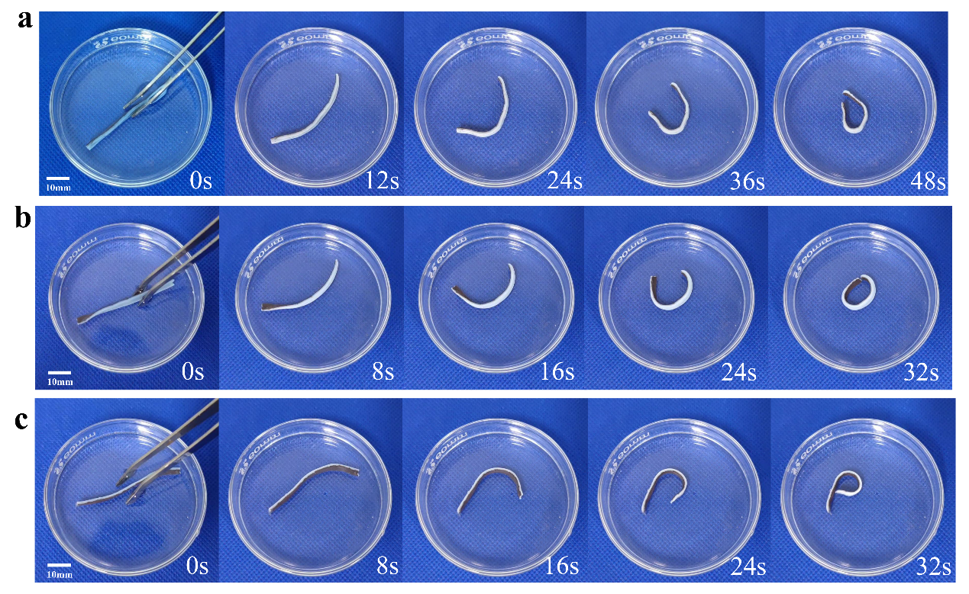
Fig. S5 Thermo-responsive actuation of hydrogels after soaking CaCl₂ for a 50 s, b 100 s, c 200 s in water at 50 °C

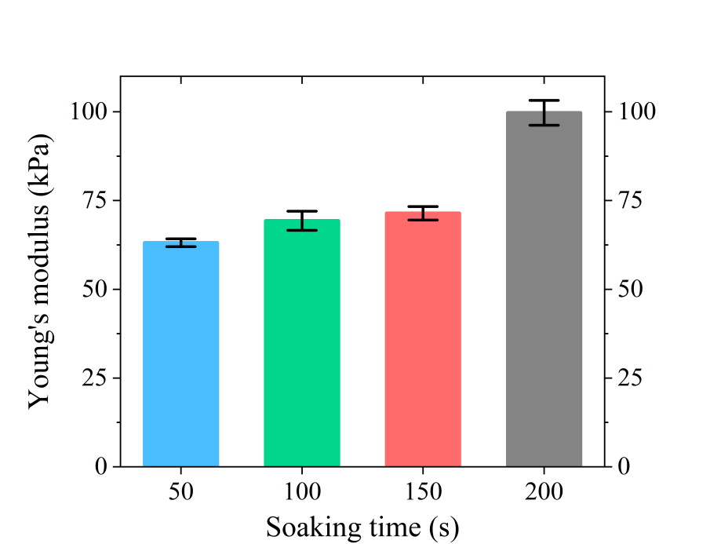
Fig. S6 The Young's modulus of PSM hydrogels soaked in CaCl₂ for 50 s, 100 s, 150 s and 200 s
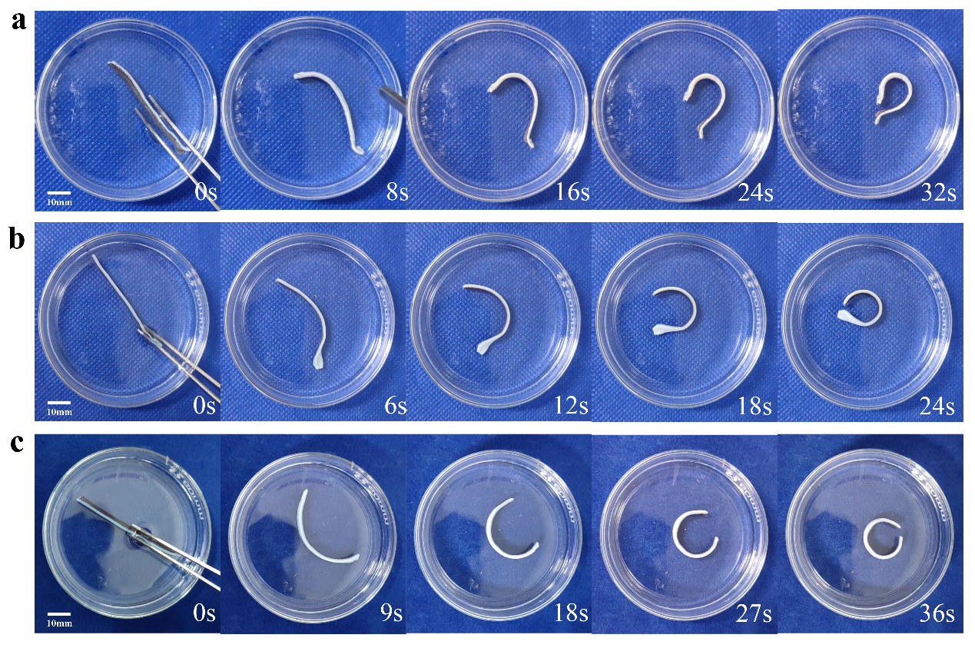
Fig. S7 Thermo-responsive actuation of a PSM_{0.2}, b PSM_{0.4}, c PSM_{0.8} hydrogels in water at 50 °C

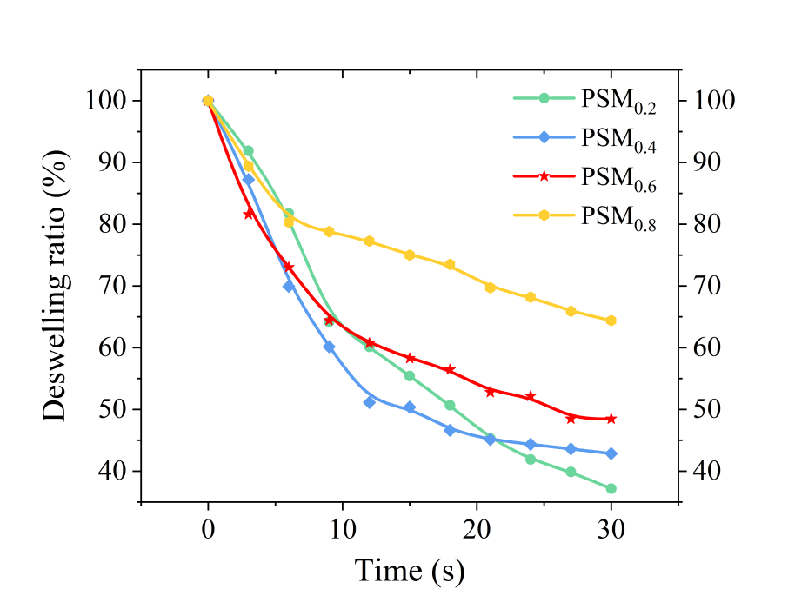
Fig. S8 Deswelling curve of PSM hydrogel in water at 50 °C

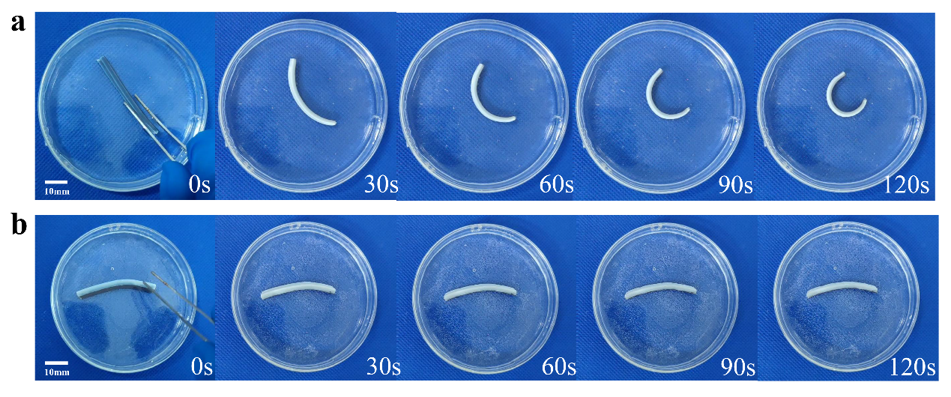
Fig. S9 Thermo-responsive actuation of hydrogels with a thickness of a 2 mm and b 3 mm in water at 50 °C

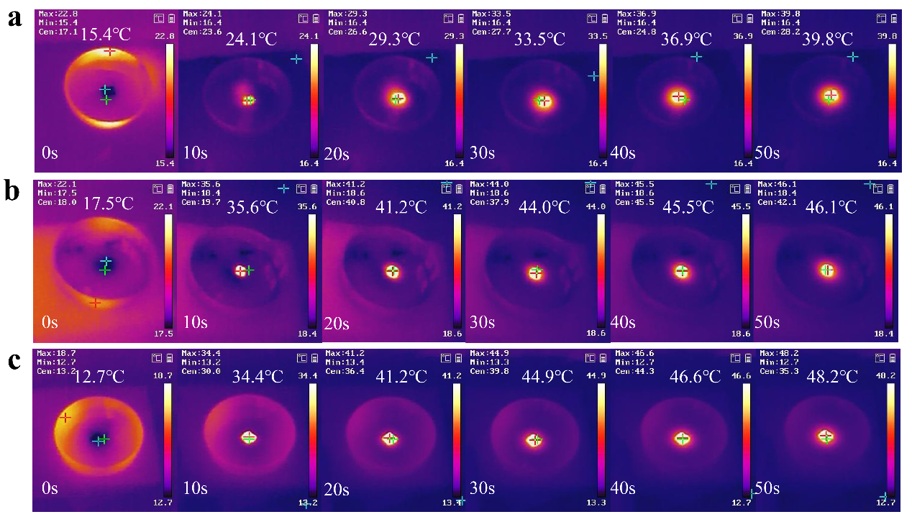
Fig. S10 Temperature response changes of a PSM_{0.2}, b PSM_{0.4} c PSM_{0.8} hydrogels under NIR light irradiation (808 nm, 1 W/cm²)

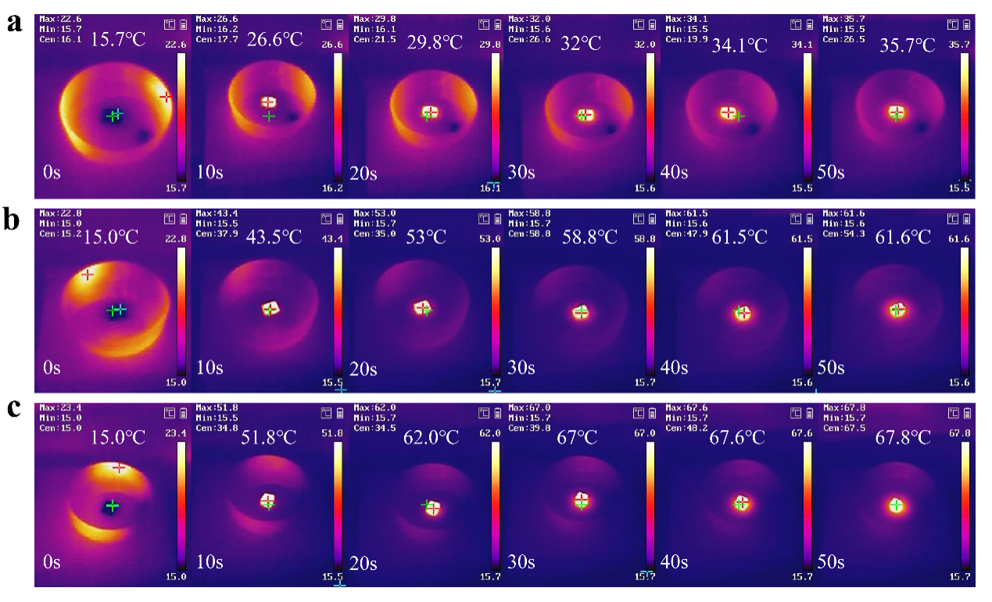
Fig. S11 Temperature response changes of PSM_{0.6} hydrogel under 808 nm NIR light irradiation with a 0.5 W/cm², b 1.5 W/cm² , c 2 W/cm²

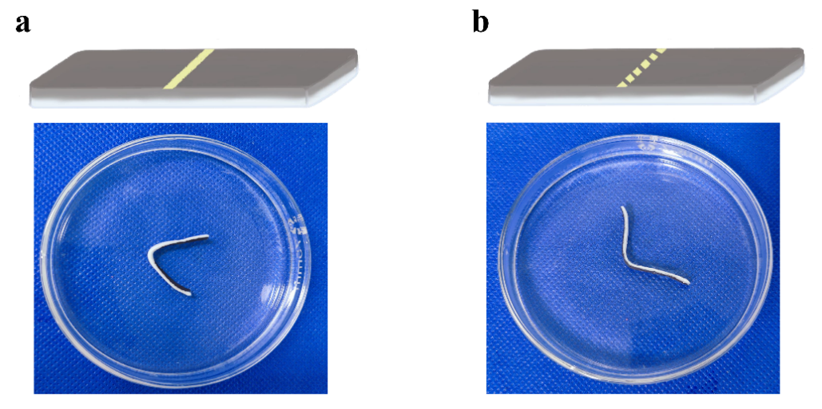
Fig. S12 Shape deformation of PSM hydrogel actuators coating Ca²⁺ in the a bottom and b top directions

Fig. S13 Diagram of encoded information written by coating Ca²⁺

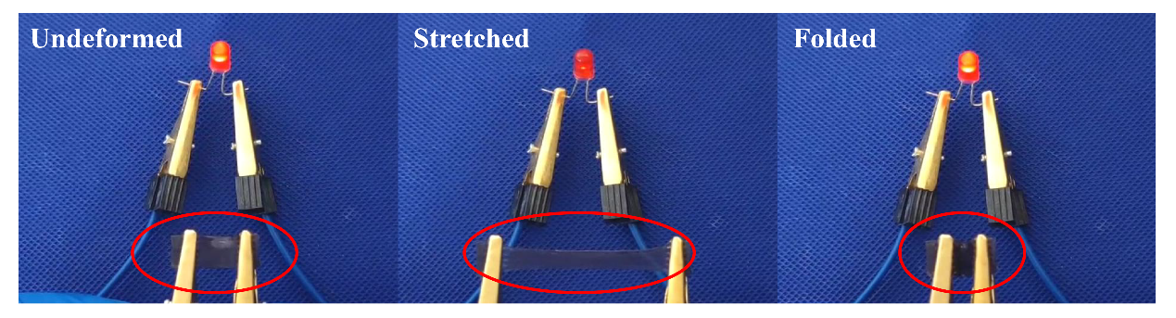
Fig. S14 Brightness changes of LED in the undeformed, stretched and folded states of PSM hydrogels

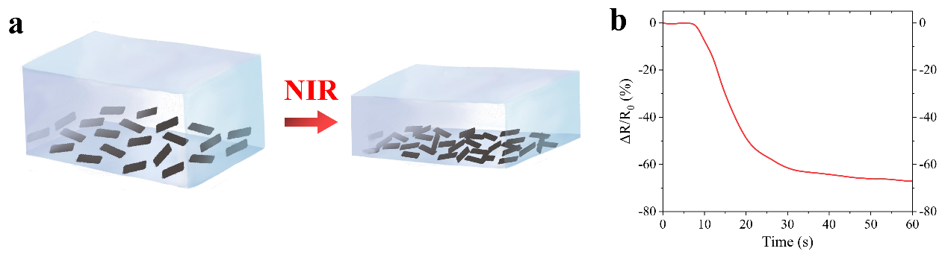
Fig. S15 a Photothermal sensing mechanism. b The relative resistance changes of PSM hydrogel under NIR irradiation

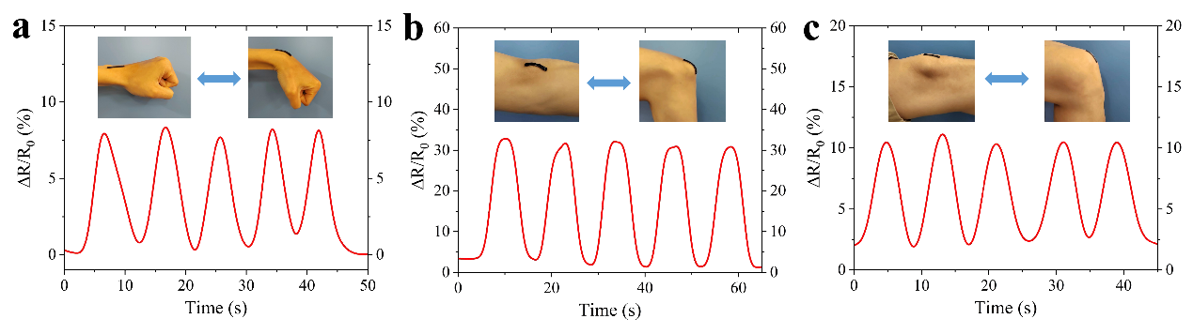
Fig. S16 The relative resistance changes of PSM hydrogel under different joints include a wrist, b arm and c leg

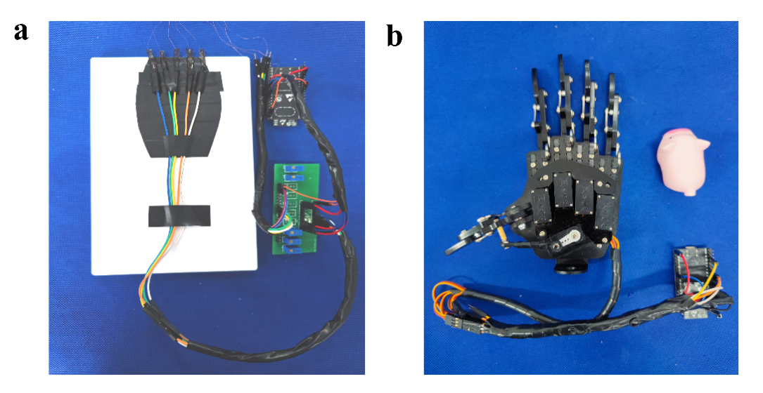
Fig. S17 Hardware schematic of a PSM hydrogel and the signal transmission system, b Robotic hand and the signal receiver system

Table S1. Summarization for the bending speed and bending amplitude of hydrogel actuators

Material | Structure | Bending speed | Bending amplitude | Stimulation conditions | Sample size (mm³) | Ref
PNIPAM/  XLG/  HEA | Gradient | 9.8°/s | 206° | 50 ℃ water | 25 × 5 × 1 | [S1]
PNIPAM  /XLG | Gradient | 2.38°/s | 57.2° | 50 ℃ water | 25 × 5 × 1 | [S2]
P(NIPAM-co-SPA)/  TCNC | Gradient | 10.2°/s | 225° | 60 ℃ water | 25 × 5 × 0.3 | [S3]
PNIPAM/  XLG/NFC | Bilayer | 9°/s | 180° | 50 ℃ water | 65 × 7 × 2 | [S4]
PNIPAM/  PAAM-  PTCA | Bilayer | 6.1°/s | 305° | 45 ℃ water | —— | [S5]
PNIPAM/  XLG/  MoO₂ | Bilayer | 3°/s | 90° | NIR 808 nm 0.8 W/cm² | —— | [S6]
PNIPAM/PVA | Bilayer | 2.1°/s | 65° | NIR 808 nm 0.2 W/cm² | —— | [S7]
PNIPAM/ SA/MoO₂ | Gradient | 21°/s | 336° | 50 ℃ water | 50 × 10 × 1 | This work

Notes: The comparison is only rough because these hydrogels have different sample sizes and stimulation conditions

Table S2. Comparison of the main conductive parameters of PSM hydrogel and conductive hydrogel strain sensors in previous mainstream work

Material | Strain (%) | Gauge Factor | Linear or Nonlinear | Conductive mechanism | Ref
PAA/NCT | 500 | 2.69 | Linear | Ionic conduction | [S8]
TA@HAP NWs/PVA(W/EG) | 350 | 2.84 | Linear | Ionic conduction | [S9]
PAAM/SA/LiCl/CaCl₂/glycerin | 0-100 | 0.45 | Nonlinear | Ionic conduction | [S10]
 | 200-300 | 2.31
[EMIm][DCA]/WPU | 0-30 | 0.53 | Nonlinear | Ionic conduction | [S11]
 | 30-100 | 0.83
 | 100-200 | 1.38
HF(PVA-C/P) | 400 | 2.1 | Linear | Electronic conduction | [S12]
MWCNTs-PDMS | 160 | 3.77 | Linear | Electronic conduction | [S13]
PVA-CBA/PAAm/TA/  Ti₃C₂Tx | 0-80 | 1.2 | Nonlinear | Electronic conduction | [S14]
 | 80-150 | 1.57
 | 150-220 | 2.34
 | 220-280 | 3.51
PVA/G/PDA/AgNPs | 0-70 | 0.94 | Nonlinear | Electronic conduction | [S15]
 | 70-315 | 0.13
PNIPAM/SA/ MoO₂ | 600 | 3.94 | Linear | Electronic conduction | This work

Supporting Movie 1 Thermo-responsive actuation behavior of hydrogels
Supporting Movie 2 PSM hydrogel gripper grabs metal sheet from 50 °C water
Supporting Movie 3 Bioinspired jellyfish swimming under NIR switch
Supporting Movie 4 Self-assembly folding cube
Supporting Movie 5 Brightness changes of LED in the undeformed, stretched and folded states of PSM hydrogel
Supporting Movie 6 Remote interaction of soft-hard robot via IoT

Reference
[S1] Y. Tan, D. Wang, H. Xu, Y. Yang, X. L. Wang, F. Tian, P. Xu, W. An, X. Zhao, S. Xu. Rapid recovery hydrogel actuators in air with bionic large-ranged gradient structure. ACS Appl. Mater. Interfaces. 10(46), 40125-40131 (2018). https://doi.org/10.1021/acsami.8b13235
[S2] Y. Tan, D. Wang, H. Xu, Y. Yang, W. An, L. Yu, Z. Xiao, S. Xu. A fast, reversible, and robust gradient nanocomposite hydrogel actuator with water-promoted thermal response. Macromol. Rapid Commun. 39(8), e1700863 (2018). https://doi.org/10.1002/marc.201700863
[S3] J. Lin, Y. Han, Y. Cui, W. Zhao, C. Chang. Ionic coordination strengthening of temperature-driven gradient hydrogel actuators with rapid responsiveness. Compos. B. Eng. 245, (2022). https://doi.org/10.1016/j.compositesb.2022.110210
[S4] Q. Zhao, Y. Liang, L. Ren, Z. Yu, Z. Zhang, F. Qiu, L. Ren. Design and fabrication of nanofibrillated cellulose-containing bilayer hydrogel actuators with temperature and near infrared laser responses. J Mater Chem B. 6(8), 1260-1271 (2018). https://doi.org/10.1039/c7tb02853a
[S5] B. Y. Wu, X. X. Le, Y. K. Jian, W. Lu, Z. Y. Yang, Z. K. Zheng, P. Theato, J. W. Zhang, A. Zhang, T. Chen. Ph and thermo dual-responsive fluorescent hydrogel actuator. Macromol. Rapid Commun. 40(4), e1800648 (2019). https://doi.org/10.1002/marc.201800648
[S6] Z. Sun, C. Wei, W. Liu, H. Liu, J. Liu, R. Hao, M. Huang, S. He. Two-dimensional moo(2) nanosheet composite hydrogels with high transmittance and excellent photothermal property for near-infrared responsive actuators and microvalves. ACS Appl. Mater. Interfaces. 13(28), 33404-33416 (2021). https://doi.org/10.1021/acsami.1c04110
[S7] N. Chen, Y. Zhou, Y. Liu, Y. Mi, S. Zhao, W. Yang, S. Che, H. Liu, F. Chen, C. Xu, G. Ma, X. Peng, Y. Li. Conductive photo-thermal responsive bifunctional hydrogel system with self-actuating and self-monitoring abilities. Nano Res. 15(8), 7703-7712 (2022). https://doi.org/10.1007/s12274-022-4394-3
[S8] X. Jing, P. Feng, Z. Chen, Z. Xie, H. Li, X.-F. Peng, H.-Y. Mi, Y. Liu. Highly stretchable, self-healable, freezing-tolerant, and transparent polyacrylic acid/nanochitin composite hydrogel for self-powered multifunctional sensors. ACS Sustainable Chem. Eng. 9(28), 9209-9220 (2021). https://doi.org/10.1021/acssuschemeng.1c00949
[S9] J. Wen, J. Tang, H. Ning, N. Hu, Y. Zhu, Y. Gong, C. Xu, Q. Zhao, X. Jiang, X. Hu, L. Lei, D. Wu, T. Huang. Multifunctional ionic skin with sensing, uv‐filtering, water‐retaining, and anti‐freezing capabilities. Adv. Funct. Mater. 31(21), 2011176 (2021). https://doi.org/10.1002/adfm.202011176
[S10] X.-y. Wang, H.-J. Kim. Ultra-stretchable dual-network ionic hydrogel strain sensor with moistening and anti-freezing ability. Prog. Org. Coat. 166, 106784 (2022). https://doi.org/10.1016/j.porgcoat.2022.106784
[S11] B. Zhao, J. Yan, F. Long, W. Qiu, G. Meng, Z. Zeng, H. Huang, H. Wang, N. Lin, X. Y. Liu. Bioinspired conductive enhanced polyurethane ionic skin as reliable multifunctional sensors. Adv. Sci. 10(19), e2300857 (2023). https://doi.org/10.1002/advs.202300857
[S12] Q. Zhang, Q. Wang, G. Wang, Z. Zhang, S. Xia, G. Gao. Ultrathin and highly tough hydrogel films for multifunctional strain sensors. ACS Appl. Mater. Interfaces. 13(42), 50411-50421 (2021). https://doi.org/10.1021/acsami.1c15784
[S13] K. Zhang, C. Song, Z. Wang, C. Gao, Y. Wu, Y. Liu. A stretchable and self-healable organosilicon conductive nanocomposite for a reliable and sensitive strain sensor. J. Mater. Chem. C. 8(48), 17277-17288 (2020). https://doi.org/10.1039/d0tc04719h
[S14] T. Gong, Z. N. Li, H. Liang, Y. Li, X. Tang, F. Chen, Q. Hu, H. Wang. High-sensitivity wearable sensor based on a mxene nanochannel self-adhesive hydrogel. ACS Appl. Mater. Interfaces. 15(15), 19349-19361 (2023). https://doi.org/10.1021/acsami.3c01748
[S15] L. Fan, J. Xie, Y. Zheng, D. Wei, D. Yao, J. Zhang, T. Zhang. Antibacterial, self-adhesive, recyclable, and tough conductive composite hydrogels for ultrasensitive strain sensing. ACS Appl. Mater. Interfaces. 12(19), 22225-22236 (2020). https://doi.org/10.1021/acsami.0c06091

