Supporting Information for
Structural Engineering of Hierarchical Magnetic/Carbon Nanocomposites via In-Situ Growth for High-Efficient Electromagnetic Wave Absorption
Xianyuan Liu¹, Jinman Zhou¹, Ying Xue, Xianyong Lu^{1,} *
Key Laboratory of Bio-Inspired Smart Interfacial Science and Technology of Ministry of Education, School of Chemistry, Beihang University, Beijing 100191, P. R. China
*Corresponding author. E-mail: xylu@buaa.edu.cn (Xianyong Lu)
Supplementary Figures and Table
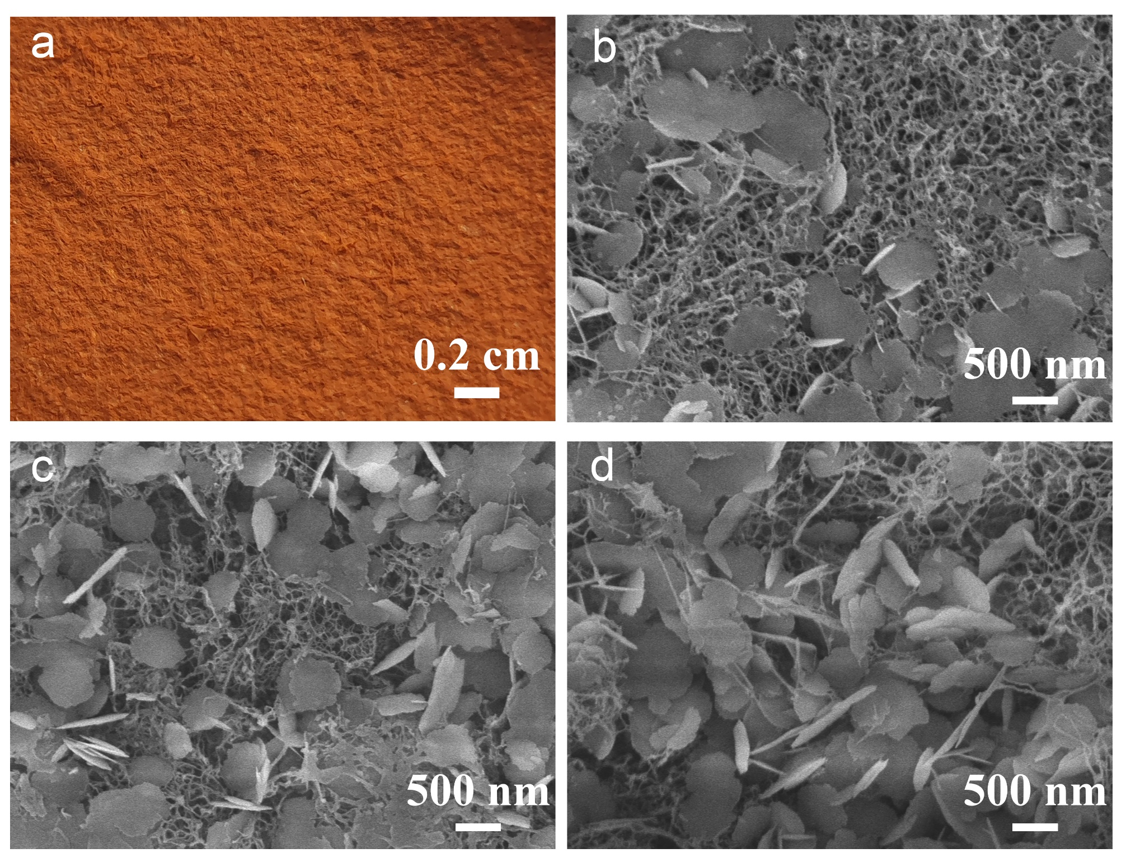
Fig. S1 a Optical image of the surface of α-Fe₂O₃@ANFs/Al-α-Fe₂O₃ aerogel. SEM images of b α-Fe₂O₃@ANFs/Al-α-Fe₂O_{3(1:1)} aerogel, c α-Fe₂O₃@ANFs/Al-α-Fe₂O_{3(1:2)} aerogel, and d α-Fe₂O₃@ANFs/Al-α-Fe₂O_{3(1:2.5)} aerogel

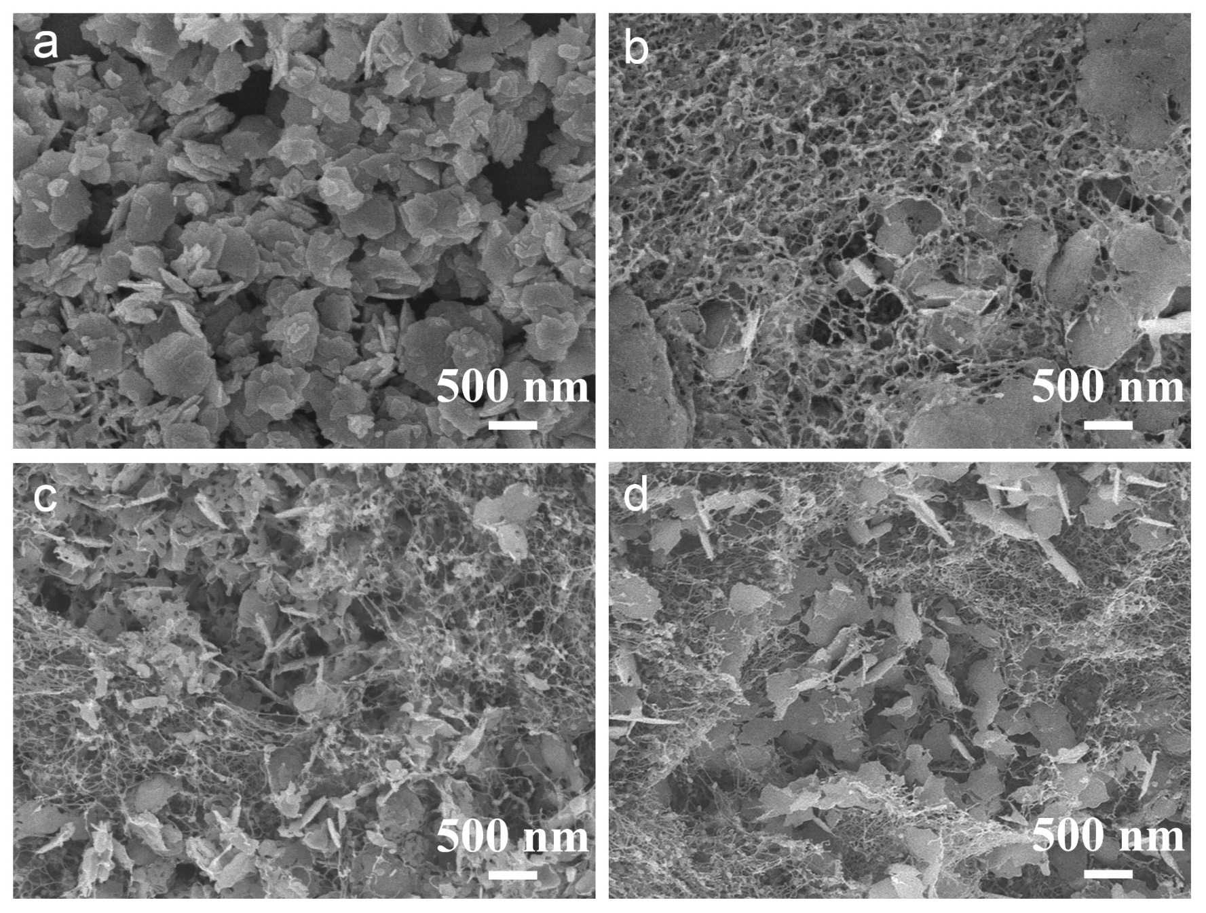
Fig. S2 SEM images of a Al-Fe₃O₄ nanosheets, b Fe₃O₄-Fe@CNFs/Al-Fe₃O₄-Fe_{(1:1)}, c Fe₃O₄-Fe@CNFs/Al-Fe₃O₄-Fe_{(1:2)}, and d Fe₃O₄-Fe@CNFs/Al-Fe₃O₄-Fe_{(1:2.5)}

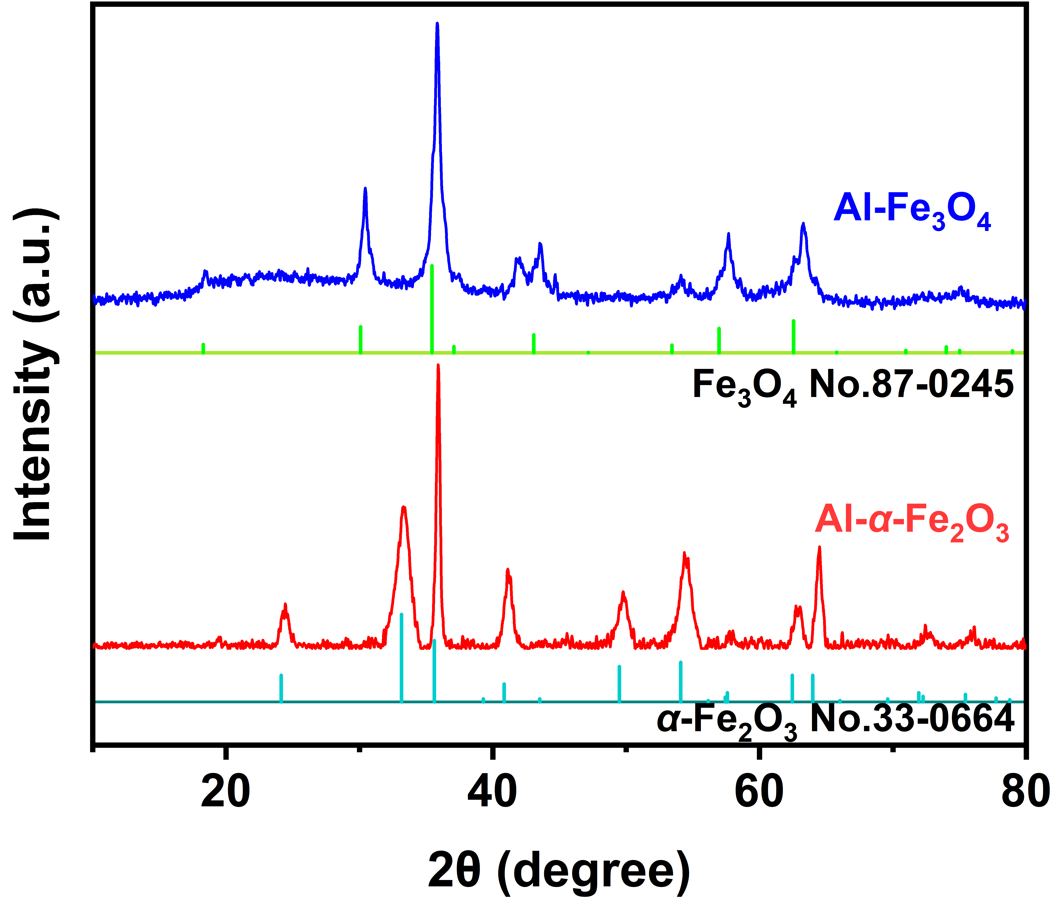
Fig. S3 XRD patterns of Al-α-Fe₂O₃ nanosheets, and Al-Fe₃O₄ nanosheets
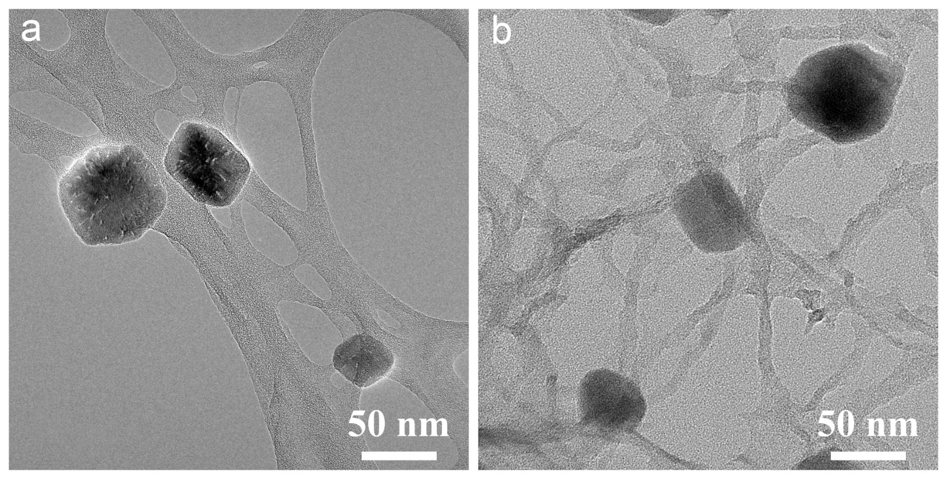
Fig. S4 TEM images of a α-Fe₂O₃@ANFs and b Fe₃O₄-Fe@CNFs
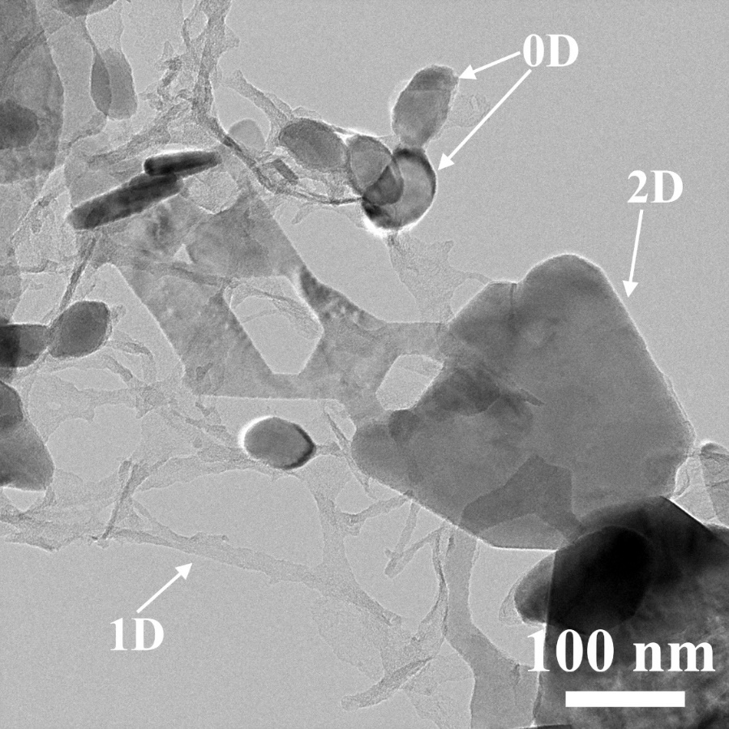
Fig. S5 TEM image of 0D@1D/2D Fe₃O₄-Fe@CNFs/Al-Fe₃O₄-Fe
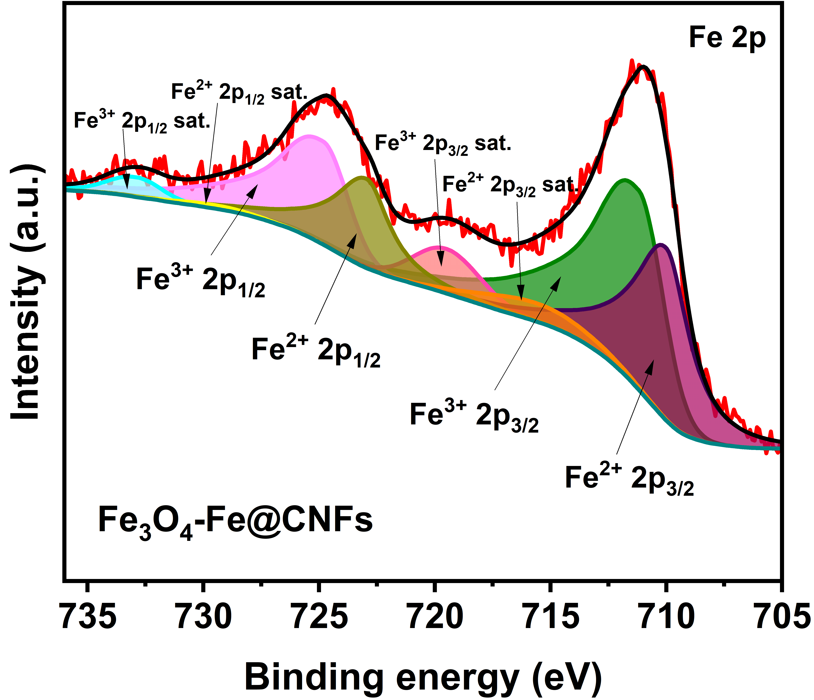
Fig. S6 XPS spectra of Fe 2p of Fe₃O₄-Fe@CNFs
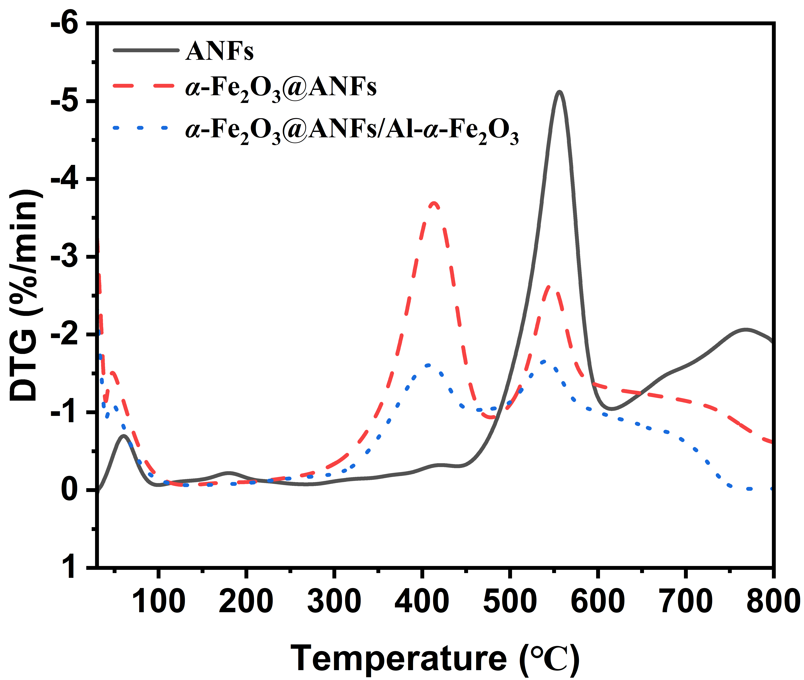
Fig. S7 DTG curves of ANFs, α-Fe₂O₃@ANFs, and α-Fe₂O₃@ANFs/Al-α-Fe₂O₃
Fig. S8 3D reflection loss curves maps of a Fe₃O₄-Fe@CNFs/Al-Fe₃O₄-Fe_{(1:1)} and b Fe₃O₄-Fe@CNFs/Al-Fe₃O₄-Fe_{(1:2.5)}
Table S1 Comparison of electromagnetic wave absorption of the samples
Absorbers | Component, wt | RL, min |  | RL≤-10 dB
Absorbers | Fe₃O₄-Fe : Al-Fe₃O₄-Fe | RL_{min}  (dB) | Thickness  (mm) | EAB  (GHz) | Thickness  (mm)
CNFs | - | -3.8 | 0.9 | 0 | -
Fe₃O₄-Fe@CNFs | - | -24.2 | 1.9 | 5.9 | 1.9
Al-Fe₃O₄ | - | -39.6 | 8.0 | 2.4 | 7.4
Fe₃O₄-Fe@CNFs/Al-Fe₃O₄-Fe | 1: 3 | -59.3 | 4.3 | 5.6 | 2.2
Fe₃O₄-Fe@CNFs/Al-Fe₃O₄-Fe_{(1:2.5)} | 1 : 2.5 | -49.5 | 2.3 | 6.1 | 2.1
Fe₃O₄-Fe@CNFs/Al-Fe₃O₄-Fe_{(1:2)} | 1 : 2 | -49.5 | 2.1 | 6.4 | 2.2
Fe₃O₄-Fe@CNFs/Al-Fe₃O₄-Fe_{(1:1)} | 1 : 1 | -15.4 | 1.5 | 5.7 | 1.8

