Supporting Information for
Dual-Defect Engineering Strategy Enables High-Durability Rechargeable Magnesium-Metal Batteries
Fuyu Chen^{1,2}, Bai-Qing Zhao³, Kaifeng Huang^{1,2}, Xiu-Fen Ma^{1,2}, Hong-Yi Li^{1,2,}*, Xie Zhang⁴, Jiang Diao^{1,2}, Jili Yue^{1,2}, Guangsheng Huang^{1,2}, Jingfeng Wang^{1,2}, Fusheng Pan^{1,2,5,}*
¹ National Innovation Center for lndustry-Education Integration of Energy Storage Technology, School of Materials Science and Engineering, Chongqing University, Chongqing 400044, P. R. China
² National Magnesium Alloy Material Engineering Technology Research Center, Chongqing University, Chongqing 400044, P. R. China
³ Materials and Energy Division, Beijing Computational Science Research Center, Beijing 100193, P. R. China
⁴ School of Materials Science and Engineering, Northwestern Polytechnical University, Xi'an 710072, P. R. China.
⁵ National Key Laboratory of Advanced Casting Technologies, Chongqing University, Chongqing 400044, P. R. China
*Corresponding authors. E-mail: hongyi.li@cqu.edu.cn (Hong-Yi Li); fspan@cqu.edu.cn (Fusheng Pan)
Supplementary Figures and Tables
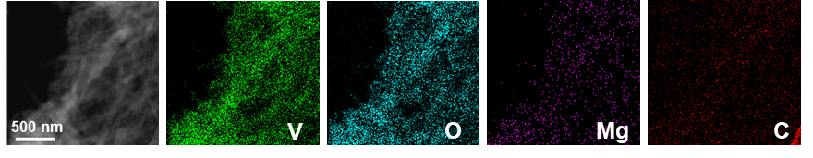
Fig. S1 Elemental mapping results of V, O, Mg, and C in MVOH/rGO
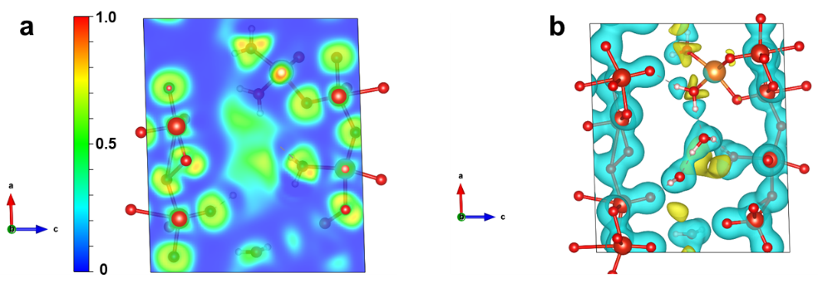
Fig. S2 The Electron Localization Function simulations results of (a) and Charge Density Difference of (b)
Electron Localization Function (ELF) results in Fig. S2a demonstrate strong localization of electrons around Mg, suggesting an increased tendency for these electrons to transfer from O, and the large ELF on Mg−O bond confirms the presence of strong interactions between Mg and O. Subsequently, the calculated Charge Density Difference (CDD) in Fig. S2b reveals charge accumulation around Mg (represented by the blue electron cloud) and corresponding electron loss around O (depicted by the yellow electron cloud), this suggests that O in V−O layers can donate its lone pair electrons to the vacant orbitals of P-Mg_{d}, indicating a strong tendency to generate coordination bonds between Mg and O from V−O layers. Therefore, it is demonstrated that the bonding occurs between P-Mg_{d} and O in the V−O layers, leading to the generation of MgO₅ polyhedra.
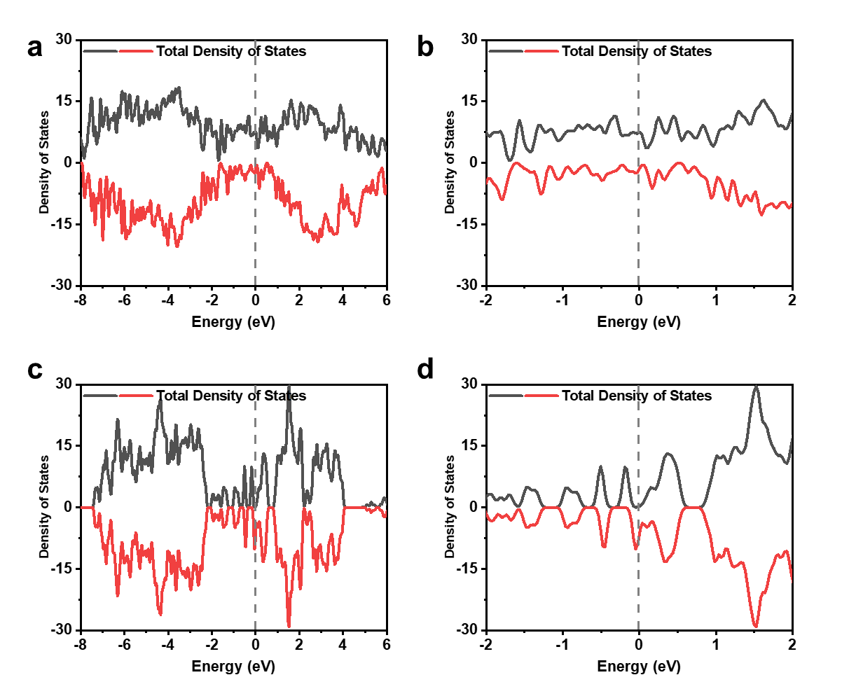
Fig. S3 Total Density of States (TDOS) of (a, b) MVOH and (c, d) VOH
The TDOS of MVOH (Fig. S3a and S3b) demonstrates a higher density of electronic states near the Fermi level compared to VOH (Fig. S3c and S3d), verifying the enhancement of conductivity attributed to the P-Mg_{d} in V₂O₅·nH₂O.
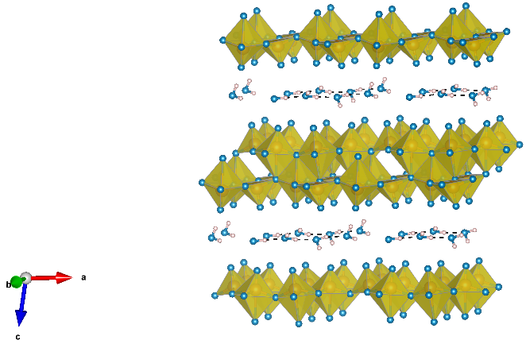
Fig. S4 Lamellar crystal structure of VOH
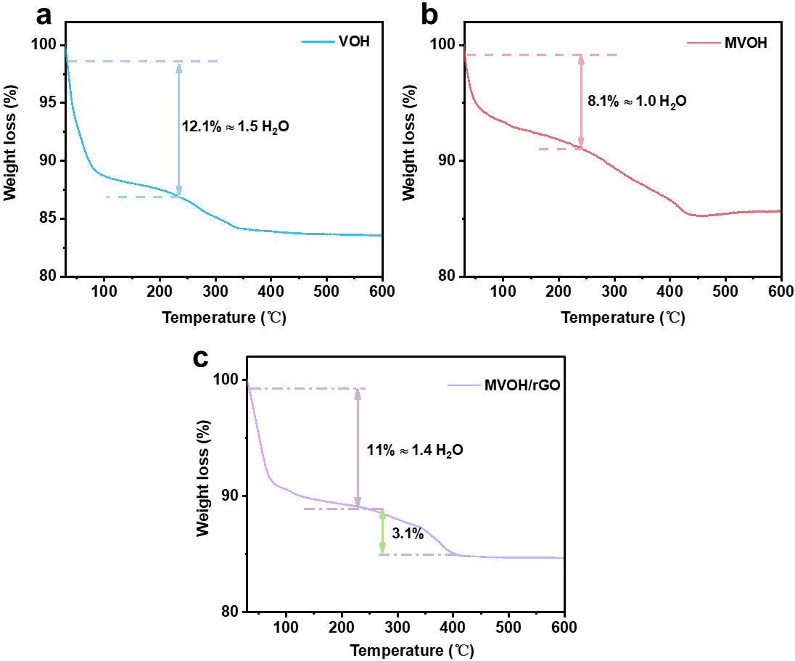
Fig. S5 TG profiles of (a) VOH, (b) MVOH, and (c) MVOH/rGO
Results show that pristine VOH contains 1.5 crystal water molecules per unit. The crystal water content of MVOH decreases to 1.0 because the interaction force between the pre-interalated Mg²⁺ and V–O layers shrinks the interlayer spacing. However, O_{d} can greatly alleviate the interaction caused by P-Mg_{d}, and the crystal water content of MVOH/rGO thus recovers to 1.4 per unit. Furthermore, the 3.1% weight loss observed in Fig. S5c between 270°C and 400°C can primarily be attributed to the thermal degradation of rGO in MVOH/rGO composite. The rGO content is thus deduced to be 11.4% in MVOH/rGO composite, with Mg_{0.07}V₂O₅·1.4H₂O content of 88.6%.

Fig. S6 XRD patterns of VOH, MVOH, and MVOH/rGO
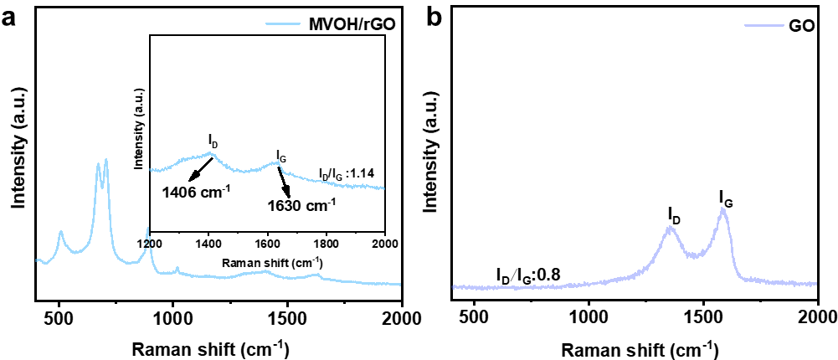
Fig. S7 Raman spectra of (a) MVOH/rGO and (b) GO
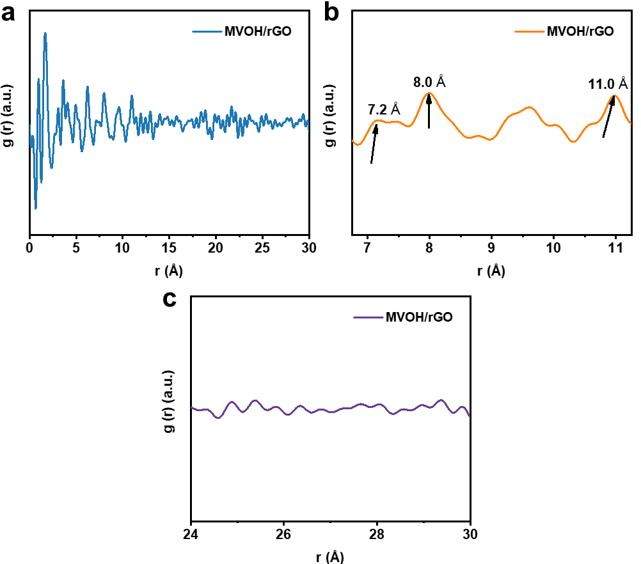
Fig. S8 (a−c) The pair distribution function results of MVOH/rGO at different midden range
The PDF analysis results at 5-10 Å in Fig. S8a reveal the typical characterization of V₂O₅ [S1], in which the peaks at 7.2 Å, 8.0 Å, and 11.0 Å in Fig. S8b represent the interatomic distance of V−V along the b direction and the a direction, respectively.
Fig. S9 XPS survey spectra of MVOH/rGO at the Ar ion etching depth of 0, 10, 20 nm
In agreement with the ICP–OES and EDX analysis results, the XPS survey spectra in Fig. S9 shows the signals of V, Mg, O, and C. The signal intensity of C element decreases as the etching depth increasing from 0 to 20 nm, while the signals of V, Mg, and O elements increase, which verifies the surface contact between MVOH and rGO.
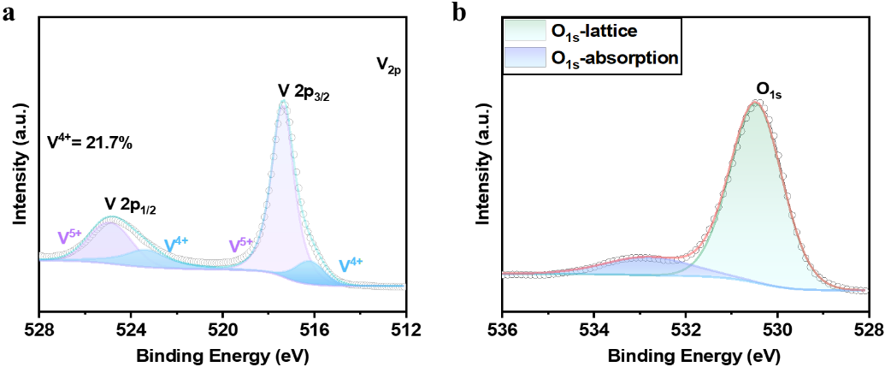
Fig. S10 (a) V 2p and (b) O 1s high-resolution XPS spectra of MVOH
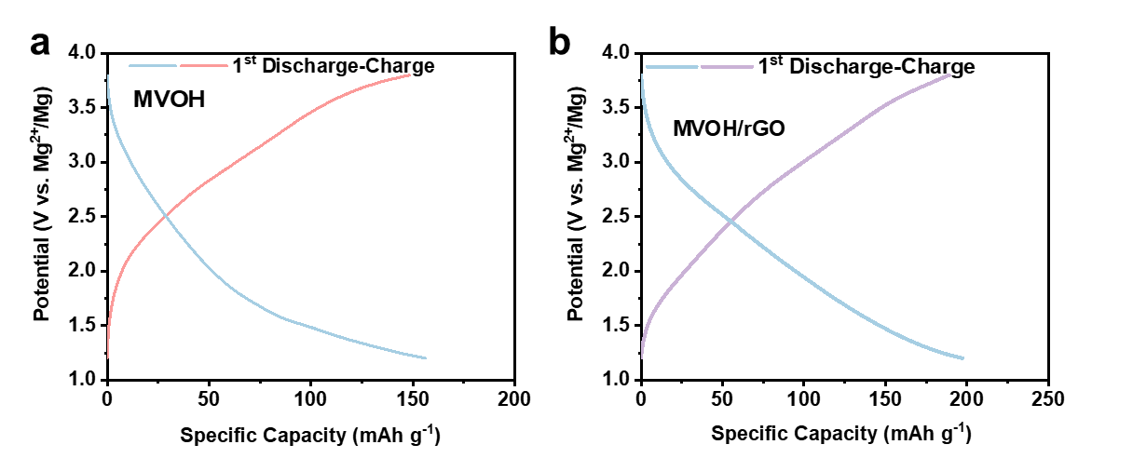
Fig. S11 Initial GCD curves at 0.02 A g⁻¹ of (a) MVOH and (b) MVOH/rGO cathodes
Fig. S12 CV curves of MVOH/rGO at 0.1 mV s⁻¹ for the initial three cycles
Fig. S13 EPR spectrum of VOH-O_{d}
As shown in Fig. S13, the characteristic peaks of O_{d} were clearly observed, implying the existence of O_{d} in VOH-O_{d}.
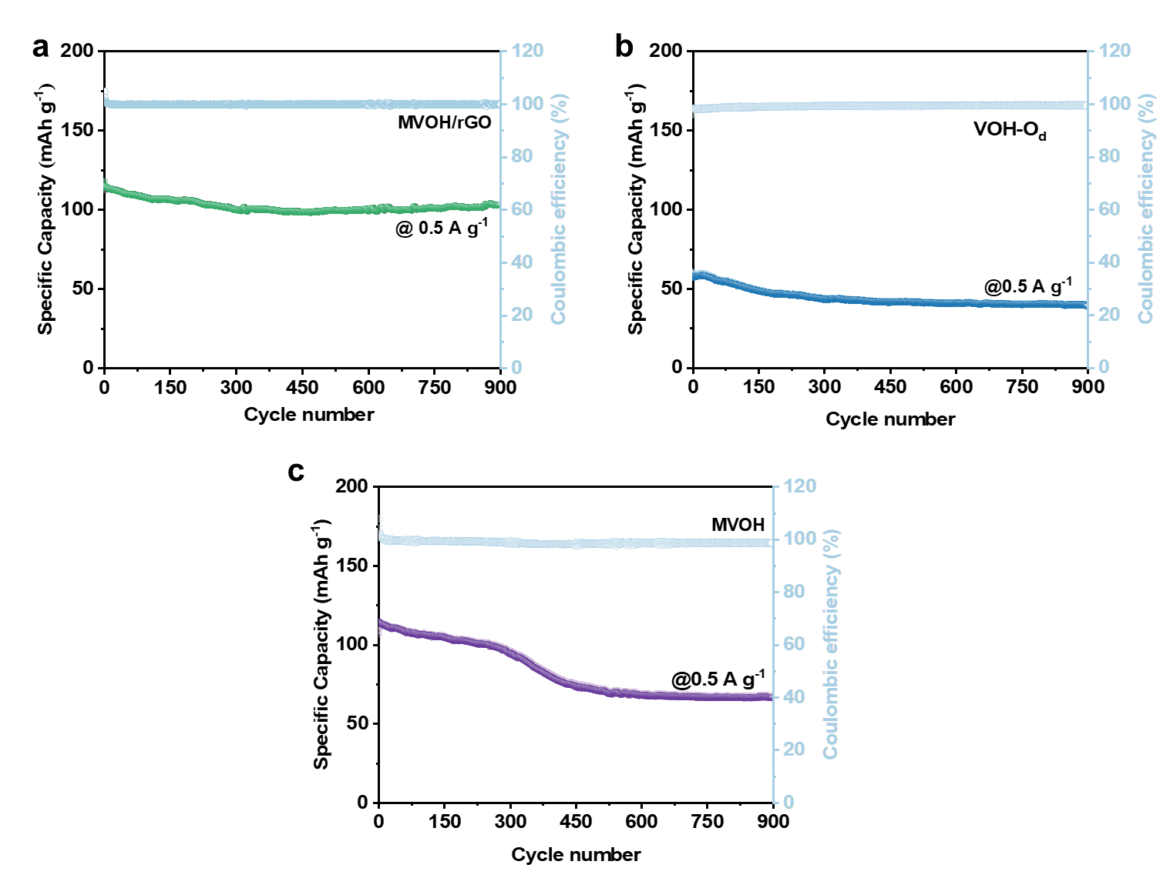
Fig. S14 Long-term cycling performance at 0.5 A g⁻¹ of (a) MVOH/rGO, (b) VOH-O_{d}, and (c) MVOH cathodes
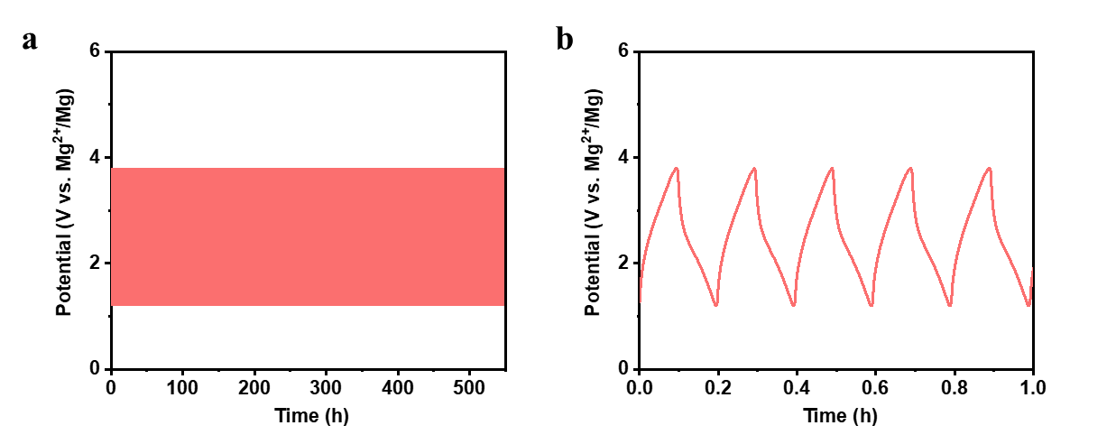
Fig. S15 (a, b) Time-potential curves of MVOH/rGO cahode during long-term cycling at 1 A g⁻¹
Fig. S16 Fitting curves for Peaks A−B in CV curves of MVOH/rGO at 0.1−0.8 mV s⁻¹
Fig. S17 Current contribution ratios of capacitive processes for VOH, MVOH, and MVOH/rGO cathodes at 0.1−0.8 mV s⁻¹
The contribution ratios of capacitive and diffusion processes in VOH, MVOH, and MVOH/rGO cathodes are calculated from the following equation [S2, S3]:
$\text{i}\text{ = }{\text{k}}_{\text{1}}\text{v+ }{\text{k}}_{\text{2}}{\text{v}}^{\text{1}\text{/2}}$ (S1)
Where ‘i’ represents the peak current, and k₁ and k₂ represent the capacitive and diffusion contribution coefficients, respectively.
Fig. S18 EIS spectra of VOH, MVOH, and MVOH/rGO cathodes
Mg²⁺ Diffusion coefficient (${\text{D}}_{{\text{Mg}}^{\text{2+}}}$) in the low-frequency region is calculated by the following equation [S4−S7]:
${\text{D}}_{{\text{Mg}}^{\text{2+}}}\text{= }\frac{{\text{R}}^{\text{2}}{\text{T}}^{\text{2}}}{\text{2}{\text{A}}^{\text{2}}{\text{n}}^{\text{4}}{\text{F}}^{\text{4}}{\text{C}}^{\text{2}}{\text{σ}}_{\text{ω}}^{\text{2}}}$($\text{ω}\text{≫}\frac{\text{2}{\text{D}}_{{\text{Mg}}^{\text{2+}}}}{{\text{L}}^{\text{2}}}$) (S2)
Where R represents the gas constant, T is the absolute temperature, A denotes the electrode area, n stands for the amount of charge transferred per unit of molecule, F is the Faraday constant, C signifies the ion concentration in the electrolyte, and σ_{ω} represents the Warburg coefficient. The low-frequency region σ_{ω} and the real part of impedance (Z') are related by the following equation:
${\text{ Z}}^{\text{'}}\text{=}{\text{ R}}_{\text{s}}\text{ + }{\text{R}}_{\text{ct}}\text{ +}{\text{σ}}_{\text{ω}}^{\text{1}\text{/2}}$ (S3)
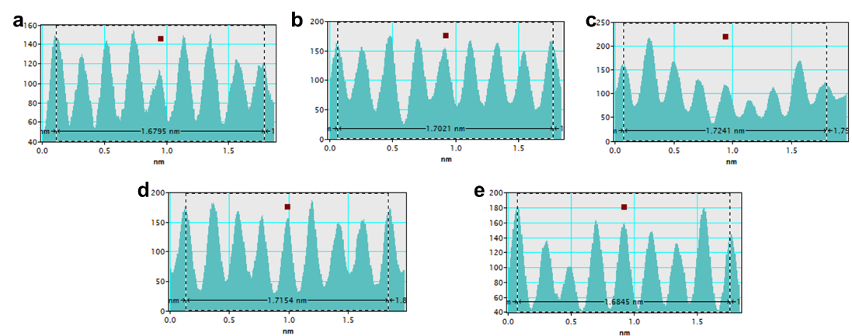
Fig. S19 (a−e) Interlayer spacing results of ex-situ TEM characterization
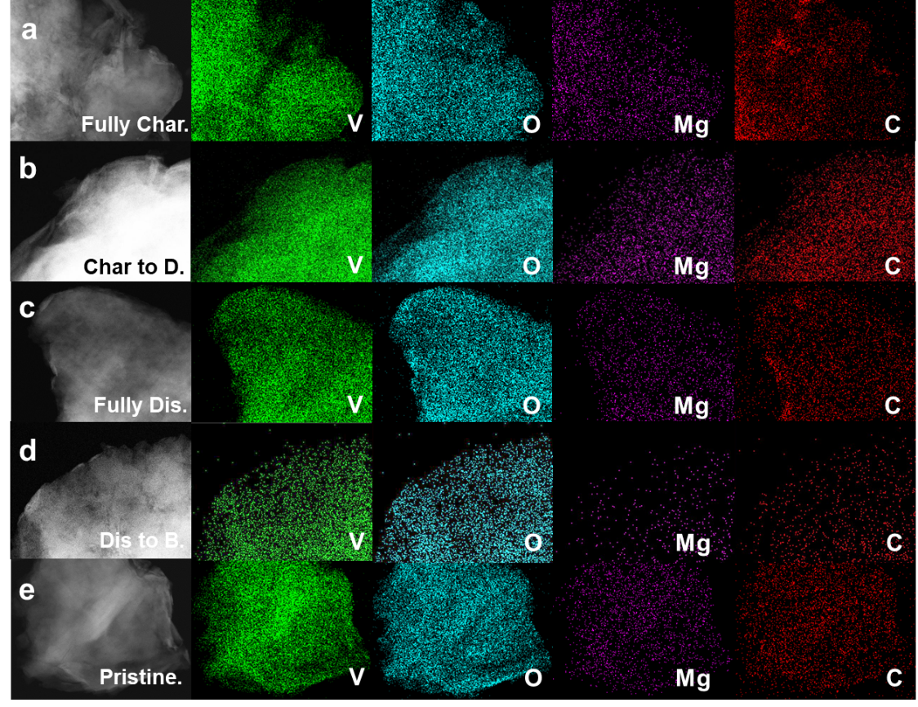
Fig. S20 Elemental mapping results of V, O, Mg, and C elements in MVOH/rGO at (a) fully charged, (b) charge states of D, (c) fully discharged, (d) discharg state of B, and (e) pristine states
Fig. S21 Cycling performance of Mg foil//MVOH/rGO full cell at 0.05 A g⁻¹
Table S1 ICP–OES results of Mg and V elements in MVOH/rGO and MVOH
Samples | Elements | C₁(mg/L) | RSD | Mg:V  (atomic ratio) | Formula
MVOH/rGO-1 | Mg/V | 0.963/58.27 | 0.04%/1.14% | 0.07: 2 | Mg_{0.07}V₂O₅
MVOH/rGO-2 | Mg/V | 0.959/58.06 | 0.04%/1.14% | 0.07: 2 | Mg_{0.07}V₂O₅
MVOH-1 | Mg/V | 0.322/28.37 | 0.013%/0.56% | 0.05: 2 | Mg_{0.05}V₂O₅
MVOH-2 | Mg/V | 0.320/27.87 | 0.013%/0.55% | 0.05: 2 | Mg_{0.05}V₂O₅
Table S2 XRD Rietveld refinement results of MVOH/rGO
Samples | R_{wp} | R_{p} | GOF | χ²
MVOH/rGO | 3.49% | 2.77% | 1.37 | GOF^2
Where, R_{wp} represents the Weighted Profile R-factor, R_{p} is the Profile R-factor, GOF denotes the Goodness of Fit, χ² stands for the Chi-squared, respectively.
Table S3 Comparison of cycling performance between MVOH/rGO and previously reported cathodes
Cathode | Anode | Electrolyte | Cycling performance | Refs.
V₂O_{5-x} | AC | 0.5 M Mg(ClO₄)₂ | ~78.2% after 400 cycles at 0.  1 A g⁻¹ | [S7]
Mn_{0.04}V₂O₅·1.17H₂O | AC | 0.3 M Mg(TFSI)₂ | 82% after 10,000 cycles at 2 A g⁻¹ | [S8]
Mg_{0.3}V₂O₅·1.1H₂O | AC | 0.3 M Mg(TFSI)₂ | 80% after 10,000 cycles at 2 A g⁻¹ | [S9]
PANI-V₂O₅ | AC | 0.3 M Mg(TFSI)₂ | ~80% after 500 cycles at 4 A g⁻¹ | [S10]
SNVO_{X}-CNT | AC | 0.5 M Mg(ClO₄)₂ | ~82% after 400 cycles at 0.1 A g⁻¹ | [S11]
V₂O₅-PEDOT | AC | 0.3 M Mg(TFSI)₂ | 67.3% after 500 cycles at 0.5 A g⁻¹ | [S6]
NaV₂O₂(PO₄)₂F/rGO | AC | 0.3 M Mg(TFSI)₂ | 76% after 9,500 cycles at 0.5 A g⁻¹ | [S12]
(NH₄)₂V₆O₁₆·1.5H₂O | AC | 0.5 M Mg(ClO₄)₂ | ~63% after 50 cycles at 0.1 A g⁻¹ | [S13]
NaV₈O₂₀·nH₂O | - | TEGDME/H₂O | ~52.5% after 1,000 cycles at 1.5 A g⁻¹ | [S14]
PANI/CC | AC | 0.3 M Mg(TFSI)₂ | 97.3% after 1500 cycles at 1 A g⁻¹ | [S15]
Mg(Mg_{0.5}V_{1.5})O₄ | AC | 0.3 M Mg(TFSI)₂ | 71.4% after 500 cycles at 1 A g⁻¹ | [S16]
MVOH/rGO | AC | 0.5 M Mg(TFSI)₂ | 95% after 7,000 cycles at 1 A g⁻¹ | This work
Table S4 Comparison of cycling performance between Mg foil//MVOH/rGO full cell and previously reported RMMBs
Cathode | Anode | Electrolyte | Cycling performance | Refs.
Na₂Ti₆O₁₃ | Mg foil | 0.4 M APC | 58.8% after 300 cycles at 0.1 A g⁻¹ | [S17]
NiS@C-C | Mg foil | APC-LiCl | 65% after 45 cycles at 0.05 A g⁻¹ | [S18]
Te@CSs | Mg foil | 0.4 M APC | 77.1% after 500 cycles at 0.5 A g⁻¹ | [S19]
RFC/V₂O₅ | Mg foil | 0.2 M [Mg₂(μ-Cl)₂(DME)₄][AlCl₄]₂ in DME | 67% after 100 cycles at 0.32 A g⁻¹ | [S20]
PA-VOPO₄ | Mg foil | 0.25 M APC | 70% after 500 cycles at 0.1 A g⁻¹ | [S21]
PVO | Mg foil | 0.2 M Mg(CF₃SO₃)₂-  MgCl₂-AlCl₃ | 69.6% after 50 cycles at 0.1 A g⁻¹ | [S10]
Ag₂Se@C | Mg foil | 0.2 M APC | 65% after 500 cycles at 0.2 A g⁻¹ | [S22]
Ti₃C₂Tx@C | Mg AZ31 | 0.4 M Mg₂Cl₃⁺  ·AlPh₂Cl₂-/THF | 85% after 400 cycles at 0.05 A g⁻¹ | [S23]
Mo₆S₈ | Mg foil | PDEGVE@GF GPE | 80.3% after 500 cycles at 0.13 A g⁻¹ | [S24]
MoS₂/graphene | Mg foil | 0.25 M APC | 83% after 500 cycles at 0.5 A g⁻¹ | [S25]
CuSe | Mg foil | 0.3 M Mg[B(hfip)₄]₂/DME-NaOTf | 84.0% after 100 cycles at 0.1 A g⁻¹ | [S26]
V₂O₅-PEDOT | Mg foil | 0.4 M APC-CTAB | ~49.7% after 150 cycles at  0.1 A g⁻¹  ~62.3% after 500 cycles at  0.5 A g⁻¹ | [S27]
NaV₃O₈·1.69H₂O | Mg foil | 0.4 M APC | 80% after 100 cycles at 0.05 A g⁻¹ | [S28]
MVOH/rGO | Mg foil | 0.4 M APC-CTAB | 84% after 850 cycles at 0.1 A g⁻¹ | This work
Supplementary References
[S1] X. Zhao, L. Li, L. Zheng, L. Fan, Y. Yi, et al., 3d‐orbital regulation of transition metal intercalated vanadate as optimized cathodes for calcium‐ion batteries. Adv. Funct. Mater. 34, 2309753 (2023). https://doi.org/10.1002/adfm.202309753
[S2] Y. Zheng, Z. Yao, Z. Shadike, M. Lei, J. Liu, et al., Defect-concentration-mediated T-Nb₂O₅ anodes for durable and fast-charging Li-Ion batteries. Adv. Funct. Mater. 32, 2107060 (2021). https://doi.org/10.1002/adfm.202107060
[S3] J. Liu, Y. Wang, C. Yang, K. Mu, S. Wang, et al., A microcapsule‐assistant self‐healing magnesium battery cathodes. Energy Technol. 9, 2100393 (2021). https://doi.org/10.1002/ente.202100393
[S4] Q. Zong, Q. Wang, C. Liu, D. Tao, J. Wang, et al., Potassium ammonium vanadate with rich oxygen vacancies for fast and highly stable Zn-Ion storage. ACS Nano 16, 4588-4598 (2022). https://doi.org/10.1021/acsnano.1c11169
[S5] D. Wu, J. Zeng, H. Hua, J. Wu, Y. Yang, et al., NaV₆O₁₅: A promising cathode material for insertion/extraction of Mg²⁺ with excellent cycling performance. Nano Res. 13, 335-343 (2020). https://doi.org/10.1007/s12274-019-2602-6
[S6] Y. S. Joe, M. S. Kang, G. Jang, S. J. Lee, P. Nakhanivei, et al., Intercalation of bilayered V₂O₅ by electronically coupled pedot for greatly improved kinetic performance of magnesium ion battery cathodes. Chem. Eng. J. 460, 141706 (2023). https://doi.org/10.1016/j.cej.2023.141706
[S7] D. Wu, Y. Zhuang, F. Wang, Y. Yang, J. Zeng, et al., High-rate performance magnesium batteries achieved by direct growth of honeycomb-like V₂O₅ electrodes with rich oxygen vacancies. Nano Res. 16, 4880–4887 (2023). https://doi.org/10.1007/s12274-021-3679-2
[S8] X. Deng, Y. Xu, Q. An, F. Xiong, S. Tan, et al., Manganese ion pre-intercalated hydrated vanadium oxide as a high-performance cathode for magnesium ion batteries. J. Mater. Chem. A. 7, 10644–10650 (2019). https://doi.org/10.1039/c8ta11236c
[S9] Y. Xu, X. Deng, Q. Li, G. Zhang, F. Xiong, et al., Vanadium oxide pillared by interlayer Mg²⁺ ions and water as ultralong-life cathodes for magnesium-ion batteries. Chem 5, 1194–1209 (2019). https://doi.org/10.1016/j.chempr.2019.02.014
[S10] C. Zuo, Y. Xiao, X. Pan, F. Xiong, W. Zhang, et al., Organic-inorganic superlattices of vanadium oxide@polyaniline for high-performance magnesium-ion batteries. ChemSusChem 14, 2093–2099 (2021). https://doi.org/10.1002/cssc.202100263
[S11] D. Wu, Z. Wen, H. Jiang, H. Li, Y. Zhuang, et al., Ultralong-lifespan magnesium batteries enabled by the synergetic manipulation of oxygen vacancies and electronic conduction. ACS Appl. Mater. Interfaces 13, 12049-12058 (2021). https://doi.org/10.1021/acsami.1c00170
[S12] J. Wang, S. Tan, G. Zhang, Y. Jiang, Y. Yin, et al., Fast and stable Mg²⁺ intercalation in a high voltage NaV₂O₂(PO₄)₂F/rGO cathode material for magnesium-ion batteries. Sci. China Mater. 63, 1651–1662 (2020). https://doi.org/10.1007/s40843-020-1311-1
[S13] L. Wei, R. Lian, D. Wang, Y. Zhao, D. Yang, et al., Magnesium ion storage properties in a layered (NH₄)₂V₆O₁₆·1.5H₂O nanobelt cathode material activated by lattice water. ACS Appl. Mater. Interfaces 13, 30625–30632 (2021). https://doi.org/10.1021/acsami.1c06398
[S14] X. Wang, X. Zhang, G. Zhao, H. Hong, Z. Tang, et al., Ether-water hybrid electrolyte contributing to excellent Mg ion storage in layered sodium vanadate. ACS Nano 16, 6093–6102 (2022). https://doi.org/10.1021/acsnano.1c11590
[S15] P. Luo, Y. Xiao, J. Yang, C. Zuo, F. Xiong, et al., Polyaniline nanoarrays/carbon cloth as binder-free and flexible cathode for magnesium ion batteries. Chem. Eng. J. 433, 133772 (2021). https://doi.org/10.1016/j.cej.2021.133772
[S16] C. Zuo, W. Tang, B. Lan, F. Xiong, H. Tang, et al., Unexpected discovery of magnesium-vanadium spinel oxide containing extractable Mg²⁺ as a high-capacity cathode material for magnesium ion batteries. Chem. Eng. J. 405, 127005 (2021). https://doi.org/10.1016/j.cej.2020.127005
[S17] L. Luo, Y. Zhen, Y. Lu, K. Zhou, J. Huang, et al., Structural evolution from layered Na₂Ti₃O₇ to Na₂Ti₆O₁₃ nanowires enabling a highly reversible anode for Mg-ion batteries. Nanoscale 12, 230-238 (2020). https://doi.org/10.1039/c9nr08003a
[S18] G. Zhu, G. Xia, H. Pan, X. Yu. Size-controllable nickel sulfide nanoparticles embedded in carbon nanofibers as high-rate conversion cathodes for hybrid Mg-based battery. Adv. Sci. 9, e2106107 (2022). https://doi.org/10.1002/advs.202106107
[S19] Z. Chen, Q. Yang, D. Wang, A. Chen, X. Li, et al., Tellurium: a high-performance cathode for magnesium ion batteries based on a conversion mechanism. ACS Nano 16, 5349–5357 (2022). https://doi.org/10.1021/acsnano.1c07939
[S20] Y. Cheng, Y. Shao, V. Raju, X. Ji, B. L. Mehdi, et al., Molecular storage of Mg ions with vanadium oxide nanoclusters. Adv. Funct. Mater. 26, 3446–3453 (2016). https://doi.org/10.1002/adfm.201505501
[S21] L. Zhou, Q. Liu, Z. Zhang, K. Zhang, F. Xiong, et al., Interlayer-spacing-regulated VOPO₄ nanosheets with fast kinetics for high-capacity and durable rechargeable magnesium batteries. Adv. Mater. 30, e1801984 (2018). https://doi.org/10.1002/adma.201801984
[S22] J. H. Ha, B. Lee, J. H. Kim, B. W. Cho, S.-O. Kim, et al., Silver chalco-genides (Ag₂X, X=S, Se) nanoparticles embedded in carbon matrix for facile magnesium storage via conversion chemistry. Energy Storage Mater. 27, 459–465 (2020). https://doi.org/10.1016/j.ensm.2019.12.008
[S23] F. Liu, Y. Liu, X. Zhao, X. Liu, L.-Z. Fan. Pursuit of a high-capacity and long-life Mg-storage cathode by tailoring sandwich-structured Mxene@carbon nanosphere composites. J. Mater. Chem. A. 7, 16712–16719 (2019). https://doi.org/10.1039/c9ta02212k
[S24] X. Ge, F. Song, A. Du, G. Sun, S. Zhang, et al., Stable anion-rectifying poly (alkoxide magnesium) electrolytes for reversible magnesium metal batteries. ACS Energy Lett. 8, 3685-3692 (2023). https://doi.org/10.1021/acsenergylett.3c01192
[S25] C. Wu, G. Zhao, X. Yu, C. Liu, P. Lyu, et al., MoS₂/graphene heterostructure with facilitated Mg-diffusion kinetics for high-performance rechargeable magnesium batteries. Chem. Eng. J 412, 128736 (2021). https://doi.org/10.1016/j.cej.2021.128736
[S26] Y. Shen, Y. Wang, Y. Miao, Q. Li, X. Zhao, et al., Anion-incorporated Mg-ion solvation modulation enables fast magnesium storage kinetics of conversion-type cathode materials. Adv. Mater. 35, e2208289 (2023). https://doi.org/10.1002/adma.202208289
[S27] Z. Yao, Y. Yu, Q. Wu, M. Cui, X. Zhou, et al., Maximizing magnesiation capacity of nanowire cluster oxides by conductive macromolecule pillaring and multication intercalation. Small 17, 2102168 (2021). https://doi.org/10.1002/smll.202102168
[S28] M. Rashad, H. Zhang, M. Asif, K. Feng, X. Li, et al., Low-cost room-temperature synthesis of NaV₃O₈·1.69H₂O nanobelts for Mg batteries. ACS Appl. Mater. Interfaces 10, 4757–4766 (2018). https://doi.org/10.1021/acsami.7b18682

