Supporting Information for
MXene@c-MWCNT Adhesive Silica Nanofiber Membranes Enhancing Electromagnetic Interference Shielding and Thermal Insulation Performance in Extreme Environments
Ziyuan Han¹, Yutao Niu^{2, 3}, Xuetao Shi⁴, Duo Pan^{1,} *, Hu Liu^{1,} *, Hua Qiu⁴, Weihua Chen^{1, 5}, Ben Bin Xu⁶, Zeinhom M. El-Bahy ⁷, Hua Hou⁶, Eman Ramadan Elsharkawy⁸, Mohammed A. Amin⁹, Chuntai Liu¹ and Zhanhu Guo^{6,} *
¹ Key Laboratory of Materials Processing and Mold (Zhengzhou University), Ministry of Education; National Engineering Research Center for Advanced Polymer Processing Technology, Zhengzhou University, Zhengzhou 450002, P. R. China
² School of Nano-Tech and Nano-Bionics, University of Science and Technology of China, Hefei 230026, P. R. China
³ Key Laboratory of Multifunctional Nanomaterials and Smart Systems, Advanced Materials Division, Suzhou Institute of Nano-Tech and Nano-Bionics, Chinese Academy of Sciences, Suzhou 215123, P. R. China
⁴ Shaanxi Key Laboratory of Macromolecular Science and Technology, School of Chemistry and Chemical Engineering, Northwestern Polytechnical University, Xi’an 710072, P. R. China
⁵ College of Chemistry & Green Catalysis Center, Zhengzhou University, Zhengzhou 450001, P. R. China
⁶ Mechanical and Construction Engineering, Faculty of Engineering and Environment, Northumbria University, Newcastle Upon Tyne, NE1 8ST, UK
⁷ Department of Chemistry, Faculty of Science, Al-Azhar University, Nasr City 11884, Cairo, Egypt
⁸ Department of Chemistry, Faculty of Science, Northern Border University, Arar, Saudi Arabia
⁹ Department of Chemistry, College of Science, Taif University, P.O. Box 11099, Taif 21944, Saudi Arabia
*Corresponding authors. E-mail: panduonerc@zzu.edu.cn (Duo Pan); liuhu@zzu.edu.cn (Hu Liu); zhanhu.guo@northumbria.ac.uk (Zhanhu Guo)

Supplementary Figures and Tables
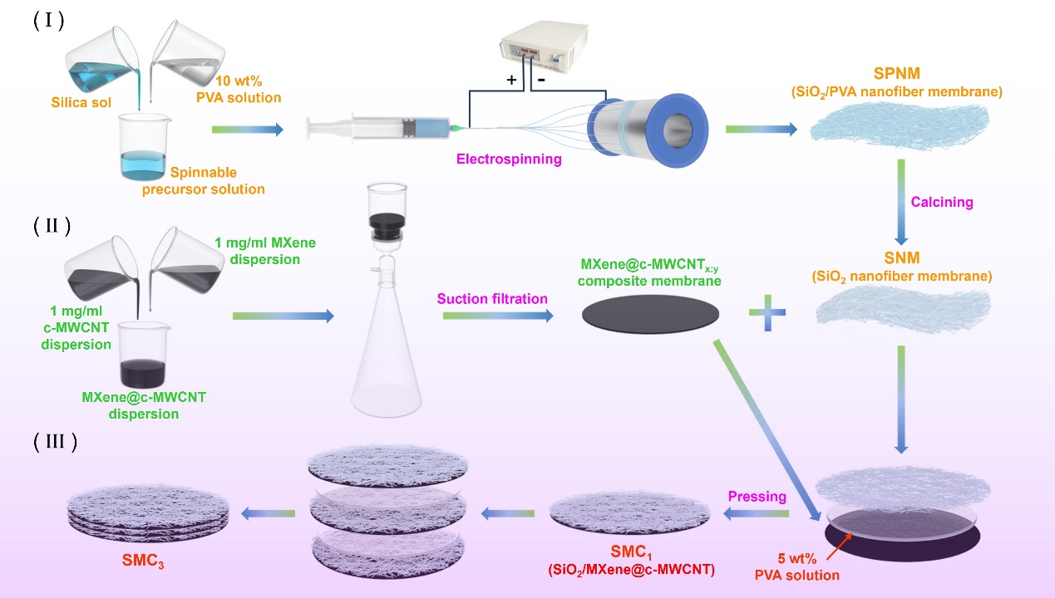
Fig. S1 Schematic diagram of preparation of SMC_{x}

Fig. S2 Thermal insulation testings in a high-temperature environment and b low-temperature environment, respectively
Fig. S3 a-e SEM images of the cross section of MXene@c-MWCNT_{x:y} with different weight ratio of MXene and c-MWCNT
Table S1a Fiber diameter (nm) before calcination
Fiber diameter (nm) | AVG
494.7 498.2 501.7 502.9 504.6  505.9 510.8 511.3 512.2 514.9 516.5 518.4 519.1 520.6 521.1 521.8 522.5 523.1 523.5 524.3 524.7 525.9 526.4 527.2 529.2 529.2 529.8 531.0 531.6 531.7 532.6 532.6 532.9 533.4 533.7 534.1 534.4 534.8 535.7 536.0 539.8 540.7 542.2 543.0 544.2 544.3 547.8 549.1 552.3 554.6 | 527.06
Table S1b Fiber diameter (nm) after calcination
Fiber diameter (nm) | AVG
315.9 325.2 331.7 334.6 337.1 337.8 339.4 341.0 342.9 343.2 343.7 344.5 345.6 345.9 346.1 347.2 350.8 351.0 352.3 353.9 354.6 354.7 356.1 358.2 358.8 358.9 360.7 361.3 362.0 362.1 362.9 363.4 363.7 363.9 364.2 364.5 364.5 365.1 365.2 367.6 369.3 369.4 370.5 371.6 371.8 374.9 375.0 375.7 377.1 383.8 | 356.03
Table S2 The average thickness (μm) of SMC_{x} and its components
Samples | SNM | MXene@c-MWCNT_{6:4} | SMC₁ | SMC₂ | SMC₃
Average thickness | 169.7 | 50 | 224.4 | 446.8 | 672.3
Table S3 The average thickness (nm) of MXene@c-MWCNT_{x:y}
X:Y | 0:10 | 4:6 | 5:5 | 6:4 | 10:0
Average thickness | 93 | 60 | 55 | 50 | 34

