Supporting Information for
MOFs Derived Strategy and Ternary Alloys Regulation in Flower-Like Magnetic-Carbon Microspheres with Broadband Electromagnetic Wave Absorption
Mengqiu Huang^{1,#}, Bangxin Li^{2,#}, Yuetong Qian^{3,#}, Lei Wang⁴, Huibin Zhang³, Chendi Yang¹, Longjun Rao¹, Gang Zhou¹, Chongyun Liang^{2,}* and Renchao Che^{1,5,6,}*
¹Laboratory of Advanced Materials, Shanghai Key Lab of Molecular Catalysis and Innovative Materials, Academy for Engineering & Technology, Fudan University, Shanghai 200438, P. R. China
²Department of Chemistry, Fudan University, Shanghai 200438, P. R. China
³Materials Genome Institute, Shanghai University, Shanghai 200444, P. R. China
⁴School of Materials Science and Engineering, Shanghai Institute of Technology, Shanghai 201418, P. R. China
⁵College of Physics, Donghua University, Shanghai 201620, P. R. China
⁶Zhejiang Laboratory, Hangzhou 311100, P. R. China
#Mengqiu Huang, Bangxin Li, and Yuetong Qian contributed equally to this work.
*Corresponding authors. E-mail: cyliang@fudan.edu.cn (Chongyun Liang); rcche@fudan.edu.cn (Renchao Che)
Supplementary Figures
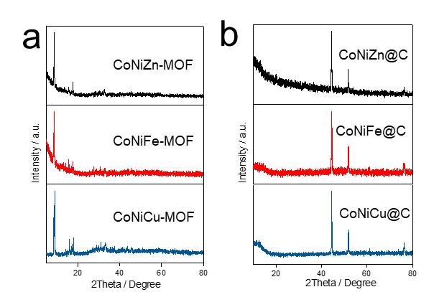
Fig. S1 XRD patterns of a CoNiZn-MOF, CoNiFe-MOF, CoNiCu-MOF precursors and b CoNiZn@C, CoNiFe@C, CoNiCu@C composites
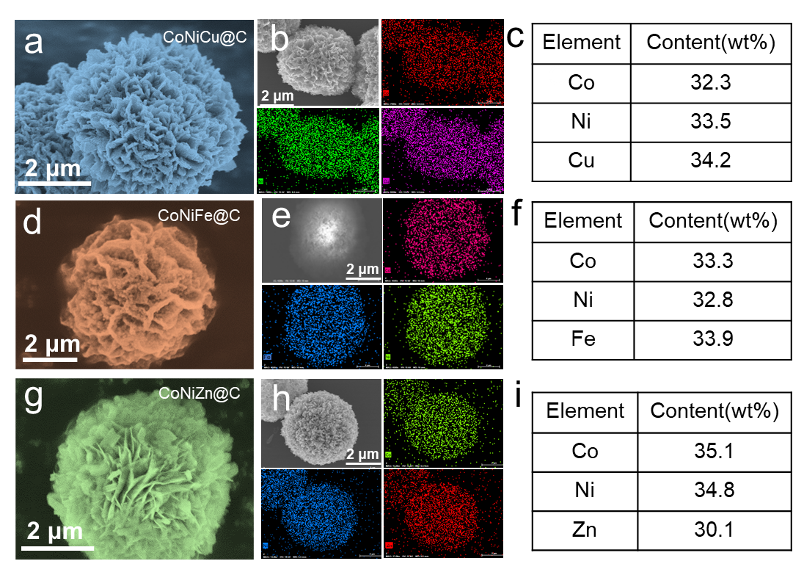
Fig. S2 SEM images and EDX mapping of a-c CoNiCu@C, d-f CoNiFe@C, and g-i CoNiZn@C

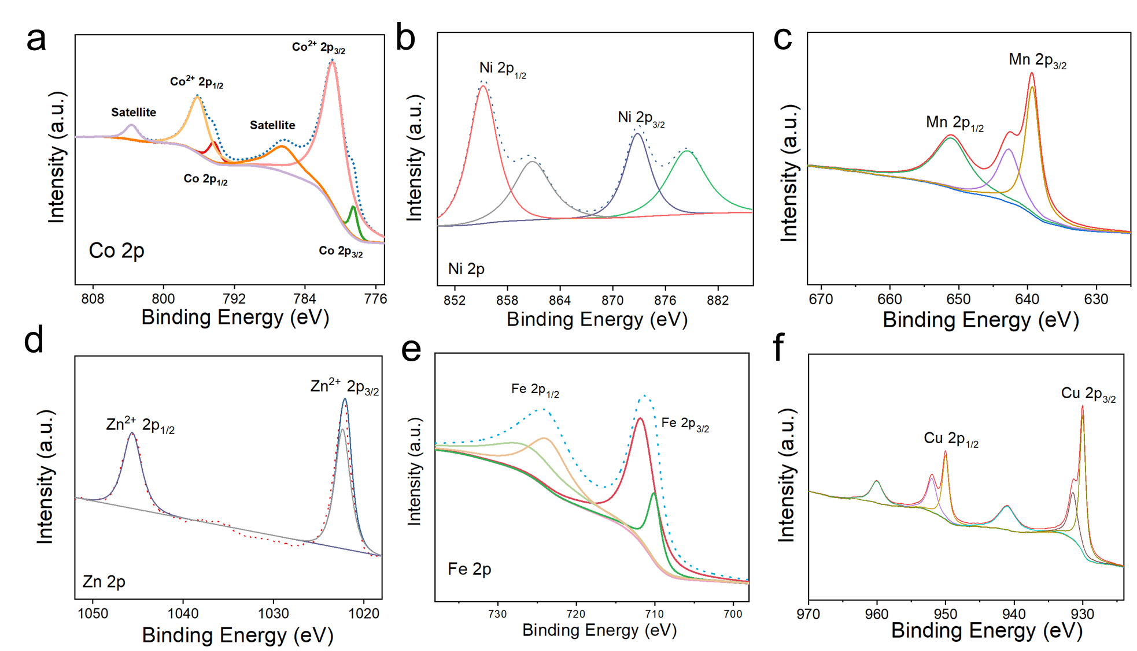
Fig. S3 High resolution XPS spectra of a Co 2p, b Ni 2p, c Mn 2p, d Zn 2p, e Fe 2p and f Cu 2p for CoNiM@C microsphere
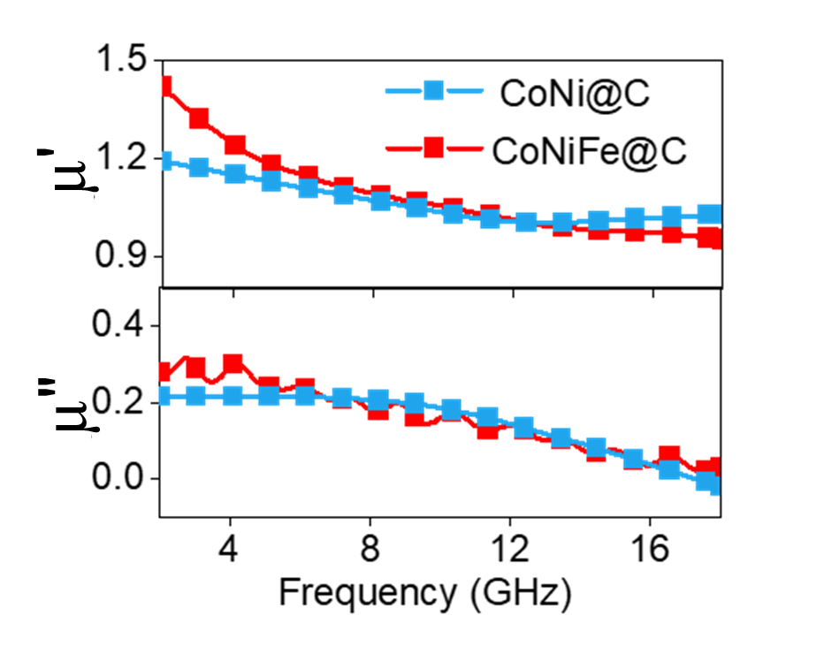
Fig. S4 Real and imaginary part of permeability of CoNi@C and CoNiFe@C
Fig. S5 Room-temperature hysteresis loops of CoNi@C and CoNiFe@C

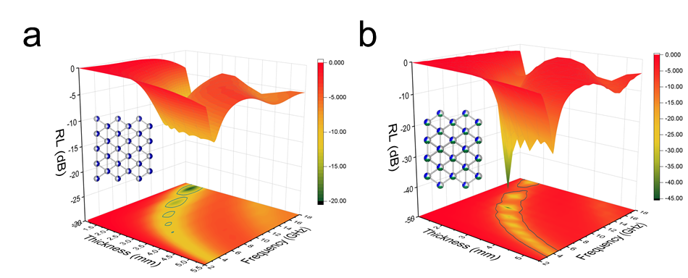
Fig. S6 3D reflection loss mapping of a CoNi@C and b CoNiFe@C
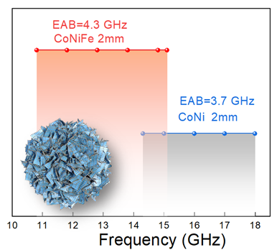
Fig. S7 Effective absorption bandwidth of CoNi@C and CoNiFe@C

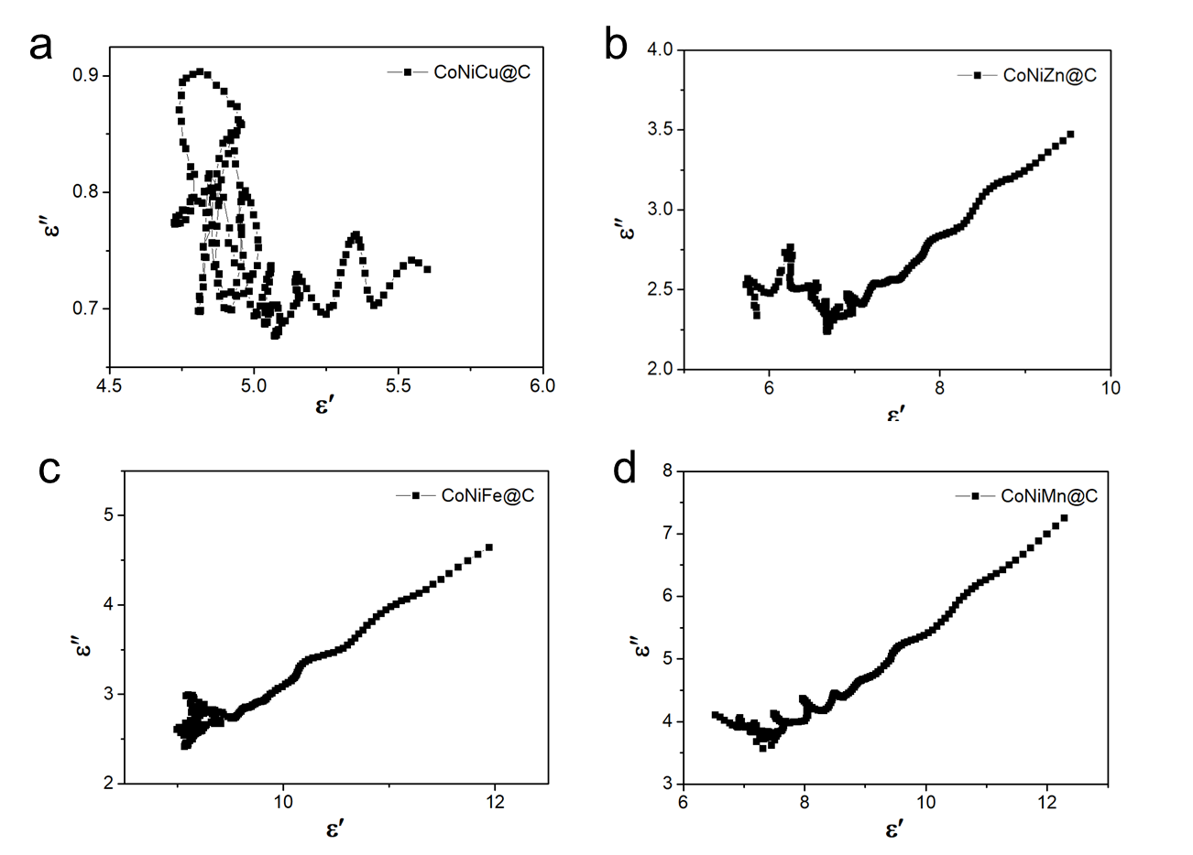
Fig. S8 Cole-Cole semicircular of CoNiM@C microspheres
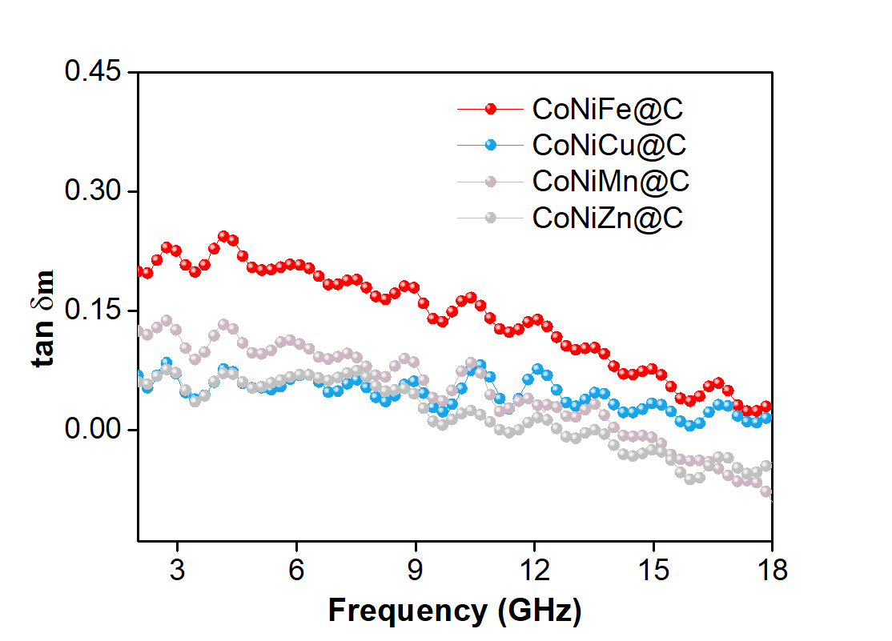
Fig. S9 The magnetic loss tangent value of CoNiM composites
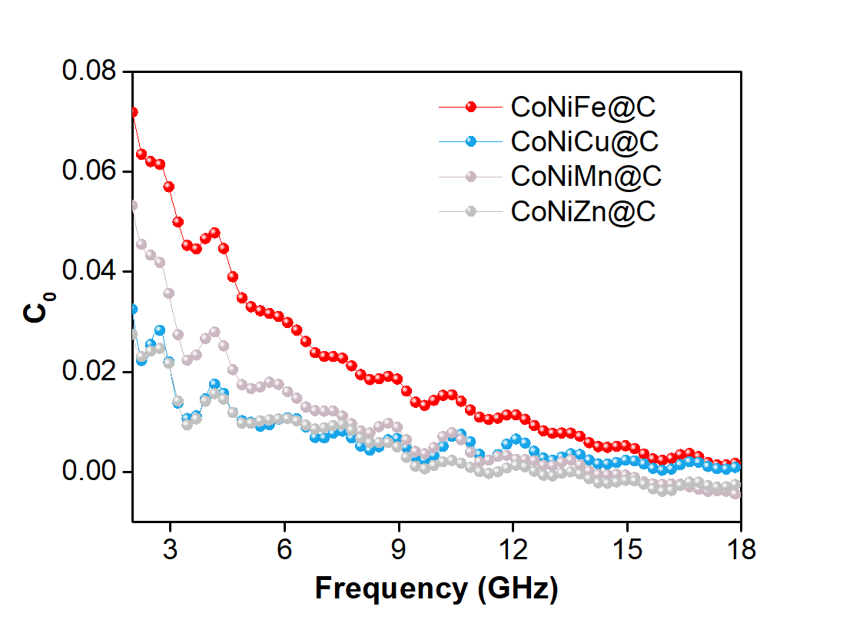
Fig. S10 The eddy current loss coefficient C₀ value of CoNiM composites

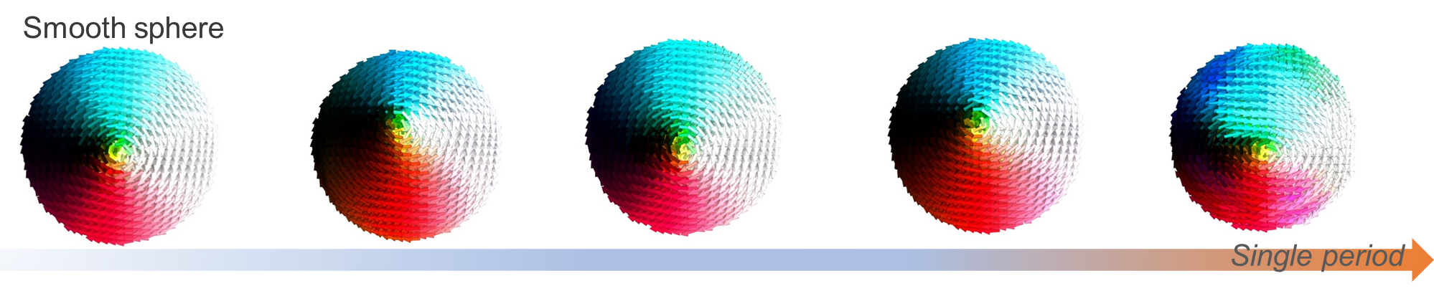
Fig. S11 The simulated magnetic moments in smooth microspheres
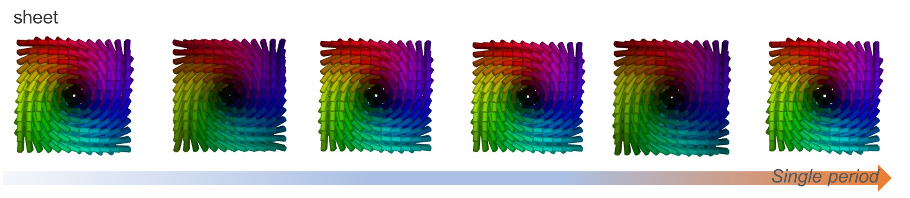
Fig. S12 The simulated magnetic moments in sheets

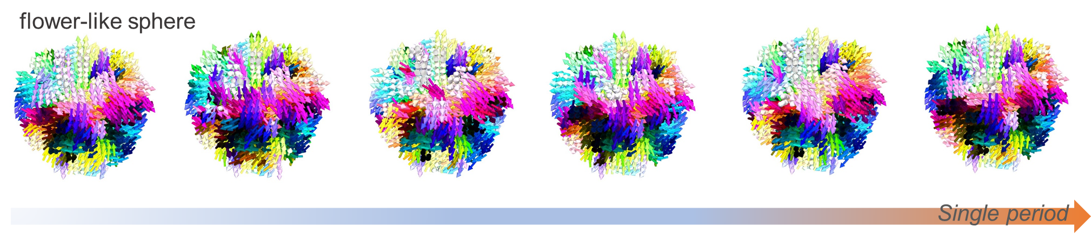
Fig. S13 The simulated magnetic moments in flower-like microspheres
Supplementary Table
Table S1 The electromagnetic wave absorption performance comparison of CoNi-based composites
Sample | Filler loading (wt %) | Thickness  (mm) | EAB (GHz) | Refs.
CoNi microspheres | 60 | 1 | 2.96 | [S1]
CoNi chains | 60 | 5.4 | 3.5 | [S2]
CoNi Nanoparticles | 65 | 1.4 | 4.4 | [S3]
CoNi@NC hollow microspheres | 30 | 3.08 | 4.5 | [S4]
CoNiMPC @CNT/MXene | 15 | 2.7 | 5.0 | [S5]
CoNi@graphite carbon@carbon | 70 | 2.0 | 5.51 | [S6]
CoNi/C hybrids | 20 | 2.1 | 5.7 | [S7]
Co_{x}Ni_{y}@C nanocomposites | 20 | 1.8 | 5.7 | [S8]
CoNi@NC/rGO-600 | 25 | 2.5 | 6.7 | [S9]
CoNi microflowers | 16.7 | 2 | 6.8 | [S10]
CoNiMn@C flower | 40 | 2 | 5.8 | This work
EAB: Efficient absorption bandwidth
Supplementary References
- Z. Wang, W. Yang, Q. Lv, S. Liu, Z. Fang, Ferromagnetic and excellent microwave absorbing properties of CoNi microspheres and heterogeneous Co/Ni nanocrystallines. RSC Adv. 9(24), 13365-13371 (2019). https://doi.org/ 10.1039/C9RA02013F
- M. Qiao, J. Li, S. Li, D. Wei, X. Lei, Hierarchical CoNi alloys toward microwave absorption application: Chain-like versus particle-like. J. Alloy Compd. 926, 166854 (2022). https://doi.org/10.1016/j.jallcom.2022.166854
- J. Park, D. Ahn, J. Ro, S. Suh, CoNi Nanoparticles with different compositions using a polyol method for a microwave absorber in high-frequency bands. Met. Mater. Int. 29(5), 1542-1554 (2023). https://doi.org/10.1007/s12540-022-01298-2
- W. Min, D.Xu, P. Chen, G. Chen, Q. Yu et al., Synthesis of novel hierarchical CoNi@NC hollow microspheres with enhanced microwave absorption performance. J. Mater. Sci-Mater El. 32, 8000-8016 (2021). https://doi.org/10.1007/s10854-021-05523-3
- T. Wu, F. Ren, Z. Guo, J. Zhang, X. Hou et al., Bayberry-like bimetallic CoNi-MOF-74 derivatives/MXene hybrids with abundant heterointerfaces toward high-efficiency electromagnetic wave absorption. J. Alloy. Compd. 976, 172984 (2024). https://doi.org/10.1016/j.jallcom.2023.172984
- X. Wu, W. Ma, J. Xu, P. He, Y. Du, et al., Hierarchical Multi-Core–Shell CoNi@Graphite Carbon@Carbon Nanoboxes for Highly Efficient Broadband Microwave Absorption. ACS Appl. Nano Mater. 5(5), 7300-7311 (2022). https://doi.org/10.1021/acsanm.2c01215
- J. Ge, Y. Cui, J. Qian, L. Liu, F. Meng et al., Morphology-controlled CoNi/C hybrids with bifunctions of efficient anti-corrosion and microwave absorption. J. Mater. Sci. Technol. 102, 24-35 (2022). https://doi.org/10.1016/j.jmst.2021.07.003
- X. Liang, Z. Man, B. Quan, J. Zheng, W. Gu et al., Environment-stable Co_{x}Ni_{y} encapsulation in stacked porous carbon nanosheets for enhanced microwave absorption. Nano-Micro Lett. 12, 102 (2020). https://doi.org/10.1007/s40820-020-00432-2
- X. Xu, F. Ran, Z. Fan, Z. Cheng, T. Lv et al., Bimetallic metal-organic framework-derived pomegranate-like nanoclusters coupled with CoNi-doped graphene for strong wideband microwave absorption. ACS Appl. Mater. Interfaces 12(15), 17870-17880 (2020). https://doi.org/10.1021/acsami.0c01572
- Q. Liu, Qi Cao, X. Zhao, H. Bi, C. Wang, Insights into size-dominant magnetic microwave absorption properties of CoNi microflowers via off-axis electron holography. ACS Appl. Mater. Interfaces 7(7), 4233-4240 (2015) https://doi.org/10.1021/am508527s

