Supporting Information for
Interpenetrated Structures for Enhancing Ion Diffusion Kinetics in Electrochemical Energy Storage Devices
Xinzhe Xue¹, Longsheng Feng², Qiu Ren¹, Cassidy Tran¹, Samuel Eisenberg¹, Anica Pinongcos¹, Logan Valdovinos¹, Cathleen Hsieh¹, Tae Wook Heo², Marcus A. Worsley^{2,} *, Cheng Zhu^{2,} *, Yat Li^{1,} *
¹Department of Chemistry and Biochemistry, University of California, 1156 High Street, Santa Cruz, California 95064, United States of America
²Lawrence Livermore National Laboratory, 7000 East Avenue, Livermore, California 94550, United States of America
*Corresponding authors. E-mail: worsley1@llnl.gov (Marcus A. Worsley); zhu6@llnl.gov (Cheng Zhu); yatli@ucsc.edu (Yat Li)

Supplementary Figures
Fig. S1 GCD curves of 3 mm interpenetrated Zn//MnO₂ devices obtained at 0.2 mA cm⁻² in electrolytes with and without MnSO₄
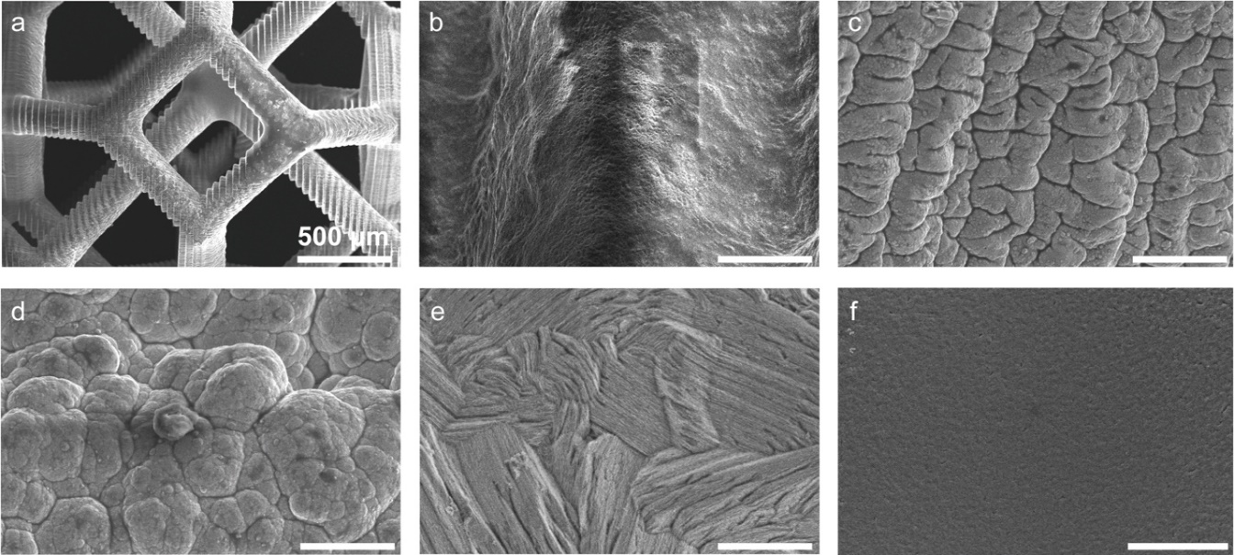
Fig. S2 SEM images of a a 3D-printed interpenetrated polymer substrate, and magnified images of b the bare substrate and after c Ni electroless plating, d Ni electro-plating, e Zn electro-plating, f electrodeposition of MnO₂/PEDOT surface. Scale bars in b-f are 10 μm
Fig. S3 XRD patterns of an interpenetrated polymer substrate after Ni electroless (blue) and electro-plating (red). Dashed lines highlight the peak position of Ni (111) and (200). The arrow highlights the peak position of Ni₂P
Fig. S4 EDS elemental analysis of a MnO₂/PEDOT cathode and b Zn anode
Table S1 Structural data of interpenetrated devices with different feature sizes
m value / mm | Number of unit cells | Geometric Area / cm² | Unit Density / cm⁻² | Average Inter-electrode Distance / μm | Volume / cm³ | Normalized Volume Ratio / %
8 | 4 | 2.56 | 1.56 | 1380 | 2.048 | 100
4 | 12 | 1.92 | 6.25 | 742.38 | 0.768 | 37.5
3 | 15 | 1.8 | 8.33 | 557.16 | 0.54 | 26.4

Fig. S5 a Electrochemical impedance spectra of Zn//MnO₂ devices with different feature sizes, and b Magnified view of the spectra in the high-frequency region

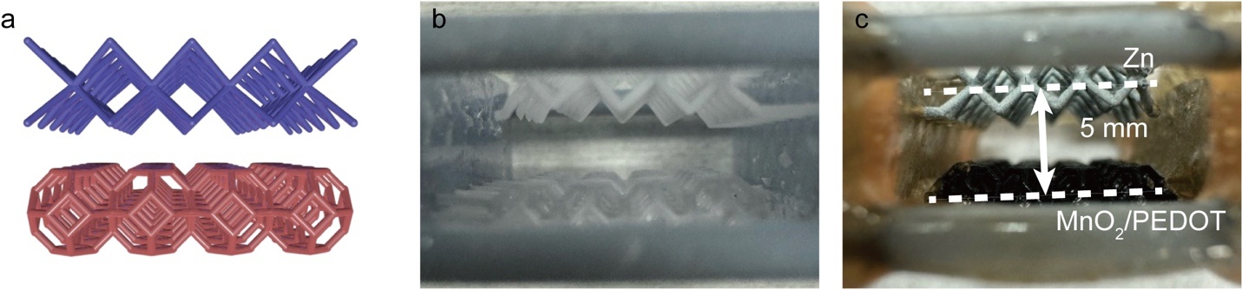
Fig. S6 a Schematic illustration and optical images of the separate electrodes b before and c after the deposition of Zn and MnO₂/PEDOT

Fig. S7 CV scans of both separate and interpenetrated devices collected at 1 mV s⁻¹

Fig. S8 Normalized a charging and b discharging profiles of interpenetrated and separate device configurations via charging and discharging capacity collected at 0.2 mA cm⁻²

Fig. S9 a Cycling stability and b time of a 3 mm device obtained at 0.2 mA cm⁻². c EIS spectra collected from the device before and after cycling test

Fig. S10 a EIS spectra of Zn//MnO₂ devices with separate and interpenetrated configurations. Fitted data for b charge transfer controlled high frequency region, and c mass transfer controlled low frequency zones. The inset Figures are fitting equivalent circuits for lower and higher frequencies. The inset tables are b solid-state charge transfer controlled R_{ct}, R_{d}, and c mass transfer-controlled ion diffusion resistance R_{d}

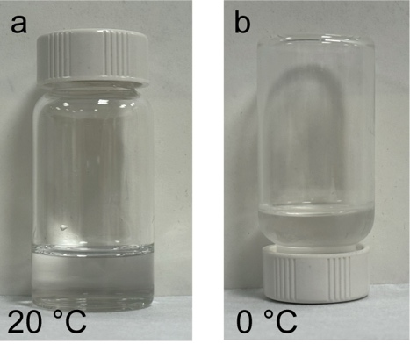
Fig. S11 Digital images showing the electrolyte under a 20 °C and b 0 °C. The electrolyte is composed of 2 M ZnSO₄, 0.1 M MnSO₄ in H₂O/DMSO (v : v = 5 : 1)

Fig. S12 Representative Zn stripping/plating overpotentials of the interpenetrated and separate devices under a 20 °C and b 0 °C are selected for comparison

Table S2 Performance comparisons between 2D and 3D Zn//MnO₂ battery devices
Device Configurations | Electrolyte | Capacity / mAh cm⁻² | Device Area / cm² | Device thickness / cm | Device Volume / cm³ | References
Zn//3D MnO₂@nickel nanocone array | 2 M ZnSO₄ + 0.2 M MnSO₄ aq. | 3.959 | 0.48 | 7.4$×$10⁻³ | 3.55$×$10⁻³ | [S1]
Interdigitated 3D Zn//MnO₂ battery | 2 M ZnSO₄ + 0.1 M MnSO₄ in PVA gel | 0.215 | 1 | 5$×$10⁻³ | 5$×$10⁻³ | [S2]
Quasi-solid-state 2D Zn//MnO₂ battery | 3 M LiCl + 2 M ZnCl₂ + 0.4 M MnSO₄ in PVA gel | 2.2 | 0.5 | 0.08 | 0.04 | [S3]
2D Zn//δ-MnO₂ | 2 M ZnSO₄ + 0.1 M MnSO₄ in PAM gel | 0.58 | - | - | - | [S4]
2D Zn//MnO₂@CNT | 3 M LiCl + 2 M ZnCl₂ + 0.4 M MnSO₄ in PVA gel | 1.4 | 1 | 0.08 | 0.08 | [S5]
Interpenetrated Zn//MnO₂ battery | 2 M ZnSO₄ + 0.1 M MnSO₄ aq. | 1.71 | 1.8 | 0.3 | 0.54 | This work
Supplementary References
- W. Lai, Y. Wang, Z. Lei, R. Wang, Z. Lin, C.-P. Wong, F. Kang, C. Yang. High performance, environmentally benign and integratable Zn//MnO₂ microbatteries. Journal of Materials Chemistry A 6(9), 3933-3940 (2018). https://doi.org/10.1039/C7TA10936A
- H. Wang, R. Guo, H. Li, J. Wang, C. Du, X. Wang, Z. Zheng. 2d metal patterns transformed from 3d printed stamps for flexible Zn//MnO₂ in-plane micro-batteries. Chemical Engineering Journal 429(132196 (2022). https://doi.org/https://doi.org/10.1016/j.cej.2021.132196
- Y. Zeng, X. Zhang, Y. Meng, M. Yu, J. Yi, Y. Wu, X. Lu, Y. Tong. Achieving ultrahigh energy density and long durability in a flexible rechargeable quasi-solid-state Zn–MnO₂ battery. Advanced Materials 29(26), 1700274 (2017). https://doi.org/https://doi.org/10.1002/adma.201700274
- D. Wang, L. Wang, G. Liang, H. Li, Z. Liu, Z. Tang, J. Liang, C. Zhi. A superior δ-MnO₂ cathode and a self-healing Zn-δ-MnO₂ battery. ACS Nano 13(9), 10643-10652 (2019). https://doi.org/10.1021/acsnano.9b04916
- X. Zhang, S. Wu, S. Deng, W. Wu, Y. Zeng, X. Xia, G. Pan, Y. Tong, X. Lu. 3d cnts networks enable MnO₂ cathodes with high capacity and superior rate capability for flexible rechargeable Zn–MnO₂ batteries. Small Methods 3(12), 1900525 (2019). https://doi.org/https://doi.org/10.1002/smtd.201900525

