Supporting Information for
Enhancing Defect-Induced Dipole Polarization Strategy of SiC@MoO₃ Nanocomposite Towards Electromagnetic Wave Absorption
Ting Wang¹, Wenxin Zhao², Yukun Miao², Anguo Cui³, Chuanhui Gao¹, Chang Wang², Liying Yuan², Zhongning Tian², Alan Meng⁴, Zhenjiang Li^{2,} *, Meng Zhang^{2,} *
¹ College of Chemical Engineering, Qingdao University of Science and Technology, Qingdao, Shandong province, 266042, P. R. China
² College of Materials Science and Engineering, Qingdao University of Science and Technology, Qingdao, Shandong province, 266042, P. R. China
³ Shandong Engineering Laboratory for Preparation and Application of High-Performance Carbon-Materials, College of Electromechanical Engineering, Qingdao University of Science and Technology, Qingdao 266061, P. R. China
⁴ Key Laboratory of Optic-electric Sensing and Analytical Chemistry for Life Science, MOE, Shandong Key Laboratory of Biochemical Analysis, College of Chemistry and Molecular Engineering, Qingdao University of Science and Technology, Qingdao, Shandong province, 266042, P. R. China
*Corresponding authors. E-mail: mengzhang@qust.edu.cn (Meng Zhang); zjli126@126.com (Zhenjiang Li)
Supplementary Figures and Table
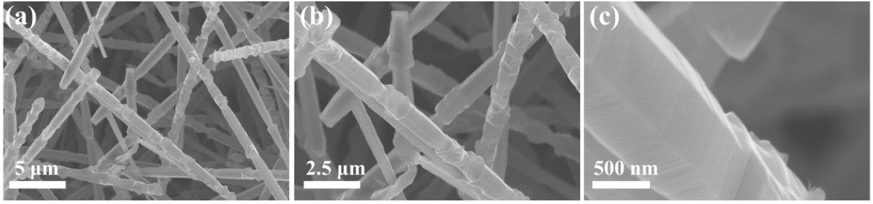
Fig. S1 a~c SEM images of SiC_{NWS}
Fig. S2 EDX spectrum of SiC@MoO₃ nanocomposite
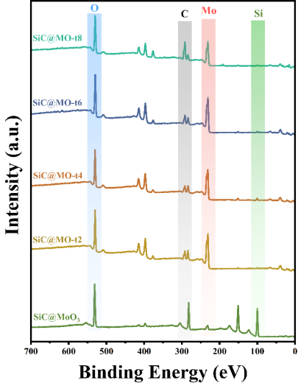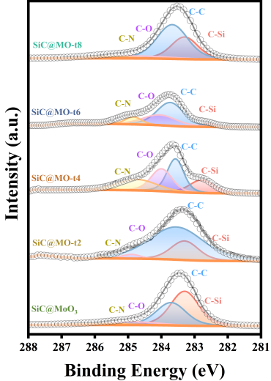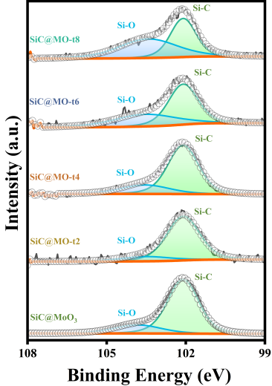
(a)
(b)
(c)
Fig. S3 a XPS spectra full spectrum, b C1s and c Si 2p spectra of SiC@MoO₃, SiC@MO-t2, SiC@MO-t4, SiC@MO-t6 and SiC@MO-t8
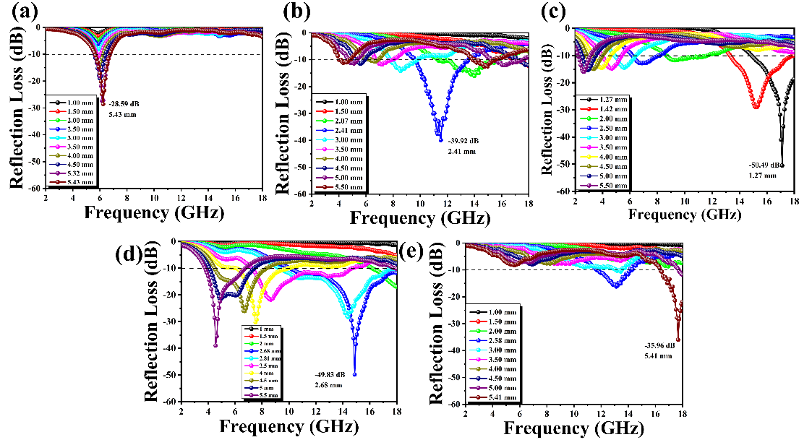
Fig. S4 Two-dimensional graph of a SiC@MoO₃, b SiC@MO-t2, c SiC@MO-t4, d SiC@MO-t6 and e SiC@MO-t8
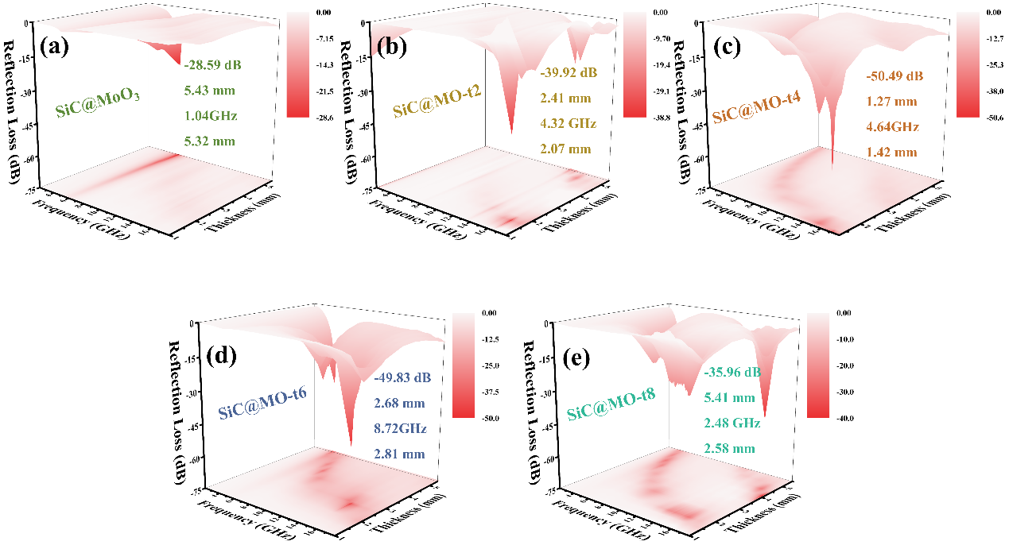
Fig. S5 Three-dimensional graph of a SiC@MoO₃, b SiC@MO-t2, c SiC@MO-t4, d SiC@MO-t6 and e SiC@MO-t8
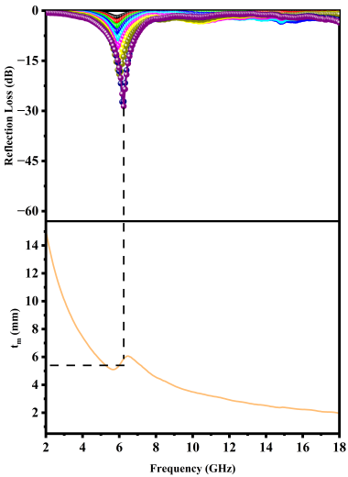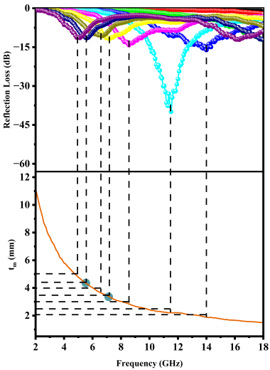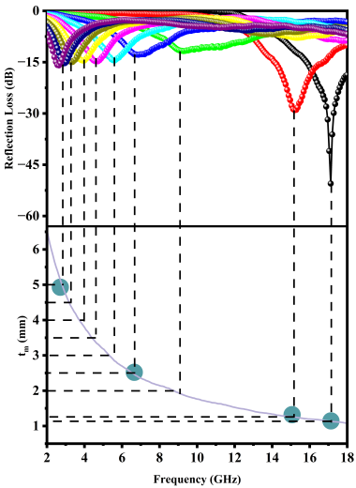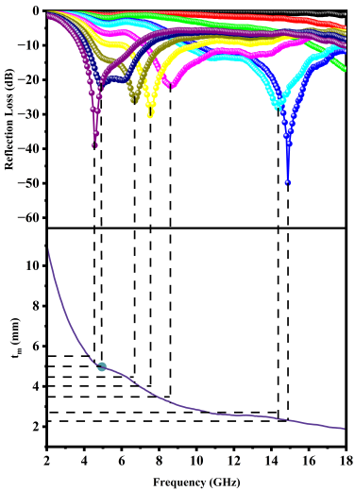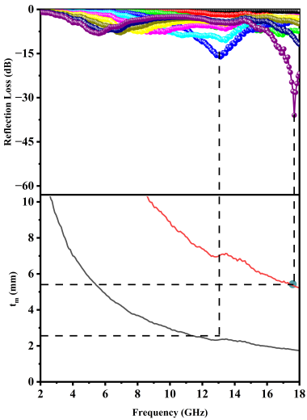
(a)
(b)
(c)
(d)
(e)
Fig. S6 Absorption curves and corresponding 1/4 λ matching properties of a SiC@MoO₃ nanocomposite and b SiC@MO-t2, c SiC@MO-t4, d SiC@MO-t6 and e SiC@MO-t8

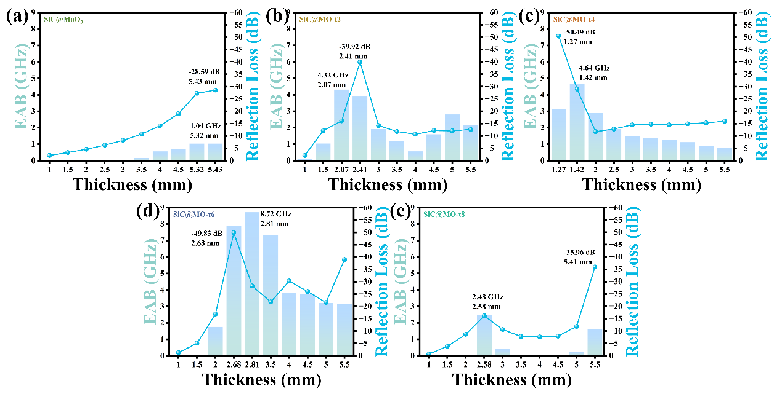
Fig. S7 EAB and RL_{min} values of different samples under different matching thicknesses a SiC@MoO₃ nanocomposite, b SiC@MO-t2, c SiC@MO-t4, d SiC@MO-t6 and e SiC@MO-t8

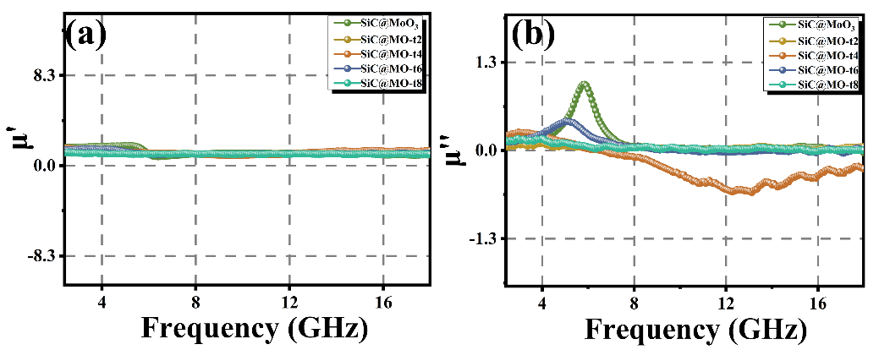
Fig. S8 a Magnetic permeability real and b magnetic permeability imaginary part of SiC@MoO₃, SiC@MO-t2, SiC@MO-t4, SiC@MO-t6 and SiC@MO-t8

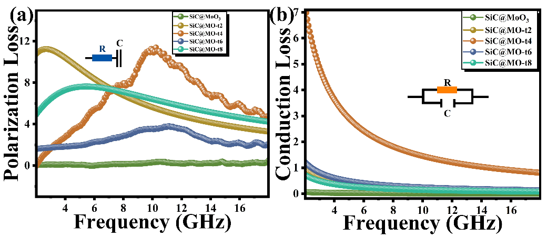
Fig. S9 a Polarization Loss and b Conduction Loss values of SiC@MoO₃, SiC@MO-t2, SiC@MO-t4, SiC@MO-t6 and SiC@MO-t8

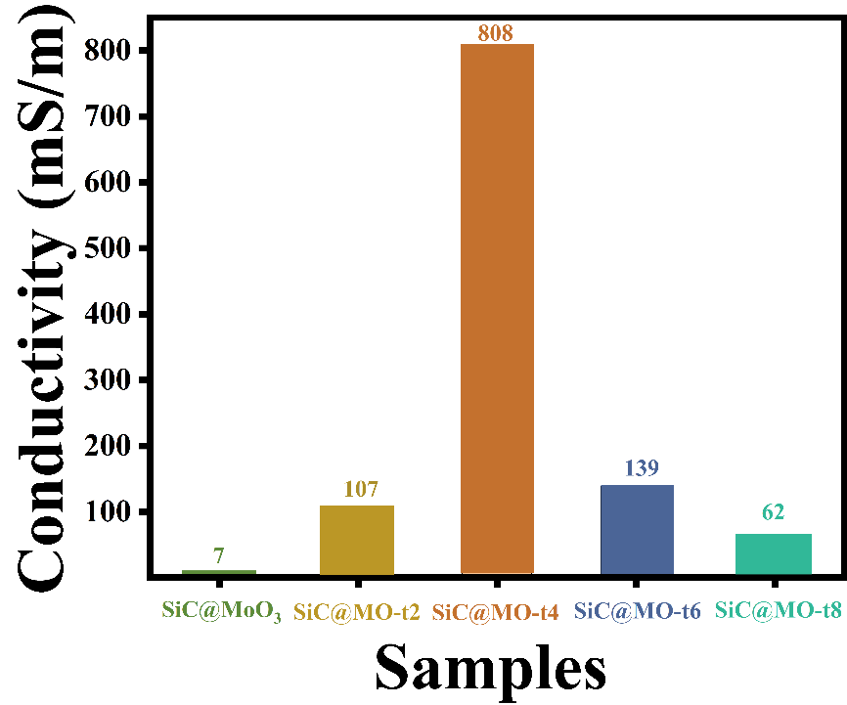
Fig. S10 Conductivity values of SiC@MoO₃, SiC@MO-t2, SiC@MO-t4, SiC@MO-t6 and SiC@MO-t8
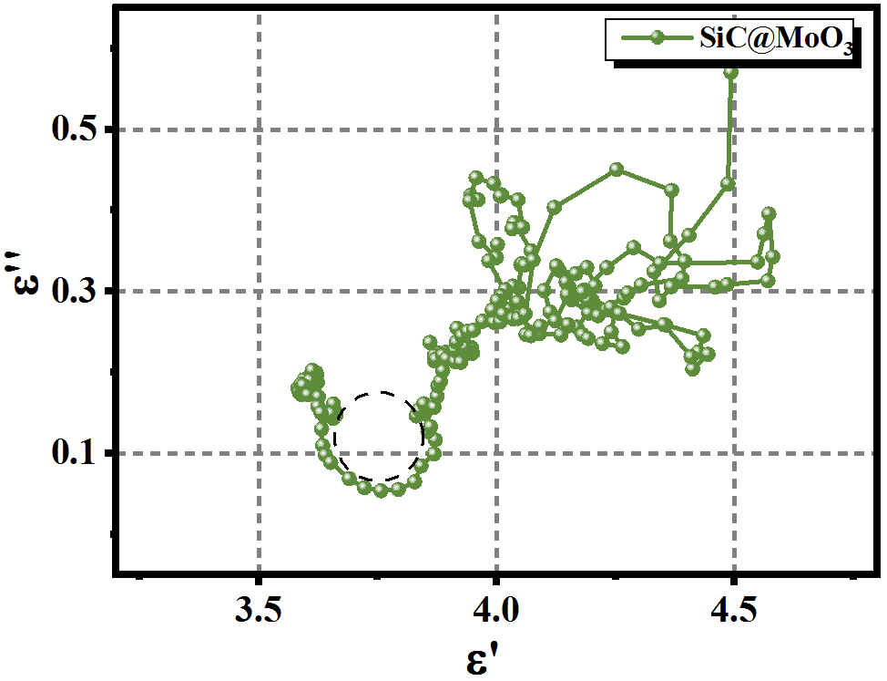
Fig. S11 Cole-Cole curve of SiC@MoO₃ nanocomposites
Table R1 Comparison of RLmin and EAB values of the SiC@MO-t4 and SiC@MO-t6 samples with recent reports related absorbers
Samples | EAB  (GHz) | Matching thickness (mm) | RL_{min}  (dB) | Matching thickness (mm) | References
o-MoO₃/PPy | 6.40 | 2.30 | -31.80 | 2.30 | [45]
MoO₃/TiO₂/Mo₂TiC₂T_{x} | 8.60 | 1.80 | -30.76 | 2.30 | [46]
graphene/g-C₃N₄ | 4.60 | 4.50 | -34.69 | 4.50 | [47]
SnO/SnO₂ | 4.3 | 1.40 | -37.60 | 1.40 | [48]
Fe₃O₄/Fe₃S₄ | 4.39 | 1.46 | −45.33 | 3.30 | [49]
Fe₃O₄@SiO₂@MnO₂ | 5.1 | 2.60 | -50.20 | 2.60 | [50]
Fe₃O₄@MnO₂@Ni–Co/C | 7.1 | 2.00 | -41.2 | 4.00 | [51]
ZnFe₂O₄@MnO₂@MXene | 4.7 | 1.40 | -50.4 | 1.40 | [52]
SiC@MO-t4 | 4.64 | 1.42 | -50.49 | 1.27 | This work
SiC@MO-t6 | 8.72 | 2.81 | -49.83 | 2.68 | This work

