Supporting Information for
Enhancing the Electrocatalytic Oxidation of 5-Hydroxymethylfurfural through Cascade Structure Tuning for Highly Stable Biomass Upgrading
Xiaoli Jiang¹, Xianhui Ma², Yuanteng Yang¹, Yang Liu¹, Yanxia Liu¹, Lin Zhao¹, Penglei Wang¹, Yagang Zhang^{1,}*, Yue Lin^{2,}*, Yen Wei^{3,4,}*
1 School of Materials and Energy, University of Electronic Science and Technology of China, Chengdu 611731, P. R. China
2 Hefei National Research Center for Physical Sciences at the Microscale, University of Science and Technology of China, Hefei 230026, P. R. China
3 The Key Laboratory of Bioorganic Phosphorus Chemistry & Chemical Biology (Ministry of Education), Department of Chemistry, Tsinghua University, Beijing 100084, P. R. China
4 School of Materials Science and Engineering, North Minzu University, Yinchuan 750021, P. R. China
*Corresponding authors. E-mail: ygzhang@uestc.edu.cn (Yagang Zhang); linyue@ustc.edu.cn (Yue Lin); weiyen@tsinghua.edu.cn (Yen Wei)
Supplementary Figures and Tables
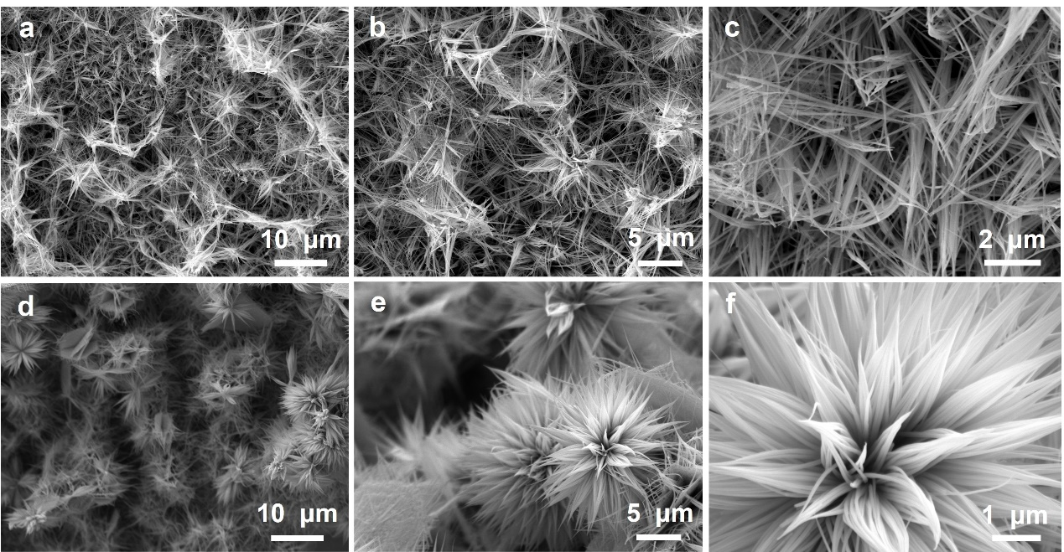
Fig. S1 SEM images of (a-c) Co₃O₄ and (d-f) NiCo₂O₄ at different magnifications

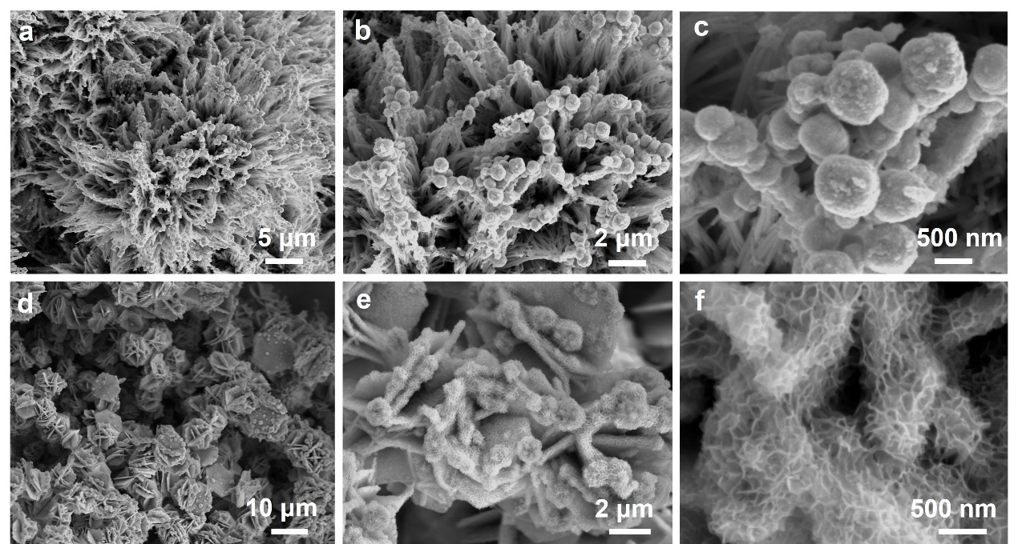
Fig. S2 SEM images of (a-c) Pd-NiCo₂O₄-1 and (d-f) Pd-NiCo₂O₄-3 at different magnifications

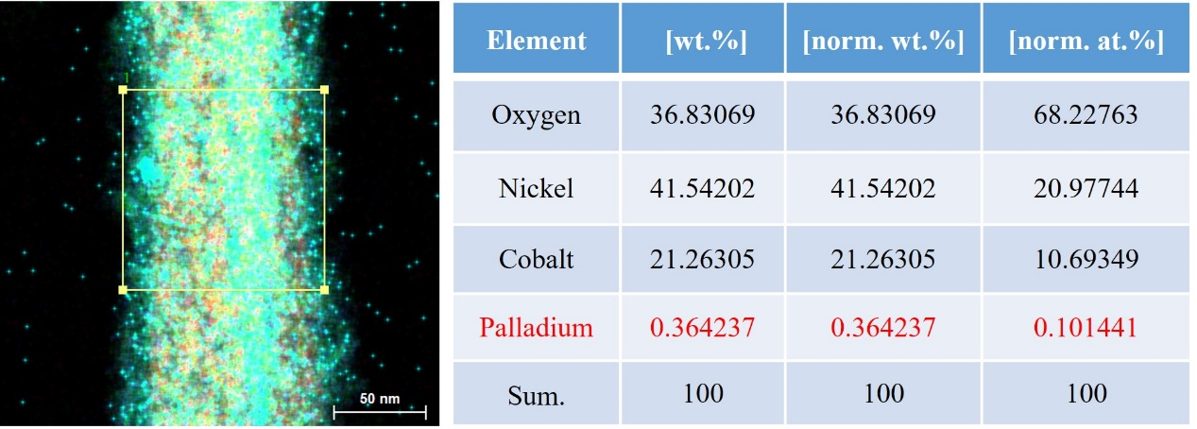
Fig. S3 TEM-EDS of Pd-NiCo₂O₄

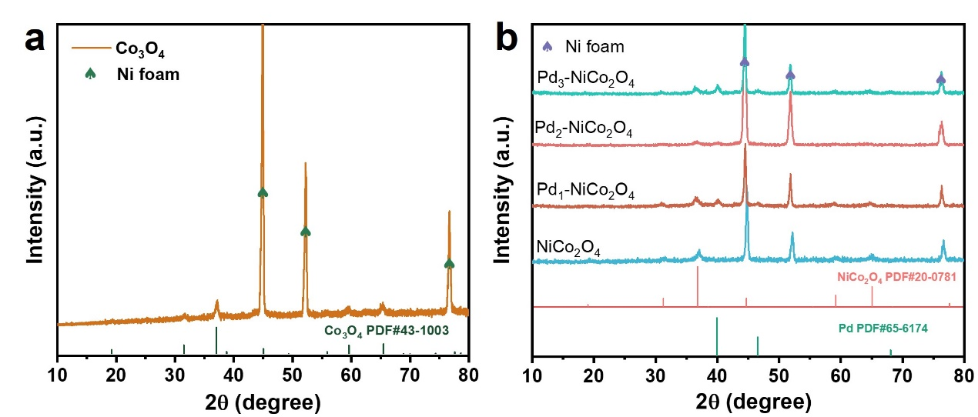
Fig. S4 XRD pattern of (a) Co₃O₄ and (b) NiCo₂O₄ and Pd- NiCo₂O₄ with different Pd loading
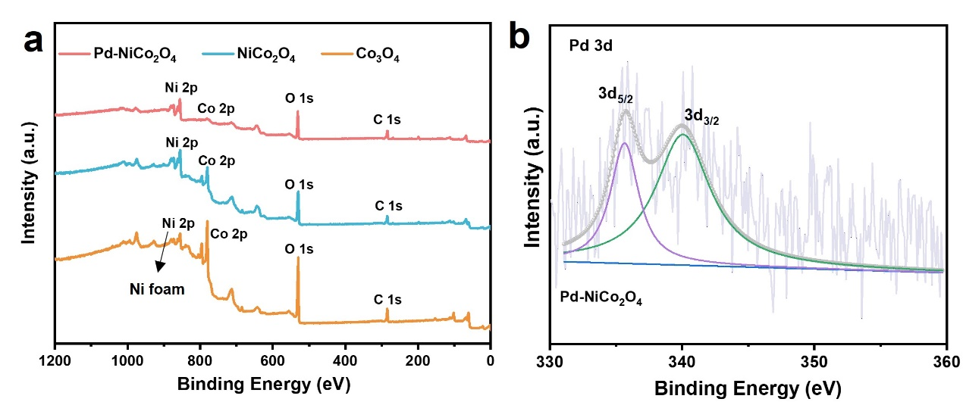
Fig. S5 (a) XPS Survey spectra of Co₃O₄, NiCo₂O₄, Pd-NiCo₂O₄. (b) High-resolution XPS spectra of Pd 3d
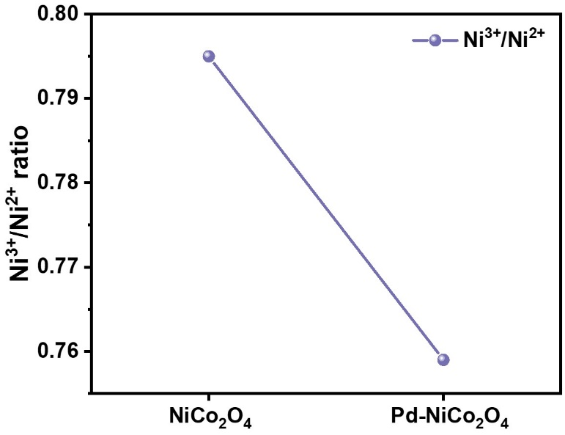
Fig. S6 Ni³⁺/Ni²⁺ ratios obtained from XPS spectra of NiCo₂O₄ and Pd-NiCo₂O₄
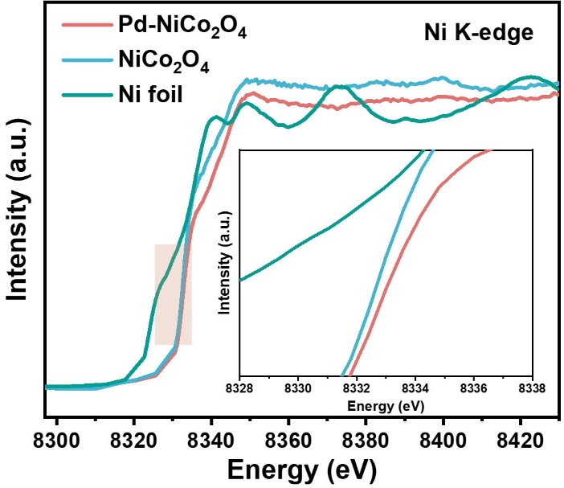
Fig. S7 Ni K-edge XANES spectra of NiCo₂O₄, Pd-NiCo₂O₄
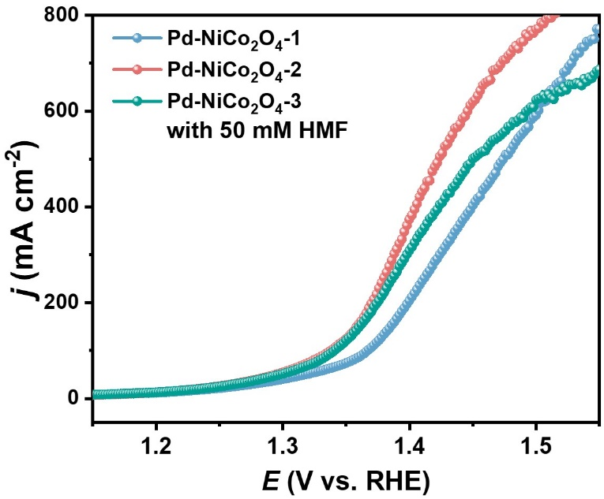
Fig. S8 LSV curves of NiCo₂O₄ with various Pd loading in 1 M KOH with 50 mM HMF
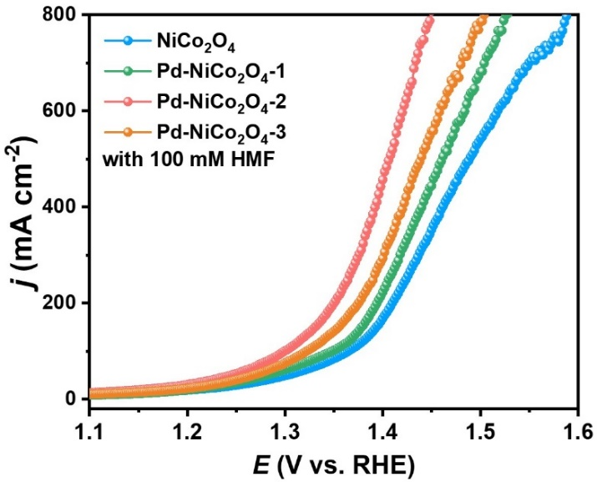
Fig. S9 LSV curves of NiCo₂O₄ and NiCo₂O₄ with various Pd loading in 1 M KOH with 100 mM HMF
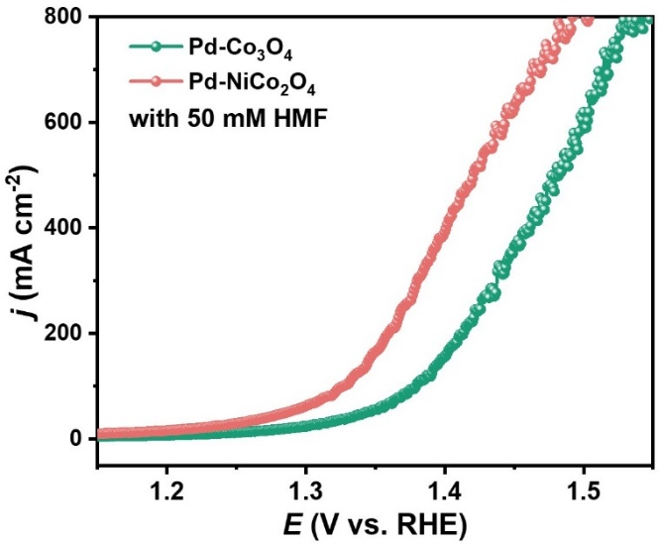
Fig. S10 LSV curves of Pd-NiCo₂O₄ and Pd-Co₃O₄ in 1 M KOH with 50 mM HMF
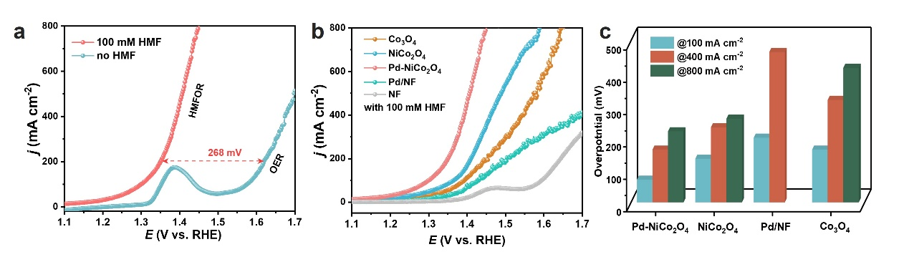
Fig. S11 (a) LSV curves of Pd-NiCo₂O₄ in 1.0 M KOH with and without 100 mM HMF. (b) LSV curves of different samples in 1.0 M KOH with 100 mM HMF, and (c) corresponding overpotential at various current densities for HMFOR

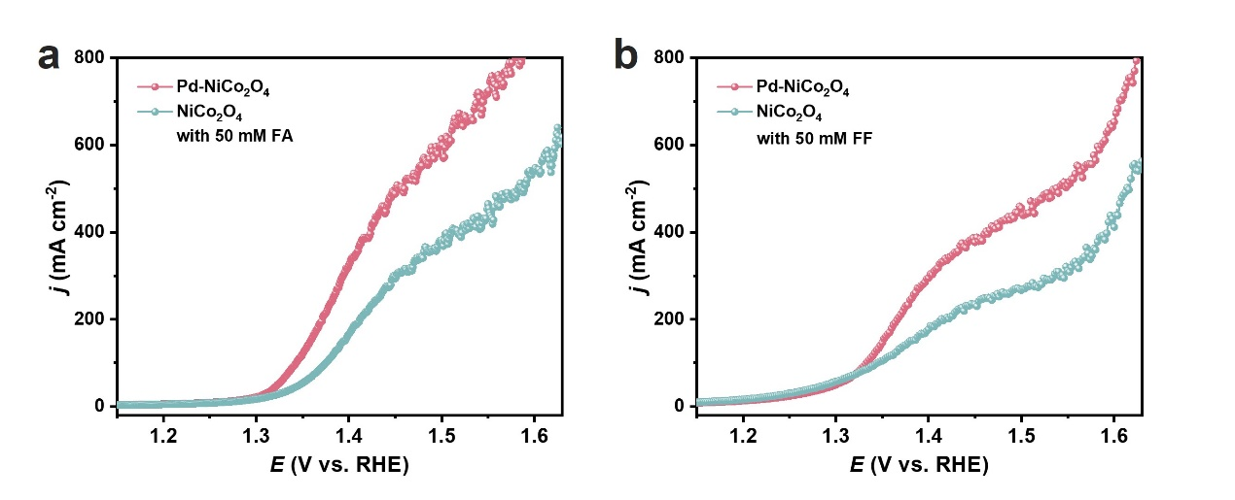
Fig. S12 Electrochemical behavior of (a) furfuryl alcohol (R-OH) and (b) furfural (R-CHO) oxidation on Pd-NiCo₂O₄ and NiCo₂O₄ electrodes.

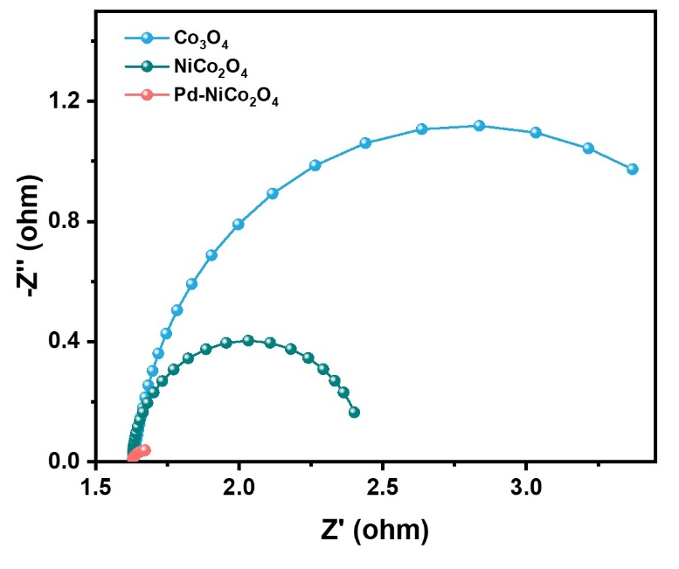
Fig. S13 Nyquist plots of Co₃O₄, NiCo₂O₄, and Pd-NiCo₂O₄

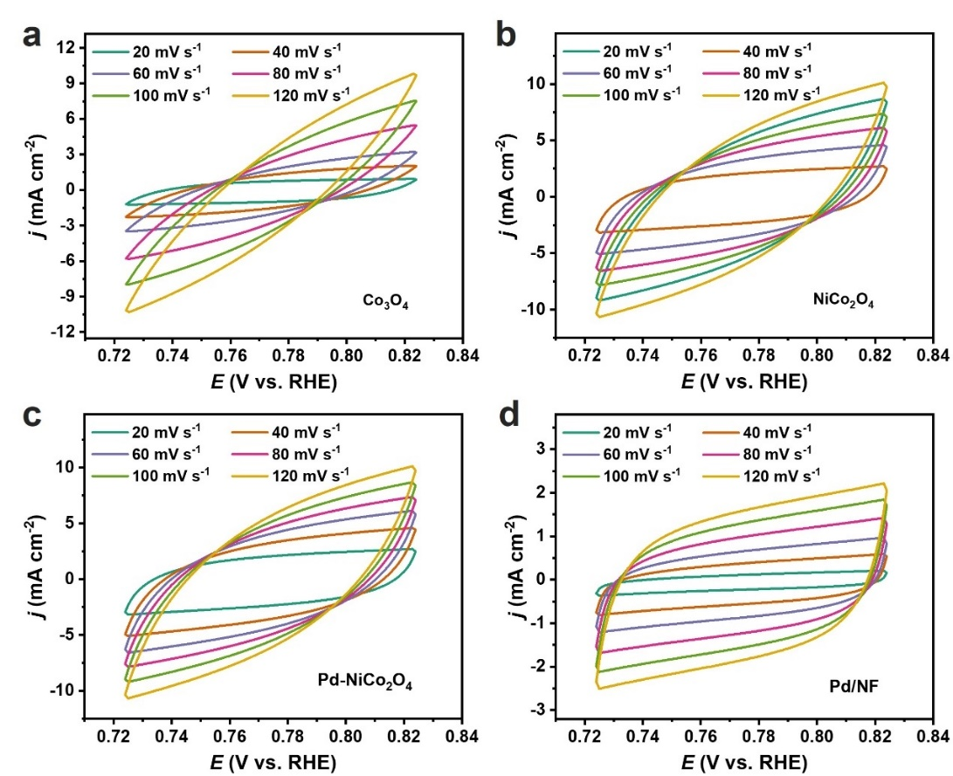
Fig. S14 Cyclic voltammograms (CVs) curves of (a) Co₃O₄, (b) NiCo₂O₄, (c) Pd-NiCo₂O₄ and (d) Pd/NF at different scan rates increasing from 20 to 120 mV s^{–1} with an interval point of 20 mV s^{–1}
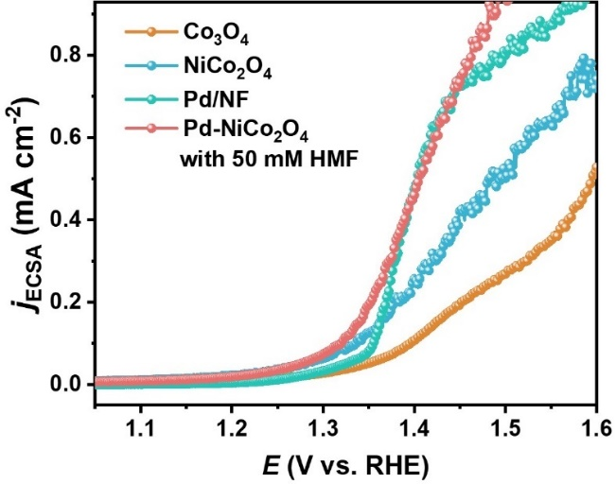
Fig. S15 ECSA-normalized LSV curves of samples in 1 M KOH with 50 mM HMF
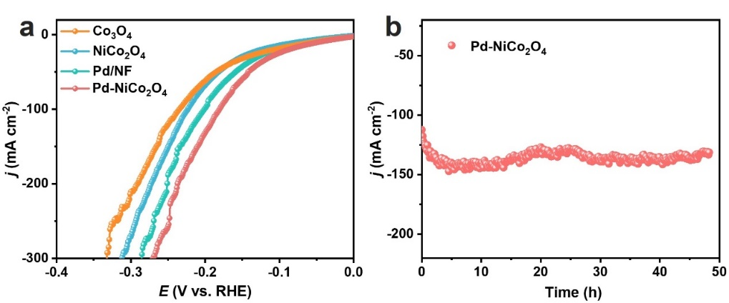
Fig. S16 (a) HER LSV curves of samples and (b) stability (I-t) test at –150 mA cm^{–2}
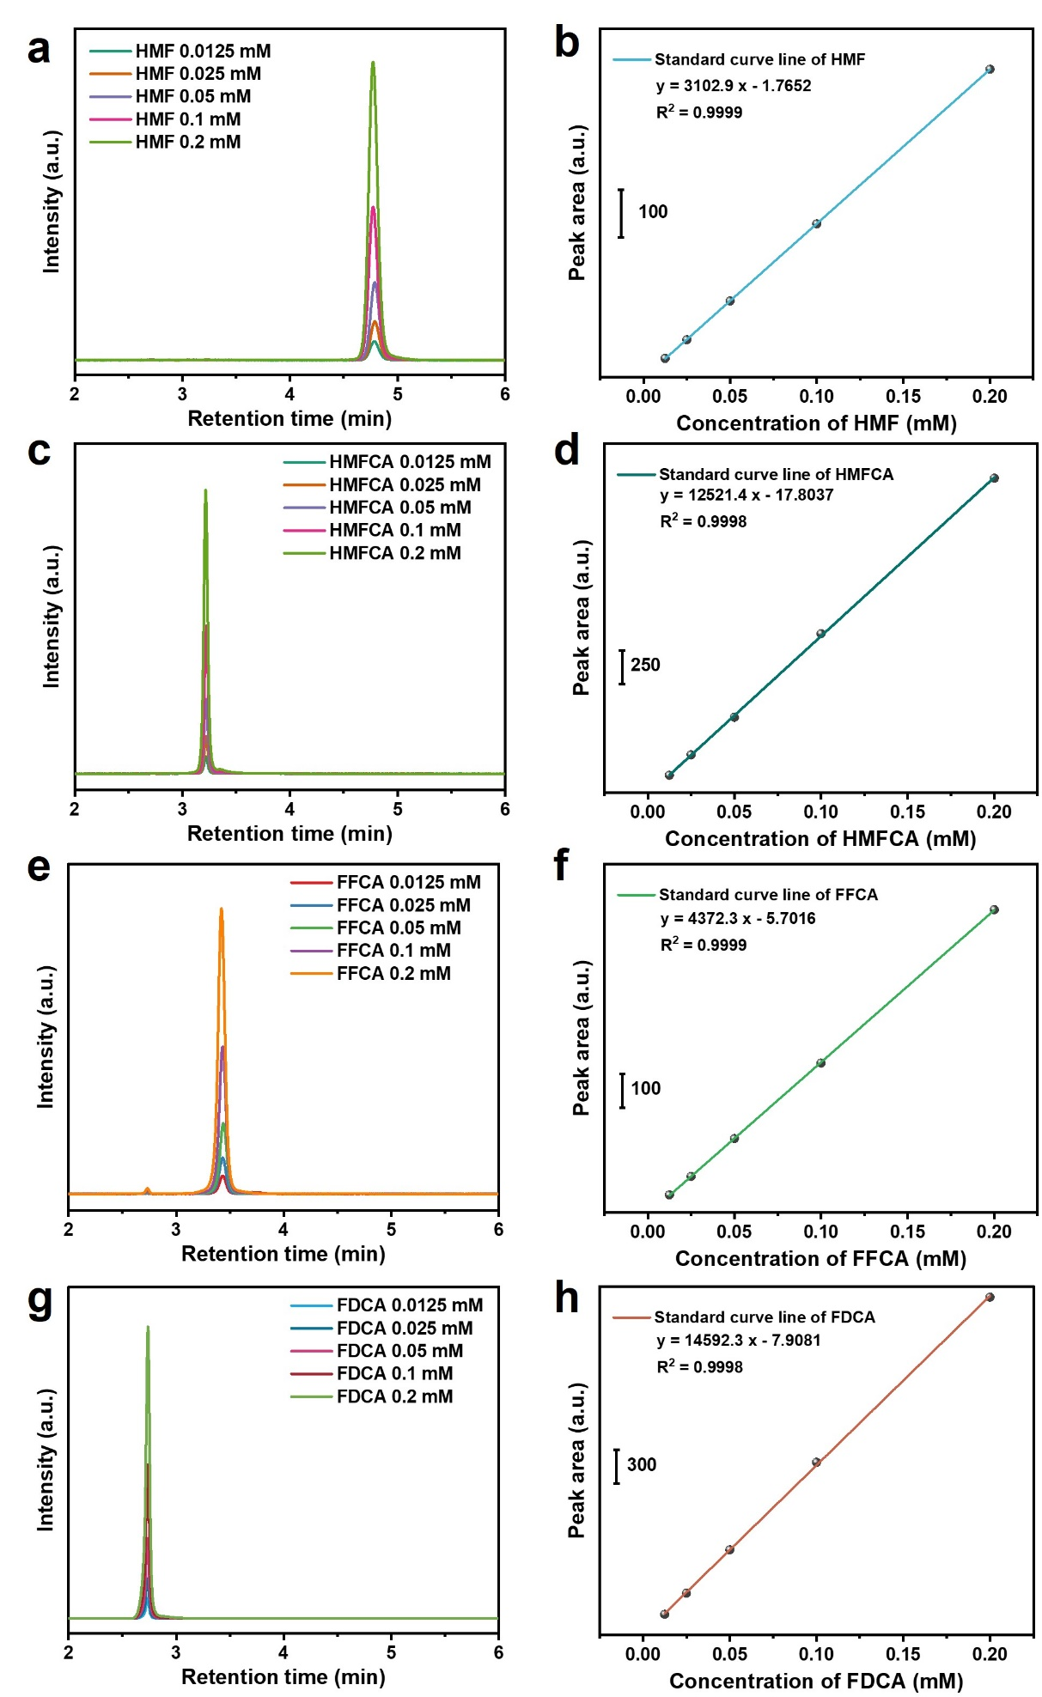
Fig. S17 HPLC standard curve measurements of pure (a, b) HMF, (c, d) HMFCA, (e, f) FFCA, (g, h) FDCA
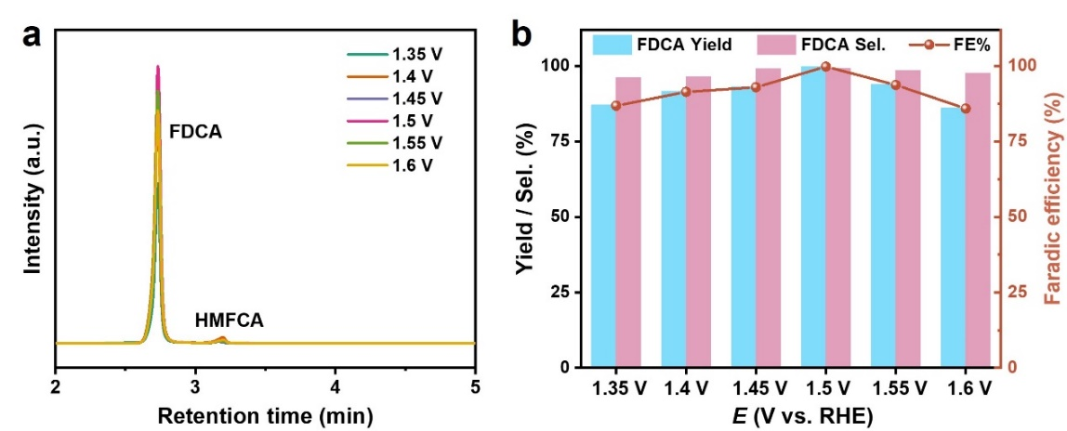
Fig. S18 (a) HPLC curve measurements (b) the FDCA selectivity and Faradaic efficiency at different potentials for Pd-NiCo₂O₄
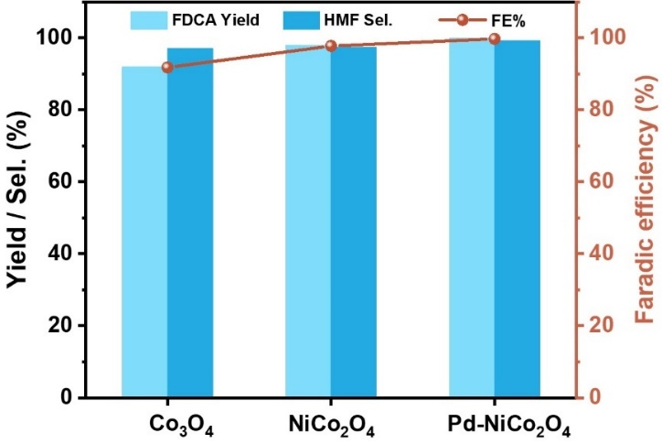
Fig. S19 HMF conversion, FDCA yield and Faradaic efficiency for different samples
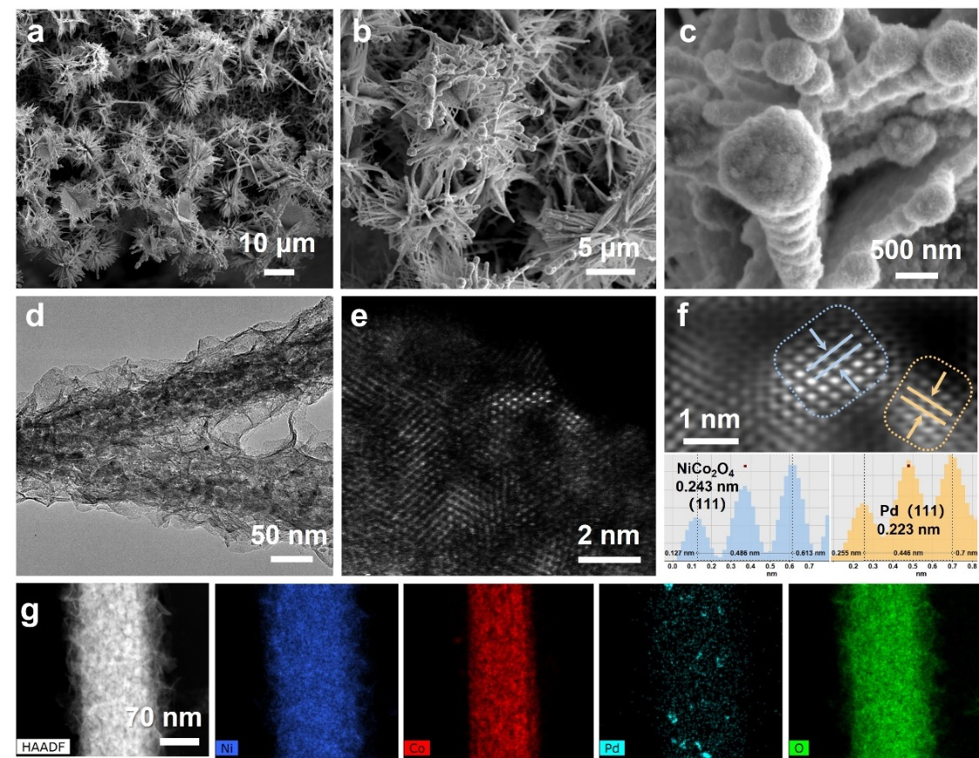
Fig. S20 (a-c) SEM images (d) TEM, (e, f) HAADF-STEM images and (g) STEM-mapping of Pd-NiCo₂O₄ after HMFOR
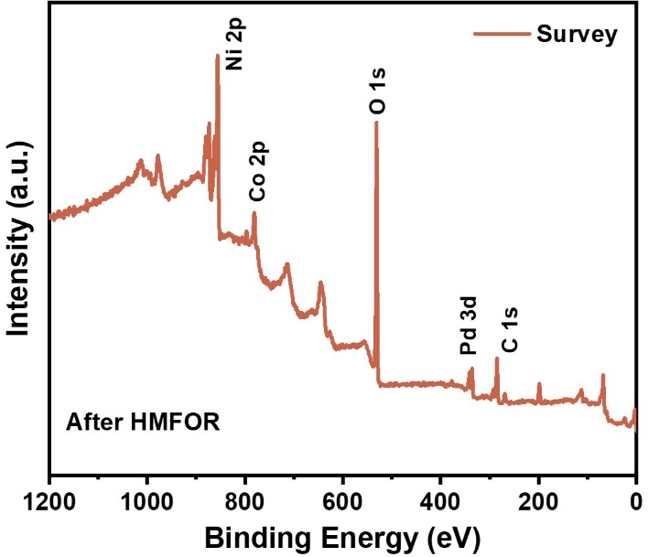
Fig. S21 XPS Survey spectrum of Pd-NiCo₂O₄ after HMFOR

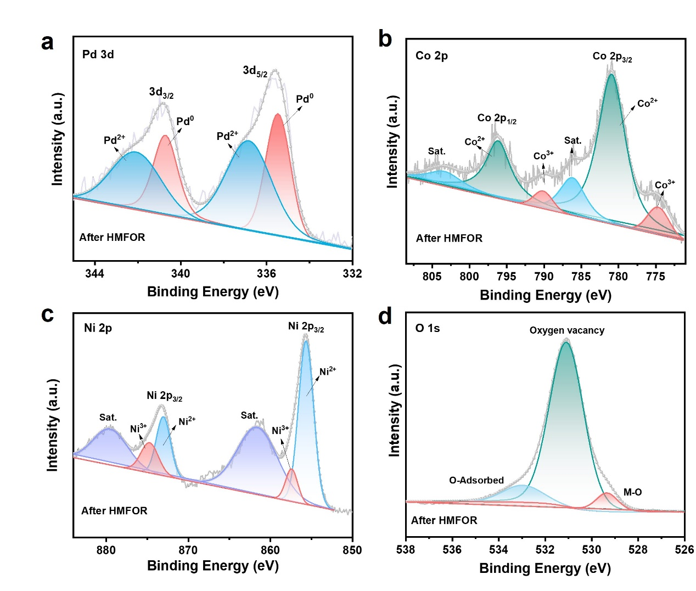
Fig. S22 High-resolution (a) Pd 3d, (b) Co 2p, (c) Ni 2p, (d) O 1s XPS spectra of Pd-NiCo₂O₄ after HMFOR

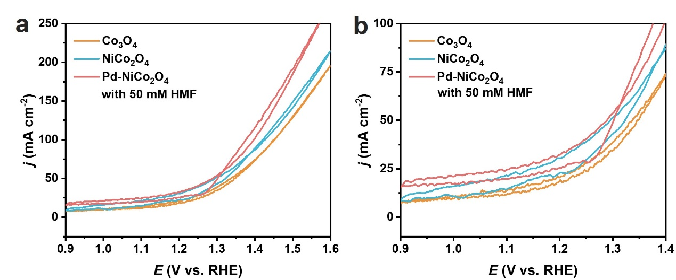
Fig. S23 CV curves of Co₃O₄, NiCo₂O₄, and Pd-NiCo₂O₄ in 1 M KOH with 50 mM HMF
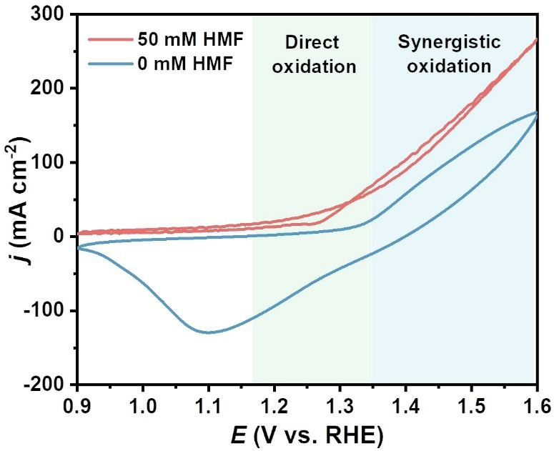
Fig. S24 CV curves of Pd-NiCo₂O₄ in 1 M KOH with and without 50 mM HMF

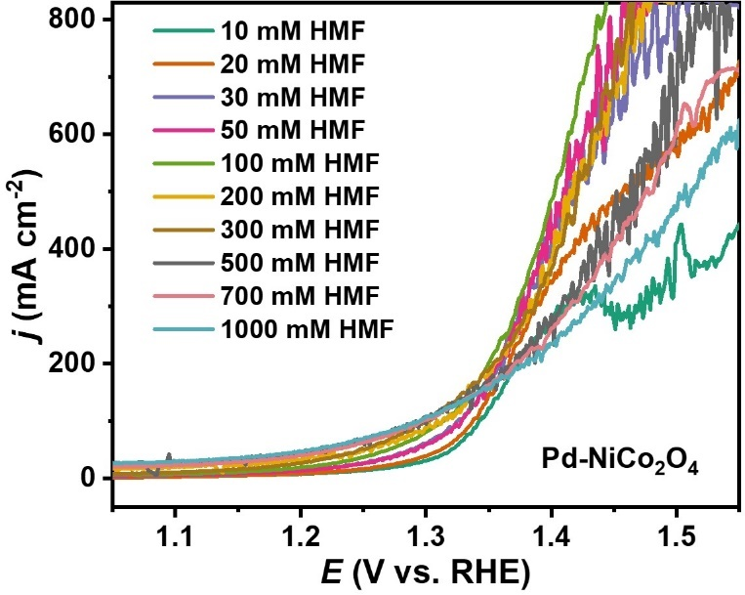
Fig. S25 LSV curves of Pd-NiCo₂O₄ in 1 M KOH with different HMF concentration
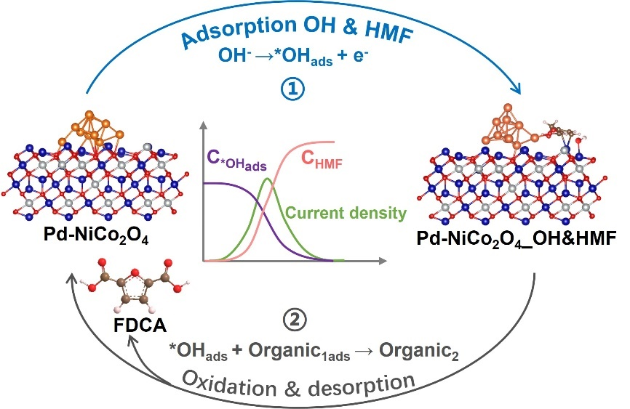

Fig. S26 Schematic representation of the direct oxidation of HMF

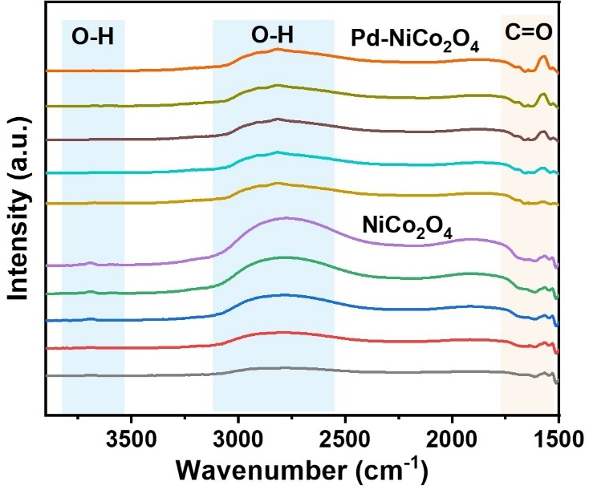

Fig. S27 In situ ATR-FTIR spectra over Pd-NiCo₂O₄ and NiCo₂O₄ samples

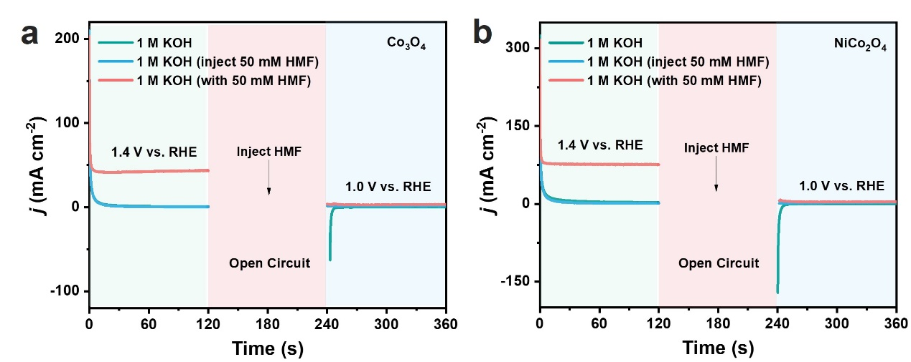
Fig. S28 Multipotential-step curves of and (a) Co₂O₄ and (b) NiCo₂O₄ in 1 M KOH solution with and without 50 mM HMF addition

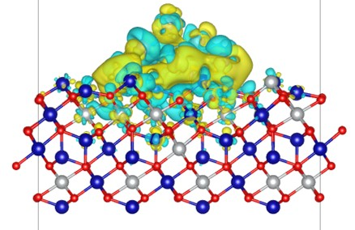
Fig. S29 Charge density difference for Pd-NiCo₂O₄
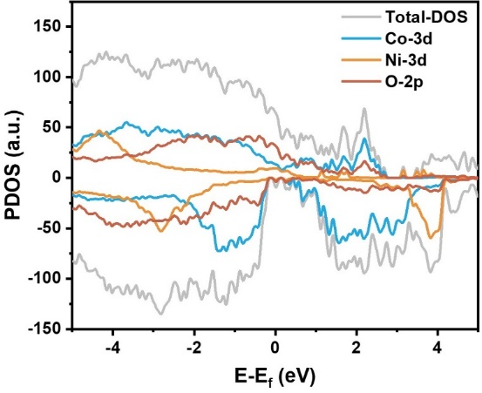
Fig. S30 PDOS of NiCo₂O₄
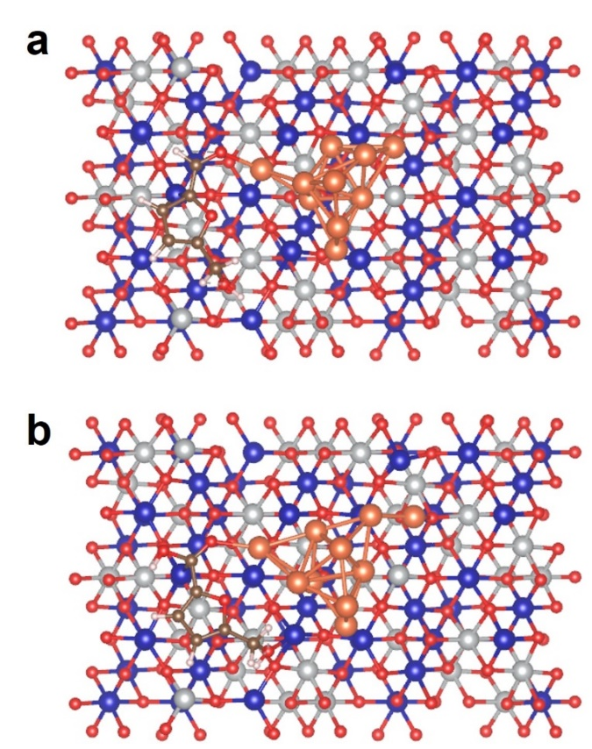
Fig. S31 Optimized stable adsorption configures (top review) for HMF and HMFCA on Pd-NiCo₂O₄
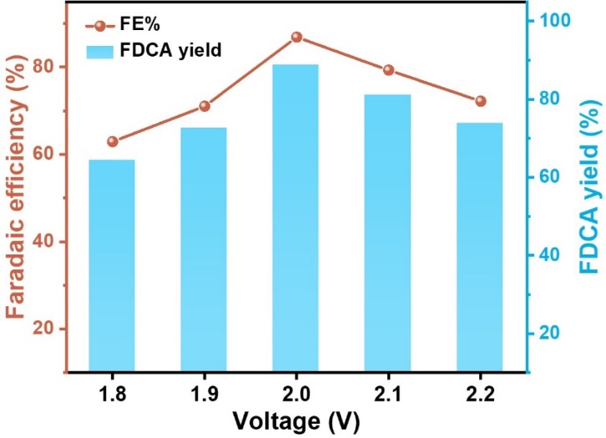
Fig. S32 FDCA yield and Faradaic efficiency of Pd-NiCo₂O₄ in coupled two-electrode cell at different voltages

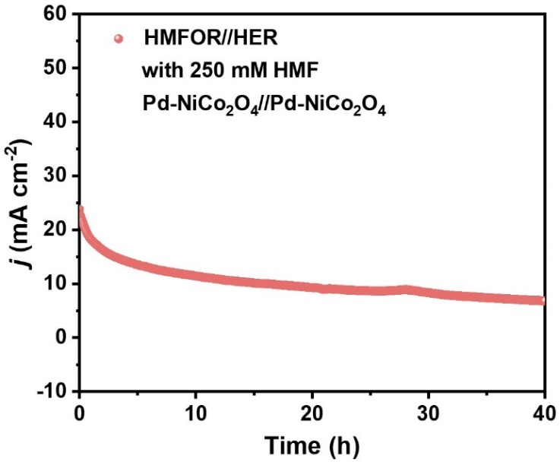
Fig. S33 Long-term test of Pd-NiCo₂O₄ in two-electrode cell

Table S1 ICP results of Co, Ni and Pd elements in Pd-NiCo₂O₄
Element | Wt% | At%
Co | 19.54 | 0.33
Ni | 32.94 | 0.56
Pd | 10.80 | 0.10
Table S2 XPS results of Pd-NiCo₂O₄
Name | Atomic% |  | PP Hgt (N) | PP At%
C 1s | 35.23 |  | 31.88 | 40.52
Co 2p | 2.9 |  | 0.56 | 0.71
Ni 2p | 18.67 |  | 5.44 | 6.91
O 1s | 42.7 |  | 40.65 | 51.67
Pd 3d | 0.5 |  | 0.15 | 0.19
Table S3 XPS fitting results of samples
Catalyst | Binding energy (eV)
Catalyst | Co²⁺ |  | Co³⁺ |  | Ni²⁺ |  | Ni³⁺
Co₃O₄ | 796.38 | 781.46 | 794.80 | 779.83 | / | / | / | /
NiCo₂O₄ | 796.45 | 781.64 | 794.67 | 779.76 | 872.54 | 854.62 | 874.59 | 856.41
Pd-NiCo₂O₄ | 797.28 | 781.29 | 792.73 | 775.42 | 873.32 | 855.64 | 874.92 | 857.09
Table S4 Comparison of the HMFOR performance between Pd-NiCo₂O₄ and recently reported advanced catalysts
Catalysts | C_{HMF}  (mM) | Potential  (V vs. RHE) | Current density  (mA cm⁻²) | Faradaic efficiency (FE, %) | References
NiFe-1 | 50 | 1.5 | 630 | 92 | [S1]
CoOOH/CF | 50 | 1.5 | 420 | 99 | [S2]
CuCo₂O₄ | 50 | 1.5 | 225 | 94 | [S3]
Pd/NiCo | 50 | 1.5 | 81 | 95.9 | [S4]
Pt/Ni(OH)₂ | 50 | 1.6 | 38 | 98.7 | [S5]
NiFeLDH/CPF | 10 | 1.45 | 20 | 99.4 | [S6]
Co_{0.4}NiS@NF | 50 | 1.45 | 497 | 99.1 | [S7]
NF@Co₃O₄/CeO₂ | 50 | 1.4 | 32 | 97.5 | [S8]
NiS_{x}/β-Ni(OH)₂/Ni | 50 | 1.38  1.4 | 120  392 | 98.3 | [S9]
Pd-NiCo₂O₄ | 50 | 1.44  1.5 | 596  800 | 99.6 | This work
Table S5 Comparison of catalytic performance of the state-of-the-art catalysts reported in literatures and the catalyst in this work
Catalysts | HMFOR//HER |  |  | HMFOR performance |  | References
Catalysts | E_{j10} (V) | E_{j50} (V) | j_{F.E.} | E_{j100} (V) | F.E. (%) | References
MoO₂-FeP@C | 1.49 | 1.6 | 20 | 1.42 | 97.8 | [S10]
E-CoAl-LDH-NSA | 1.5 | 1.74 | - | 1.59 | 99.4 | [S11]
NF@Mo-Ni_{0.85}Se | 1.4 | 1.5 | - | 1.46 | 95 | [S12]
Cu_{x}S@NiCo-LDH | 1.34 | 1.49 | - | 1.36 | 99 | [S13]
NiSe/NiO_{x} | 1.56 | 1.65 | - | 1.35 | 99 | [S14]
NiCu NTs | 1.3 | 1.47 | - | 1.38 | 96.4 | [S15]
NiCo₂@MoO₂/NF | 1.25 | 1.48 | - | 1.27 | 99.2 | [S16]
Rh-O₅-Ni(Fe) | 1.32 | 1.42 | 40 | 1.39 | 98.5 | [S17]
Co₉S₈@Ni₃S₂/NF | 1.42 | 1.61 | - | 1.42 | 98.4 | [S18]
Pd-NiCo₂O₄ | 1.07 | 1.40 | 100 | 1.32 | 99.6 | This work
Supplementary References
- C. Wang, Y. Wu, A. Bodach, M. L. Krebs, W. Schuhmann et al. A novel electrode for value-generating anode reactions in water electrolyzers at industrial current densities. Angew. Chem., Int. Ed. 62(7), e202215804 (2023). https://doi.org/https://doi.org/10.1002/anie.202215804
- R. Zhang, S. Jiang, Y. Rao, S. Chen, Q. Yue et al. Electrochemical biomass upgrading on CoOOH nanosheets in a hybrid water electrolyzer. Green Chem. 23(6), 2525-2530 (2021). https://doi.org/10.1039/D0GC04157B
- Y. Lu, C.-L. Dong, Y.-C. Huang, Y. Zou, Z. Liu et al. Identifying the geometric site dependence of spinel oxides for the electrooxidation of 5-hydroxymethylfurfural. Angew. Chem., Int. Ed. 59(43), 19215-19221 (2020). https://doi.org/https://doi.org/10.1002/anie.202007767
- G. Liu, T. Nie, Z. Song, X. Sun, T. Shen et al. Pd loaded nico hydroxides for biomass electrooxidation: Understanding the synergistic effect of proton deintercalation and adsorption kinetics. Angew. Chem., Int. Ed. 62(45), e202311696 (2023). https://doi.org/https://doi.org/10.1002/anie.202311696
- B. Zhou, Y. Li, Y. Zou, W. Chen, W. Zhou et al. Platinum modulates redox properties and 5-hydroxymethylfurfural adsorption kinetics of Ni(OH)₂ for biomass upgrading. Angew. Chem., Int. Ed. 60(42), 22908-22914 (2021). https://doi.org/https://doi.org/10.1002/anie.202109211
- W.-J. Liu, L. Dang, Z. Xu, H.-Q. Yu, S. Jin et al. Electrochemical oxidation of 5-hydroxymethylfurfural with NiFe layered double hydroxide (LDH) nanosheet catalysts. ACS Cataly. 8(6), 5533-5541 (2018). https://doi.org/10.1021/acscatal.8b01017
- Y. Sun, J. Wang, Y. Qi, W. Li, C. Wang. Efficient electrooxidation of 5-hydroxymethylfurfural using Co-doped Ni₃S₂ catalyst: Promising for H₂ production under industrial-level current density. Adv. Sci. 9(17), 2200957 (2022). https://doi.org/https://doi.org/10.1002/advs.202200957
- G. Zhao, G. Hai, P. Zhou, Z. Liu, Y. Zhang et al. Electrochemical oxidation of 5-hydroxymethylfurfural on CeO₂-modified Co₃O₄ with regulated intermediate adsorption and promoted charge transfer. Adv. Funct. Mater. 33(14), 2213170 (2023). https://doi.org/https://doi.org/10.1002/adfm.202213170
- C. Liu, X.-R. Shi, K. Yue, P. Wang, K. Zhan et al. S-species-evoked high-valence Ni^{2+δ} of the evolved β-Ni(OH)₂ electrode for selective oxidation of 5-hydroxymethylfurfural. Adv. Mater. 35(12), 2211177 (2023). https://doi.org/https://doi.org/10.1002/adma.202211177
- G. Yang, Y. Jiao, H. Yan, Y. Xie, A. Wu et al. Interfacial engineering of MoO₂-FeP heterojunction for highly efficient hydrogen evolution coupled with biomass electrooxidation. Adv. Mater. 32(17), 2000455 (2020). https://doi.org/https://doi.org/10.1002/adma.202000455
- Y. Song, Z. Li, K. Fan, Z. Ren, W. Xie et al. Ultrathin layered double hydroxides nanosheets array towards efficient electrooxidation of 5-hydroxymethylfurfural coupled with hydrogen generation. Appl. Catal., B. 299(120669 (2021). https://doi.org/https://doi.org/10.1016/j.apcatb.2021.120669
- C. Yang, C. Wang, L. Zhou, W. Duan, Y. Song et al. Refining d-band center in Ni_{0.85}Se by Mo doping: A strategy for boosting hydrogen generation via coupling electrocatalytic oxidation 5-hydroxymethylfurfural. Chem. Eng. J. 422(130125 (2021). https://doi.org/https://doi.org/10.1016/j.cej.2021.130125
- X. Deng, X. Kang, M. Li, K. Xiang, C. Wang et al. Coupling efficient biomass upgrading with H₂ production via bifunctional Cu_{x}S@NiCo-LDH core–shell nanoarray electrocatalysts. J. Mater. Chem. A 8(3), 1138-1146 (2020). https://doi.org/10.1039/C9TA06917H
- L. Gao, Z. Liu, J. Ma, L. Zhong, Z. Song et al. NiSe@NiO_{x} core-shell nanowires as a non-precious electrocatalyst for upgrading 5-hydroxymethylfurfural into 2,5-furandicarboxylic acid. Appl. Catal., B. 261, 118235 (2020). https://doi.org/https://doi.org/10.1016/j.apcatb.2019.118235
- L. Zheng, Y. Zhao, P. Xu, Z. Lv, X. Shi et al. Biomass upgrading coupled with H₂ production via a nonprecious and versatile cu-doped nickel nanotube electrocatalyst. J. Mater. Chem. A 10(18), 10181-10191 (2022). https://doi.org/10.1039/D2TA00579D
- J. Wu, J. Chen, T. Yu, Z. Zhai, Y. Zhu et al. Boosting electrochemical kinetics of NiCo₂ via MoO₂ modification for biomass upgrading assisted hydrogen evolution. ACS Catal. 13(20), 13257-13266 (2023). https://doi.org/10.1021/acscatal.3c03094
- L. Zeng, Y. Chen, M. Sun, Q. Huang, K. Sun et al. Cooperative Rh-O₅/Ni(Fe) site for efficient biomass upgrading coupled with H₂ production. J. Am. Chem. Soc. 145(32), 17577-17587 (2023). https://doi.org/10.1021/jacs.3c02570
- R. Zhang, F. Gao, C. Yang, Y. Bian, G. Wang et al. Boosting hydrogen evolution via anodic oxidation of 5-hydroxymethylfurfural in anion exchange membrane electrolyzer over a metallic heterostructure. Mater. Today Nano 23, 100373 (2023). https://doi.org/https://doi.org/10.1016/j.mtnano.2023.100373

