Supporting Information for
Photo-Energized MoS₂/CNT Cathode for High Performance Li–CO₂ Batteries in a Wide Temperature Range
Tingsong Hu¹, Wenyi Lian¹, Kang Hu¹, Qiuju Li¹, Xueliang Cui¹, Tengyu Yao¹, Laifa Shen^{1,}*
¹Jiangsu Key Laboratory of Materials and Technologies for Energy Storage, College of Materials Science and Technology, Nanjing University of Aeronautics and Astronautics, Nanjing 210016, People’s Republic of China.
*Corresponding author. E-mail: lfshen@nuaa.edu.cn (Laifa Shen)
Supplementary Fiures and Tables
Fig. S1 Representations of the design of MoS₂/CNT

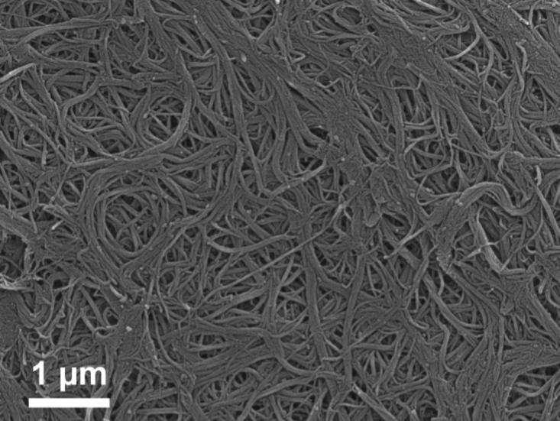

Fig. S2 Scanning electron microscopy image of pristine CNT

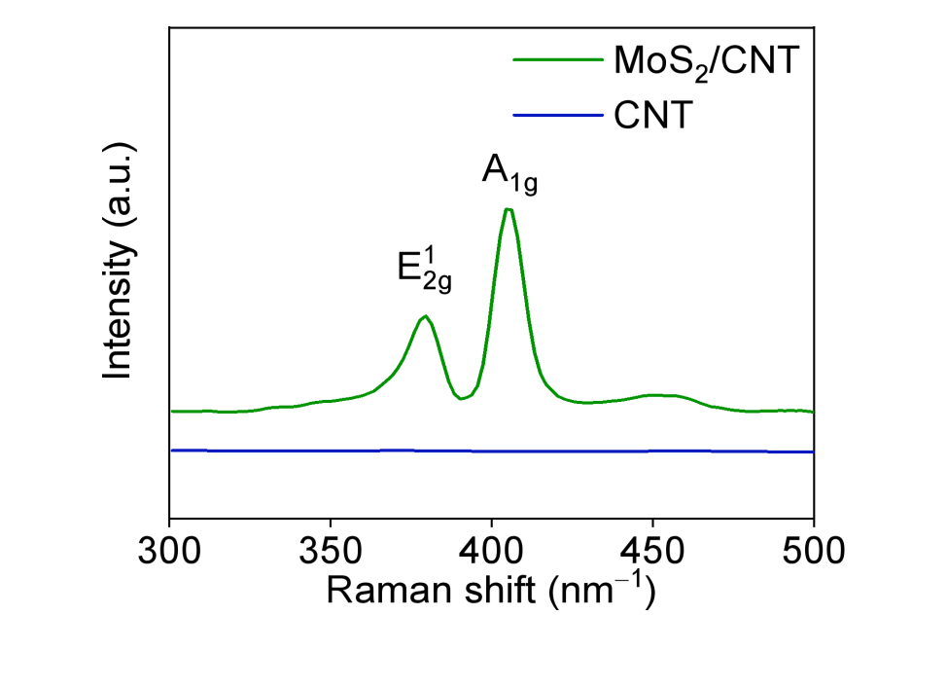
Fig. S3 Raman spectra of CNT and MoS₂/CNT cathode

Fig. S4 X-ray photoelectron spectroscopy image of (a) Mo and (b) S in MoS₂/CNT cathode

Fig. S5 Partial Density of States of Mo and S in (a) MoS₂/CNT or (b) MoS₂
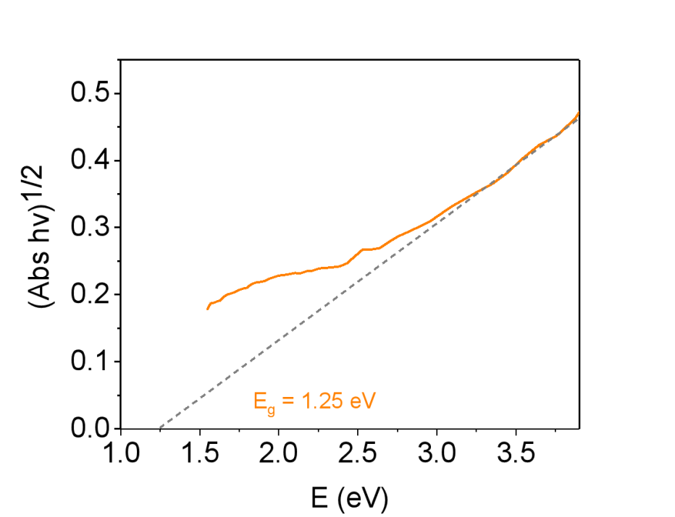
Fig. S6 Tauc plot corresponding to UV-vis absorption of MoS₂/CNT
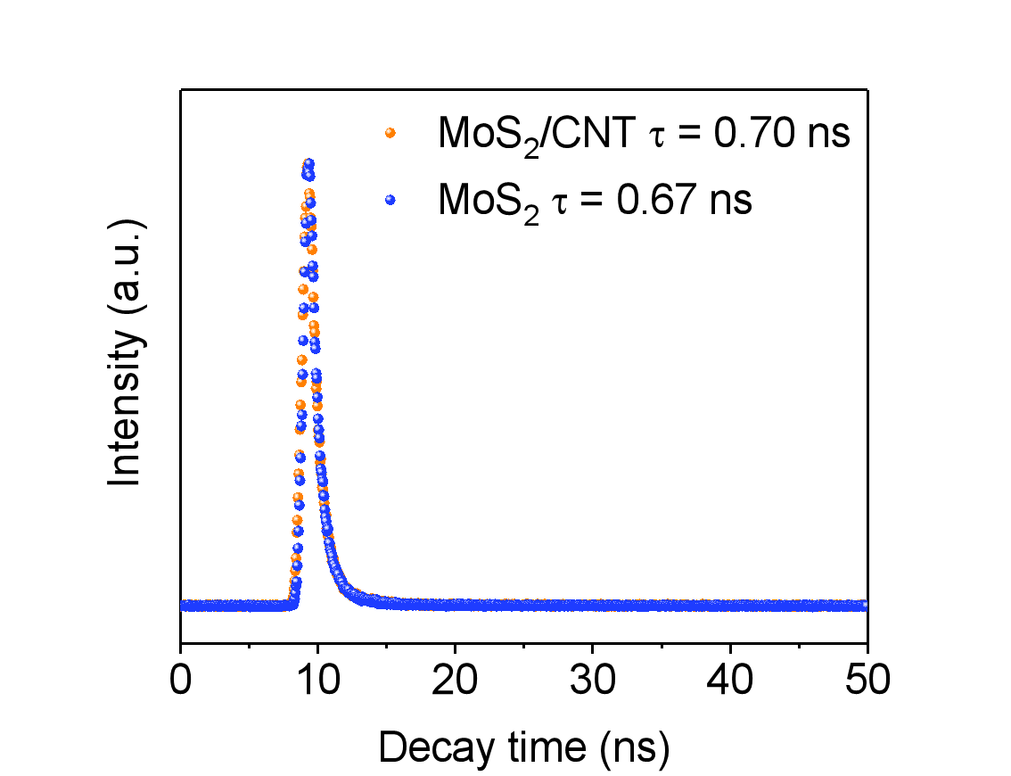
Fig. S7 Time-resolved transient photoluminescence decay spectra of MoS₂ and MoS₂/CNT
First-principles calculations were carried out using density functional theory (DFT) to calculate the kinetic processes under light and no light. According to the intensity value of the Ultraviolet curing lamp in the experiment, the applied electric field component for computation could be calculated by the following equations. According to the intensity value of the Ultraviolet curing lamp in the experiment, the applied electric field component for computation could be calculated by the following equations.
Z₀ = μ₀c (S1)
H₀ = (2S/Z₀)^{1/2} (S2)
E₀ = (2Z₀S)^{1/2} (S3)
Where Z₀ is the impedance of free space, μ₀ is the permeability of vacuum (μ₀= 4π×10⁻⁷ H/m), c is the light speed (c = 3×10⁸ m/s), S is the electromagnetic wave intensity (S = 42 mW/cm², the intensity of Ultraviolet lamp), H₀ is the magnetic field intensity, and E₀ is the electric field intensity. The incident electric field component was calculated to be 563 V/m. To facilitate the subsequent calculation process, the electric field intensity applied in the computation was 600 V/m.
Table S1 Reaction path and energy changes during the charging process
Reaction path(charge) | Reaction equation | No lighting (eV) | Lighting (eV)
a1 | *Li₂CO₃ + C = *LiCO₃ + C + Li | 4.6250 | 4.3285
a2 | *LiCO₃ + C = *CO₃ + C + Li | 2.9887 | 2.8845
a3 | *CO₃ + C = *CO + CO₂ | -6.4143 | -6.2816
a4 | *Li₂CO₃ + CO = *LiCO₃ + CO + Li | 4.5535 | 4.3064
a5 | *LiCO₃ + CO + Li = *LiCO₂ + Li + CO₂ | -1.8243 | -1.8366
a6 | *LiCO₂ + Li + CO₂ = *Li + Li + 2CO₂ | -0.8993 | -0.8575
a7 | *Li + Li + 2CO₂ = * + 2Li + 2CO₂ | 1.4534 | 1.5423
Table S2 Reaction path and energy changes during the discharge process
Reaction path(discharge) | Reaction equation | No lighting (eV) | Lighting (eV)
b1 | * + 2Li + 2CO₂ = *Li + Li + 2CO₂ | -1.4534 | -1.5423
b2 | *Li + Li + 2CO₂ = *LiCO₂ + Li + CO₂ | 0.8993 | 0.8575
b3 | *LiCO₂ + Li + CO₂ = *LiCO₃ + CO + Li | 1.8243 | 1.8366
b4 | *LiCO₃ + CO + Li = *Li₂CO₃ + CO | -4.5535 | -4.3064
b5 | *CO + CO₂ = *CO₃ + C | 6.4143 | 6.2816
b6 | *CO₃ + C + Li = *LiCO₃ + C | -2.9887 | -2.8845
b7 | *LiCO₃ + C + Li = *Li₂CO₃ + C | -4.6250 | -4.3285

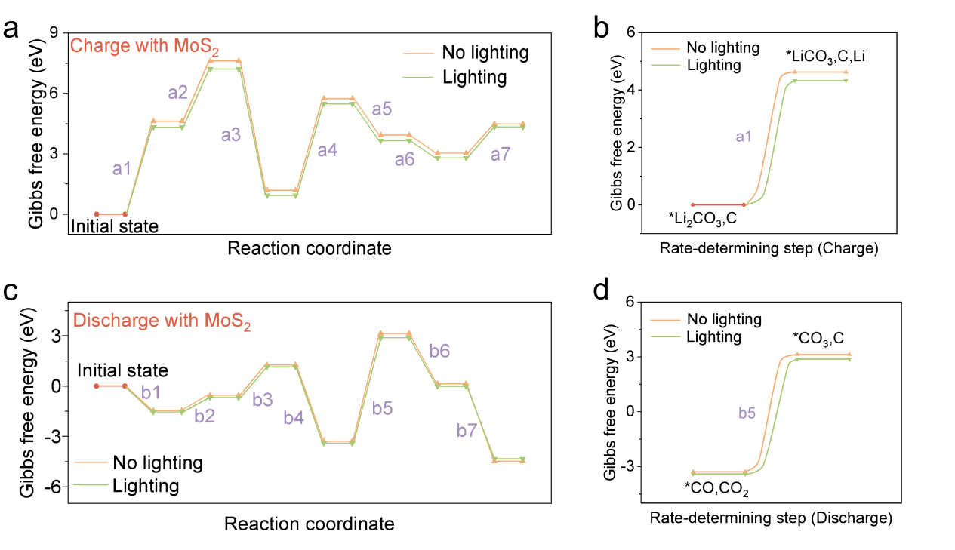
Fig. S8 (a) Charging reaction path with MoS₂ under lighting and no lighting. (b) Rate-determining step in charging reaction. (c) Discharge reaction path with MoS₂ under lighting and no lighting. (d) Rate-determining step in discharge reaction
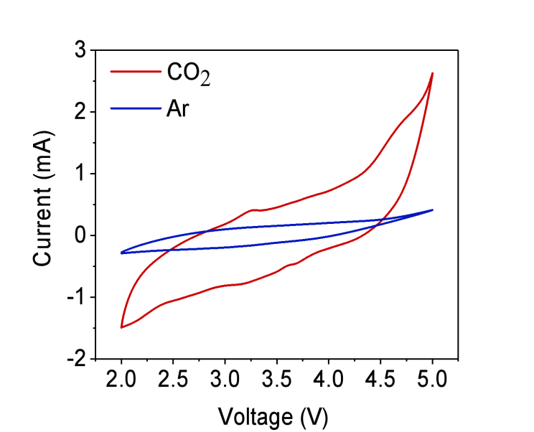
Fig. S9 Cyclic voltammetry curves of Li–CO₂ batteries with MoS₂/CNT cathode in Ar or CO₂ atmosphere at 1 mV s^{–1}
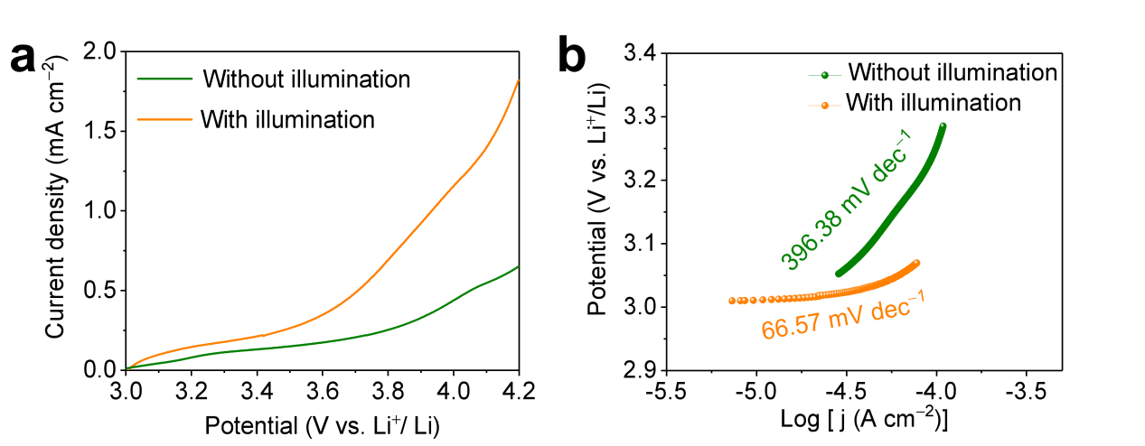
Fig. S10 (a) Linear sweep voltammetry curves in CO₂ oxidation process at 5 mV s^{–1} and (b) corresponding Tafel curves of Li–CO₂ battery with MoS₂/CNT cathode in the presence and absence of illumination
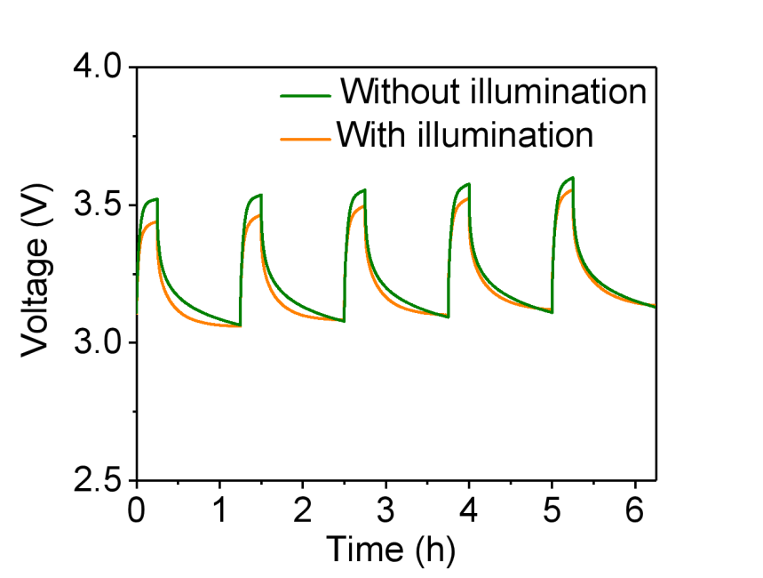
Fig. S11 Galvanostatic intermittent titration spectra during charge of Li–CO₂ battery with MoS₂/CNT cathode with or without illumination

Fig. S12 Differential electrochemical mass spectrometry results of discharge process (a) with and (b) without illumination in Li–CO₂ battery with MoS₂/CNT cathode. DEMS results of recharge process (c) with and (d) without illumination in Li–CO₂ battery with MoS₂/CNT cathode

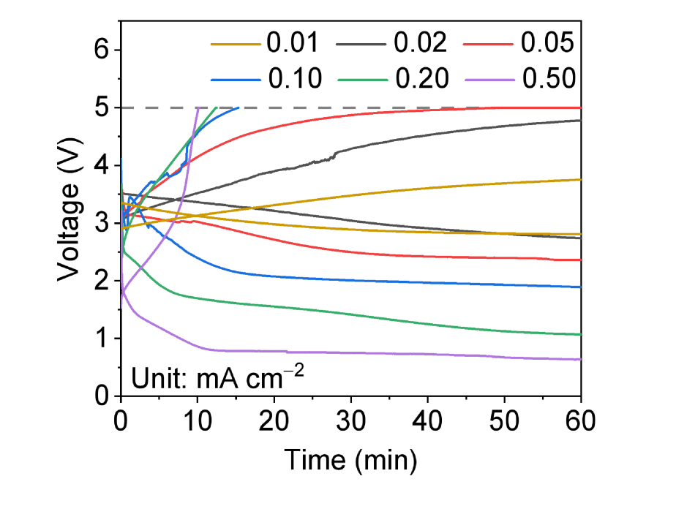
Fig. S13 Discharge and charge curves of the Li–CO₂ battery based on the MoS₂/CNT cathode without illumination at different current density
Fig. S14 Scanning electron microscopy image of MoS₂/CNT cathode collected from full-discharge Li–CO₂ battery (a) with or (b) without illumination
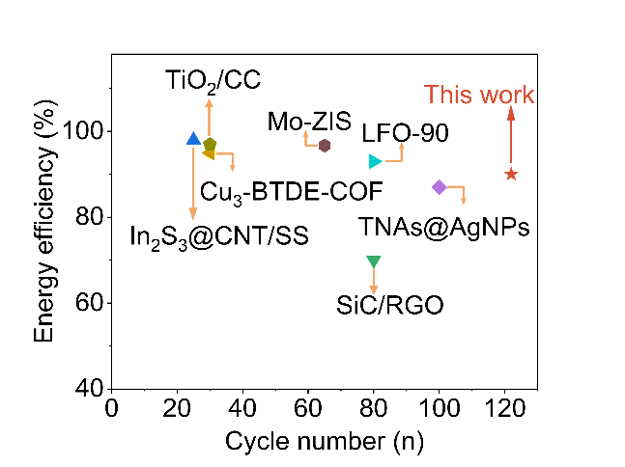
Fig. S15 Comparison of energy efficiency and cycle performance of Li–O₂ and Li–CO₂ batteries with the state-of-the-art cases reported in the literature
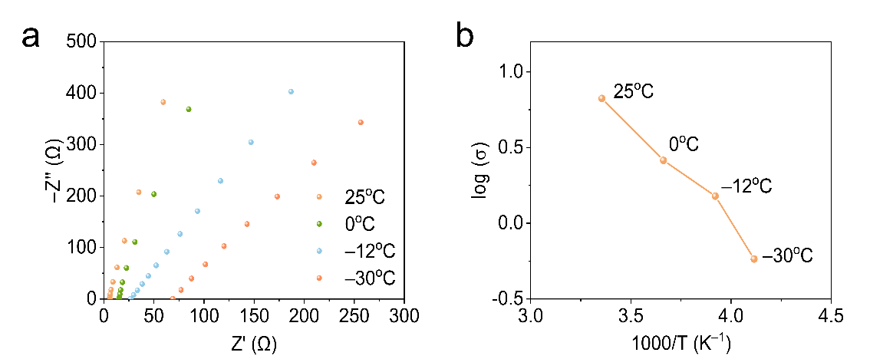
Fig. S16 (a) Nyquist plots and (b) ionic conductivity at different temperatures (TEGEDME with 1.0 M LiTFSI is used as electrolyte)

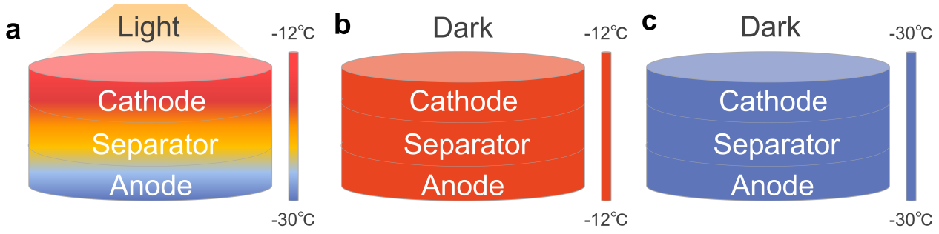
Fig. S17 Schematic diagram of temperature gradient of Li–CO₂ battery with MoS₂/CNT cathode with illumination at –30 ºC, without illumination at –30 ºC, and without illumination at –12 ºC

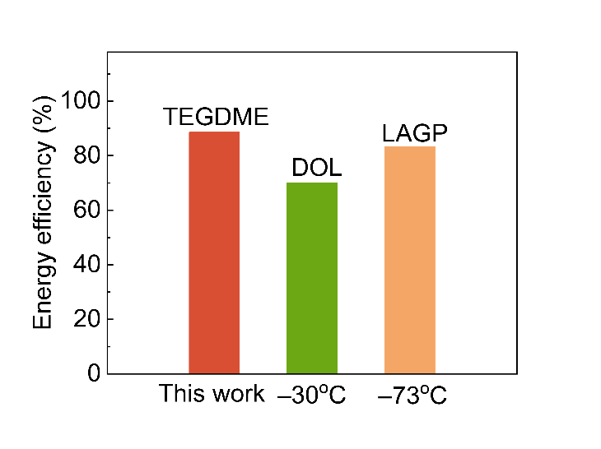
Fig. S18 Comparison of energy efficiency with different electrolytes (conventional electrolytes, cryo-electrolytes and solid electrolytes) at low temperature
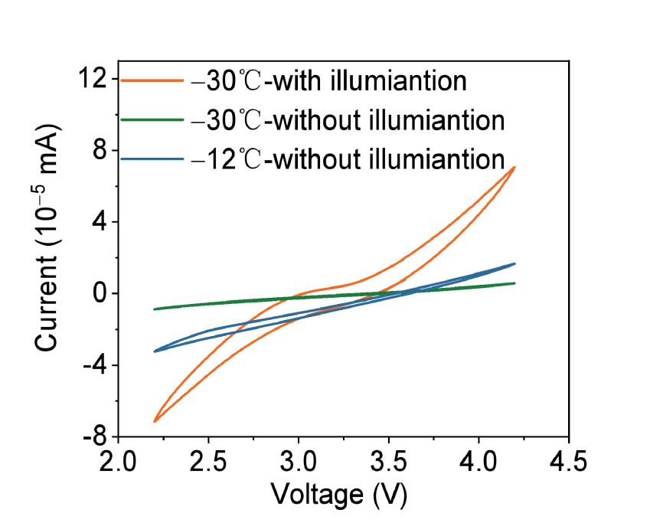
Fig. S19 Cyclic voltammetry curves of Li–CO₂ battery with MoS₂/CNT cathode with illumination at –30 ºC, without illumination at –30 ºC, and without illumination at –12 ºC
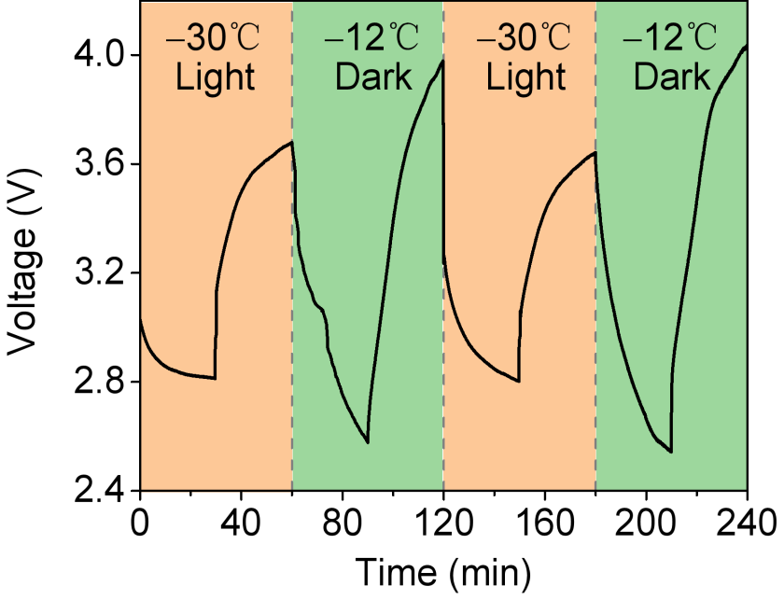
Fig. S20 Discharge/charge behaviors responding to the Li–CO₂ battery with illumination at –30 ºC and without illumination at –12 ºC
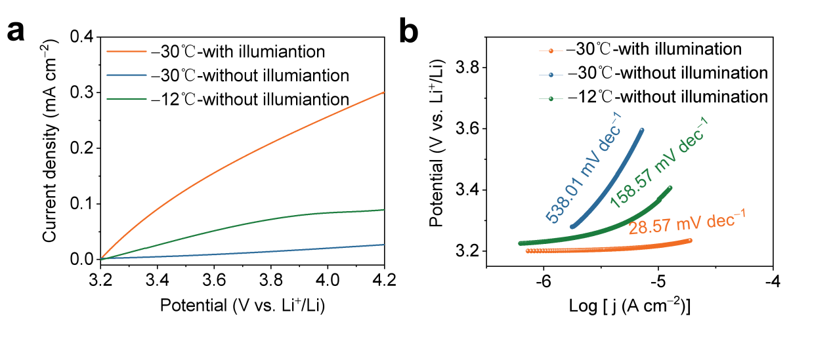
Fig. S21 (a) Linear sweep voltammetry curves in CO₂ oxidation process and (b) Corresponding Tafel curves of Li–CO₂ battery with MoS₂/CNT cathode with illumination at –30 ºC, without illumination at –30 ºC, and without illumination at –12 ºC
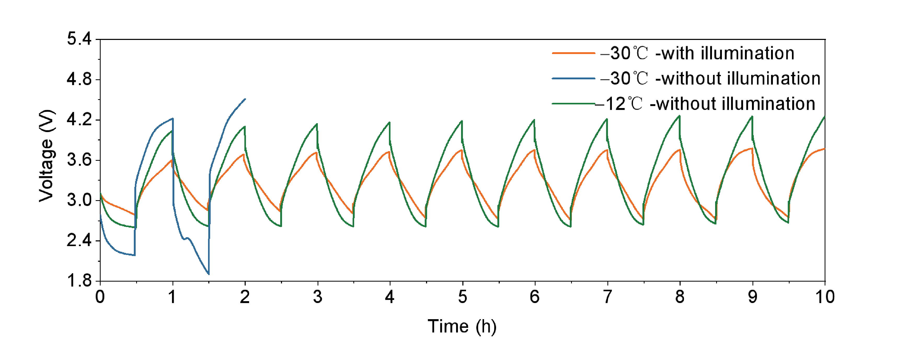
Fig. S22 Cycling profiles at 0.01 mA cm^{–1} of Li–CO₂ battery with MoS₂/CNT cathode with illumination at –30 ºC, without illumination at –30 ºC, and without illumination at –12 ºC
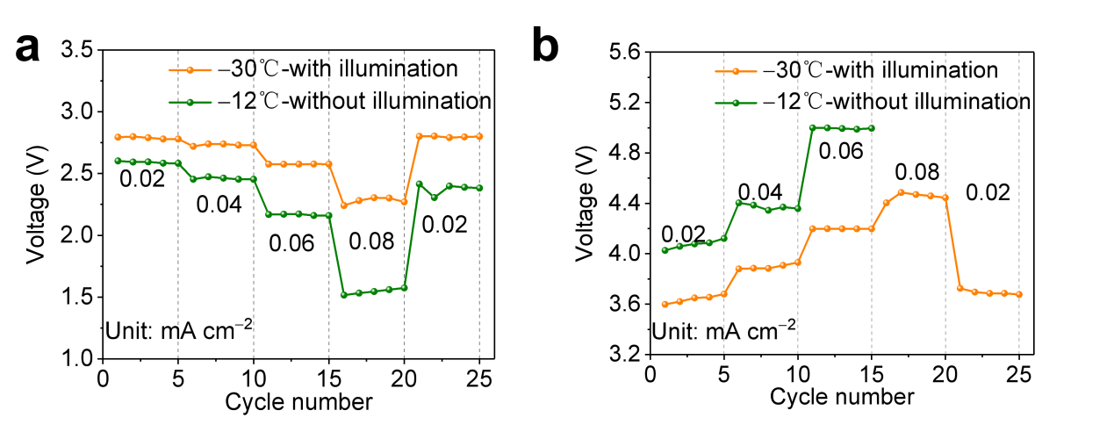
Fig. S23 (a) Discharge rate capability and (b) Charge rate capability of Li–CO₂ battery with MoS₂/CNT cathode with illumination at –30 ºC and without illumination at –12 ºC

