Supporting Information for
Smart Cellulose-Based Janus Fabrics with Switchable Liquid Transportation for Personal Moisture and Thermal Management
Jianfeng Xi¹, Yanling Lou¹, Liucheng Meng¹, Chao Deng⁴, Youlu Chu¹, Zhaoyang Xu², Huining Xiao³, Weibing Wu^{1,} *
¹Jiangsu Co-Innovation Center of Efficient Processing and Utilization of Forest Resources, International Innovation Center for Forest Chemicals and Materials, Jiangsu Provincial Key Lab of Sustainable Pulp and Paper Technology and Biomass Materials, Nanjing Forestry University, Nanjing 210037, P. R. China
²College of Materials Science and Engineering, Nanjing Forestry University, Nanjing 210037, P. R. China
³Department of Chemical Engineering, University of New Brunswick, Fredericton, NB E3B 5A3, Canada
⁴Macromolecular Chemistry and Bavarian Polymer Institute, University of Bayreuth, 95440 Bayreuth, Germany
*Corresponding author. E-mail: wbwu@njfu.edu.cn (Weibing Wu)
Supplementary Figures and Tables
Table S1 Hydrophilic/hydrophobic composition of different fabrics
Sample name | Hydrophobic side | Hydrophilic side
NCFB | √ | ╳
NCFH | ╳ | √
NCFBM | EC ethanol solution with a total mass 4 times the mass of CF | √
JCF | √ | √
Note: √ means that this part of the experiment has been processed, and ╳ means that this part of the experiment has not been processed.
g-C₃N₄ nanosheets were prepared by urea thermal polymerization. Briefly, the urea was heated to 550 °C at a rate of 2 °C /min and kept for 4 h. After cooling, light-yellow g-C₃N₄ nanosheets were obtained.
The g-C₃N₄ nanosheets were successfully obtained by urea thermal polymerization. As shown in Fig. S1a, the obtained g-C₃N₄ nanosheets present a dense multi-layer stacked structure. In addition, CNF is between 4-10 nm in diameter and 1-3 μm in length (Fig. S1b).
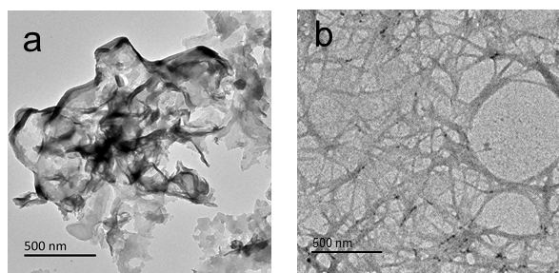
Fig. S1 TEM images of a g-C₃N₄ nanosheets and b CNF
As can be seen from the floor plan, after the fabric is sprayed by EC, EC acts like glue to bind the fibers on the yarn together, and it is obvious that there is a layer of coating on the yarn (Fig. S2). The SEM image of the cross section also shows that the fibers on the hydrophobic side are glued to each other. Because the CNF just spray on the fiber surface, so from the cross-sectional SEM, the NIPAM modified layer and hydrophilic layer without obvious changes. However, it can be clearly seen from the floor plan that the surface roughness of the hydrophilic layer is improved.
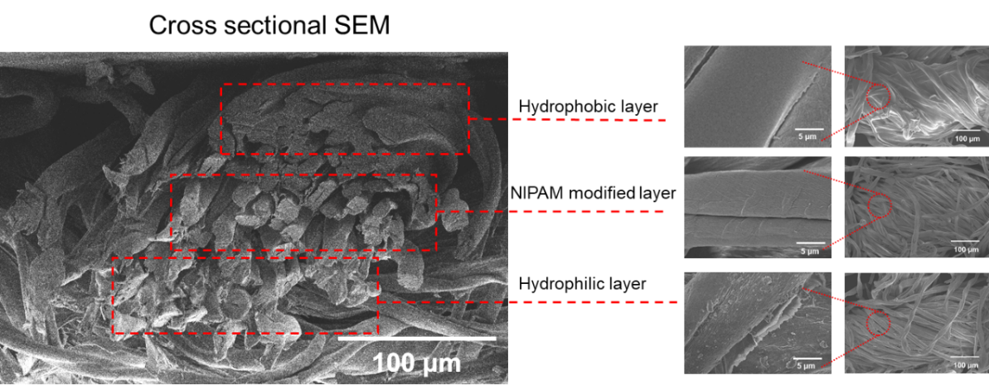
Fig. S2 SEM images of the yarn
Each sample has the main infrared characteristic peaks of CF (Fig. S3a), such as the peak around 3320 cm⁻¹, which corresponds to the stretching vibration of -OH, and the peak at 2920 cm⁻¹, which corresponds to the stretching vibration of -C-H. The NCF modified by NIPAM appears two new infrared characteristic absorption peaks, the stretching vibration of amide group appeared at 1546 cm⁻¹, and the stretching vibration of C-N appeared at 1450 cm⁻¹. In addition, the infrared absorption peak of carboxyl group appeared in JCF due to CNF spray and citric acid crosslinking modification. The surface elements of the fabrics were detected by X-ray photoelectron spectroscopy (XPS). The photoelectron peaks at 285, 399, and 531 eV correspond to C1s, N1s and O1s, respectively (Fig. S3b). In comparison with CF, the NCF shows new photoelectron peak of N element and the relative content of N element reached 3.95% (Table S1), indicating that NIPAM was successfully introduced into CF. At the same time, the presence of g-C₃N₄ nanosheets increases the relative content of N element in JCF to 5.90%.
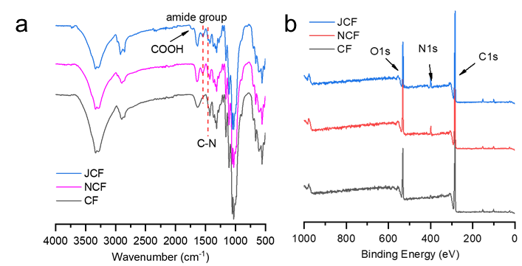
Fig. S3 a FT-IR spectra and b XPS of the fabrics
Table S2 Elemental composition characterized by XPS
Sample name | O 1s/% | N 1s/% | C 1s/%
CF | 20.74 | 0.00 | 79.26
NCF | 18.15 | 3.95 | 77.90
JCF | 17.11 | 5.90 | 76.99
With the extension of time, the WCA of the hydrophilic side of JCF reaches 0° when the water drops behind 4s, while it only takes 3 s after the addition of g-C₃N₄ (Fig. S4a-b). The presence of g-C₃N₄ further improves the hydrophilicity of the hydrophilic side.
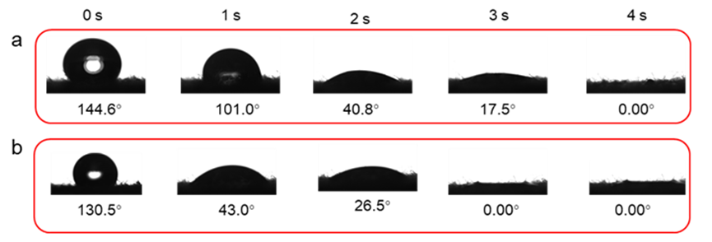
Fig. S4 a WCA of JCF-without C₃N₄ and b JCF hydrophilic side of changes with time
NCF has different wettability at different temperatures (Fig. S5a). After multiple temperature cycles, the NCF exhibits reversible temperature responsiveness (Fig. S5b). For JCF sprayed with EC and CNF, they only cover the surface of the yarn and do not penetrate into the interior of the yarn. Therefore, spraying EC and CNF does not affect the temperature responsiveness of the yarn. We verified this by measuring the WCA decline rate on the hydrophobic side of JCF at different temperatures. As the temperature increases, the contact angle decreases at a faster rate (Fig. S5c).
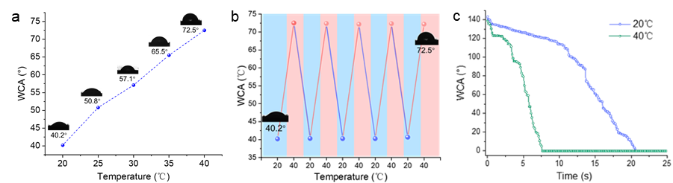
Fig. S5 a NCF temperature response wettability. b NCF reversible temperature response wettability. c The change of JCF hydrophobic side WCA with time at different temperatures
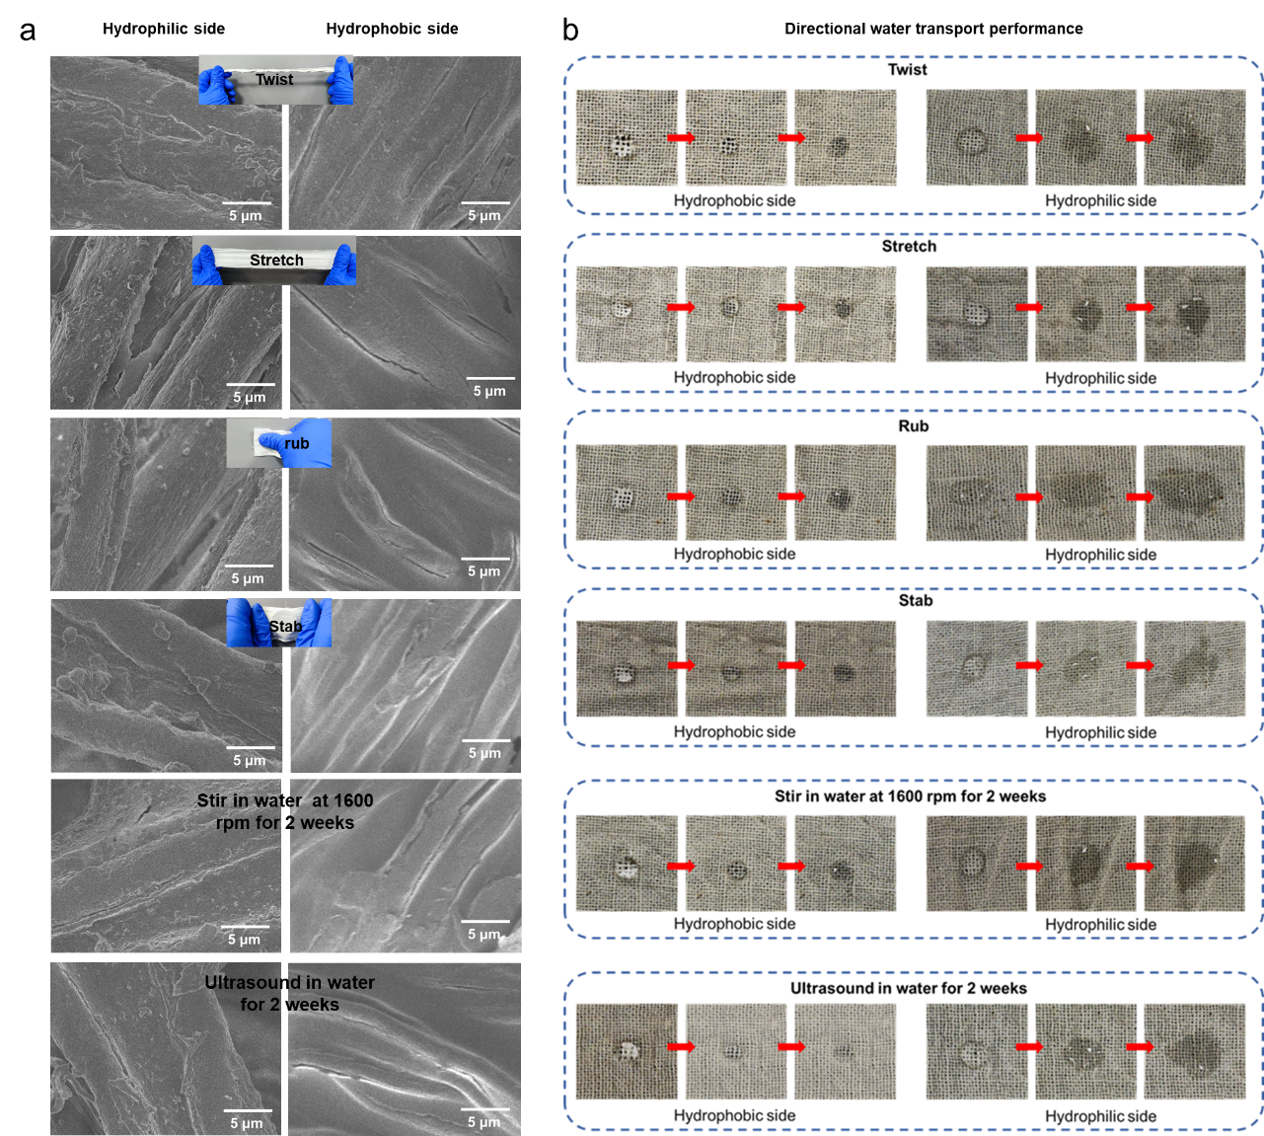
Fig. S6 a Surface morphologies and b directional water transport performance of JCF under fabric deformation, after 1600 rpm for two weeks, and after 100 W ultrasonic treatment for two weeks
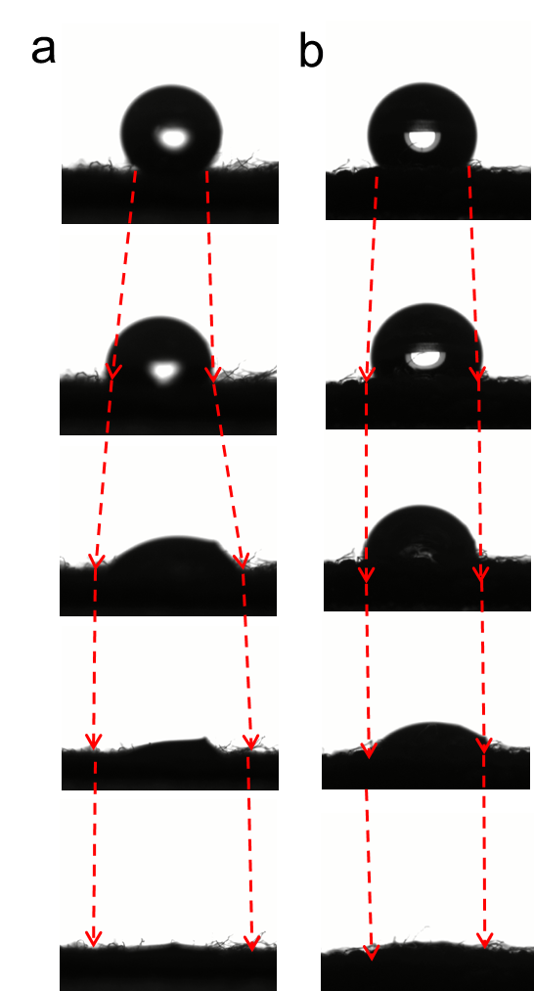
Fig. S7 Changes in a water contact angle of droplets on the hydrophilic surface and b hydrophobic surface
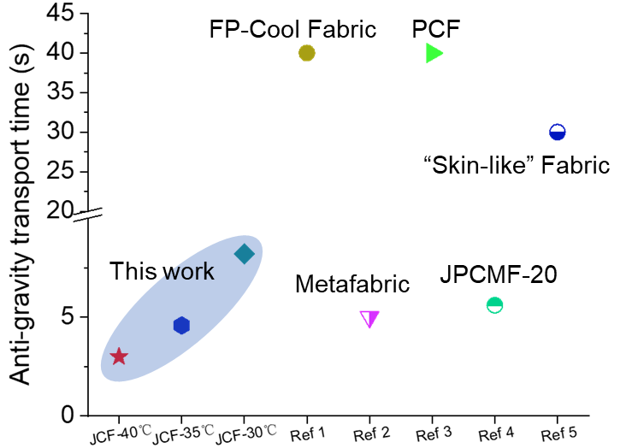
Fig. S8 The antigravity water transport speed comparison of other Janus fabric
The air permeability of JCF shows a slight decline due to the decrease in air permeability after NIPAM modification. However, this reduction is only 9.82% compared to CF (Fig. S9).
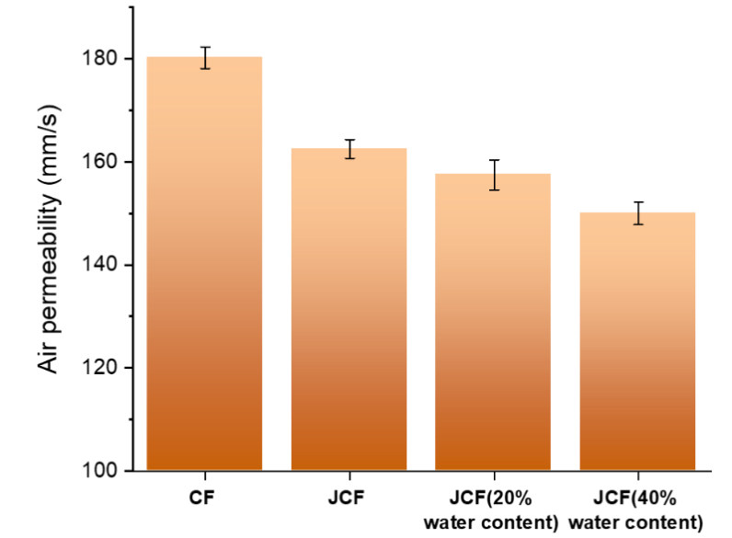
Fig. S9 Air permeabilities of CF and JCF under different water content
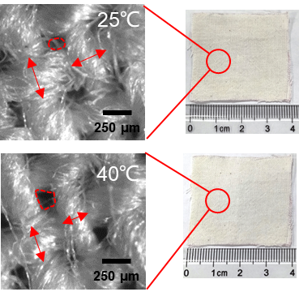
Fig. S10 Pore size change of fabric at 25 and 40 °C
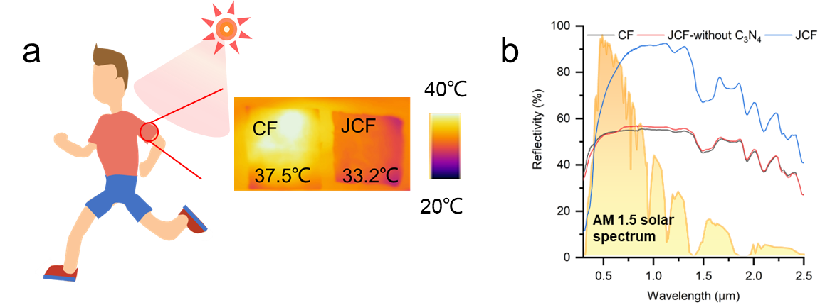
Fig. S11 a Infrared images taken when fabrics were applied to skin at 40 ℃ under sunlight. b The reflectivity of fabrics
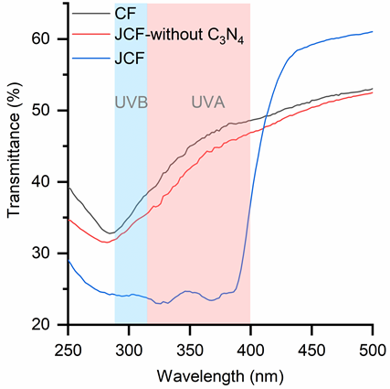
Fig. S12 UV–vis transmission spectra of fabrics
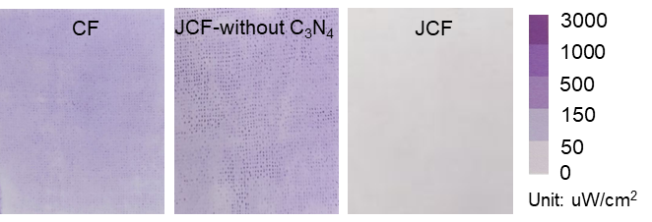
Fig. S13 UV transmittance of fabric characterized by UV-induced color change card
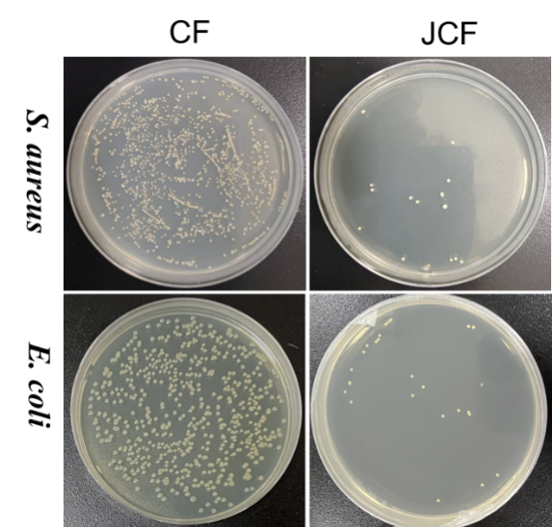
Fig. S14 Photodynamic antimicrobial performance of JCF

