Supporting Information for
Molecule-Level Multiscale Design of Non-Flammable Gel Polymer Electrolyte to Build Stable SEI/CEI for Lithium Metal Battery
Qiqi Sun¹, Zelong Gong¹, Tao Zhang¹, Jiafeng Li¹, Xianli Zhu¹, Ruixiao Zhu¹, Lingxu Wang¹, Leyuan Ma¹, Xuehui Li¹, Miaofa Yuan¹, Zhiwei Zhang¹, Luyuan Zhang¹, Zhao Qian^{1,*}, Longwei Yin^{1,*}, Rajeev Ahuja² and Chengxiang Wang^{1,*}
¹ Key Laboratory for Liquid-Solid Structural Evolution and Processing of Materials (Ministry of Education), School of Materials Science and Engineering, Shandong University, Jinan 250061, P. R. China
² Condensed Matter Theory, Department of Physics and Astronomy, Uppsala University, Uppsala 75120, Sweden
*Corresponding authors. E-mail: qianzhao@sdu.edu.cn (Zhao Qian); yinlw@sdu.edu.cn (Longwei Yin); wcxmat@sdu.edu.cn (Chengxiang Wang)
Supplementary Figures and Tables
Fig. S1 Molecular structures of TFMA (a) and HEMA (b)
Fig. S2 Optical photographs of in-situ prepared (a) 10TFMA-0.5LF-0.5LB, (b) 20TFMA-0.5LF-0.5LB, (c) 30TFMA-0.5LF-0.5LB, (d) 35TFMA-0.5LF-0.5LB and (e) 35HEMA -0.5LF -0.5LB within vials
Fig. S3 SEM images of a) original cellulose separator and b) obtained GPE with corresponding element mapping
Fig. S4 ¹H nuclear magnetic resonance (¹H NMR) spectra of a) TFMA and b) HEMA monomer before and after polymerization
Fig. S5 Nyquist plots of various electrolytes obtained with SS|GPEs|SS at room temperatures
Fig. S6 Nyquist plots of a) SGPE electrolyte, b) CGPE electrolyte, c) 60TFMA-0.5LF-0.5LB electrolyte and d) 40TFMA-1.5LF-0.5LB electrolyte under various temperature
Fig. S7 Chronoamperometry profile collected from a symmetric Li|CGPE|Li cell (The inset corresponds to the EIS plots before and after chronoamperometry)
Fig. S8 TGA thermograms of the CGPE electrolyte
Fig. S9 Stress-strain curves of GPEs
Fig. S10 EIS spectra of a) Li|SGPE|Li and b) Li|CGPE|Li cells after 150 cycles
Fig. S11 Long-term cycling of Li|1MLF-35|Li symmetrical cells, with a current density of 0.1 mA cm⁻² and 0.05 mAh cm⁻² Li plated and stripped per cycle
Fig. S12 Cross-sectional SEM images and EDS mappings of the interface between SGPE and the LiFePO₄ cathode
Fig. S13 Typical charge–discharge curves of a) LiFePO₄/SGPE/Li cell at 0.5 C, b) LiFePO₄/LE/Li cell at 0.3 C, c) LiFePO₄/CGPE/Li cell at 0.3 C and at room temperature
Fig. S14 Long-term cycling performance for LiFePO₄|SGPE|Li cell at a current density of (a) 1 C and (b) 2 C
Fig. S15 Typical charge/discharge curves of a) LiFePO₄/LE/Li cell, b) LiFePO₄/CGPE/Li cell under the varied rate from 0.1 C to 2 C
Fig. S16 Typical charge–discharge curves of a) LiCoO₂|SGPE|Li cell, b) LiCoO₂|LE|Li cell and c) LiCoO₂|CGPE|Li cell at 0.2 C after being activated at 0.1 C at room temperature
Fig. S17 Contour plot of dQ/dV results of the LiCoO₂|CGPE|Li cell from the 10th cycle to the 150th cycle
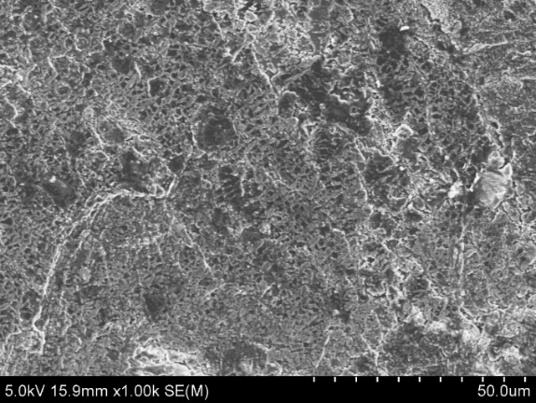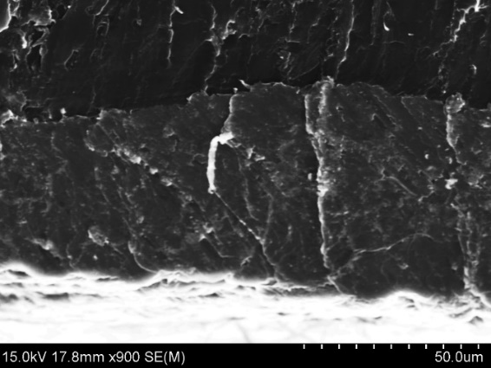
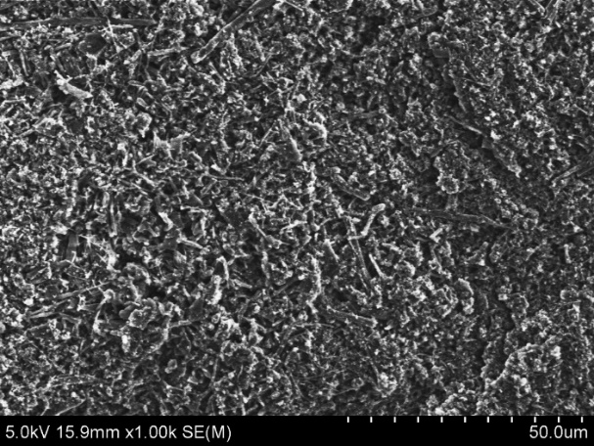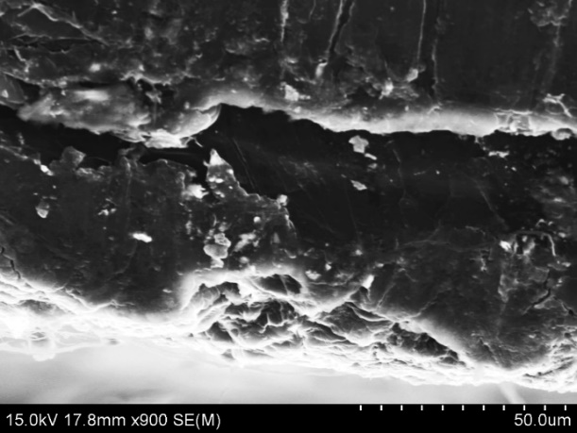
Fig. S18 The raw SEM images of Fig. 5a-d, respectively

Fig. S19 XRD patterns of pristine and cycled LiCoO₂ cathodes after 30 cycles using SGPE, CGPE and LE electrolyte
Fig. S20 XPS spectra for B 1s and F 1s of the LiCoO₂ cathodes cycled in a) SGPE electrolyte and b) CGPE electrolyte after 30 cycles

Fig. S21 FTIR spectra of –P=O peaks in TEP-based samples with different HEMA concentrations
Fig. S22 Deconvolution of peaks of the S-N-S stretching vibrational mode (CIP: contact ion pair, AGG: aggregated ion pair) in CGPE electrolyte
Table S1 The compositions of electrolyte used to optimize ionic conductivity
Electrolytes | LiTFSI  (mg) | TEP  (μL) | TFMA  (μL) | LiDFOB  (mg) | RT Ionic conductivity  (mS cm⁻¹)
35TFMA-0.2LF-0.5LB | 57.6 | 650 | 350 | 72 | 0.177
35TFMA-0.5LF-0.5LB | 144.0 | 650 | 350 | 72 | 0.933
35TFMA-1LF-0.5LB | 288.0 | 650 | 350 | 72 | 0.127
35TFMA-1.5LF-0.5LB | 432.0 | 650 | 350 | 72 | 0.070
35TFMA-2LF-0.5LB | 574.0 | 650 | 350 | 72 | 0.045
35TFMA-2.5LF-0.5LB | 718.0 | 650 | 350 | 72 | 0.021
40TFMA-0.5LF-0.5LB | 144.0 | 600 | 400 | 72 | 0.208
40TFMA-1.5LF-0.5LB | 432.0 | 600 | 400 | 72 | 0.041
10TFMA-0.5LF-0.5LB | 144.0 | 900 | 100 | 72 | 2.799
20TFMA-0.5LF-0.5LB | 144.0 | 800 | 200 | 72 | 1.495
30TFMA-0.5LF-0.5LB | 144.0 | 700 | 300 | 72 | 1.162
60TFMA-0.5LF-0.5LB | 144.0 | 400 | 600 | 72 | 0.009
60TFMA-1.5LF-0.5LB | 432.0 | 400 | 600 | 72 | 7.694E-04
80TFMA-0.5LF-0.5LB | 144.0 | 200 | 800 | 72 | 3.673E-06
Table S2 Comparison in LiFePO₄||Li full cells performance (upper voltage, final capacity, cycle numbers, C rate, running temperature and LFP loading) with the SGPE electrolyte and other reported electrolytes
Type | Electrolyte | Anode  /Cathode | VR  (V) | Electrochemical  properties | Refs. | T | Loading  (mg/cm²)
Liquid electrolyte | 1 M LiTFSI  /EC/DEC | LiFePO4||Li | 3.0-3.8 | 102.7 mAh g⁻¹ for 125 cycles at 0.2 C, 65.2% capacity retention | [S1] | 25℃ | 2.08
Gel electrolyte | PMLSE | LiFePO4||Li | 3.0-3.8 | ~ 95 mAh g⁻¹ for 200 cycles at 1 C,  85.5% capacity retention | [S1] | 25℃ | 2.08
Gel electrolyte | PMLSE | LiFePO4||Li | 3.0-3.8 | 127.7 mAh g⁻¹ for 200 cycles at 0.2 C, 87.3% capacity retention | [S1] | 25℃ | 2.08
Polymer electrolyte | PI/DBDPE  /PEO/LiTFSI | LiFePO4||Li | 2.5-3.8 | ~120 mAh g⁻¹ for 300 cycles at 0.5 C,  ~ 85% capacity retention | [S2] | 60℃ | 1.5
Polymer electrolyte | PEO/LiTFSI | LiFePO4||Li | 2.5-3.8 | ~100 mAh g⁻¹ for 150 cycles at 0.5 C,  ~78% capacity retention | [S2] | 60℃ | 1.5
Gel electrolyte | CMP/MMT | LiFePO4||Li | 3.0-4.2 | 140 mAh g⁻¹ for 400 cycles at 0.3 C,  >98% capacity retention | [S3] | RT | 5
Gel electrolyte | CMP | LiFePO4||Li | 3.0-4.2 | ~50 mAh g⁻¹ for 400 cycles at 0.3 C,  rapid capacity decay | [S3] | RT | 5
Hybrid SSE | LIM-L | LiFePO4||Li | 2.5-4.2 | ~130 mAh g⁻¹ for 150 cycles at 0.1 C;  97% capacity retention; 37 mAh g⁻¹ at 0.8 C | [S4] | RT | 12.4
Composite electrolyte | PVDFHFP/  LiFSI/LLZTO | LiFePO4||Li | 2.5-4.0 | 142.2 mAh g⁻¹ for 300 cycles at 0.5 C, 97.2% capacity retention | [S5] | RT | 2
Gel electrolyte | PDIL | LiFePO4||Li | 2.0-4.5 | 127.2 mAh g⁻¹ for 50 cycles at 0.3 C, ~87.1% capacity retention | [S6] | 25℃ | 1.5
Gel electrolyte | PDIL | LiFePO4||Li | 2.0-4.5 | 111.1 mAh g⁻¹ for 150 cycles at 1 C,  90.6% capacity retention | [S6] | 25℃ | 1.5
Quasi-solid-state electrolyte | CLSPE-IL4 | LiFePO4||Li | 2.5-4.0 | 136.7 mAh g⁻¹ for 500 cycles at 0.2 C,  91% capacity retention | [S7] | 25℃ | 1.94
Gel electrolyte | FRSE | LiFePO4||Li | 2.5-4.0 | 147 mAh g⁻¹ for 500 cycles at 0.5 C,  98.7% capacity retention | [S8] | RT | ~5.8
Quasi-solid-state electrolyte | PEMD | LiFePO4||Li | 2.5-3.9 | 155.6 mAh g⁻¹ for 85 cycles at 0.2 C,  ~97% capacity retention | [S9] | 30 | 2.0-3.0
Gel electrolyte | SGPE | LiFePO4||Li | 2.5-4.0 | 110.4 mAh g⁻¹ for 500 cycles at 0.5 C,  ~65.8% capacity retention | this work | RT | 1.5-2.0
1 M LiTFSI/EC/DEC: 1 M LiTFSI/EC/DEC, 1:1 by volume
PMLSE: PVDF-HFP/MOF composite gel/LLZN nanowires solid electrolyte
PI: polyimide
DBDPE: decabromodiphenyl ethane
CMP: a solid composite electrolyte, UV initiated in situ cross-linked of poly (ethylene glycol) methyl ether acrylate (MPEGA) and poly (ethylene glycol) diacrylate (PEGDA) between cathodes and anodes of cell
CMP/MMT: a novel solid polymer/montmorillonite (MMT) composite electrolyte
LIM-L: LI-IL@MOF-LLZO hybrid electrolyte
PDIL: polymer dispersed ionic liquid‐based solid polymer electrolyte (PDIL‐SPE)
CLSPE-IL4: the EA and VC based polymer electrolytes, with 40% mass ratio of [PY13] [TFSI], denoted as CLSPE-IL4
FRSE: a flame-retardant solid-liquid hybrid electrolyte
PEMD: a unique solid electrolyte complexion consisted of polyethylene oxide, UiO-66-NH₂, and deep eutectic solvents
Supplementary References
- J. Sun, X. Yao, Y. Li, Q. Zhang, C. Hou et al., Facilitating Interfacial Stability Via Bilayer Heterostructure Solid Electrolyte Toward High‐energy, Safe and Adaptable Lithium Batteries. Adv. Energy Mater. 10(31), 2000709 (2020). https://doi.org/10.1002/aenm.202000709
- Y. Cui, J. Wan, Y. Ye, K. Liu, L.-Y. Chou et al., A Fireproof, Lightweight, Polymer–Polymer Solid-State Electrolyte for Safe Lithium Batteries. Nano Lett. 20(3), 1686–1692 (2020). https://doi.org/10.1021/acs.nanolett.9b04815
- Y. Wang, X. Li, Y. Qin, D. Zhang, Z. Song et al., Local electric field effect of montmorillonite in solid polymer electrolytes for lithium metal batteries. Nano Energy 90, 106490 (2021). https://doi.org/10.1016/j.nanoen.2021.106490
- Z. Wang, Z. Wang, L. Yang, H. Wang, Y. Song et al., Boosting interfacial Li+ transport with a MOF-based ionic conductor for solid-state batteries. Nano Energy 49, 580–587 (2018). https://doi.org/10.1016/j.nanoen.2018.04.076
- J. Zhang, Y. Zeng, Q. Li, Z. Tang, D. Sun et al., Polymer-in-salt electrolyte enables ultrahigh ionic conductivity for advanced solid-state lithium metal batteries. Energy Storage Mater. 54, 440–449 (2023). https://doi.org/10.1016/j.ensm.2022.10.055
- S. Qin, Y. Cao, J. Zhang, Y. Ren, C. Sun et al., Polymer dispersed ionic liquid electrolytes with high ionic conductivity for ultrastable solid‐state lithium batteries. Carbon Energy 5, e316 (2023). https://doi.org/10.1002/cey2.316
- Z. Wang, Y. Wang, P. Zhai, P. Poldorn, S. Jungsuttiwong et al., A cation-dipole-reinforced elastic polymer electrolyte enabling long-cycling quasi-solid-state lithium metal batteries. J. Energy Chem. 75, 340–348 (2022). https://doi.org/10.1016/j.jechem.2022.08.042
- S.-J. Tan, J. Yue, Y.-F. Tian, Q. Ma, J. Wan et al., In-situ encapsulating flame-retardant phosphate into robust polymer matrix for safe and stable quasi-solid-state lithium metal batteries. Energy Storage Mater. 39, 186–193 (2021). https://doi.org/10.1016/j.ensm.2021.04.020
- S. Wang, Y. Chen, Q. Fang, J. Huang, X. Wang et al., Facilitating uniform lithium deposition via nanoconfinement of free amide molecules in solid electrolyte complexion for lithium metal batteries. Energy Storage Mater. 54, 596–604 (2023). https://doi.org/10.1016/j.ensm.2022.11.002

