Supporting Information for
Constructing Donor−Acceptor Linked COFs Electrolytes to Regulate Electron Density and Accelerate the Li⁺ Migration in Quasi-Solid-State Battery
Genfu Zhao¹, Hang Ma², Conghui Zhang¹, Yongxin Yang¹, Shuyuan Yu¹, Haiye Zhu¹, Yongjiang Sun¹, Hong Guo^{1,3,}*
¹ School of Materials and Energy, International Joint Research Center for Advanced Energy Materials of Yunnan Province, Yunnan University, Kunming 650091, P. R. China.
² R & D Center, Yunnan Yuntianhua Co., Ltd., Kunming 650228, P. R. China
³ Southwest United Graduate School, Kunming 650091, P. R. China
*Corresponding author. E-mail: guohong@ynu.edu.cn (Hong Guo)
S1 Materials
All the starting materials and solvents, unless otherwise noted, are used without purification. Tetra(p-amino-phenyl)porphyrin (TAPP), biphenyl dialdehyde (Bph), bipyridine-dialdehyde (Bpy) and 2,3,5,6-tetrafluoroterephthaldehyde (Tfa) were purchased from the Jilin Chinese Academy of Sciences-Yanshen Technology Co., Ltd. 1,2-Dichlorobenzene, n-butanol, tetrahydrofuran, polyvinylidene fluoride (PVDF), N-methyl pyrrolidone (NMP) and CH₃COOH (6.0 M) were obtained from Shanghai Titan Scientific Co. Ltd. LFP and carbon black (Super P) were obtained from Hefei Kejing Materials Technology Co., Ltd.
S2 Characterized Instruments
The crystallinity of obtained COFs was measured by powder X-ray diffraction (PXRD) and recorded using a Bruker D8 Advance X-ray diffractometer at 40 kV and 40 mA over 2° to 30° 2θ range with a Cu Kα radiation. The microstructures of prepared materials were studied by scanning electron microscope (SEM) (AMRAY 1000B) and transmission electron micrographs images (TEM, JEM-2010). The porosity of COFs was investigated by nitrogen adsorption–desorption isotherms measured at 77 K on an Autosorb IQ2 absorptiometer (Quantachrome Instruments). The thermostability of COFs were measured by thermogravimetric analysis (TGA) carried out on a Netzch STA449F3 analyzer under N₂ atmosphere at a heating rate of 10 °C/min from 25 to 800 °C. Solid-state nuclear magnetic resonance (NMR) experiments were conducted using an Agilent VNMRS 600 MHz NMR spectrometer at room temperature. The galvanostatic discharge/charge tests were carried out by using Neware CT-4008-5V50mA-164 laboratory instrument at different current densities.
S3 Density Functional Theory (DFT) Calculations
Density functional theory was carried out using the Ab-initio Simulation Package (VASP).¹ The Generalized Gradient Approximation (GGA) within the Perdew-Burke-Ernzerh (PBE) functional was employed.² The projector augmented wave (PAW)³ method and plane wave basis sets were used. And the plane wave cut-off energy was set as 450 eV. Structural optimizations were performed by minimizing the forces on all the atoms to below 0.05 eV·Å⁻¹ and the energy to below 10⁻⁵ eV. Γ point was used in the k-point sampling. The Brillouin zone was sampled using 2 × 1 × 1 for three structures. Furthermore, to determine the diffusion energy barrier and the minimum energy pathways for Li diffusion in COF, the nudged elastic band (NEB)⁴ method was performed.
S4 Preparation of LFP Solid-state Battery
The LFP powders, super P and poly(vinyl difluoride) (PVDF) were mixed at a weight ratio of 90:5:5 in NMP solvent to form a homogeneous slurry and then coated on Al foil. The electrodes were dried at 80 °C for 10 h under vacuum. It was then punched into discs (Φ = 14.0 mm). The active cathode materials loading was about 3.0 and 9.0 mg cm⁻². Solid-state battery (Li|COF SSE|LFP) was assembled by LFP as cathode, COF as separator, metal Li as anode. The galvanostatic charge/discharge tests of solid-state battery (Li|COF SSE|LFP) are recorded in battery testing system (using Neware CT-4008-5V50mA-164 laboratory instrument) with the cut-off voltages of 2.5–4.2 V under various current density at room temperature.
S5 Li⁺ Transference Number
Li⁺ transference number (t_{Li⁺}) was evaluated using a potentiostatic polarization method at room temperature. The DC current flowing through the Li/Li symmetric cell and the AC impedance of the cell before and after polarization were measured to determine the t_{Li⁺} value of COFs according to following equation:
t_{Li⁺} $\frac{Iss\left(△V−I0R0\right)}{I0\left(△V−IssRss\right)}$
where I₀ is the initial current, I_{SS} represents the steady-state current, ∆V symbolizes the applied potential, R₀ and R_{SS} are the interfacial resistances before and after the polarization, respectively.
S6 Li⁺ Conductivities
Li⁺ conductivities σ of C-COF, N-COF and F-COF were determined based on EIS measurements on an electrochemical workstation with a frequency of 10⁵ Hz to 0.1 Hz and a temperature control system. The ionic conductivities were then calculated according to following equation:
σ $\frac{l}{SR}$
where l (cm) is the thickness of the electrolyte, S (cm²) is the area of the electrolyte, and R (Ω) is the bulk resistance.
S7 Supplementary Figures
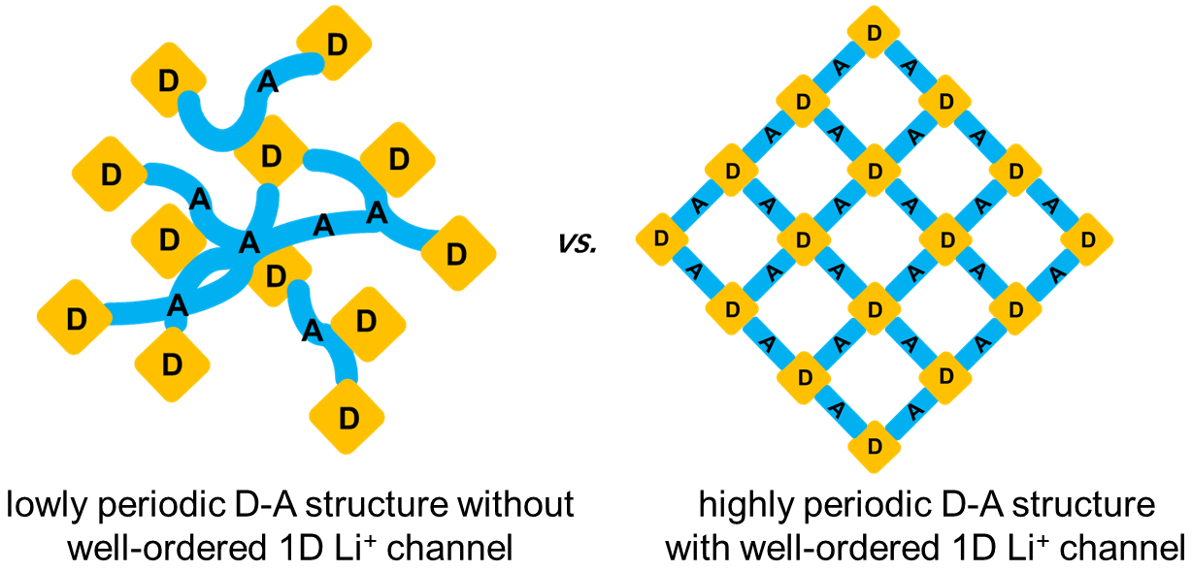
Scheme S1 Schematic illustration of lowly and highly periodic D-A strucutre

Fig. S1 The synthetic route of C-COF, N-COF and F-COF, and the electron transfer

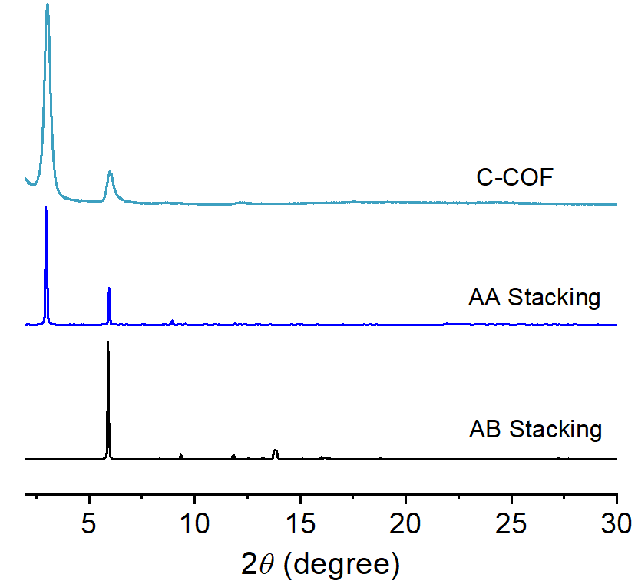
Fig. S2 Calculated PXRD patterns of AA and AB and experimental results for C-COF
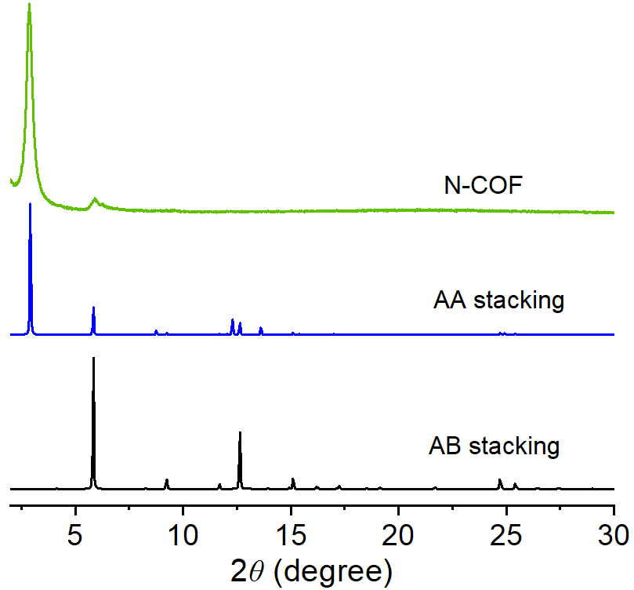
Fig. S3 Calculated PXRD patterns of AA and AB and experimental results for N-COF
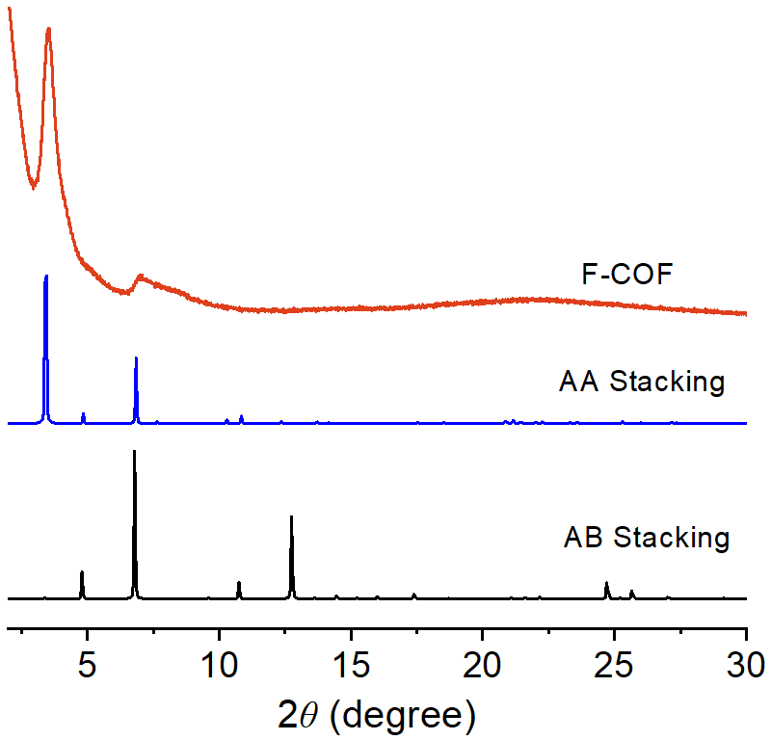
Fig. S4 Calculated PXRD patterns of AA and AB and experimental results for F-COF
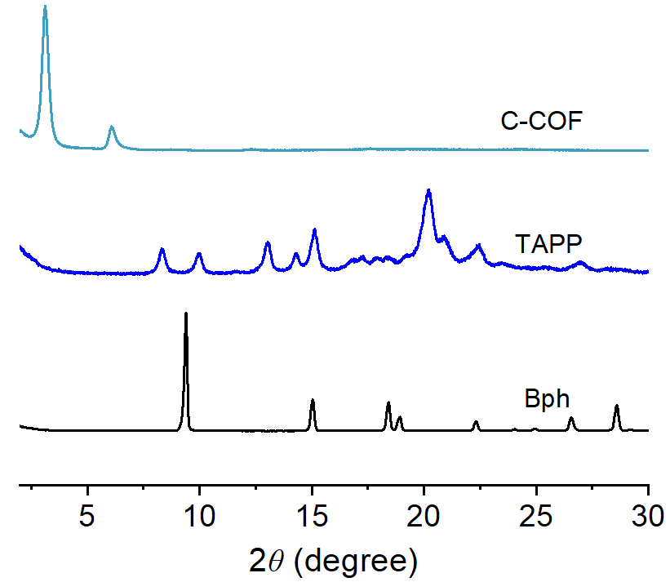
Fig. S5 PXRD patterns of synthesized C-COF and starting materials of Bph and TAPP
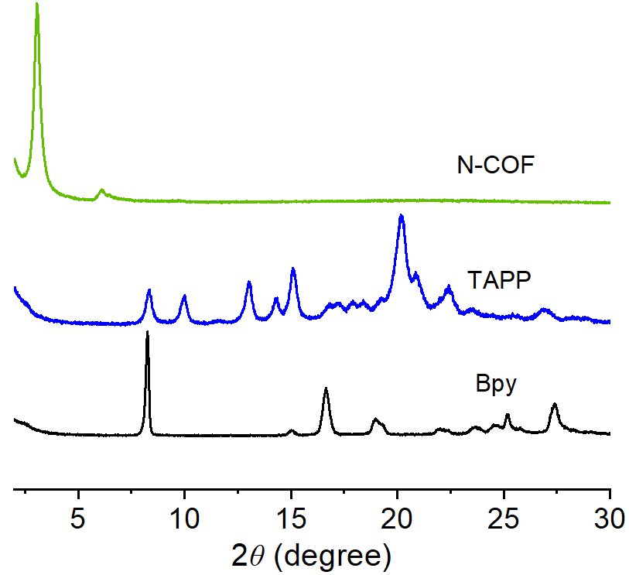
Fig. S6 PXRD patterns of synthesized N-COF and starting materials of Bpy and TAPP
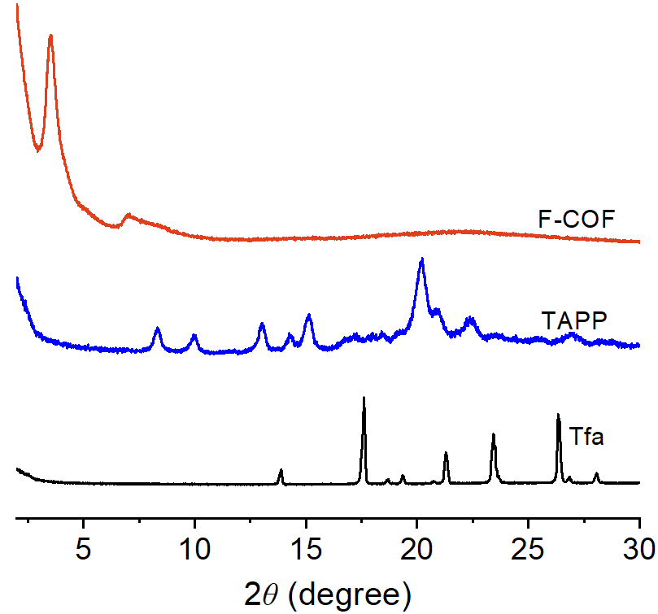
Fig. S7 PXRD patterns of synthesized F-COF and starting materials of Tfa and TAPP

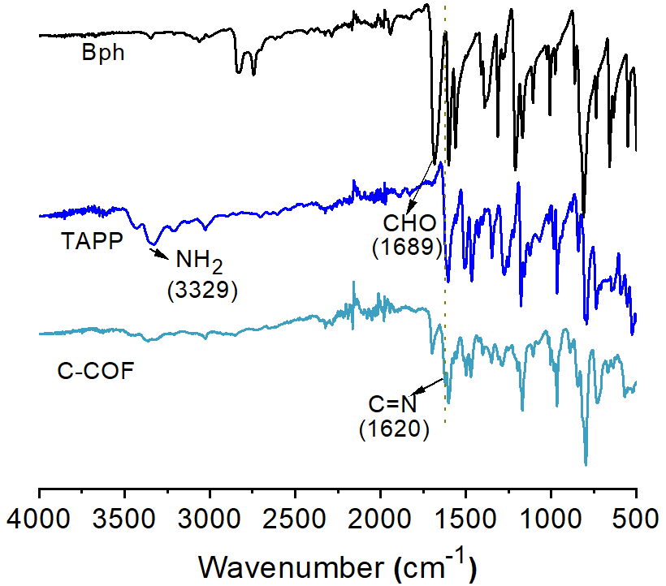
Fig. S8 FT-IR spectra of starting materials of Bph, TAPP and as-prepared C-COF, respectively

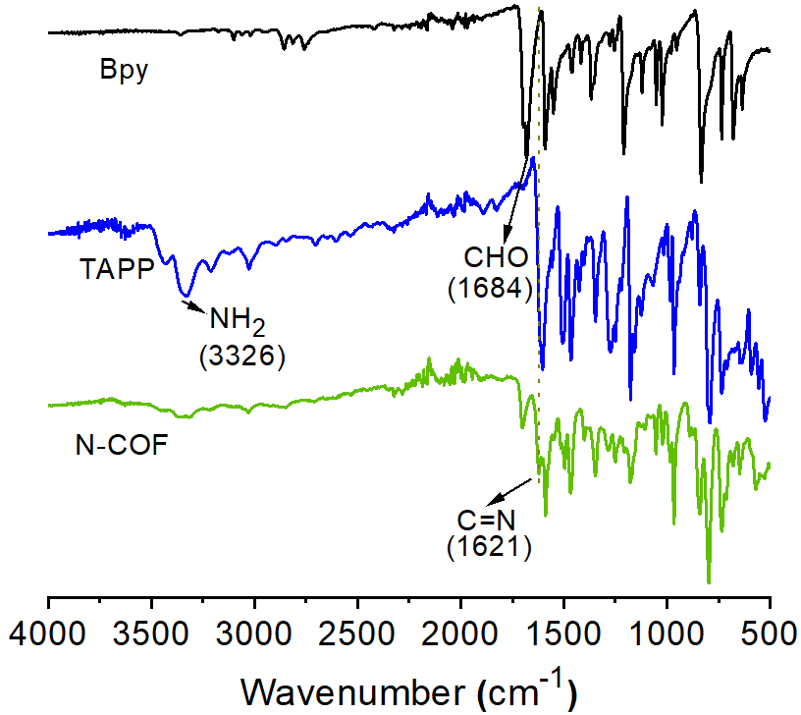
Fig. S9 FT-IR spectra of starting materials of Bpy, TAPP and as-prepared N-COF

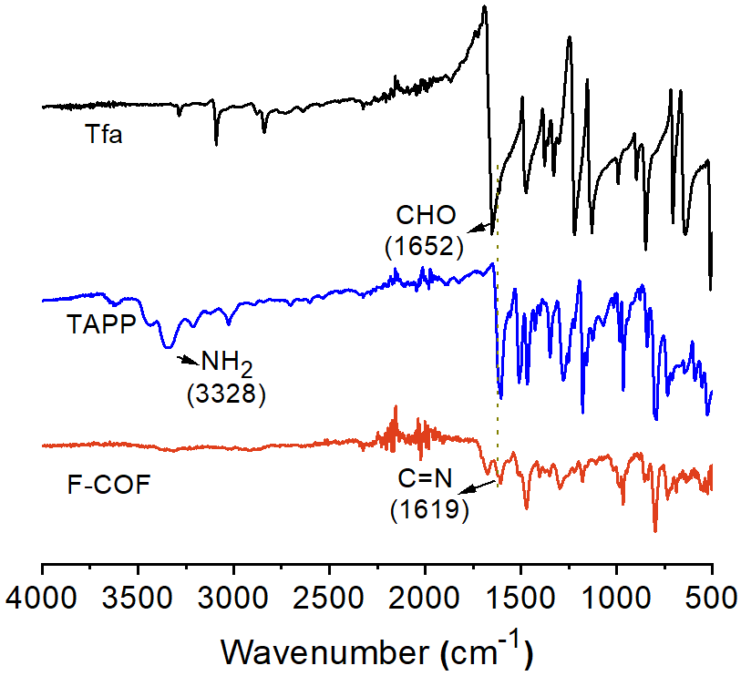
Fig. S10 FT-IR spectra of starting materials of Tfa, TAPP and as-prepared F-COF

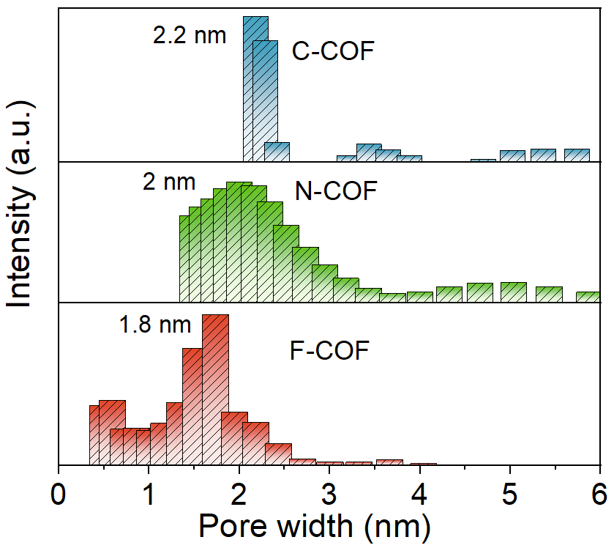
Fig. S11 Pore size distribution of C-COF, N-COF and F-COF

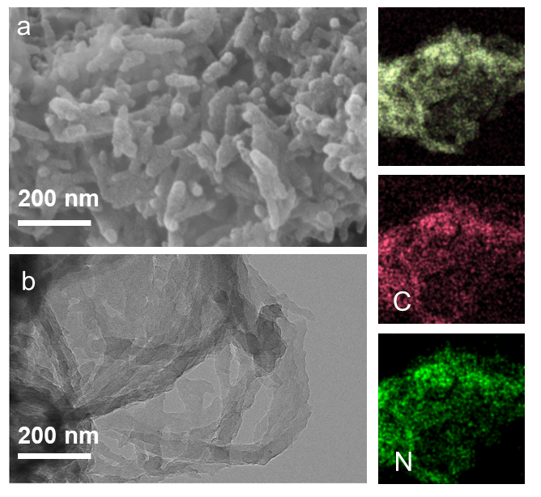
Fig. S12 SEM (a) image of C-COF, TEM (b) and EDS mapping C-COF

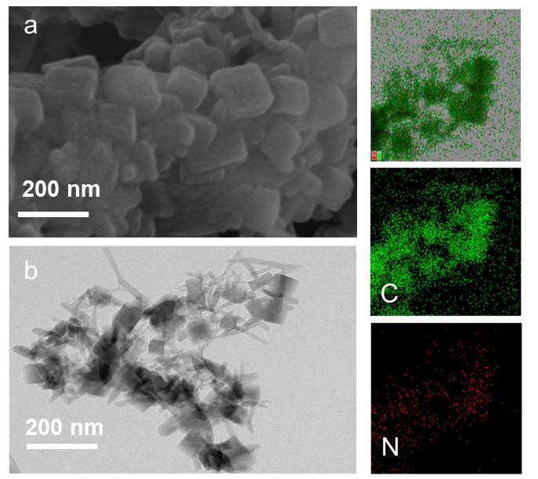
Fig. S13 SEM (a) image of C-COF, TEM (b) and EDS mapping N-COF
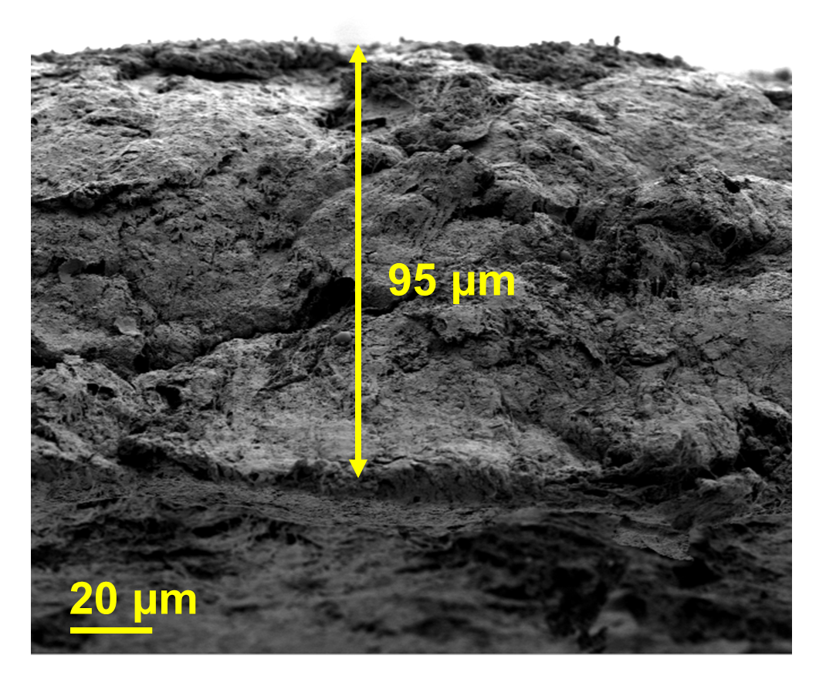
Fig. S14 Cross-sectional SEM image of F-COF SSE membrane
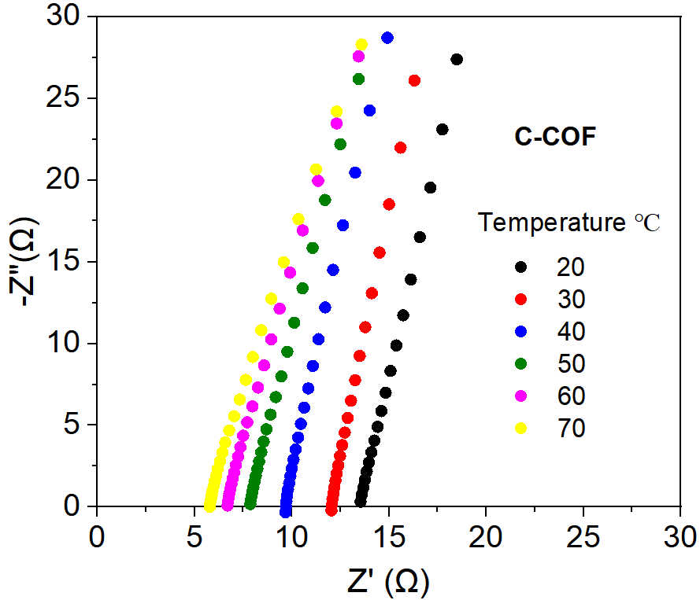
Fig. S15 EIS spectra of C-COF SSE from 20 to 70 °C
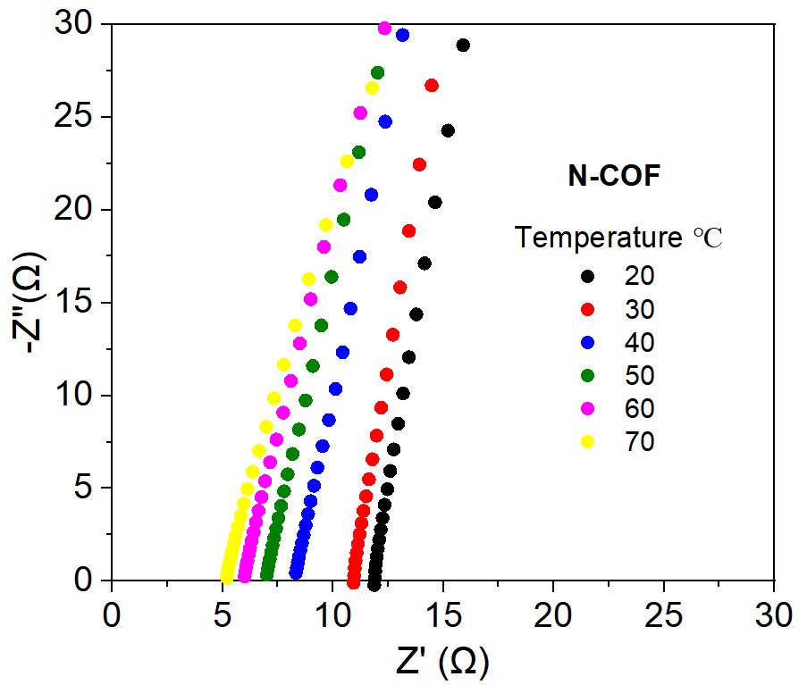
Fig. S16 EIS spectra of N-COF SSE from 20 to 70 °C
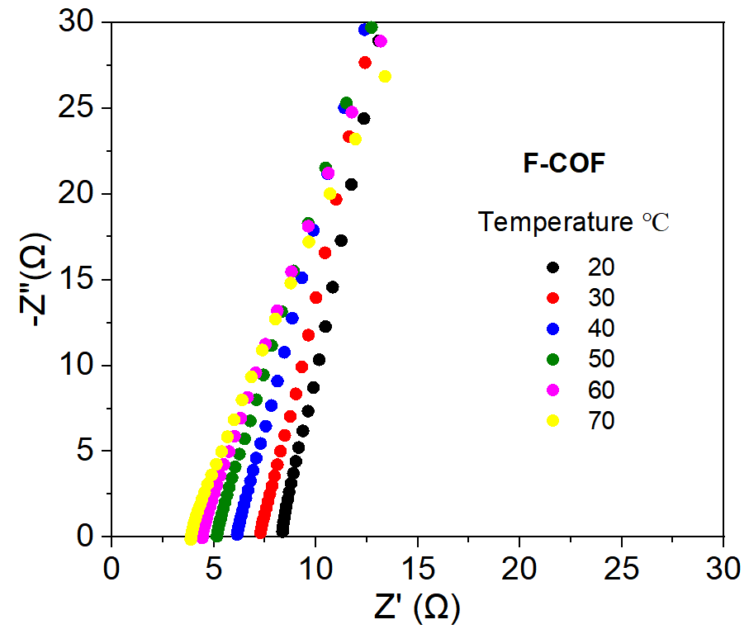
Fig. S17 EIS spectra of F-COF SSE from 20 to 70 °C
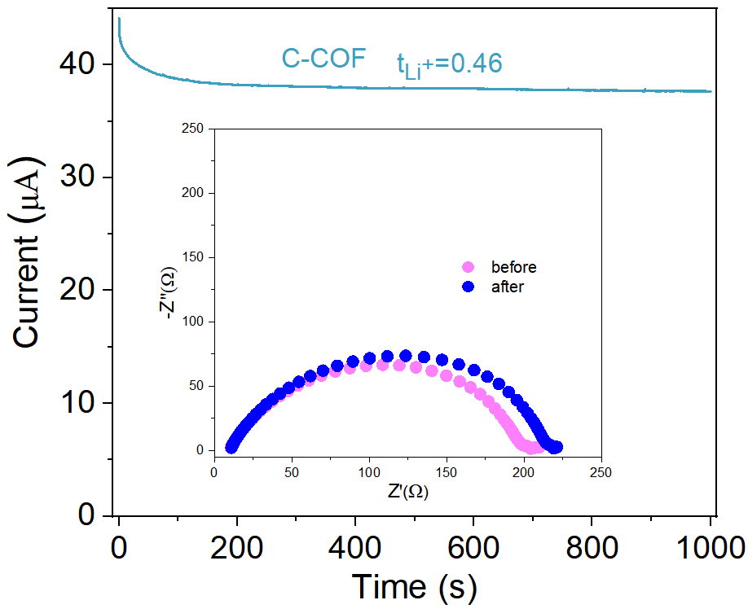
Fig. S18 Current-time curve of Li|C-COF|Li cell (inset: EIS spectra of Li|C-COF|Li cell before and after polarization
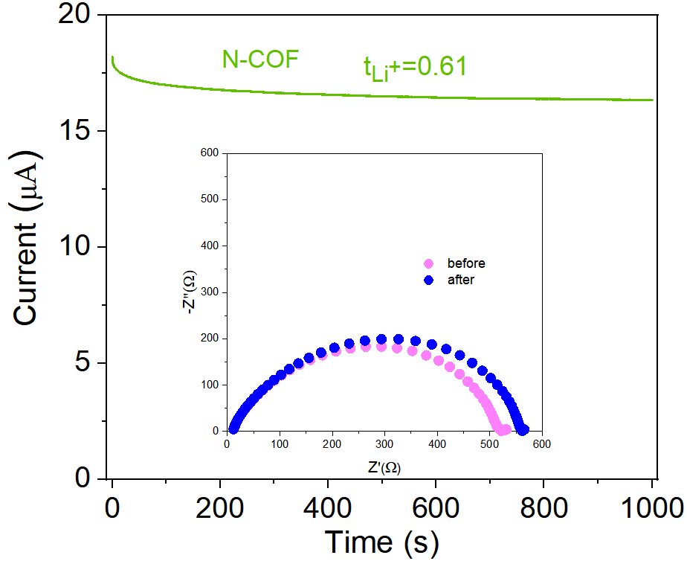
Fig. S19 Current-time curve of Li|N-COF|Li cell (inset: EIS spectra of Li|N-COF|Li cell before and after polarization
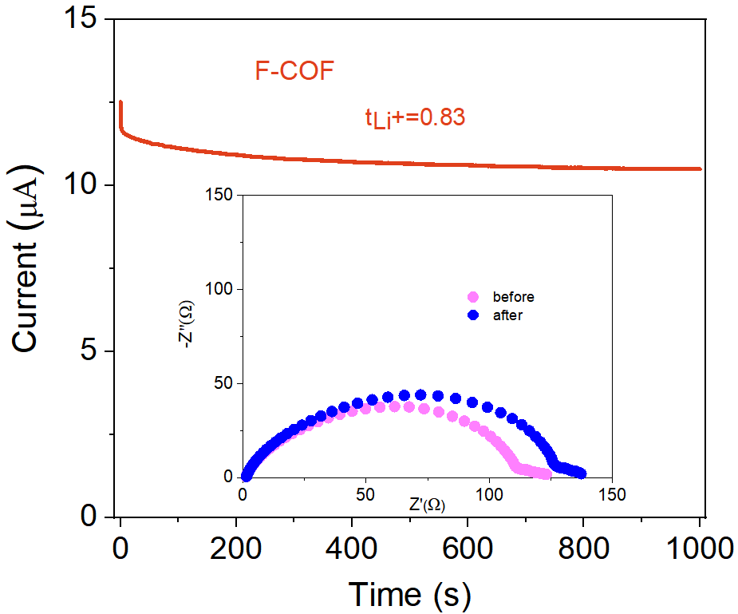
Fig. S20 Current-time curve of Li|F-COF|Li cell (inset: EIS spectra of Li|F-COF|Li cell before and after polarization
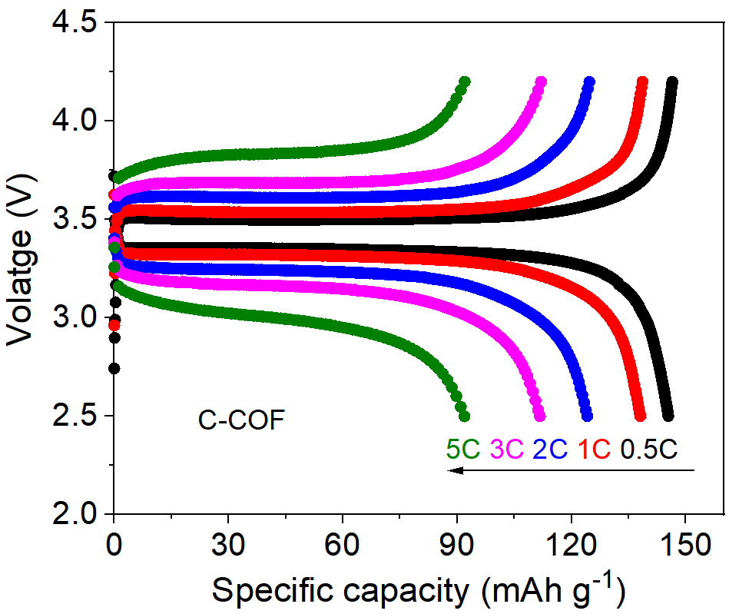
Fig. S21 The charge-discharge curves of Li|C-COF SSE|LFP quasi-solid-state battery at 0.5, 1, 2, 3 and 5C
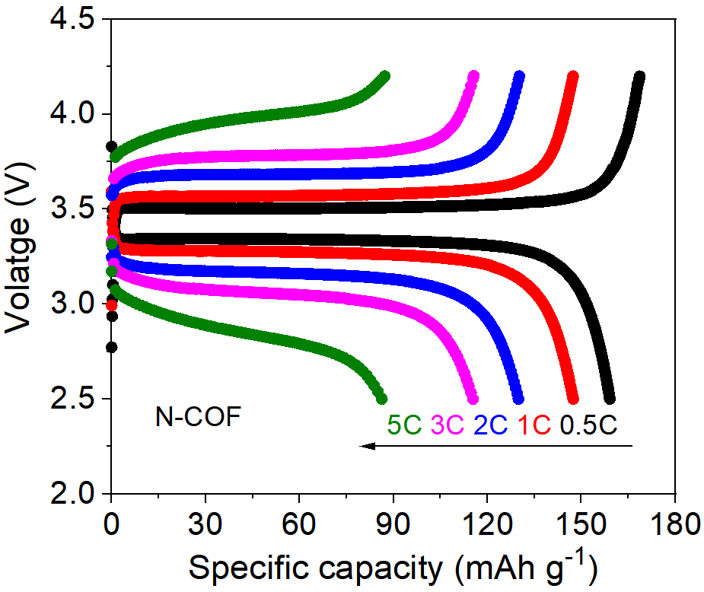
Fig. S22 The charge-discharge curves of Li|N-COF SSE|LFP quasi-solid-state battery at 0.5, 1, 2, 3 and 5C
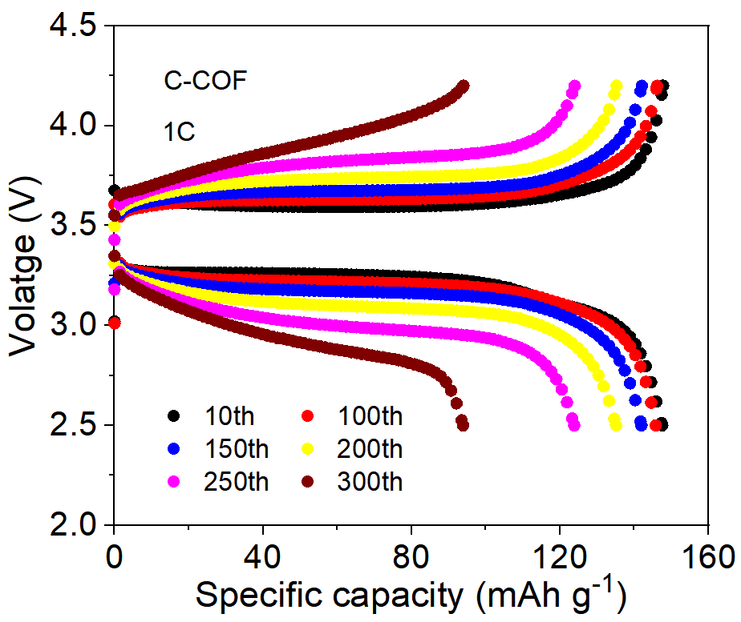
Fig. S23 The charge-discharge curves of Li|C-COF SSE|LFP quasi-solid-state battery at various cycle
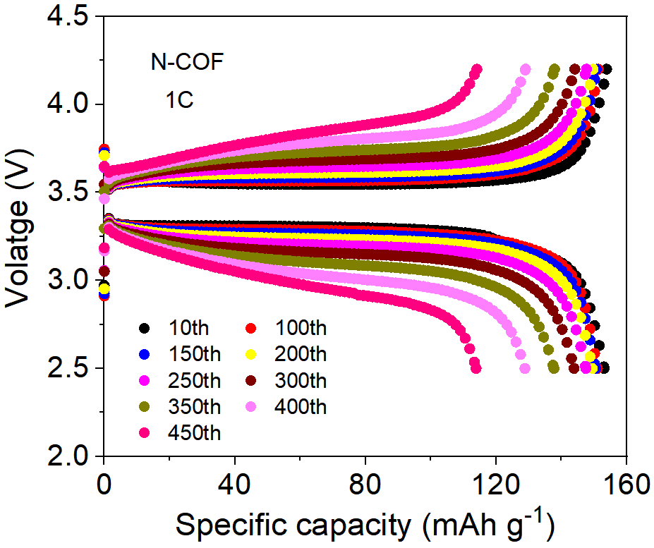
Fig. S24 The charge-discharge curves of Li|N-COF SSE|LFP quasi-solid-state battery at various cycle
Supplementary References
- G. Kresse, J. Furthmüller, Efficient iterative schemes for ab initio total-energy calculations using a plane-wave basis set. Phys. Rev. B 54, 11169 (1996). https://doi.org/10.1103/PhysRevB.54.11169
- J. P. Perdew, K. Burke, M. Ernzerhof, Generalized Gradient Approximation Made Simple. Phys. Rev. Lett. 77, 3865 (1996). https://doi.org/10.1103/PhysRevLett.77.3865
- P. E. Blochl, Phys. Rev. B: Condens. Projector augmented-wave method. Matter Mater. Phys. 50, 17953−17979 (1994). https://doi.org/10.1103/PhysRevB.50.17953
- H. Jónsson, G. Mills, K. W. Jacobsen, Nudged elastic band method for finding minimum energy paths of transitions. Proceedings of the International School of Physics, LERICI, Villa Marigola (1998). https://doi.org/10.1142/9789812839664_0016

