Supporting Information for
Defects-Rich Heterostructures Trigger Strong Polarization Coupling in Sulfides/Carbon Composites with Robust Electromagnetic Wave Absorption
Jiaolong Liu¹, SiYu Zhang¹, Dan Qu¹, Xuejiao Zhou², Moxuan Yin³, Chenxuan Wang³, Xuelin Zhang⁴, Sichen Li², Peijun Zhang¹, Yuqi Zhou¹, Mengyang Li^{1,}*, Bing Wei^{1,}*, Hongjing Wu^{5,}*
¹ School of Physics, Xidian University, Xian 710071, P. R. China
² School of Advanced Materials and Nanotechnology, State Key Discipline Laboratory of Wide Band Gap Semiconductor Technology, Xidian University, Xian 710071, P. R. China
³ School of Microelectronics, Xidian University, Xian 710071, P. R. China
⁴ School of Telecommunication Engineering, Xidian University, Xian 710071, P. R. China
⁵ MOE Key Laboratory of Material Physics and Chemistry under Extraordinary, School of Physical Science and Technology, Northwestern Polytechnical University, Xi’an 710072, P. R. China
*Corresponding authors. E-mail: limengyang@xidian.edu.cn (Mengyang Li), bwei@xidian.edu.cn (Bing Wei); wuhongjing@nwpu.edu.cn (Hongjing Wu)

Supplementary Figures and Tables
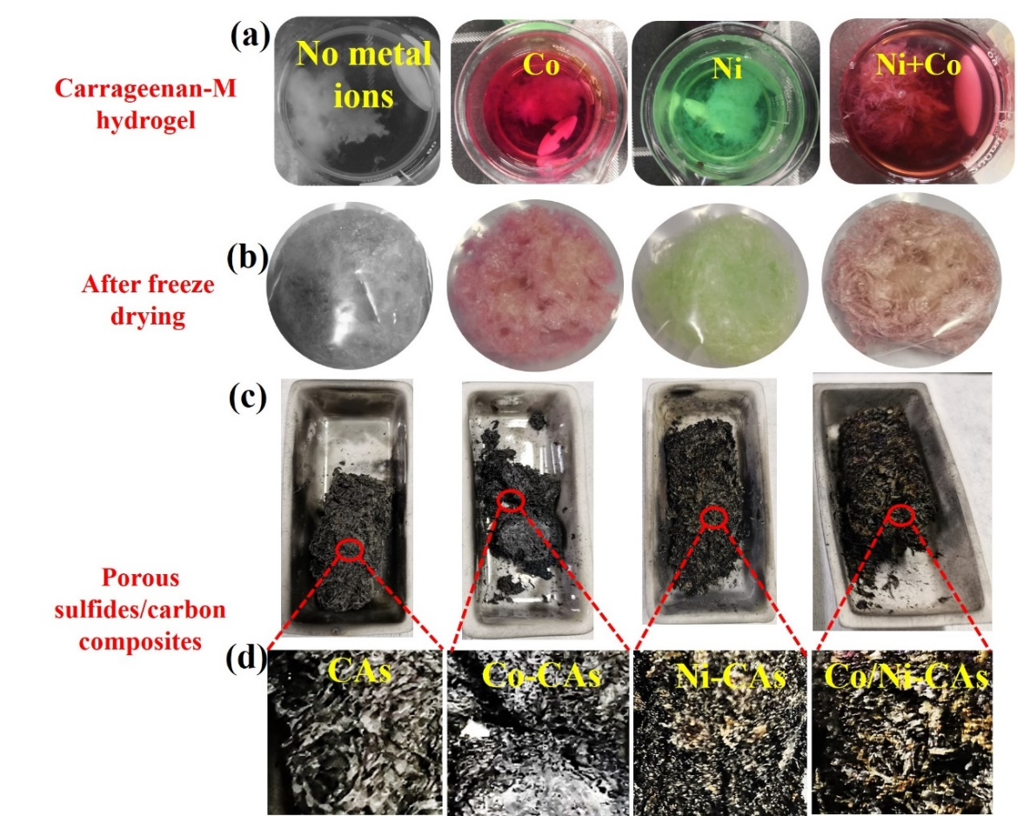
Fig. S1 Digital photographs of (a) carrageenan-M hydrogel, (b) after freeze drying; and (c, d) porous sulfides/carbon composites
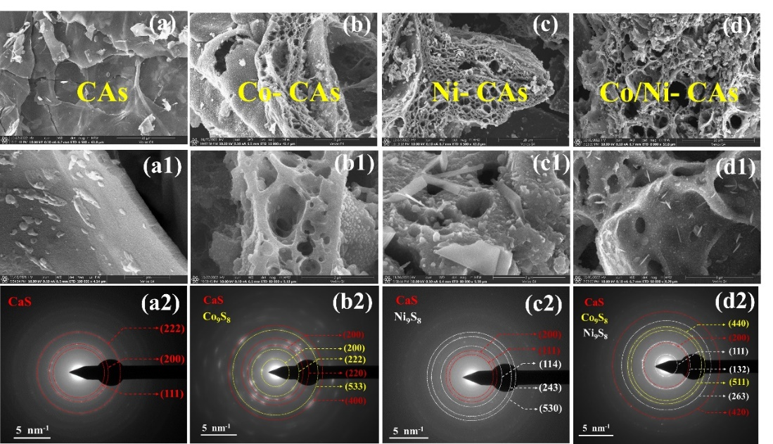
Fig. S2 SEM and SAED images for (a-a2) CAs, (b-b2) Co-CAs, (c-c2) Ni-CAs, and (d-d2) Co/Ni-CAs
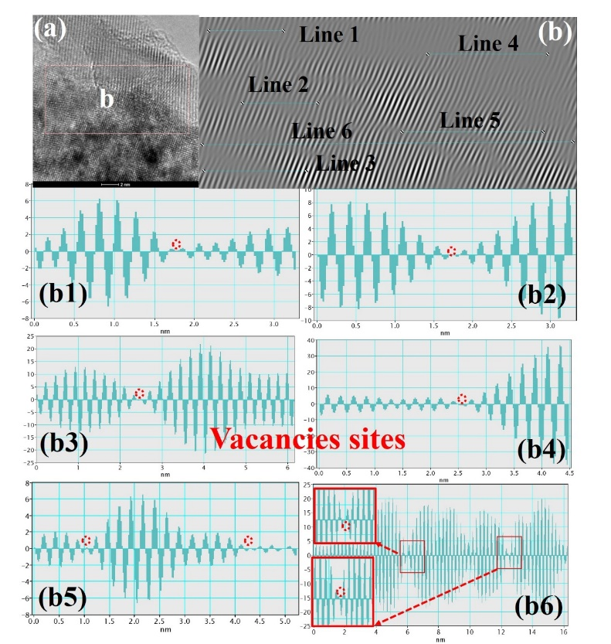
Fig. S3 (a) TEM images of Co/Ni-CAs; (b) Lattice information taken from the figure (a), showing that a number of (b1-b6) vacancy sites exist in Co₉S₈/Ni₉S₈ heterointerfaces for Co/Ni-CAs
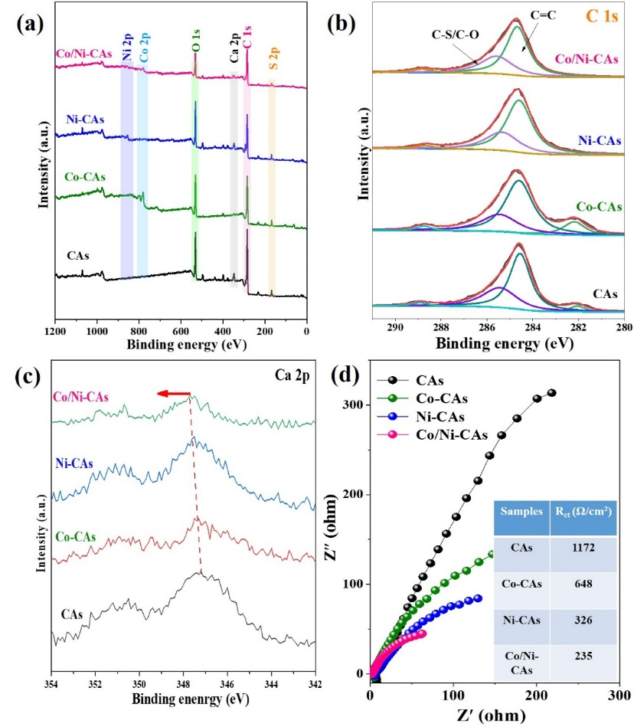
Fig. S4 XPS spectra of (a) survey, (b) C 1s and (c) Ca 2p, and (d) Nyquist plots for M-CAs and CAs
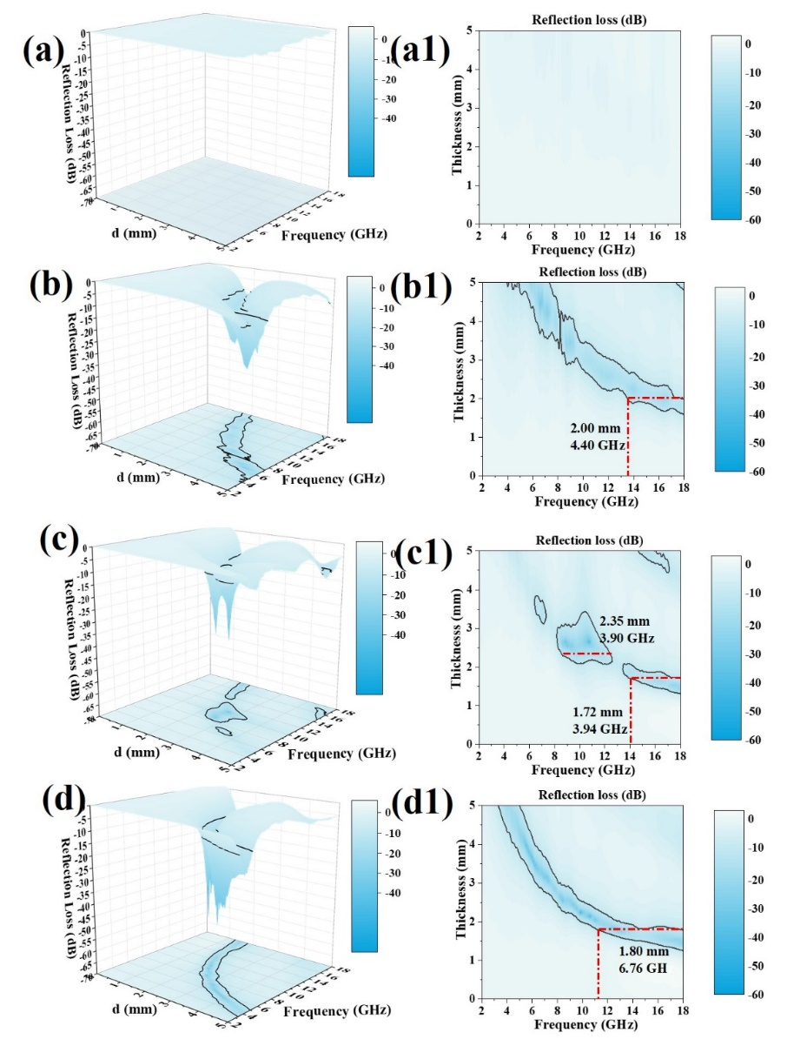
Fig. S5 EMW absorption performance of samples. (a, a1) CAs; (b, b1) Co-CAs; (c, c1) Ni-CAs; (d, d1) Co/Ni-CAs
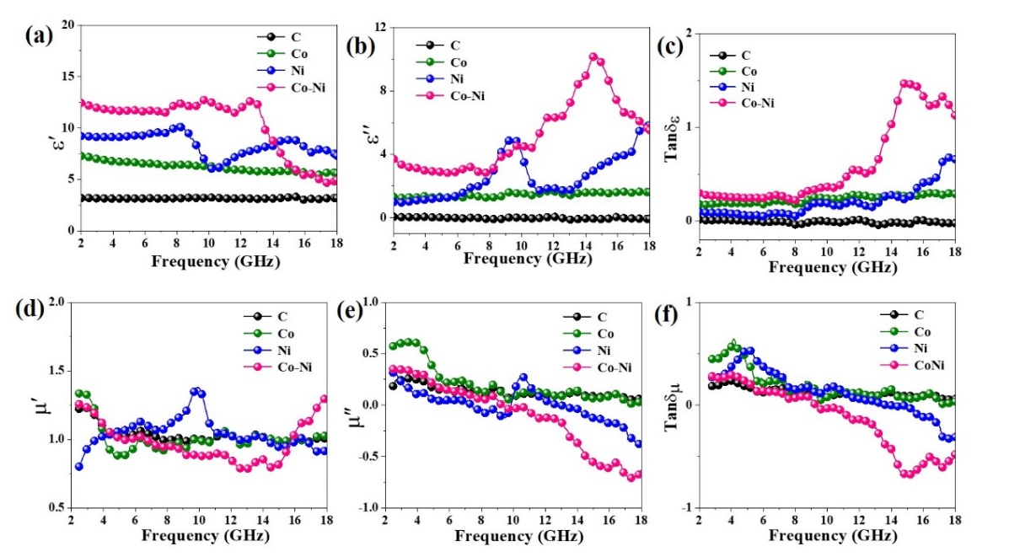
Fig. S6 EM parameters of samples. (a) ε′, (b) ε″, (c) Tanδ_{ε}, (d) μ′, (e) μ″, and (f) Tanδ_{μ}
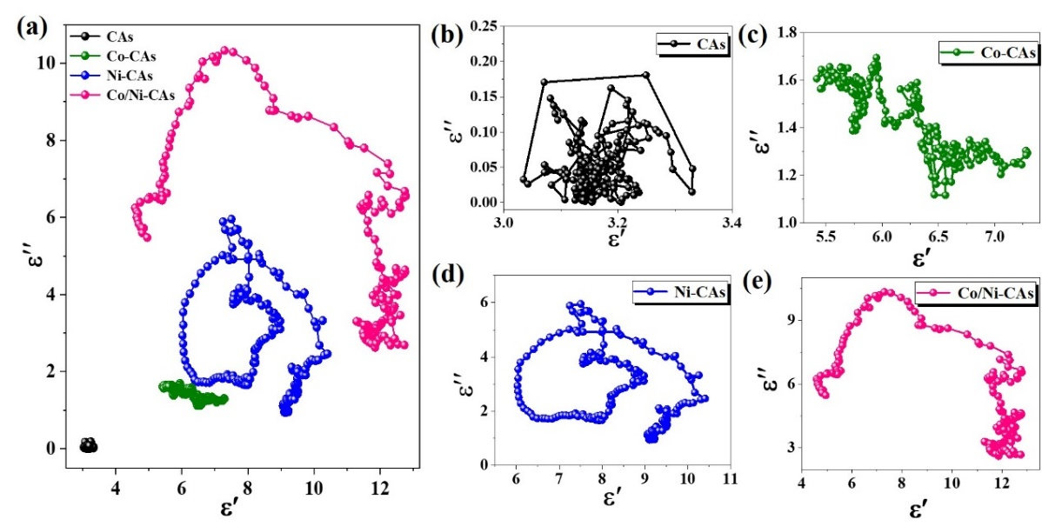
Fig. S7 (a) Cole-Cole semicircles of samples. (b) CAs, (c) Co-CAs, (d) Ni-CAs and (e) Co/Ni-CAs
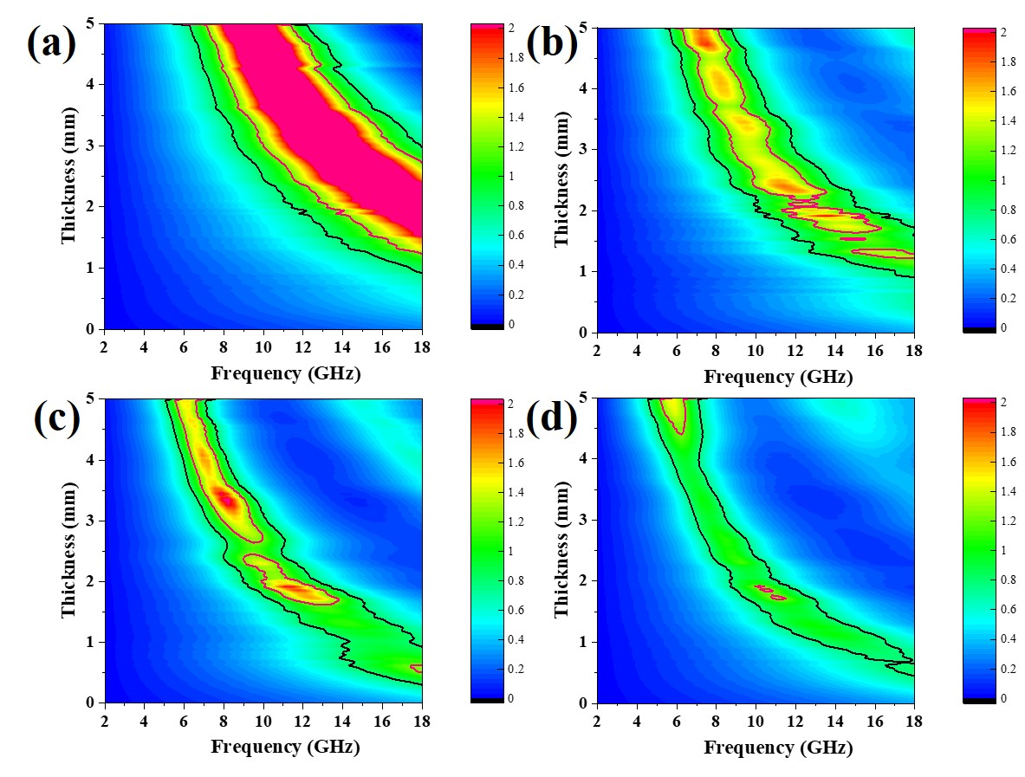
Fig. S8 (a-d) 2D plots of impedance matching degree for samples
Generally, the normalized impedance Z can measure materials’ impedance matching level, and it is appraised by following equations according to the Maxwell′s equations:
$\text{Z = |}{\text{Z}}_{\text{in }}\text{/}{\text{Z}}_{\text{0}}\text{|=}\sqrt{\frac{μ_{r}}{{\text{ε}}_{\text{r}}}}\text{tanh}\left(\text{j}\frac{\text{2πfd}}{\text{c}}\sqrt{μ_{r}{\text{ε}}_{\text{r}}} \right)$
where Z₀ and Z_{in} embody the input impedance of the air and absorber, d is the thickness of absorber, f is the frequency of an electromagnetic wave and c represent the velocity of light in a vacuum.
The larger area between Z= 0.8 (black solid lines) and Z= 1.2 (red solid lines), the better impedance matching characteristic of absorber.
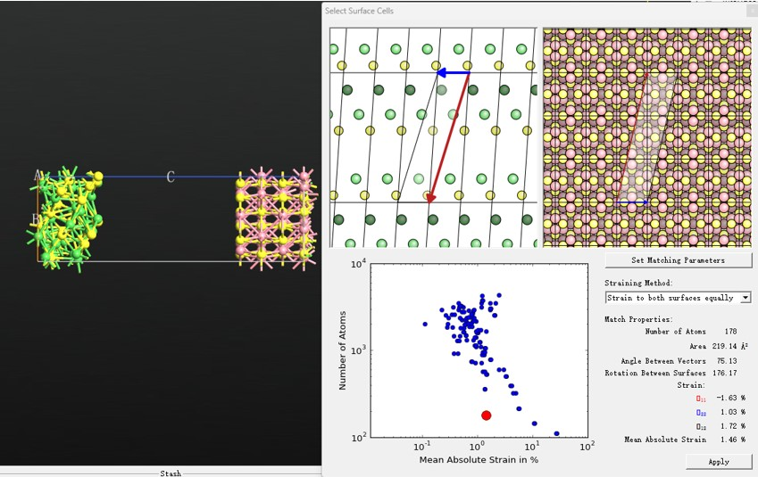
Fig. S9 Constructing Co₉S₈(220)/Ni₉S₈(114) heterointerface model by Quantum ATK software
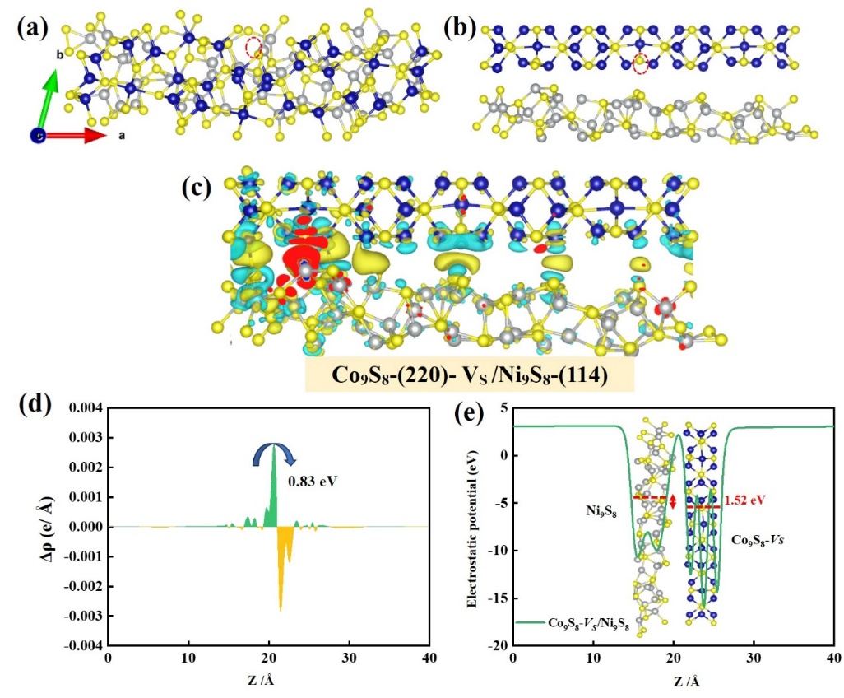
Fig. S10 (a) Front and (b) top view, (c) charge density difference as well as (d) the planar-averaged charge density difference along the Z direction Δρ(z) and (e) electrostatic potential of Co₉S₈-Vs/Ni₉S₈ models
Table S1 Phase composition of M-CAs
Samples | CAs | Co-CAs | Ni-CAs | Co/Ni-CAs
Products | CaS | CaS  Co₉S₈ | CaS  Ni₉S₈ | CaS  Ni₉S₈  Co₉S₈
Table S2 Binding energies (eV) of all samples and the shift values of binding energy of Co/Ni-CAs, Ni-CAs and Co-CAs relative to CAs
 | Binding energy of samples |  |  |  | Shift values of binding energy  relative to F-0
Samples | S 2p_{3/2}  (eV) | Co  2p_{3/2}  (eV) | Ni 2p_{3/2}  (eV) | Ca 2p_{3/2}  (eV) |  | ΔS2p_{3/2}  (eV) | ΔCo 2p_{3/2}  (eV) | ΔNi 2p_{3/2}  (eV) | ΔCa 2p_{3/2}
CAs | 162.43 | -- | -- | 347.19 | 0 |  | -- | -- | 0
Co-CAs | 162.26 | 780.23 | -- | 347.32 | -0.17 |  | 0 | -- | 0.13
Ni-CAs | 161.62 | -- | 854.56 | 347.60 | -0.81 |  | -- | 0 | 0.41
Co/Ni-CAs | 161.48 | 781.13 | 855.26 | 347.73 | -0.95 |  | 0.90 | 0.70 | 0.54
Table S3 Binding energies (eV) of S 2p and the calculated sulfur vacancy concentration, -C-S=C bond for samples
 |  |  |  |  | S 2p
 | 163.3(eV) | 162.5(eV) |  | 161.4 (eV)
Samples | -C-S=C- | S2p_{1/2} |  | S2p_{3/2} |  | S2p_{1/2}/Total (%) |  |  | -C-S=C/Total (%)
CAs | 299.6 | 559.3 |  | 987.3 |  | 30.3 |  |  | 16.2
Co-CAs | 95.6 | 163.6 |  | 252.7 |  | 32.0 |  |  | 18.7
Ni-CAs | 84.2 | 156.3 |  | 154.5 |  | 39.6 |  |  | 21.4
Co/Ni-CAs | 196.5 | 231.1 |  | 137.9 |  | 40.9 |  |  | 34.8
Table S4 Comparison of EMW absorption performance of some representative sulfides-based absorbers
Absorber |  | RL_{min} (dB) | EAB (GHz) | Matching  Thickness d (mm) | Refs.
Ni_{x}S_{y}/Co_{x}S_{y}@C | -47.20 |  | 3.70 | 2.50 | [S1]
WS₂/NiO | -53.31 |  | 4.88 | 2.22 | [S2]
ZnO/ZnS/CuS | -43.88 |  | 5.10 | 1.59 | [S3]
CuS/MXene | -45.30 |  | 5.20 | 2.00 | [S4]
NiS₂@MoS₂ | -18.13 |  | 5.17 | 1.60 | [S5]
CuCo₂S₄/C | -52.60 |  | 6.00 | 2.00 | [S6]
Cu₂S/Cu₃₁S₁₆ | -15.10 |  | 6.20 | 2.30 | [S7]
CoS₂@MoS₂/rGO | -58.00 |  | 6.24 | 2.40 | [S8]
CaS/Ni₉S₈/Co₉S₈@C | -48.30 |  | 6.76 | 1.80 | This work

Table S5 Electrostatic potential of samples
Samples | Ni₉S₈ | Co₉S₈ | electrostatic potential difference (eV)
Co₉S₈/Ni₉S₈ | -8.01 | -8.34 | 0.33
Co₉S₈/Ni₉S₈-Vs | -7.52 | -9.65 | 2.13
Co₉S₈-Vs/Ni₉S₈ | -7.998 | -9.52 | 1.52
Supplementary References
- L. Gai, G. Song, Y. Li, W. Niu, L. Qin et al., Versatile bimetal sulfides nanoparticles-embedded N-doped hierarchical carbonaceous aerogels (N-Ni_{x}Sy/CoxSy@C) for excellent supercapacitors and microwave absorption. Carbon 179, 111–124 (2021). https://doi.org/10.1016/j.carbon.2021.04.029
- D. Zhang, Y. Xiong, J. Cheng, J. Chai, T. Liu, X. Ba, S. Ullah, G. Zheng, M. Yan, M. Cao, et al., Synergetic dielectric loss and magnetic loss towards superior microwave absorption through hybridization of few-layer WS₂ nanosheets with NiO nanoparticles. Sci. Bulletin 65, 138-146 (2020). https://doi.org/10.1016/j.scib.2019.10.011
- G. Chen, L. Zhang, B. Luo, H. Wu, Optimal control of the compositions, interfaces, and defects of hollow sulfide for electromagnetic wave absorption. J. Colloid Interface Sci. 607, 24–33 (2022). https://doi.org/10.1016/j.jcis.2021.08.186
- G. Cui, L. Wang, L. Li, W. Xie, G. Gu, Synthesis of CuS nanoparticles decorated Ti₃C₂T_{x} MXene with enhanced microwave absorption performance. Prog. Nat. Sci. Mater. Int. 30, 343–351 (2020). https://doi.org/10.1016/j.pnsc.2020.06.001
- X.-J. Zhang, S.-W. Wang, G.-S. Wang, Z. Li, A.-P. Guo et al., Facile synthesis of NiS₂@MoS₂ core-shell nanospheres for effective enhancement in microwave absorption, RSC Adv. 7, 22454-22460 (2017). https://doi.org/10.1039/C7RA03260A
- Q. Ma, Z. Xu, X. Li, X. Cheng, Core-shell CuCo₂S₄ based microspheres composited with carbon black nanoparticles for effective microwave absorption, J. Alloys Compd. 938, 168577 (2023). https://doi.org/10.1016/j.jallcom.2022.168577
- W. Li, J. Chen, P. Gao, MOFs-derived hollow Copper-based sulfides for optimized electromagnetic behaviors. J. Colloid Interface Sci. 606, 719–727 (2022). https://doi.org/10.1016/j.jcis.2021.08.019
- T. Zhu, W. Shen, X. Wang, Y.-F. Song, W. Wang, Paramagnetic CoS₂@MoS₂ core-shell composites coated by reduced graphene oxide as broadband and tunable high-performance microwave absorbers. Chem. Eng. J. 378, 122159 (2019). https://doi.org/10.1016/j.cej.2019.122159

