Supporting Information for
MoS₂ Lubricate-Toughened MXene/ANF Composites for Multifunctional Electromagnetic Interference Shielding
Jiaen Wang^{1, #}, Wei Ming^{1, #}, Longfu Chen¹, Tianliang Song¹, Moxi Yele¹, Hao Zhang¹, Long Yang¹, Gegen Sarula¹, Benliang Liang^{1,} *, Luting Yan ^{1,} * and Guangsheng Wang ^{2,} *
¹ School of Physical Science and Engineering, Beijing Jiaotong University, Beijing 100044, P. R. China
² Key Laboratory of Bio-Inspired Smart Interfacial Science and Technology of Ministry of Education, School of Chemistry, Beihang University, Beijing 100191, P. R. China
#Jiaen Wang and Wei Ming contributed equally to this work.
*Corresponding authors. E-mail: blliang@bjtu.edu.cn (Benliang Liang); ltyan@bjtu.edu.cn (Luting Yan); wanggsh@buaa.edu.cn (Guangsheng Wang)
Supplementary Figures and Tables
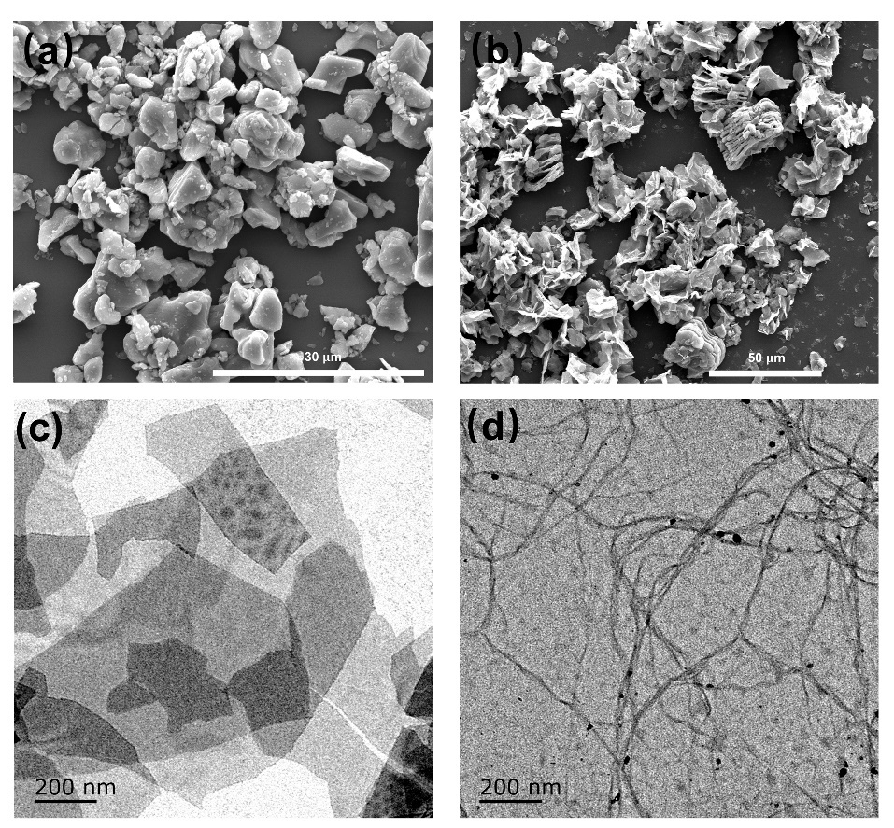
Fig. S1 (a) SEM image of Ti₃AlC₂. (b) SEM image of m-MXene. (c) TEM image of MXene. (d) TEM image of ANF
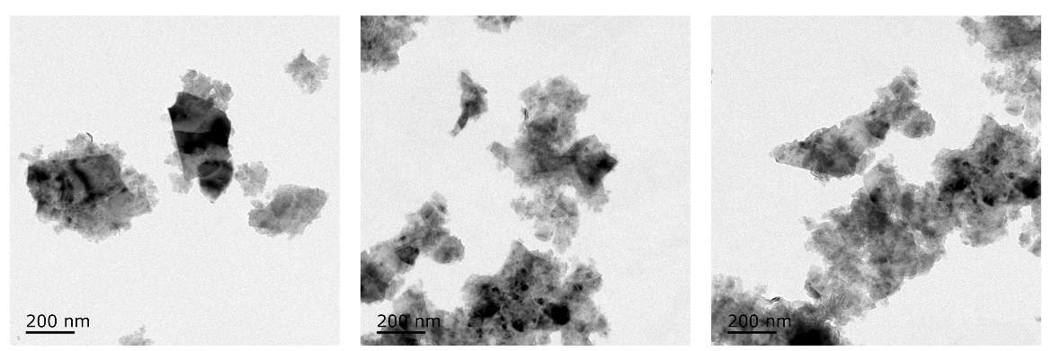
Fig. S2 TEM images of MoS₂
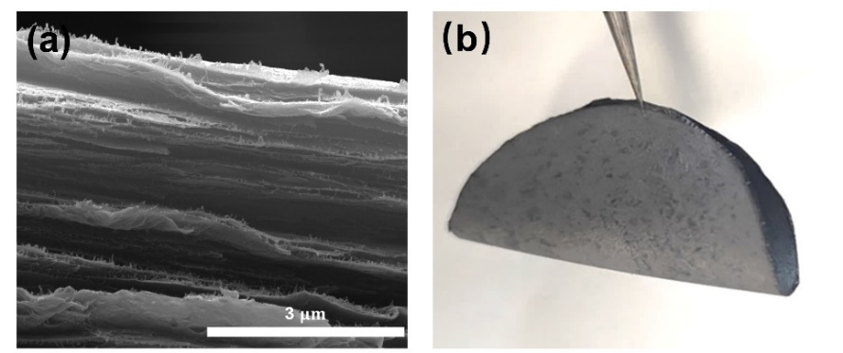
Fig. S3 (a) Cross section SEM image of ternary MXene/ANF-MoS₂ composite films. (b) Ternary MXene/ANF-MoS₂ composite film digital picture
Fig. S4 (a) XRD spectrum of MoS₂. (b) XRD spectrum of ANF-MoS₂ composite films. (c) XRD spectrum of ANF/MXene-MoS₂
Fig. S5 XPS spectrum of MoS₂
Fig. S6 Fracture cross section EDS mapping images
Fig. S7 Tensile stress-strain curves of different composite films: (a) ANF/MoS₂; (b) 2AMMO; (c) 4AMMO; (d) 5AMMO; (e) 6AMMO; (f) 7AMMO
Fig. S8 The tensile stress-strain curves of ternary MXene/ANF-MoS₂ composite films and control samples: binary MXene/ANF composite films [S1]

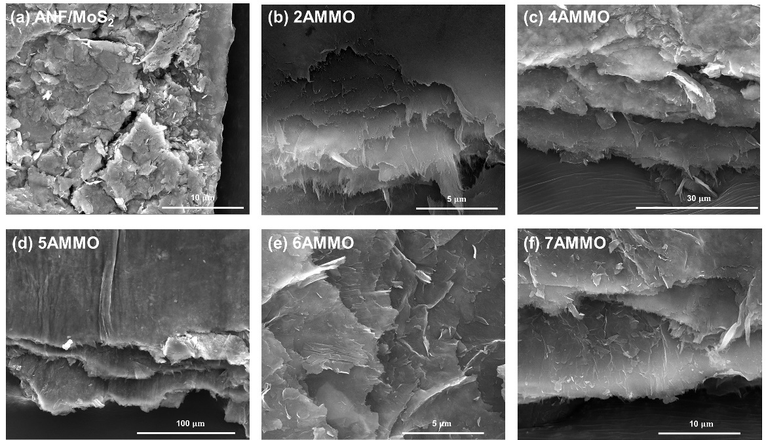
Fig. S9 Fracture surface SEM images: (a) ANF/MoS₂. (b) 2AMMO. (c) 4AMMO. (d) 5AMMO. (e) 6AMMO. (f) 7AMMO

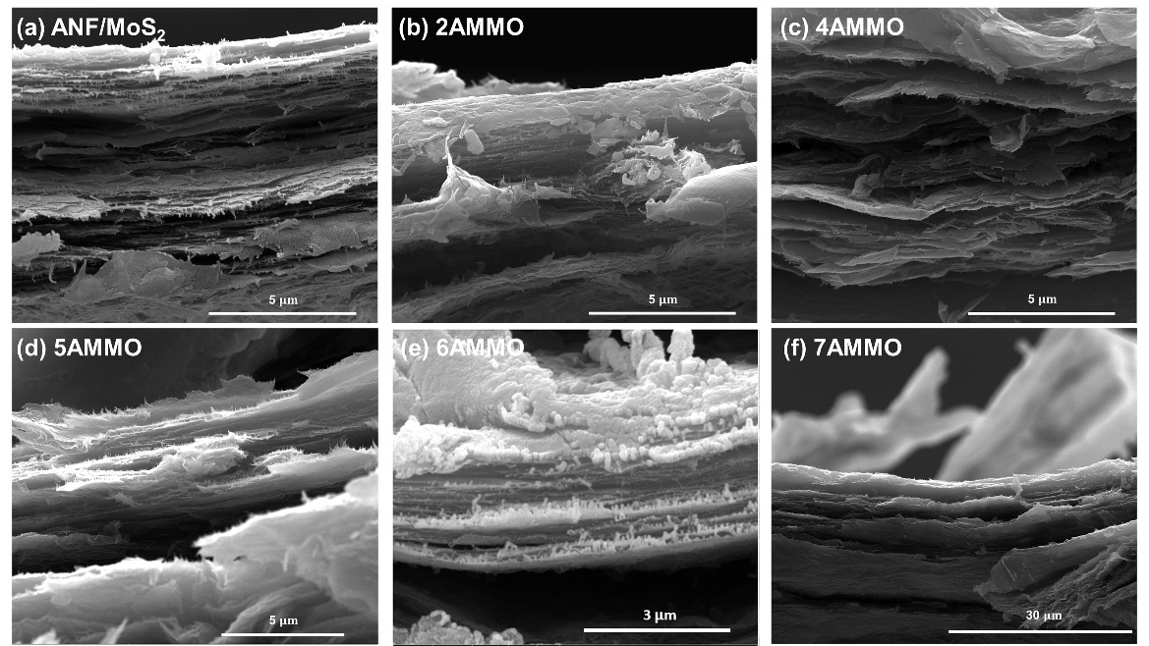
Fig. S10 Fracture cross-section SEM images: (a) ANF/MoS₂. (b) 2AMMO. (c) 4AMMO. (d) 5AMMO. (e) 6AMMO. (f) 7AMMO
Fig. S11 Fracture surface EDS mapping images
Fig. S12 Electrical conductivity of AMMO composite films
Fig. S13 EMI shielding effectiveness of ternary MXene/ANF-MoS₂ composite films in 1-18 GHz
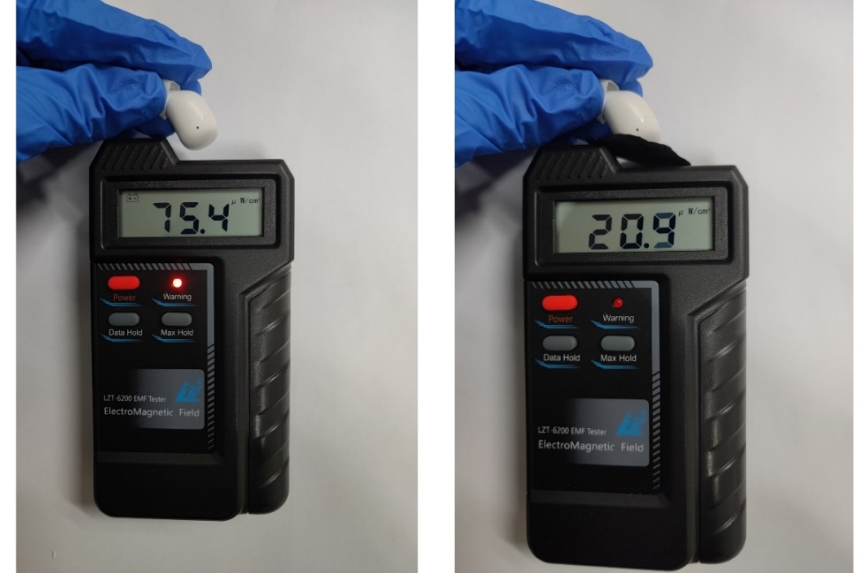
Fig. S14 EMI shielding result of a Bluetooth headset
Fig. S15 (a) I-V curve of ternary MXene/ANF-MoS₂ composite films. (b) The linear fitting of temperature and U²
Fig. S16 Infrared thermal images of ternary MXene/ANF-MoS₂ composite films under different electric heating voltages
Fig. S17 Infrared thermal images in photothermal conversion: (a) binary MXene/ANF composite films; (b) ternary MXene/ANF-MoS₂ composite films
Fig. S18 The comparison between binary 5AM and ternary 5AMMO
Table S1 The detailed additive amounts of different components in the experimental preparation process
 | MXene：ANF | MXene  (0.29 wt%) | ANF  (1 wt%) | MoS₂  (0.55 wt%) | Filler content
ANF/MoS₂ |  |  | 1.8 g | 1.4025 g | 0.3
2AMMO | 2:8 | 1.55 g | 1.8 g | 1.4025 g | 0.4041
4AMMO | 4:6 | 4.14 g | 1.8 g | 1.4025 g | 0.5228
5AMMO | 5:5 | 6.21 g | 1.8 g | 1.4025 g | 0.5883
6AMMO | 6:4 | 9.31 g | 1.8 g | 1.4025 g | 0.6585
7AMMO | 7:3 | 14.48 g | 1.8 g | 1.4025 g | 0.7341

Table S2 Mechanical performance of MXene/ANF and MXene/ANF-MoS₂ composite films
 | Tensile Strength (MPa) | Strain-to-failure (%) | Toughness (MJ∙m⁻³)
ANF | 60.02.9 | 44.03.7 | 16.82.8
2AM | 136.55.1 | 34.00.7 | 29.74.1
4AM | 140.91.8 | 26.32.5 | 20.32.1
5AM | 105.76.4 | 22.11.7 | 13.04.1
6AM | 85.54.4 | 18.31.9 | 8.81.8
7AM | 82.15.1 | 14.41.7 | 6.10.3
ANF/MoS₂ | 67.9$±$8.6 | 57.0$±$6.2 | 21.4$±$5.0
2AMMO | 181.8$±$1.4 | 32.2$±$2.4 | 36.5$±$2.6
4AMMO | 211.9$±$7.0 | 27.0$±$2.4 | 37.6$±$2.6
5AMMO | 167.3$±$9.1 | 25.8$±$0.7 | 26.3$±$0.8
6AMMO | 86.7$±$6.8 | 28.1$±$0.7 | 14.5$±$1.1
7AMMO | 68.1$±$4.4 | 24.5$±$1.6 | 9.4$±$1.0
Table S3 The comparison of toughness and strain-to-failure between ternary MXene/ANF-MoS₂ composite films and other works
Materials | Strain-to-failure (%) | Toughness (MJ$∙$m⁻³) | References
MMT/PVA-GA 70/30 | 0.33 | 0.5 | [S2]
MTM/PVA 70/30 | 1.7 | 2.1 | [S3]
MTM/CS 65/35 | 2.3 | 1.3 | [S4]
MTM/PDDA 70/30 | 2.1 | 1.4 | [S5]
MMT/CMC 20/80 | 2.6 | ~5.3 | [S6]
RGO/CS 95/5 | 10.4 | 17.7 | [S7]
RGO/MoS2-TPU 86/14 | 5.8 | 6.9 | [S8]
RGO/CS-Cu⁺ 91/9 | 4.4 | 14 | [S9]
RGO/CMC-Mn²⁺ 87/13 | 3.7 | 6.6 | [S10]
RGO/PVA 58/42 | 10.4 | 8.5 | [S11]
GO/Al₂O₃-CMC 8/92 | 5 | 8.2 | [S12]
GO/PAA 95/5 | 7.9 | 8.9 | [S13]
MTM/NFC 50/50 | 2.8 | 2.3 | [S14, S15]
MXene/NFC 50/50 | 16.7 | 14.8 | [S16]
Aminoclay/TOCN 33/67 | 11.7 | 20 | [S17]
RGO/TOCN 95/5 | 6.2 | 15.6 | [S18]
RGO/DWNT 95/5 | 7.9 | 9.2 | [S19]
Alumina/CMC/Cu²⁺  13.3/20 | ~6.8 | 17.2 | [S20]
MXene/BN-PBO 25/75 | ~9.8 | ~8 | [S21]
MXene/ANF 20/80 | 15.3 | 21.87 | [S22]
MXene/ANF 20/80 | 12.45 | 19.97 | [S23]
MXene/  heterocyclic aramid  50/50 | 6.9 | 16.29 | [S24]
CuNW/  MXene/ANF  60/40 | 18.25 | 15.59 | [S25]
Al–Ti₃C₂T_{x}/ANF  40/60 | 8.05 | 9.96 | [S26]
Ti₃C₂T_{x} /BC | 11.2 | 8.1 | [S27]
2AMMO | 32.19 | 36.54 | This  Work
4AMMO | 26.95 | 37.6 | This  Work
5AMMO | 25.78 | 26.27 | This  Work
6AMMO | 28.08 | 14.51 | This  Work
7AMMO | 24.47 | 9.44 | This  Work
Table S4 EMI SE of ternary MXene/ANF-MoS₂ composite films
 | Thickness($μ$m) | SE_{R} (dB) | SE_{A} (dB) | SE_{T} (dB)
2AMMO | 19 | 7.10 | 11.32 | 18.42
4AMMO | 20 | 13.23 | 12.64 | 25.87
5AMMO | 25 | 14.33 | 26.62 | 40.95
6AMMO | 33 | 13.88 | 30.00 | 43.88
7AMMO | 48 | 14.95 | 30.05 | 45.00
Table S5 The comparison statistic between ternary MXene/ANF-MoS₂ composite films and binary MXene/ANF composite films
Material | SE_{A}/SE_{R} | Strain-to-failure (%) | Toughness  (MJ∙m⁻³) | Electric heating  Temperature ($℃$) | Photothermal  conversion temperature ($℃$) | Reference
6AM | 1.54 | 18.80 | 8.82 | 88.6 | 43.8 | [S1]
6AMMO | 2.16 | 28.08 | 14.51 | 91.6 | 53.7 | This work

Table S6 The comparison statistic between ternary MXene/ANF-MoS₂ composite films and binary MXene/ANF composite films
Material | SE_{A}/SE_{R} | Strain-to-failure (%) | Toughness  (MJ∙m⁻³) | Tensile  strength ($℃$)) | SE_{T} ($℃$) | Reference
5AM | 1.49 | 21.86 | 12.83 | 104.65 | 40.02 | [1]
5AMMO | 1.86 | 25.78 | 26.27 | 167.30 | 40.95 | This work
Table S7 Comparison statistic about filler content, strain-to-failure and EMI SE of the MXene/ANF composite films with other reported materials.
Material | Thickness($μ$m) | Fequen-cy Range(GHz) | Filler content (wt%) | Strain-to-failure (%) | EMI SE  (dB) | Toughness  (MJ$∙$m⁻³) | Refer-ences
Ti₃C₂T_{X}/BC | 6.7 | 8.2-12.4 | 44.9 | 7.6 | 25 | - | [S28]
Ti₃C₂T_{X}/BC | 5.2 | 8.2-12.4 | 55.8 | 6.6 | 27 | - | [S28]
Ti₃C₂T_{X}/BC | 4 | 8.2-12.4 | 76.9 | 2.4 | 38 | - | [S28]
Ti₃C₂T_{X}/PEDOT:PSS | 15.2 | 8.2-12.4 | 75.0 | 1.5 | 9 | - | [S29]
Ti₃C₂T_{X}/PEDOT:PSS | 12.5 | 8.2-12.4 | 80.0 | 0.82 | 24 | - | [S29]
Ti₃C₂T_{X}/PEDOT:PSS | 6.6 | 8.2-12.5  and  11.9-18 | 70 | 0.3 | 42 | - | [S30]
Ti₃C₂T_{X}/CNF | 167 | 8.2-12.4 | 50 | 16.7 | 25 | 14.8 | [S16]
Ti₃C₂T_{X}/CNF | 74 | 8.2-12.4 | 80 | 4.9 | 26 | 2.0 | [S16]
Ti₃C₂T_{X}/CNF | 47 | 8.2-12.4 | 90 | 3.1 | 24 | 1.2 | [S16]
Ti₃C₂T_{X}/CNF | 35 | 8.2-12.4 | 52.8 | 4.3 | 41 | - | [S31]
Ti₃C₂T_{X}/PVA | - | 8-12 | 35.5 | 5.0 | 37 | - | [S32]
Ti₃C₂T_{X}/TOCNF | 33 | 8.2-12.4 | 30 | 3.6 | 29 | 4.1 | [S33]
Ti₃C₂T_{X}/TOCNF | 38 | 8.2-12.4 | 50 | 2.1 | 35 | 1.7 | [S33]
PIF/ Ti₃C₂T_{X} | - | 8.2-12.4 | 13.8 | 10 | 22 | - | [S34]
PIF/ Ti₃C₂T_{X} | 256 | 8.2-12.4 | 49.1 | 3 | 40 | - | [S34]
Ti₃C₂T_{X} /cellulose | - | 8.2-12.4 | 20.0 | 4 | 34.9 | - | [S35]
PVDF/Ti₃C₂T_{X}/AgNWs | 300 | 8.2-12.4 | 15 | 9.47 | 25 | - | [S36]
Ti₃C₂T_{X} /BCNFs | 11.4 | 8.2-12.4 | 50 | 2.6 | 42 | - | [S37]
Ti₃C₂T_{X} /BCNFs | - | 8.2-12.4 | 87.5 | 1.4 | 54 | - | [S37]
Ti₃C₂T_{X} /SA/Ca²⁺ | 2.8 | 0.3-18 | 80 | 3.8 | 46 | - | [S38]
MXene/BC/APP | - | 8.2-12.4 | 80 | 4.3 | 41 | 2.9 | [S39]
MXene/ heterocyclic aramid | 16 | 8.2-12.4 | 50 | 6.9 | 25.9 | 16.29 | [S24]
MXene/ heterocyclic aramid | 14.4 | 8.2-12.4 | 60 | 3.51 | 34.2 | 5.81 | [S24]
Al–Ti₃C₂T_{x}/ANF | - | 8.2-12.4 | 40 | 8.05 | 39.1 | 9.96 | [S26]
Ti₃C₂T_{x} /BC | - | 8.2-12.4 | 50 | 11.2 | 43.7 | 8.1 | [S27]
f-Ti₃C₂T_{x} /PNFs | 1705 | 8.2-12.4 | 50 | 16 | 28 | - | [S40]
MXene/MMT-CNF | - | 8.2-12.4 | 30 | 7 | 45 | - | [S41]
MXeneAgNW-CNF | 26 | 8.2-12.4 | 30 | 5.5 | 44 | - | [S42]
Ti₃C₂T_{X} /CMC | 3 | 0.3-18 | 90 | 4.5 | 53 | - | [S43]
Ti₃C₂T_{X} /ANF | 5.1 | 8.2-12.4 | 20 | 7 | 13 | 11 | [S44]
Ti₃C₂T_{X} /ANF | 4.5 | 8.2-12.4 | 40 | 2.8 | 28 | 4.5 | [S44]
Ti₃C₂T_{X} /ANF | 3.9 | 8.2-12.4 | 60 | 1.5 | 33 | 2 | [S44]
Ti₃C₂T_{X} /ANF | 3.2 | 8.2-12.4 | 80 | 1.7 | 39 | 1.8 | [S44]
Ti₃C₂T_{X} /ANF | 23 | 8.2-12.4 | 20 | 8.45 | 12.74 | - | [S45]
Ti₃C₂T_{X} /ANF | 22 | 8.2-12.4 | 40 | 7.23 | 19.43 | - | [S45]
Ti₃C₂T_{X} /ANF | 20 | 8.2-12.4 | 60 | 2.20 | 28.54 | - | [S45]
Ti₃C₂T_{X} /ANF | 17 | 8.2-12.4 | 80 | 1.80 | 30.0 | - | [S45]
Ti₃C₂T_{X} /ANF | - | 8.2-12.4 | 20 | 3.3 | 8 | 5.1 | [S46]
Ti₃C₂T_{X} /ANF | - | 8.2-12.4 | 40 | 3.0 | 26 | 5.3 | [S46]
Ti₃C₂T_{X} /ANF | - | 8.2-12.4 | 60 | 1.74 | 35 | 1.2 | [S46]
Ti₃C₂T_{X} /ANF | - | 8.2-12.4 | 80 | 1.75 | 42 | 1.1 | [S46]
Ti₃C₂T_{X} /ANF | 12 | 8.2-12.4 | 10 | 13.3 | 27 | 13.7 | [S47]
Ti₃C₂T_{X} /ANF | 12 | 8.2-12.4 | 20 | 11.9 | 30 | 9.5 | [S47]
Ti₃C₂T_{X} /ANF | 9 | 8.2-12.4 | 30 | 12.4 | 33 | 9.9 | [S47]
Ti₃C₂T_{X} /ANF | 9 | 8.2-12.4 | 40 | 8.1 | 41 | 6.3 | [S47]
Ti₃C₂T_{X} /ANF | - | 8.2-12.4 | 20 | 15.30 | 8 | 21.87 | [S22]
Ti₃C₂T_{X} /ANF | - | 8.2-12.4 | 40 | 7.52 | 19 | 13.39 | [S22]
Ti₃C₂T_{X} /ANF | 40 | 8.2-12.4 | 60 | 5.41 | 39 | 6.01 | [S22]
Ti₃C₂T_{X} /ANF | 37 | 8.2-12.4 | 80 | 3.26 | 50 | 2.37 | [S22]
Ti₃C₂T_{X} /ANF | 10 | 8.2-12.4 | 20 | 12.45 | 24.17 | 19.97 | [S23]
Ti₃C₂T_{X} /ANF | 12 | 8.2-12.4 | 40 | 7.17 | 35.09 | 17.35 | [S23]
Ti₃C₂T_{X} /ANF | 15 | 8.2-12.4 | 60 | 5.25 | 46.89 | 7.71 | [S23]
Ti₃C₂T_{X} /ANF | 28 | 8.2-12.4 | 80 | 5.03 | 53.48 | 5.77 | [S23]
Pure MXene | 3.4 | 0.3-18 | 100 | 2.26 | 60.9 | - | [S43]
This work | 19 | 8.2-12.4 | 40.42 | 32.19 | 18.42 | 36.54
This work | 20 | 8.2-12.4 | 52.28 | 26.95 | 25.87 | 37.6
This work | 33 | 8.2-12.4 | 65.85 | 28.08 | 43.88 | 14.51
This work | 48 | 8.2-12.4 | 73.41 | 24.47 | 45.00 | 9.44
Supplementary References
- J. Wang, T. Song, W. Ming, M. Yele, L. Chen et al., High MXene loading, nacre-inspired MXene/ANF electromagnetic interference shielding composite films with ultralong strain-to-failure and excellent joule heating performance. Nano Res. 17, 2061-2069 (2024). https://doi.org/10.1007/s12274-023-6232-y
- P. Podsiadlo, A. K. Kaushik, E. M. Arruda, A. M. Waas, B. S. Shim et al., Ultrastrong and stiff layered polymer nanocomposites. Science 318, 80-83 (2007). https://doi.org/10.1126/science.1143176
- A. Walther, I. Bjurhager, J.-M. Malho, J. Pere, J. Ruokolainen et al., Large-area, lightweight and thick biomimetic composites with superior material properties via fast, economic, and green pathways. Nano Lett. 10, 2742-2748 (2010). https://doi.org/10.1021/nl1003224
- H.-B. Yao, Z.-H. Tan, H.-Y. Fang, S.-H. Yu, Artificial nacre-like bionanocomposite films from the self-assembly of chitosan–montmorillonite hybrid building blocks. Angew. Chem. Int. Ed. 49, 10127-10131 (2010). https://doi.org/10.1002/anie.201004748
- A. Walther, I. Bjurhager, J.-M. Malho, J. Ruokolainen, L. Berglund et al., Supramolecular control of stiffness and strength in lightweight high-performance nacre-mimetic paper with fire-shielding properties. Angew. Chem. Int. Ed. 49, 6448-6453 (2010). https://doi.org/10.1002/anie.201001577
- P. Das, S. Schipmann, J.-M. Malho, B. Zhu, U. Klemradt et al., Facile access to large-scale, self-assembled, nacre-inspired, high-performance materials with tunable nanoscale periodicities. ACS Appl. Mater. Interfaces 5, 3738-3747 (2013). https://doi.org/10.1021/am400350q
- S. Wan, J. Peng, Y. Li, H. Hu, L. Jiang et al., Use of synergistic interactions to fabricate strong, tough, and conductive artificial nacre based on graphene oxide and chitosan. ACS Nano 9, 9830-9836 (2015). https://doi.org/10.1021/acsnano.5b02902
- S. Wan, Y. Li, J. Peng, H. Hu, Q. Cheng et al., Synergistic toughening of graphene oxide–molybdenum disulfide–thermoplastic polyurethane ternary artificial nacre. ACS Nano 9, 708-714 (2015). https://doi.org/10.1021/nn506148w
- Y. Cheng, J. Peng, H. Xu, Q. Cheng, Glycera-inspired synergistic interfacial interactions for constructing ultrastrong graphene-based nanocomposites. Adv. Funct. Mater. 28, 1800924 (2018). https://doi.org/10.1002/adfm.201800924
- S. Gong, Q. Zhang, R. Wang, L. Jiang, Q. Cheng, Synergistically toughening nacre-like graphene nanocomposites via gel-film transformation. J. Mater. Chem. A 5, 16386-16392 (2017). https://doi.org/10.1039/C7TA03535G
- N. Zhao, M. Yang, Q. Zhao, W. Gao, T. Xie et al., Superstretchable nacre-mimetic graphene/poly(vinyl alcohol) composite film based on interfacial architectural engineering. ACS Nano 11, 4777-4784 (2017). https://doi.org/10.1021/acsnano.7b01089
- H. Zhao, Y. Yue, Y. Zhang, L. Li, L. Guo, Ternary artificial nacre reinforced by ultrathin amorphous alumina with exceptional mechanical properties. Adv. Mater. 28, 2037-2042 (2016). https://doi.org/10.1002/adma.201505511
- S. Wan, H. Hu, J. Peng, Y. Li, Y. Fan et al., Nacre-inspired integrated strong and tough reduced graphene oxide–poly(acrylic acid) nanocomposites. Nanoscale 8, 5649-5656 (2016). https://doi.org/10.1039/C6NR00562D
- A. Liu, A. Walther, O. Ikkala, L. Belova, L. A. Berglund, Clay nanopaper with tough cellulose nanofiber matrix for fire retardancy and gas barrier functions. Biomacromolecules 12, 633-641 (2011). https://doi.org/10.1021/bm101296z
- H. Sehaqui, A. Liu, Q. Zhou, L. A. Berglund, Fast preparation procedure for large, flat cellulose and cellulose/inorganic nanopaper structures. Biomacromolecules 11, 2195-2198 (2010). https://doi.org/10.1021/bm100490s
- W.-T. Cao, F.-F. Chen, Y.-J. Zhu, Y.-G. Zhang, Y.-Y. Jiang et al., Binary strengthening and toughening of MXene/cellulose nanofiber composite paper with nacre-inspired structure and superior electromagnetic interference shielding properties. ACS Nano 12, 4583-4593 (2018). https://doi.org/10.1021/acsnano.8b00997
- Y. Liu, S.-H. Yu, L. Bergström, Transparent and flexible nacre-like hybrid films of aminoclays and carboxylated cellulose nanofibrils. Adv. Funct. Mater. 28, 1703277 (2018). https://doi.org/10.1002/adfm.201703277
- Y. Wen, M. Wu, M. Zhang, C. Li, G. Shi, Topological design of ultrastrong and highly conductive graphene films. Adv. Mater. 29, 1702831 (2017). https://doi.org/10.1002/adma.201702831
- S. Gong, W. Cui, Q. Zhang, A. Cao, L. Jiang et al., Integrated ternary bioinspired nanocomposites via synergistic toughening of reduced graphene oxide and double-walled carbon nanotubes. ACS Nano 9, 11568-11573 (2015). https://doi.org/10.1021/acsnano.5b05252
- H. Li, X. Dai, X. Han, J. Wang, Molecular orientation-regulated bioinspired multilayer composites with largely enhanced mechanical properties. ACS Appl. Mater. Interfaces 15, 21467-21475 (2023). https://doi.org/10.1021/acsami.3c01647
- Y. Liu, N. Zhao, J. Xu, Mechanically strong and flame-retardant PBO/BN/MXene nanocomposite paper with low thermal expansion coefficient, for efficient EMI shielding and heat dissipation. Adv. Fiber Mater. 5, 1657-1670 (2023). https://doi.org/10.1007/s42765-023-00298-0
- J. Wang, X. Ma, J. Zhou, F. Du, C. Teng, Bioinspired, high-strength, and flexible MXene/aramid fiber for electromagnetic interference shielding papers with joule heating performance. ACS Nano 16, 6700-6711 (2022). https://doi.org/10.1021/acsnano.2c01323
- C. Liu, Y. Ma, Y. Xie, J. Zou, H. Wu et al., Enhanced electromagnetic shielding and thermal management properties in MXene/aramid nanofiber films fabricated by intermittent filtration. ACS Appl. Mater. Interfaces 15, 4516-4526 (2023). https://doi.org/10.1021/acsami.2c20101
- J. Xiong, R. Ding, Z. Liu, H. Zheng, P. Li et al., High-strength, super-tough, and durable nacre-inspired MXene/heterocyclic aramid nanocomposite films for electromagnetic interference shielding and thermal management. Chem. Eng. J. 474, 145972 (2023). https://doi.org/10.1016/j.cej.2023.145972
- F. Jia, J. Dong, X. Dai, Y. Liu, H. Wang et al., Robust, flexible, and stable CuNWs/MXene/ANFs hybrid film constructed by structural assemble strategy for efficient EMI shielding. Chem. Eng. J. 452, 139395 (2023). https://doi.org/10.1016/j.cej.2022.139395
- J. Wang, R. Zhai, X. Ma, W. Liu, C. Teng, Large flakes of Al–Ti₃C₂t_{x} MXene constructing highly ordered layered MXene/ANF films with integrated multifunctionalities. Ceram. Int. 50, 11379-11391 (2024). https://doi.org/10.1016/j.ceramint.2024.01.038
- H. Liu, Z. Cui, L. Luo, Q. Liao, R. Xiong et al., Facile fabrication of flexible and ultrathin self-assembled Ti₃C₂t_{x}/bacterial cellulose composite films with multifunctional electromagnetic shielding and photothermal conversion performances. Chem. Eng. J. 454, 140288 (2023). https://doi.org/10.1016/j.cej.2022.140288
- Y. Wan, P. Xiong, J. Liu, F. Feng, X. Xun et al., Ultrathin, strong, and highly flexible Ti₃C₂t_{x} MXene/bacterial cellulose composite films for high-performance electromagnetic interference shielding. ACS Nano 15, 8439-8449 (2021). https://doi.org/10.1021/acsnano.0c10666
- R. Liu, M. Miao, Y. Li, J. Zhang, S. Cao et al., Ultrathin biomimetic polymeric Ti₃C₂t_{x} MXene composite films for electromagnetic interference shielding. ACS Appl. Mater. Interfaces 10, 44787-44795 (2018). https://doi.org/10.1021/acsami.8b18347
- Y.-J. Wan, X.-M. Li, P.-L. Zhu, R. Sun, C.-P. Wong et al., Lightweight, flexible MXene/polymer film with simultaneously excellent mechanical property and high-performance electromagnetic interference shielding. Composites, Part A 130, 105764 (2020). https://doi.org/10.1016/j.compositesa.2020.105764
- B. Zhou, Z. Zhang, Y. Li, G. Han, Y. Feng et al., Flexible, robust, and multifunctional electromagnetic interference shielding film with alternating cellulose nanofiber and MXene layers. ACS Appl. Mater. Interfaces 12, 4895-4905 (2020). https://doi.org/10.1021/acsami.9b19768
- W. Wang, A. C. Y. Yuen, H. Long, W. Yang, A. Li et al., Random nano-structuring of PVA/MXene membranes for outstanding flammability resistance and electromagnetic interference shielding performances. Composites, Part B 224, 109174 (2021). https://doi.org/10.1016/j.compositesb.2021.109174
- Z. Zhan, Q. Song, Z. Zhou, C. Lu, Ultrastrong and conductive MXene/cellulose nanofiber films enhanced by hierarchical nano-architecture and interfacial interaction for flexible electromagnetic interference shielding. J. Mater. Chem. C 7, 9820-9829 (2019). https://doi.org/10.1039/C9TC03309B
- K. Sun, F. Wang, W. Yang, H. Liu, C. Pan et al., Flexible conductive polyimide fiber/MXene composite film for electromagnetic interference shielding and joule heating with excellent harsh environment tolerance. ACS Appl. Mater. Interfaces 13, 50368-50380 (2021). https://doi.org/10.1021/acsami.1c15467
- M. Zhu, X. Yan, H. Xu, Y. Xu, L. Kong, Highly conductive and flexible bilayered MXene/cellulose paper sheet for efficient electromagnetic interference shielding applications. Ceram. Int. 47, 17234-17244 (2021). https://doi.org/10.1016/j.ceramint.2021.03.034
- H. Cheng, Y. Pan, Q. Chen, R. Che, G. Zheng et al., Ultrathin flexible poly(vinylidene fluoride)/MXene/silver nanowire film with outstanding specific emi shielding and high heat dissipation. Adv. Compos. Hybrid Mater. 4, 505-513 (2021). https://doi.org/10.1007/s42114-021-00224-1
- X. Xu, S. Wu, J. Cui, L. Yang, D. Liu et al., Insights into the microstructures and reinforcement mechanism of nano-fibrillated cellulose/MXene based electromagnetic interference shielding film. Cellulose 28, 3311-3325 (2021). https://doi.org/10.1007/s10570-021-03765-2
- S. Wan, X. Li, Y. Wang, Y. Chen, X. Xie et al., Strong sequentially bridged MXene sheets. Proc. Natl. Acad. Sci. U.S.A. 117, 27154-27161 (2020). https://doi.org/10.1073/pnas.2009432117
- S. Luo, Q. Li, Y. Xue, B. Zhou, Y. Feng et al., Reinforcing and toughening bacterial cellulose/MXene films assisted by interfacial multiple cross-linking for electromagnetic interference shielding and photothermal response. J. Colloid Interface Sci. 652, 1645-1652 (2023). https://doi.org/10.1016/j.jcis.2023.08.177
- L. Wang, Z. Ma, Y. Zhang, H. Qiu, K. Ruan et al., Mechanically strong and folding-endurance Ti₃C₂t_{x} MXene/PBO nanofiber films for efficient electromagnetic interference shielding and thermal management. Carbon Energy 4, 200-210 (2022). https://doi.org/10.1002/cey2.174
- R. Cheng, Y. Wu, B. Wang, J. Zeng, J. Li et al., Fireproof ultrastrong all-natural cellulose nanofiber/montmorillonite-supported mxene nanocomposites with electromagnetic interference shielding and thermal management multifunctional applications. J. Mater. Chem. A 11, 18323-18335 (2023). https://doi.org/10.1039/D3TA03798C
- R. Cheng, B. Wang, J. Zeng, J. Li, J. Xu et al., Janus-inspired flexible cellulose nanofiber-assisted MXene/silver nanowire papers with fascinating mechanical properties for efficient electromagnetic interference shielding. Carbon 202, 314-324 (2023). https://doi.org/10.1016/j.carbon.2022.10.079
- S. Wan, X. Li, Y. Chen, N. Liu, Y. Du et al., High-strength scalable MXene films through bridging-induced densification. Science 374, 96-99 (2021). https://doi.org/10.1126/science.abg2026
- C. Weng, T. Xing, H. Jin, G. Wang, Z. Dai et al., Mechanically robust ANF/MXene composite films with tunable electromagnetic interference shielding performance. Composites, Part A 135, 105927 (2020). https://doi.org/10.1016/j.compositesa.2020.105927
- F. Xie, F. Jia, L. Zhuo, Z. Lu, L. Si et al., Ultrathin MXene/aramid nanofiber composite paper with excellent mechanical properties for efficient electromagnetic interference shielding. Nanoscale 11, 23382-23391 (2019). https://doi.org/10.1039/C9NR07331K
- C. Lei, Y. Zhang, D. Liu, K. Wu, Q. Fu, Metal-level robust, folding endurance, and highly temperature-stable MXene-based film with engineered aramid nanofiber for extreme-condition electromagnetic interference shielding applications. ACS Appl. Mater. Interfaces 12, 26485-26495 (2020). https://doi.org/10.1021/acsami.0c07387
- D. Hu, S. Wang, C. Zhang, P. Yi, P. Jiang et al., Ultrathin MXene-aramid nanofiber electromagnetic interference shielding films with tactile sensing ability withstanding harsh temperatures. Nano Res. 14, 2837-2845 (2021). https://doi.org/10.1007/s12274-021-3297-z

