Supporting Information for
Integration of Electrical Properties and Polarization Loss Modulation on Atomic Fe-N-RGO for Boosting Electromagnetic Wave Absorption
Kaili Zhang^{1, 2, 3}, Yuefeng Yan², Zhen Wang^{2, *}, Guansheng Ma², DeChang Jia^{1, 2, 3}, Xiaoxiao Huang^{1, 2, 3, *}, Yu Zhou^{1, 2, 3}
¹ State Key Laboratory of Precision Welding & Joining of Materials and Structures, Harbin Institute of Technology, Harbin 150001, P. R. China
² School of Materials Science and Engineering, Harbin Institute of Technology, Harbin 150001, P. R. China
³ MIIT Key Laboratory of Advanced Structural-Functional Integration Materials & Green Manufacturing Technology, Harbin Institute of Technology, Harbin 150001, P. R. China
*Corresponding authors. E-mail: swliza@hit.edu.cn (Xiaoxiao Huang); hagongdawangzhen@163.com (Zhen Wang)

S1 Experimental Section
S1.1 Synthesis of M-N-RGO (M= Mn, Co, Ni, Cu, Zn, Nb, Cd and Sn)
First of all, metal salts of the same molar ratio were added into the 10 mL deionized water and stirred till solid particle were completely dissolved, respectively. Then, 0.5 g GO (5 mg/mL, 100 mL) was sonication treated for 1 h, and 8 parts were treated in the same way. 1.2 g CO(NH₂)₂ was added to the dispersion and magnetically stirred for 1h. 10 mL metal salt solution was added to the mixture drop by drop separately and stirred for 2 h at room temperature. The mixture was frozen for 24 h in the refrigerator and treated by freeze-drying method (-60 °C, 0.1 Pa) for 48 h. The above products were put into the tube furnace and carbonized at 800 °C for 1 h at a heating rate of 5 °C /min under Ar atmosphere. The black solids were referred to as M-N-RGO (M= Mn, Co, Ni, Cu, Zn, Nb, Cd and Sn).
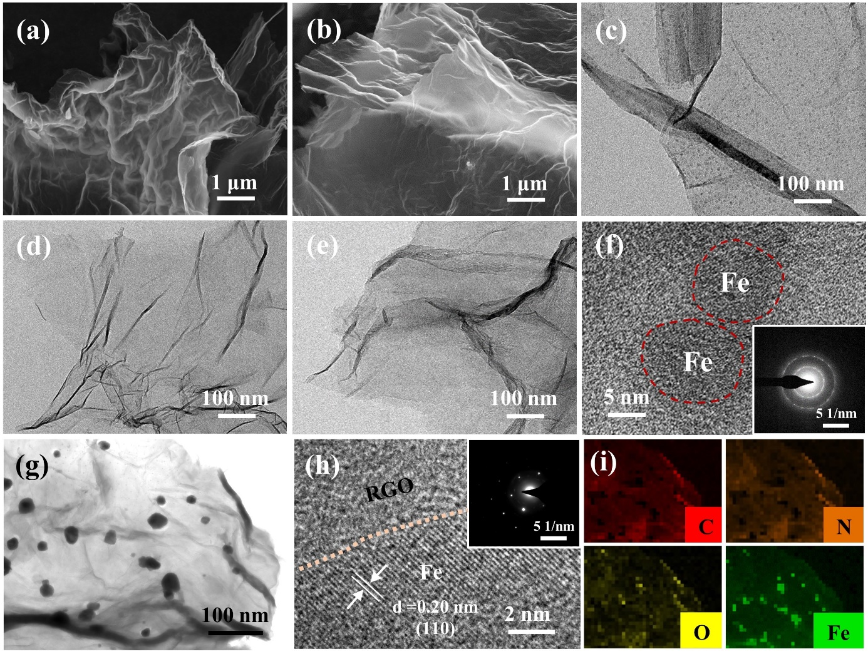
S2 Supplementary Figures and Tables
Fig. S1 Microstructural characterization of samples. a, d SEM and TEM images of RGO. b, e SEM and TEM images of N-RGO. c, f TEM images of Fe/RGO (inset: SAED pattern). g, h, i TEM, HRTEM images and EDS elemental mappings of Fe-NPS/Fe-N-RGO
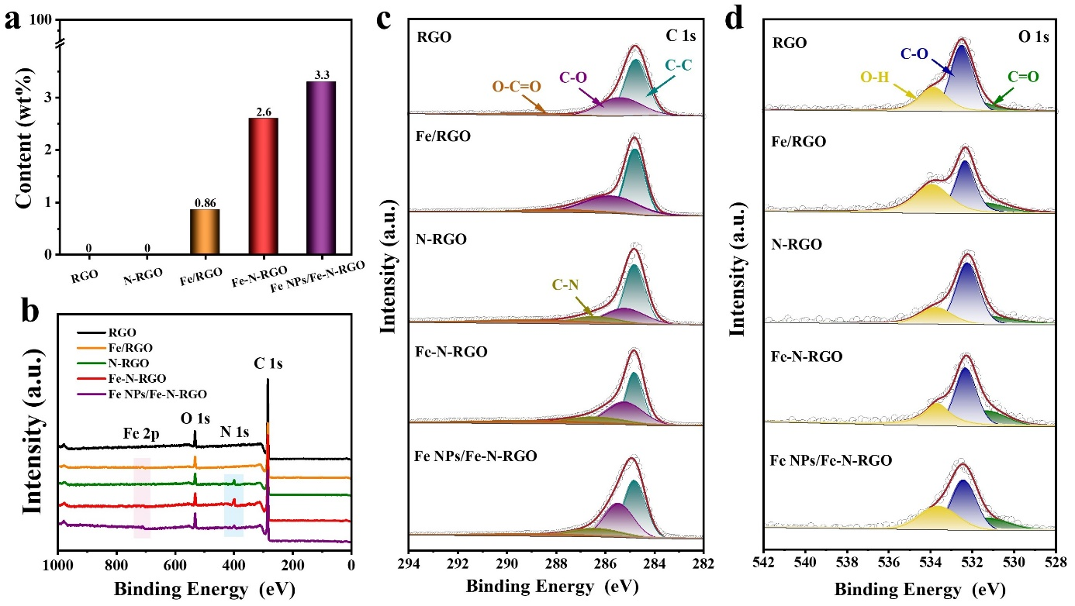
Fig. S2 a Fe content in ICP measurement. b XPS survey, high-resolution c C 1s and d O 1s XPS spectrum of RGO, Fe/RGO, N-RGO, Fe-N-RGO and Fe NPs/Fe-N-RGO, respectively
Fig. S3 FTIR spectra of RGO, Fe/RGO, N-RGO, Fe-N-RGO and Fe NPs/Fe-N-RGO, respectively
Fig. S4 The corresponding EXAFS fitting curves of Fe foil a, b and FePc c, d at k space and R space, respectively

Fig. S5 a, c N₂ adsorption-desorption isotherms and b, d the corresponding pore size distribution of N-RGO and Fe-N-RGO
Fig. S6 a Real part (µ') and b imaginary part (µ") of permeability of RGO, Fe/RGO, N-RGO, Fe-N-RGO and Fe NPs/Fe-N-RGO, respectively. c Magnetic hysteresis loops of Fe/RGO, Fe-N-RGO and Fe NPs/Fe-N-RGO
Due to the low Fe content (0.86 ~3.3 wt%) in Fe/RGO, Fe-N-RGO and Fe NPs/Fe-N-RGO, the μ' and μ" values of all samples are ≈1 and ≈0 (Fig. S5) with a low filler loading of only 1 wt%. The saturation magnetization (Ms) values are about 0, indicating that Fe has no obvious magnetic loss at the measured frequency in the alternating EM field.

Fig. S7 RL curves with different thickness and frequency of a RGO, b Fe/RGO, c N-RGO, d Fe-N-RGO and e Fe NPs/Fe-N-RGO

Fig. S8 a σ and b-f Cole–Cole plots of RGO, Fe/RGO, N-RGO, Fe-N-RGO and Fe NPs/Fe-N-RGO
Fig. S9 Impedance match (Z) of RGO, Fe/RGO, N-RGO, Fe-N-RGO and Fe NPs/Fe-N-RGO
The impedance matching ratio (Z) of samples can be calculated as:
$Z=\frac{z_{r}}{z_{0}}∨$ (S1)
$z_{r}=\sqrt{\frac{μ_{r}}{ε_{r}}},z_{0}=\sqrt{\frac{μ_{0}}{ε_{0}}},$ (S2)
$Z_{r}$ represents the material′s intrinsic impedance and $Z_{0}$ is the free space impedance. The closer the Z value of the absorbing material is to 1, the better the impedance matching, so that more electromagnetic waves enter the material.
Fig. S10 RL values, calculated and experimental values of matching thicknesses t_{m} under λ/4 condition, impedance matching values for a N-RGO and b Fe-N-RGO over 2-18 GHz
Fig. S11 a µ', b µ", c tanδ_{μ}, d σ e ε_{c}″ and f ε_{p}″ of M-N-RGO composites (M= Mn, Fe, Co, Ni, Cu, Zn, Nb, Cd and Sn)

Fig. S12 2D color-mapping RLvalues with different thickness of Cu-N-RGO a and Zn-N-RGO b. c Z and d α of M-N-RGO composites (M= Mn, Fe, Co, Ni, Cu, Zn, Nb, Cd and Sn)
Fig. S13 DOS and PDOS of M-N-Graphene composites (M= Mn, Fe, Co, Ni, Cu, Zn, Nb, Cd and Sn)

Table S1 EXAFS fitting structural parameters at the Fe K-edge of Fe foil, FePc and Fe-N-RGO
Sample | Path | C.N. | R(Å) | σ²(Å²) | ΔE₀ (eV) | R factor
Fe foil | Fe-Fe | 8* | 2.46±0.01 | 0.0053±0.0010 | 4.1±0.5 | 0.0092
Fe foil | Fe-Fe | 6* | 2.85±0.01 | 0.0049±0.0011 | 4.6±0.8 | 0.0092
FePc | Fe-N | 4.0±0.4 | 1.97±0.01 | 0.0058±0.0017 | -0.2±0.5 | 0.0075
Fe-N-RGO | Fe-N | 3.9±0.4 | 1.98±0.01 | 0.0162±0.0020 | -1.8±0.5 | 0.0032
C. N. is the coordination number; R is interatomic distance; σ² is Debye-Waller factor (the Mean Square Relative Displacement (MSRD)); ΔE₀ is inner potential correction. R factor is used to value the goodness of the fitting.

Table S2 The optimal EMWA properties of reported N-doped RGO-based EM absorbers
EM absorbers | Mass Ratio (wt%) | EAB |  | RL |  | Refs.
EM absorbers | Mass Ratio (wt%) | EAB_{max} (GHz) | d (mm) | RL_{min} (dB) | d (mm) | Refs.
N-rGO@CNTs | 2 | 7.1 | 2.6 | -49.4 | 2.6 | [S1]
CoP/NC@rGO | 4 | 7 | 2.71 | -67.5 | 2.14 | [S2]
N-doped-rGO/g-C₃N₄ | 5 | 4.56 | 1.6 | -49.59 | 1.6 | [S3]
AgNWs@NGA | 5 | 3.5 | 2.66 | -79.99 | 2.66 | [S4]
NGAs | 6 | 6.8 | 2.35 | -56.4 | 2.0 | [S5]
rGO/N-C/FeNi | 8 | 6.88 | 2.2 | -68.87 | 2.5 | [S6]
N-rGA/Ni | 10 | 5.1 | 2.1 | -60.8 | 2.1 | [S7]
NiO/NiFe₂O₄@N-rGA | 15 | 6.58 | 1.93 | -57.7 | 1.93 | [S8]
NRGO/CoFe₂O₄ | 15 | 5.2 | 1.8 | -44.7 | 1.8 | [S9]
CoFe₂O₄/N-rGO | 20 | 6.48 | 2.2 | -60.4 | 2.1 | [S10]
LaFeO₃/N-rGO | 20 | 6.72 | 2.83 | -64.5 | 2.83 | [S11]
FeCo@NC/NCR/rGO | 20 | 5.28 | 1.66 | -59.42 | 1.42 | [S12]
NS-rGO/Fe₃O₄/C | 20 | 5.04 | 2.7 | -46.33 | 2.7 | [S13]
NRGO/MgFe₂O₄ | 25 | 4.8 | 2.0 | -48 | 2.0 | [S14]
ZnO/CuO/N-RGO | 25 | 2.8 | 2.8 | -17.1 | 2.8 | [S15]
Fe-Co/NC/rGO | 25 | 9.29 | 2.63 | -43.26 | 2.5 | [S16]
γ-Fe₂O₃@N-rGO/MWCNT | 25 | 3.4 | 3.5 | -59.2 | 4.98 | [S17]
Cu/NC@Co/NC | 35 | 5.19 | 2.5 | -54.13 | 3 | [S18]
CoFe@NC/rGO | 35 | 4.48 | 1.7 | -53.0 | 2.4 | [S19]
Fe₄N/N-rGO | 50 | 5.27 | 1.61 | -53.1 | 1.6 | [S20]
FePc/N-rGO | 60 | 4.2 | 3.8 | -49.3 | 3.8 | [S21]
N-RGO | 1 | 6.41 | 2.16 | -45.27 | 3.5 | This work
Nb-N-RGO | 1 | 4.96 | 2.19 | -43.31 | 2.0 | This work
Zn-N-RGO | 1 | 5.16 | 2.16 | -48.33 | 4.0 | This work
Fe-N-RGO | 1 | 7.05 | 1.89 | -74.05 | 2.0 | This work
Supplementary References
- Z. Sun, Z. Yan, K. Yue, A. Li, L. Qian, Multi-scale structural nitrogen-doped rGO@CNTs composites with ultra-low loading towards microwave absorption. Appl. Surf. Sci. 538, 147943 (2021). https://doi.org/10.1016/j.apsusc.2020.147943
- G. Qin, X. Huang, Y. Liu, K. Zhang, Y. Yan et al., MOF-derived N-doped carbon nanocages trap CoP nanoparticles anchored on rGO to modulate dielectric polarization behavior for microwave absorption. Compos. Part A-Appl. S. 175, 107808 (2023). https://doi.org/10.1016/j.compositesa.2023.107808
- Q. Su, Y. He, D. Liu, K. Jia, L. Xia et al., Facile fabrication of ultra-light N-doped-rGO/g-C₃N₄ for broadband microwave absorption. J. Colloid Interf. Sci. 650, 47-57 (2023). https://doi.org/10.1016/j.jcis.2023.06.151
- X. Shu, S. Yan, B. Fang, Y. Song, Z. Zhao, A 3D multifunctional nitrogen-doped RGO-based aerogel with silver nanowires assisted self-supporting networks for enhanced electromagnetic wave absorption. Chem. Eng. J. 451, 138825 (2023). https://doi.org/10.1016/j.cej.2022.138825
- R. Shu, G. Zhang, C. Zhang, Y. Wu, J. Zhang, Nitrogen‐doping‐regulated electromagnetic wave absorption properties of ultralight three‐dimensional porous reduced graphene oxide aerogels. Adv. Electron. Mater. 7, 2001001 (2020). https://doi.org/10.1002/aelm.202001001
- H. Zhang, C. Shi, Z. Jia, X. Liu, B. Xu et al., FeNi nanoparticles embedded reduced graphene/nitrogen-doped carbon composites towards the ultra-wideband electromagnetic wave absorption. J. Colloid Interf. Sci. 584, 382-394 (2021). https://doi.org/10.1016/j.jcis.2020.09.122
- J. Tang, N. Liang, L. Wang, J. Li, G. Tian et al., Three-dimensional nitrogen-doped reduced graphene oxide aerogel decorated with Ni nanoparticles with tunable and unique microwave absorption. Carbon 152, 575-586 (2019). https://doi.org/10.1016/j.carbon.2019.06.049
- Q. Wang, J. Wang, Y. Zhao, Y. Zhao, J. Yan et al., NiO/NiFe₂O₄@N-doped reduced graphene oxide aerogel towards the wideband electromagnetic wave absorption: Experimental and theoretical study. Chem. Eng. J. 430, 132814 (2022). https://doi.org/10.1016/j.cej.2021.132814
- J. Xu, R. Shu, Z. Wan, J. Shi, Construction of three-dimensional hierarchical porous nitrogen-doped reduced graphene oxide/hollow cobalt ferrite composite aerogels toward highly efficient electromagnetic wave absorption. J. Mater. Sci. Technol. 132, 193-200 (2023). https://doi.org/10.1016/j.jmst.2022.05.050
- X. Wang, Y. Lu, T. Zhu, S. Chang, W. Wang, CoFe₂O₄/N-doped reduced graphene oxide aerogels for high-performance microwave absorption. Chem. Eng. J. 388, 124317 (2020). https://doi.org/10.1016/j.cej.2020.124317
- K. Fu, J. Zhao, F. Liu, L. Wu, Z. Jin et al., Enhanced electromagnetic wave absorption of nitrogen-doped reduced graphene oxide aerogels with LaFeO₃ cluster modifications. Carbon 210, 118071 (2023). https://doi.org/10.1016/j.carbon.2023.118071
- J. Luo, H. Guo, J. Zhou, F. Guo, G. Liu et al., Rational construction of heterogeneous interfaces for bimetallic MOFs-derived/rGO composites towards optimizing the electromagnetic wave absorption. Chem. Eng. J. 429, 132238 (2022). https://doi.org/10.1016/j.cej.2021.132238
- K. Zhang, X. Gai, X. Zhang, X. Chen, H. L et al., Preparation of nitrogen and sulfur co‐doped graphene/Fe₃O₄/C nanocomposite and study on the absorbing properties. J. Mater. Sci-Mater. El. 32, 8807-8818 (2021). https://doi.org/10.1007/s10854-021-05552-y
- R. Shu, X. Li, Y. Wu, J. Zhang, Z. Wan, Fabrication of magnesium ferrite microspheres decorated nitrogen-doped reduced graphene oxide hybrid composite toward high-efficiency electromagnetic wave absorption. J. Alloy. Compd. 859, 157865 (2021). https://doi.org/10.1016/j.jallcom.2020.157865
- X. Liu, X. Lu, H. Guan, X. Liu, Y. Wang et al., Controllable synthesis of flower-like ZnO modified by CuO nanoparticles/N-RGO composites for efficient microwave absorption properties. Ceram. Int. 48, 6948-6955 (2022). https://doi.org/10.1016/j.ceramint.2021.11.251
- S. Wang, Y. Xu, R. Fu, H. Zhu, Q. Jiao et al., Rational construction of hierarchically porous Fe-Co/N-doped carbon/rGO composites for broadband microwave absorption. Nano-Micro Lett. 11, 76 (2019). https://doi.org/10.1007/s40820-019-0307-8
- W. Hou, Q. Liao, M. Wu, K. Liao, Y. Song et al., High-performance pinecone-like MOF derivative electromagnetic wave-absorbing composite via in situ anisotropic-oriented growth. J. Alloy. Compd. 937, 168283 (2023). https://doi.org/10.1016/j.jallcom.2022.168283
- H. Zhu, Q. Jiao, R. Fu, P. Su, C. Yang et al., Cu/NC@Co/NC composites derived from core-shell Cu-MOF@Co-MOF and their electromagnetic wave absorption properties. J. Colloid Interf. Sci. 613, 182-193 (2022). https://doi.org/10.1016/j.jcis.2021.11.166
- S. Wei, T. Chen, Z. Shi, S. Chen, Preparation of CoFe@N-doped C/rGO composites derived from CoFe prussian blue analogues for efficient microwave absorption. J. Colloid Interf. Sci. 610, 395-406 (2022). https://doi.org/10.1016/j.jcis.2021.12.051
- J. Ren, L. Zhang, N. Bao, X. Fan, H. Yang, Graphene-assisted synthesis of Fe₄N with enhanced microwave absorption performance. J. Electron. Mater. 51, 966-977 (2022). https://doi.org/10.1007/s11664-021-09412-7
- J. Zhang, L. Chen, X. Li, H. Cao, W. Chen et al., Regulation dipole moments of N-doped graphene coordinated with FePc toward highly efficient microwave absorption performance in C band. Small 2308459 (2024). https://doi.org/10.1002/smll.202308459

