Supporting Information for
Wafer-Scale Vertical 1D GaN Nanorods/2D MoS₂/PEDOT:PSS for Piezophototronic Effect Enhanced Self-Powered Flexible Photodetectors
Xin Tang^{1,2}, Hongsheng Jiang^{1,2}, Zhengliang Lin^{1,2}, Xuan Wang^{1,2}, Wenliang Wang^{1,2,}* and Guoqiang Li^{1,2,}*
¹ State Key Laboratory of Luminescent Materials and Devices, South China University of Technology, Guangzhou 510640, P. R. China
² Department of Electronic Materials, School of Materials Science and Engineering, South China University of Technology, Guangzhou 510640, P. R. China
*Corresponding authors. E-mail: wenliangwang@scut.edu.cn (Wenliang Wang); msgli@scut.edu.cn (Guoqiang Li)
Supplementary Figures
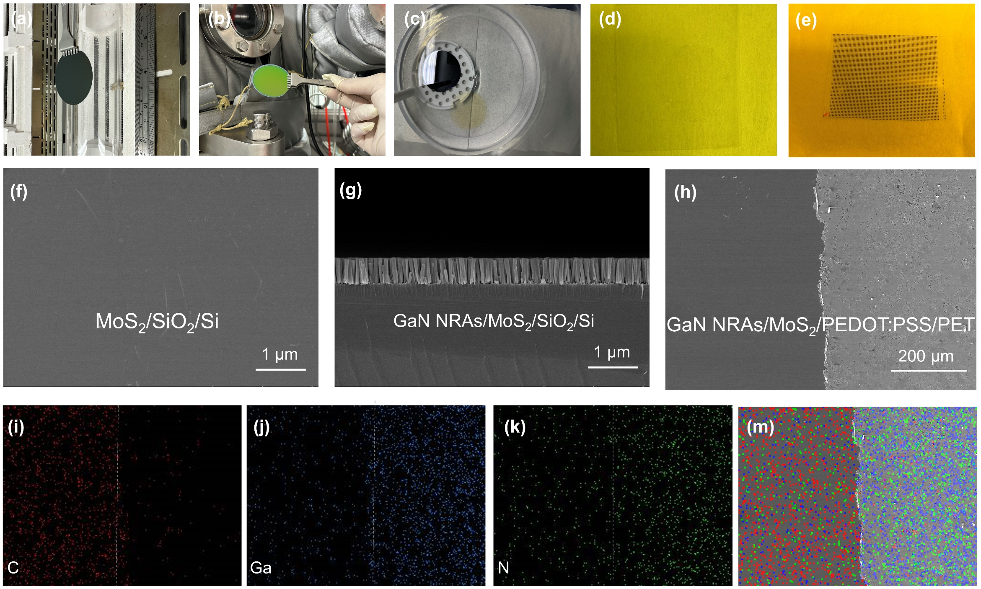
Fig. S1 a-c Fabrication process of vertical heterostructures for flexible photodetector arrays. (a) 2-inch MoS₂/SiO₂/Si prepared by CVD, (b) GaN NRAs/MoS₂/SiO₂/Si prepared by MBE, (c) GaN NRAs/MoS₂ etched by HF, (d) GaN NRAs/MoS₂/ PEDOT:PSS flexible heterojunction, (e) GaN NRAs/MoS₂/PEDOT:PSS flexible photodetector arrays, and corresponding (f-h) SEM images. i-m EDS mapping of GaN NRAs/MoS₂/PEDOT:PSS heterojunction.
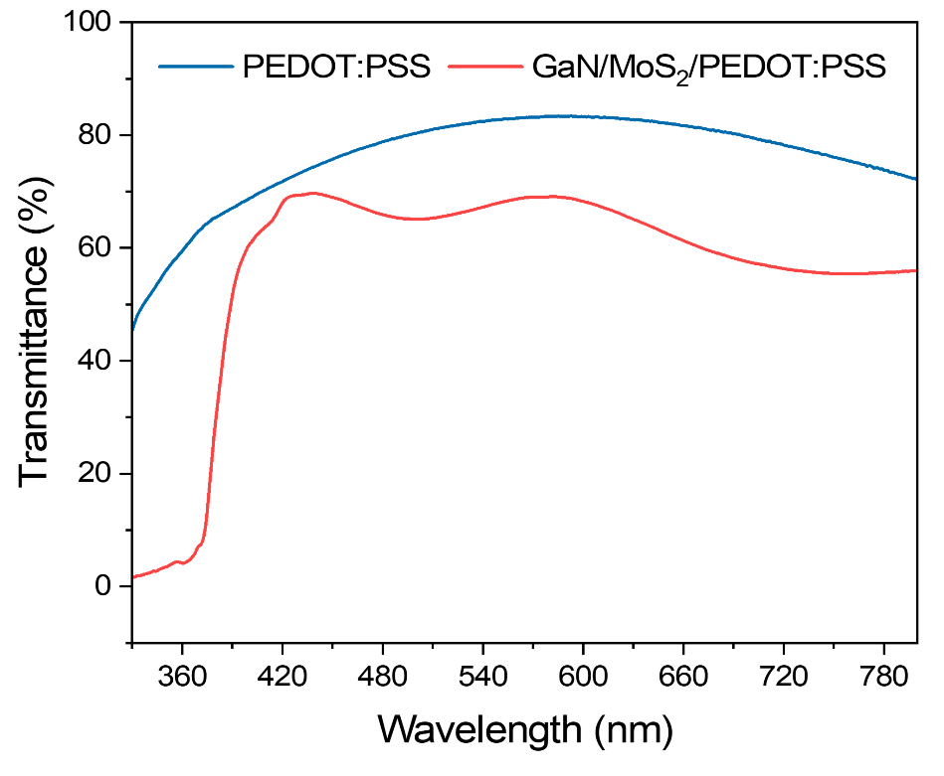
Fig. S2 Transmittance before and after GaN NRAs/MoS₂ was transfer onto PEDOT:PSS/ITO/PET
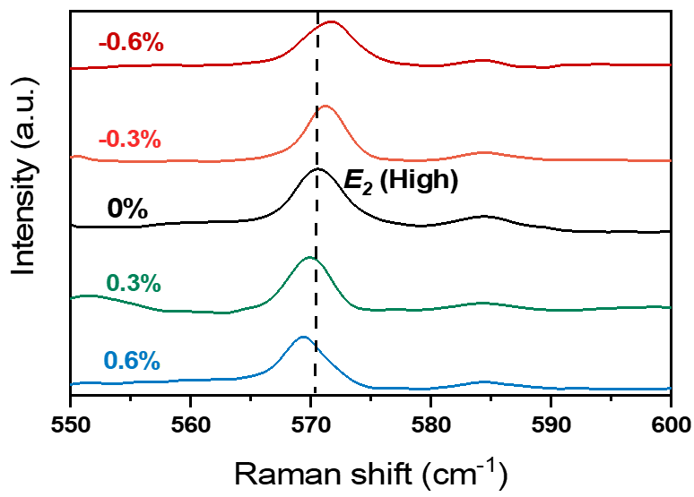
Fig. S3 Raman spectra of vertical GaN/MoS₂/PEDOT:PSS heterojunction at different strains
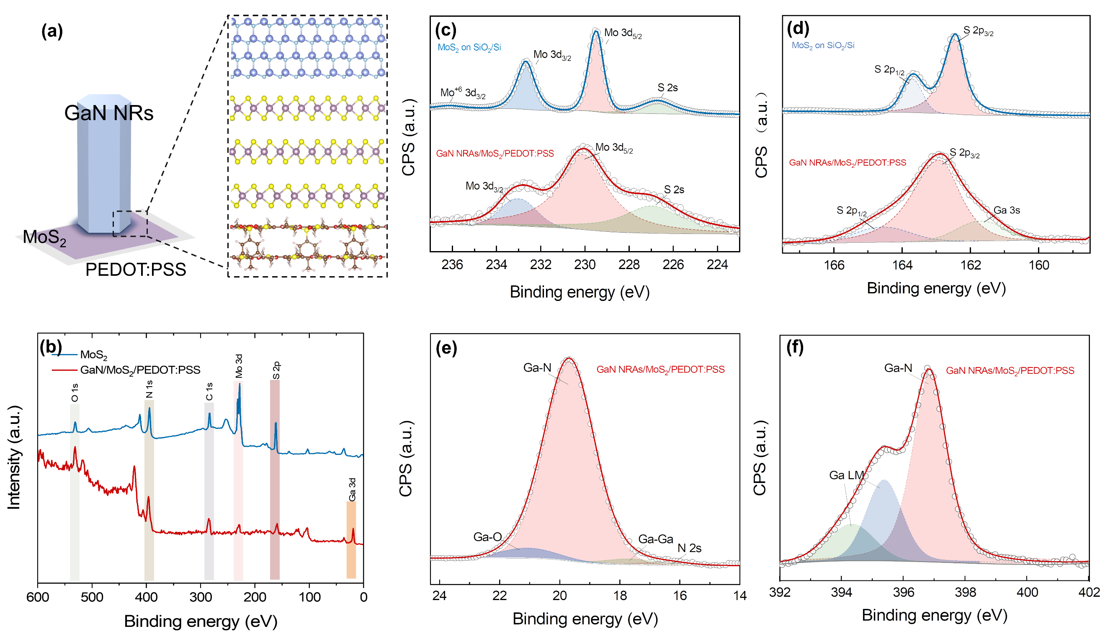
Fig. S4 a Schematic diagram and simulated atomic configuration of the vertical heterostructure. (b) XPS full survey spectra of GaN/MoS₂/PEDOT:PSS and original MoS₂. (c-f) Mo 3d, S 2p, Ga 3d and N 1s XPS spectra for GaN/MoS₂/PEDOT:PSS, refered to fitted XPS spectra for pure MoS₂/SiO₂/Si
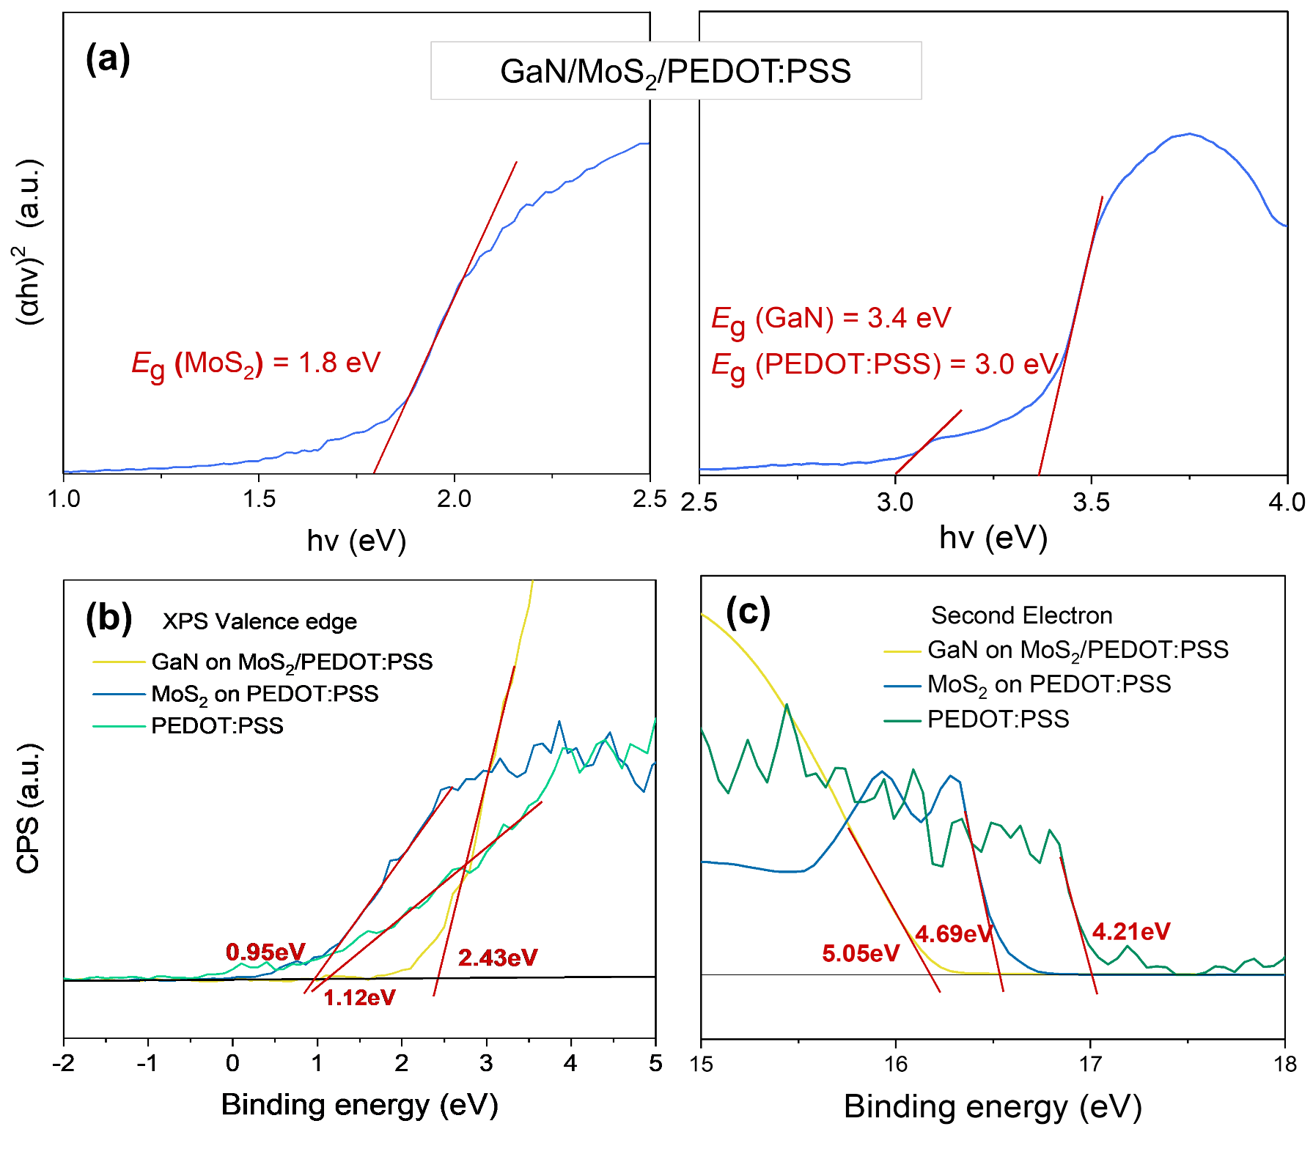
Fig. S5 a UV-vis absorption spectrum for GaN/MoS₂/PEDOT:PSS. (b) XPS valence band edge (VB) and (c) ultraviolet photoelectron spectra (UPS) work function spectra for MoS₂, PEDOT:PSS and GaN NRAs. The work functions (Φ) can be obtained from the difference between the photon energy of radiation (21.21 eV) and the second electron cutoff energy
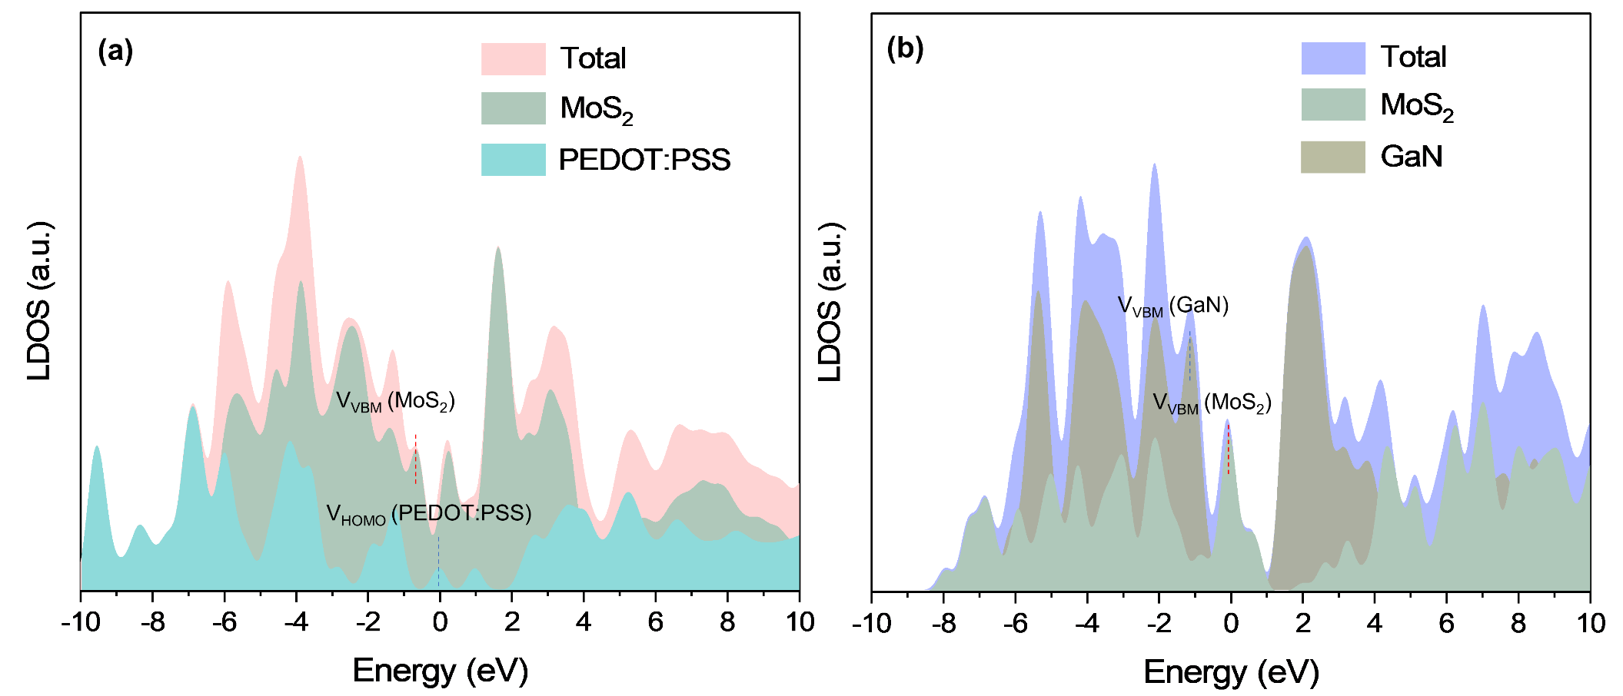
Fig. S6 The local density of states (LDOS) of hybrid heterojunction
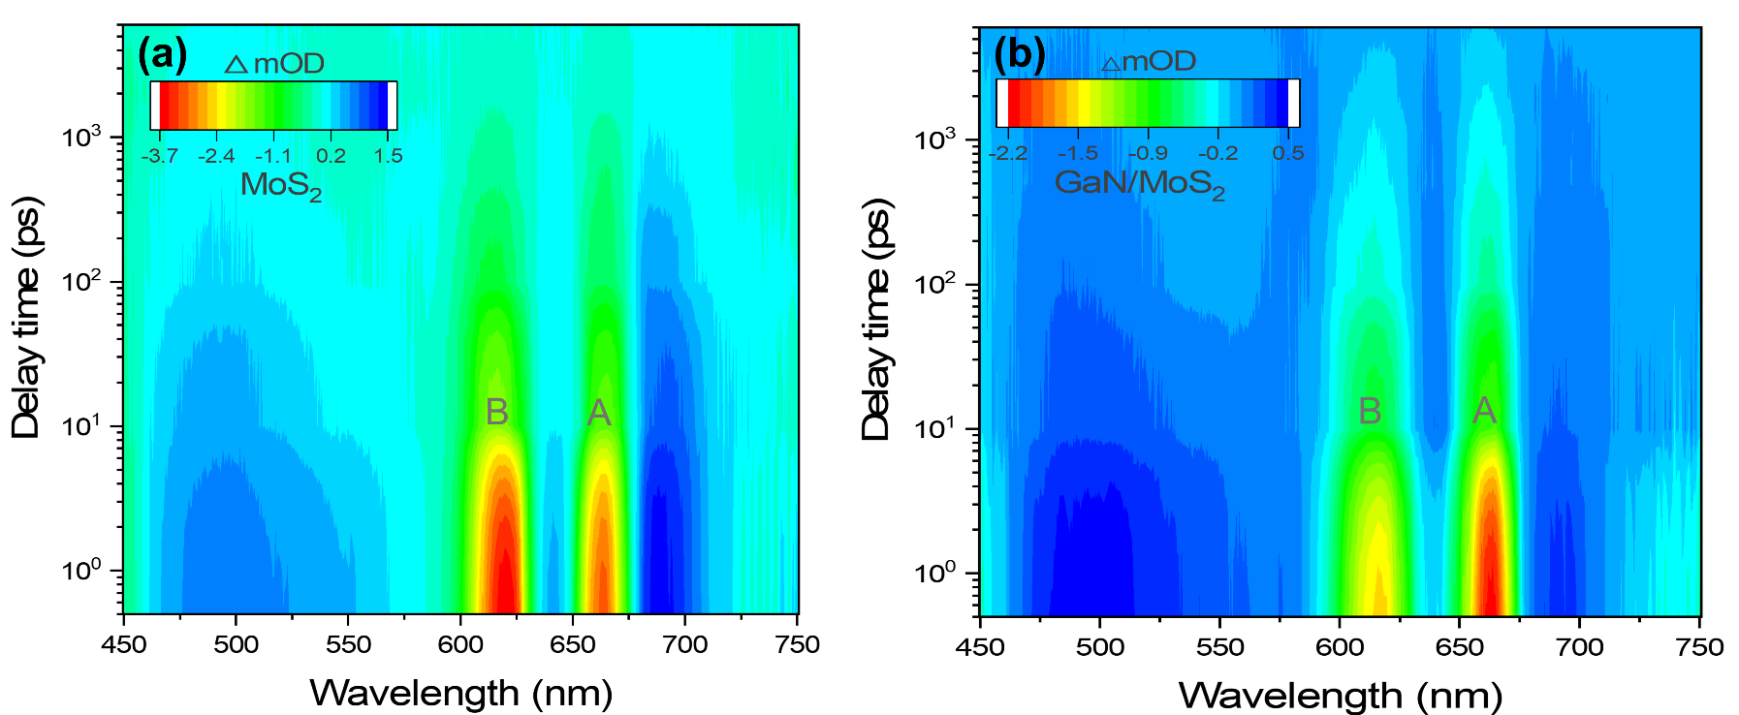
Fig. S7 Transient absorption (TA) mapping of MoS₂ and GaN/MoS₂ at different delays
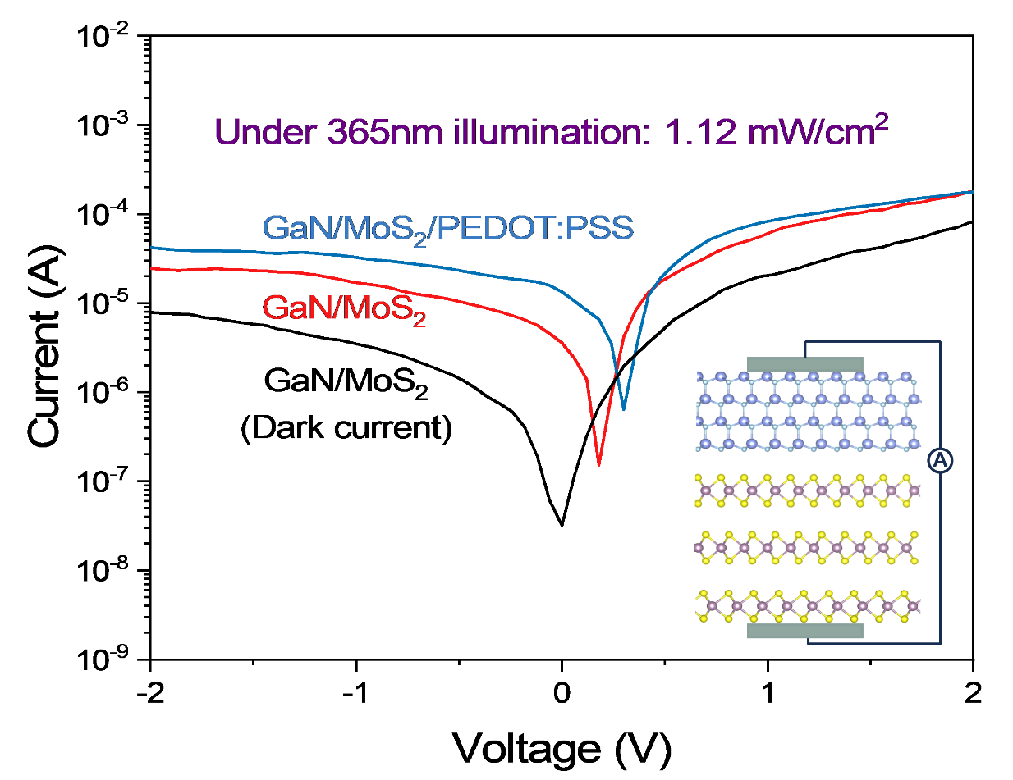
Fig. S8 Typical I–V characteristics (in logarithmic ordinate scale) of GaN/MoS₂ and GaN/MoS₂/PEDOT:PSS photodetectors under 365 nm illumination of 1.12 mW/cm²
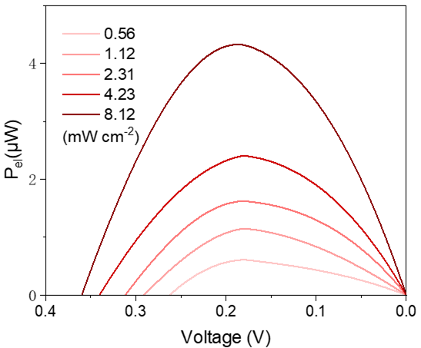
Fig. S9 a The output electrical power (P_{el}) of GaN/MoS₂/PEDOT:PSS heterojunction.
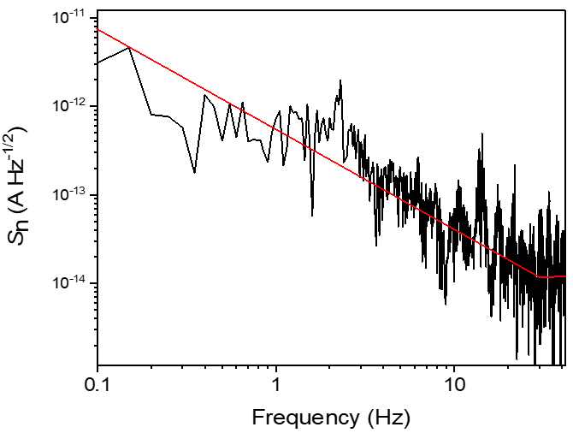
Fig. S10 The noise spectral densities (S_{n}) as a function of frequency by taking the Fourier transform of dark current traces
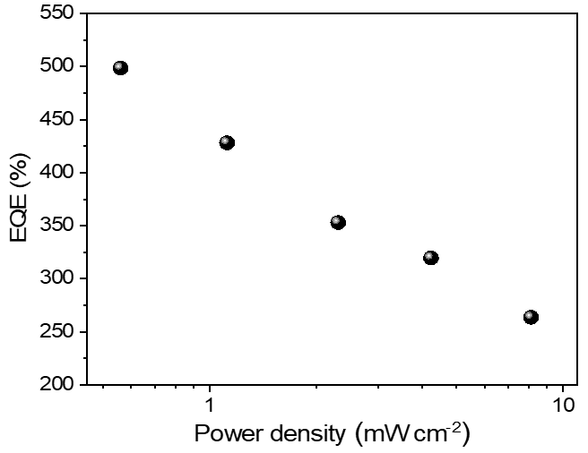
Fig. S11 The EQE as function of light power density
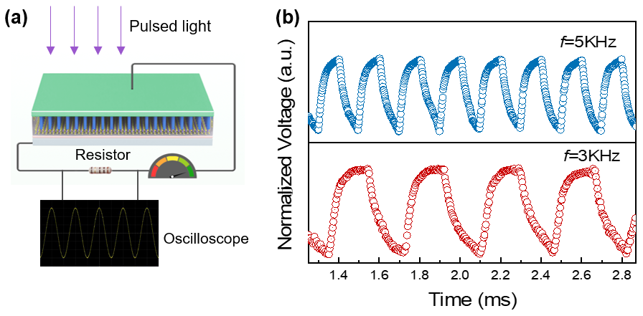
Fig. S12 (a) The schematic of the response time test and (b) multiple rapid-changing impulse responses under 5kHz and 3 kHz pulsed 365 nm light
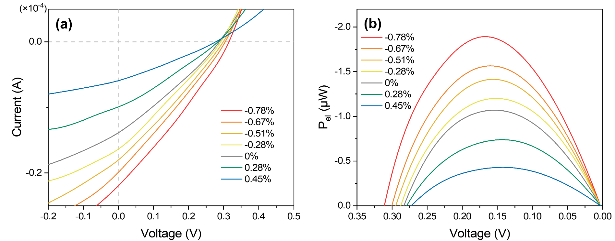
Fig. S13 (a) I-V characteristics and (b) P_{el} of the photodetectors at different strain

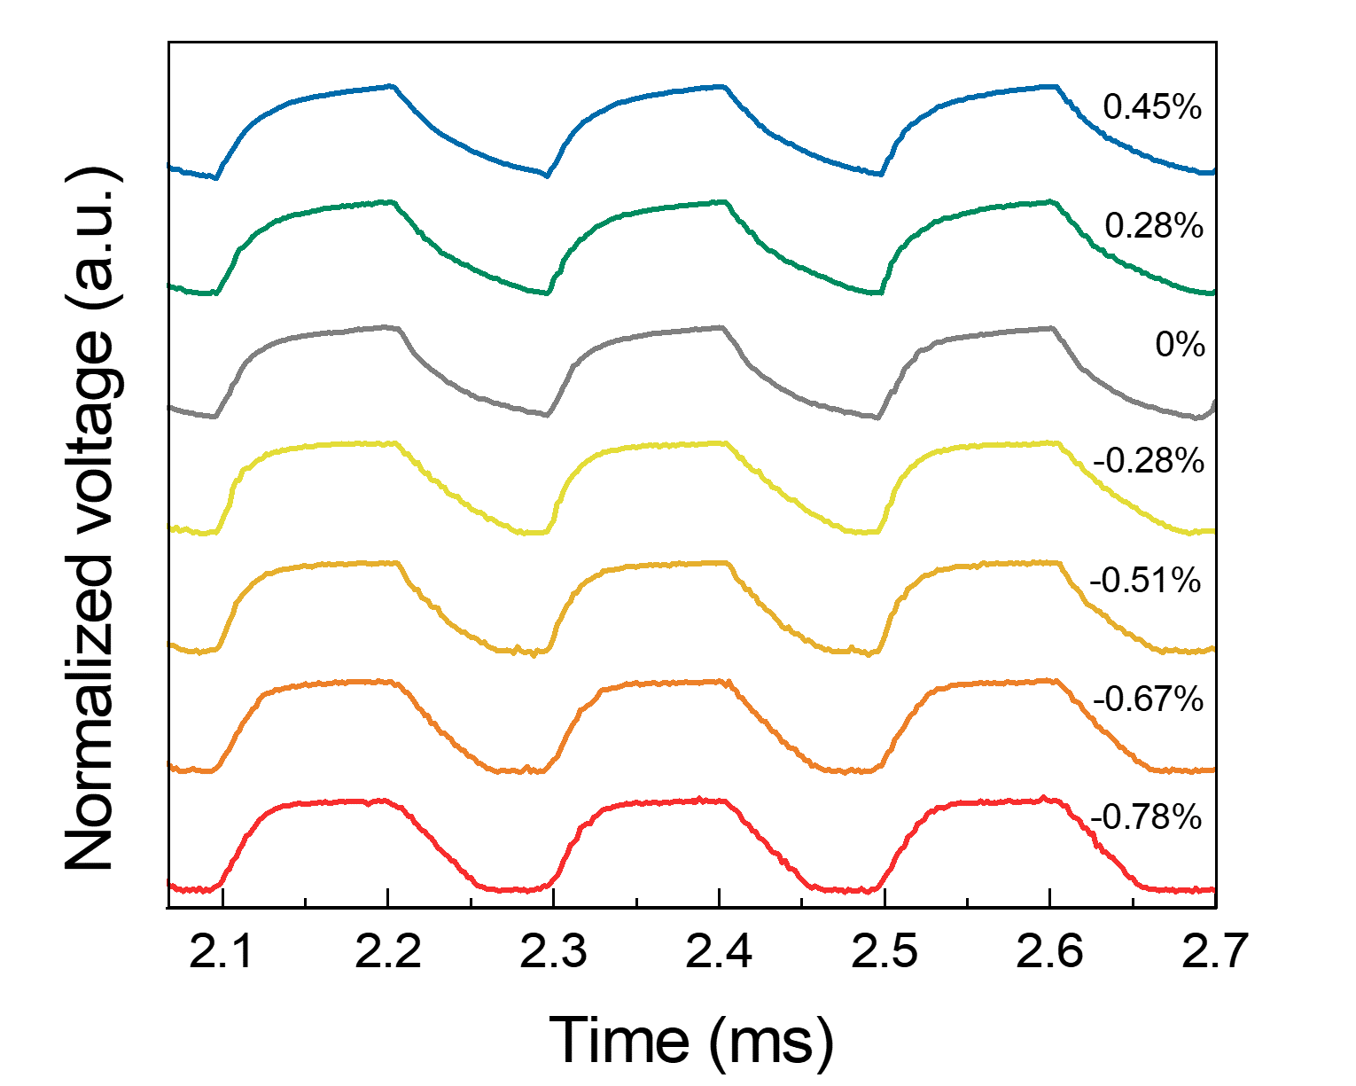
Fig. S14 The temporal photoresponse of device at different strain

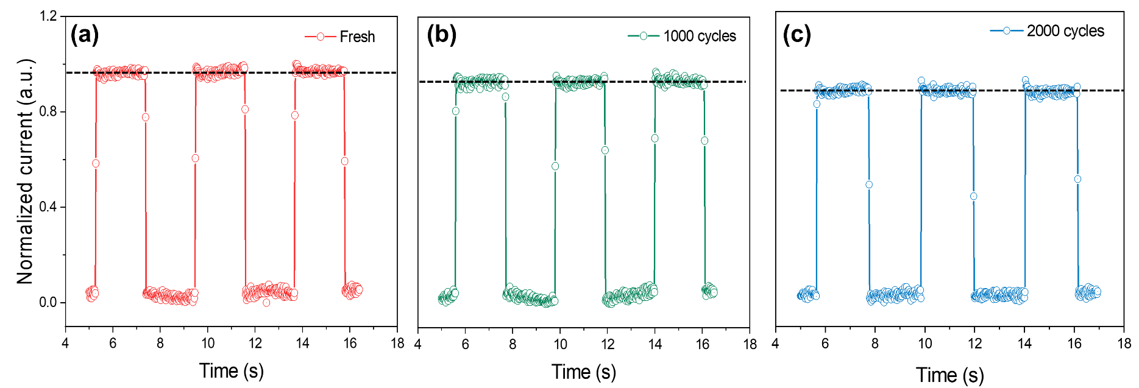
Fig. S15 The photoresponse of device (a) at fresh state and after (b) 1000 and (c) 2000 bending cycles
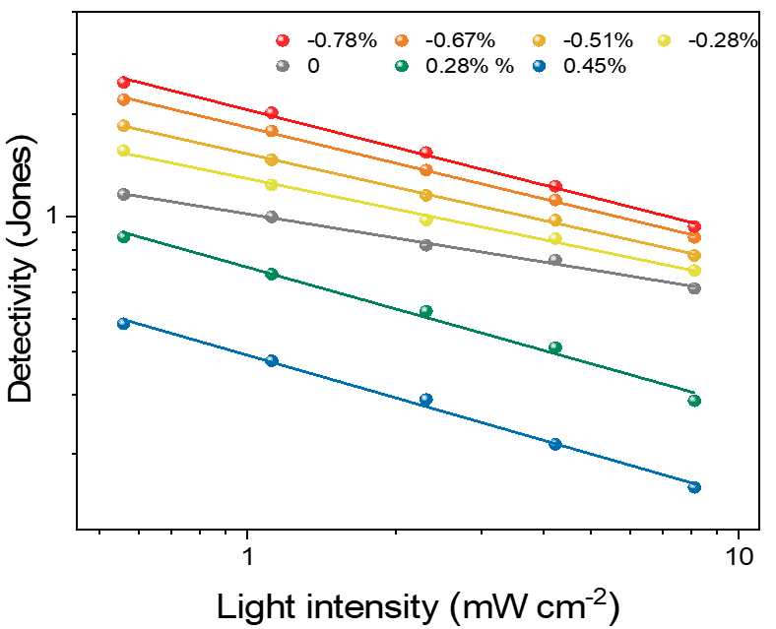
Fig. S16 Variations in detectivity for the different strained photodetectors under increasing illumination power densities
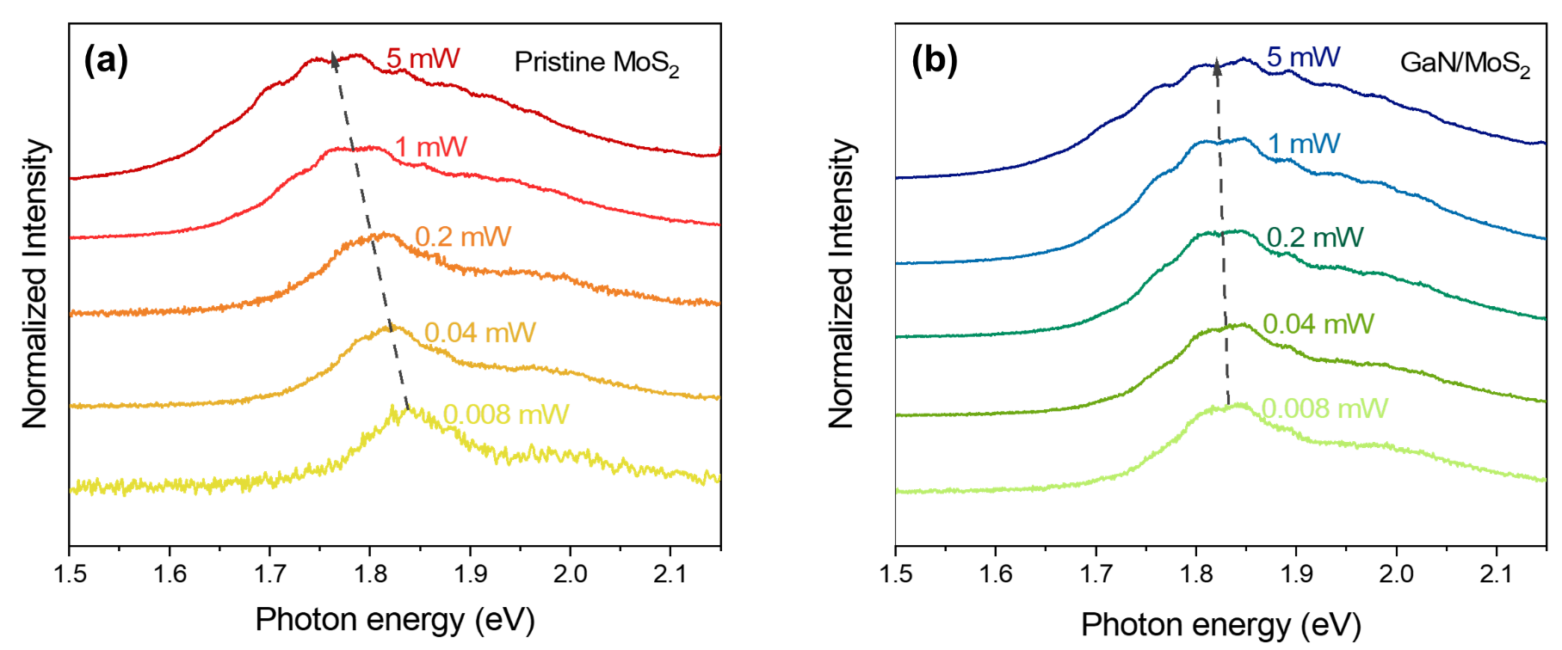
Fig. S17 Power-dependent (0.008~5 mW) PL spectra for MoS₂ and GaN/MoS₂
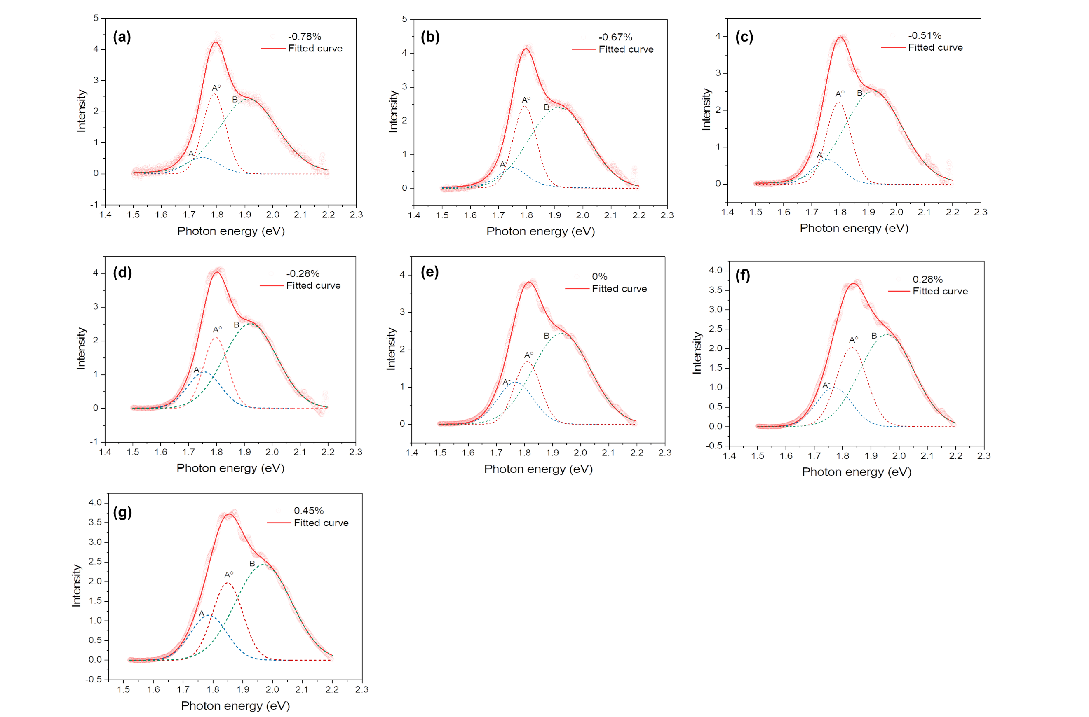
Fig. S18 PL spectrum at different strains normalized by peak area
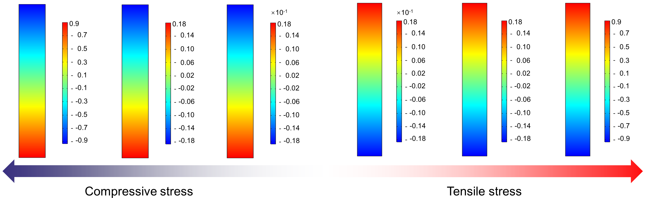
Fig. S19 The simulations of the GaN nanowire piezopotential distribution for different strains
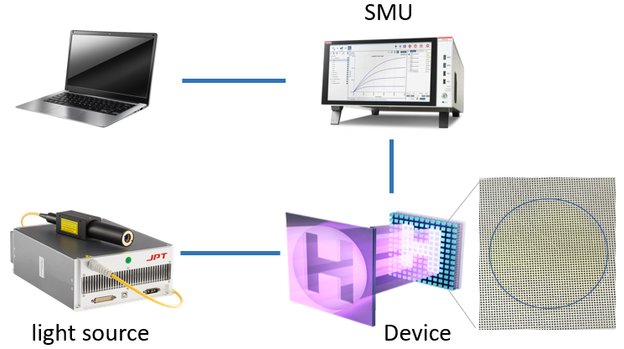
Fig. S20 The schematic of the image sensing analysis system
Table 1 Summary of key parameters of self-powered flexible and similar material structured photodetectors in this work and previous reports
Description | Flexibility | λ (nm) | R (A/W) | D* (Jones) | τ_{r}/τ_{d} | Refs.
GaN NRAs/MoS₂  /PEDOT:PSS | Yes | 365 | 1.47~2.47 | 1.2×10¹¹~  2.6×10¹¹ | 54/71~  40/45µs | This work
GaN NRAs/ZnO film | Yes | 325 | 2.82 | 6.82×10¹³ | 6.9/6.4ms | [S1]
1D GaAs/2D WSe₂ | Yes | 532 | 0.51 | 6.0×10¹¹ | NA | [S2]
1D Se/2D InSe | Yes | 460 | 0.11 | 5.6×10¹¹ | 30/37ms | [S3]
2D Ga₂O₃/2D PbI₂ | Yes | 405 | 0.105 | 3.85×10¹¹ | 2/3ms | [S4]
PbI₂ Nanoplates | Yes | 405 | 0.65 | 0.95×10¹³ | 2/3ms | [S5]
2D MoS₂/Au | Yes | 450 | 0.431 | 2.54×10⁸ | 40/40ms | [S6]
Multilayer γ-InSe | Yes | 400 | 0.824 | 1.7×10¹² | 20/10µs | [S7]
Cs₃Cu₂I₅/PEDOT:PSS | Yes | 275 | 0.17 | 1.0×10¹³ | 177/195µs | [S8]
PEDOT:PSS/TiO₂/ZnO | Yes | 325 | 1.257 | 2.9×10¹³ | 0.52/0.87s | [S9]
FA_{0.8}PEA_{0.2}SnI₃ | Yes | 630 | 0.262 | 2.3×10¹¹ | 25/42µs | [S10]
MoS₂/GaN | No | 365 | 0.015 | 4.7×10¹³ | 4/8ms | [S11]
MoS₂/GaN | No | 532 | 0.13 | 3.8×10¹⁰ | 18/123ms | [S12]
GaN/PEDOT:PSS | No | 365 | 0.96 | 5.7×10¹² | 60/124ms | [S13]
Supplementary References
- Y. Peng, J. Lu, X. Wang, W. Ma, M. Que, et al., Self-powered high-performance flexible GaN/ZnO heterostructure UV photodetectors with piezo-phototronic effect enhanced photoresponse. Nano Energy 94, 106945 (2022). https://doi.org/10.1016/j.nanoen.2022.106945
- X. Chen, B. Jiang, D. Wang, G. Li, H. Wang, et al., Gate-tunable the interface properties of GaAs-WSe₂ (1D-2D) vdWs heterojunction for high-responsivity, self-powered photodetector. Appl. Phys. Lett. 118, 041102 (2021). https://doi.org/10.1063/5.0035275
- H. Shang, H. Chen, M. Dai, Y. Hu, F. Gao, et al., A Mixed-dimensional 1D Se-2D InSe van der Waals Heterojunction for High Responsivity Self-powered Photodetectors. Nanoscale Horiz. 5, 564-572 (2020). https://doi.org/10.1039/c9nh00705a
- J. Zhang, F. Liu, D. Liu, Y. Yin, M. Wang, et al., Toward Smart Flexible Self-powered Near-UV Photodetector of Amorphous Ga₂O₃ Nanosheet. Mater. Today Phys. 31, 100997 (2023). https://doi.org/10.1016/j.mtphys.2023.100997
- D. Liu, R. Chen, F. Liu, J. Zhang, X. Zhuang, et al., Flexible Omnidirectional Self-powered Photodetectors Enabled by Solution-processed Two-dimensional Layered PbI₂ Nanoplates. ACS Appl. Mater. Inter. 14, 46748-46755 (2022). https://doi.org/10.1021/acsami.2c13373
- X. Tang, S. Wang, Y. Liang, D. Bai, J. Xu, et al., High-performance, Self-powered Flexible MoS₂ Photodetectors with Asymmetric van der Waals Gaps. PCCP 24, 7323-7330 (2022). https://doi.org/10.1039/d1cp05602f
- M. Dai, H. Chen, F. Wang, Y. Hu, S. Wei, et al., Robust Piezo-phototronic Effect in Multilayer γ-InSe for High-performance Self-powered Flexible Photodetectors. Acs Nano 13, 7291-7299 (2019). https://doi.org/10.1021/acsnano.9b03278
- T.-L. Shen, Y.-W. Chu, Y.-K. Liao, W.-Y. Lee, H.-C. Kuo, et al., Ultrahigh-performance Self-powered Flexible Photodetector Driven From Photogating, Piezo-phototronic, and Ferroelectric Effects. Adv. Opt. Mater. 8, 1901334 (2020). https://doi.org/10.1002/adom.201901334
- Y. Cheng, C. Li, J. Li, T. Li, Y. Sun, et al., Highly-sensitive, flexible, and self-powered UV photodetectors based on perovskites Cs₃Cu₂I₅/PEDOT:PSS heterostructure. IEEE Electron Device Lett. 43, 2137-2140 (2022). https://doi.org/10.1109/led.2022.3218647
- M. He, Z. Xu, C. Zhao, Y. Gao, K. Ke, et al., Sn-based self-powered ultrafast perovskite photodetectors with highly crystalline order for flexible imaging applications. Adv. Funct. Mater. 33, 2300282 (2023). https://doi.org/10.1002/adfm.202300282
- T. J. Lin, W. L. Wang, Polarization-sensitive self-powered MoS₂/a-GaN heterojunction photodetectors for ultraviolet polarized imaging. Appl. Phys. Lett. 124, 252102 (2024). https://doi.org/10.1063/5.0215741
- B. W. Liang, W. H. Chang, C. S. Huang, Y. J. Huang, J. H. Chen, et al., Self-powered broadband photodetection enabled by facile CVD-grown MoS₂/GaN heterostructures. Nanoscale 15, 18233-18240 (2023). https://doi.org/10.1039/d3nr03877g
- S. Li, Z. Liu, M. L. Zhang, L. L. Yang, Y. F. Guo, et al., High-performance self-powered GaN/PEDOT:PSS hybrid heterojunction UV photodetector for optical communication. Sci. China Tech. Sci. 67, 608-615 (2024). https://doi.org/10.1007/s11431-023-2501-5

