Supporting Information for
MXene Hybridized Polymer with Enhanced Electromagnetic Energy Harvest for Sensitized Microwave Actuation and Self-powered Motion Sensing
Yu-Ze Wang¹, Yu-Chang Wang^{1, 2}, Ting-Ting Liu¹, Quan-Liang Zhao³, Chen-Sha Li⁴, Mao-Sheng Cao^{1,} *
¹ School of Materials Science and Engineering, Beijing Institute of Technology, Beijing 100081, P. R. China
² School of Materials Science and Engineering, Peking University, Beijing 100871, P. R. China
³ School of Mechanical and Material Engineering, North China University of Technology, Beijing 100144, P. R. China
⁴ Key Laboratory of Functional Inorganic Material Chemistry, Ministry of Education of the People’s Republic of China, Heilongjiang University, Harbin 150080, P. R. China
* Corresponding authors. E-mail: caomaosheng@bit.edu.cn (Mao-Sheng Cao)
S1 Calculations and Statistical Analysis
S1.1 First-principles calculation
The first-principles plane-wave pseudopotential method was adopted. The difference charge density around vacancy and functional group sites was obtained by the CASTEP program with a function of generalized gradient approximation (GGA) and Perdew-Burke-Ernzerhof (PBE), a 3a × 3b × c supercell, a custom cutoff energy of 450 eV, a SCF tolerance of 2 × 10⁻⁶ eV/atom, a k-point Monkhorst-Pack grid of 3×3×1 and the vacuum layer of 20 Å were adopted.
S1.2 Calculation of order parameters (S) based on 2D-WAXS results
$S=\frac{3<\cos^{2}φ>−1}{2}$ (S1)
$\cos^{2}φ≥\frac{\int_{0}^{\frac{π}{2}}{I\left(φ\right)sinφ\cos^{2}φdφ}}{\int_{0}^{\frac{π}{2}}{I\left(φ\right)sinφdφ}}$ (S2)
Where I is the intensity and φ is the azimuthal angle presented in Fig. 2c. $\cos^{2}φ>$ is the mean squared cosine of the angle between the direction of mesogen alignment and the axial direction of the actuator.
S1.3 Evaluation of EM properties
The real part (ε’) and imaginary part (ε”) of complex permittivity (ε*) are defined by Debye Eqs. (S3 and S4).
$ε^{'}=ε_{∞}+\frac{ε_{s}−ε_{∞}}{1+ω^{2}τ^{2}}$ (S3)
$ε^{''}=\frac{ε_{s}−ε_{∞}}{1+ω^{2}τ^{2}}ωτ+\frac{σ}{ωε_{0}}=ε_{p}^{''}+ε_{c}^{''}$ (S4)
where ε∞ is the relative dielectric permittivity at infinite frequency and εs is the static permittivity; ω is the angular frequency; τ is the relaxation time; σ is the electric conductivity. According to Debye’s relaxation theory and circular arc law, classic relaxation process shall be reflected by the peak of ε″_{p} and a semicircle curve in Cole-Cole plot, which conform to Eq. S5.
${\left(ε | | '−\frac{ε_{s}+ε_{∞}}{2}\right)}^{2}+{ε_{p}^{}}^{2}={\left(\frac{ε_{s}−ε_{∞}}{2}\right)}^{2}$ (S5)

S1.4 Calculation of ratio of converted EM energy to stored EM energy (ω_{r})
$ω_{r}=\frac{ε^{''}ε_{0}E_{0}^{2}+μ^{''}μ_{0}H_{0}^{2}}{ε^{'}ε_{0}E_{0}^{2}+μ^{'}μ_{0}H_{0}^{2}}$ (S6)
where ε₀ and μ₀ represent vacuum permittivity and permeability, respectively; E₀ and H₀ are the electric field intensity amplitude and magnetic field intensity amplitude of the EM wave, respectively.
Calculation of heating rate (R_{H}) of LCE-M actuators under microwave stimulus:
$R_{h}=\frac{T_{}−T_{r}}{t_{1}}$ (S7)
where Tr and Tni are room temperature and phase transition temperature, respectively; t₁ is the response time.
S1.5 Calculation of apparent EM energy harvest efficiency (AE_{EM})
${AE}_{EM}=\frac{Q_{a}}{W_{mic}}$ (S8)
$Q_{a}=\int_{T_{r}}^{T_{}}{C_{p}\left(T\right)dT}×m$ (S9)
$W_{mic}=P_{r}×t_{1}$ (S10)
where Q_{a} and W_{mic} stand for necessary heat for activating an actuator and total output work from the microwave generator during activation, respectively; T_{r} and T_{ni} refer to room temperature and phase transition temperature, respectively; C_{p} refers to the specific heat capacity of the actuator, which is a function of temperature (T) and is acquired from the DSC results; m is the mass of the actuator; P_{r} is the rated output power of the microwave generator and t₁ is the response time.
S1.6 Calculation of work capacity (W) and power density (P)
$W=\frac{F_{max}∆L}{V}$ (S11)
$P=\frac{W}{t_{2}}$ (S12)
where F_{max} is the maximum actuation stress; ΔL refers to the length variation corresponding to 90% of the maximum actuation strain, which conform to the identification of deformation period; t₂ is the deformation period.
S1.7 Pre-processing of data
Irradiation time in all actuation tests is normalized to start at the moment of turning on the energy source.
S1.8 Data presentation
Error bars stand for standard deviation in bar charts (mean ± SD). Sample size for each statistical analysis is contained in the corresponding Figure legend.
S2 Supplementary Figures and Tables
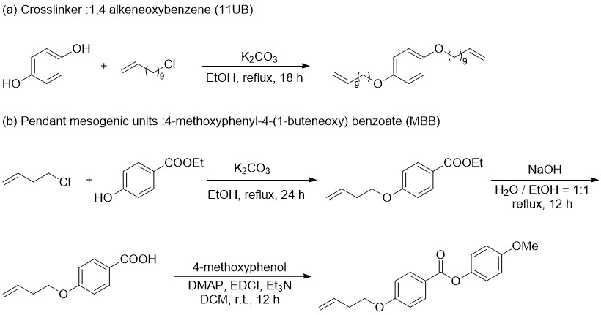
Fig. S1 Synthetic route of crosslinker of 11UB and mesogenic unit of MBB

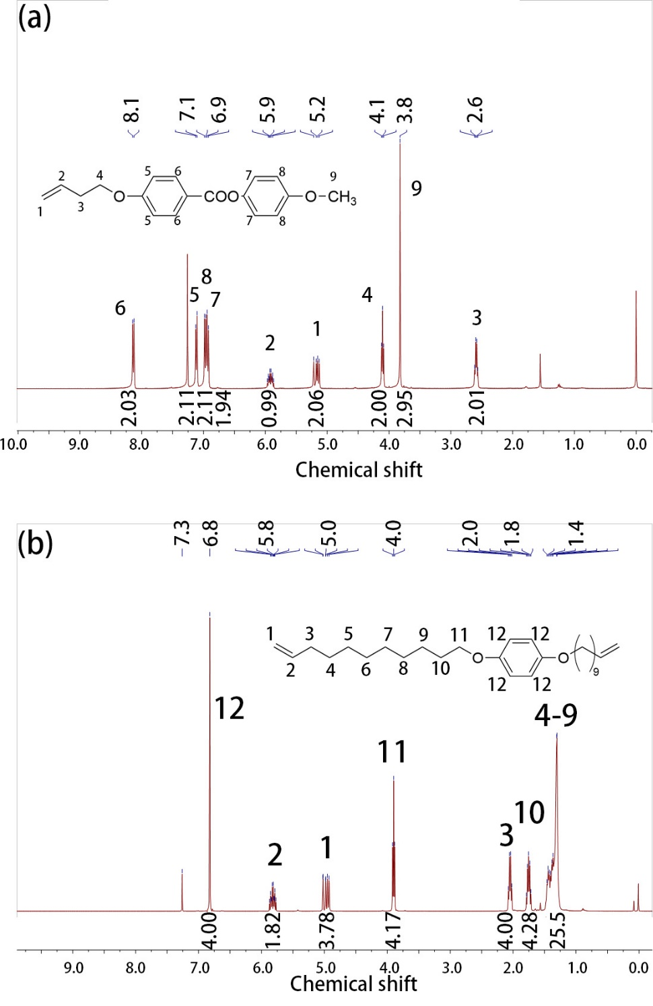
Fig. S2 H-NMR spectroscopy results of the as prepared building blocks. (a) MBB; (b) 11UB

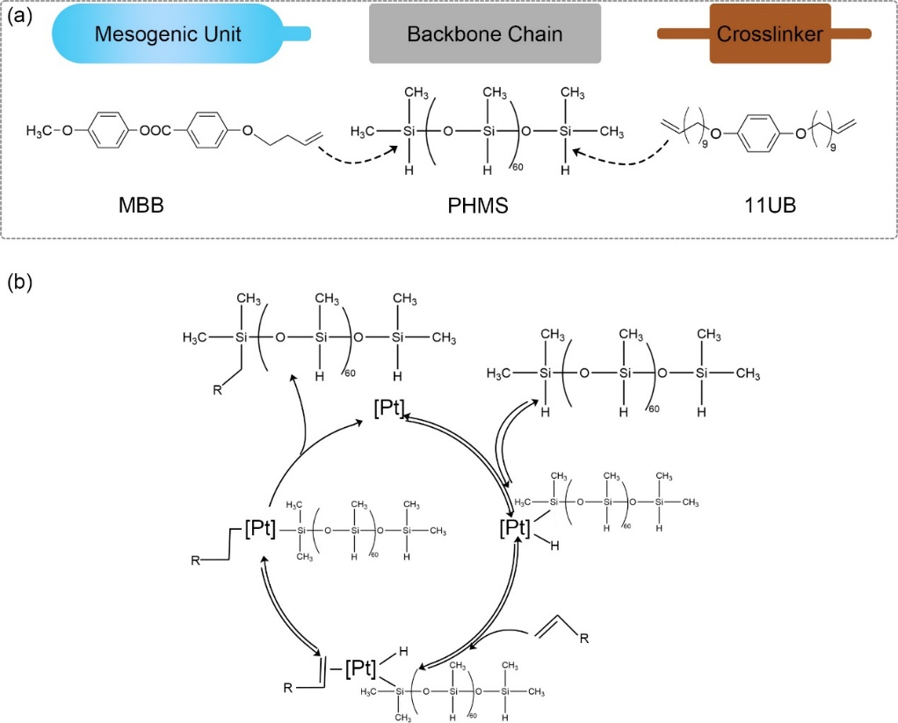
Fig. S3 Reaction pathway of Pt catalized Si-H addition in the crosslinking process

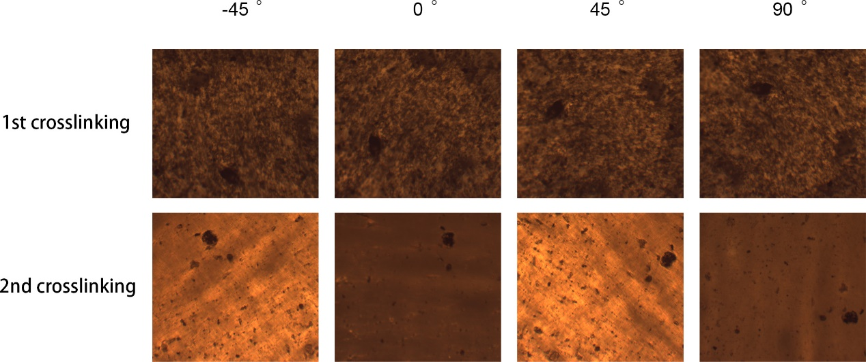
Fig. S4 POM images of the polydomain conformation in LCE matrix after primary crosslinking and the monodomain conformation after secondary crosslinking.
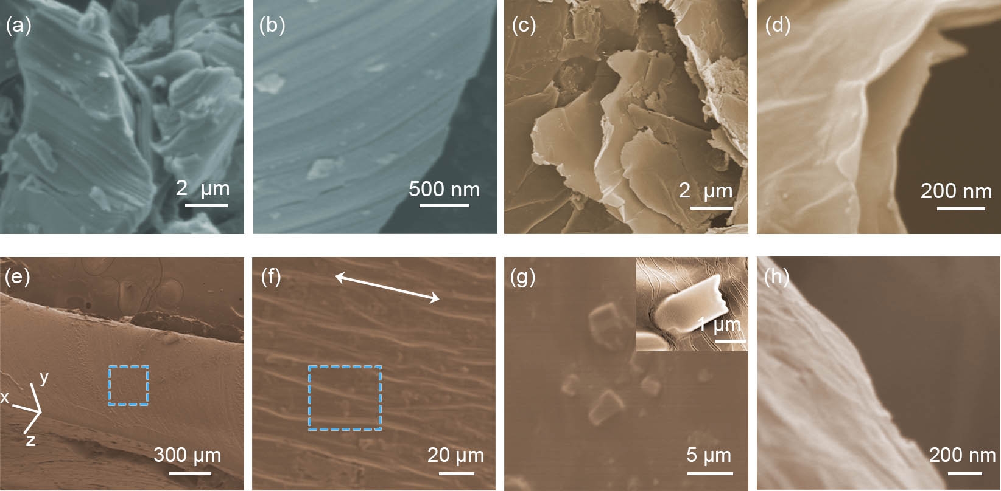
Fig. S5 SEM images of MAX phase (a-b); MXene sheets (c-d); SEM images of LCE-M3 from cross-sectional view (e-g) and the edge area of a MXene sheet (h)

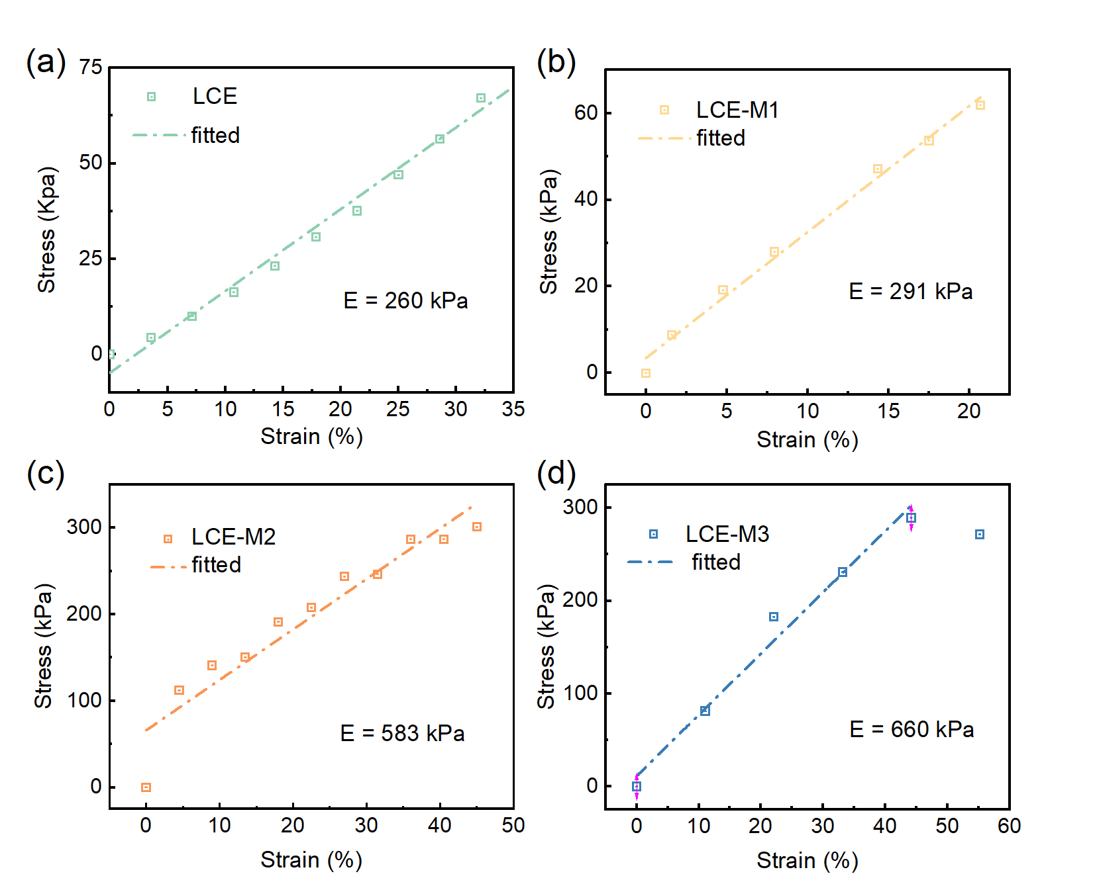
Fig. S6 Stress-strain properties of LCE (a) LCE-M1 (b), LCE-M2 (c), LCE-M3 (d) and corresponding Young’s modulus

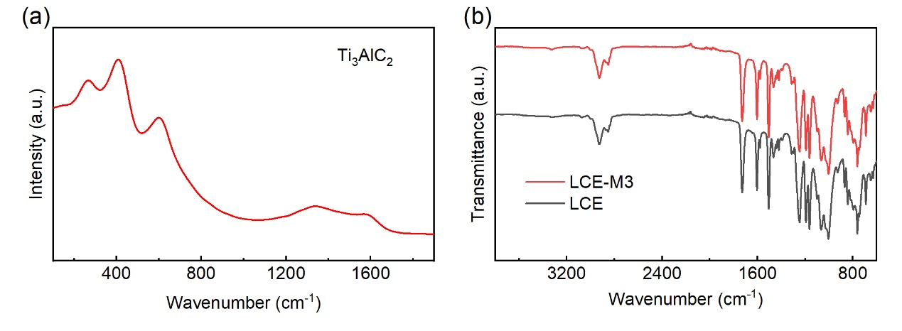
Fig. S7 (a) Raman spectra of Ti₃AlC₂. (b) Comparation of ATR-FTIR spectra of LCE-M3 and LCE
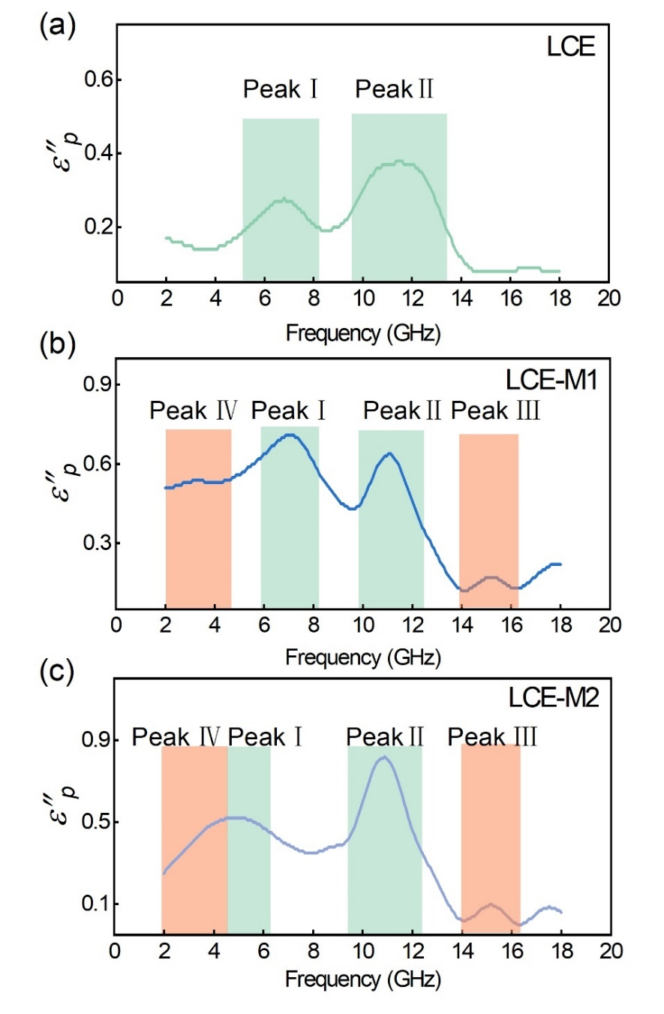
Fig. S8 Relaxation peaks based on ε″_{p} of LCE (a), LCE-M1 (b) and LCE-M2 (c)

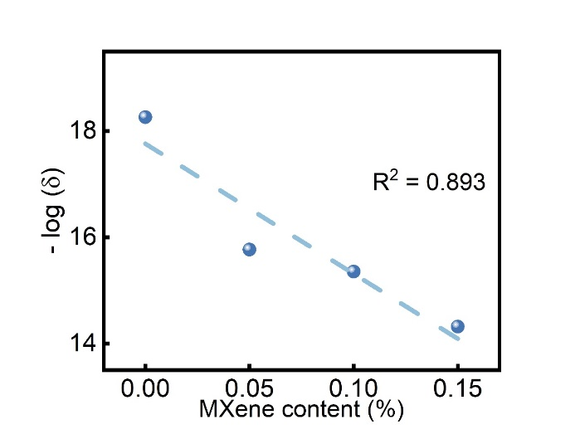
Fig. S9 Linear fitting of the negative logarithm of conductivity versus loading content of MXene in LCE-M

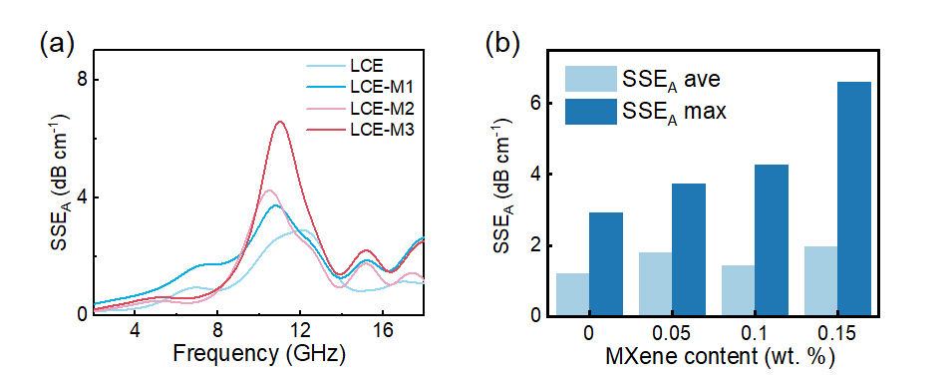
Fig. S10 Specific absorption efficiency (SSE_{A}) of LCE-M composites. (a) Frequency dependent SSE_{A} in the range of 2-18 GHz. (b) Average SSE_{A} and maximum SSE_{A} for various MXene content in LCE-M
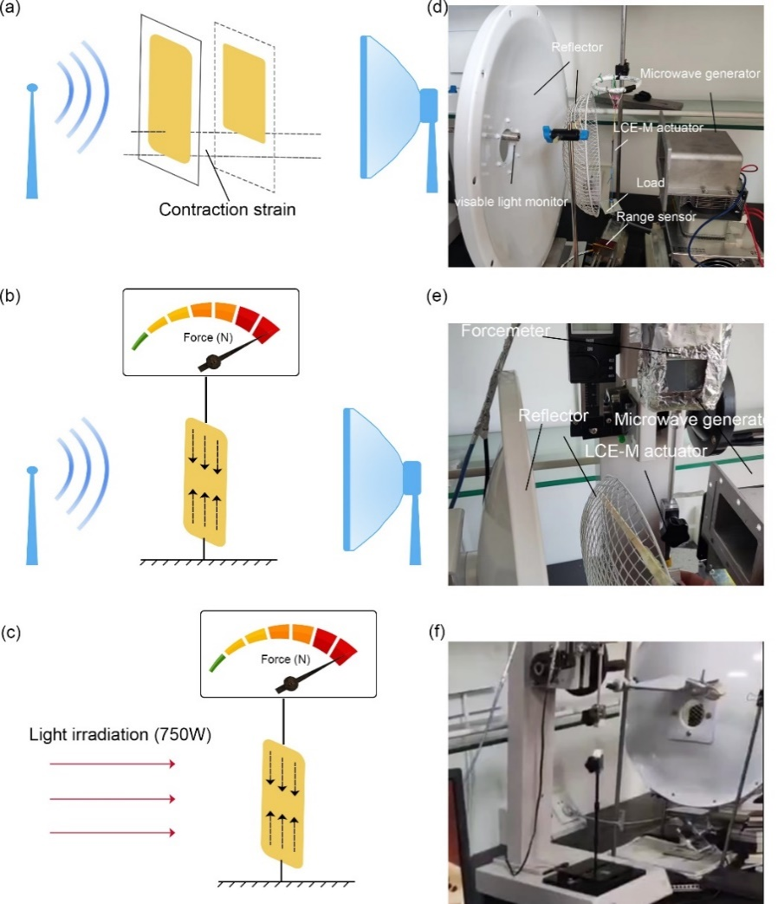
Fig. S11 Deployment of the actuation test. (a-c) Schematic illustration of actuation strain testing (a), microwave actuation stress testing (b) and light actuation stress testing (c). (d-f) Photograph of the testing system corresponding to (a-c)
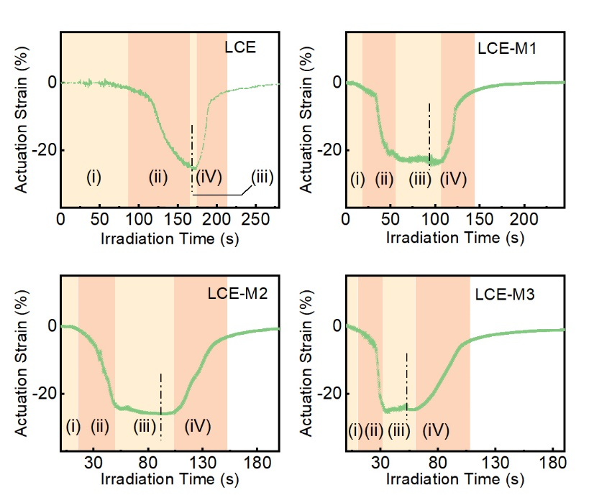
Fig. S12 Actuation strain of the four actuators under microwave irradiation and their recovery in room temperature versus time. The dot-dash lines inset indicate the microwave being switched off
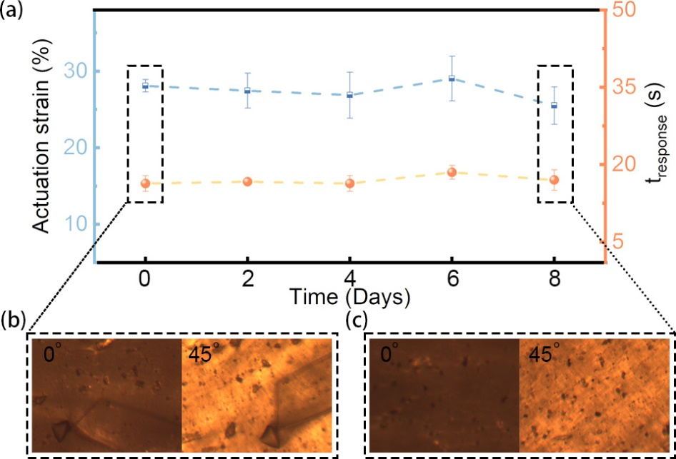
Fig. S13 Stability of LCE-M3 actuator after microwave irradiation and storage for 8days. Sample size for each day is 5
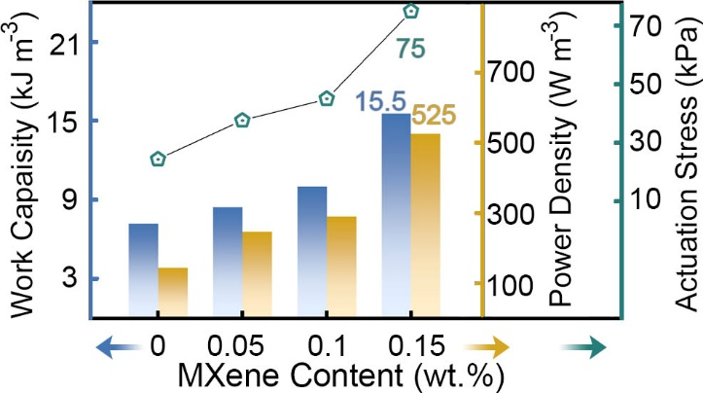
Fig. S14 Actuation stress, work capacity and power density of LCE and LCE-M actuators
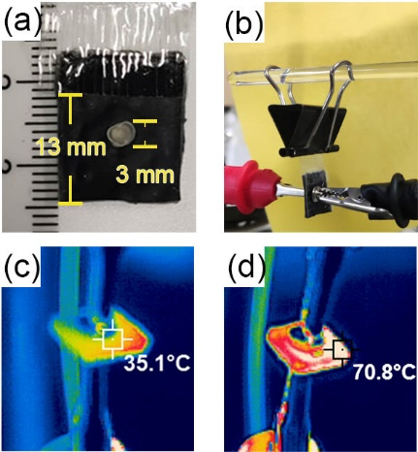
Fig. S15 Photographs of a) prototype self-sensing artificial muscle and b) testing device collecting proprioceptive voltage signal. c-d) Infrared thermal images of PVDF@LCE-M3 before and after actuation
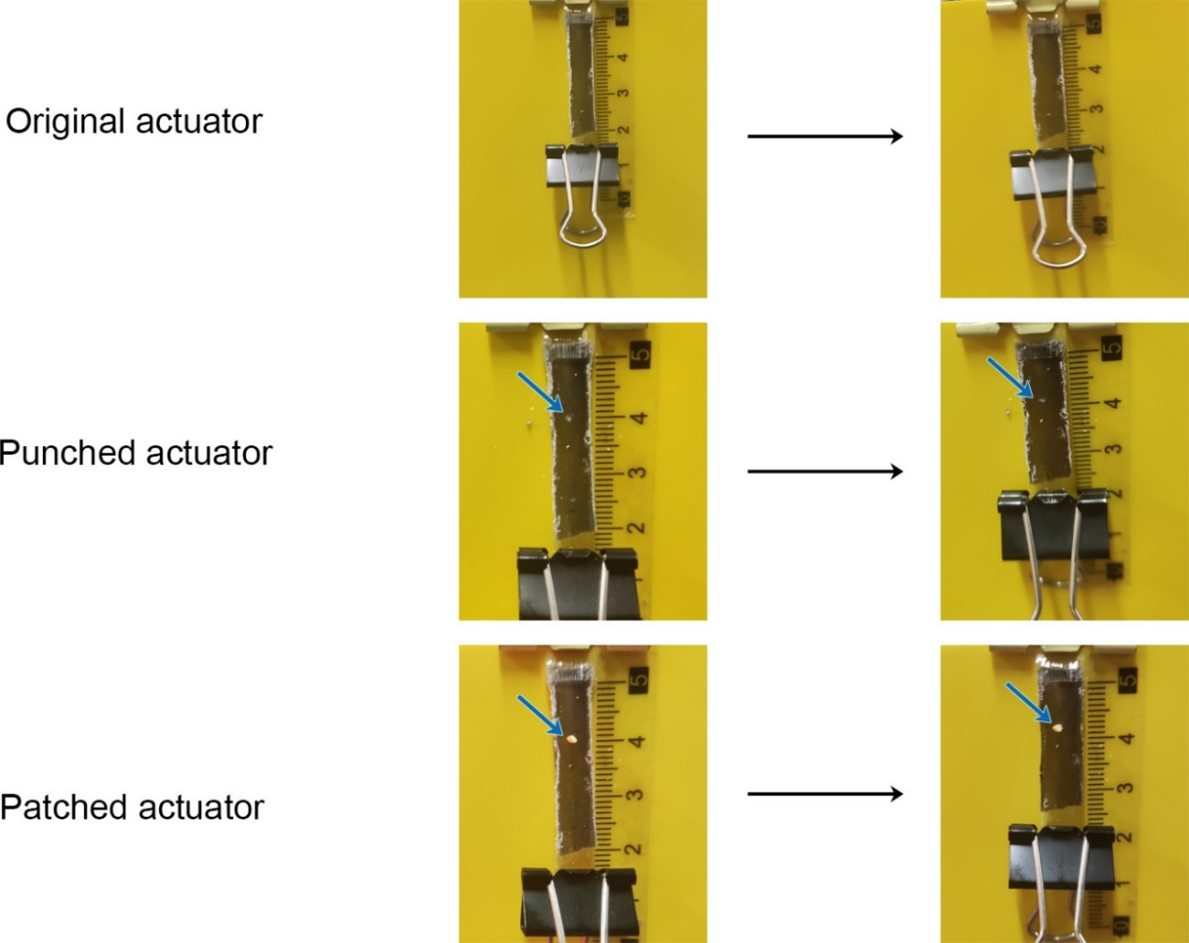
Fig. S16 Photographs depicting the actuation strain of the LCE-M3, as well as its condition before and after patching

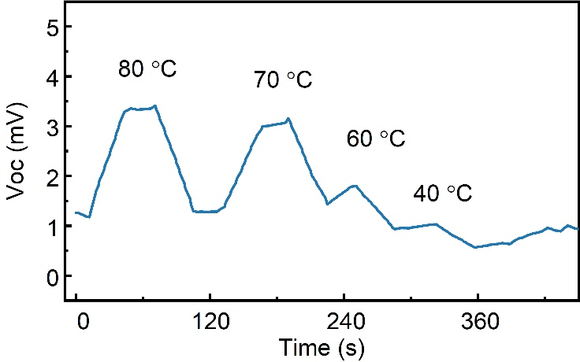
Fig. S17 V_{OC} output collected under different temperature

Table S1 Comparison of microwave responsive shape memory polymers in actuation performance and energy conversion mechanism
Material | Filler content (wt%) | Response time (s)* | Maximum strain (%) | Energy conversion mechanism | Refs.
iron@PLA | 45 | 30 | 43.2 | Condutive & magnetic loss | [S1]
Graphite@PLA | 15 | 5 | - | Not reported | [S2]
CNT@nylon 6 | 2 | 10 | 9.1 | Joule heating | [S3]
SiC@PVA | 1.5 | 45 | - | Dipole movement | [S4]
Expanded graphite@epoxy | 2.15 | 26 | - | Scattering & defect polarization | [S5]
rGO@LCE | 0.3 | 10 | 35.7 | Defect polarization | [S6]
LCE | - | 60 | 32.5 | Molecular polarization | [S7]
MXene-LCE | 0.15 | 10.3 | 25.5 | Multiple polarizaiton | This work
* The specific definitions of response time vary in different literature, and can be significantly influenced by experimental settings. Here, response time is used to describe the period from microwave irradiation to forming significant deformation.
Supplementary References
- T. Y. Koh, A. Sutradhar, Untethered selectively actuated microwave 4d printing through ferromagnetic PLA. Addit. Manuf. 56, 102866 (2022). https://doi.org/10.1016/j.addma.2022.102866
- S. C. An, Y. Lim, Y. C. Jun, Rapid and selective actuation of 3d-printed shape-memory composites via microwave heating. Sci. Rep. 13, 18179 (2023). https://doi.org/10.1038/s41598-023-45519-z
- S. Aziz, B. Villacorta, S. Naficy, B. Salahuddin, S. Gao et al., A microwave powered polymeric artificial muscle. Appl. Mater. Today 23, 101021 (2021). https://doi.org/10.1016/j.apmt.2021.101021
- H. Y. Du, Z. Song, J. J. Wang, Z. H. Liang, Y. H. Shen et al., Microwave-induced shape-memory effect of silicon carbide/poly(vinyl alcohol) composite. Sens. Actuator A Phys. 228, 1-8 (2015). https://doi.org/10.1016/j.sna.2015.01.012
- L. Chen, Y. Liu, J. Leng, Microwave responsive epoxy nanocomposites reinforced by carbon nanomaterials of different dimensions. J. Appl. Polym. Sci. 135, 45676 (2018). https://doi.org/10.1002/app.45676
- Y. C. Wang, Y. Z. Wang, J. C. Shu, W. Q. Cao, C. S. Li et al., Graphene implanted shape memory polymers with dielectric gene dominated highly efficient microwave drive. Adv. Funct. Mater. 33, 2303560 (2023). https://doi.org/10.1002/adfm.202303560
- X. Wang, Y. Wang, X. Wang, H. Niu, B. Ridi et al., A study of the microwave actuation of a liquid crystalline elastomer. Soft Matter 16, 7332-7341 (2020). https://doi.org/10.1039/d0sm00493f

