Supporting Information for
Direct Photolithography of WO_{x} Nanoparticles for High-Resolution Non-Emissive Displays
Chang Gu^{1,2}, Guojian Yang^{1,3,}*, Wenxuan Wang^{1,4}, Aiyan Shi^{1,3}, Wenjuan Fang^{1,2}, Lei Qian^{1,2}, Xiaofei Hu^{1,2}, Ting Zhang^{1,2,}*, Chaoyu Xiang^{1,2,}* and Yu-Mo Zhang^{5,}*
¹ Laboratory of Optoelectronic Information Technology and Devices, Ningbo Institute of Materials Technology and Engineering, Chinese Academy of Sciences, Ningbo, Zhejiang 315201, P. R. China
² Hangzhou Bay Laboratory of Advanced Nano-Optoelectronic Materials and Devices, Qianwan Institute of CNITECH, Ningbo, Zhejiang 315336, P. R. China
³ Smart Materials for Architecture Research Lab, Innovation Center of Yangtze River Delta, Zhejiang University, Jiaxing 314100, P. R. China
⁴ University of Science and Technology of China, Hefei 230026, P. R. China
⁵ State Key Lab of Supramolecular Structure and Materials, College of Chemistry, Jilin University, Changchun 130012, P.R. China
* Corresponding authors. E-mail: yangguojian1@nimte.ac.cn (Guojian Yang); zhangting@nimte.ac.cn (Ting Zhang); xiangchaoyu@nimte.ac.cn (Chaoyu Xiang); zhangyumo@jlu.edu.cn (Yu-Mo Zhang)

Supplementary Notes

Note S1 Materials
Tungsten chloride (WCl₆, 99.5%) was obtained from Energy Chemical (3A) Company. Zinc sulfate heptahydrate (ZnSO₄·7H₂O, 99%) was purchased from Macklin Company. Oleic acid (OA, 90%) was purchased from Alfa Aesar. Oleylamine (OAm, C18: 80-90%) and n-hexane (≥98%) were purchased from Aladdin Reagent Company. Toluene and isopropanol were obtained from Sinopharm Chemical Reagent Co., Ltd. PAGs including MBT (2-(4-methoxystyryl)-4,6-bis(trichloromethyl)-1,3,5-triazine, 98%), PAG-1 ((4-methylthiophenyl)methyl phenyl sulfonium triflate), PAG-2 (triphenylsulfonium trifluoromethanesulfonate) and PAG-3 (diphenyliodonium triflate, ≥99%) were obtained from Sigma Aldrich. Zn foil (>99.9%) was purchased from Yuqian Metal Materials, Hebei province, China.
ITO (10 Ω sq⁻¹) and PET-ITO (15 Ω sq⁻¹) were obtained from HUAYI ELECTRONIC Co., Ltd, Southern China Xiang's Science & Technology, and Liaoning Advanced Election Technology, respectively. ITO was cleaned with deionized water, and then washed with acetone and isopropanol for 15 min before use.

Note S2 Instrument characterization
UV-vis spectra were measured using a Shimadzu UV-2600i double-beam spectrophotometer. Electrochemistry experiments were performed using a Bio-logic electrochemical workstation at room temperature unless other mentioned. The morphology was observed with a Hitachi SU8200 scanning electron microscope (SEM), Bruker DIMENSION Icon (AFM), and Talos F200X Transmission Electron Microscope (TEM). Thermogravimetric analysis (TGA) was determined with a TGA209F1 (NETZSCH) at a heating rate of 10 ºC/min under a flow of nitrogen. X-ray diffraction (XRD) analysis was determined with ADVANCE D8 (Bruker). X-ray photoelectron spectroscopy (XPS) was performed using an AXIS SUPRA+. Fourier transform infrared (FT-IR) spectra were performed using a IS50 (Thermo Fisher Scientific).
Direct photolithography was performed with a UV LED lamp (centered at 365 nm, 60 mW/cm²) from Yanxizao Factory, Zhongshan, China. The power density was measured by UV-Integrator from Yeguan Factory, Shenzhen, China. EC materials were coated on the substrate by EZ4 SPIN COATER (Schwan technology).

Note S3 Size calculation of WO_{x} nanoparticles
The size of WO_{x} nanoparticles was calculated using Scherrer equation (D = K λ / (β cosθ) (Ref S2). Here, K is a numerical factor frequently referred to as the crystallite-shape factor (~0.89). λ is the wavelength of the X-rays. β is the width (full-width at half-maximum) of the X-ray diffraction peak in radians and θ is the Bragg angle. And D is the crystallite size. Here, the clear XRD peak at 23.7 (2θ) was used to calculate the size of WO_{x} nanoparticles.

Note S4 Adhesion test
The adhesion of WO_{x} films with ITO electrode was measured by the coat tester (EDKORS QFH-A). And a transparent tape (3M-600) was used to assist in peeling, as shown in Fig. S7.
Based on the international cross-cut method of Standard Test Methods for Rating Adhesion by Tape Test in ASTM-3359, the classification represents different film removal percent including 5B (None), 4B (less than 5%), 3B (5% - 15%), 2B (15% - 35%), 1B (35% - 65%) and 0B (greater than 65%).

Supplementary Figures
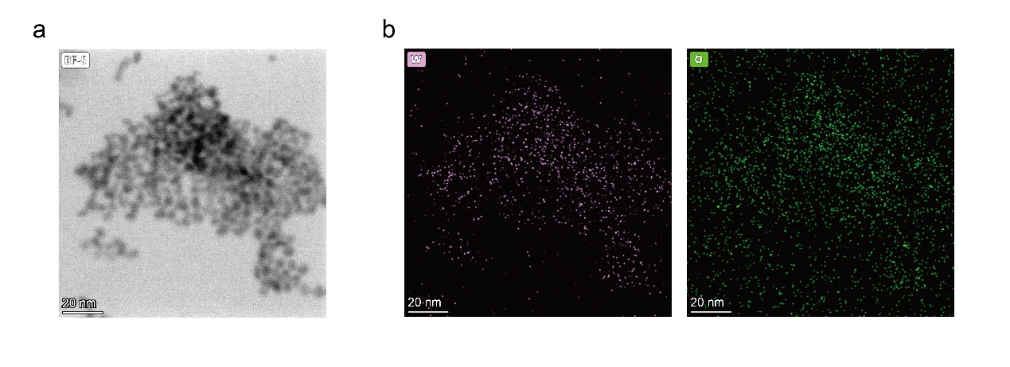
Fig. S1 STEM image (a) and corresponding EDS elemental mapping of W and O elements (b)

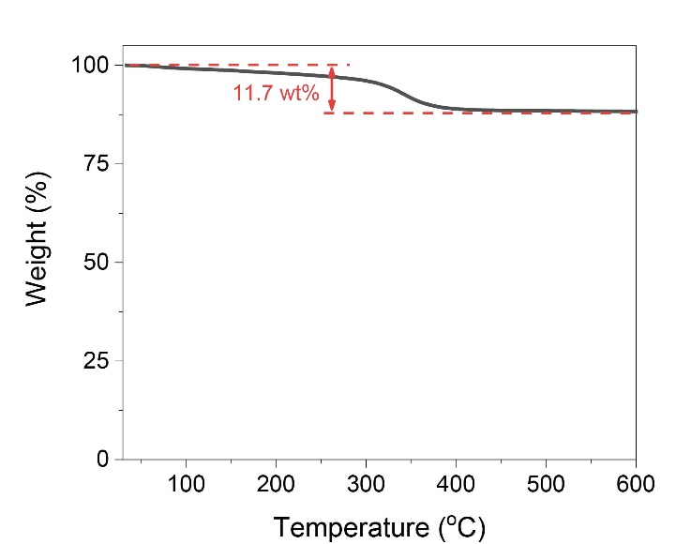
Fig. S2 Result of thermogravimetry of as-synthesized WO_{x} NPs
Note: the content of surface ligand might be slightly lower than the actual value due to the loss of ligand during multiple post-processing and drying preparation for the test sample.

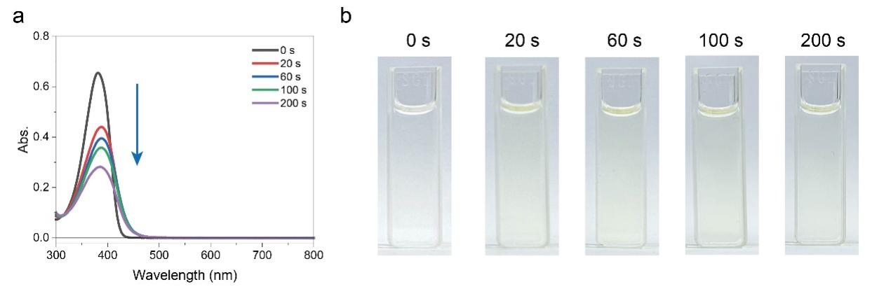
Fig. S3 UV-vis spectra (a) and corresponding photos (b) of MBT (0.01 mg/mL in toluene) under a UV radiation (centered at 365 nm) for different times

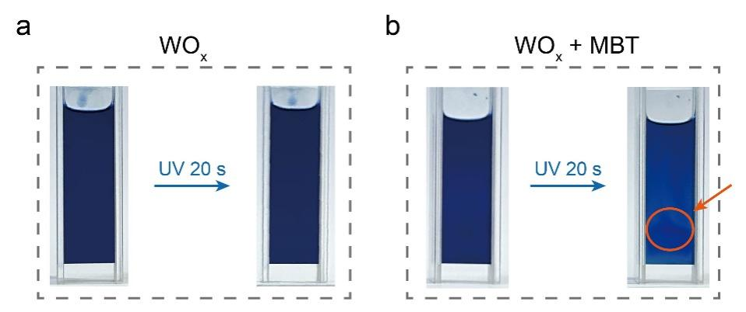
Fig. S4 Photos of WO_{x} NPs (3 mg/mL in toluene) without (a) and with (b) 10 wt% MBT before and after UV radiation (centered at 365 nm). The insoluble precipitations were marked

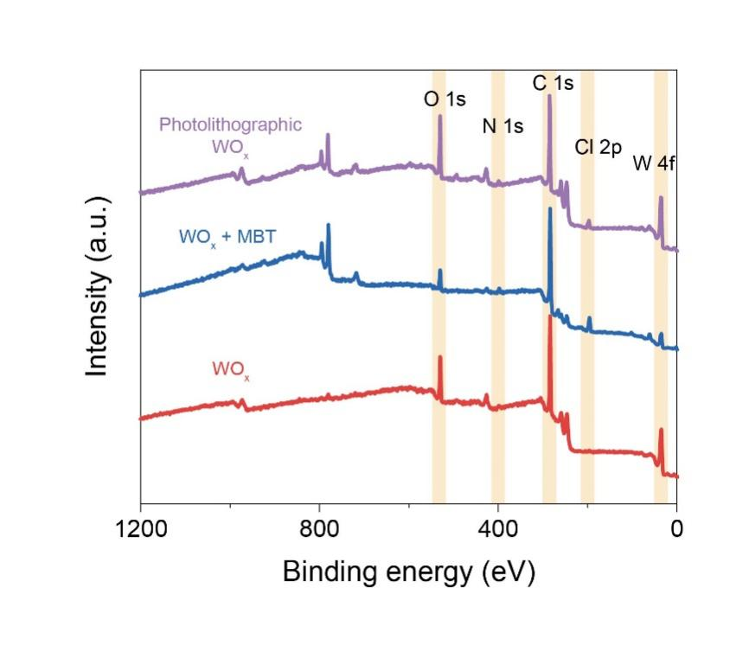
Fig. S5 XPS survey spectra of pristine WO_{x}, WO_{x} with 20.0 wt% MBT, and photolithographic WO_{x}

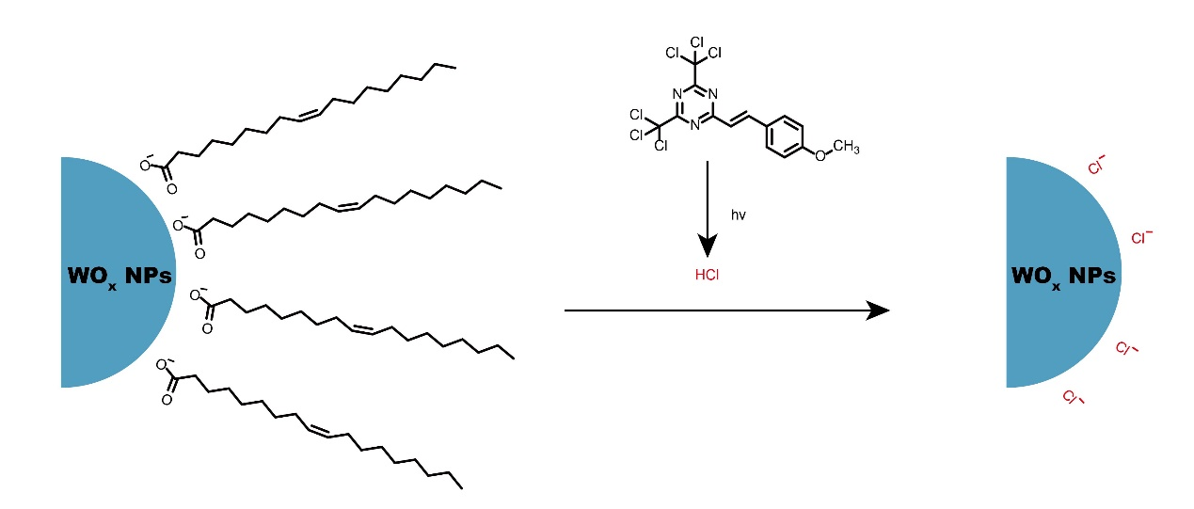
Fig. S6 The schematic of direct photolithography of WO_{x} NPs via in situ ligand exchange from organic ligands, taking oleic acid (OA) as an example, to chlorine (Cl) ligand

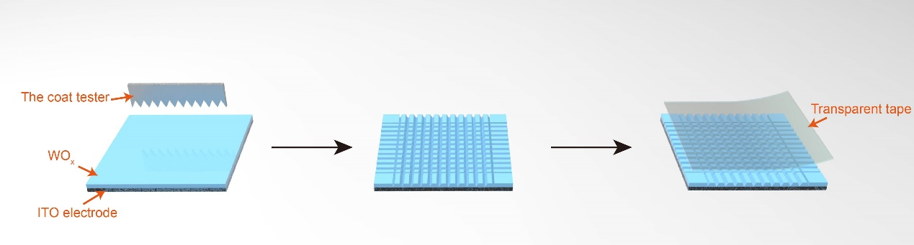
Fig. S7 The schematic of the adhesion test of WO_{x} films on ITO electrode by the coat tester

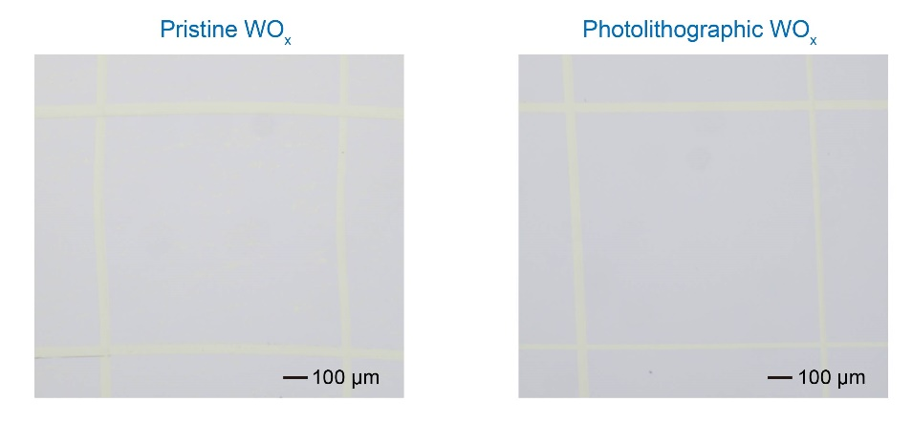
Fig. S8 The microscopic images of pristine WO_{x} and photolithographic WO_{x} films treated by the coat tester
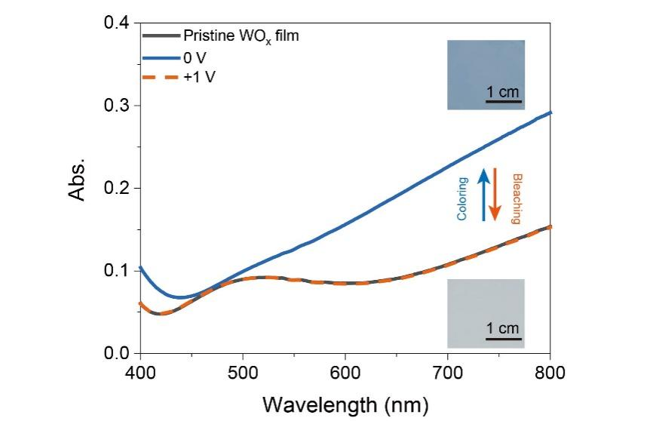
Fig. S9 The absorption spectra in visible region of pristine WO_{x} film under different electrochemical stimulations and corresponding photos
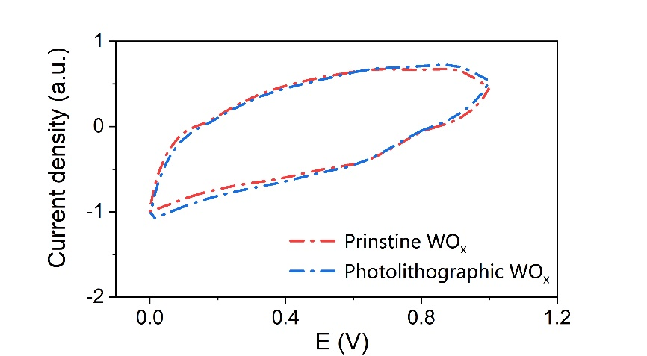
Fig. S10 The CV data of pristine WO_{x} and photolithographic WO_{x}. Scan rate: 100 mV/s. A zinc foil was used as the counter electrode. 1.0 mol/L ZnSO₄ in deionized water was used as the electrolyte solution

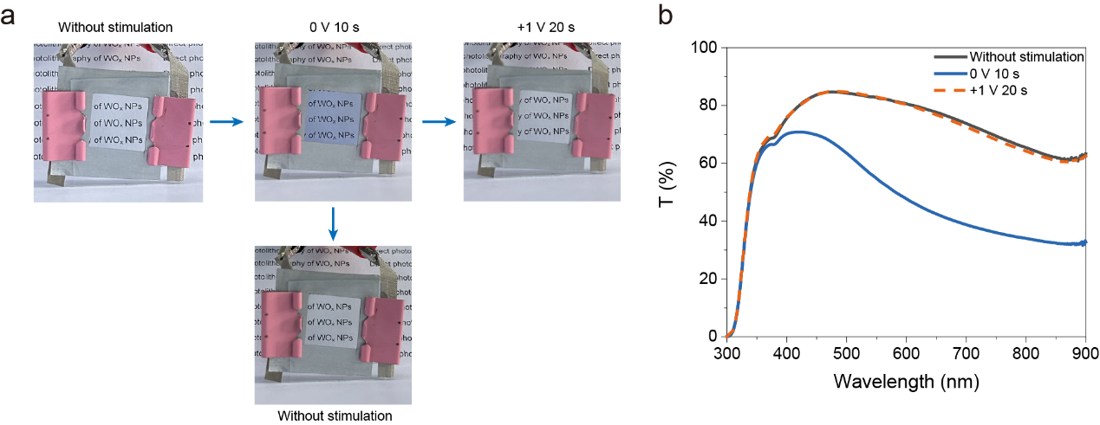
Fig. S11 Photos (a) and transmittance spectra (b) of the self-powered EC device prepared by photolithographic WO_{x} NPs in different optical states

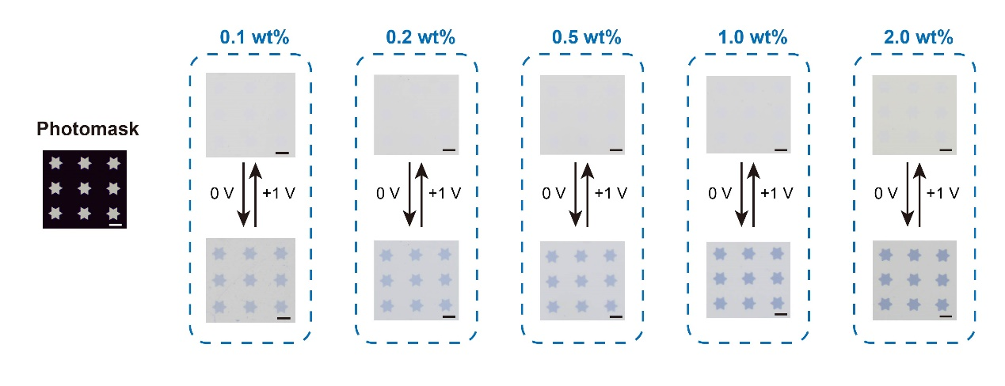
Fig. S12 Photos of the photomask (left) and as-prepared EC devices (right) under different optical states with different MBT contents. Scale bar: 50 μm

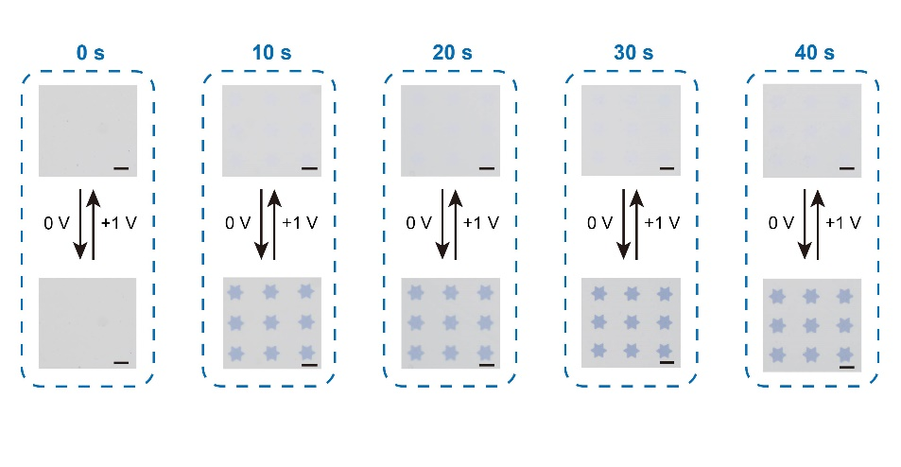
Fig. S13 Photos of as-prepared EC devices under different optical states with different UV times. Scale bar: 50 μm

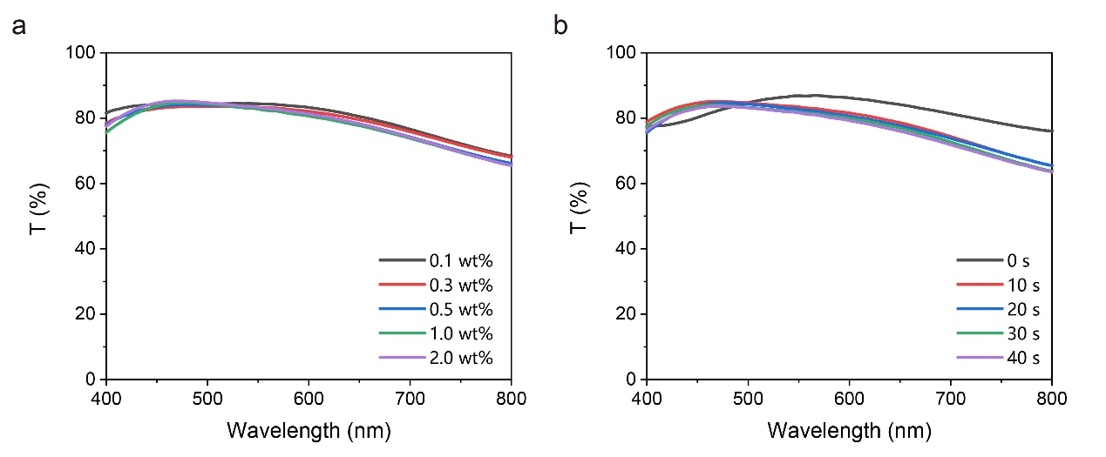
Fig. S14 The visible spectra of EC devices based on photolithographic WO_{x} film with different MBT contents (a) and UV times (b). Note that the WO_{x} film could be dissolved by the developer when the UV time was 0 s, resulting a large spectral difference with other devices
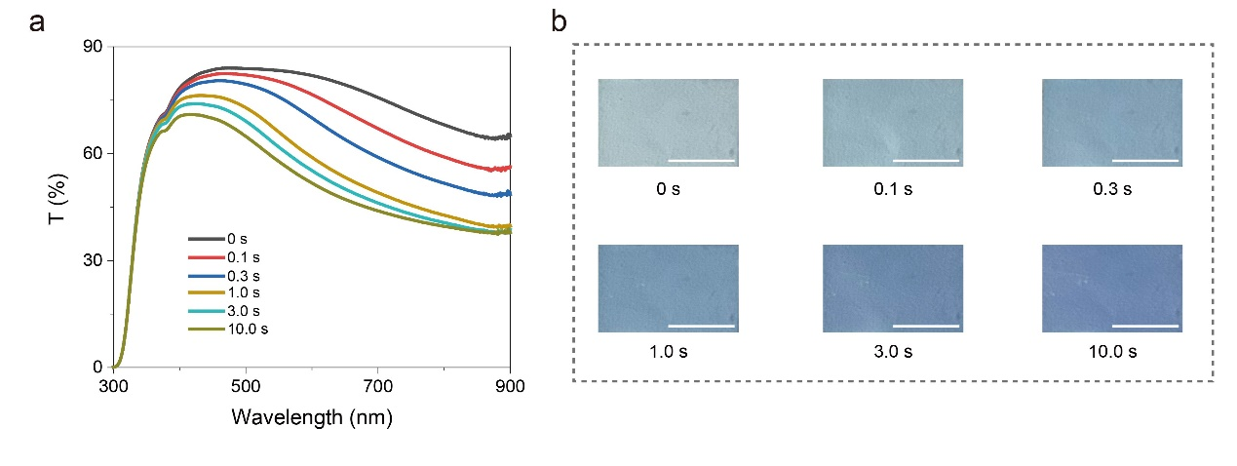
Fig. S15 The UV-vis spectra (a) and photos (b) of the EC device based on photolithographic WO_{x} film (thickness: ~53 nm) under electrical stimulations of 0 V for different times. Scale bar: 1 cm
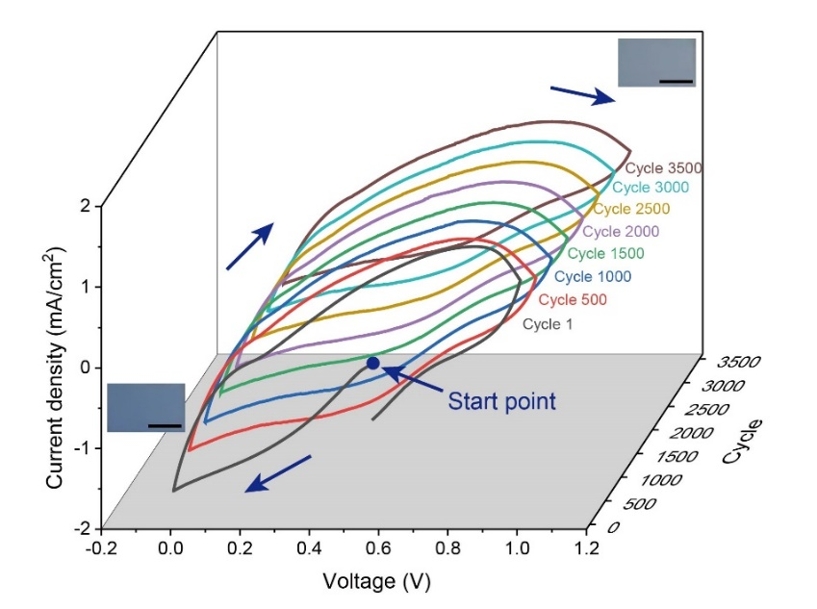
Fig. S16 The CV data of the device at different cycles. Scan rate: 500 mV/s. Insert: photos of the device at the colored state and colorless state in CV tests. Scale bar: 1 cm
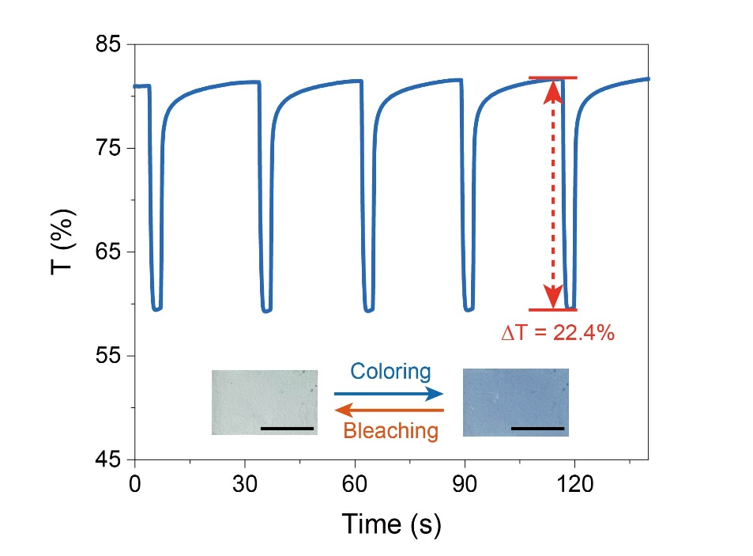
Fig. S17 Transmittance at 633 nm of the EC device after cyclic stability test under the electrical stimulations of 0 V 1 s in coloring processes. And +1 V was used for corresponding bleaching processes. Insert: photos of the device at the colored state and colorless state. Scale bar: 1 cm.
Note: the device still had a remarkable optical modulation after cyclic stability test (ΔT = 22.4%). Compared with its optical modulation before cyclic stability test (ΔT = 28.7%), its optical modulation was well maintained (maintain ratio = ~78%).

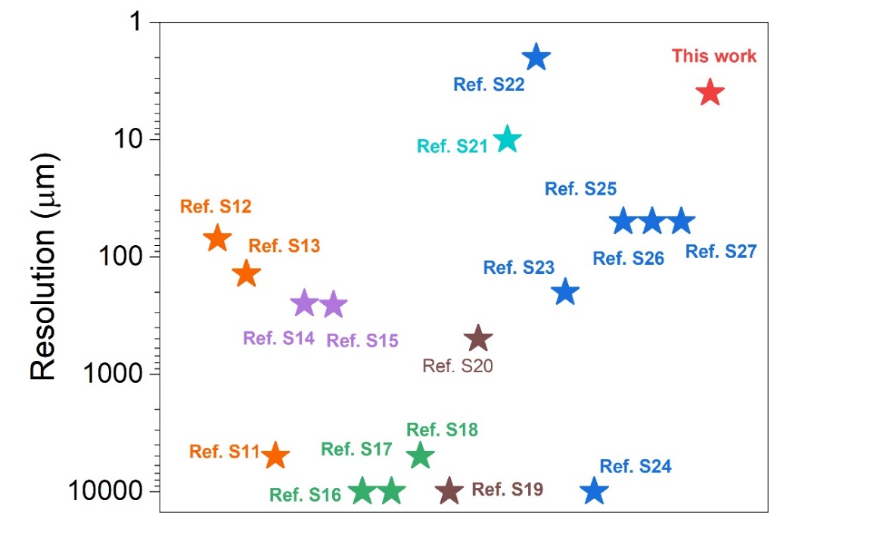

Fig. S18 Reported resolution (pattern size or line width) of EC patterns. Corresponding data were listed on Table S3

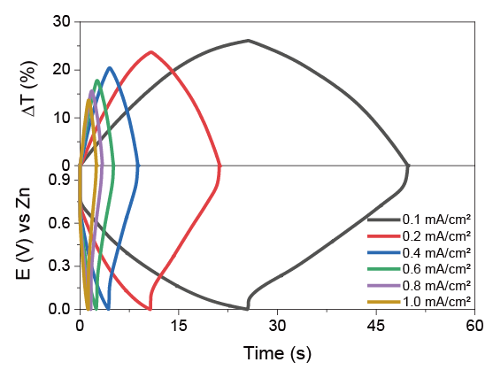
Fig. S19 Galvanostatic charge and discharge curves (bottom) of EC devices based on photolithographic WO_{x} film and corresponding transmittance changes at 633 nm (top)

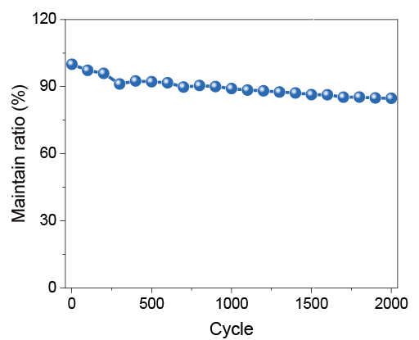
Fig. S20 Long-term cycling performance at 1.0 mA/cm² between 0 V and +1 V for 2000 cycles
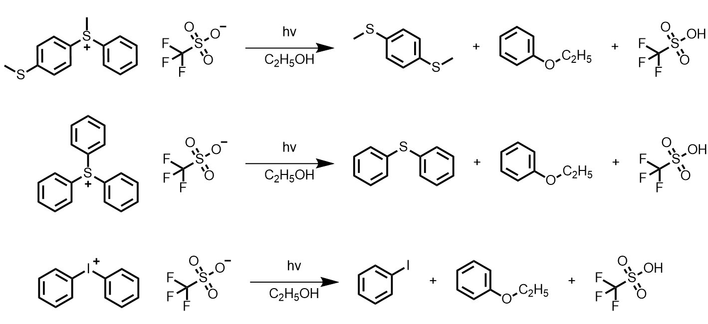
Fig. S21 Photochemical reaction processes of PAGs under deep UV radiation

Supplementary Tables
Table S1 The thickness of photolithographic WO_{x} film via different spin speeds
Spin speed (rpm) | Thickness (nm)
5000 | ~18
3000 | ~30
1000 | ~53
500 | ~71
200 | ~90
Table S2 EC performance of devices or films based on WO_{x}
Refs. | EC materials | EC electrode or device | Coloring voltage (V) | Response  Speed (s) | Cyclic  stability | Optical  Modulation (%) | Coloration  efficiency  (cm²/C)
[S1] | WO_{x} | Device | 0 V | 4.5 s | 1000 | 76% at 633 nm | 97.7
[S3] | WO₃ | Device | −3.0 V | 2.4 s | 2000 | <20% (reflection mode) | -
[S4] | WO₃ | Device | +0.1 V | 4.0 s | 1000 | 72.6% | 101.6
[S5] | WO₃ | Device | 2.4 V | 0.7 s | 3000 | 90% at 650 nm | 109
[S6] | WO₃ | Device | 1.2 V | 5.7 s | 200 | ~77% | -
[S7] | m-WO_{3-x} | Film | −0.9 V (vs. Ag/Ag⁺) | 16 s | 2000 | 93.2% | 121
[S8] | a-WO₃ | Device | −3.5 V | 12 s | 1000 | 70% | 133
[S9] | WO₃ and NiO  nanostructured  films | Device | −2.5 V | 10 s | 100 | 75.4% | 131.9
[S10] | WO₃ | Electrode | 2.0 - 4.0 V (vs. Li/Li⁺) | - | 400 | 50% | -
[S11] | WO₃ | Electrode | −1.2 V | - | ~8 | ~60% | 65.5
This work | WO_{x} | Device | 0 V | < 1 s | >3600 | 55.9% at 633 nm | 119.5

Table S3 Reported resolution of EC patterns
Refs. | Patterning method | EC materials | Pattern size or line width
[S12] | Inkjet printing | Metallo-supramolecular polymers | 70 μm
[S13] | Inkjet printing | Conjugated polymer | 140 μm
[S11] | Inkjet printing | WO₃ | < 5 mm
[S14] | Dispensing printing | WO₃ | < 250 μm
[S15] | Dispensing printing | Viologen | 258 μm
[S16] | Screen printing | Conjugated polymer | ≥ 1 cm²
[S17] | Screen printing | Conjugated polymer | < 1 cm²
[S18] | Screen printing | Conjugated polymer | 5 × 5 mm²
[S19] | Template | Viologen | 1 × 1 mm²
[S20] | Template | Conjugated polymer | 500 μm
[S21] | Thermal curing | Conjugated polymer | ≥ 10 μm
[S22] | Direct photolithography | Organic materials based on proton-coupled electron transfer | ~ 2 μm
[S23] | Direct photolithography | Viologen | 200 μm
[S24] | Direct photolithography | Conjugated polymer | 1 × 1 mm²
[S25] | Direct photolithography | Conjugated polymer | 50 μm
[S26] | Direct photolithography | PProDOT (conjugated polymer) | < 50 μm
[S27] | Direct photolithography | PEDOT:PSS | < 50 μm
This work | Direct photolithography | WO_{x} NPs | < 4 μm

Supplementary References
- L. Zhang, D. Chao, P. Yang, L. Weber, J. Li et al., Flexible pseudocapacitive electrochromics via inkjet printing of additive-free tungsten oxide nanocrystal ink. Adv. Energy Mater. 10, 2000142 (2020). https://doi.org/10.1002/aenm.202000142
- U. Holzwarth, N. Gibson, The scherrer equation versus the ‘Debye-scherrer equation’. Nat. Nanotechnol. 6, 534 (2011). https://doi.org/10.1038/nnano.2011.145
- Y. Li, P. Sun, J. Chen, X. Zha, X. Tang et al., Colorful electrochromic displays with high visual quality based on porous metamaterials. Adv. Mater. 35, 2300116 (2023). https://doi.org/10.1002/adma.202300116
- W. Zhang, H. Li, A.Y. Elezzabi A dual-mode electrochromic platform integrating zinc anode-based and rocking-chair electrochromic devices. Adv. Funct. Mater. 33, 2300155 (2023). https://doi.org/10.1002/adfm.202300155
- Z. Shao, A. Huang, C. Ming, J. Bell, P. Yu et al., All-solid-state proton-based tandem structures for fast-switching electrochromic devices. Nat. Electron. 5, 45–52 (2022). https://doi.org/10.1038/s41928-021-00697-4
- H. Li, C.J. Firby, A.Y. Elezzabi, Rechargeable aqueous hybrid Zn²⁺/Al³⁺ electrochromic batteries. Joule 3, 2268–2278 (2019). https://doi.org/10.1016/j.joule.2019.06.021
- S. Zhang, S. Cao, T. Zhang, A. Fisher, J.Y. Lee, Al³⁺ intercalation/de-intercalation-enabled dual-band electrochromic smart windows with a high optical modulation, quick response and long cycle life. Energy Environ. Sci. 11, 2884–2892 (2018). https://doi.org/10.1039/C8EE01718B
- W. Cheng, J. He, K.E. Dettelbach, N.J.J. Johnson, R.S. Sherbo et al., Photodeposited amorphous oxide films for electrochromic windows. Chem 4, 821–832 (2018). https://doi.org/10.1016/j.chempr.2017.12.030
- G. Cai, P. Darmawan, M. Cui, J. Chen, X. Wang et al., Inkjet-printed all solid-state electrochromic devices based on NiO/WO₃ nanoparticle complementary electrodes. Nanoscale 8, 348–357 (2016). https://doi.org/10.1039/C5NR06995E
- R.-T. Wen, C.G. Granqvist, G.A. Niklasson, Eliminating degradation and uncovering ion-trapping dynamics in electrochromic WO₃ thin films. Nat. Mater. 14, 996–1001 (2015). https://doi.org/10.1038/nmat4368
- M. Layani, P. Darmawan, W.L. Foo, L. Liu, A. Kamyshny et al., Nanostructured electrochromic films by inkjet printing on large area and flexible transparent silver electrodes. Nanoscale 6, 4572–4576 (2014). https://doi.org/10.1039/C3NR06890K
- B.-H. Chen, S.-Y. Kao, C.-W. Hu, M. Higuchi, K.-C. Ho et al., Printed multicolor high-contrast electrochromic devices. ACS Appl. Mater. Interfaces 7, 25069–25076 (2015). https://doi.org/10.1021/acsami.5b08061
- A.M. Österholm, D.E. Shen, D.S. Gottfried, J.R. Reynolds, Full color control and high-resolution patterning from inkjet printable cyan/magenta/yellow colored-to-colorless electrochromic polymer inks. Adv. Mater. Technol. 1, 1600063 (2016). https://doi.org/10.1002/admt.201600063
- X. Li, T.Y. Yun, K.W. Kim, S.H. Kim, H.C. Moon, Voltage-tunable dual image of electrostatic force-assisted dispensing printed, tungsten trioxide-based electrochromic devices with a symmetric configuration. ACS Appl. Mater. Interfaces 12, 4022–4030 (2020). https://doi.org/10.1021/acsami.9b21254
- K.W. Kim, H. Oh, J.H. Bae, H. Kim, H.C. Moon et al., Electrostatic-force-assisted dispensing printing of electrochromic gels for low-voltage displays. ACS Appl. Mater. Interfaces 9, 18994–19000 (2017). https://doi.org/10.1021/acsami.7b00946
- P. Andersson, R. Forchheimer, P. Tehrani, M. Berggren, Printable all-organic electrochromic active-matrix displays. Adv. Funct. Mater. 17, 3074–3082 (2007). https://doi.org/10.1002/adfm.200601241
- X. Cao, C. Lau, Y. Liu, F. Wu, H. Gui et al., Fully screen-printed, large-area, and flexible active-matrix electrochromic displays using carbon nanotube thin-film transistors. ACS Nano 10, 9816–9822 (2016). https://doi.org/10.1021/acsnano.6b05368
- P. Andersson Ersman, R. Lassnig, J. Strandberg, P. Dyreklev, Flexible active matrix addressed displays manufactured by screen printing. Adv. Eng. Mater. 23, 2000771 (2021). https://doi.org/10.1002/adem.202000771
- H.C. Moon, T.P. Lodge, C.D. Frisbie, Solution processable, electrochromic ion gels for sub-1 V, flexible displays on plastic. Chem. Mater. 27, 1420–1425 (2015). https://doi.org/10.1021/acs.chemmater.5b00026
- D. Kim, J. Kim, Y. Ko, K. Shim, J.H. Kim et al., A facile approach for constructing conductive polymer patterns for application in electrochromic devices and flexible microelectrodes. ACS Appl. Mater. Interfaces 8, 33175–33182 (2016). https://doi.org/10.1021/acsami.6b10103
- T.J. Gordon, J. Yu, C. Yang, S. Holdcroft, Direct thermal patterning of a π-conjugated polymer. Chem. Mater. 19, 2155–2161 (2007). https://doi.org/10.1021/cm062107c
- C. Gu, S. Wang, J. He, Y.-M. Zhang, S.X.-A. Zhang, High-durability organic electrochromic devices based on in-situ-photocurable electrochromic materials. Chem 9, 2841–2854 (2023). https://doi.org/10.1016/j.chempr.2023.05.015
- J.-W. Kim, J.-M. Myoung, Flexible and transparent electrochromic displays with simultaneously implementable subpixelated ion gel-based viologens by multiple patterning. Adv. Funct. Mater. 29, 1808911 (2019). https://doi.org/10.1002/adfm.201808911
- J. Jensen, A.L. Dyer, D.E. Shen, F.C. Krebs, J.R. Reynolds, Direct photopatterning of electrochromic polymers. Adv. Funct. Mater. 23, 3728–3737 (2013). https://doi.org/10.1002/adfm.201203005
- J. Kim, J. You, B. Kim, T. Park, E. Kim, Solution processable and patternable poly(3, 4-alkylenedioxythiophene)s for large-area electrochromic films. Adv. Mater. 23, 4168–4173 (2011). https://doi.org/10.1002/adma.201101900
- C. Huang, Y.-Q.-Q. Yi, Z. Hu, S. Zhang, X. Wu et al., Photolithographically patterned and highly stable electrochromic displays enabled by a photo-assisted cross-linker. J. Mater. Chem. C 11, 15591–15598 (2023). https://doi.org/10.1039/D3TC03088A
- G. Yang, J. Fan, K. Zhang, C. Gu, J. Li et al., Electrochromic reflective displays based on in situ photo-crosslinked PEDOT: PSS patterns. Adv. Funct. Mater. 34, 2314983 (2024). https://doi.org/10.1002/adfm.202314983

