Supporting Information for
Efficient and Stable Photo-Assisted Lithium-Ion Battery Enabled by Photocathode with Synergistically Boosted Carriers Dynamics
Zelin Ma^{1,‡}, Shiyao Wang^{2,‡}, Zhuangzhuang Ma⁵, Juan Li³, Luomeng Zhao¹, Zhihuan Li³, Shiyuan Wang¹, Yazhou Shuang¹, Jiulong Wang¹, Fang Wang¹, Weiwei Xia¹, Jie Jian¹, Yibo He^{3, 4,}* Junjie Wang², Pengfei Guo^{1,4,}* and Hongqiang Wang^{1,}*
¹State Key Laboratory of Solidification Processing, Center for Nano Energy Materials, School of Materials Science and Engineering, Northwestern Polytechnical University and Shaanxi Joint Laboratory of Graphene (NPU), Xi’an 710072, P. R. China
²State Key Laboratory of Solidification Processing, School of Materials Science and Engineering Department, Northwestern Polytechnical University, Xi’an 710072, P. R. China
³State Key Laboratory of Solidification Processing, Center of Advanced Lubrication and Seal Materials, School of Materials Science and Engineering, Northwestern Polytechnical University, Xi’an, Shaanxi 710072, P. R. China
⁴Research& Development Institute of Northwestern Polytechnical University in Shenzhen, Shenzhen, 518063, P. R. China
⁵Key Laboratory of Applied Surface and Colloid Chemistry, Shaanxi Key Laboratory for Advanced Energy Devices, Shaanxi Engineering Lab for Advanced Energy Technology, School of Materials Science and Engineering, National Ministry of Education, Shaanxi Normal University, Xi'an 710119, P. R. China
‡ Zelin Ma and Shiyao Wang contributed equally to this work.
*Corresponding authors. E-mail: heyibo@nwpu.edu.cn (Yibo He); guopengfei@nwpu.edu.cn (Pengfei Guo); hongqiang.wang@nwpu.edu.cn (Hongqiang Wang)
Supplementary Figures and Tables

Fig. S1 Optimized structure models of (a) TiO₂ and (b) Au-TiO₂
Fig. S2 Schematic diagram of preparation process for Au nanocrystals-embedded TiO₂ nanofibers

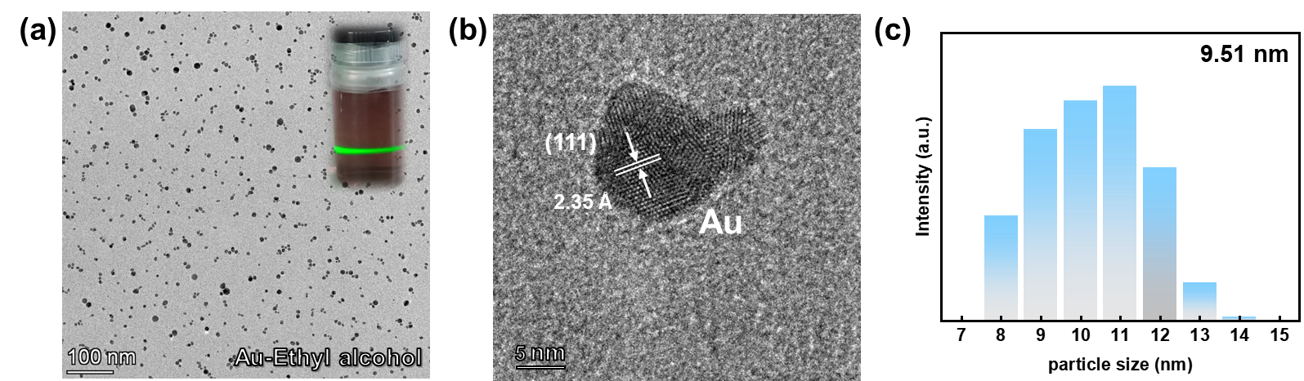

Fig. S3 (a) TEM image of Au nanocrystals prepared by laser irradiation (insert, Mie-scattering image of laser-manufactured Au colloidal solution), (b) HRTEM image of Au nanocrystal and (c) particle size distribution histogram of Au nanocrystals

Fig. S4 XRD patterns and Rietveld plots of TiO₂

Fig. S5 XPS spectra of Ti-2p peaks of TiO₂ and Au-TiO₂

Fig. S6 SEM images of TiO₂ and Au-TiO₂ nanofibers

Fig. S7 SEM image of TiO₂ nanofibers with Au nanoparticles prepared by the traditional method with surfactants

Fig. S8 TEM and HRTEM images of TiO₂ nanofibers

Fig. S9 EDX mapping images of TiO₂ nanofibers (Ti and O elements)

Fig. S10 Schematic diagram of the photodetector measurement system

Fig. S11 LSV curves of TiO₂ and Au-TiO₂ in illuminated conditions

Fig. S12 I-t curves of TiO₂ and Au-TiO₂ in illumination conditions at an external bias voltage of 1V

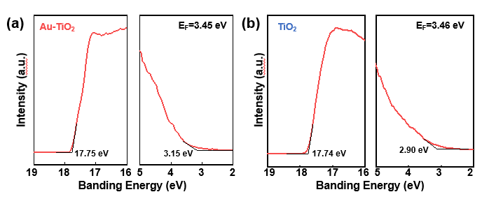
Fig. S13 UPS spectra of (a) Au-TiO₂ and (b) TiO₂
Fig. S14 Structure diagram (a) and optical photograph (b) of photo-assisted coin cell

Fig. S15 Discharge-charge curves of TiO₂ samples at 0.2 A g⁻¹ in the dark and light conditions

Fig. S16 dQ/dV versus voltage of TiO₂ samples at 0.2 A g⁻¹ in the dark and light conditions

Fig. S17 Photo-conversion efficiency of TiO₂ and Au-TiO₂ photocathodes under illumination at 3.0 A g⁻¹
Fig. S18 Z′ vs ω^{−1/2} curves of TiO₂ and Au-TiO₂ in the dark and light conditions
Fig. S19 TEM images of Ag (a) and Pt (b) nanocrystals prepared by laser irradiation
Fig. S20 UV-vis absorption spectra of the Ag nanocrystals, Pt nanocrystals, Ag-TiO₂ nanofiber and Pt-TiO₂ nanofiber

Fig. S21 SEM images of (a) Ag-TiO₂ and (b) Pt-TiO₂ nanofibers

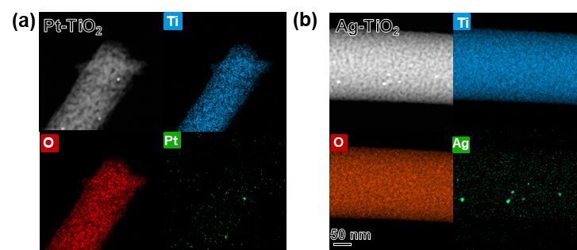
Fig. S22 EDX mapping images of (a) Pt-TiO₂ nanofiber (Ti, O and Pt elements) and (b) Ag-TiO₂ nanofiber (Ti, O and Ag elements)

Table S1 Refinement results of TiO₂ and Au-TiO₂
Phase |  | TiO₂ | Au-TiO₂
Symmetry |  | anatase | anatase
Space group |  | I41/amd | I41/amd
Cell parameters | a(Å) | 3.7771 (1) | 3.7779 (0)
Cell parameters | b(Å) | 3.7771 (1) | 3.7779 (0)
Cell parameters | c(Å) | 9.4550 (3) | 9.4559 (1)
Cell parameters | α(°) | 90 (0) | 90 (0)
Cell parameters | β(°) | 90 (0) | 90 (0)
Cell parameters | γ(°) | 90 (0) | 90 (0)
Cell parameters | V (Å³) | 134.892 (1) | 135.013 (0)
 | R_{wp}(%) | 6.61 | 7.23
Agreement factors | R_{p}(%) | 5.18 | 5.52
 | χ² | 1.536 | 1.668
Table S2 ICP data of Au-TiO₂
Sample | Au | Ti | O
Au-TiO2 | ~4.1% | ~95.9 % | /
TiO2 | / | ~100 % | /
Table S3 Specific capacities of TiO₂ and Au-TiO₂ in dark and light condition at different current densities
Current density | Capacity  (mAh g⁻¹) | TiO₂ |  | Au-TiO₂
Current density | Capacity  (mAh g⁻¹) | Dark | Illuminated | Dark | Illuminated
0.2 A g⁻¹ | discharge | 185 | 218 (18 %) | 203 | 276 (34 %)
0.2 A g⁻¹ | charge | 178 | 208 | 199 | 267
0.5 A g⁻¹ | discharge | 165 | 198 (21 %) | 182 | 251 (38 %)
0.5 A g⁻¹ | charge | 154 | 187 | 175 | 243
1 A g⁻¹ | discharge | 144 | 182 (27 %) | 164 | 233 (42 %)
1 A g⁻¹ | charge | 136 | 175 | 158 | 226
2 A g⁻¹ | discharge | 125 | 162 (30 %) | 143 | 204 (45 %)
2 A g⁻¹ | charge | 116 | 151 | 135 | 197
3 A g⁻¹ | discharge | 88 | 121 (37 %) | 105 | 163 (55 %)
3 A g⁻¹ | charge | 79 | 112 | 96 | 153

Table S4 Discharge-charge voltages of TiO₂ and Au-TiO₂ in dark and light condition at different current densities
Current density | Voltage (V) | TiO₂ |  | Au-TiO₂
Current density | Voltage (V) | Dark | Illuminated | Dark | Illuminated
0.2 A g-1 | discharge | 1.710 | 1.741 | 1.738 | 1.755
0.2 A g-1 | charge | 1.967 | 1.931 | 1.958 | 1.896
0.5 A g-1 | discharge | 1.710 | 1.727 | 1.715 | 1.745
0.5 A g-1 | charge | 1.988 | 1.959 | 1.980 | 1.918
1 A g-1 | discharge | 1.696 | 1.721 | 1.698 | 1.739
1 A g-1 | charge | 2.053 | 2.008 | 2.046 | 1.954
2 A g-1 | discharge | 1.644 | 1.663 | 1.655 | 1.693
2 A g-1 | charge | 2.110 | 2.071 | 2.100 | 2.030
Table S5 Photo-conversion efficiency of Au-TiO₂ photocathodes under dark and illuminated at different current densities
Current density (A g-1) | Charge capacity (mAh g⁻¹) |  | Energy (mW h) |  | Illuminated  Time (h) | Photo-coversion efficiency (%)
Current density (A g-1) | Dark | Illuminated | Dark | Illuminated | Illuminated  Time (h) | Photo-coversion efficiency (%)
0.2 | 199 | 267 | 0.239 | 0.267 | 1.34 | 0.042
0.5 | 175 | 243 | 0.210 | 0.243 | 0.49 | 0.135
1.0 | 158 | 226 | 0.190 | 0.226 | 0.23 | 0.313
2.0 | 135 | 197 | 0.162 | 0.207 | 0.11 | 0.818
3.0 | 96 | 153 | 0.115 | 0.153 | 0.06 | 1.267
Table S6 Photo-conversion efficiency of TiO₂ photocathodes under dark and illuminated at different current densities
Current density (A g-1) | Charge capacity (mAh g⁻¹) |  | Energy (mW h) |  | Illuminated  Time (h) | Photo-coversion efficiency (%)
Current density (A g-1) | Dark | Illuminated | Dark | Illuminated | Illuminated  Time (h) | Photo-coversion efficiency (%)
0.2 | 178 | 208 | 0.214 | 0.228 | 1.04 | 0.027
0.5 | 154 | 187 | 0.185 | 0.196 | 0.38 | 0.058
1.0 | 136 | 175 | 0.163 | 0.175 | 0.18 | 0.133
2.0 | 116 | 151 | 0.139 | 0.151 | 0.08 | 0.300
3.0 | 79 | 112 | 0.095 | 0.112 | 0.04 | 0.850
Table S7 EIS fitting data of TiO₂ and Au-TiO₂ in the dark and light condition
 | Rs (Ω) | Rct (Ω) | DLi+ (cm² s⁻¹)
TiO2 (dark) | 3.35 | 232.1 | 4.25×10-8
TiO2 (light) | 2.03 | 98.4 | 7.18×10-8
Au-TiO2 (dark) | 2.22 | 136.6 | 5.84×10-8
Au-TiO2 (light) | 1.49 | 45.0 | 8.72×10-8
Table S8 Comparison of this work and other related work in literatures
Number | Sample | Type | Specific capacity | Rate | Light | References
1 | TiO₂ | anatase/rutile | 180 mAh g⁻¹ (0.2 A g⁻¹) | 180 mAh g⁻¹∼140 mAh g⁻¹ (0.2~3 A g⁻¹) | / | [S1]
2 | TiO₂ | anatase | 110 mAh g⁻¹ (0.2 A g⁻¹) | 110 mAh g⁻¹∼45 mAh g⁻¹ (0.2~2 A g⁻¹) | / | [S2]
3 | TiO₂ | anatase | 130 mAh g⁻¹ (0.15 A g⁻¹) | 130 mAh g⁻¹∼85 mAh g⁻¹ (0.15~0.6 A g⁻¹) | / | [S3]
4 | TiO₂ | anatase | 150 mAh g⁻¹ (0.5 A g⁻¹) | 130 mAh g⁻¹∼115 mAh g⁻¹ (0.5~1.5 A g⁻) | / | [S4]
5 | TiO₂ | anatase | 90 mAh g⁻¹ (0.15 A g⁻¹) | 90 mAh g⁻¹∼25 mAh g⁻¹ (0.15~3 A g⁻¹) | / | [S5]
6 | TiO₂ | anatase | 210 mAh g⁻¹ (0.2 A g⁻¹) | 210 mAh g⁻¹∼160 mAh g⁻¹ (0.2~2 A g⁻¹) | / | [S6]
7 | TiO₂ | anatase | 160 mAh g⁻¹ (0.1 A g⁻¹) | 160 mAh g⁻¹∼50 mAh g⁻¹ (0.1~3 A g⁻¹) | / | [S7]
8 | Ag/TiO₂ | anatase | 150 mAh g⁻¹ (0.1 A g⁻¹) | 150 mAh g⁻¹∼55 mAh g⁻¹ (0.1~1 A g⁻¹) | / | [S8]
9 | TiO₂ | anatase | 140 mAh g⁻¹ (0.15 A g⁻¹) | 140 mAh g⁻¹∼55 mAh g⁻¹ (0.15~1.5 A g⁻¹) | / | [S9]
10 | TiO₂ | anatase | 130 mAh g⁻¹ (1.84 uA cm⁻²) | / | / | [S10]
11 | TiO₂ | anatase | 190 mAh g⁻¹ （0.3 A g⁻¹） | / | 230 mAh g⁻¹ (0.3 A g⁻¹) | [S11]
12 | TiO₂ | anatase | 185 mAh g⁻¹ (0.2 A g⁻¹) | 185mAh g⁻¹∼88 mAh g⁻¹ (0.2 A g⁻¹~3 A g⁻¹) | 218 mAh g⁻¹∼121 mAh g⁻¹ (0.2 A g⁻¹~3 A g⁻¹) | This work
13 | Au-TiO₂ | anatase | 205 mAh g⁻¹ (0.2 A g⁻¹) | 205 mAh g⁻¹∼105 mAh g⁻¹ (0.2 A g⁻¹~3 A g⁻¹) | 276 mAh g⁻¹∼163 mAh g⁻¹ (0.2 A g⁻¹~3 A g⁻¹) | This work
Supplementary References
- W. Song, Q. Jiang, X. Xie, A. Brookfield, E.J.L. McInnes et al., Synergistic storage of lithium ions in defective anatase/rutile TiO₂ for high-rate batteries. Energy Storage Mater. 22, 441-449 (2019). https://doi.org/10.1016/j.ensm.2019.07.025
- Y. Chen, J. Chen, J. Liu, Z. Lin, X. Hu et al., Metal-organic framework-derived mixed-phase anatase/rutile TiO₂ towards boosted lithium storage: Surface engineering and design strategy through crystal phase transition. Mater. Today Nano 22, 100265 (2022). https://doi.org/10.1016/j.mtnano.2022.100265
- J. Ma, K.G. Reeves, A.-G.P. Gutierrez, M. Body, C. Legein et al., Layered lepidocrocite type structure isolated by revisiting the sol–gel chemistry of anatase TiO₂: A new anode material for batteries. Chem. Mater. 29, 8313-8324 (2017). https://doi.org/10.1021/acs.chemmater.7b02674
- Y. Cai, H.-E. Wang, X. Zhao, F. Huang, C. Wang et al., Walnut-like porous core/shell TiO₂ with hybridized phases enabling fast and stable lithium storage. ACS Appl. Mater. Interfaces 9, 10652 (2017). https://doi.org/10.1021/acsami.6b16498
- M. Zhang, K. Yin, Z.D. Hood, Z. Bi, C.A. Bridges et al., In situ TEM observation of the electrochemical lithiation of N-doped anatase TiO₂ nanotubes as anodes for lithium-ion batteries. J. Mater. Chem. A 5, 20651-20657 (2017). https://doi.org/10.1039/C7TA05877B
- D.-H. Lee, B.-H. Lee, A.K. Sinha, J.-H. Park, M.-S. Kim et al., Engineering titanium dioxide nanostructures for enhanced lithium-ion storage. J. Am. Chem. Soc. 140, 16676-16684 (2018). https://doi.org/10.1021/jacs.8b09487
- Y. Qiu, K. Yan, S. Yang, L. Jin, H. Deng et al., Synthesis of size-tunable anatase TiO₂ nanospindles and their assembly into anatase@titanium oxynitride/titanium nitride−graphene nanocomposites for rechargeable lithium ion batteries with high cycling performance. ACS Nano 11, 6515-6526 (2010). https://doi.org/10.1021/nn101603g
- Y. Zhang, J. Li, W. Li, D. Kang, Synthesis of one-dimensional mesoporous Ag nanoparticles-modified TiO₂ nanofibers by electrospinning for lithium ion batteries. Materials 12, 2630 (2019). https://doi.org/10.3390/ma12162630
- D.T. D, S. Mohapatra, S.V. Nair, A.S. Nair, A.K. Ra, Surfactant-assisted synthesis of porous TiO₂ nanofibers as an anode material for secondary lithium ion batteries. Sustainable Energy Fuels 1, 138-144 (2017). https://doi.org/10.1039/C6SE00030D
- D. Imazeki, C.C. Gils, K. Nishio, R. Shimizu, T. Hitosugi, Effects of anisotropy in rutile TiO₂ on the performance of solid-state lithium batteries. ACS Appl. Energy Mater. 3, 8338-8343 (2020). https://doi.org/10.1021/acsaem.0c00910
- O. Nguyen, E. Courtin, F. Sauvage, N. Krins, C. Sancheza et al., Shedding light on the light-driven lithium ion de-insertion reaction: towards the design of a photo-rechargeable battery. J. Mater. Chem. A 5, 5927-5933 (2017). https://doi.org/10.1039/C7TA00493A

