Supporting Information for
Ligand Engineering Achieves Suppression of Temperature Quenching in Pure Green Perovskite Nanocrystals for Efficient and Thermostable Electroluminescence
Kaiwang Chen¹, Qing Du¹, Qiufen Cao¹, Chao Du¹, Shangwei Feng¹, Yutong Pan¹, Yue Liang¹, Lei Wang², Jiangshan Chen^{1,}* and Dongge Ma^{1,}*
¹ Institute of Polymer Optoelectronic Materials and Devices, Guangdong Basic Research Center of Excellence for Energy & Information Polymer Materials, State Key Laboratory of Luminescent Materials and Devices, Guangdong Provincial Key Laboratory of Luminescence from Molecular Aggregates, South China University of Technology, Guangzhou 510640, P. R. China
² Wuhan National Laboratory for Optoelectronics, Huazhong University of Science and Technology, Wuhan 430074, P. R. China
*Corresponding authors. E-mail: msjschen@scut.edu.cn (Jiangshan Chen); msdgma@scut.edu.cn (Dongge Ma)
Supplementary Figures and Tables

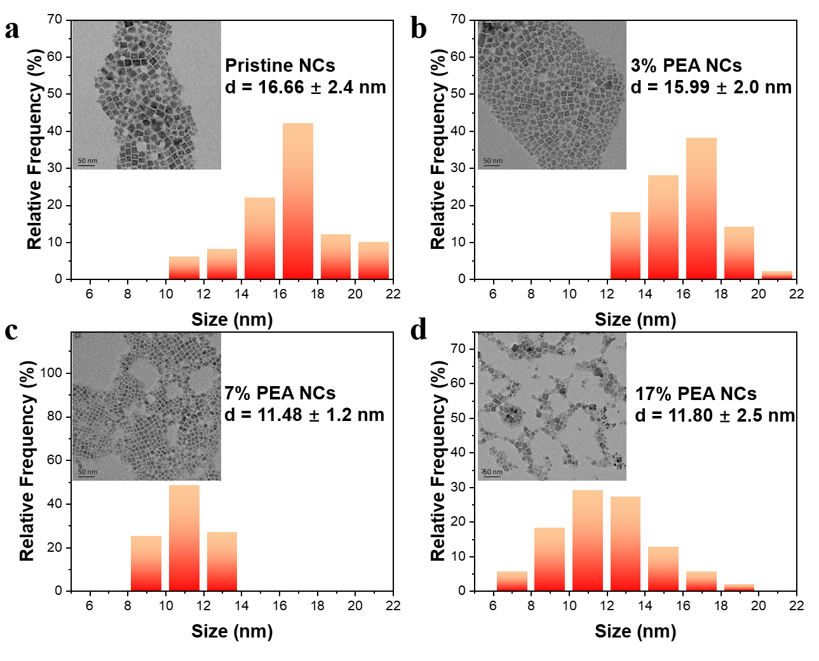
Fig. S1 Size histogram of the perovskite NCs: a pristine NCs, b 3% PEA NCs, c 7% PEA NCs and d 17% PEA NCs (inset: TEM images of the perovskite NCs)

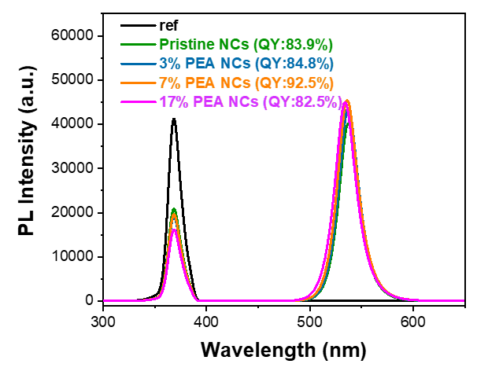
Fig. S2 PLQY results of the perovskite NCs in solutions

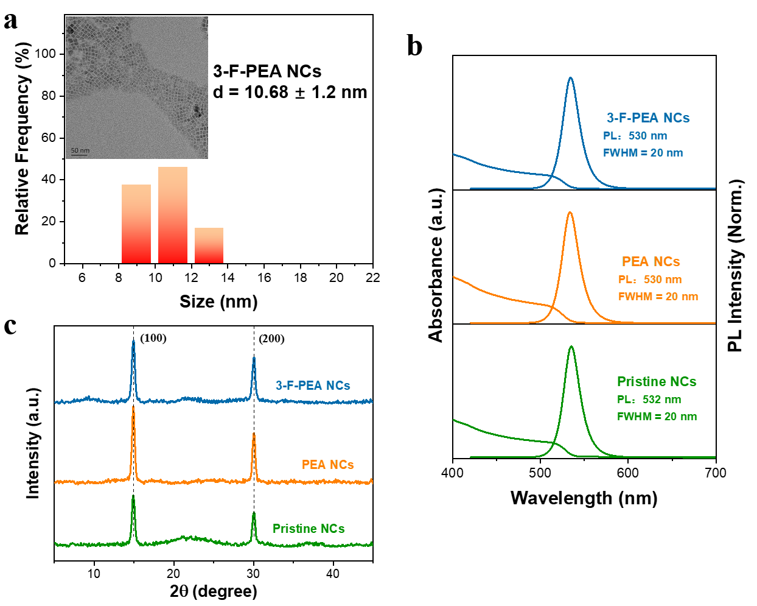
Fig. S3 a Size histogram of the 3-F-PEA NCs (inset: TEM image). b Absorption and PL spectra. c XRD patterns
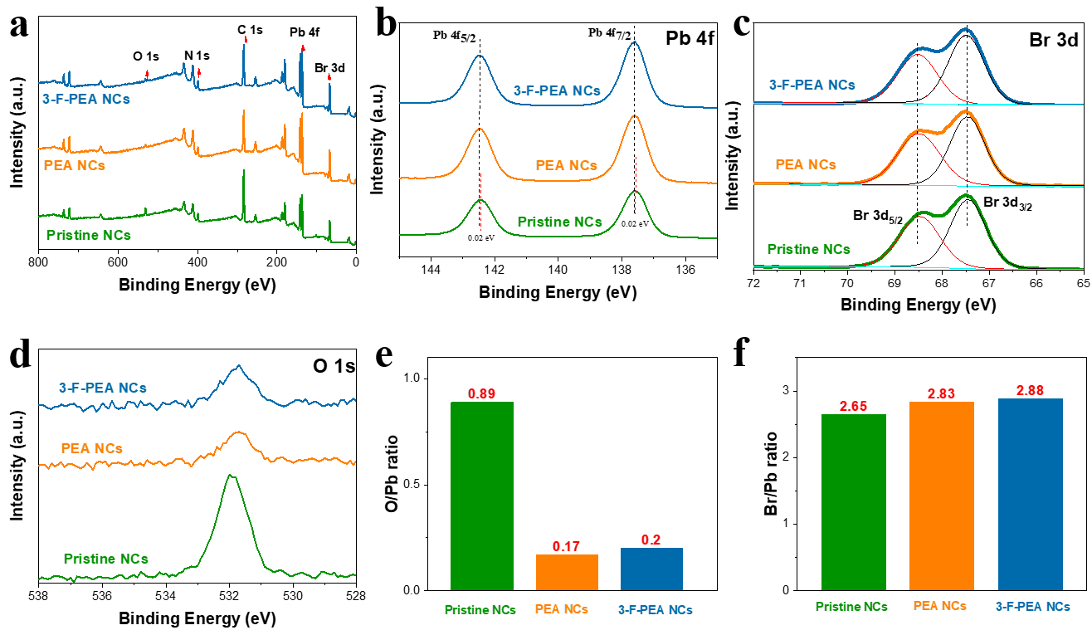Fig. S4 XPS results of perovskite NCs films: a survey spectra, b Pb 4f spectra, c Br 3d spectra, d O 1s spectra, e O/Pb atomic ratios and f O/Pb atomic ratios in the perovskite NCs films calculated from the XPS data
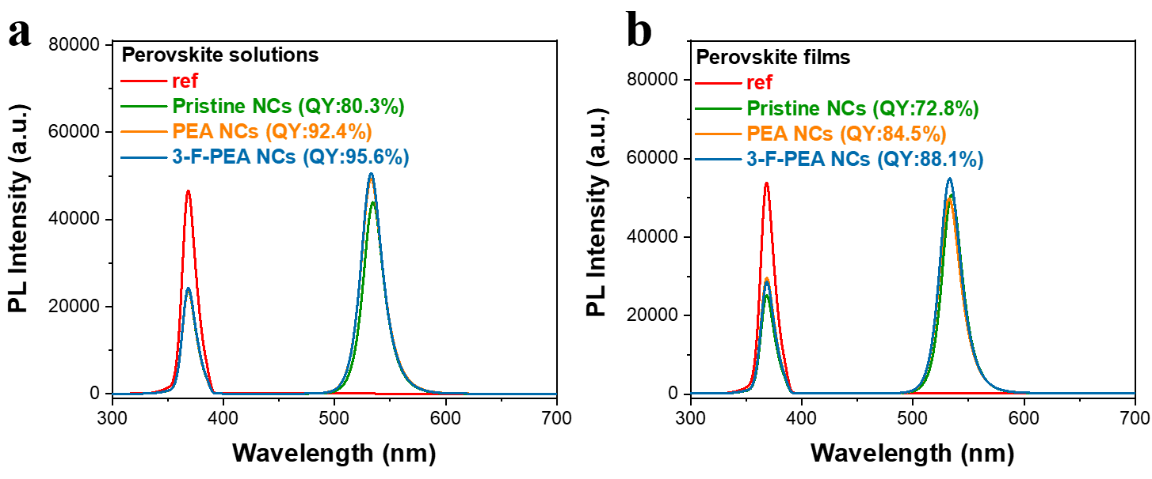
Fig. S5 PLQY results of the perovskite NCs in a solutions and b films
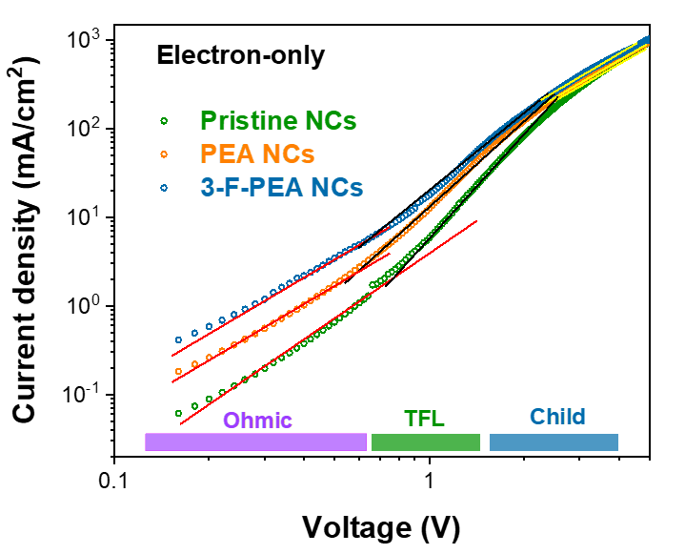
Fig. S6 Double logarithmic current density-voltage curves of the electron-only devices based on the pristine NCs, PEA NCs, and 3-F-PEA NCs
Mott-Gurney Equation:
The trap density (n_{trap}) is calculated according to the following equation:
n_{trap}=2ε₀εV_{TFL}/eL² (S1)
where ε stands for the relative dielectric constants of FAPbBr₃ (~ 20), ε₀ is the vacuum permittivity, V_{TFL} is the trap-filled limit voltage, e represents the elementary charge, and L is the thickness of perovskite NCs films.

The carrier mobilities of the perovskite NCs films were obtained by fitting the current-voltage curves at the trap-free space charge limit current (SCLC) regime using the following equation:
J=9ε₀εμV²/8L³ (S2)
Where J is dark current and V is applied voltage.
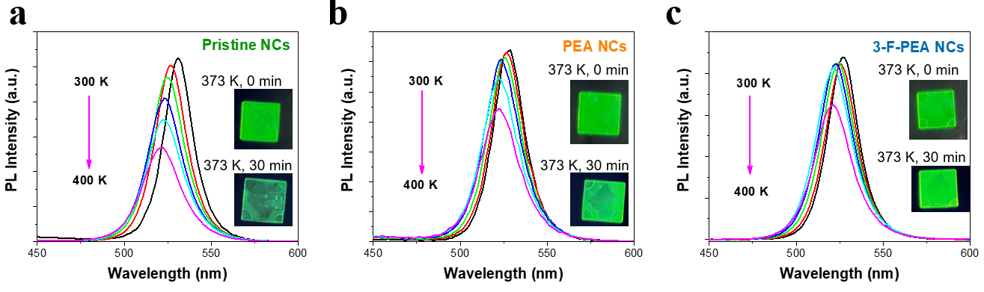
Fig. S7 PL spectra of a the pristine NCs, b PEA NCs and c 3-F-PEA NCs films measured at the temperatures increasing from 300 K to 400 K. The inset shows pictures of the perovskite NCs film with thermal stress test at 373 K for 30 minutes under ultraviolet radiation in a 50% humidity environment
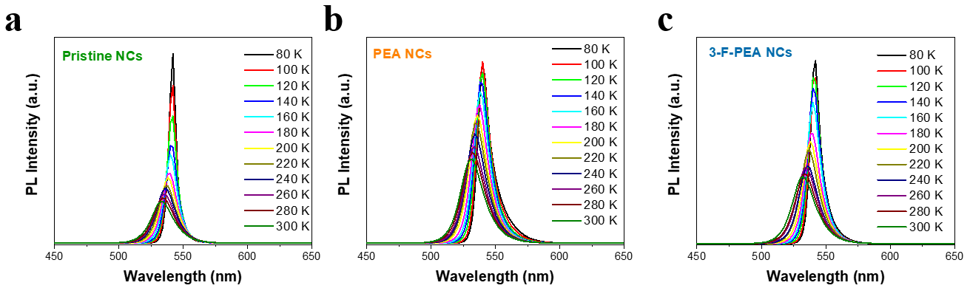
Fig. S8 PL spectra of a the pristine NCs, b PEA NCs and c 3-F-PEA NCs films measured at the temperatures decreasing from 300 K to 80 K.
Table S1 System total energy (E_{TOT}) for the perovskite NCs
 | Pristine NCs | PEA NCs | 3-F-PEA NCs
E_{TOT} (eV) | -697.43 | -779.13 | -781.21
All calculations were performed using Kohn-Sham density functional theory (DFT). Projector augmented wave (PAW) pseudopotentials as implemented in the Vienna Ab initio Simulation Package (VASP) were used. Atomic structure optimization calculations were operated and absolute electron energy was calculated then with band alignment analysis using local density of states (LDOS).
The plane-wave kinetic cutoff energy was set to 520 eV. For atomic structure optimization calculations and electron energy calculations, the Perdew-Burke-Ernzerhof exchange-correlation functional (PBE) was employed with convergence criteria of 10⁻⁴ eV for total energy and 10⁻⁴ eV/Å for forces on the unit cell. Moreover, the k-points grids are automatically generated as Monkhost-Pack 2×2×4 in structure optimization and 4×4×8 in electron energy calculation.
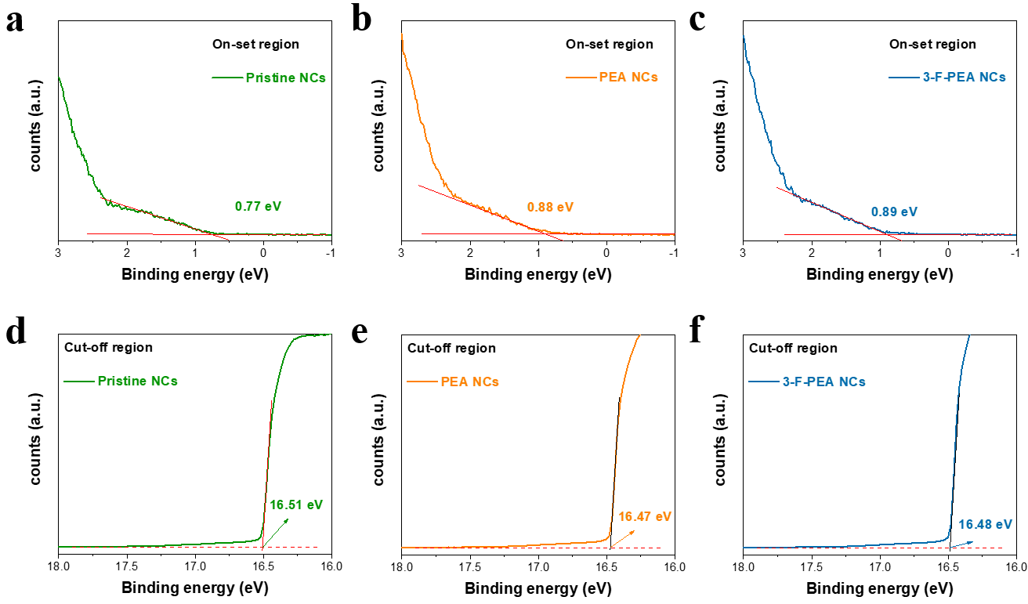
Fig. S9 UPS spectra at the on-set and cut-off regions. a, d the pristine NCs, b, e PEA NCs and c, f 3-F-PEA NCs films
UPS analysis:
The valence band maximum (E_{VBM}) of the PeNCs films were calculated using Eq. S3:
E_{VBM} = hν - (E_{cut-off} - E_{onset}) (S3)
where hν is the ultraviolet radiation energy (21.22 eV).
The Fermi levels of the PeNCs films were calculated using Eq. S4:
E_{Fermi} = hv - E_{cut-off} (S4)
The extracted optical bandgap (E_{g}) values of the PeNCs films were from the PL peak position and were determined using Eq. S5:
E_{g} = hc/λ_{em} (S5)
The conduction band minimum (E_{CBM}) of the PeNCs were calculated using Eq. S6:
E_{CBM} = E_{VBM}-E_{g} (S6)

Table S2 Performance of state-of-the-art of pure green PeLEDs based on FAPbBr₃ NCs.
Perovskite NCs | EL  [nm] | EQE_{max}  [%] | L_{max}  [cd/m²] | Refs.
FAPbBr₃ | 530 | 21.9  (@ 1580 cd/m²) | 10200 | This work
FAPbBr₃ | 530 | 2.05  (@ ~ 200 cd/m²) | ~1000 | Nano Energy 2017, 38, 51
FAPbBr₃ | 531 | 20.1  (@ ~ 1000 cd/m²) | 5980 | Joule 2020, 4, 1977
FAPbBr₃ | 532 | 3.53  (@ < 500 cd/m²) | 3062 | Nano Research 2018, 12, 171
FAPbBr₃ | 534 | 11.33  (@ 2804 cd/m²) | 21304 | Advanced Optical Materials 2023, 11, 2300486
FAPbBr₃ | 529 | 3.04  (@ < 10 cd/m²) | 2939 | Nano Lett 2017, 17, 5277
FA_{0.5}MA_{0.5}PbBr₃ | 528 | 24.96  (@ ~100 cd/m²) | ~4000 | Nat Commun 2022, 13, 2106
FA_{x}GA_{1-x}PbBr₃ | 530 | 23.26  (@ ~300 cd/m²) | ~10000 | Nat Nanotechnol 2022, 17, 590
FAPbBr₃ | 532 | 19.2  (@ 4711 cd/m²) | 67115 | ACS Energy Letters 2021, 6, 2395
FAPbBr₃ | 530 | 18.04  (@ ~ 2000 cd/m²) | ~60000 | ACS Energy Letters 2023, 8, 3710
FA_{0.9}GA_{0.1}PbBr₃ | 531 | 23.4  (@ ~ 300 cd/m²) | ~25000 | Nature Photonics 2021, 15, 148
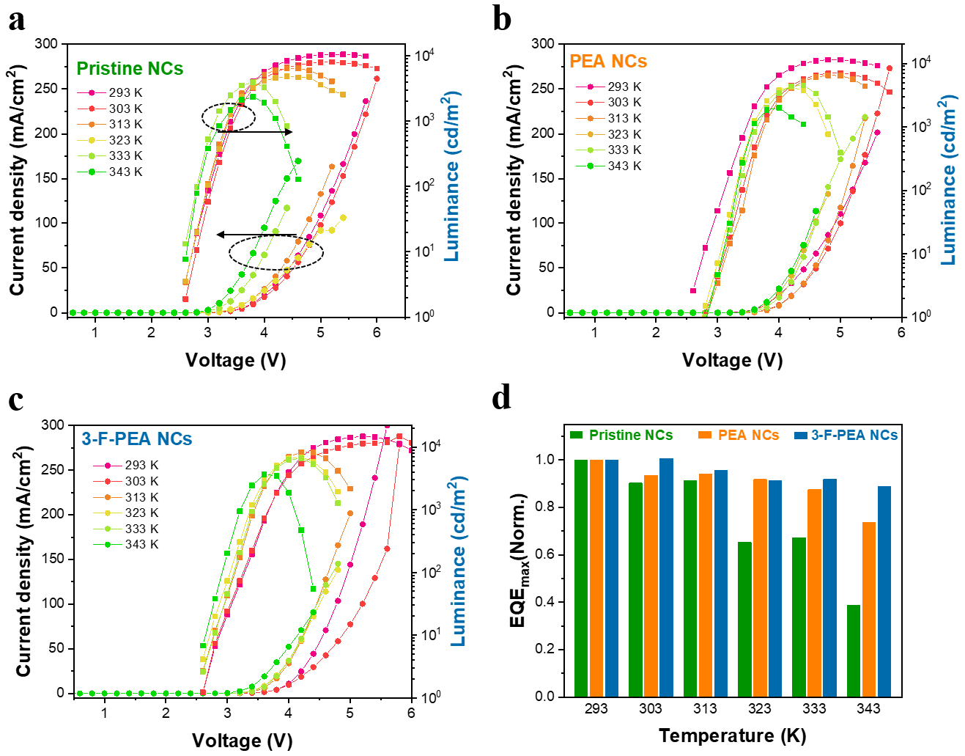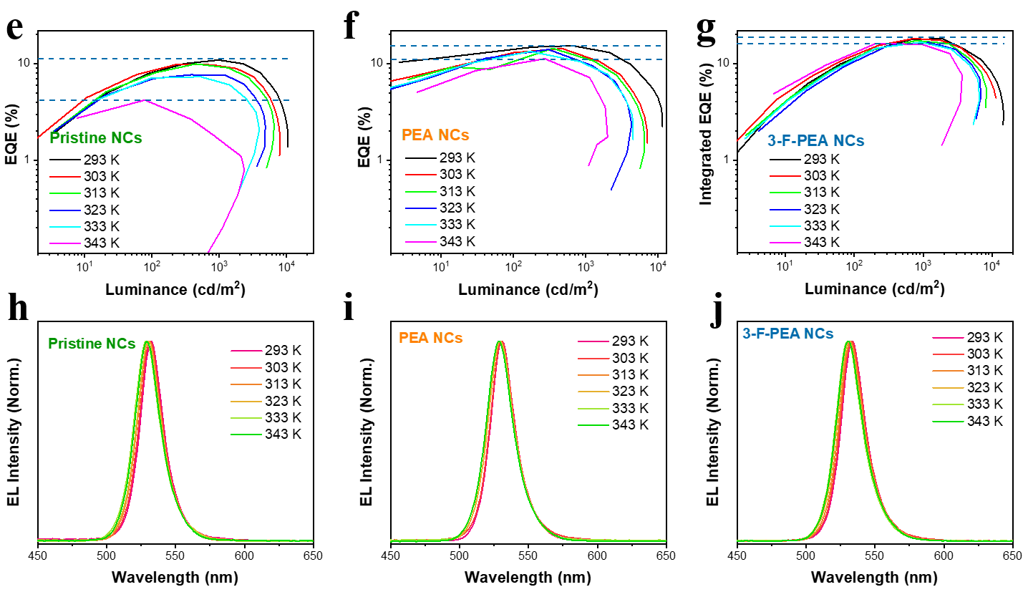
Fig. S10 Performance of PeLEDs measured at the temperatures increasing from 293 K to 343 K. a-c Current density-luminance-voltage characteristics. d Change of EQE_{max}. e-g Temperature-dependent EQE-Luminance curves. h-j Normalized EL spectra

