Supporting Information for
Revealing the Role of Hydrogen in Highly Efficient Ag-Substituted CZTSSe Photovoltaic Devices: Photoelectric Properties Modulation and Defect Passivation
Xiaoyue Zhao¹, Jingru Li¹, Chenyang Hu1, Yafang Qi¹,*, Zhengji Zhou¹, Dongxing Kou¹, Wenhui Zhou¹, Shengjie Yuan¹, and Sixin Wu¹,*
¹The Key Laboratory for Special Functional Materials of MOE, School of Nanoscience and Materials Engineering, National & Local Joint Engineering Research Center for High-efficiency Display and Lighting Technology, Collaborative Innovation Center of Nano Functional Materials and Applications, Henan University, Kaifeng 475004, P. R. China
*Corresponding authors. E-mail: qiyafang@henu.edu.cn (Yafang Qi); wusixin@henu.edu.cn (Sixin Wu)
Supplementary Figures and Tables
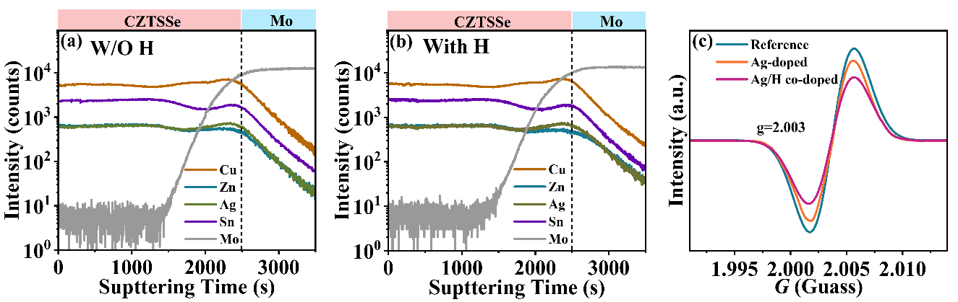
Fig. S1 Element distribution TOF-SIMS depth profiles of the CAZTSSe thin films without (a) and with (b) H-doping. (c) The EPR spectra of the Reference, Ag-doped, and Ag/H co-doped CZTSSe absorbers
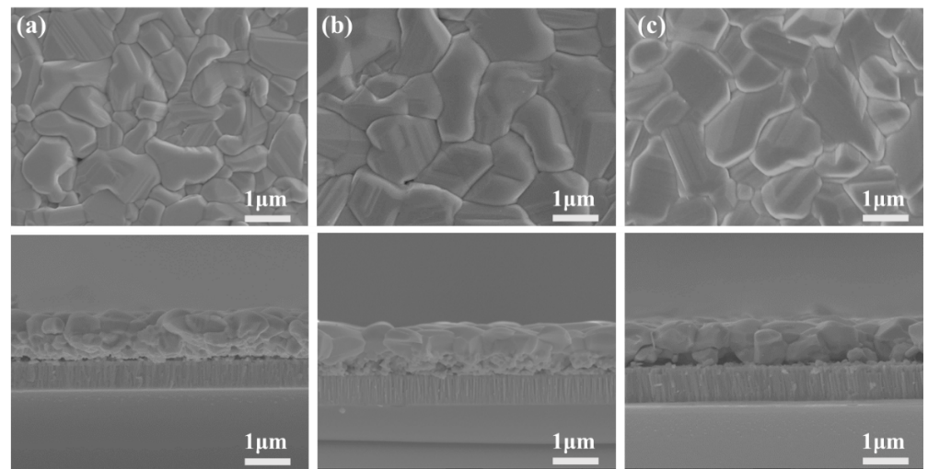
Fig. S2 Top-view and cross-sectional SEM images of the CZTSSe thin films: (a) Reference, (b) Ag-doped, and (c) Ag/H co-doped samples

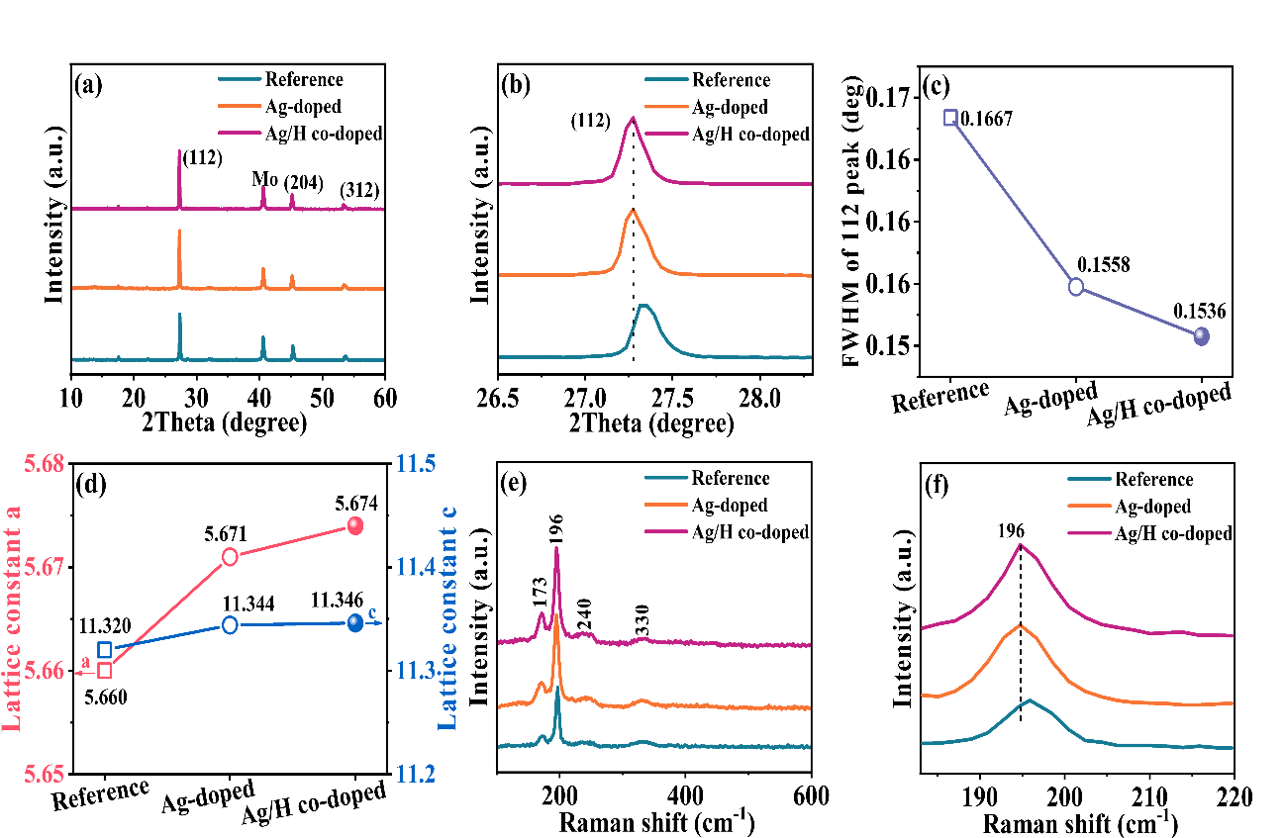

Fig. S3 (a) X-ray diffraction (XRD) patterns of CZTSSe samples, (b) the magnified (112) peaks, (c) The FWHM of (112) peaks. (d) The lattice constants a and c for the Reference, Ag-doped, and Ag/H co-doped absorbers, and (e) Raman spectra of CZTSSe samples. (f) The enlarged view of the Raman peak located at 196 cm⁻¹

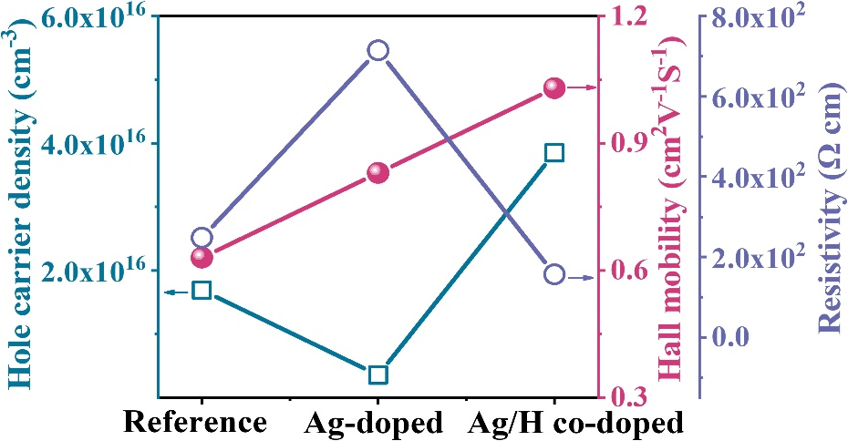

Fig. S4 Hole carrier density, Hall mobility, and Resistivity of the Reference, Ag-doped, and Ag/H co-doped samples obtained by Hall measurement
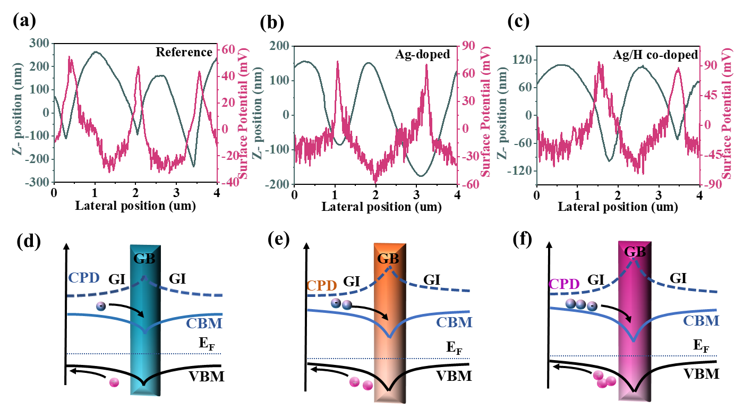

Fig. S5 Plots of the surface topography and surface potential line scan for the (a) Reference film (b) Ag-doped film and (c) Ag/H co-doped film. The schematic diagrams of band bending near GBs for the CZTSSe absorbers: (d) Reference, (e) Ag-doped, and (f) Ag/H co-doped samples
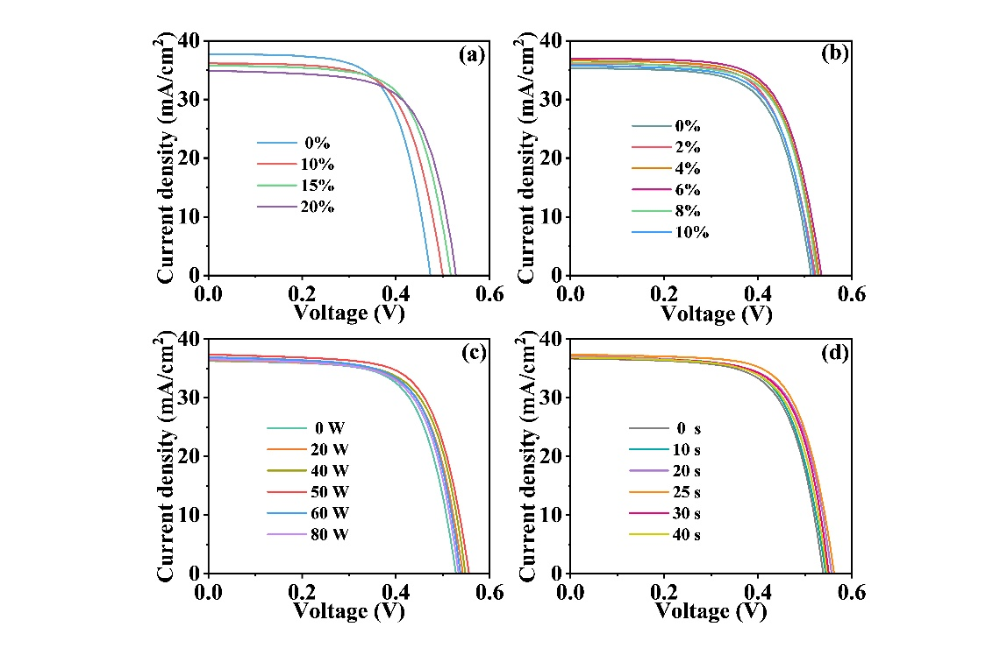
Fig. S6 (a) The J-V curves of the champion device with different Ag concentrations (0 wt%, 10 wt%, 15 wt%, and 20 wt%). (b) J-V curves of the champion device with different H₂ concentrations (0%, 2%, 4%, 6%, 8%, and 10%). (c) J-V curves of the champion device with different H-plasma treatment powers (0, 20, 40, 50, 60, and 80 w). (d) J-V curves of the champion device with different H-plasma treatment times (0, 10, 20, 25, 30, and 40 s).
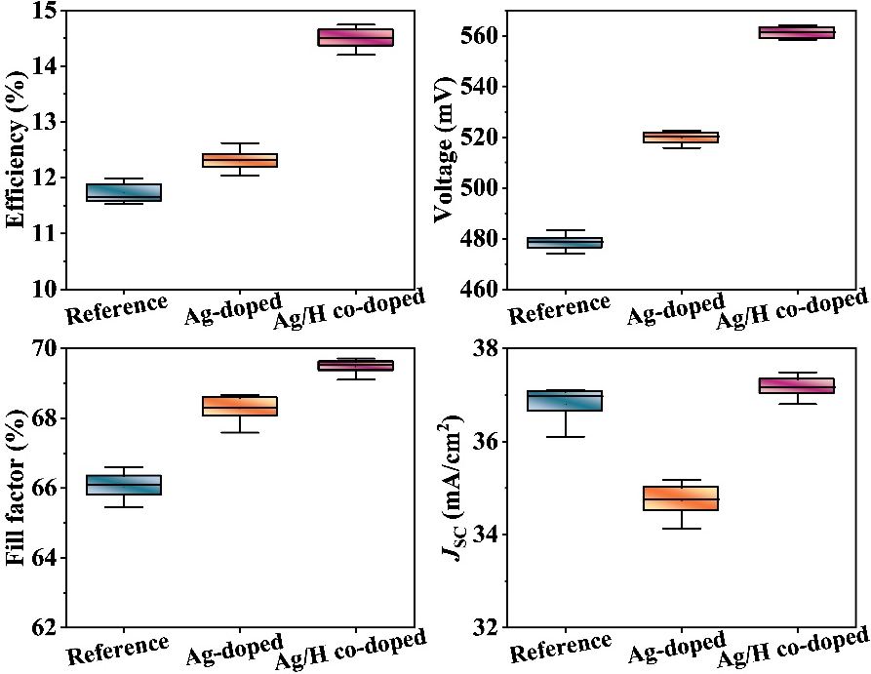
Fig. S7 Statistical box plots of photovoltaic parameters for the Reference, Ag-doped, and Ag/H co-doped solar cells. Data are extrapolated from the analysis of 18 solar cells

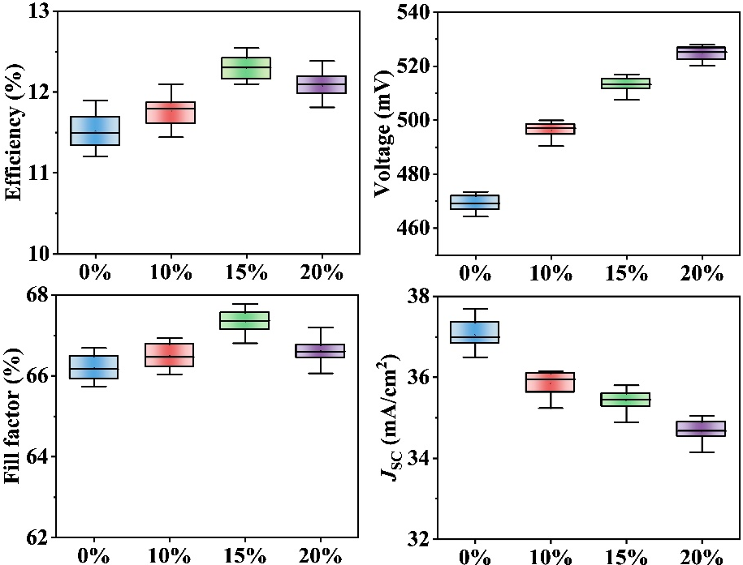
Fig. S8 Statistical box plots of photovoltaic parameters for the CZTSSe device with different Ag concentrations (0 wt%, 10 wt%, 15 wt%, 20 wt%).
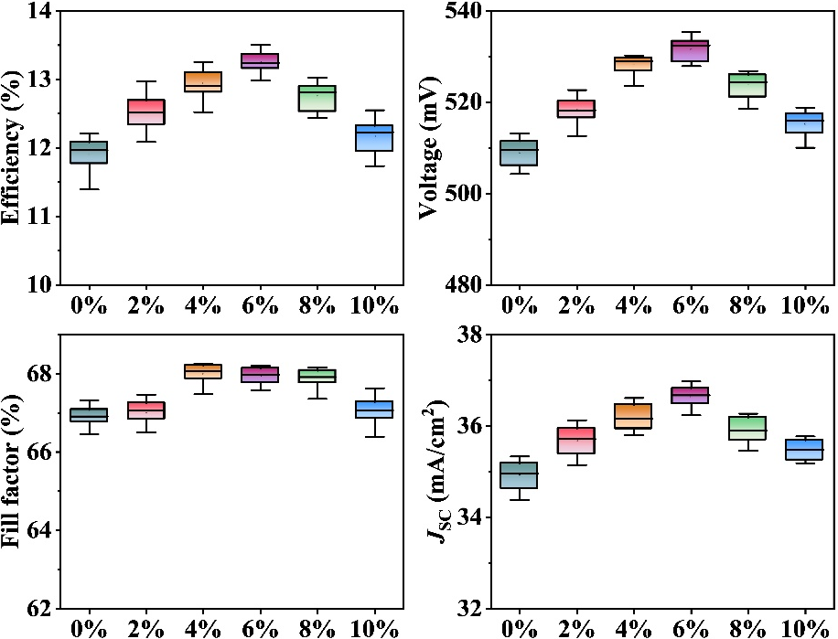
Fig. S9 Statistical box plots of photovoltaic parameters for the Ag/H co-doped CZTSSe devices with different H₂ concentrations (0%, 2%, 4%, 6%, 8%, and 10%)
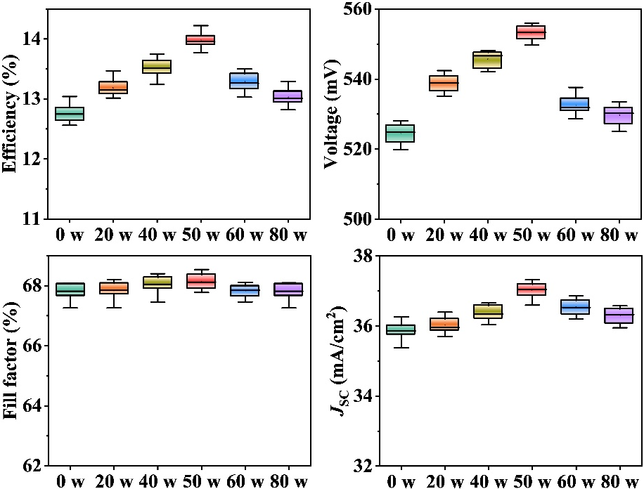
Fig. S10 Statistical box plots of photovoltaic parameters for the Ag/H co-doped CZTSSe devices with different H-plasma treatment powers (0, 20, 40, 50, 60, and 80 W)
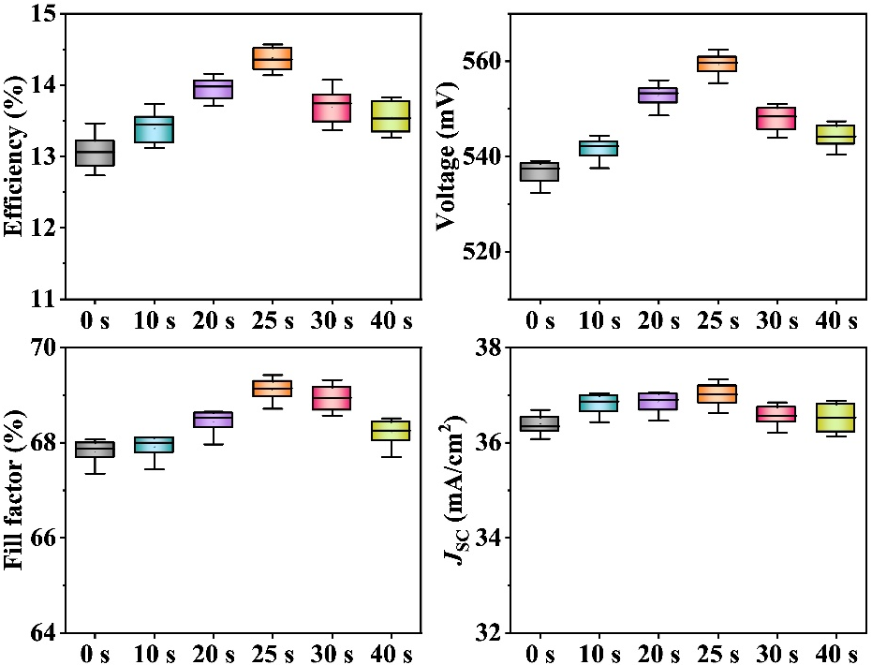
Fig. S11 Statistical box plots of photovoltaic parameters for the Ag/H co-doped CZTSSe device with different H-plasma treatment times (0, 10, 20, 25, 30, and 40 s)
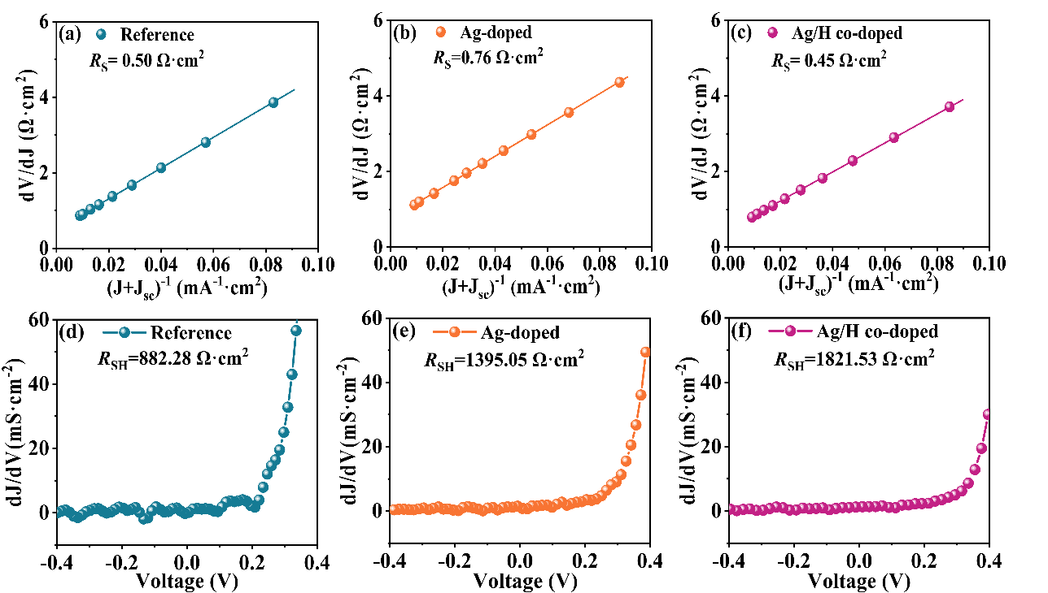
Fig. S12 Calculation of the diode parameters for the champion Reference, Ag-doped, and Ag/H co-doped CZTSSe devices on the basis of light J-V curves: (a-c) series resistance R_{S}, and (d-f) shunt resistance R_{SH}
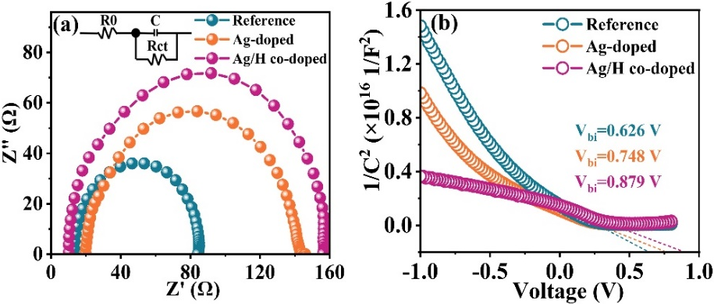
Fig. S13 (a) Impedance plots at a bias of -0.45 V. Inset: the corresponding equivalent circuit. (b) 1/C²-V curves of Reference, Ag-doped, and Ag/H co-doped CZTSSe devices
Table S1 The detailed lattice constants of the Reference sample. The average values are calculated from 5 samples with standard deviation
Sample |  | S1 | S2 | S3 | S4 | S5 | Average
Lattice constant | a(Å) | 5.659 | 5.666 | 5.671 | 5.655 | 5.651 | 5.660±0.007
Lattice constant | c(Å) | 11.321 | 11.313 | 11.318 | 11.324 | 11.328 | 11.320±0.005
Table S2 The detailed lattice constants of the Ag-doped sample. The average values are calculated from 5 samples with standard deviation
Sample |  | S1 | S2 | S3 | S4 | S5 | Average
Lattice constant | a(Å) | 5.670 | 5.672 | 5.669 | 5.663 | 5.683 | 5.671±0.006
Lattice constant | c(Å) | 11.345 | 11.340 | 11.350 | 11.349 | 11.339 | 11.344±0.004
Table S3 The detailed lattice constants of the Ag/H co-doped sample. The average values are calculated from 5 samples with standard deviation
Sample |  | S1 | S2 | S3 | S4 | S5 | Average
Lattice constant | a(Å) | 5.673 | 5.678 | 5.668 | 5.674 | 5.680 | 5.674±0.004
Lattice constant | c(Å) | 11.347 | 11.341 | 11.343 | 11.352 | 11.351 | 11.346±0.004

Table S4 Summary of the photovoltaic parameters for the CZTSSe solar cells. The data are the average values calculated from 18 devices with standard deviation
Sample | PCE [%] | V_{OC} [mV] | FF [%] | J_{SC} [mA/cm²]
Reference | 11.71±0.17 | 478.44±2.68 | 66.04±0.37 | 36.79±0.35
Ag-doped | 12.30±0.17 | 519.90±2.29 | 68.26±0.33 | 34.74±0.31
Ag/H co-doped | 14.50±0.16 | 561.25±2.21 | 69.47±0.18 | 37.16±0.20

Table S5 Summary of detailed photovoltaic parameters for the CZTSSe solar cells with different Ag-doping levels
Sample | PCE [%] (%) | V_{OC} [mV] | FF [%] | J_{SC} [mA/cm²]
0% | 11.89 | 473.42 | 66.68 | 37.68
10% | 12.09 | 499.90 | 66.93 | 36.15
15% | 12.54 | 516.98 | 67.77 | 35.80
20% | 12.38 | 527.92 | 67.19 | 34.90

Table S6 Summary of the photovoltaic parameters for CZTSSe solar cells with different Ag concentrations (0-20 wt%). The data are the average value calculated from 18 devices with standard deviation
Sample | PCE [%] (%) | V_{OC} [mV] | FF [%] | J_{SC} [mA/cm²]
0% | 11.51±0.22 | 469.22±2.85 | 66.18±0.30 | 37.05±0.33
10% | 11.76±0.17 | 496.23±2.79 | 66.48±0.29 | 35.84±0.31
15% | 12.29±0.13 | 513.24±2.66 | 67.32±0.28 | 35.43±0.24
20% | 12.07±0.15 | 524.73±2.44 | 66.60±0.28 | 34.65±0.24

Table S7 Summary of detailed photovoltaic parameters for the Ag/H co-doped CZTSSe solar cells with different H₂ concentrations
Sample | PCE [%] | V_{OC} [mV] | FF [%] | J_{SC} [mA/cm²]
0% | 12.20 | 513.18 | 67.32 | 35.33
2% | 12.73 | 522.68 | 67.47 | 36.12
4% | 13.25 | 530.25 | 68.25 | 36.61
6% | 13.50 | 535.37 | 68.20 | 36.97
8% | 13.02 | 526.85 | 68.16 | 36.27
10% | 12.55 | 518.81 | 67.62 | 35.77

Table S8 Summary of the photovoltaic parameters for the Ag/H co-doped CZTSSe solar cells with different H₂ concentrations (0-10%). The data are the average values calculated from 18 devices with standard deviation
Sample | PCE [%] | V_{OC} [mV] | FF [%] | J_{SC} [mA/cm²]
0% | 11.90±0.25 | 509.02±2.84 | 66.92±0.25 | 34.90±0.30
2% | 12.49±0.23 | 518.28±2.73 | 67.02±0.28 | 35.68±0.31
4% | 12.94±0.20 | 528.11±2.13 | 67.99±0.25 | 36.17±0.28
6% | 13.24±0.16 | 531.52±2.38 | 67.93±0.19 | 36.64±0.21
8% | 12.75±0.19 | 523.72±2.58 | 67.89±0.21 | 35.90±0.26
10% | 12.17±0.22 | 515.25±2.59 | 67.06±0.34 | 35.47±0.21

Table S9 Summary of detailed photovoltaic parameters for the Ag/H co-doped CZTSSe solar cells with different H-plasma treatment powers
Sample | PCE [%] (%) | V_{OC} [mV] | FF [%] | J_{SC} [mA/cm²]
0 W | 13.03 | 528.09 | 68.08 | 36.26
20 W | 13.46 | 542.42 | 68.20 | 36.39
40 W | 13.74 | 548.15 | 68.40 | 36.65
50 W | 14.22 | 555.92 | 68.54 | 37.32
60 W | 13.49 | 537.65 | 68.11 | 36.85
80 W | 13.28 | 533.53 | 68.10 | 36.57

Table S10 Summary of the photovoltaic parameters for the Ag/H co-doped CZTSSe solar cells with different H-plasma treatment powers (0-80 W). The data are the average values calculated from 18 devices with standard deviation
Sample | PCE [%] | V_{OC} [mV] | FF [%] | J_{SC} [mA/cm²]
0 W | 12.75±0.13 | 524.39±2.79 | 67.81±0.23 | 35.85±0.24
20 W | 13.18±0.13 | 538.72±2.73 | 67.83±0.28 | 36.00±0.22
40 W | 13.51±0.15 | 545.64±2.26 | 68.02±0.28 | 36.36±0.21
50 W | 13.97±0.11 | 553.18±2.11 | 68.12±0.25 | 37.01±0.21
60 W | 13.28±0.14 | 532.50±2.52 | 67.82±0.22 | 36.53±0.21
80 W | 13.03±0.12 | 529.63±2.64 | 67.81±0.23 | 36.29±0.22

Table S11 Detailed device parameters for the Ag/H co-doped CZTSSe solar cells with various H-plasma treatment times
Sample | PCE [%] | V_{OC} [mV] | FF [%] | J_{SC} [mA/cm²]
0 s | 13.46 | 539.12 | 68.07 | 36.68
10 s | 13.73 | 544.37 | 68.11 | 37.03
20 s | 14.16 | 556.00 | 68.65 | 37.06
25 s | 14.57 | 562.45 | 69.42 | 37.33
30 s | 14.07 | 551.03 | 69.31 | 36.84
40 s | 13.83 | 547.38 | 68.51 | 36.87

Table S12 Summary of the photovoltaic parameters for CAZTSSe solar cells with different H-plasma treatment times (0-40 s). The data are the average values calculated from 18 devices with standard deviation
Sample | PCE [%] | V_{OC} [mV] | FF [%] | J_{SC} [mA/cm²]
0 s | 13.04±0.21 | 536.63±2.31 | 67.81±0.21 | 36.37±0.20
10 s | 13.39±0.20 | 541.57±2.08 | 67.91±0.21 | 36.81±0.19
20 s | 13.94±0.15 | 552.71±2.12 | 68.44±0.21 | 36.85±0.19
25 s | 14.37±0.15 | 559.22±2.19 | 69.09±0.20 | 36.99±0.21
30 s | 13.70±0.21 | 548.09±2.32 | 68.93±0.25 | 36.56±0.20
40 s | 13.55±0.21 | 544.30±2.37 | 68.20±0.25 | 36.50±0.29

Table S13 Summary of the relevant parameters derived from C-V and DLCP measurements
Sample |  | Reference | Ag-doped | Ag/H co-doped
 | N_{IT} (cm⁻³) | 1.20×10¹⁶ | 8.89×10¹⁵ | 5.40×10¹⁵
 | N_{BT} (cm⁻³) | 9.01×10¹⁵ | 5.17×10¹⁵ | 1.21×10¹⁵

