Supporting Information for
Breaking Solvation Dominance Effect Enabled by Ion-Dipole Interaction towards Long-Spanlife Silicon Oxide Anodes in Lithium-Ion Batteries
Shengwei Dong¹, Lingfeng Shi¹, Shenglu Geng¹, Yanbin Ning¹, Cong Kang¹,Yan Zhang¹, Ziwei Liu¹, Jiaming Zhu¹, Zhuomin Qiang¹, Lin Zhou², Geping Yin¹, Dalong Li^{2,} *, Tiansheng Mu^{1,} *, Shuaifeng Lou^{1, 3,}*
¹ State Key Laboratory of Space Power-Sources, School of Chemistry and Chemical Engineering, Harbin Institute of Technology, Harbin 150001, P. R. China
² School of Marine Science and Technology, Harbin Institute of Technology at Weihai, Weihai 264200, P. R. China
³ Chongqing Research Institute of HIT, Chongqing 401135, P. R. China
*Corresponding authors. E-mail: lidalong@hit.edu.cn (Dalong Li); mutiansheng@hit.edu.cn (Tiansheng Mu); shuaifeng.lou@hit.edu.cn (Shuaifeng Lou)
Supplementary Figures
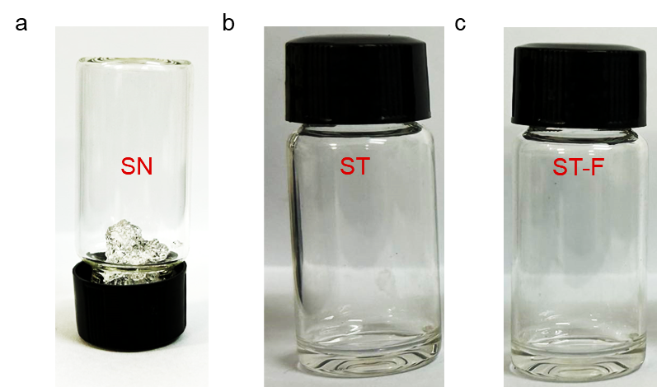
Fig. S1 Digital photos of SN and SN-based electrolytes. (a) SN, (b) ST, (c) ST-F
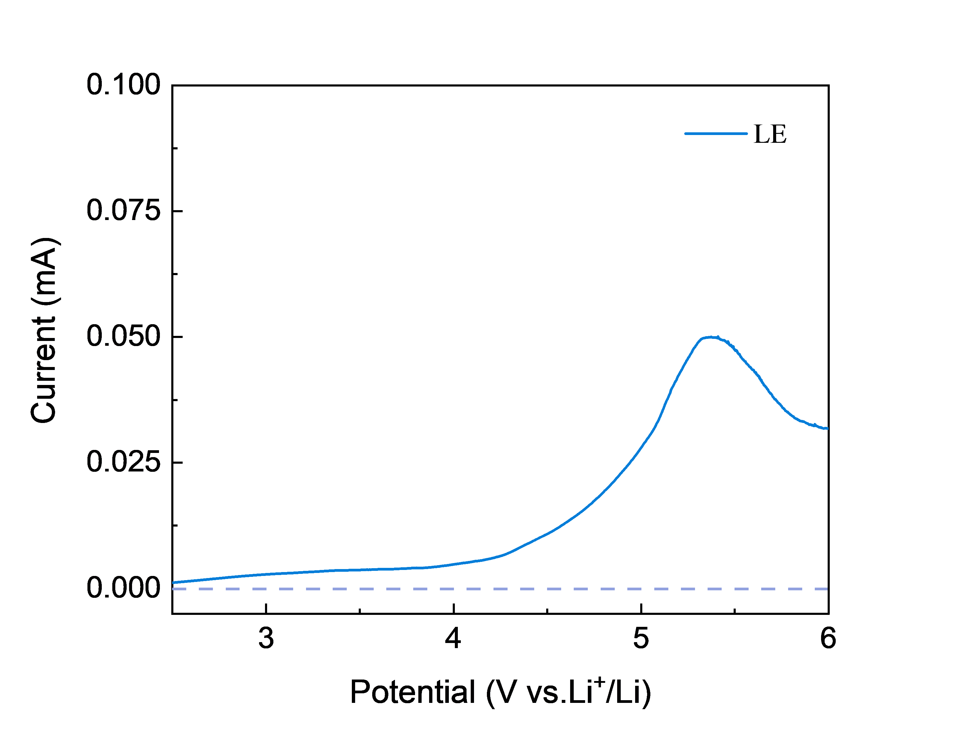
Fig. S2 LSV curves of LE

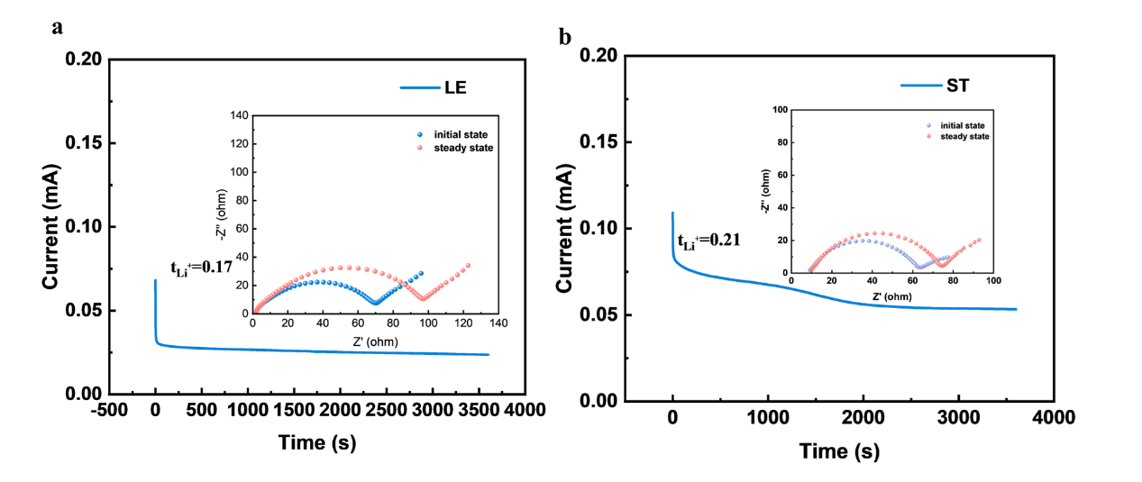
Fig. S3 Transference number of the electrolytes. (a) LE, (b) ST

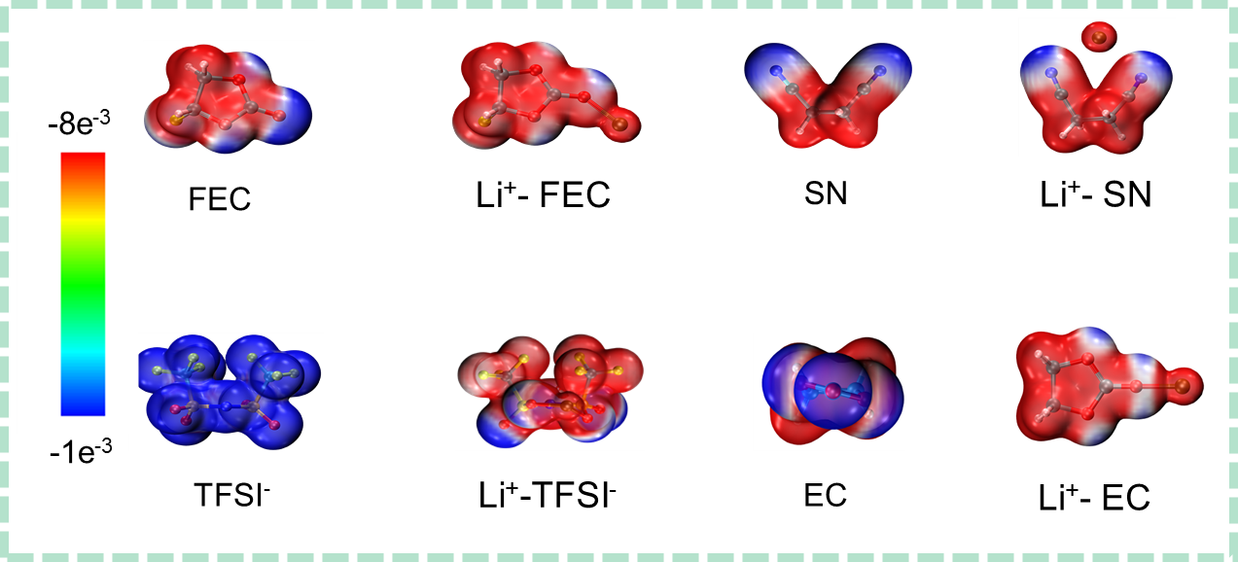
Fig. S4 Electrostatic potential density distribution
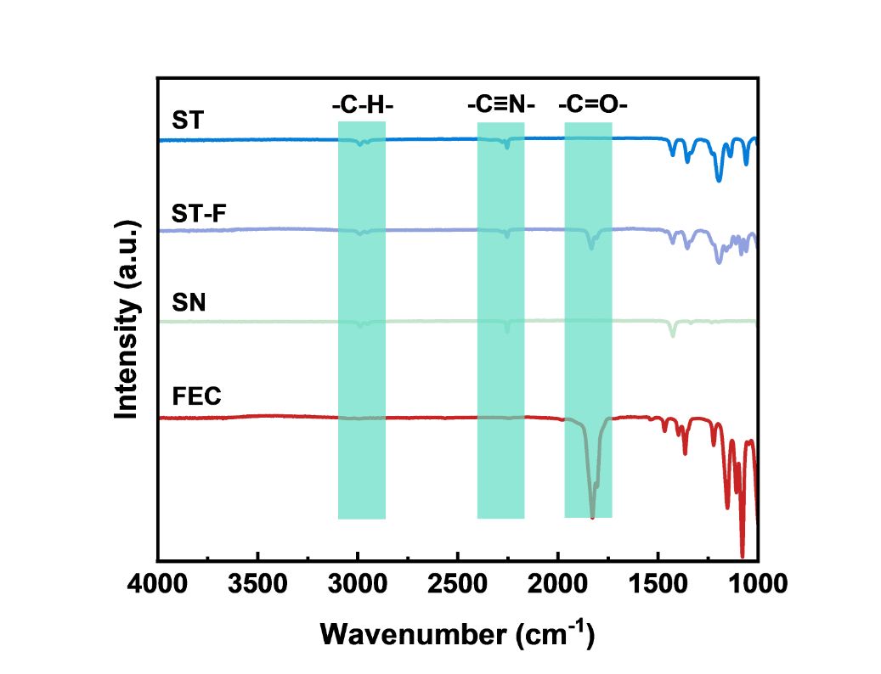
Fig. S5 Fourier Transform Infrared Spectroscopy test

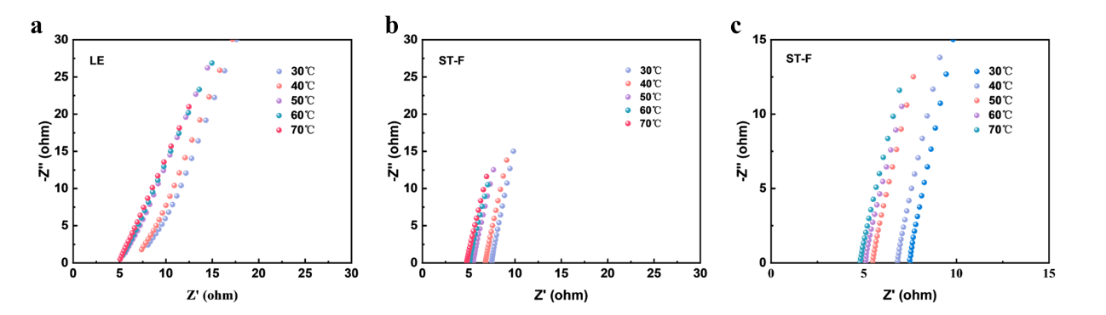
Fig. S6 Variable temperature conductivity Test. (a) LE, (b) ST, (c) ST-F

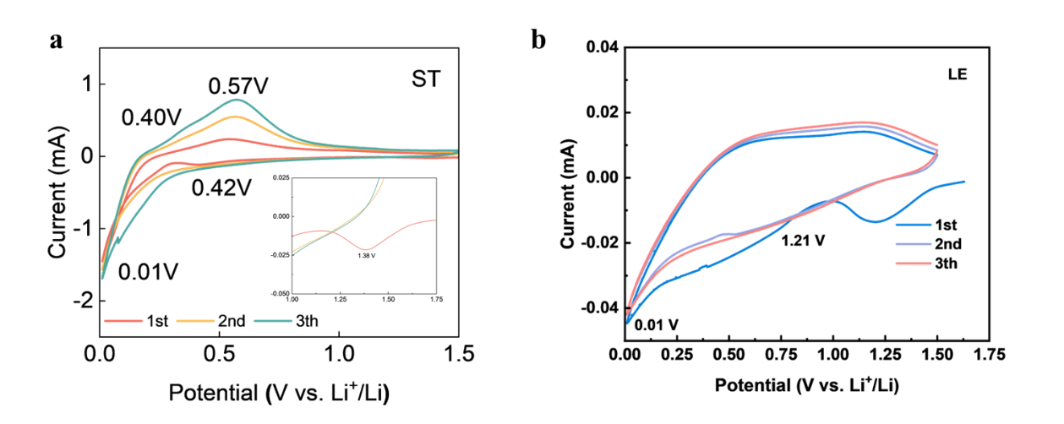
Fig. S7 Variable temperature conductivity Test. (a) ST, (b) LE
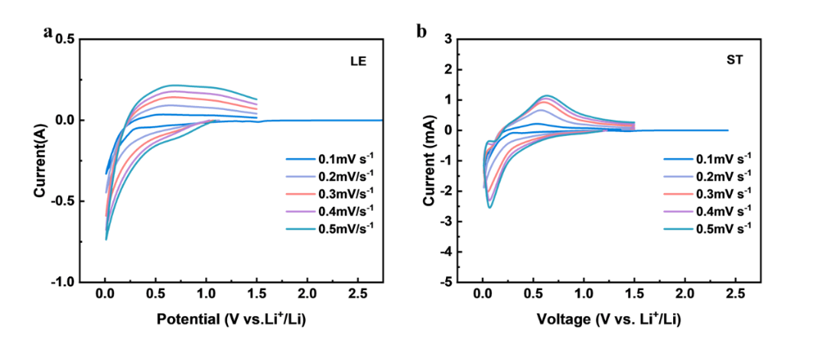
Fig. S8 CV curves of SiO anode in ST-F electrolyte with different sweep speeds. (a) LE, (b) ST
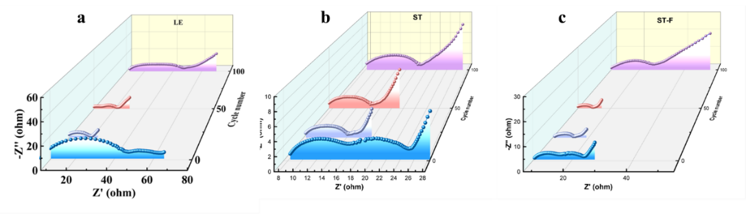
Fig. S9 SiO anode impedance during cycling in electrolyte of 1st、20th、50th and 100th. (a) ST, (b) ST-F, (c) ST-F, (d) LE
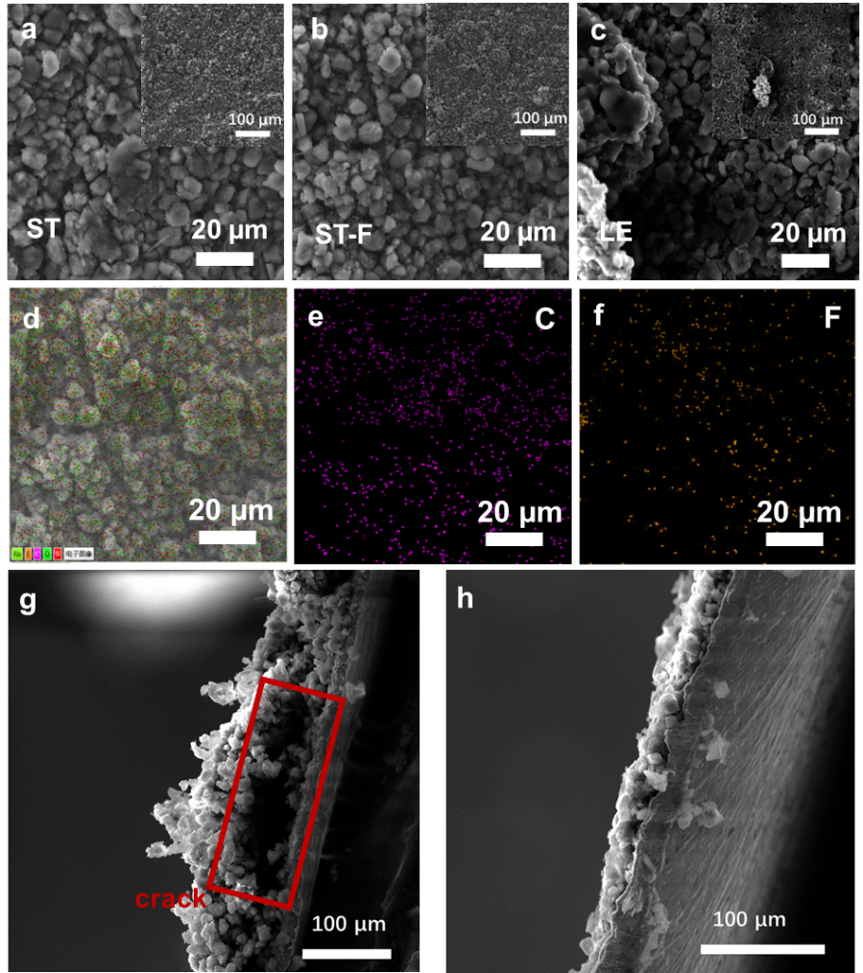
Fig. S10 Surface morphology of SiO anode after cycling. (a) ST (b) ST-F, (c) LE. EDS energy spectrum analysis (d) EDS energy spectrum of ST- F, (e) C, (f) F. Cross-section after cycling. (g) ST, (h) ST-F
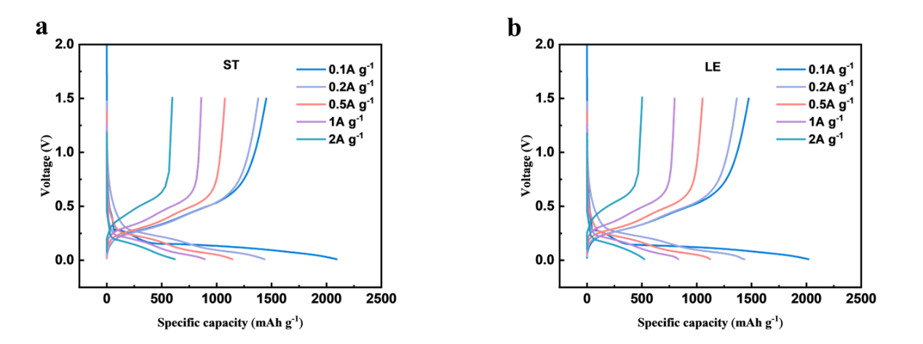
Fig. S11 Charge/discharge curves at different current densities. (a) ST, (b) LE

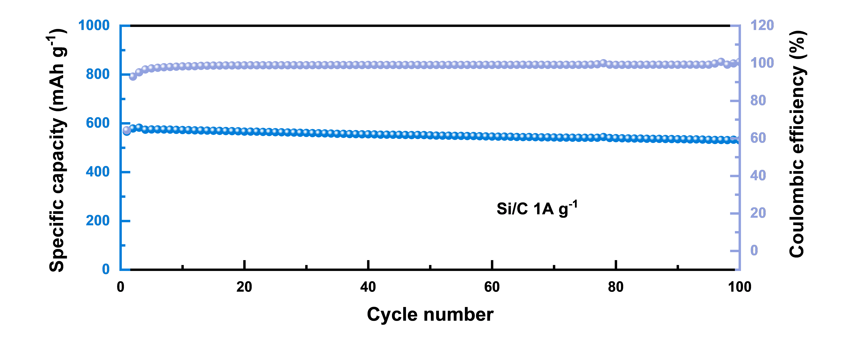
Fig. S12 SiC cycling performance in ST-F electrolytes
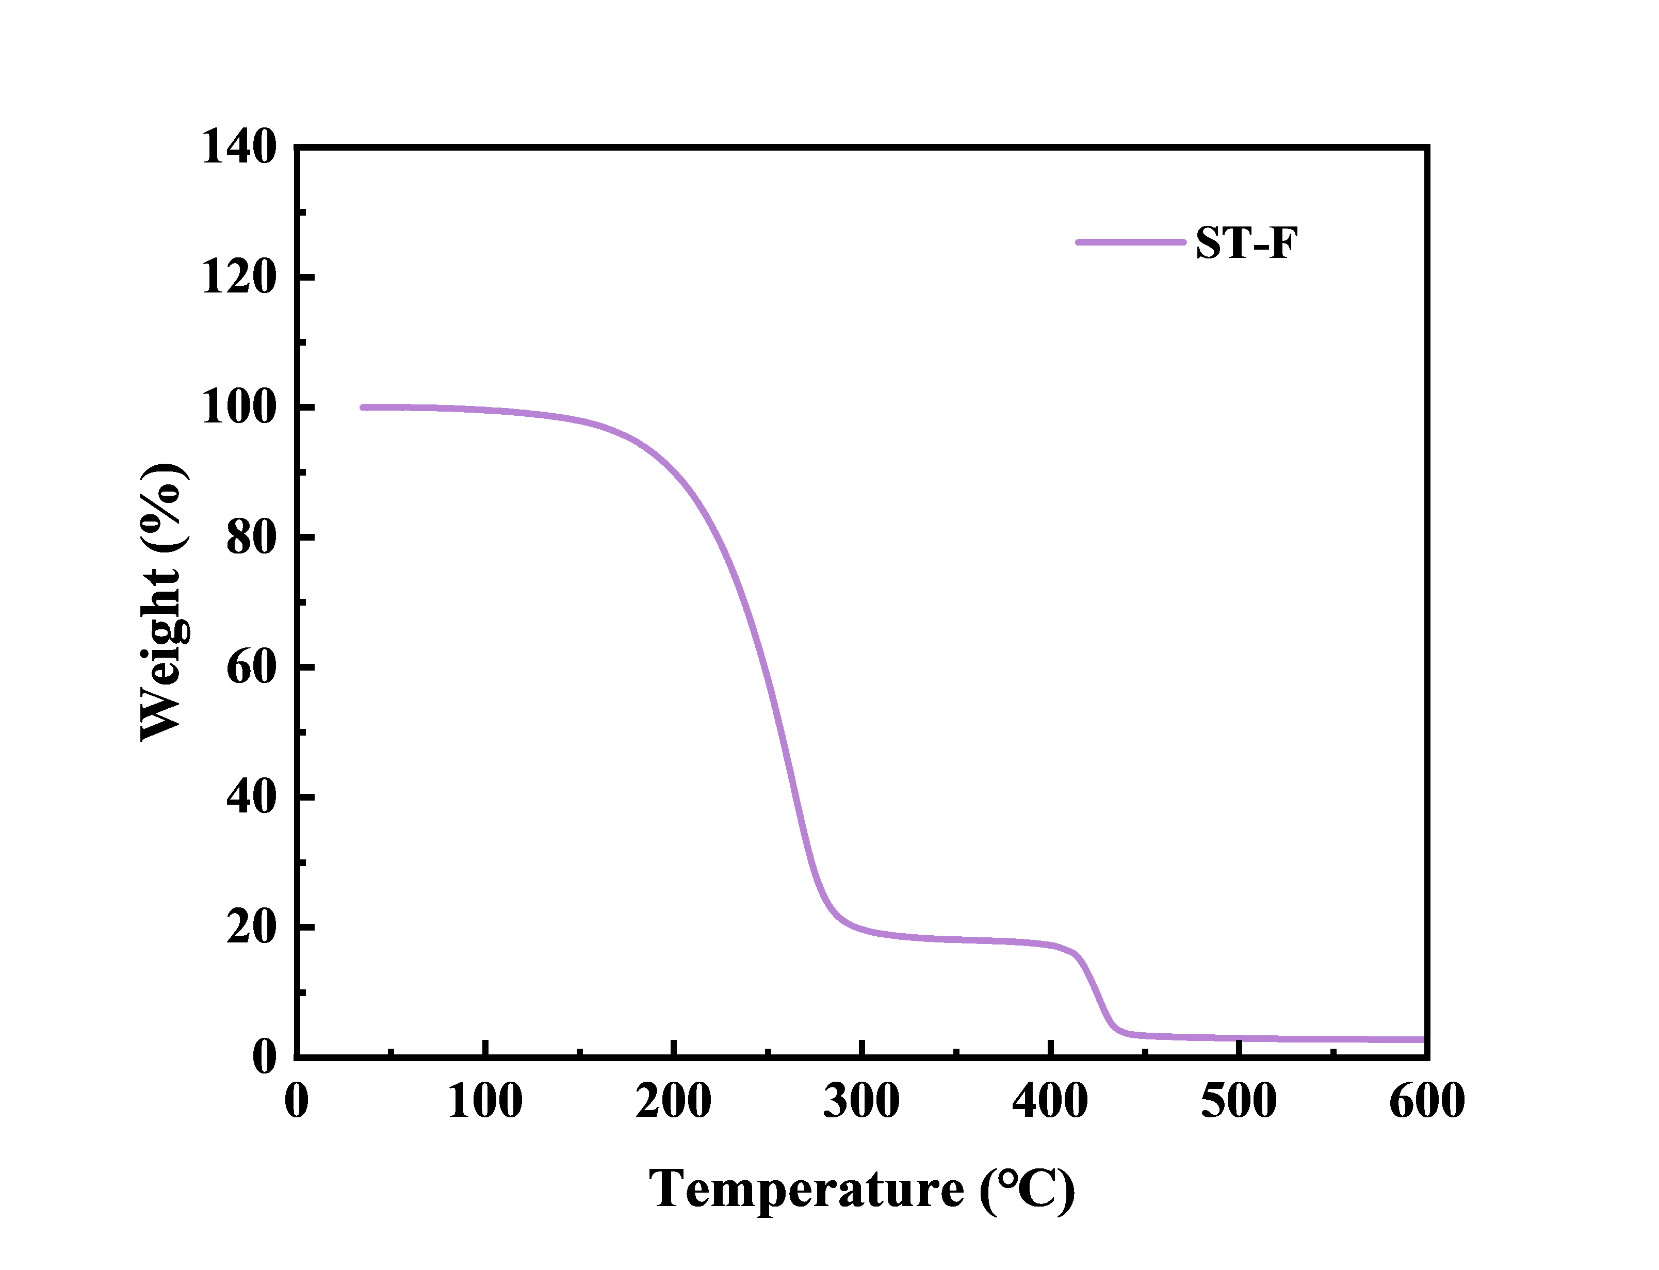
Fig. S13 TG curve of ST-F electrolyte

