Supporting Information for
An Efficient and Flexible Bifunctional Dual-Band Electrochromic Device Integrating with Energy Storage
Zekun Huang^{1,#}, Yutao Peng^{1,#}, Jing Zhao^{1,#}, Shengliang Zhang^{1,2,}*, Penglu Qi¹, Xianlin Qu³, Fuqiang Yan¹, Bing Ding¹, Yimin Xuan^{2,}* and Xiaogang Zhang^{1,}*
¹ Jiangsu Key Laboratory of Electrochemical Energy Storage Technologies, College of Materials Science and Technology, Nanjing University of Aeronautics and Astronautics, Nanjing 210016, P. R. China
² Key Laboratory of Thermal Management and Energy Utilization of Aviation Vehicles, College of Energy and Power Engineering, Nanjing University of Aeronautics and Astronautics, Nanjing 210016, P. R. China
³ Center for Microscopy and Analysis, Nanjing University of Aeronautics and Astronautics, Nanjing 211106, P. R. China
# Zekun Huang, Yutao Peng, and Jing Zhao contributed equally to this work.
*Corresponding authors. E-mail: zhangsl@nuaa.edu.cn (Shengliang Zhang); ymxuan@nuaa.edu.cn (Yimin Xuan); azhangxg@nuaa.edu.cn (Xiaogang Zhang)
Supplementary Equation, Figures and Tables
The solvothermal reaction of WCl₆ with C₂H₅OH produces W₁₈O₄₉, which can be represented by the chemical equation S1:
WCl₆ + 2C₂H₅OH → W₁₈O₄₉ + 6HCl + 2CH₃CHO (S1)
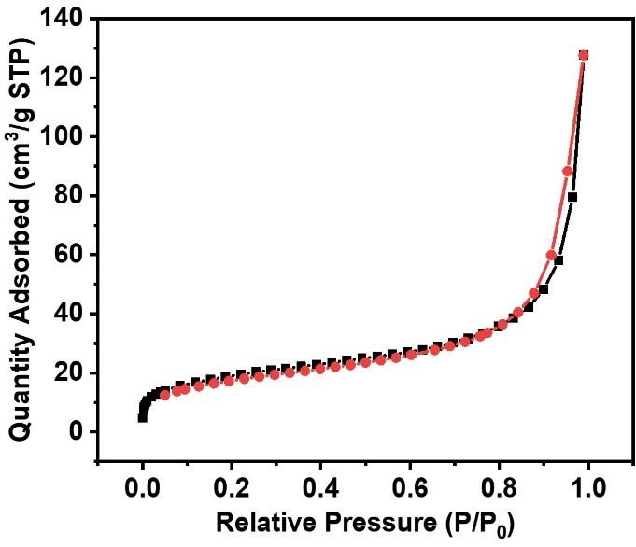
Fig. S1 Nitrogen adsorption/desorption isotherms of W₁₈O₄₉ NWs
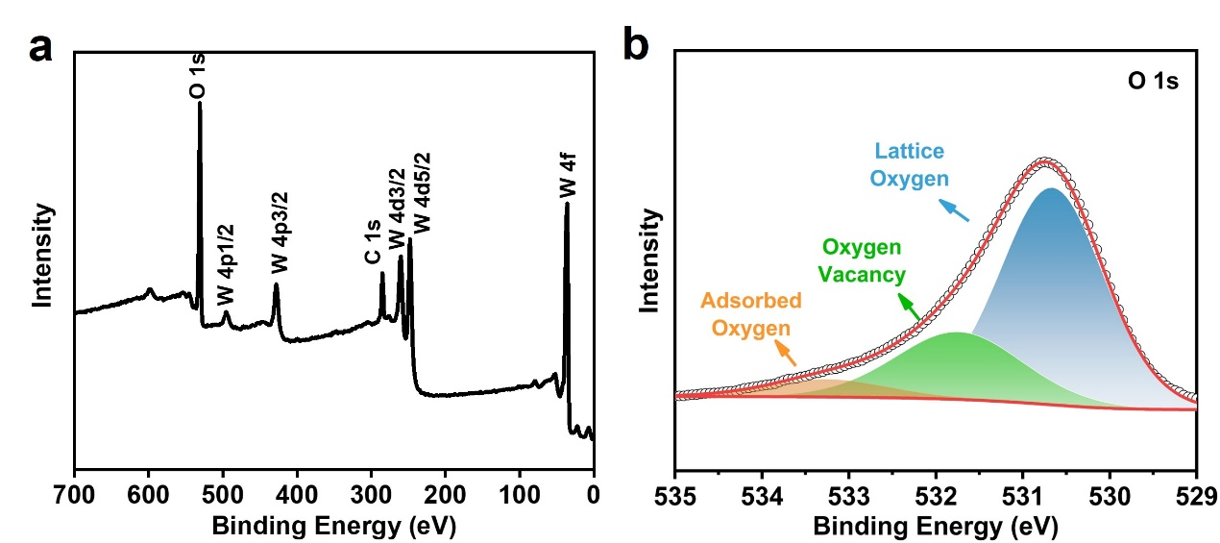
Fig. S2 XPS survey spectra of a W₁₈O₄₉ NWs and b O 1s
Fig. S3 The transmittance spectra of W₁₈O₄₉ NWs films with different ultrasonic spraying times. a 50, b 100, c 150. The digital photo of W₁₈O₄₉ NWs films with different ultrasonic spraying times. d 50, e 100, f 150
Fig. S4 laser confocal microscopy Surface roughness of W₁₈O₄₉ NWs film sprayed 100 times
Fig. S5 a Surface SEM image of porous PANI anodes. b Cross-sectional SEM image of porous PANI anodes

Fig. S6 a Transmittance spectra of PANI anodes at different applied potentials. b Real-time transmittance spectra at 633 nm of PANI anodes. c Optical density changes of PANI thin films at 633 nm as a function of injected charge density

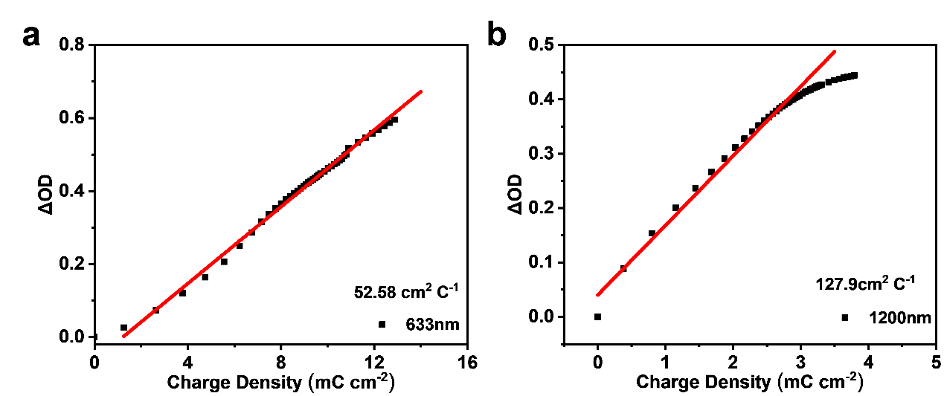
Fig. S7 Optical density changes of DBED at a 633 and b 1200 nm as a function of injected charge density

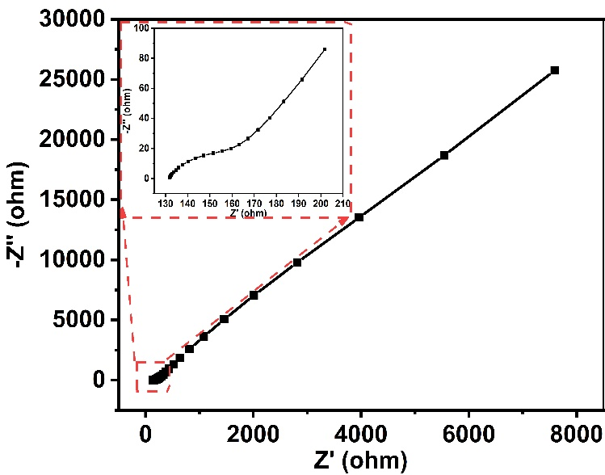
Fig. S8 Impedance spectra of the DBED. Inset shows the enlarged impedance curve
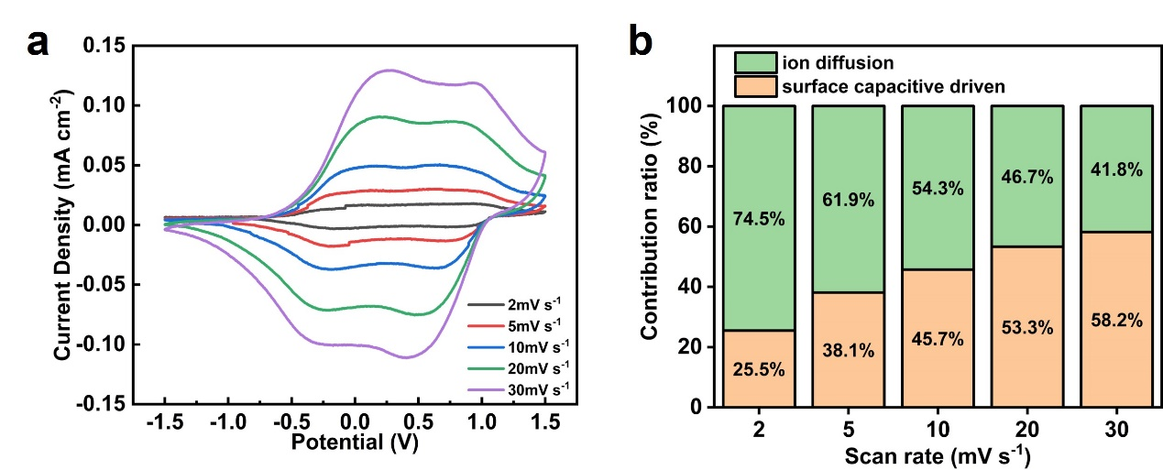
Fig. S9 a Cyclic voltammograms and b the ratios of capacitance and diffusion-controlled contribution of DBED at different scan rates
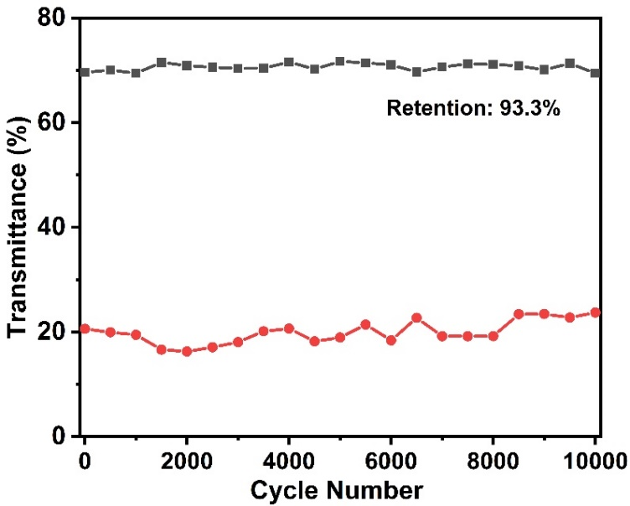
Fig. S10 Optical transmittance changes (at 633 nm) of DBED over 10,000 cycles between 1.5 and −1.5 V for 30 s at each potential
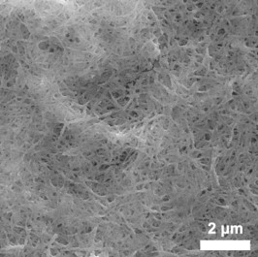
Fig. S11 Surface SEM images of W₁₈O₄₉ NW film after cycling
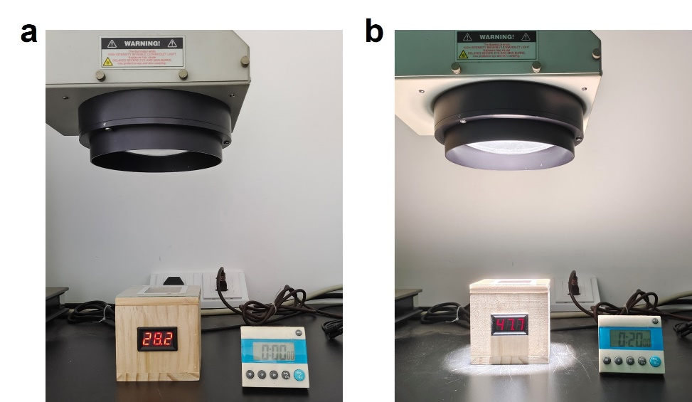
Fig. S12 The digital photos of the model room with common glass a before and b after espousing to simulated sunlight for 20 minutes
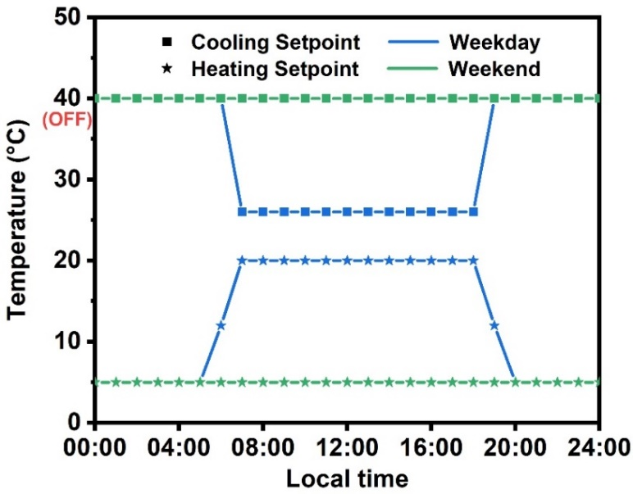
Fig. S13 The thermostat setpoints applied in actual building energy simulation
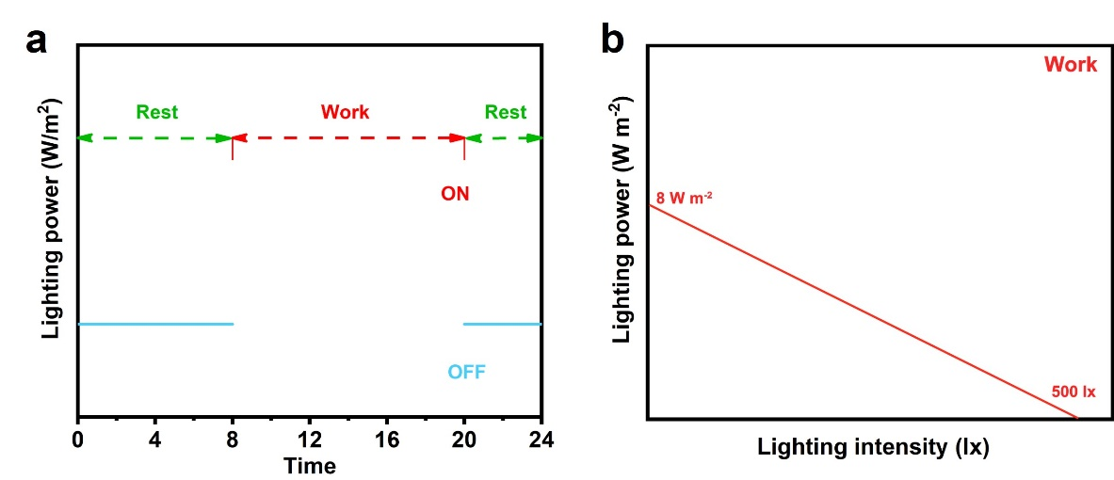
Fig. S14 a Lighting set for the simulation of lighting environment of human activity. During the night from 20:00 to 8:00, the interior light was set constantly as 0 W m⁻². During the daytime, the illuminance setting value is 500 lx. b When the daytime illuminance is higher than 500 lx, the lighting power is 0. When the daytime illuminance is lower than 500 lx, the lighting power will increase linearly from 0 to 8 W m⁻²

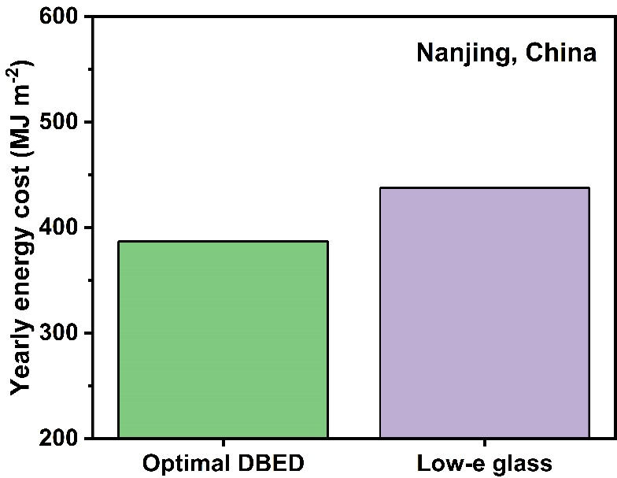
Fig. S15 Energy cost of optimal DBED, and commercial low-e glass in the climate condition of Nanjing

Table S1 Comparison of electrochromic performance of currently available dual-band electrochromic materials. (△T_{633nm} and △T_{1200nm} are the optical modulation at 633nm and 1200 nm respectively, t_{c} and t_{b} are respectively, the coloration time and the bleaching time. CE is coloration efficiency. N/A indicates data is not available.
Material | △T_{633nm} |  |  | △T_{1200nm} | t_{c}/t_{b} (s) | CE (cm² C⁻¹) | Cycle stability
ITO/NbO_{x} [S1] |  | ~35% |  | ~17% | N/A | 30 ± 4 (500 nm） | 2000 cycles  (4% capacity loss)
WO_{3-x}/NbO_{x} [S2] |  | ~80% |  | ~85% | 600/100  (633 nm) | N/A | 2000 cycles  (5.7% capacity loss)
W₁₈O₄₉/PB [S3] |  |  | 71.2% | ~50% | 2.4/4.2  (633 nm) | N/A | 100 cycles  (30% capacity loss)
P₈W₄₈/W₁₈O₄₉ [S4] |  |  | ~75% | ~65% | 26/86  (500 nm) | 21.38 (500 nm)  121.03 (1060 nm) | 500 cycles  (2.4% optical loss)
ITO/PANI [S5] |  |  | ~70% | ~80% | 19/6  (500 nm) | 60 (1600 nm) | N/A
ITO/PANI  device [S5] |  |  | ~64.5% | ~56% | N/A | 228 (600 nm)  293 (1600 nm) | N/A
W₁₈O₄₉/TiO₂ [S6] |  |  | ~45% | ~65% | NA | NA | 20,000 cycles  (15% capacity loss)
Nb-doped TiO₂ nanocrystals  device [S7] |  |  | ~76% | ~60% | 105/~10  (500 nm) | N/A | 200 cycles
Ta-doped TiO₂ nanocrystals [S8] |  |  | ~90% | ~82% | 66.8/6.9  (550 nm) | 33.2 (550 nm)  124.5 (1600 nm) | 2000 cycles  (14.8% capacity loss)
TiO_{2-x}  Nanocrystals [S9] |  |  | 95.5% | 90.5% | 35.1/9.6  (633 nm) | 38.2 (633 nm)  112.7 (1600 nm) | 2000 cycles  (4.4% capacity loss)
TiO_{2-x}  Nanocrystals  device [S9] |  |  | 74.5% | 73.2% | N/A | N/A | 500 cycles  (10.2% capacity loss)
m-WO_{3-x}  nanowires [S10] |  |  | 91.7% | 94.6% | 21/85  （633 nm）  22/75  (1200 nm) | 101.7 (633 nm)  184.3 (1200 nm) | 1000 cycles  (20.0% capacity loss)
WO₃  Nanorods [S11] |  |  | ~82% | 89% | 98/>1200  （600 nm） | 21 (600 nm)  43 (1200 nm) | 500 cycles  (~16% capacity loss)
Nb₁₂O₂₉ nanoplatelets [S12] |  |  | 71% | 83% | ~120/~60  （550 nm） | 77.3 (550 nm) | 500 cycles  （32% capacity loss）
Nb₁₈W₁₆O₉₃ [S13] |  |  | 93% | 89% | 10.1/12.7  (633 nm) | 105.6 (633 nm)  113.4 (1200 nm) | 1000 cycles  (10.5% optical loss)
MoO_{3-x}  nanowires  device [S14] |  |  | ~75.1% | ~65.8 | 13.7/6.9  (450 nm)  12.4/5.4  (1080 nm) | 211.7 (450 nm)  232.8 (1080) | 1000 cycles  (8.2% CE loss)
Li₄Ti₅O₁₂ [S15] |  |  | ~64% | ~65% | 55/42  (650 nm)  18/19  (1100 nm) | 8.81 (650 nm)  32.3 (1100 nm) | 500 cycles  (almost unchanged)
PANI [S16] |  |  | 65% | ~61% | 5.9/16.9  (633 nm)  11/32.5  (1600 nm) | 367..1 (633 nm)  299.6 (1600 nm) | 10,000 cycles  (6% optical loss)
Ti-doped WO₃  Nanocrystals [S17] |  |  | 84.9% | 90.3% | 3.3/25  (633 nm)  6/2.1  (1200 nm) | 114.9 (633 nm)  420.3 (1200 nm) | 1000 cycles  (11% optical loss)
WO_{3-x}  Nanoflowers [S18] |  |  | ~34% | ~66% | N/A | N/A | 400 cycles  (2.25% capacity loss)
WO₃/PB [S19] |  |  | 35.14% | 60.55% | N/A | N/A | 1000 cycles  (almost unchanged)
Cs_{0.32}WO₃ [S20] |  |  | ~65% | 83.7% | 18.4/15.2  (700 nm) | 112.1 (1200 nm) | 10,000 cycles  (no loss)
Cs_{0.32}WO₃  device [S20] |  |  | 65% | 70.8% | 7.6/105.5  (700 nm)  1.5/332.9  (1200 nm) | N/A | N/A
VO₂/WO₃ [S21] |  |  | 55%  (670 nm) | 52%  (1500 nm) | 6.2/3.1  (670 nm) | N/A | 1250 cycles  (4.2% capacity loss)
W₁₈O₄₉  nanowires  (This work) |  |  | 73.1% | 85.3% | 14.2/4.8  (633 nm) 12/10.8  (1200 nm) | 70.5 (633 nm)  185 (1200 nm) | N/A
W₁₈O₄₉  nanowires  device  (This work) |  |  | 51.7% | 60.0% | 8.8/15.6  (633 nm)  5/11.2  (1200 nm) | 52.6 (633 nm)  127.9 (1200 nm) | 10,000 cycles  (3.3% capacity loss)

Table S2 Information of the building model applied in actual building energy simulation
Item | Specifications
Window fraction (window-to-wall ratio) | 32% of above-grade gross wall
Window locations | Even distribution among all four sides
Floor to ceiling height | 3.00 m
Glazing sill height | 0.7 m
Exterior walls | Mass (pre-cast concrete panel): 1IN stucco + 8IN concrete HW + wall insulation + 1/2IN gypsum
Roof | Built-up roof: roof membrane + roof insulation + metal decking
Window | The window type is described accordingly
HVAC | Ideal Loads Air System
Personnel | Occupant density:10 m² per person Metabolic rate: 120 W per person
Electrical equipment | Equipment heat gain: 15 W m⁻²
Table S3 Optical and infrared properties of the samples used for the simulations
Parameters | DBED |  |  | Low-e  glass
Parameters | Bright mode | Cool mode | Dark mode | Low-e  glass
T_{sol} | 0.61 | 0.25 | 0.12 | 0.71
R_{sol-Front} | 0.12 | 0.12 | 0.12 | 0.11
R_{sol-Back} | 0.09 | 0.14 | 0.13 | 0.12
T_{VIS} | 0.64 | 0.45 | 0.24 | 0.83
R_{VIS-Front} | 0.14 | 0.12 | 0.11 | 0.11
R_{VIS-Back} | 0.13 | 0.13 | 0.12 | 0.12
T_{IR} | 0 | 0 | 0 | 0
ε_{IR-Front} | 0.93 | 0.93 | 0.93 | 0.84
ε_{IR-Back} | 0.93 | 0.93 | 0.93 | 0.17

Table S4 Climate zones of various cities around the world [S22], and heating/cooling energy consumption and saving energy consumption vs commercial low-e glass of building for different climate zones.
Climate zone name | Country | City | Optimal DBED | Low-e glass | Saving energy consumption (MJ m⁻²) | Saving energy percent (%)
AF | Singapore | Singapore | 446.70 | 563.92 | 117.22 | 20.79
AW | Brazil | Brasilia | 344.19 | 493.64 | 149.46 | 30.28
AM | America | Honolulu | 421.98 | 588.41 | 166.43 | 28.28
AM | America | Miami | 408.50 | 557.81 | 149.31 | 26.77
BWK | China | Turpan | 403.08 | 451.74 | 48.67 | 10.77
BWH | Egypt | Cairo | 368.85 | 522.91 | 154.06 | 29.46
BSK | America | Denver | 314.65 | 447.70 | 133.05 | 29.72
BSK | Spain | Zaragoza | 262.85 | 392.61 | 129.76 | 33.05
BSH | America | Phoenix | 445.94 | 624.25 | 178.31 | 28.56
CFA | China | Nanjing | 288.11 | 351.95 | 63.85 | 18.14
CSB | America | San  Francisco | 220.69 | 379.65 | 158.95 | 41.87
CFB | Iceland | Reykjavik | 276.57 | 272.15 | -4.41 | -1.62
DWB | China | Harbin | 508.90 | 495.34 | -13.56 | -2.74
DWA | China | Beijing | 317.53 | 351.01 | 33.48 | 9.54
DFB | Germany | Berlin | 239.50 | 278.49 | 38.98 | 14.00
DFB | Russia | Moscow | 397.64 | 387.55 | -10.09 | -2.60
DWB | Canada | Calgary | 410.15 | 446.80 | 36.65 | 8.20
DFA | America | Boston | 275.76 | 315.46 | 39.70 | 12.58
Supplementary References
- L. lordés, G. Garcia, J. Gazquez, D.J. Milliron, Tunable near-infrared and visible-light transmittance in nanocrystal-in-glass composites. Nature 500, 323–326 (2013). https://doi.org/10.1038/nature12398
- S. Heo, J. Kim, G.K. Ong, D.J. Milliron, Template-free mesoporous electrochromic films on flexible substrates from tungsten oxide nanorods. Nano Lett. 17, 5756–5761 (2017). https://doi.org/10.1021/acs.nanolett.7b02730
- Z. Wang, Q. Zhang, S. Cong, Z. Chen, J. Zhao et al., Using intrinsic intracrystalline tunnels for near‐infrared and visible‐light selective electrochromic modulation. Adv. Opt. Mater. 5, 1700194 (2017). https://doi.org/10.1002/adom.201700194
- H. Gu, C. Guo, S. Zhang, L. Bi, T. Li et al., Highly efficient, near-infrared and visible light modulated electrochromic devices based on polyoxometalates and W₁₈O₄₉ nanowires. ACS Nano 12, 559–567 (2018). https://doi.org/10.1021/acsnano.7b07360
- P. Yilmaz, M. Magni, S. Martinez, R. M. Gonzalez Gil, M. D. Pirriera et al., Spectrally selective PANI/ITO nanocomposite electrodes for energy-efficient dual band electrochromic windows. ACS Appl. Energy Mater. 3(4), 3779-3788 (2020). https://doi.org/10.1021/acsaem.0c00241
- Y. Huang, B. Wang, X. Bai, Y. Han, W. Zhang et al., 3D pine‐needle‐like W₁₈O₄₉/TiO₂ heterostructures as dual‐band electrochromic materials with ultrafast response and excellent stability. Adv. Opt. Mater. 10, 2102399 (2022). https://doi.org10.1002/adom.202102399
- M. Barawi, L. De Trizio, R. Giannuzzi, G. Veramonti, L. Manna et al., Dual band electrochromic devices based on Nb-doped TiO₂ nanocrystalline electrodes. ACS Nano 11, 3576-3584 (2017). https://doi.org/10.1021/acsnano.6b06664
- S. Cao, S. Zhang, T. Zhang, J.Y. Lee, Fluoride-assisted synthesis of plasmonic colloidal Ta-doped TiO₂ nanocrystals for near-infrared and visible-light selective electrochromic modulation. Chem. Mater. 30, 4838-4846 (2018). https://doi.org/10.1021/acs.chemmater.8b02196
- S. Zhang, S. Cao, T. Zhang, J.Y. Lee, Plasmonic oxygen-deficient TiO_{2-x} nanocrystals for dual-band electrochromic smart windows with efficient energy recycling. Adv. Mater. 32, 2004686 (2020). https://doi.org/10.1002/adma.202004686
- S. Zhang, S. Cao, T. Zhang, Q. Yao, A. Fisher et al., Monoclinic oxygen-deficient tungsten oxide nanowires for dynamic and independent control of near-infrared and visible light transmittance. Mater. Horiz. 5, 291–297 (2018). https://doi.org/10.1039/C7MH01128H
- R. Giannuzzi, R. Scarfiello, T. Sibillano, C. Nobile, V. Grillo et al., From capacitance-controlled to diffusion-controlled electrochromism in one-dimensional shape-tailored tungsten oxide nanocrystals. Nano Energy 41, 634-645 (2017). https://doi.org/10.1016/j.nanoen.2017.09.058
- H.C. Lu, S. Ghosh, N. Katyal, V.S. Lakhanpal, I.R. Gearba-Dolocan et al., Synthesis and dual-mode electrochromism of anisotropic monoclinic Nb₁₂O₂₉ colloidal nanoplatelets. ACS Nano 14, 10068-10082 (2020). https://doi.org/10.1021/acsnano.0c03283
- G. Cai, R. Zhu, S. Liu, J. Wang, C. Wei et al., Tunable intracrystal cavity in tungsten bronze‐like bimetallic oxides for electrochromic energy storage. Adv. Energy Mater. 12, 2103106 (2021). https://doi.org/10.1002/aenm.202103106
- T. Rao, Y. Zhou, J. Jiang, P. Yang, X. Wang et al., Fluoride-assisted preparation of plasmonic oxygen-deficient MoO_{3−x} nanowires for dual-band electrochromic smart windows. J. Electrochem. Soc. 169, 066506 (2022). https://doi.org/10.1149/1945-7111/ac741e
- T. Bai, W. Li, G. Fu, Y. Shen, Q. Zhang et al., Dual-band electrochromic optical modulation improved by a precise control of lithium content in Li_{4+x}Ti₅O₁₂. ACS Appl. Mater. Interfaces 14, 52193-52203 (2022). https://doi.org/10.1021/acsami.2c16654
- Q. Wang, S. Cao, Q. Meng, K. Wang, T. Yang et al., Robust and stable dual-band electrochromic smart window with multicolor tunability. Mater. Horiz. 10(3), 960-966 (2023). https://doi.org/10.1039/d2mh01365g
- Q. Meng, S. Cao, J. Guo, Q. Wang, K. Wang et al., Sol-gel-based porous Ti-doped tungsten oxide films for high-performance dual-band electrochromic smart windows. J. Energy Chem. 77, 137-143 (2023). https://doi.org/10.1016/j.jechem.2022.10.047
- Y. Huang, B. Wang, P. Lyu, S. Zhao, X. Wu et al., Oxygen-deficient tungsten oxide nanoflowers for dynamically tunable near-infrared light transmittance of smart windows. Nano Res. 16, 12165–12172 (2023). https://doi.org/10.1007/s12274-023-5600-7
- S. Zhao, B. Wang, Y. Huang, Y. Zhang, X. Wu et al., WO₃ nanorod array-modified prussian blue with long cycling stability for high-performance dual-band electrochromic materials. ACS Appl. Nano Mater. 6, 15021-15028 (2023). https://doi.org/10.1021/acsanm.3c02567
- F. Zhao, C. Li, S. Li, B. Wang, B. Huang et al., Continuous solar energy conversion windows integrating zinc anode‐based electrochromic device and IoT system. Adv. Mater. 36, 2405035 (2024). https://doi.org/10.1002/adma.202405035
- Z. Shao, A. Huang, C. Cao, X. Ji, W. Hu, H. Luo, J. Bell, P. Jin, R. Yang, X. Cao. Tri-band electrochromic smart window for energy savings in buildings. Nat. Sustain. 7, 796-803 (2024). https://doi.org/10.1038/s41893-024-01349-z
- H. Zhang, X. Zhang, W. Sun, M. Chen, Y. Xiao et al., All‐solid‐state transparent variable infrared emissivity devices for multi‐mode smart windows. Adv. Funct. Mater. 34, 2307356 (2023). https://doi.org/10.1002/adfm.202307356

