Supplementary Information for
Ultrasensitive Chemiresistive Gas Sensors Based on Dual-Mesoporous Zinc Stannate Composites for Room-Temperature Rice Quality Monitoring
Jinyong Xu¹, Xuxiong Fan¹, Kaichun Xu^{1, 2}, Kaidi Wu¹, Hanlin Liao², and Chao Zhang^{1,} *
¹ College of Mechanical Engineering, Yangzhou University, Yangzhou University 225127, Jiangsu Province P. R. China
² ICB UMR 6303, CNRS, Univ. Bourgogne Franche-Comté, UTBM, 90010 Belfort, France
*Corresponding author. E-mail: zhangc@yzu.edu.cn (Chao Zhang)
S1 Experimental Section
S1.1 Chemicals and materials
Zinc nitrate hydrate (Zn(NO₃)₂∙6H₂O, 98.0%) and Tin (IV) chloride pentahydrate (SnCl₄·5H₂O, 98.0%) were purchased from Sigma Aldrich Chemie GmbH (Germany). 2-Undecanone liquids (99.0%) were bought from Shanghai Aladdin Biochemical Technology Co., Ltd. Standard synthetic air (79%N₂+21%O₂) was purchased from Nanjing Special Gas Factory Co., Ltd (Nanjing, China). All chemicals and materials were of analytical grade and used without any further purification. The deionized water (18 MΩ/cm) used in all experiments was prepared by passing through an ultra-pure purification system (Aqua Solutions).
S1.2 Structure and dimension of the sensor device
The Pt layer was screen-printed on the alumina substrate (6*30 mm) (Figure S2), composed of a heating and measuring unit. The gap between the gear-shaping electrodes was 0.42 mm. The gas sensing measurement was carried out by the four-channel gas sensing testing instrument (Wuhan Huachuang Ruike Technology Co., Ltd., China), which can show real-time electrical resistance signals.
S1.3 Methods of detecting 2-undecanone concentration
The gas-sensing experiments were conducted under controlled laboratory conditions with a temperature of 25±2 ℃ and a relative humidity of 30%±10%, maintained using air conditioning. As illustrated in Figure S2, the flow (x) of 2-undecanone with a concentration of 13 ppm was controlled with one mass flow controller (MFC), the flow (y) of high-purity mixed air (Nanjing Special Gas Factory Co., Ltd.) was controlled with another MFC. The theoretical concentrations (Unit: ppm) were defined as: (theoretical concentration*x)/(x+y), by controlling the flow separately. Except in the experiment to investigate the effect of relative humidity (RH), the flow (z) of high-purity mixed air was controlled with another MFC and bubbled via the deionized water. The RH (Unit: %) was defined as z/(x+y+z)*%.
S1.4 Method used to determine the electrical resistance
The data logger supplies a steady voltage of 12 V (V_{EX}). This voltage is distributed between the reference resistor (R_{ref}), which has a known and constant resistance, and the IDA-CR, whose resistance changes according to the detected 2-undecanone concentration. The voltage is relatively distributed according to the resistance of the two circuit components. Therefore, given the voltage between V_{EX} and ground (GND), the voltage between V_{meas} and GND is measurable. From their ratio, it is possible to calculate IDA-CR resistance, as described in Equation S1.
V_{means}/V_{EX}=R_{CR}/(R_{CR}+R_{ref}) → R_{CR}=(R_{ref}·V_{means})/(V_{EX}-V_{means}) (S1)
S1.5 Theoretical calculation
All calculations were carried out based on density functional theory (DFT) as implemented in the Vienna ab initio simulation package (VASP) with exchange-correlation functional of generalized gradient approximation (GGA) using the Perdew-Burke-Emzerhof (PBE) method. A grid of 1×1×1 Monkhorst-Pack K-points was used for the structural relaxation. A vacuum layer of 15 Å was adopted in the direction perpendicular to the monolayer surface to avoid the interactions between periodic slabs. Grimme’s DFT-D3 methodology was chosen to describe the dispersion interactions and considered the valence electrons using a plane wave basis expansion with an energy cutoff of 450 eV. Partial occupancies of the Kohn-Sham orbitals were allowed utilizing the Gaussian smearing method and a width of 0.05 eV. The self-consistent calculations apply a convergence energy threshold of 10⁻⁵ eV. The adsorption ability was evaluated by comparing the adsorption energy (E_{ads}) calculated based on Equation S2.
E_{ads}=E_{gas/surface}-E_{surface}-E_{gas} (S2)
Where E_{gas/surface}, E_{surface,} and E_{gas} are the energy of adsorbate gas adsorbed on the surface, clean surface, and isolated gas molecules in a cubic periodic box, respectively.
In this work, according to the analysis of the XRD patterns shown in Figure 2a, ZnSnO₃ is ilmenite-like structured and crystallizes in the trigonal R3c space group. ZnO is Wurtzite structured and crystallizes in the hexagonal P63mc space group. The relative concentration of oxygen vacancy obtained from the corresponding XPS analysis was also considered in the establishment of the heterojunction model. Their visualized structures are vividly illustrated in Figs. S14 and S17.
S2 Supplementary Figures and Tables
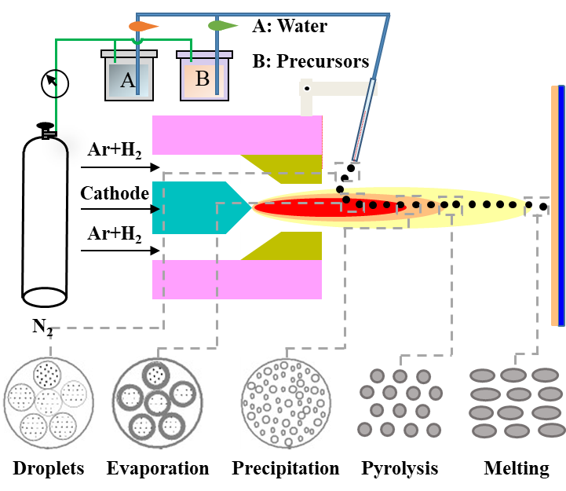
Fig. S1 Schematic illustration of the preparation and the evolution of the gas-sensing coatings deposited by SPPS
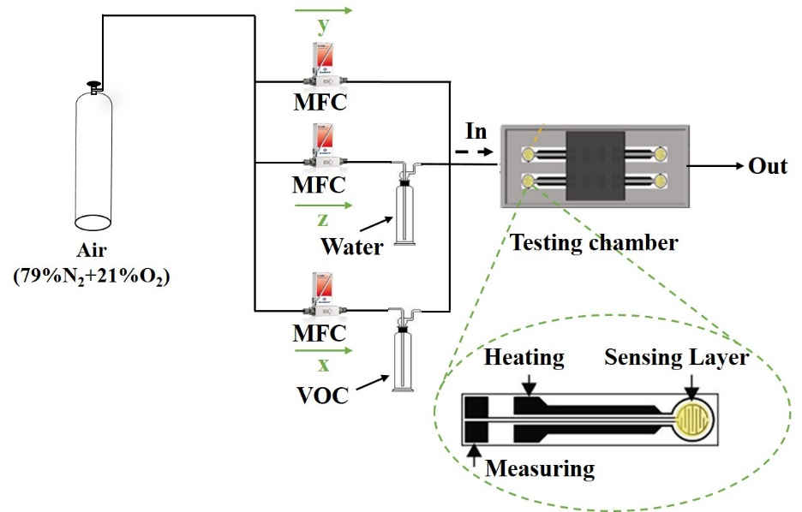
Fig. S2 Schematic illustration of the gas sensing testing system utilized in the gas-sensing experiment
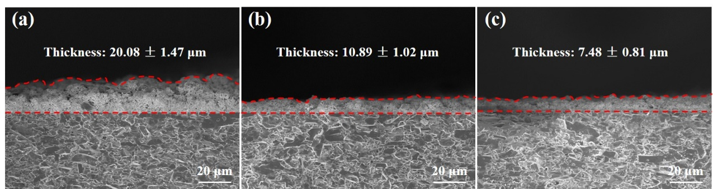
Fig. S3 Cross-sectional profiles of (a) H1, (b) H3, and (c) H5 directly deposited by SPPS

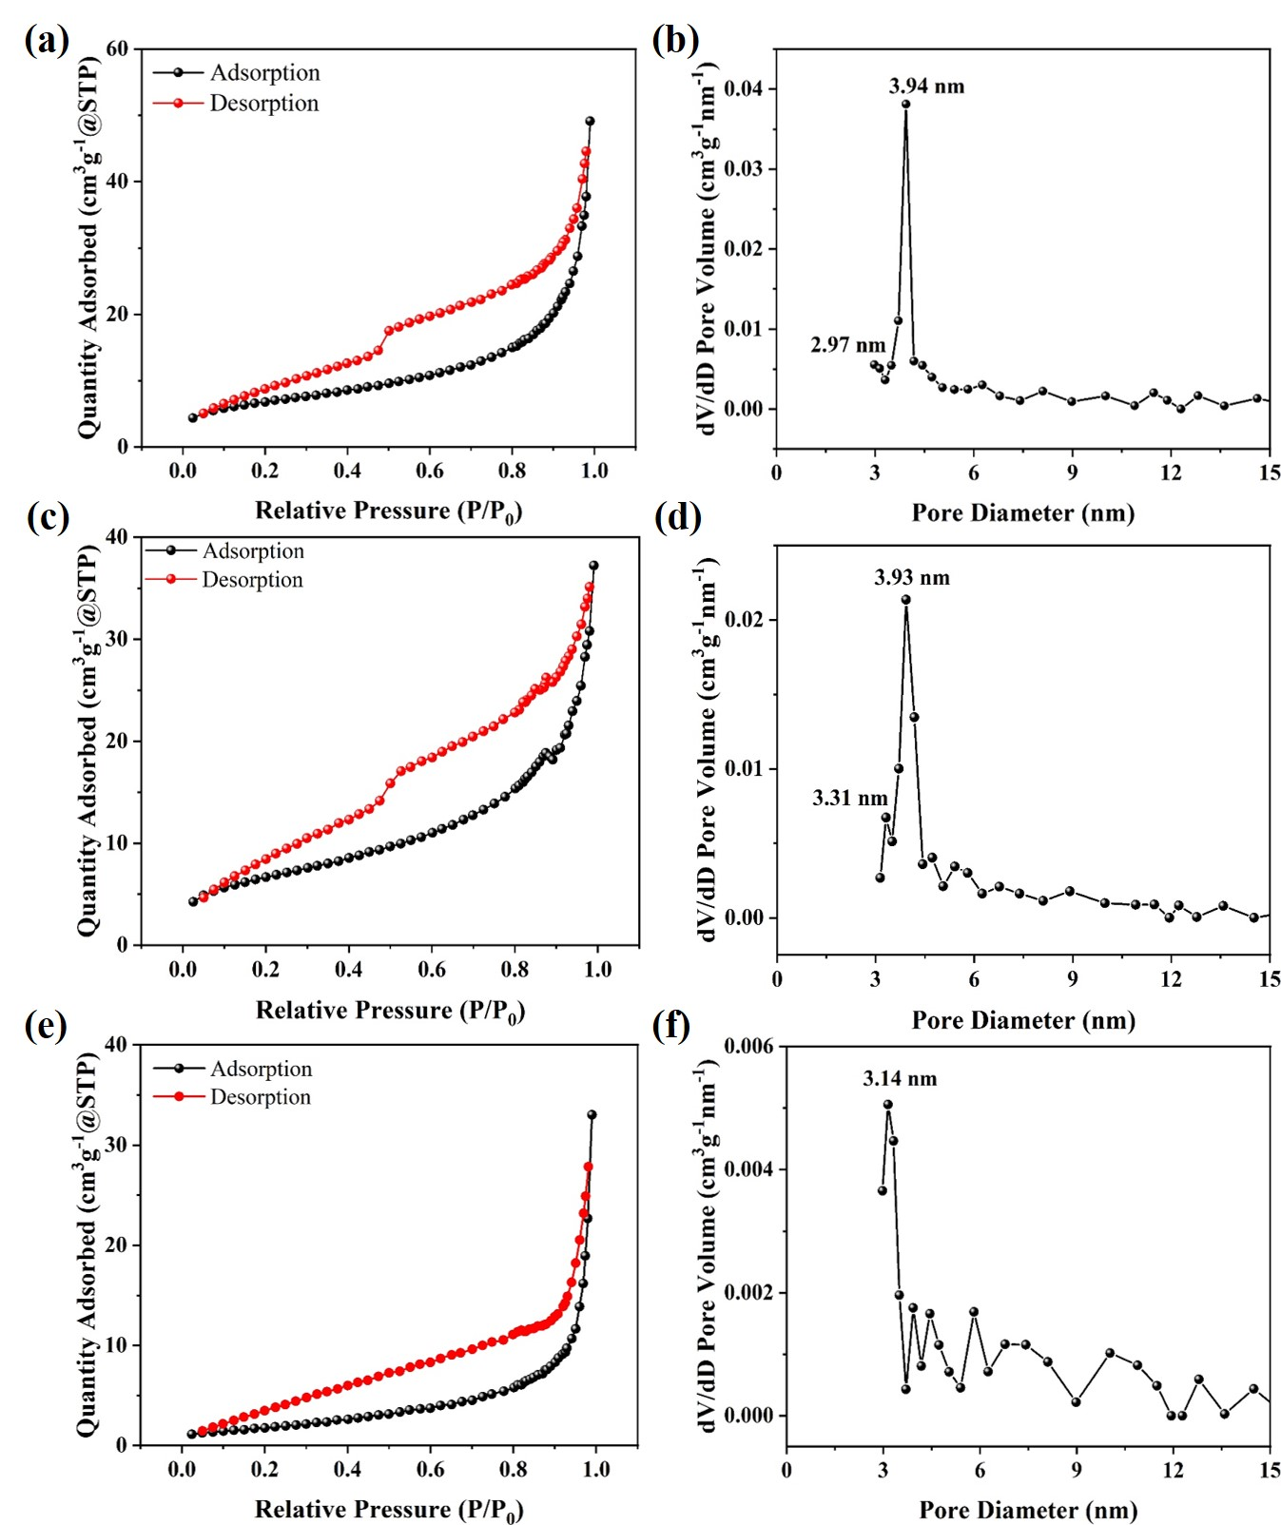
Fig. S4 Nitrogen adsorption-desorption isotherms and corresponding pore size distribution curves of (a, b) H1, (c, d) H3, and (e, f) H5
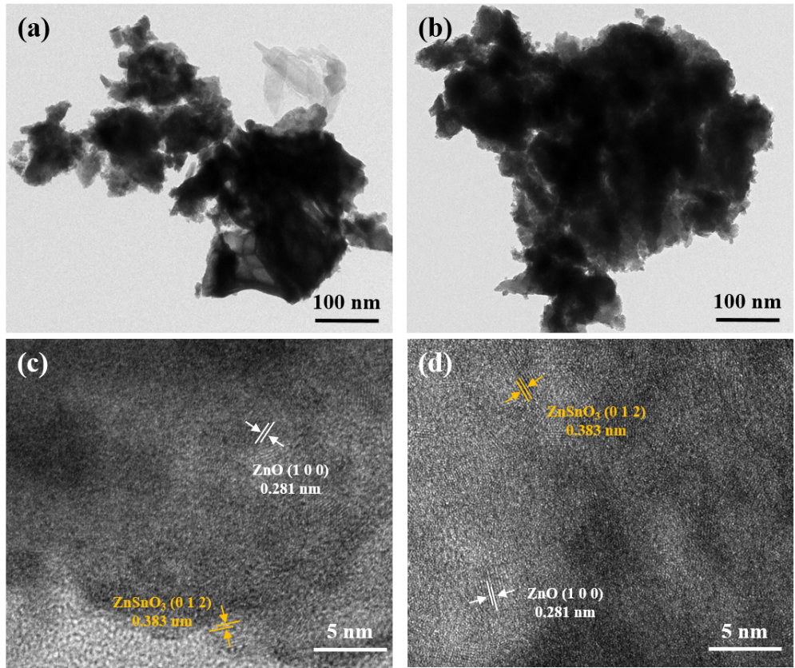
Fig. S5 TEM and HRTEM images of (a, c) H1 and (b, d) H5

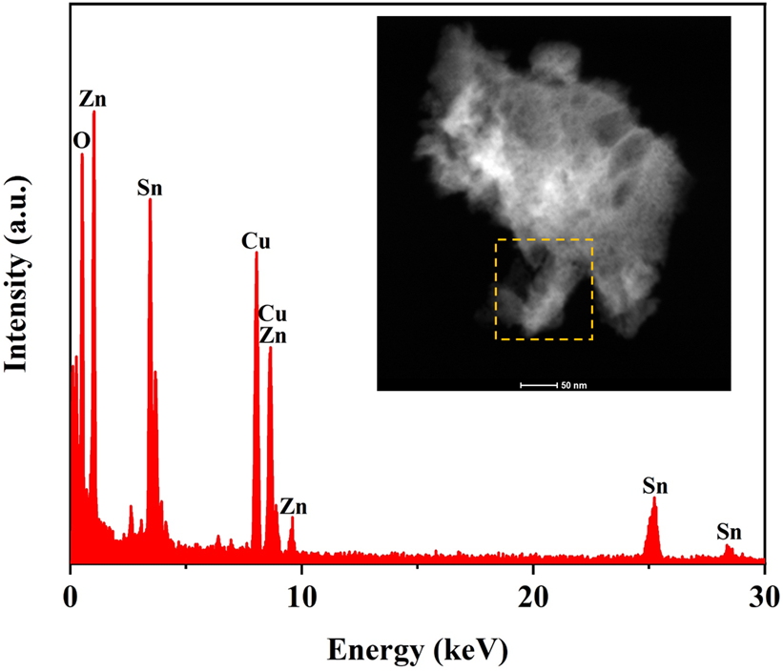
Fig. S6 Energy dispersive spectrum (EDS) of ZnO/ZnSnO₃ nanoscale heterojunctions fabricated with the hydrogen flow of 3 L/min
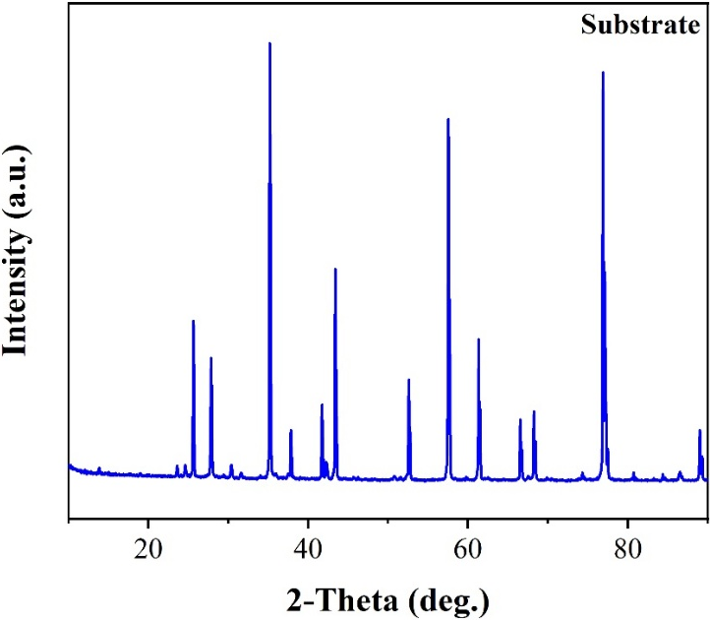
Fig. S7 XRD pattern of the substrate used in this work
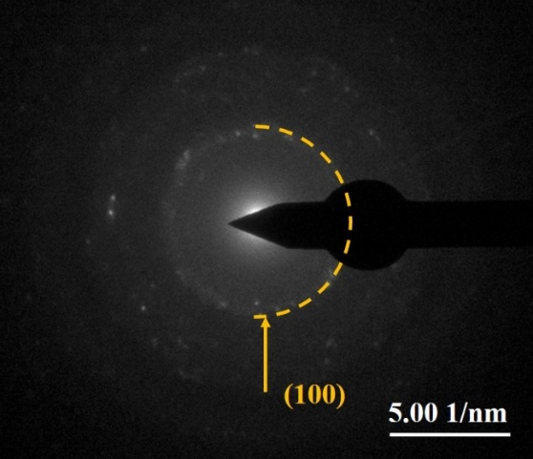
Fig. S8 Selected-area electron diffraction (SAED) pattern of ZnO/ZnSnO₃ nanoscale heterojunctions fabricated with the hydrogen flow of 3 L/min
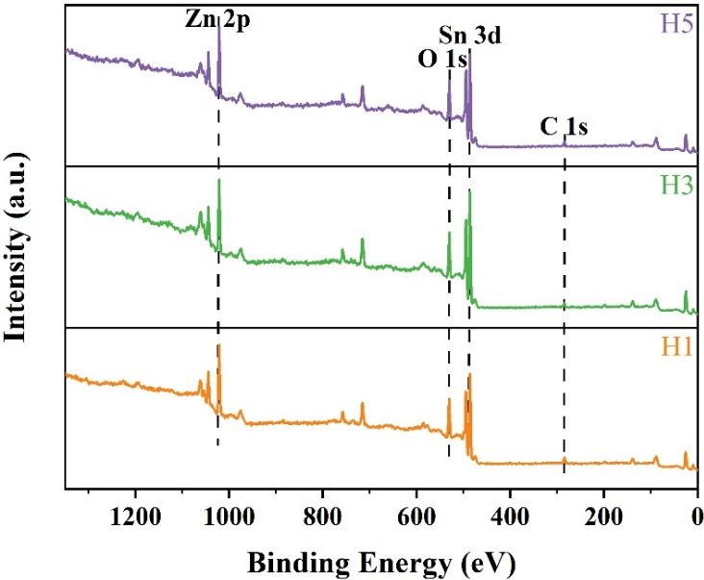
Fig. S9 XPS analysis on survey spectra of H1, H3, and H5
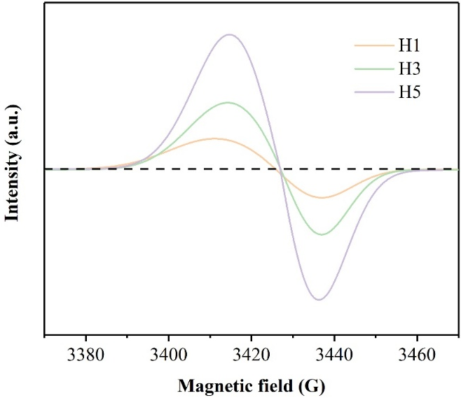
Fig. S10 EPR spectra of all samples
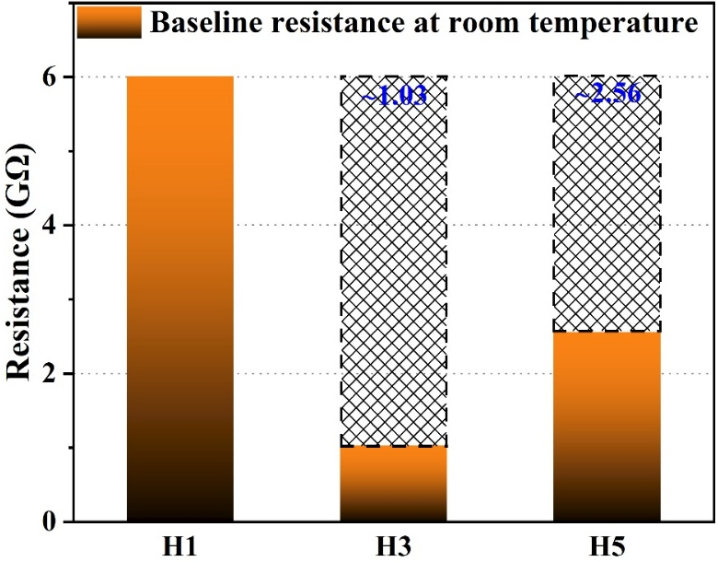
Fig. S11 Baseline resistance of H1, H3, and H5-based gas sensors towards the purified air at room temperature
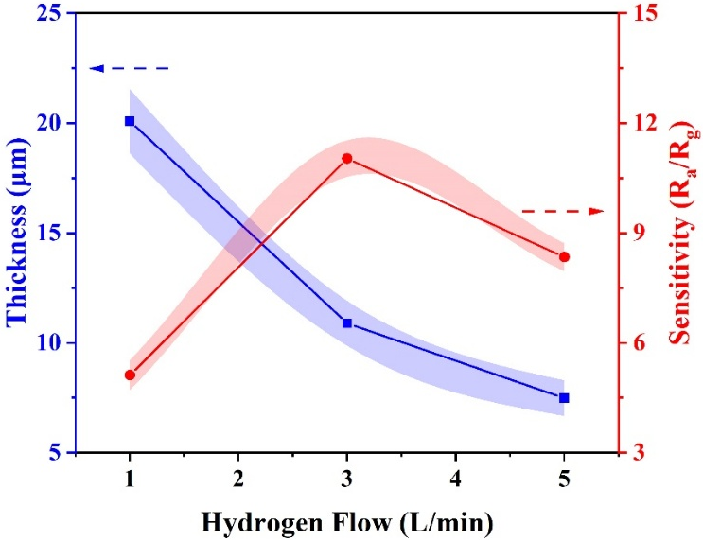
Fig. S12 Relationship between sensitivity and thickness of all samples deposited by SPPS
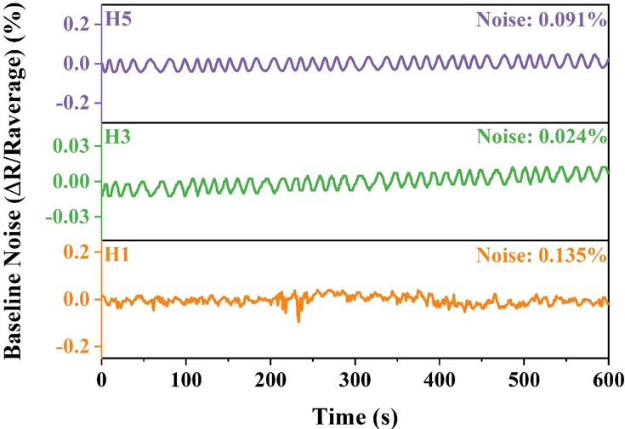
Fig. S13 Baseline noise of the sensors during purified air (79%N₂+21%O₂) exposure
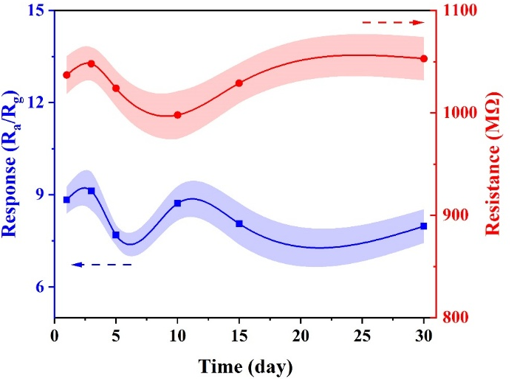
Fig. S14 Long-term stability including sensitivity and baseline resistance (R_{a}) of H3 towards 10 ppm 2-Undecanone at room temperature
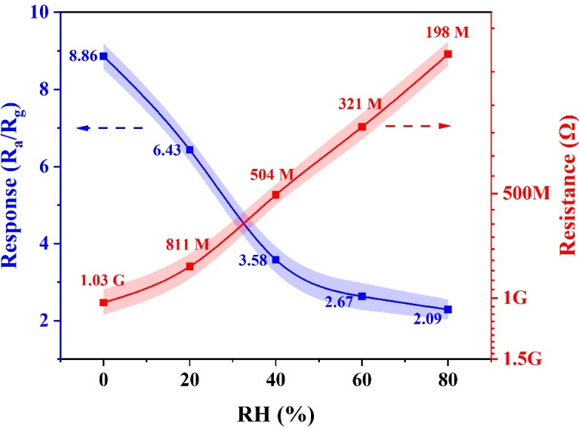
Fig. S15 Sensor responses and its corresponding baseline resistance (R_{a}) of H3 towards 10 ppm 2-Undecanone under various relative humidity conditions (0%, 20%, 40%, 60%, and 80%RH)

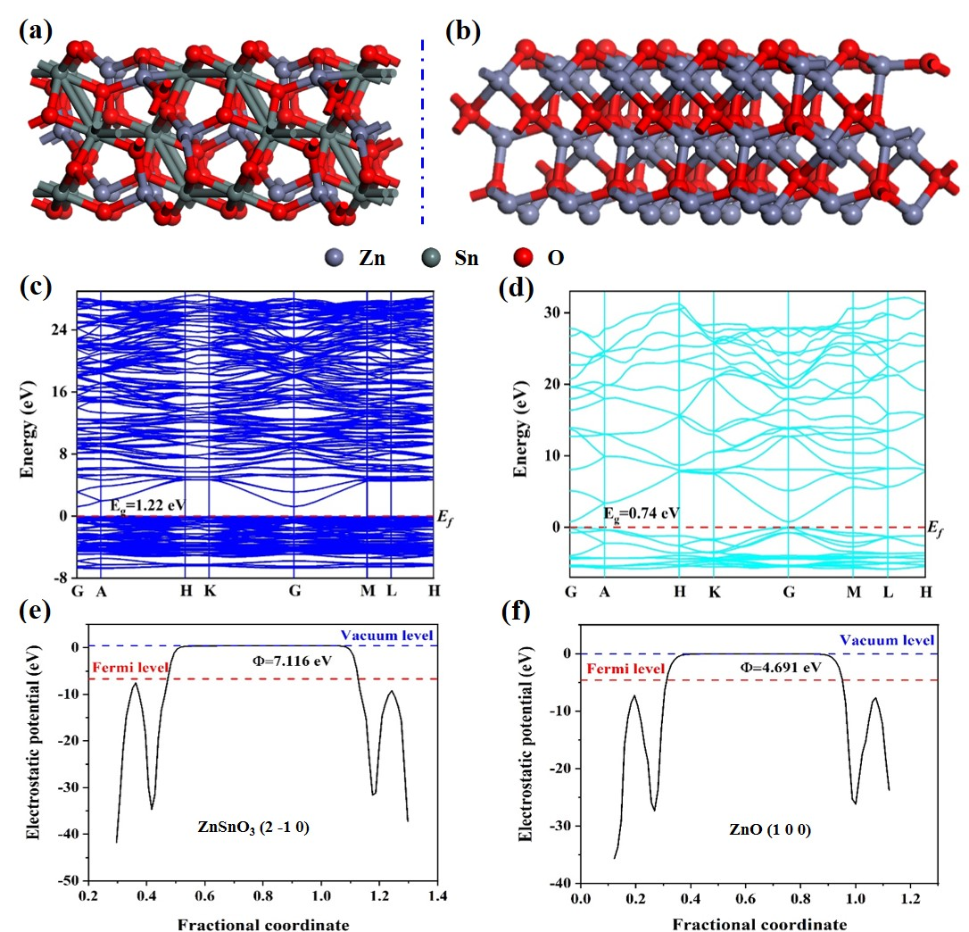
Fig. S16 The visualized structures, the calculated band structures and the work functions of a, c, e ZnSnO₃ and b, d, f ZnO obtained from the DFT calculations.
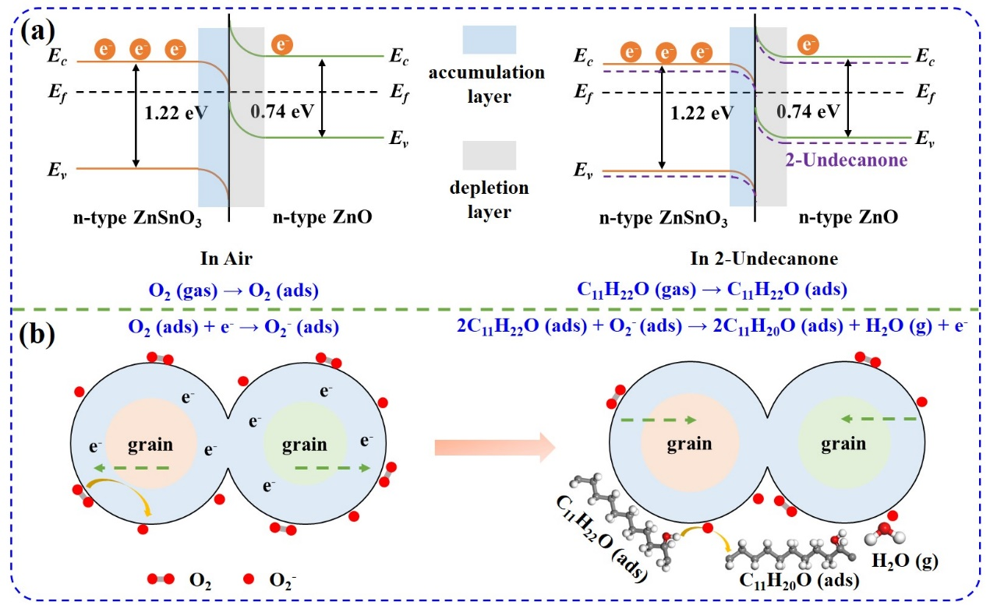
Fig. S17 Room-temperature gas-sensing mechanisms of zinc stannate heterojunctions towards 2-Undecaone. a The band alignment and energy diagram after contact. b Schematic diagrams for the adsorption of 2-Undecaone on the surface of sensing materials (E_{c}: conduction band bottom; E_{f}: Fermi level; E_{v}: valence band top)

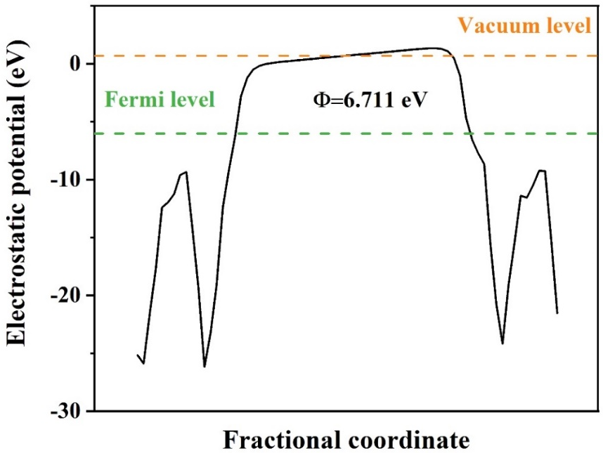
Fig. S18 The calculated work function of zinc stannate heterojunctions (ZnO/ZnSnO₃)
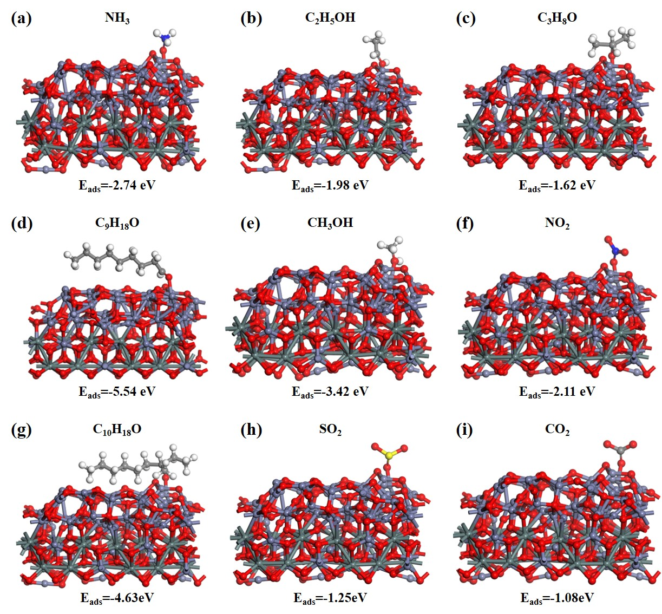
Fig. S19 The analysis of the adsorption structure with geometric binding configuration for the model of nine gases on the zinc stannate heterojunctions
Table S1 Spraying parameters for ZnO/ZnSnO₃ nanoscale heterojunctions by SPPS
Parameter/Unit | Value
Current/A | 580
Ar flow/L∙min⁻¹ | 35
H₂ flow/L∙min⁻¹ | 1, 3, 5
Spray distance/mm | 90
Solution concentration/M | 0.3
Substrate preheating temperature/℃ | 400
Solution flow rate/mL∙min⁻¹ | 28
Table S2 Average crystallite size of all samples
 | H1 | H2 | H3
Size/nm | 7.53 | 10.36 | 14.43
Table S3 Textural properties of the samples deposited by SPPS
Sample | BET surface area/m²∙g⁻¹ | Pore diameter/nm | Pore volume/cm³∙g⁻¹
H1 | 24.500 | 2.97, 3.94 | 0.073
H3 | 24.086 | 3.31, 3.93 | 0.057
H5 | 7.107 | 3.14 | 0.051
Table S4 The gas-sensing performance of all samples towards 13 ppm 2-Undecanone at 25 ± 1 ℃, 30 ± 10%RH
Material | Hydrogen/L·min⁻¹ | Sensitivity (R_{a}/R_{g}) | Response time (s) | Recovery time (s) | Linear coefficient
ZnO | 3 | 3.47 | 29 | 38 | -
SnO₂ | 3 | 2.89 | 30 | 52 | -
ZnO/ZnSnO₃ | 1 | 5.12 | 33 | 28 | 0.995
ZnO/ZnSnO₃ | 3 | 11.03 | 21 | 34 | 0.981
ZnO/ZnSnO₃ | 5 | 8.34 | 24 | 48 | 0.984
Table S5 Detailed parameters utilized for DFT calculations
Model | E_{cut}/eV | K-point | (h k l)
ZnO | 500 | 13×13×7 | (1 0 1)
ZnSnO₃ | 450 | 5×5×2 | (2 -1 0)

