Supporting Information for
Novel Cellulosic Fiber Composites with Integrated Multi-Band Electromagnetic Interference Shielding and Energy Storage Functionalities
Xuewen Han ^{1, 2}, Cheng Hao ², Yukang Peng ¹, Han Yu ¹, Tao Zhang ¹, Haonan Zhang ^{2,5} Kaiwen Chen ^{2.6} Heyu Chen ⁴, Zhenxing Wang ³, Ning Yan ^{2, *} and Junwen Pu ^{1, *}
¹ Beijing Key Laboratory of Lignocellulosic Chemistry, College of Materials Science and Technology, Beijing Forestry University, Beijing 100083, P. R. China
² Department of Chemical Engineering and Applied Chemistry, University of Toronto, Toronto, ON M5S3E5, Canada
³ Key Laboratory of Advanced Marine Materials, Ningbo Institute of Materials Technology and Engineering, Chinese Academy of Sciences, Ningbo 315201, P. R. China
⁴ College of Mechanical and Electronic Engineering, Northwest A&F University, Yangling, Shaanxi 712100, P. R. China
⁵ Jiangsu Provincial Key Lab of Sustainable Pulp and Paper Technology and Biomass Materials, Nanjing Forestry University, Nanjing 210037, P. R. China
⁶ Co-Innovation Center of Efficient Processing and Utilization of Forest Resources, Nanjing Forestry University, Nanjing 210037, P. R. China
*Corresponding authors. E-mail: ning.yan@utoronto.ca (Ning Yan); jwpu@bjfu.edu.cn (Junwen Pu)
Supplementary Figures and Tables
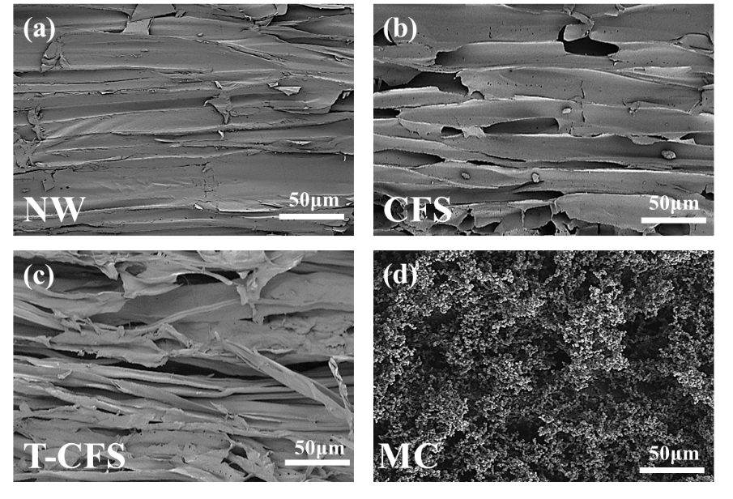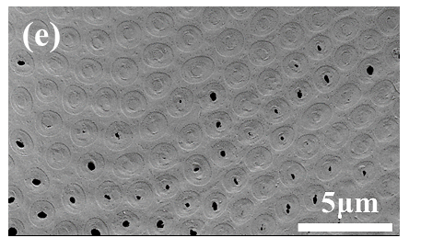
CFS
Fig. S1 The SEM images of (a) natural wood (NW), (b) cellulose fiber skeleton (CFS); (c) TEMPO-oxidized cellulose fiber skeleton (T-CFS), (d) TEMPO-oxidized cellulose fiber multifunctional composites (PPy@Fe³⁺/ T-CFS-MC), (e) Tracheids structure on the surface of cellulose fibers
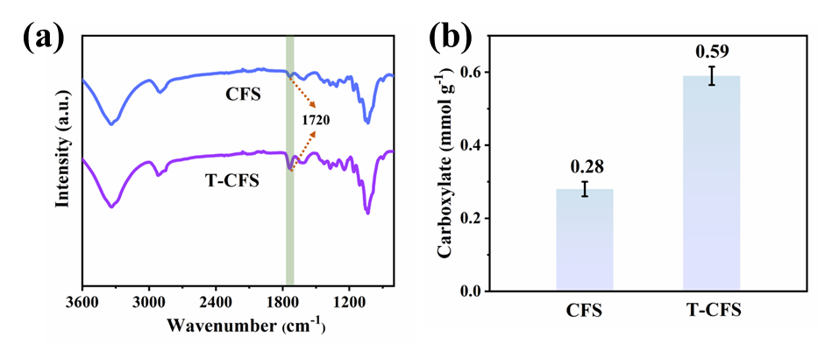
Fig. S2 (a) FTIR spectra of samples before and after TEMPO oxidation; (b) Carboxylate content of CFS and T-CFS

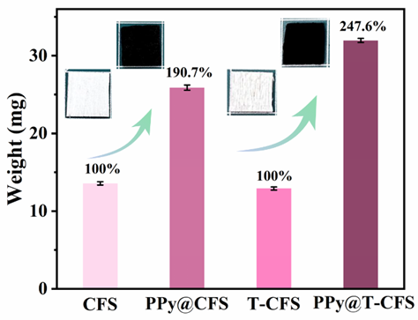
Fig. S3 Weight gain of PPy@Fe³⁺/ CFS-MC and PPy@Fe³⁺/T-CFS-MC samples

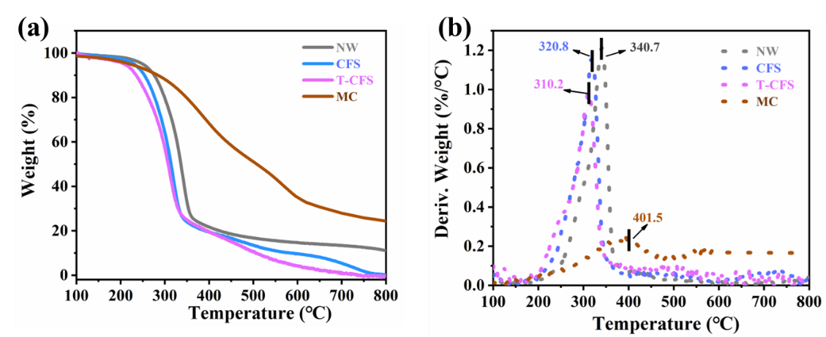
Fig. S4 (a) TG and (b) DTG analysis of the NW, CFS, T-CFS and PPy@Fe³⁺/ T-CFS-MC samples

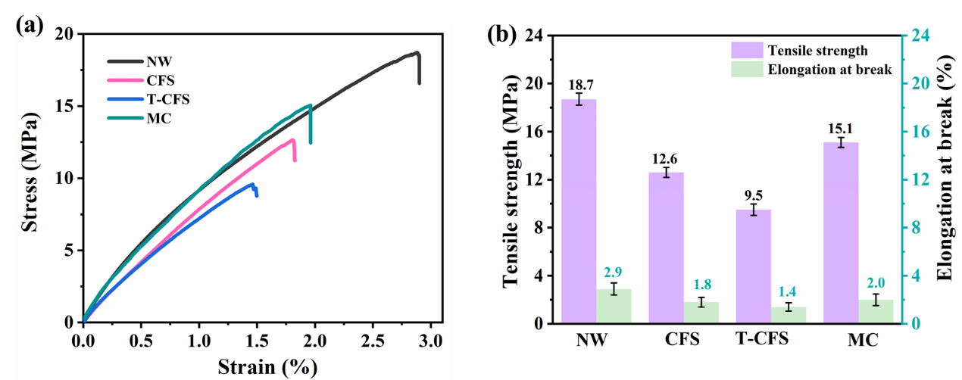
Fig. S5 (a) Tensile stress-strain curves and (b) Maximum stress and strain of NW, CFS, T-CFS, MC samples

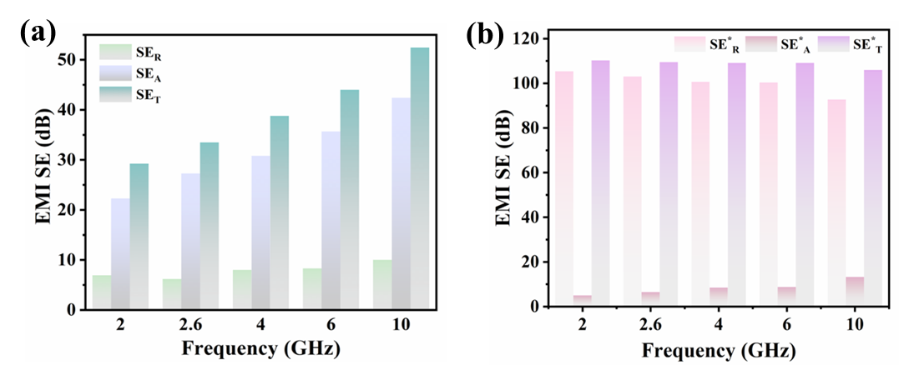
Fig. S6 (a) The EMI SE_{R}, SE_{A}, SE_{T} of the PPy@Fe³⁺/T-CFS-MC at the frequency of 2, 2.6, 4, 6, 10 GHz, respectively. (b) The EMI ${\text{ SE}}_{\text{R}}^{}$, ${\text{SE}}_{\text{A}}^{}$, ${\text{SE}}_{\text{T}}^{}$ of the PPy@Fe³⁺/T-CFS-MC at the frequency of 2, 2.6, 4, 6, 10 GHz, respectively
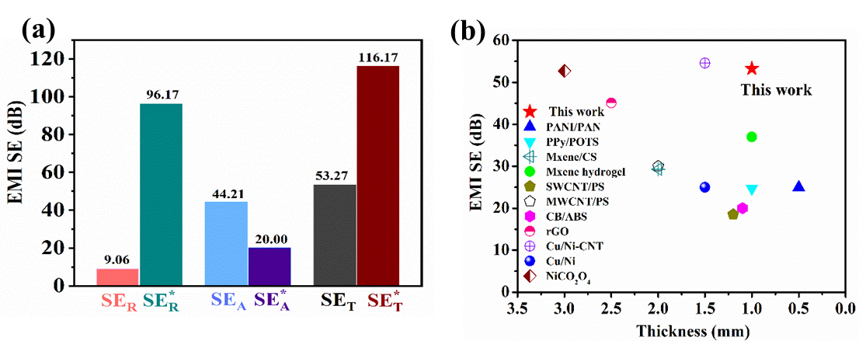
Fig. S7 (a) Comparison of SE_{T}, ${\text{SE}}_{\text{T}}^{}$, SE_{A}, ${\text{SE}}_{\text{A}}^{}$, SE_{R} and${\text{ SE}}_{\text{R}}^{}$ of PPy@Fe³⁺/T-CFS-MC at the frequency of 12.4 GHz. (b) Comparison of EMI shielding performance (EMWs that only into the materials in the X-band) with other reported materials
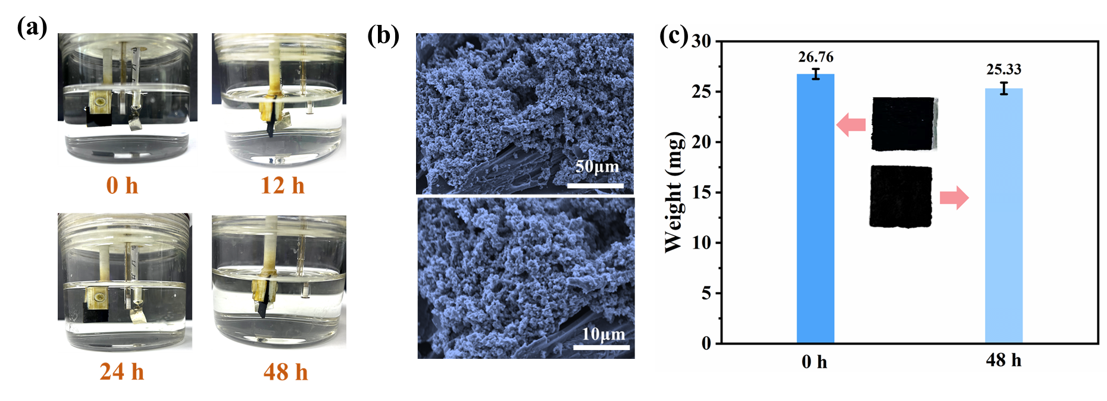
Fig. S8 (a) The state change pictures of the PPy@Fe³⁺/T-CFS-MC sample placed in 1M sulfuric acid solution for 0, 12, 24, and 48 hours. (b) The SEM images of the MC sample after being placed in 1M sulfuric acid solution for 48 hours. (c) Weight change of the sample before and after being placed in 1M sulfuric acid solution
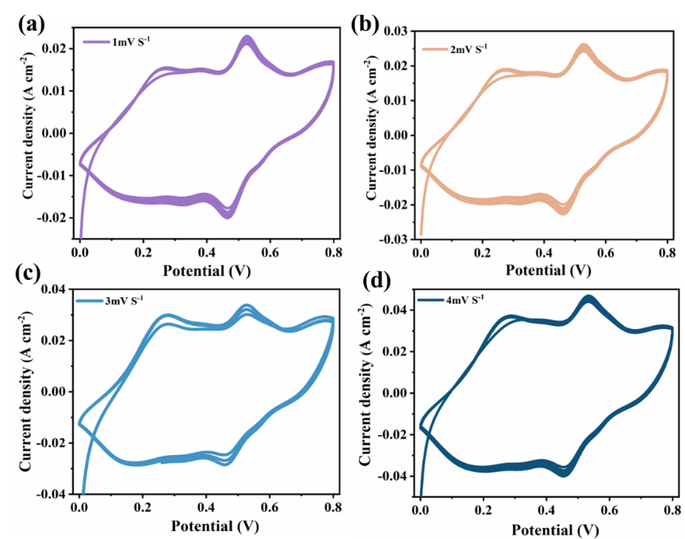
Fig. S9 PPy@Fe³⁺/T-CFS-MC samples at CV curves at scan rates of (a) 1 mV S⁻¹; (b) 2 mV S⁻¹; (c) 3 mV S⁻¹ and (d) 4 mV S⁻¹
Table S1 Comparison of the EMI shielding performance (EMWs that only into the material) of the PPy@Fe³⁺/T-CFS-MC with other reported materials [S1-S14]
Type | Sample | Materials | Thickness  (mm) | L-band  SE (dB) | S-band  SE (dB) | C-band  SE (dB) | X-band  SE (dB) | Refs.
Metal-based | 1 | NiCO₂O₄ | 3.0 | / | / | / | 52.72 | [S1]
Metal-based | 2 | Cu/Ni | 1.5 | / | / | / | 25 | [S7]
Metal-based | 3 | Cu/Ni-CNT | 1.5 | / | / | / | 54.6 | [S7]
 | 4 | NiFe₂O₄/rGO | 2 | / | / | 28.5 | / | [S13]
Carbon-based | 5 | rGO | 2.5 | / | / | / | 45.1 | [S6]
Carbon-based | 6 | CB/ABS | 1.1 | / | / | / | 20 | [S11]
Carbon-based | 7 | MWCNT/PS | 2 | / | / | / | 30 | [S10]
Carbon-based | 8 | SWCNT/PS | 1.2 | / | / | / | 18.5 | [S9]
Carbon-based | 9 | Mxene hydrogel | 1.0 | / | / | / | 37 | [S5]
Carbon-based | 10 | EG flexible graphite | 0.127 | 55 | / | / | / | [S12]
Bio-based | 11 | CS/Mxene | 2 | / | / | / | 29.3 | [S8]
Bio-based | 12 | MWCNTs/ ANFs | 0.45 | / | / | / | 41.7 | [S2]
Bio-based | 13 | CNF/ Mxene | 3 | / | 47.9 | / | 52.6 | [S14]
Polymer-based | 14 | PPy/POTS | 1 | / | / | / | 24.7 | [S3]
Polymer-based | 15 | PANI/PAN | 0.5 | / | / | / | 25 | [S4]
This work | 16 | PPy@Fe³⁺/T-CFS-MC | 1 | 29.3 | 33.6 | 44.2 | 53.27
CNT: carbon nanotubes; rGO: reduced graphene oxide; CB: carbon black; ABS: acrylonitrile butadiene styrene; SWCNT: single-walled carbon nanotubes; MWCNT: multi-walled carbon nanotubes; PS: polystyrene; EG: exfoliated graphite CS: cellulose scaffold; ANFs: aramid fibers; CNF: cellulose nanofibers; PPy: polypyrrole; POTS:1H, 1H, 2H, 2H-perfuorooctyltriethoxysilane; PANI: polyaniline; PAN: polyacrylonitrile.
Supplementary References
- M. Zhang, C. Han, W.-Q. Cao, M.-S. Cao, H.-J. Yang et al., A nano-micro engineering nanofiber for electromagnetic absorber, green shielding and sensor. Nano-Micro Lett. 13(1), 27 (2020). https://doi.org/10.1007/s40820-020-00552-9
- L. Zou, C. Lan, S. Zhang, X. Zheng, Z. Xu et al., Near-instantaneously self-healing coating toward stable and durable electromagnetic interference shielding. Nano-Micro Lett. 13(1), 190 (2021). https://doi.org/10.1007/s40820-021-00709-0
- Z. Stempien, T. Rybicki, E. Rybicki, M. Kozanecki, M.I. Szynkowska, In-situ deposition of polyaniline and polypyrrole electroconductive layers on textile surfaces by the reactive ink-jet printing technique. Synthetic Met. 202, 49-62 (2015). https://doi.org/10.1016/j.synthmet.2015.01.027
- Y. Yu, P. Yi, W. Xu, X. Sun, G. Deng et al., Environmentally tough and stretchable mxene organohydrogel with exceptionally enhanced electromagnetic interference shielding performances. Nano-Micro Lett. 14(1), 77 (2022). https://doi.org/10.1007/s40820-022-00819-3
- D.-X. Yan, H. Pang, B. Li, R. Vajtai, L. Xu et al., Structured reduced graphene oxide/polymer composites for ultra-efficient electromagnetic interference shielding. Adv. Funct. Mater. 25(4), 559-566 (2015). https://doi.org/10.1002/adfm.201403809
- K. Ji, H. Zhao, J. Zhang, J. Chen, Z. Dai, Fabrication and electromagnetic interference shielding performance of open-cell foam of a Cu–Ni alloy integrated with cnts. Appl. Surf. Sci. 311, 351-356 (2014). https://doi.org/10.1016/j.apsusc.2014.05.067
- Z.-x. Wang, X.-s. Han, Z.-j. Zhou, W.-y. Meng, X.-w. Han et al., Lightweight and elastic wood-derived composites for pressure sensing and electromagnetic interference shielding. Compos. Sci. Technol. 213, 108931 (2021). https://doi.org/10.1016/j.compscitech.2021.108931
- Y. Yang, M.C. Gupta, K.L. Dudley, R.W. Lawrence, Novel carbon nanotube−polystyrene foam composites for electromagnetic interference shielding. Nano Lett. 5(11), 2131-2134 (2005). https://doi.org/10.1021/nl051375r
- M. Arjmand, T. Apperley, M. Okoniewski, U. Sundararaj, Comparative study of electromagnetic interference shielding properties of injection molded versus compression molded multi-walled carbon nanotube/polystyrene composites. Carbon 50(14), 5126-5134 (2012). https://doi.org/10.1016/j.carbon.2012.06.053
- F. Jiang, Y.-L. Hsieh, Amphiphilic superabsorbent cellulose nanofibril aerogels. J Mater Chem. A 2(18), 6337-6342 (2014). https://doi.org/10.1039/C4TA00743C
- H. Guan, D.D.L. Chung, Radio-wave electrical conductivity and absorption-dominant interaction with radio wave of exfoliated-graphite-based flexible graphite, with relevance to electromagnetic shielding and antennas. Carbon 157, 549-562 (2020). https://doi.org/10.1016/j.carbon.2019.10.071
- R.S. Yadav, I. Kuřitka, J. Vilcakova, D. Skoda, P. Urbánek et al., Lightweight nife2o4-reduced graphene oxide-elastomer nanocomposite flexible sheet for electromagnetic interference shielding application. Compos. B Eng. 166, 95-111 (2019). https://doi.org/10.1016/j.compositesb.2018.11.069
- B. Shan, Y. Wang, X. Ji, Y. Huang, Enhancing low-frequency microwave absorption through structural polarization modulation of mxenes. Nano-Micro Lett. 16(1), 212 (2024). https://doi.org/10.1007/s40820-024-01437-x
- H. Guo, Y. Li, Y. Ji, Y. Chen, K. Liu et al., Highly flexible carbon nanotubes/aramid nanofibers composite papers with ordered and layered structures for efficient electromagnetic interference shielding. Compos. Commun. 27, 00879 (2021). https://doi.org/10.1016/j.coco.2021.100879

