Supporting Information for
Enhancing Thermal Protection in Lithium Batteries with Power Bank-Inspired Multi-Network Aerogel and Thermally Induced Flexible Composite Phase Change Material
Zaichao Li¹, Feng Cao¹, Yuang Zhang^{1,} *, Shufen Zhang¹, Bingtao Tang^{1,} *
¹State Key Laboratory of Fine Chemicals, Frontiers Science Center for Smart Materials Oriented Chemical Engineering, Dalian University of Technology, Dalian 116024, P. R. China
*Corresponding authors. E-mail: zhangyuang@dlut.edu.cn (Yuang Zhang); tangbt@dlut.edu.cn (Bingtao Tang)
S1 Experimental Sections
S1.1 Materials
Ge (analytical grade) and a 50% GLU solution were procured from Shanghai Aladdin Biochemical Technology Co., Ltd. SA with a viscosity ranging between 7000-10000 mPa·s, BA (>99.5%), SAT (99%), and a 0.2 mol/L acetic acid solution were sourced from Shanghai Macklin Biochemical Technology Co., Ltd. The TPEE (SK G130D) was supplied by China Konai New Materials Co., Ltd., while EG (50 mesh) was obtained from Qingdao Tengshengda Carbon Machinery Co., Ltd. The adhesive (LN W1350) was provided by China Lilin Co., Ltd., and dichloromethane was acquired from China National Pharmaceutical Group Co., Ltd. Unless otherwise noted, all reagents used in this study were of analytical grade.
S1.2 Characterization
The surface morphology and microstructure of the samples were analyzed using scanning electron microscopy (SEM). X-ray powder diffraction (XRD) analysis was performed with a Rigaku Smart Lab X-ray diffractometer to determine the crystal phase structure. Fourier transform infrared spectroscopy (FT-IR, NICOLETT, USA) was employed to investigate the chemical structure of the samples. The pore structure properties were characterized using a fully automated multi-station micropore physical adsorption analyzer (3FLEX, Micromeritics, USA) and a mercury intrusion porosimeter (MicroActive AutoPore V 9600). The mechanical properties were assessed using a universal testing machine (INSTRON 5982) at a compression rate of 5 mm/min.
The flame retardancy of the samples was evaluated using the limiting oxygen index (LOI) method (FTT0077, UK), where a higher oxygen requirement for sustained combustion indicates better flame retardancy. A vertical burning test (FTT0082, UK) was employed to assess the flame retardant rating of the samples. Specimens measuring 125 × 13 × 10 mm³ were vertically aligned (15 parallel samples). The materials were ignited twice, each for a duration of 10 s. If the flames extinguished within 10 s both times without any burning material dropping, the sample was rated as V-0. If the total flame duration did not exceed 30 s and the dripping material did not ignite the cotton placed below, the sample was rated as V-1. If the total flame duration did not exceed 30 s but the dripping material ignited the cotton, the sample was rated as V-2. Heat release rates, smoke production, and toxic gas emissions were measured using cone calorimetry (ISO5660, 35 KW). Thermal stability was determined through thermogravimetric analysis (TGA, TG 209, TA), with testing conducted from room temperature to 800 ℃ under a nitrogen atmosphere at a heating rate of 10 ℃/min. Decomposition products were analyzed using combined TG-FTIR (TGA8000-Frontier-Clarus SQ8T, 10 ℃/min).
Differential scanning calorimetry (DSC, DSC Q20) and reaction calorimetry were employed to measure the phase transition temperature and enthalpy of the composite PCMs over a range of 0 to 180 ℃ under a nitrogen atmosphere at a heating rate of 5 ℃/min. Thermo-mechanical properties were measured using a torque rheometer (Thermo Fisher Mars40) with a heating rate of 5 ℃/min, a frequency of 1 Hz, and a scanning temperature range of 10-70 ℃. The thermal conductivity of the composites was measured using a thermal conductivity meter (Hot Disk TPS 2500S).
An infrared thermal imager (FLUKE, USA) was used to capture the temperature distribution of the samples, and digital photographs were taken using a digital camera (Nikon, Japan). The shape stability of the samples was tested through time-lapse photography. The leakage test procedure was as follows: two different samples, each measuring 50×50×8 mm³, were placed on a heating plate at 80 ℃. A digital camera and infrared thermal imager were used to track and capture the appearance of the samples in real-time as the temperature changed. Digital photos and infrared thermal images were taken at 0, 5, 10, and 30 min. To better observe any leaked liquid, the heating plate was tilted at a certain angle (with hard objects placed underneath the plate to achieve the tilt). The specific test setup is shown in Fig. S10.
The leakage rate of the samples was tested using the following method: First, the original mass of the sample ($Q_{iginal}$) was measured. The sample was then heated on an 80 ℃ heating plate, and at specific intervals, the remaining solid mass ($Q_{n}$) was measured. The leakage rate was calculated using Eq. (S1) [S1]:
$$\begin{aligned}R_{LR}=\left(1−\frac{Q_{n}}{Q_{iginal}}\right)×100\text{\%} \\ \left(S1\right)\end{aligned}$$
The contact thermal resistance of the CPCM was measured using a steady-state thermal method. A ceramic heating block (35×20×5 mm) was placed on the CPCM, with the other surfaces insulated using thermal insulation cotton to ensure unidirectional heat transfer through the CPCM. Thermocouples T₁, T₂, and T₃ were used to monitor real-time temperatures at the center of the Li-ion battery surface, inside the CPCM, and on the CPCM surface, respectively. Assuming uniform thermal conductivity, the temperature at the CPCM-ceramic heating block interface (T_{PCM}) was calculated using thermal equilibrium equations (2 and 3 below). The interface temperature (T_{PCM}) and thermal resistance (R) were determined as follows [S2]:
$$\begin{aligned}T_{PCM}−T_{2}=T_{2}−T_{3} \\ \left(S2\right)\end{aligned}$$
$$\begin{aligned}R=\frac{T_{1}−T_{PCM}}{q} \\ \left(S3\right)\end{aligned}$$
Where T_{PCM} represents the interface temperature, and q denotes the heating power supplied by the DC power source.
S2 Supplementary Figures
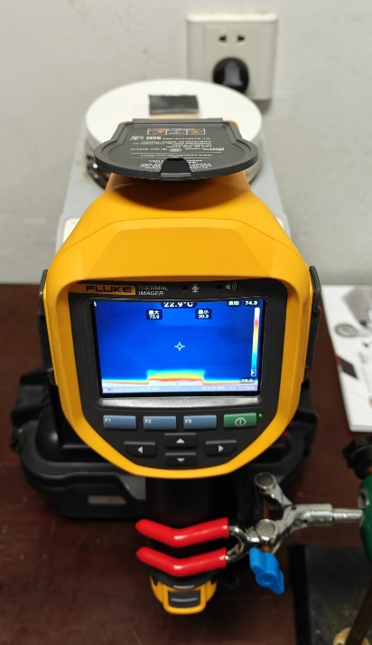
Fig. S1 The schematic diagram of the thermal insulation test of the sample to be tested

Fig. S2 Infrared spectra of Ge/SA aerogel at different temperatures

Fig. S3 a physical adsorption of nitrogen, b mercury porosimeter and c physical map of compression test device

Fig. S4 Compressive stress-strain curves of non-crosslinked Ge aerogel and crosslinked Ge aerogel

Fig. S5 Comparison of compressive strength of non-crosslinked Ge aerogel and crosslinked Ge aerogel
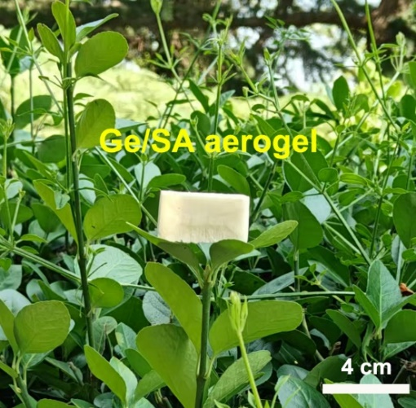
Fig. S6 Digital photo of Ge/SA aerogel

Fig. S7 Comparison of limiting oxygen index of non-crosslinked SA aerogel and SA aerogel crosslinked with boric acid
Fig. S8 Comparison of radar chart performance between different aerogels
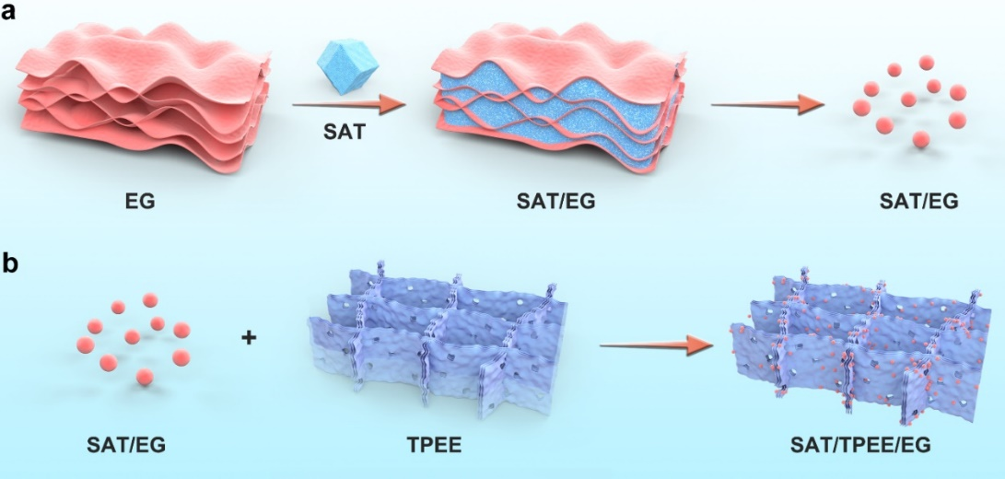
Fig. S9 The schematic diagram of the preparation of SAT/TPEE/EG CPCM
Fig. S10 The schematic diagram of leakage test
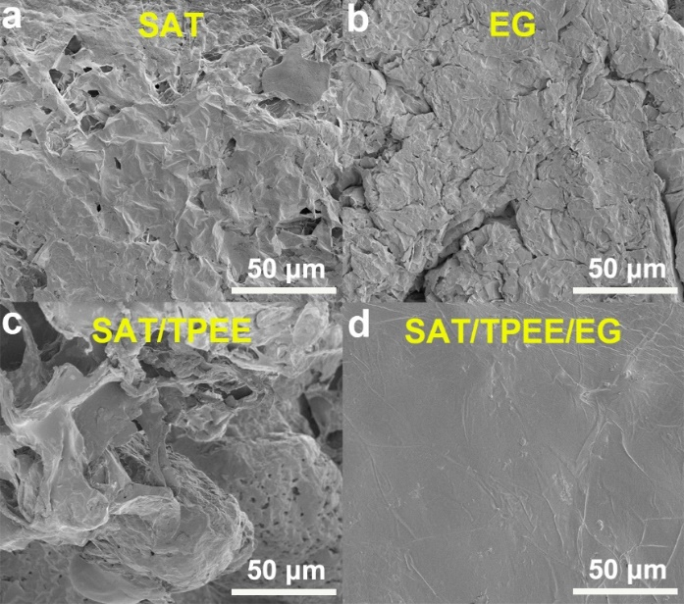
Fig. S11 a-d SEM images of SAT, TPEE, EG and SAT/TPEE/EG at 50 μm scale
Fig. S12 Chart of thermocouple arrangement for thermal runaway test of Li-ion battery

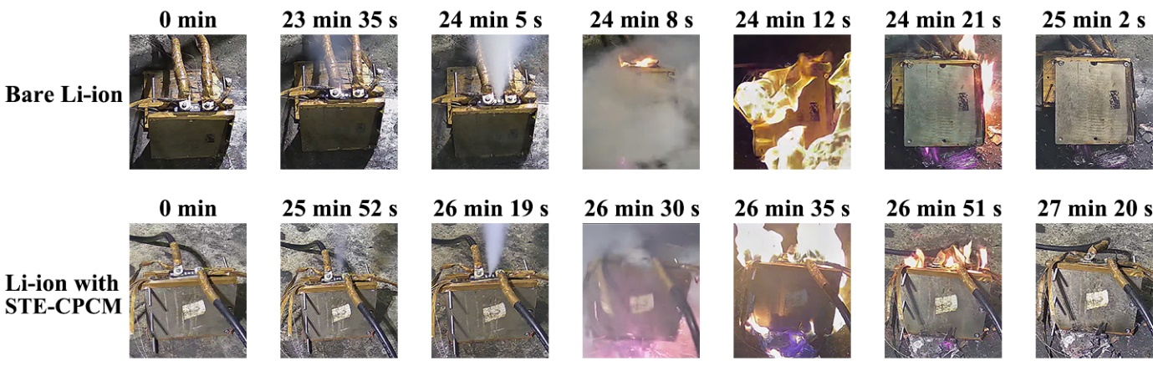
Fig. S13 Digital photos of lithium batteries with and without thermal protection materials at different times when thermal runaway occurs

Fig. S14 Temperature change curve of a bare battery and b Li-ion battery with thermal protection material during thermal runaway
Fig. S15 Possible thermal insulation mechanism of Ge/SA-STE coupled thermal protection materials

Fig. S16 FT-IR spectra of pyrolysis products of Ge/SA composite aerogel at different temperatures

Fig. S17 FT-IR spectra of pyrolysis products of SAT/TPEE/EG at different temperatures
Fig. S18 XRD patterns of Ge/SA composite aerogel and SAT/TPEE/EG carbon residue were obtained

Fig. S19 FT-IR patterns of Ge/SA composite aerogel and SAT/TPEE/EG carbon residue were obtained
S3 Supplementary Tables
Table S1 The content of each component in the sample
Sample | SAT/g | TPEE/g | EG/g
SAT/TPEE/EG (5 mm) | 22.0 | 4.0 | 0.7

Table S2 Technical parameters of the battery module
Property | Parameter
Capacity (Ah) | 30.0
Nominal voltage (V) | 3.2
Weight (g) | 640.0
Height (mm) | 100.0
Width (mm) | 140.0
Thickness (mm) | 20.5
Electrolyte material | Lithium hexafluorophosphate + Carbonate solvent + Ethylene carbonate
Cathode material | Lithium iron phosphate
Anode material | Graphite
Table S3 Rating of samples vertical combustion test
Sample | UL-94 Rating
Ge/SA aerogel | V-0
SAT/TPEE/EG | V-0
Ge/SA-STE | V-0
Table S4 Leakage results of the different PCMs
Time  (min) | Weight variation (g/%)
Time  (min) | SAT/TPEE | Leakage/% | SAT/TPEE/EG | Leakage/%
0 | 1.790 | 0.000 | 1.844 | 0.000
10 | 1.725 | 3.631 | 1.844 | 0.000
20 | 1.675 | 6.425 | 1.844 | 0.000
30 | 1.628 | 9.050 | 1.844 | 0.000
60 | 1.534 | 14.302 | 1.844 | 0.000
90 | 1.413 | 21.061 | 1.844 | 0.000
120 | 1.292 | 27.821 | 1.844 | 0.000
Table S5 Summaries of different CPCMs
CPCM | Proportion | Heat storage temperature  (℃) | Thermal storage density  (J/g) | Refs.
SAT/EG | 80.0%/20.0% | 58.5/106.5 | 793.4 | [S3]
SAT/bentonite/SCª | 64.0%/26.0%/10.0% | 57.5 | 171.9 | [S4]
SAT/SiCª/EG | 96.0%/2.0%/2.0% | 60.0 | 249.5 | [S5]
SAT/UREA/DHPD^{b}/CMC^{c}/CNTs^{d}/EG | 76.0%/24.0% | 55.8 | 180.1 | [S6]
PA^{e}/TPEE/EG | 45.0%/45.0%/10.0% | / | 102.0 | [S7]
PA/TPEE/SBS^{f}/EG | 80.0%/5.0%/10.0%/5.0% | 55.0 | 170.1 | [S8]
n-eicosane/SAT/EG | 19.3%/77.3%/3.4% | 36.3/58.2 | 266.5 | [S9]
SAT-LiCl^{g}-KCl^{h}/EG | 86.0%/14.0% | 49.3 | 196.4 | [S10]
SAT/TPEE/EG | 82.4%/15.0%/2.6% | 66.7/132.9 | 811.9 | This work
ªSC/SiC: Silicon carbide. ^{b}DHPD: Disodium hydrogen phosphate dodecahydrate
^{c}CMC: Sodium carboxymethylcellulose. ^{d}CNTs: Carbon nanotubes. ^{e}PA: Paraffin.
^{f}SBS: Styrene-butadiene-styrene triblock copolymer. ^{g}LiCl: Lithium chloride
^{h}KCl: Potassium chloride

Supplementary References
- W. Wu, W. Wu, S. Wang Form-stable and thermally induced flexible composite phase change material for thermal energy storage and thermal management applications. Appl. Energy 236, 10–21 (2019). https://doi.org/10.1016/j.apenergy.2018.11.071
- X. Liu, C. Wang, T. Wu, Z. Li, C. Wu A novel stable and flexible composite phase change materials for battery thermal management. Appl. Therm. Eng. 212, 118510 (2022). https://doi.org/10.1016/j.applthermaleng.2022.118510
- J. Cao, Z. Ling, S. Lin, Y. He, X. Fang et al., Thermochemical heat storage system for preventing battery thermal runaway propagation using sodium acetate trihydrate/expanded graphite. Chem. Eng. J. 433, 133536 (2022). https://doi.org/10.1016/j.cej.2021.133536
- C. Liu, P. Hu, Z. Xu, X. Ma, Z. Rao Experimental investigation on thermal properties of sodium acetate trihydrate based phase change materials for thermal energy storage. Thermochim. Acta 674, 28–35 (2019). https://doi.org/10.1016/j.tca.2019.02.002
- G. Fang, W. Zhang, M. Yu, K. Meng, X. Tan Experimental investigation of high performance composite phase change materials based on sodium acetate trihydrate for solar thermal energy storage. Sol. Energy Mater. Sol. Cells 234, 111418 (2022). https://doi.org/10.1016/j.solmat.2021.111418
- W. Sun, G. Liang, F. Feng, H. He, Z. Gao Study on sodium acetate trihydrate-expand graphite-carbon nanotubes composite phase change materials with enhanced thermal conductivity for waste heat recovery. J. Energy Storage 55, 105857 (2022). https://doi.org/10.1016/j.est.2022.105857
- W. Wu, G. Ye, G. Zhang, X. Yang Composite phase change material with room-temperature-flexibility for battery thermal management. Chem. Eng. J. 428, 131116 (2022). https://doi.org/10.1016/j.cej.2021.131116
- Q. Huang, X. Li, G. Zhang, Y. Wang, J. Deng et al., Pouch lithium battery with a passive thermal management system using form-stable and flexible composite phase change materials. ACS Appl. Energy Mater. 4, 1978–1992 (2021). https://doi.org/10.1021/acsaem.0c03116
- H. Lei, X. Wang, Y. Li, H. Xie, W. Yu Organic-inorganic hybrid phase change materials with high energy storage density based on porous shaped paraffin/hydrated salt/expanded graphite composites. Energy 304, 132169 (2024). https://doi.org/10.1016/j.energy.2024.132169
[S10] X. Man, H. Lu, Q. Xu, C. Wang, Z. Ling, Preparation and thermal property enhancement of sodium acetate trihydrate-lithium chloride-potassium chloride expanded graphite composite phase change materials. Sol. Energy Mater. Sol. Cells 266, 112695 (2024). https://doi.org/10.1016/j.solmat.2024.112695

