Supporting Information for
Quantum Dots Mediated Crystallization Enhancement in Two-Step Processed Perovskite Solar Cells
Heng Liu^{1,2, #}, Geyu Jin^{3, #}, Jiantao Wang²*, Weihai Zhang⁴, Long Qing², Yao Zhang³, Qiongqiong Lu¹, Pengfei Yue¹, Guoshang Zhang¹, Jing Wei³*, Hongbo Li³*, Hsing-Lin Wang²*
¹Henan Key Laboratory of Advanced Conductor Materials, Institute of Materials, Henan Academy of Sciences, Zhengzhou 450046, P. R. China
²Department of Materials Science and Engineering, Southern University of Science and Technology, Shenzhen 518055, Guangdong, P. R. China
³Beijing Key Laboratory of Construction-Tailorable Advanced Functional Materials and Green Applications, Experimental Center of Advanced Materials, School of Materials Science and Engineering, Beijing Institute of Technology, Beijing 100081, P. R. China
⁴College of New Energy, Ningbo University of Technology, Ningbo 315336, P. R. China
#Heng Liu and Geyu Jin contributed equally to this work.
*Corresponding authors. jwangdz@connect.ust.hk (Jiantao Wang); weijing@bit.edu.cn (Jing Wei); hongbo.li@bit.edu.cn (Hongbo Li); wangxl3@sustech.edu.cn (Hsing-Lin Wang)
S1 Experimental Section
Materials: The ITO glass substrates were purchased from Advanced Electronic Technology Company in China. SnO₂ was acquired from Alfa Aesar. Formamidinium Iodide (FAI), Methylammonium Bromide (MABr), Methylammonium Chloride (MACl), and Lithium-bis(trifluoromethanesulfonyl)imide (Li-TFSI) were obtained from Advanced Electronic Technology Company in China. Spiro-OMeTAD, Lead (II) iodide (PbI₂), and 4-tert-butylpyridine were procured from Xi'an Polymer Light Technology Corp (Xi'an p-OLED). N,N-dimethylformamide (DMF), isopropyl alcohol (IPA), acetonitrile (ACN), chlorobenzene (CB), and dimethylsulfoxide (DMSO) were purchased from Sigma-Aldrich. Gold (Au, 99.99%) was obtained from commercial sources. Cesium carbonate (Cs₂CO₃, 99.99%), PbBr₂ (99.99%), PbI₂ (99.99%) were purchased from Aladdin. 1-octadecene (ODE, 90%), oleic acid (OA, 90%), oleylamine (OAm, 80–90%) were purchased from Alfa Aesar.
Solution Preparation: The 12 wt% SnO₂ colloidal solution was diluted in deionized water (1:3, v:v) and stirred for 10 minutes at room temperature, followed by filtration using a syringe and an aqueous filter. For the preparation of the PbI₂ precursor solution, 691.5 mg of PbI₂ powder was dissolved in 1 mL of DMF/DMSO (900:100) and stirred overnight at 70 °C. To prepare the organic amine salt solution, an isopropyl alcohol (IPA) solution containing organic salts (with a mass ratio of FAI:MACl of 90 mg:15 mg) was stirred at 70 °C for 30 minutes. The preparation of the Spiro-OMeTAD HTL solution included 72.3 mg of Spiro-OMeTAD, 28.8 μL of 4-tertbutylpyridine, 17.5 μL of lithium-bis (trifluoromethanesulfonyl) imide (Li-TFSI) solution (520 mg Li-TFSI in 1 mL acetonitrile), and 1 mL of chlorobenzene. Cs₂CO₃ (0.2 g), ODE (10 mL), OA (0.7 mL) were loaded into a 50 mL flask and degassed for 1 h at 100 ℃ and then heated to 150 ℃ under N₂ atmosphere until the Cs₂CO₃ was completely dissolved.
Quantum dots Preparation: CsPbBr₃ QDs and CsPbI₃ QDs were synthesized through a reported method with minor modifications [S1]. PbX₂ (0.43 mmol) such as PbBr₂ (0.157g) or PbI₂ (0.2 g), ODE (10 mL), OA (1 mL) and OAm (1 mL) were loaded into a 50 mL flask and degassed for 1 h at 100 ℃ and then heated to 150 ℃ under N₂ atmosphere to form a clear solution. The temperature was increased to 170 ℃, followed by the quick injection of 0.8 mL Cs-OA solution. 5 seconds after the injection, the reaction was stopped with an ice bath. The ethyl acetate was added to the crude solution (Ethyl acetate: crude solution=1:1 by volume) to precipitate QDs, then the mixture solution was centrifugation at 7000 rpm for 3 min. The collected CsPbX₃ QDs were dispersed in toluene to form a solution with 15 mg/mL concentration.
Device Fabrication: The ITO glass substrates were initially cleaned with a detergent, followed by ultrasonic cleaning in deionized water, acetone, and isopropanol for 30 minutes each. The ITO glass was dried with nitrogen gas before undergoing a 5-minute plasma treatment. Subsequently, SnO₂ was spin-coated onto the substrates at a speed of 3500 rpm to serve as the electron transport layer, followed by thermal annealing at 150°C for 30 minutes on a hot plate. After cooling to room temperature, the substrates were transferred to a nitrogen-filled glovebox. A 1.5M PbI₂ solution (in anhydrous DMF: DMSO at a volume ratio of 9:1) was then spin-coated onto the SnO₂ layer at 1700 rpm, annealed at 70°C for 1 minute, and allowed to cool for 10 minutes. Quantum dot solution, at a concentration of 3 mg/mL, was then spin-coated on the PbI₂ layer, followed by a 70°C anneal for 1 minute. Afterwards, a FAI:MACl solution (90 mg:15 mg in 1 mL IPA) was spin-coated on the PbI₂ layer at 1800 rpm for 30 seconds, after which the substrates were transferred to an air atmosphere glovebox (RH 30%-40%) for thermal annealing at 150°C for 10 minutes on a hot plate. Post-annealing, the substrates were cooled to room temperature in a nitrogen-filled glovebox. Next, a Spiro-OMeTAD solution was spin-coated onto the prepared perovskite film at 4000 rpm for 30 seconds. Lastly, a gold electrode approximately 80 nm thick was thermally evaporated under high vacuum through a mask.
Characterizations: The crystal structure and phases of the perovskite were characterized using a Bruker Advanced D8 X-ray diffractometer under Cu Kα (λ = 0.154 nm) radiation. The absorbance spectra of the perovskite film were obtained using a UV-Vis spectrophotometer (Agilent Cary 5000). Steady-state photoluminescence (PL) spectra were recorded on a Shimadzu RF-5301pc, while time-resolved photoluminescence spectra were acquired using a picosecond pulsed laser excitation with a 1 MHz repetition rate through a photoluminescence system (Fluo-Time 300). The morphology of the film was investigated using a scanning electron microscope (SEM; TESCAN MIRA3). The surface potential of the perovskite film was measured using an atomic force microscope (AFM; Asylum Research MFP-3D-Stand Alone). X-ray photoelectron spectroscopy (XPS) was performed on a Thermo K-Alpha+ spectrometer equipped with a monochromatic Al Kα X-ray source (1486.6 eV) operating at 100 W power. The samples were analyzed under vacuum (P < 10⁻⁸ mbar), calibrated through 150 eV (survey scan) or 50 eV (high-resolution scan) energy pass, with a binding energy of C 1s at 284.8 eV for calibration. Ultraviolet photoelectron spectroscopy (UPS, ESCALAB 250Xi, Thermo Fisher) measurements were carried out using a He Iα photon source (21.22 eV). Current-voltage (J-V) curves for fabricated devices were obtained by collecting data under forward and reverse scans with 30 mV intervals and a 10 ms delay time, under AM 1.5 G illumination (100 mW cm⁻²) using a source meter (Keysight B2901A) and a solar simulator (Enlitech SS-F5-3A). The external quantum efficiency (EQE) spectra were measured using an Enlitech QER-3011 quantum efficiency test system, calibrated for each wavelength's light intensity using a Si detector before measurement. The maximum power point (MPP) output was obtained from the maximum power point current density. Electrochemical impedance spectroscopy (EIS) tests were conducted using a Princeton Applied Research P4000+ electrochemical workstation in the frequency range from 100 Hz to 1 MHz, at a bias voltage of 1 V under dark conditions with an amplitude of 10 mV.
S2 Supplementary Figures and Tables
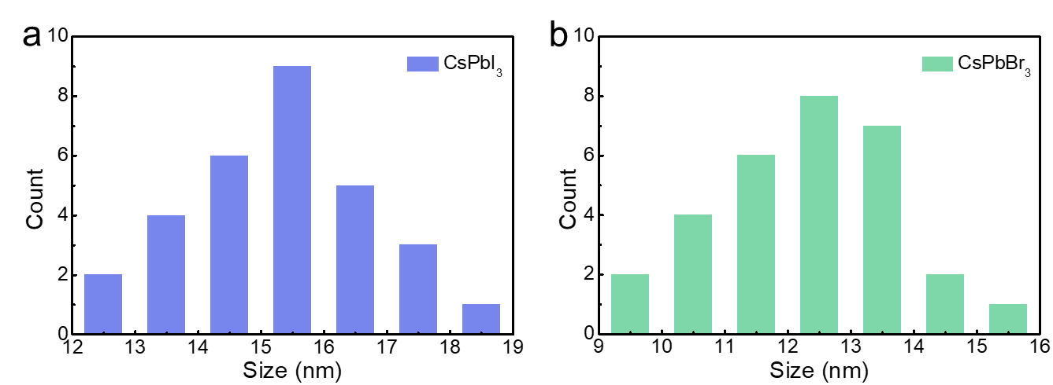
Fig. S1 Size distribution histograms of CsPbI₃ and CsPbBr₃ quantum dots

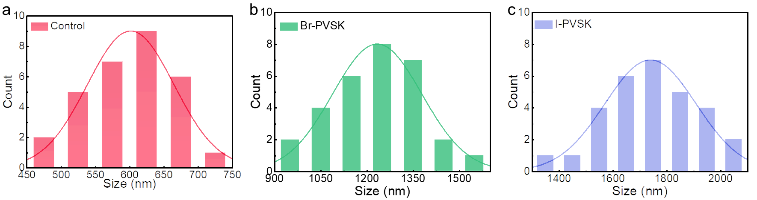
Fig. S2 (a-c) Grain size statistics for Control, Br-PVSK and I-PVSK perovskite films

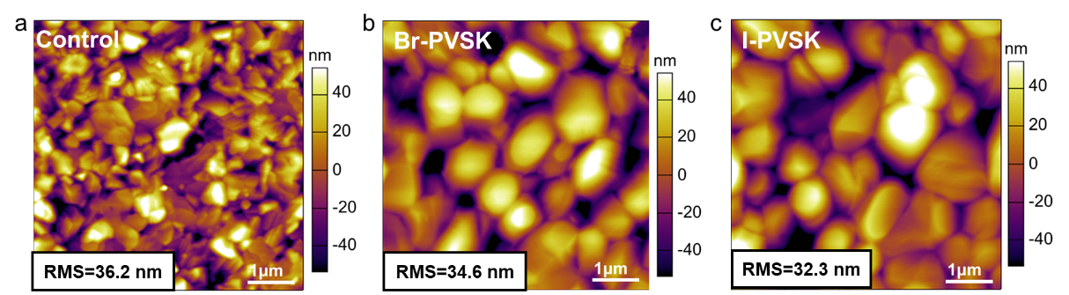
Fig. S3 AFM topographical images of Control, Br-PVSK and I-PVSK perovskites films

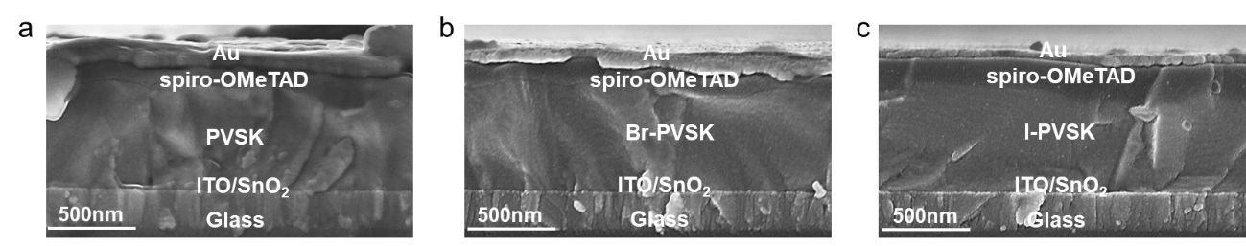
Fig. S4 (a-c) Cross-sectional SEM images of PSC devices based on Control and Br-PVSK, I-PVSK modified
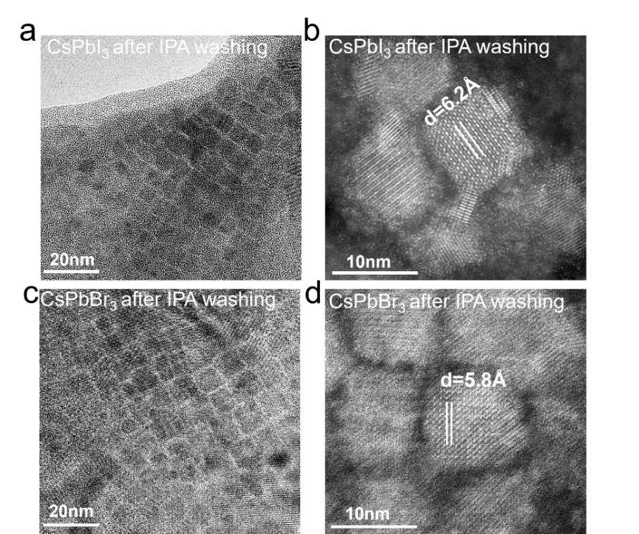
Fig. S5 TEM morphology of (a, b) CsPbI₃ and (c, d) CsPbBr₃ QDs after IPA washing
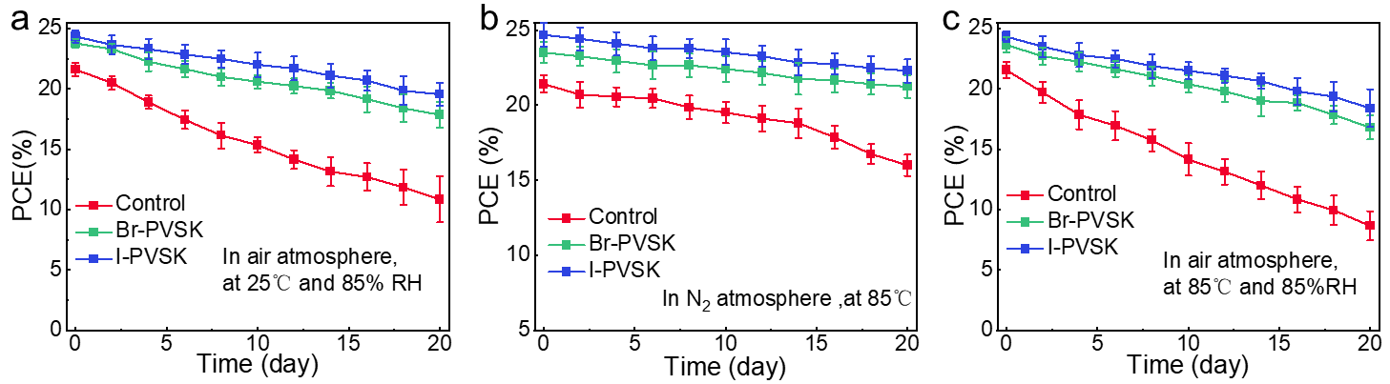
Fig. S6 (a) The humidity stability of unencapsulated PSCs was evaluated in ambient air at approximately 85% relative humidity (RH) at room temperature. The devices were subjected to periodic testing under AM 1.5G illumination using a xenon arc lamp at a power density of 100 mW cm⁻². (b) The thermal stability of unencapsulated PSCs was assessed under continuous heating at 85 °C in a nitrogen atmosphere. These devices were also periodic testing under AM 1.5G irradiation from a xenon arc lamp at 100 mW cm⁻². (c) The stability of unencapsulated PSCs was examined during storage in ambient air at around 85% RH, coupled with heating at 85 °C. Periodic testing of these devices was conducted under AM 1.5G illumination from a xenon arc lamp at a power density of 100 mW cm⁻²
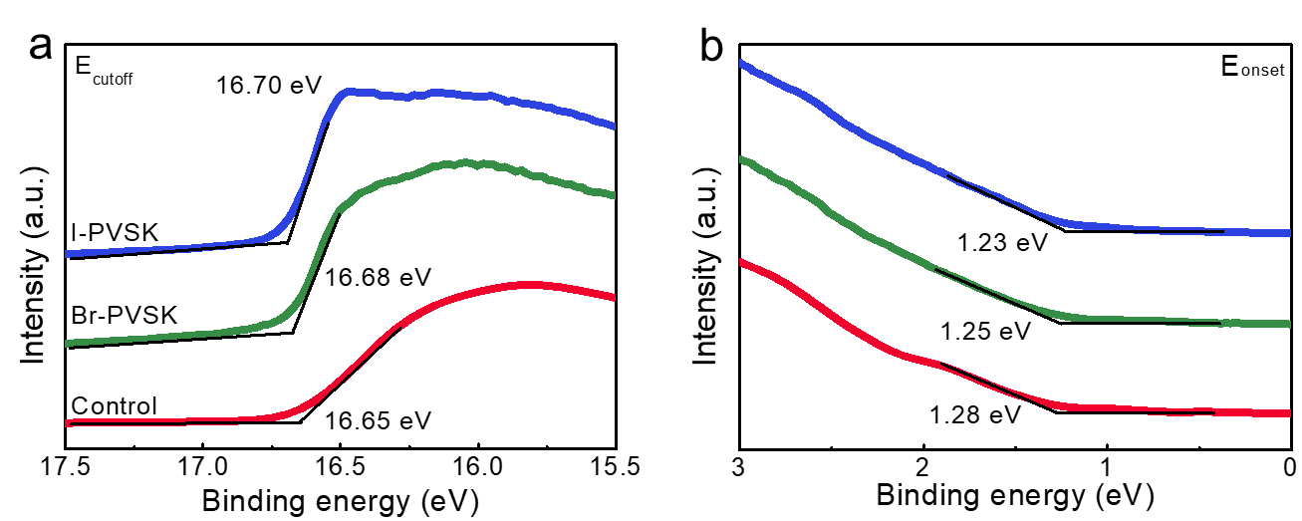
Fig. S7 UPS spectra of secondary electron cutoff and valence bands for Control, Br-PVSK and I-PVSK perovskite films, respectively

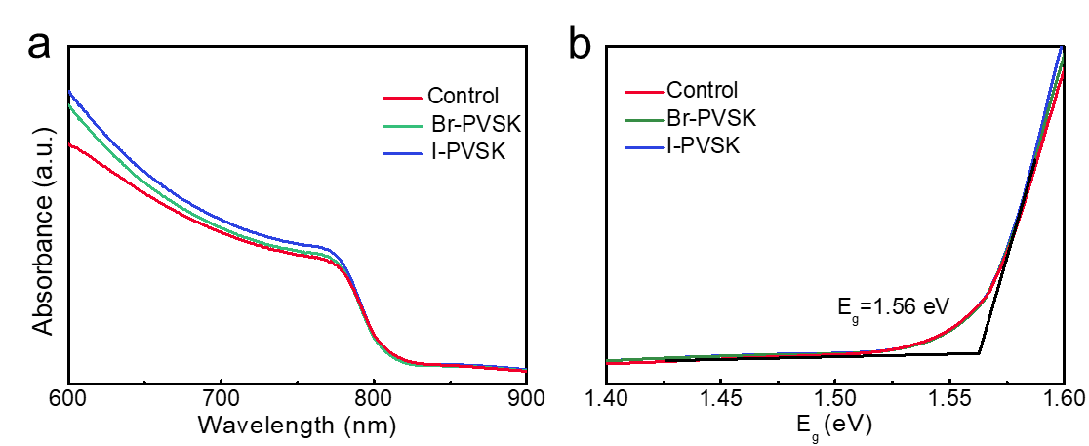
Fig. S8 (a) UV–vis absorption spectra of perovskite films on top of Control, Br-PVSK and I-PVSK. (b) Tauc’s plot calculated from the UV-Vis absorption spectra with equation (αhυ)² = A(hυ-E_{g}), where α is the absorption coefficient, hυ is the photon energy, and E_{g} is the bandgap

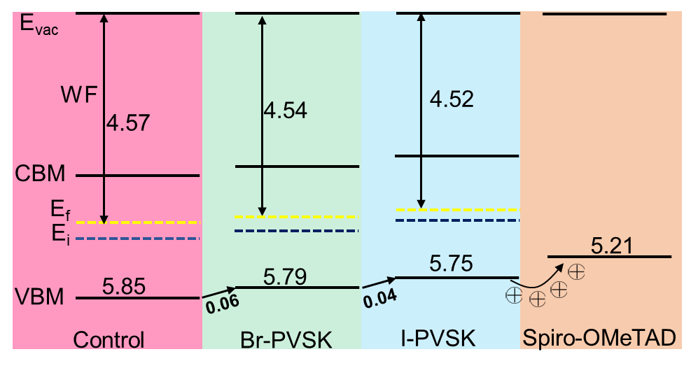
Fig. S9 Perovskite energy level diagram constructed from UPS results, where E_{vac} stands for vacuum energy level, CBM is conduction band minimum, E_{f} is fermi level of as-deposited perovskite film, E_{i} is fermi level of intrinsic perovskite film, and VBM is valence band maximum

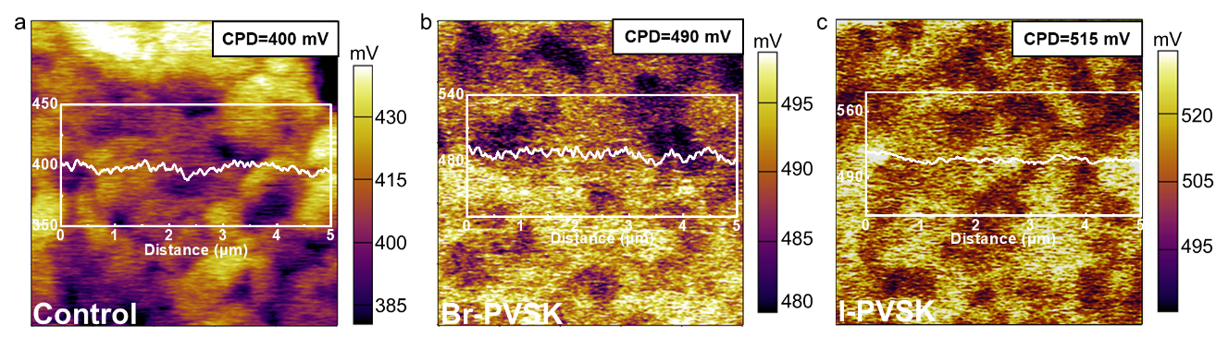
Fig. S10 KPFM images of Control, Br-PVSK and I-PVSK perovskites films

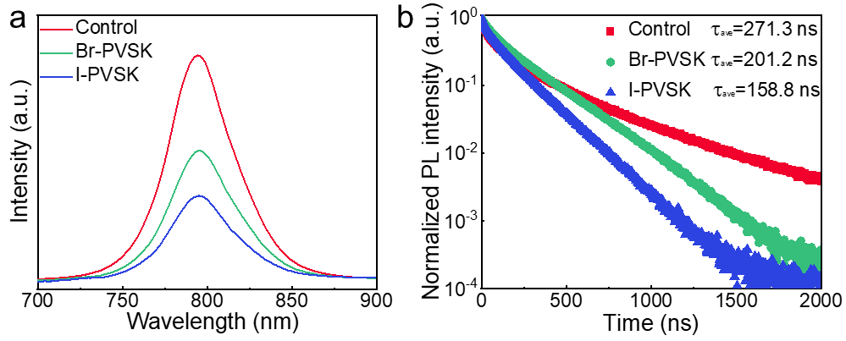
Fig. S11 (a) Steady-state PL and (b) TRPL spectra of Glass/PVSK/ Spiro-OMeTAD, Glass/Br-PVSK/Spiro-OMeTAD and Glass/I-PVSK/Spiro-OMeTAD
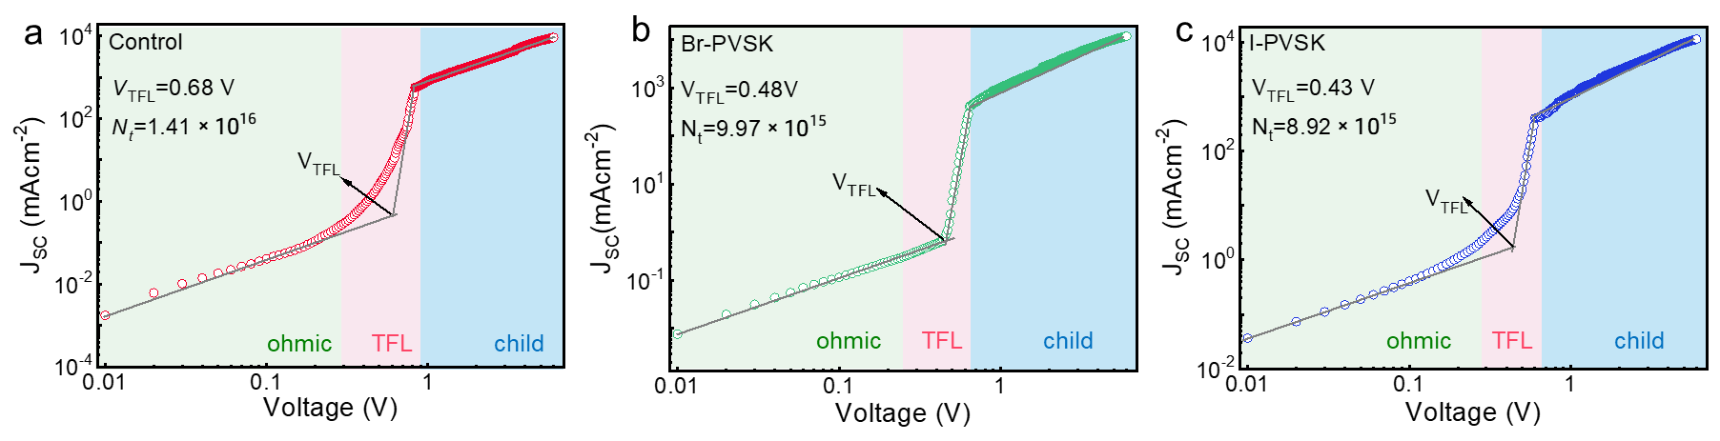
Fig. S12 (a−c) Dark J−V curves representing electron-only devices fabricated by using control, Br-PVSK, and I-PVSK perovskite films
Table S1 TRPL parameters of the control, Br-PVSK and I-PVSK perovskite films
Sample | A₁ | τ₁ [ns] | A₂ | τ₂ [ns] | τ_{ave} [ns]
Control | 0.51 | 74.91 | 0.53 | 447.40 | 395.60
Br-PVSK | 0.29 | 1346.10 | 1.72 | 267.35 | 759.90
I-PVSK | 0.28 | 1388.40 | 0.79 | 265.90 | 994.50
Table S2 TRPL parameters of the Glass/PVSK/Spiro-OMeTAD, Glass/Br-PVSK/Spiro-OMeTAD and Glass/I-PVSK/Spiro-OMeTAD
Sample | A₁ | τ₁ [ns] | A₂ | τ₂ [ns] | τ_{ave} [ns]
Control | 0.85 | 43.20 | 0.45 | 324.80 | 271.30
Br-PVSK | 0.36 | 55.50 | 0.63 | 205.10 | 201.20
I-PVSK | 0.31 | 32.40 | 0.68 | 169.60 | 158.80
Table S3 Photovoltaic performance of the champion devices for the corresponding PSCs
Sample | Scan direction | V_{oc} [V] | J_{sc} [mA cm⁻²] | FF [%] | PCE [%] | Integrated J_{sc} [mA cm^{–2}]
 | Forward | 1.106 | 25.26 | 76.64 | 21.43
Control | Reverse | 1.116 | 25.34 | 77.04 | 22.05 | 24.20
 | Forward | 1.181 | 25.47 | 79.51 | 23.91
Br-PVSK | Reverse | 1.184 | 25.55 | 79.70 | 24.11 | 24.51
 | Forward | 1.194 | 25.38 | 81.42 | 24.67
I-PVSK | Reverse | 1.196 | 25.38 | 81.55 | 24.75 | 24.34
Table S4 Conduction band minimum (CBM) and valence band maximum (VBM) of control, Br-PVSK and I-PVSK perovskite films
Sample | VBM | CBM | E_{g} | WF
Control | 5.85 | 4.29 | 1.56 | 4.57
Br-PVSK | 5.79 | 4.23 | 1.56 | 4.54
I-PVSK | 5.75 | 4.19 | 1.56 | 4.52
Supplementary Reference
[S1] L. Protesescu, S. Yakunin, M.I. Bodnarchuk, et al. Nanocrystals of cesium lead halide perovskites (CsPbX₃, X = Cl, Br, and I): novel optoelectronic materials showing bright emission with wide color gamut. Nano Lett. 15(6), 3692-3696 (2015). https://doi.org/10.1021/nl5048779

