Supporting Information for
Boosting Sensitivity of Cellulose Pressure Sensor via Hierarchically Porous Structure
Minzhang Chen^{1,#}, Xiaoni An^{1,#}, Fengyan Zhao¹, Pan Chen^{2,}*, Junfeng Wang^{2,}*, Miaoqian Zhang¹, Ang Lu^{1,} *,
¹ College of Chemistry and Molecular Sciences, Wuhan University, Wuhan 430072, P. R. China
² School of Material Science & Engineering, Beijing Institute of Technology, Beijing 100081, P. R. China
# Minzhang Chen and Xiaoni An contributed equally to this work.
* Corresponding authors. E-mail: anglu@whu.edu.cn (Ang Lu); panchen@bit.edu.cn (Pan Chen); wjf2015@bit.edu.cn (Junfeng Wang)
Supplementary Figures and Tables
Table S1 Deformations corresponding to different parts of HPCH during compression
Compression deformation of HPCH | Compression deformation of Soft part | Compression deformation of Hard part
0 | 0 | 0
16% | 21% | 4%
39% | 50% | 13%
56% | 62% | 32%
68% | 83% | 55%
Table S2 Comparison of HPCH with other materials in sensing properties
Material composition | Sensitivity (kPa⁻¹) | Range (kPa) | Specific conductance (S/m) | Response time (ms) | Detection limit (Pa)
Cellulose/PVA hydrogel [S1] | 13.91 | 37.3 | 0.46 | - | 14.7
Cellulose ion-conductive hydrogel [S2] | 89.81 | 140 | 3.17 | - | -
PAA/Ag⁰ [S3] | 171.4 | - | - | 38 | 0.075
CNT/Ecoflex [S4] | 3.13 | 50 | - | 94 | 0.07
AM / THMA/ VBIMBF4 [S5] | 0.14 | 500 | - | 180 | -
Ag/PA@BC aerogel [S6] | 6.92 | - | - | 200 | 28
ACC/PAA/alginate hydrogel [S7] | 1 | - | - | - | -
TPU/Ag NW/NaCl [S8] | 1167 | 10.24 | - | - | 1.34
CNTs/GNP Micro@Sponge [S9] | 39.007 | 160 | - | 70 | 0.9
CNT-PDMS [S10] | 372.2 | - | - | 3.33 | -
IAH-PET [S11] | 9.32 | - | - | - | 25
TA-SGs [S12] | 9.26 | - | - | 32 | -
CF-hydrogel [S13] | 6.01 | - | - | 161 | 1
PVA/MWCNT/CF gel [S14] | 4.2 | 54 | - | 231 | 1.2
This Work | 1622 | 164.707 | 4.01 | 45 | 17
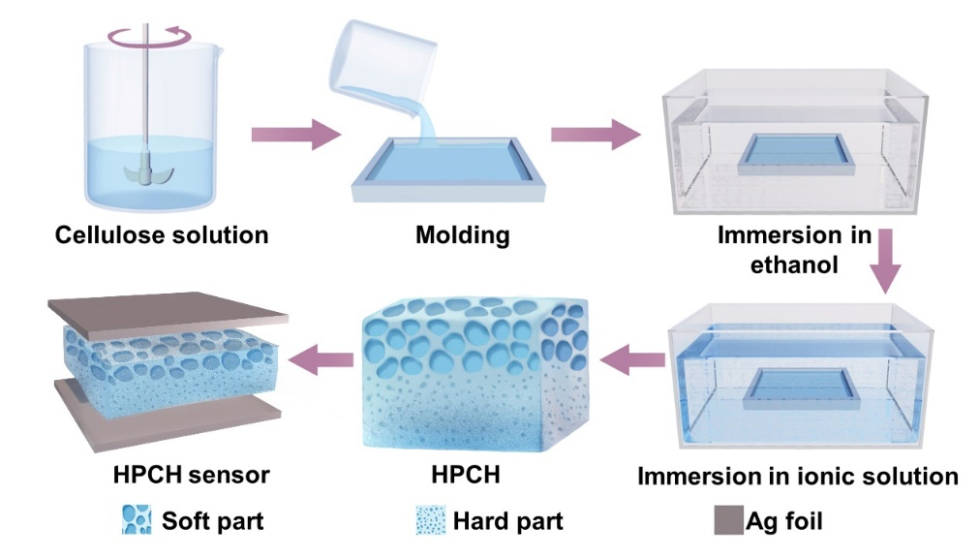
Fig. S1 Preparation of the HPCH sensor
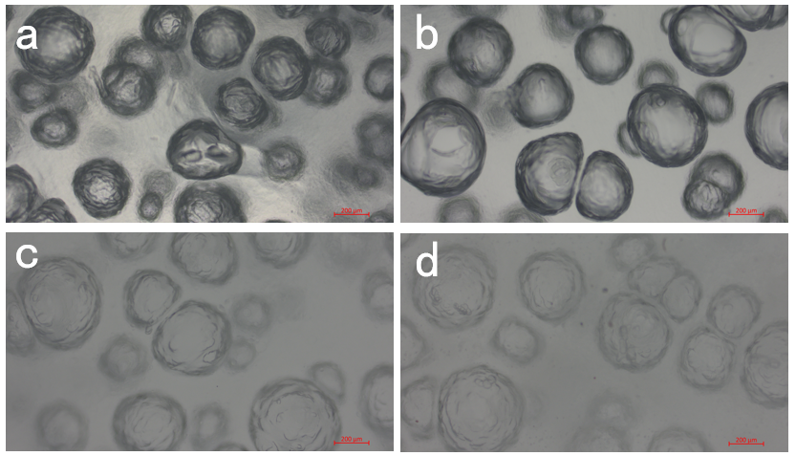
Fig. S2 Optical micrographs of the upper portion (soft part) of the HPCH immersed in different solutions: (a) ethanol; (b) KCl, (c) LiCl and (d) trisodium citrate
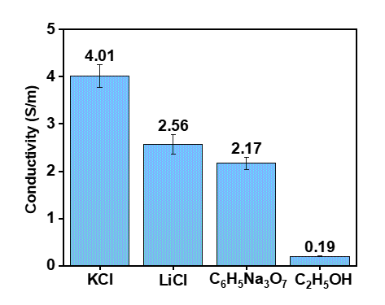
Fig. S3 Conductivity of HPCHs immersed in different solutions
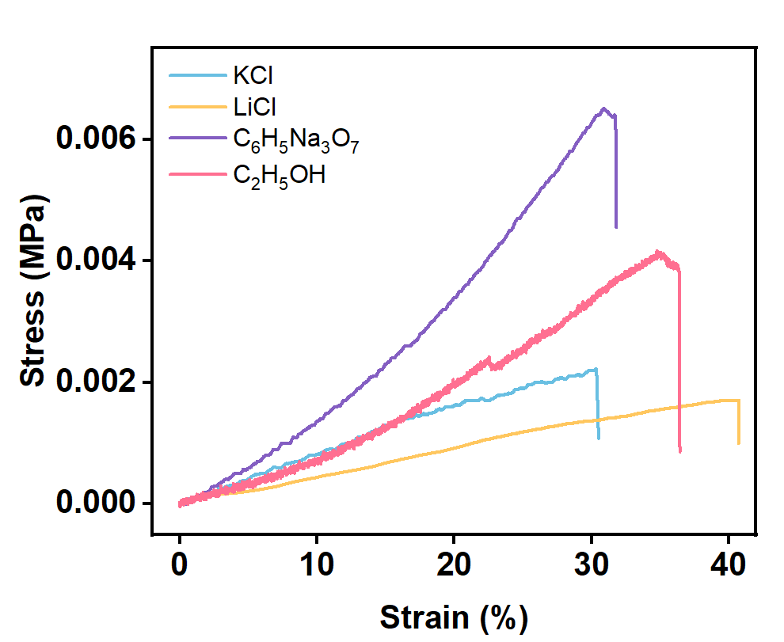
Fig. S4 Tensile stress-strain curves of HPCHs immersed in different solutions
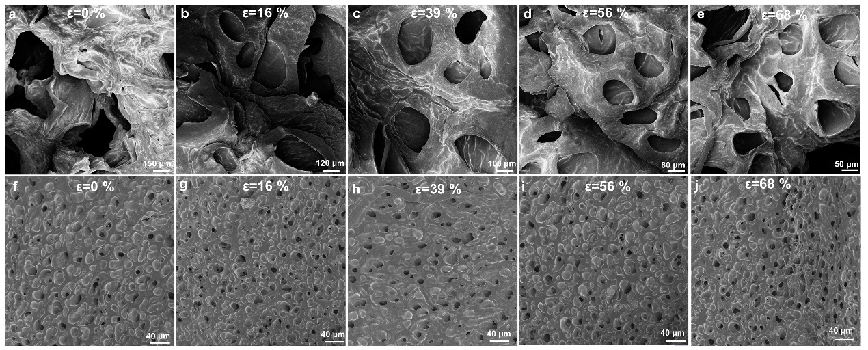
Fig. S5 SEM images of the soft layer of HPCH during compression with different strains of (a) 0%, (b) 16%, (c) 39%, (d) 56%, (e) 68%. SEM images of the hard layer of HPCH during compression with different strains of (f) 0 %, (g) 16 %, (h) 39 %, (i) 56%, (j) 68%

Fig. S6 ΔC/C₀ variations of HPCHs with pressure

Fig. S7 Change in capacitance with continued application of a small pressure in a large pressure situation

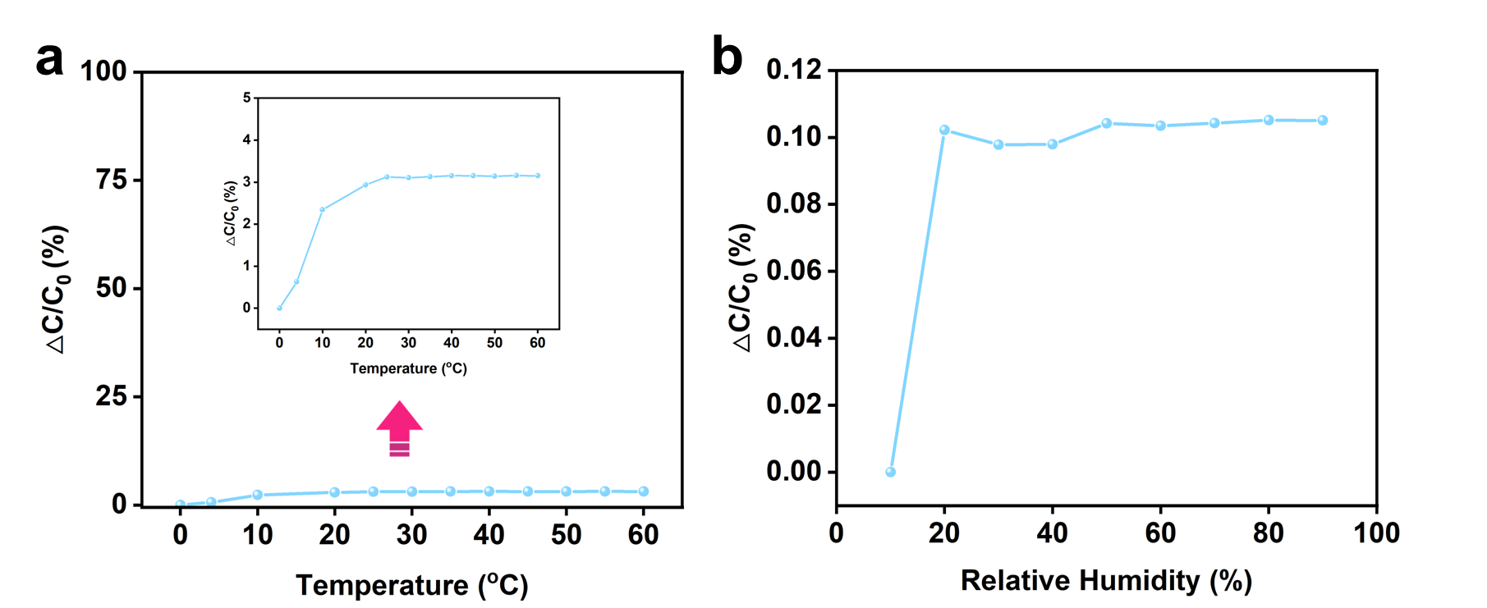
Fig. S8 (a) The capacitance responses of the HPCH sensor at different temperatures (0-60 °C). (b) The capacitance response of HPCH sensor in the 10~90 % R.H. range

Fig. S9 The corresponding capacitive signals of mouth

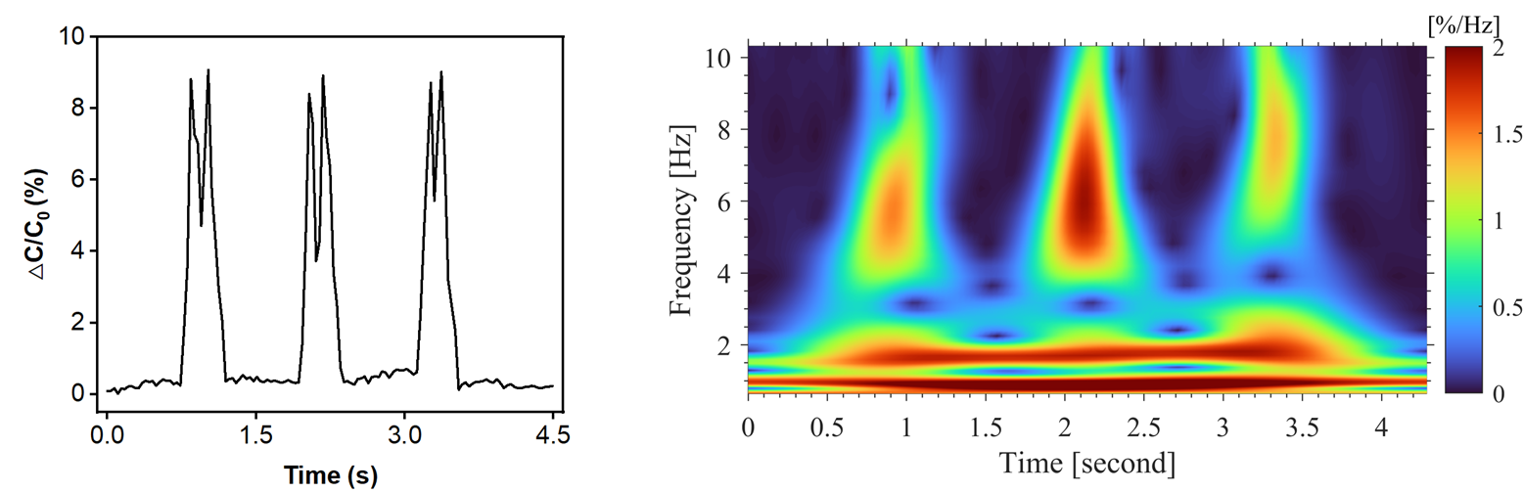
Fig. S10 Capacitive signals from hairdryer vibrations detected by the sensor, and frequency-time window of capacitive signals from hairdryer vibrations obtained by using wavelet transform

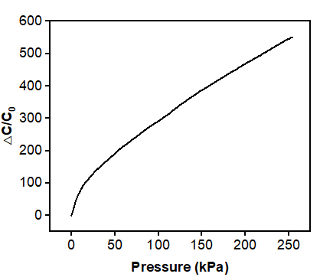
Fig. S11 Calibration curve for pressure versus capacitance change for HPCH sensor encapsulated by VHB

Supplementary References
- Y. Wang, L. Zhang, A. Lu, Highly stretchable, transparent cellulose/pva composite hydrogel for multiple sensing and triboelectric nanogenerators. J. Mater. Chem. A 8, 13935-13941 (2020). https://doi.org/10.1039/D0TA02010A
- M. Chen, H. Wan, Y. Hu, F. Zhao, X. An et al., Rationally designed cellulose hydrogel for an ultrasensitive pressure sensor. Mater. Horiz. 10, 4510-4520 (2023). https://doi.org/10.1039/D3MH01051A
- H. Ding, Z. Xin, Y. Yang, Y. Luo, K. Xia et al., Ultrasensitive, low-voltage operational, and asymmetric ionic sensing hydrogel for multipurpose applications. Adv. Funct. Mater. 30, 1909616 (2020). https://doi.org/10.1002/adfm.201909616
- K.-H. Ha, W. Zhang, H. Jang, S. Kang, L. Wang et al., Highly sensitive capacitive pressure sensors over a wide pressure range enabled by the hybrid responses of a highly porous nanocomposite. Adv. Mater. 33, 2103320 (2021). https://doi.org/10.1002/adma.202103320
- S. Han, Y. Hu, J. Wei, S. Li, P. Yang et al., A semi-interpenetrating poly(ionic liquid) network-driven low hysteresis and transparent hydrogel as a self-powered multifunctional sensor. Adv. Funct. Mater. 34, 2401607 (2024). https://doi.org/10.1002/adfm.202401607
- Y. Huang, P. Zhou, X. Zhang, Green synthesis of ag-doped cellulose aerogel for highly sensitive, flame retardant strain sensors. Cellulose 29, 8719-8731 (2022). https://doi.org/10.1007/s10570-022-04802-4
- Z. Lei, Q. Wang, S. Sun, W. Zhu, P. Wu, A bioinspired mineral hydrogel as a self-healable, mechanically adaptable ionic skin for highly sensitive pressure sensing. Adv. Mater. 29, 1700321 (2017). https://doi.org/10.1002/adma.201700321
- Y. Liu, J. Tao, Y. Mo, R. Bao, C. Pan, Ultrasensitive touch sensor for simultaneous tactile and slip sensing. Adv. Mater. 36, 2313857 (2024). https://doi.org/10.1002/adma.202313857
- Y. Ni, L. Liu, J. Huang, S. Li, Z. Chen et al., Rational designed microstructure pressure sensors with highly sensitive and wide detection range performance. J. Mater. Sci. Technol. 130, 184-192 (2022). https://doi.org/10.1016/j.jmst.2022.05.021
- L. Shi, Z. Li, M. Chen, T. Zhu, L. Wu, Ultrasensitive and ultraprecise pressure sensors for soft systems. Adv. Mater. 35, 2210091 (2023). https://doi.org/10.1002/adma.202210091
- Y. Tai, Z. Yang, Toward flexible wireless pressure-sensing device via ionic hydrogel microsphere for continuously mapping human-skin signals. Adv. Mater. Interfaces. 4, 1700496 (2017). https://doi.org/10.1002/admi.201700496
- D. Yang, K. Zhao, R. Yang, S.-W. Zhou, M. Chen et al., A rational design of bio-derived disulfide cans for wearable capacitive pressure sensor. Adv. Mater. 36, 2403880 (2024). https://doi.org/10.1002/adma.202403880
- H. Yuan, M. Wang, J. Zhang, J. Wang, Y. Le, Hydrogels from chrome shavings for a highly sensitive capacitive pressure sensor. J. Mater. Chem. A 12, 9797-9805 (2024). https://doi.org/10.1039/D4TA00702F
- H. Yuan, J. Zhang, J. Zhang, M. Wang, J. Wang et al., A “soft and hard” bioinspired hydrogel for enhanced pressure sensing. J. Mater. Chem. C 11, 10562-10572 (2023). https://doi.org/10.1039/D3TC01223A

