Supporting Information for
Transformative Effect of Li Salt for Proactively Mitigating Interfacial Side Reactions in Sodium-Ion Batteries
Jooeun Byun ^{1,#}, Joon Ha Chang ^{2,#}, Chihyun Hwang ^{1,#}, Chae Rim Lee ¹, Miseung Kim ¹, Jun Ho Song ¹, Boseong Heo ³, Sunghun Choi ³, Jong Hyeok Han ⁴, Hee-Jae Jeon ⁵, Beom Tak Na ⁶, Youngjin Kim ^{3,}*, Ji-Sang Yu ^{1,}*, and Hyun-seung Kim ^{1,}*
¹ Advanced Batteries Research Center, Korea Electronics Technology Institute, 25, Saenari-ro, Seongnam 13509, Republic of Korea
² Analysis and Assessment Research Group, Research Institute of Industrial Science and Technology, Cheongam-ro 67, Pohang 37673, Republic of Korea
³ Department of Battery Convergence Engineering, Kangwon National University1, Kangwon-daehakro, Chuncheon-si, Kangwon 24341, Republic of Korea
⁴ Department of Mechanical and Biomedical Engineering, Kangwon National University 1, Kangwon-daehakro, Chuncheon-si, Kangwon 24341, Republic of Korea
⁵ Department of Smart Health Science and Technology, Kangwon National University 1, Kangwon-daehakro, Chuncheon-si, Kangwon 24341, Republic of Korea
⁶ Research Institute of Intelligent Manufacturing & Materials Technology, Korea Institute of Industrial Technology, Gaetbeol-ro 156, Incheon, Republic of Korea
#Jooeun Byun, Joon Ha Chang, and Chihyun Hwang contributed equally to this work.
*Corresponding authors. E-mail: ykim@kangwon.ac.kr (Youngjin Kim); jisang@keti.re.kr (Ji-Sang Yu); hskim0113@keti.re.kr (Hyun-seung Kim)
Supplementary Figures and Table
Fig. S1 Raman spectra obtained from background and LiPF₆-added electrolytes, respectively
Fig. S2 Linear sweep voltammogram obtained from Cu/Na cell with background and LiPF₆-added electrolytes
Fig. S3 Ionic conductivities of background and LiPF₆-added electrolytes
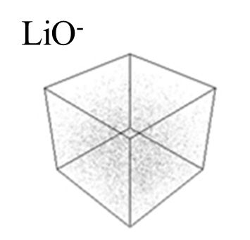
Fig. S4. Three-dimensionally reconstructed time-of-flight secondary ion-mass spectroscopy (ToF-SIMS) map obtained from the O3-type positive electrode cycled with the LiPF₆-added electrolyte
Fig. S5 First cycle voltage profile of the O3-type positive electrode in a sodium half-cell
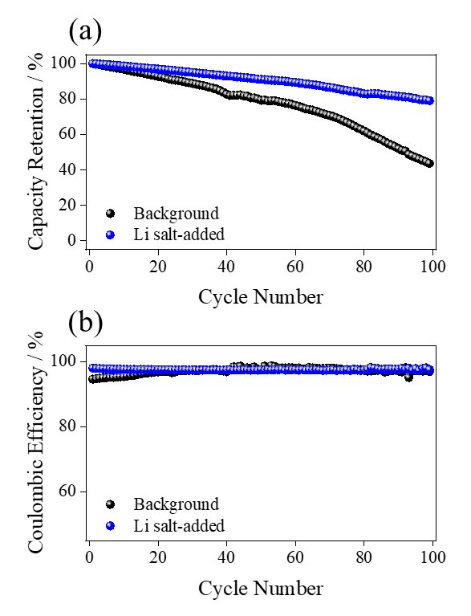

Fig. S6 (a) Cycleability and (b) Coulombic efficiency obtained from the O3 electrode-based half-cells with background and Li salt-added electrolytes
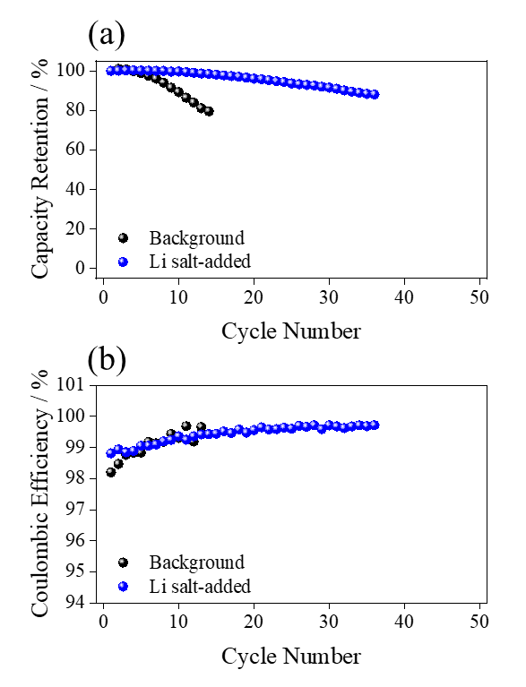

Fig. S7 (a) Cycleability and (b) Coulombic efficiency obtained from the hard carbon electrode-based half-cells with background and Li salt-added electrolytes

Fig. S8 Coulombic efficiency obtained from the hard carbon/O3-type electrode based pouch-cells with FEC-added and Li salt-added electrolytes, respectively

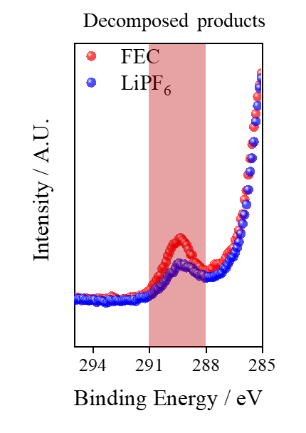
Fig. S9 C 1s X-ray photoelectron spectra obtained from the hard-carbon electrode after 400 cycles with the addition of the FEC and LiPF₆ electrolytes

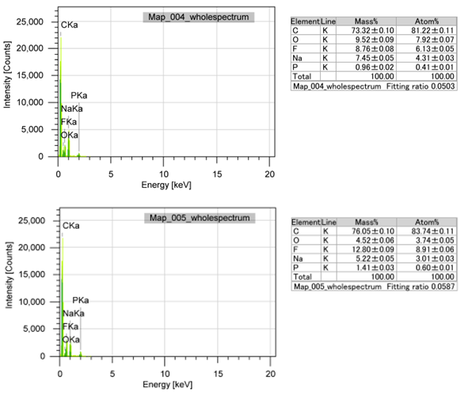
Fig. S10 Energy-dispersive spectroscopic results recorded from the cycled hard-carbon electrodes following the addition of the FEC and LiPF₆ electrolytes
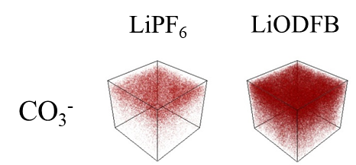
Fig. S11 Three-dimensionally reconstructed ToF-SIMS map of the hard-carbon electrode after formation following the addition of the LiPF₆ and lithium difluoro(oxalato)borate (LiODFB) electrolytes
Fig. S12 Initial voltage profiles after the formation at pouch cells with the LiPF₆ and LiODFB electrolytes
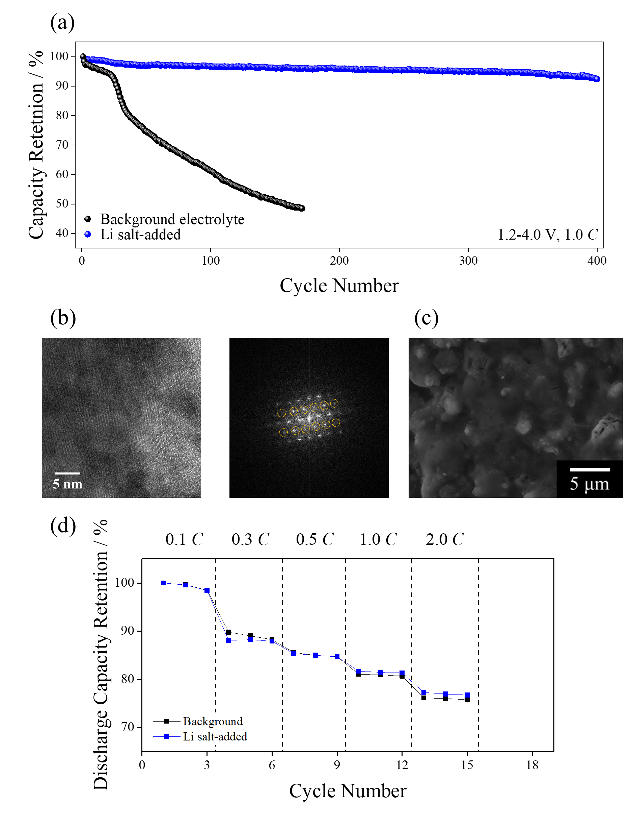
Fig. S13 (a) cycle performance obtained from background, FEC-added, and Li salt-added electrolytes, respectively, (b) HR-TEM and corresponding FFT images of cycled positive electrode, (c) SEM image of cycled negative electrode, (d) rate capability obtained from pouch cells with background and Li salt-added electrolytes

Table S1 The acheived capacity retention from recently reported literature and this work with hard carbon/O3 electrodes configuration
 | Voltage Range  / V | Cycle Number | Retention / % | Mass loading  / mg cm⁻² | C-rate  / C | References
1 | 1.5-4.0 | 170 | 96 | 1.6 | 0.3 | Chemical Engineering Journal,  2024, 491, 151949
2 | 2.0-4.0 | 500 | 81 | 2.0 | 0.2 | Small, 2024, 2407425
3 | 1.5-4.0 | 16 | 80 | 4.3 | 0.2 | Electrochimica Acta, 2018, 281, 370
4 | 1.9-3.9 | 200 | 85 | 1.0 | 1.0 | Energy Storage Materials,  2025, 74, 103894
5 | 1.5-4.2 | 100 | 68 | N.A. | 1.0 | Journal of Alloys and Compounds, 2023, 968, 171808
6 | 1.0-4.0 | 200 | 77 | 1.0 | 1.0 | Journal of The Electrochemical Society, 2023, 170, 070518
7 | 1.2-4.0 | 400 | 92.7 | 15.0 | 1.0 | This Work

