Supporting Information for
A Flexible Dual-Mode Photodetector for Human-Machine Collaborative IR Imaging
Huajing Fang^{1,}*, Xinxing Xie¹, Kai Jing¹, Shaojie Liu¹, Ainong Chen¹, Daixuan Wu^{2,*}, Liyan Zhang¹ and He Tian^{2,}*
¹Center for Advancing Materials Performance From the Nanoscale (CAMP-Nano), State Key Laboratory for Mechanical Behavior of Materials, Xi’an Jiaotong University, Xi’an 710049, P. R. China
²School of Integrated Circuits and Beijing National Research Center for Information Science and Technology (BNRist), Tsinghua University, Beijing 100084, P. R. China
*Corresponding authors. E-mail: fanghj@xjtu.edu.cn (Huajing Fang); wxyjqm@yeah.net (Daixuan Wu); tianhe88@tsinghua.edu.cn (He Tian)
Supplementary Figures and Tables
Fig. S1 The thickness of the MXene film
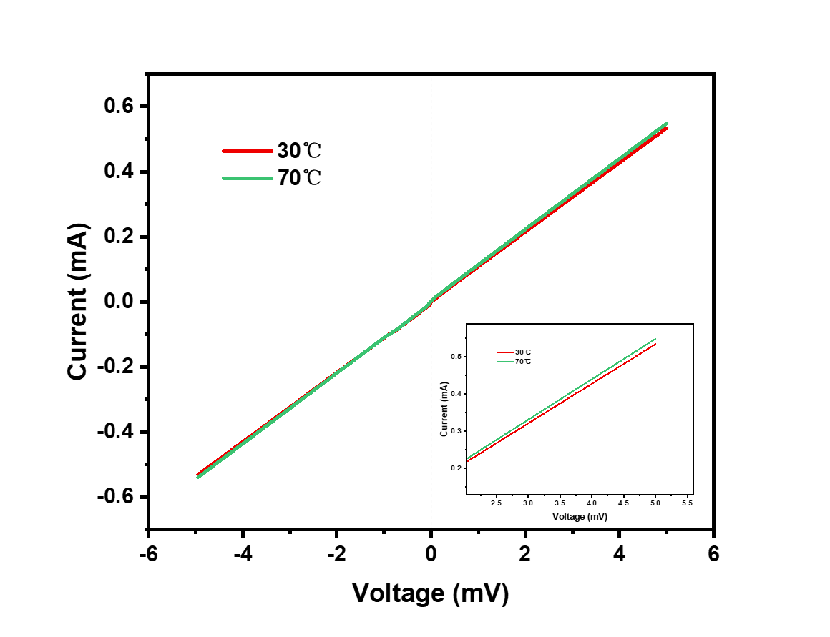
Fig. S2 I-V curves of MXene film at 30 ℃ and 70 ℃

Fig. S3 Current change of the device during heating and cooling narrow electrode

Fig. S4 The rise time and fall time of asymmetric device for N-side illumination

Fig. S5 Photocurrent of the three devices with different electrode configurations

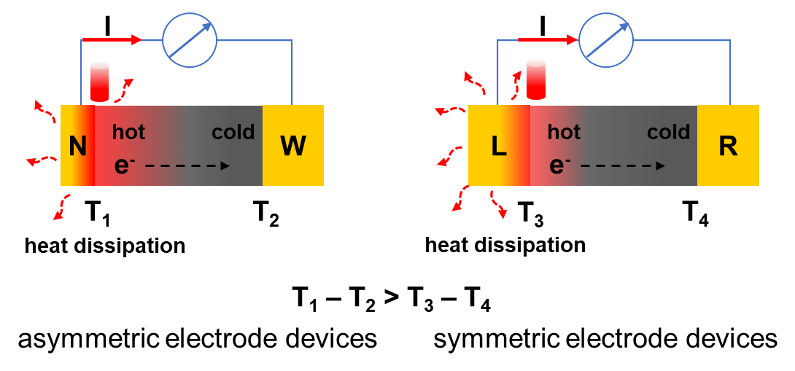
Fig. S6 The working mechanism of asymmetric and symmetric PTE photodetector
Table S1 comparison with previously reported work with figure of merits of the sensors
Materials | Bias  Voltage (V) | Responsivity  (mA/W) | Response  time | Flexibility | Operational  Stability (cycles) | Refs.
MXene | 0 | 0.33 (808 nm) | 8.53 s | Yes | 300 | This work
WSe₂/Ag | 1 | 0.43 (780 nm) | 4.1 s | Yes | 20 | [S1]
Bi₂Te₃ | 0 | 0.388 (8 μm) | 10 ms | No | 50 | [S2]
WSe₂/CuO | 2 | 0.28 (700 nm) | 5.4 s | Yes | 1000 | [S3]
SnS/Mg | 10 | 52 (470 nm) | 3.9 s | Yes | 50 | [S4]
Graphene/Al | 0 | 0.25 (825 nm) | / | No | / | [S5]
SWCNTs/MoS₂ | 0 | 0.088  (532 nm) | 102 ms | No | / | [S6]
Fig. S7 Radar chart to compare the comprehensive metrics of photothermoelectric detectors based on MXene, ZnO [S7] and Bi₂Te₃ [S2]
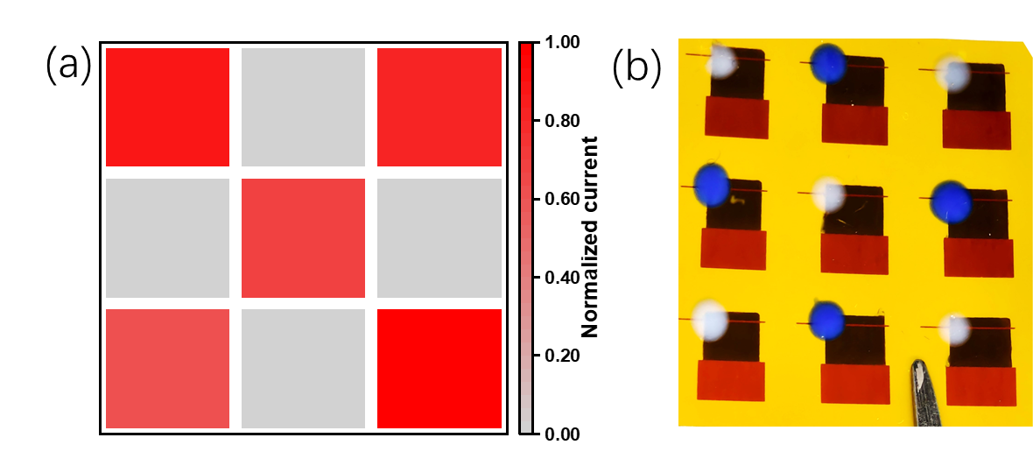
Fig. S8 Image of “X”pattern from (a) machine read mode (b) human read mode
Supplementary References
- R. P. Patel, P. M. Pataniya, M. Patel, K. Joshi, K. H. Modi et al., Hand-Print method for preparation of large area and binder free electrodes for photodetection and electrocatalytic hydrogen evolution. Sol. Energy 246, 343-354 (2022). https://doi.org/10.1016/j.solener.2022.09.016
- Y. Zhang, J. Jiang, Z. Zhang, H. Yu, Y. Lian et al., Long-wave infrared photothermoelectric detectors with resonant nanophotonics. J. Mater. Chem. C 12, 16714–16721 (2024). https://doi.org/10.1039/D4TC02504K
- R. P. Patel, P. M. Pataniya, M. Patel, V. Adepu, P. Sahatiya et al., Highly flexible and foldable broad band WSe₂/CuO heterostructure photodetector. Sensor Actuat A-phys 356, 114339 (2023). https://doi.org/10.1016/j.sna.2023.114339
- P. V. Shah, P. Pataniya, N. N. Som, V. Sathe, S. Ck, Flexible and hand-printed photodetector based on Mg–SnS nanoflakes. ACS Appl. Nano Mater. 7, 5967-5981 (2024). https://doi.org/10.1021/acsanm.3c05876
- D. Wang, A. E. L. Allcca, T. F. Chung, A. V. Kildishev, Y. P. Chen et al., Enhancing the graphene photocurrent using surface plasmons and a p-n junction. Light Sci. Appl. 9, 126 (2020). https://doi.org/10.1038/s41377-020-00344-1
- P.-Y. Huang, H.-J. Chen, J.-K. Qin, L. Zhen, C.-Y. Xu. A polarization-sensitive photothermoelectric photodetector based on mixed-dimensional SWCNT–MoS₂ heterostructures. Nanoscale Adv. 4, 5290-5296 (2022). https://doi.org/10.1039/D2NA00609J
- K. Zhang, B. Ouyang, Y. Wang, Y. Xia, Y. Yang, Coupling Enhancement of Photo-Thermoelectric Conversion in a Lateral ZnO Nanowire Array. ACS Appl. Energy Mater. 2, 7647−7654 (2019). https://doi.org/10.1021/acsaem.9b01633

