Supporting Information for
Buried Interface Regulation with TbCl₃ for Highly-Efficient All-Inorganic Perovskite/Silicon Tandem Solar Cells
Wenming Chai¹, Weidong Zhu¹*, He Xi^{1,3}, Dazheng Chen¹, Hang Dong¹, Long Zhou¹, Hailong You¹, Jincheng Zhang¹, Chunfu Zhang¹*, Chunxiang Zhu² and Yue Hao¹
¹State Key Laboratory of Wide-Bandgap Semiconductor Devices and Integrated Technology, School of Microelectronics, Xidian University, Xi'an 710071, P. R. China
²Department of Electrical and Computer Engineering, National University of Singapore, 10 Kent Ridge Crescent, 119260, Singapore
³Department of nanomaterials, University of Melbourne, Parkville Victoria, 3010, Australia
*Corresponding authors. E-mail: wdzhu@xidian.edu.cn (Weidong Zhu); cfzhang@xidian.edu.cn (Chunfu Zhang)
Supplementary Figures and Tables
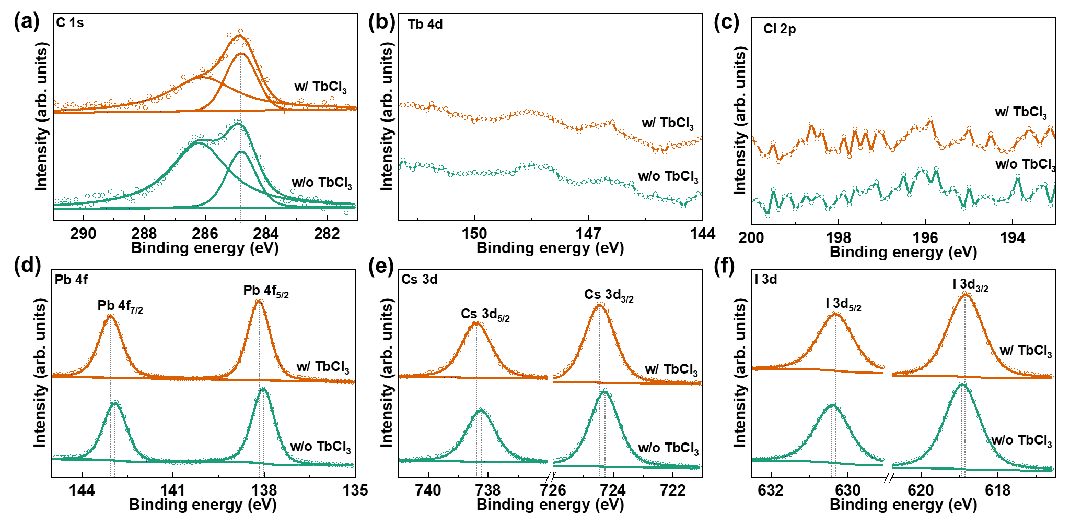
Fig. S1 a C 1s, b Tb 4d, c Cl 2p, d Pb 4f, e Cs 3d, and f I 3d core-level XPS spectra of CsPbI₃ films based on Me-4PACz with and without TbCl₃ doping
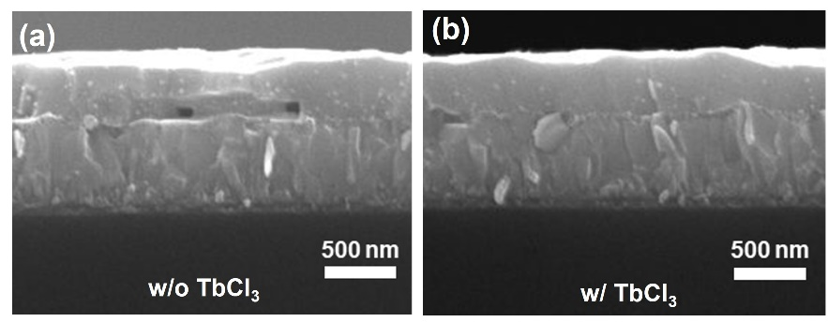
Fig. S2 Cross-section SEM images of the CsPbI₃ films based on Me-4PACz a without and b with TbCl₃ doping

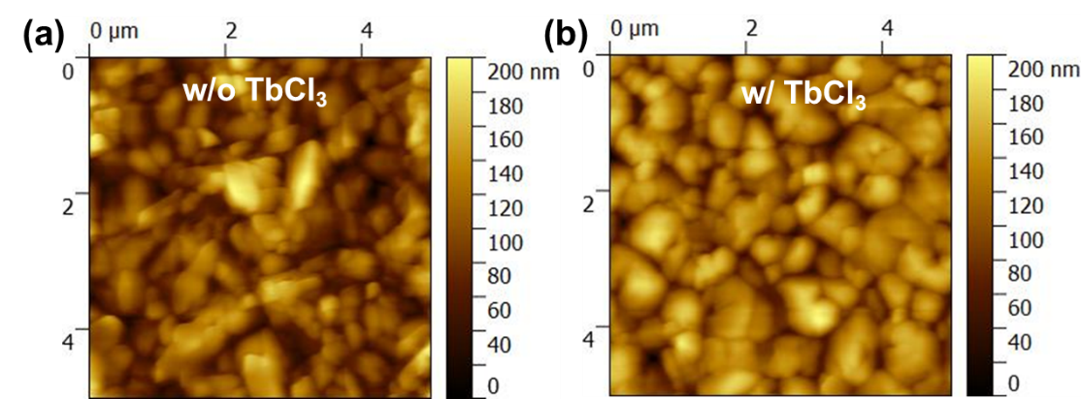
Fig. S3 AFM images of the CsPbI₃ films based on Me-4PACz a without and b with TbCl₃ doping

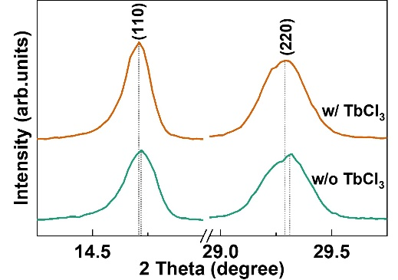
Fig. S4 Magnified (110) and (220) XRD peaks of CsPbI₃ films prepared on Me-4PACz with and without TbCl₃ doping
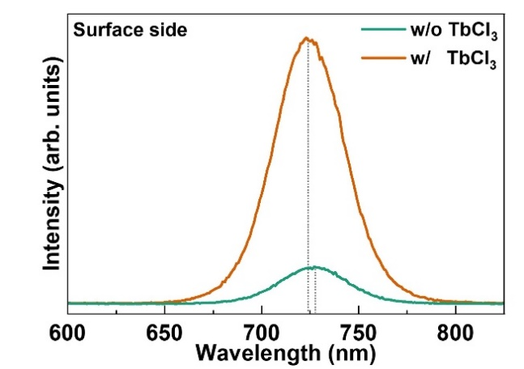
Fig. S5 PL spectra from the surface side of CsPbI₃ films prepared on Me-4PACz with and without TbCl₃ doping
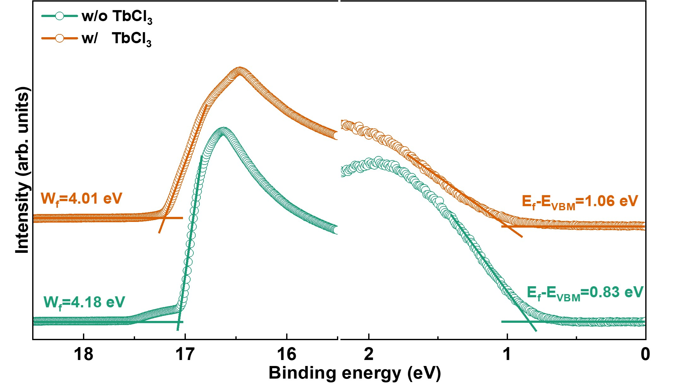
Fig. S6 UPS spectra of Me-4PACz with and without TbCl₃ doping
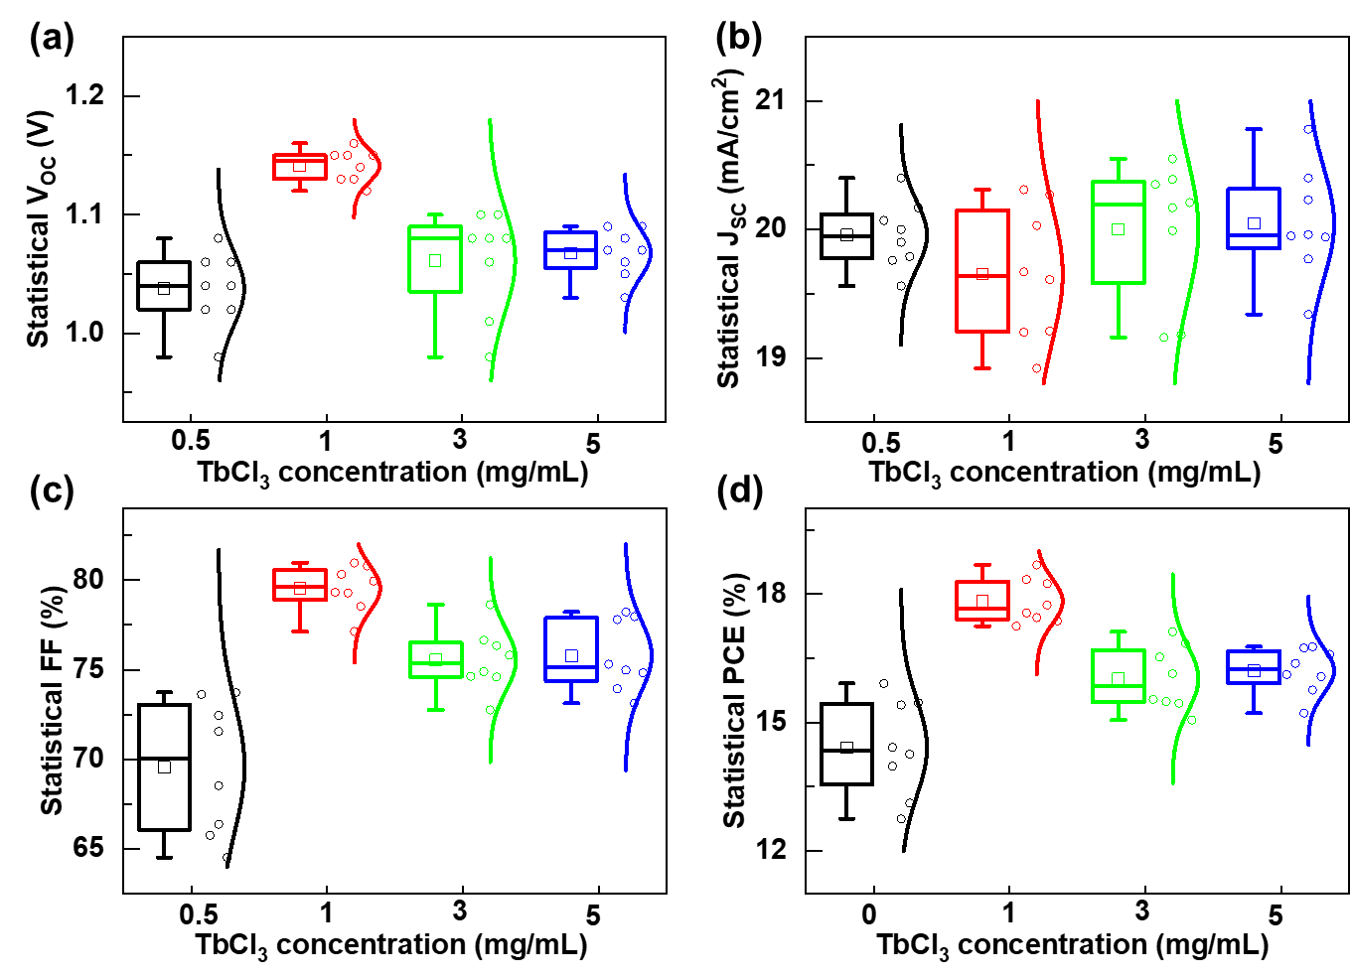
Fig. S7 Statistical a V_{OC}, b J_{SC}, c FF and d PCE for CsPbI₃ PSCs prepared on Me-4PACz with 0.5, 1, 3, and 5 mg/mL TbCl₃ doping
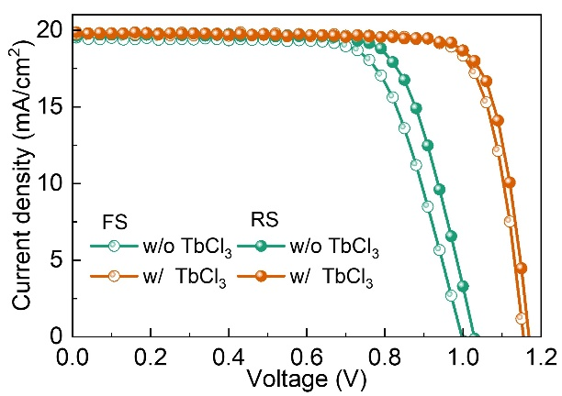
Fig. S8 Light J-V curves recorded under forward voltage scan from -0.1 to 1.3 V and reverse voltage scan from 1.3 to -0.1 V for the champion CsPbI3 PSC prepared without and with TbCl3-doped Me-4PACz

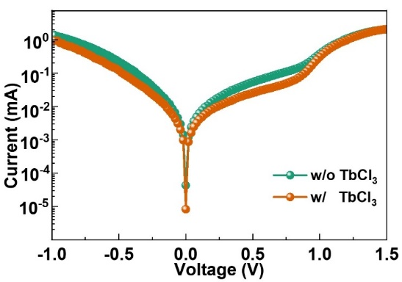
Fig. S9 Dark J-V curves of CsPbI₃ PSCs based on Me-4PACz with and without TbCl₃ doping
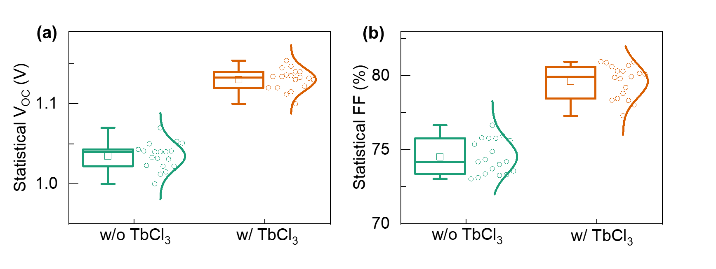
Fig. S10 Statistical a V_{OC} and b FF for CsPbI₃ PSCs prepared on Me-4PACz without and with TbCl₃ doping
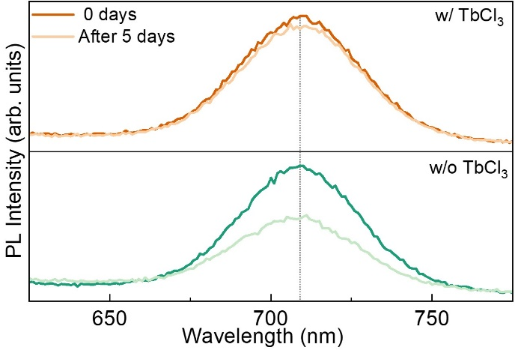
Fig. S11 PL spectral of CsPbI₃ films prepared without and with TbCl₃-doped Me-4PACz after storing for 5 days in ambient air

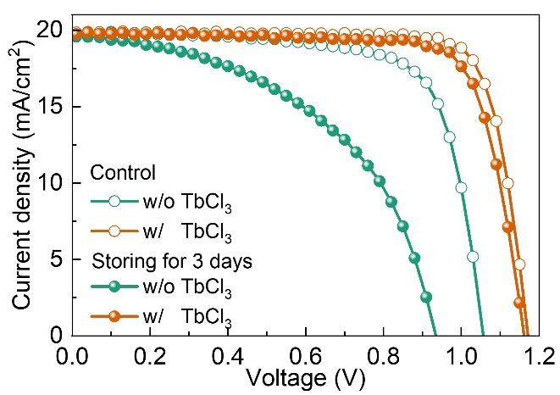
Fig. S12 J-V curves of CsPbI₃ PSCs fabricated without and with TbCl₃-doped Me-4PACz after storing for 5 days in ambient air

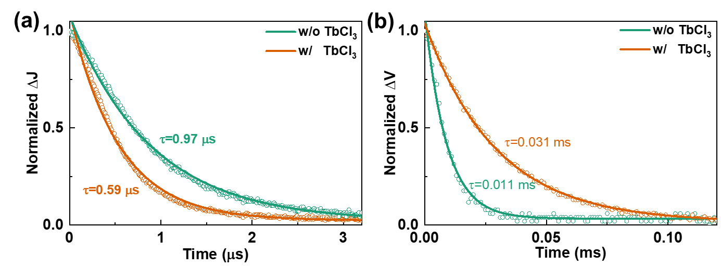
Fig. S13 a TPC and b TPV curves of CsPbI₃ PSCs based on Me-4PACz with and without TbCl₃ doping
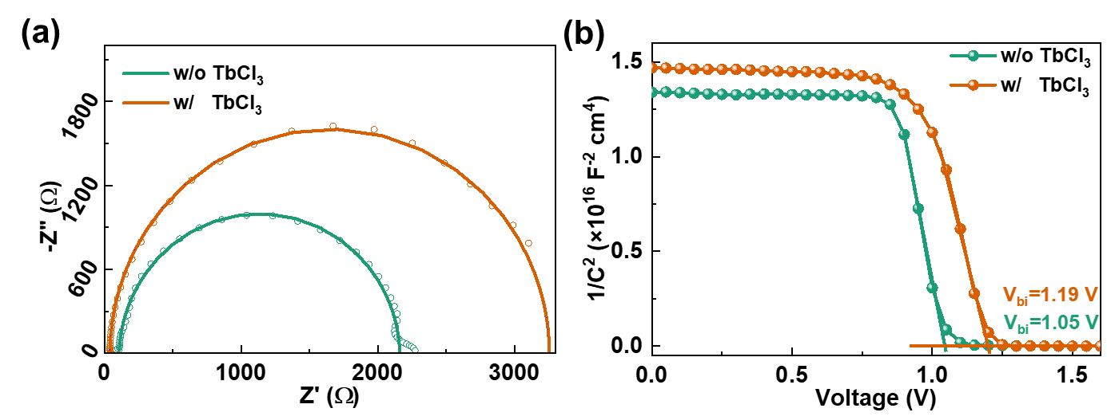
Fig. S14 a Nyquist and b M-S plots of CsPbI₃ PSCs based on Me-4PACz with and without TbCl₃ doping
Table S1 The fitting parameters of TRPL spectra for CsPbI₃ films on Me-4PACz with and without TbCl₃ doping
 | A₁ | τ₁ (ns) | A₁ | τ₂ (ns) | τ_{ave} (ns)
w/o TbCl₃ | 21.93 | 0.46 | 0.37 | 1.66 | 2.67
w/ TbCl₃ | 2.02 | 0.28 | 0.59 | 2.79 | 1.55
Table S2 Photovoltaic parameters of the optimized CsPbI₃ PSCs based on Me-4PACz with and without TbCl₃ doping
Samples | V_{OC} (V) | J_{SC} (mA/cm²) | FF | PCE (%)
w/o TbCl₃ | 1.017 | 19.9 | 0.758 | 15.34
w/ TbCl₃ | 1.162 | 20.12 | 0.799 | 18.68
Table S3 Photovoltaic parameters of the semitransparent CsPbI₃ PSC, the silicon solar cell before and after filtering, and the perovskite/silicon tandem device
Samples | J_{SC} (mA/cm²) | V_{OC} (V) | FF | PCE (%)
Si-Cell | 41.81 | 0.72 | 0.761 | 22.91
Si-Filtered | 21.93 | 0.70 | 0.770 | 11.83
Semitransparent PSCs | 19.75 | 1.11 | 0.802 | 17.57
4T TSCs |  |  |  | 29.40
2T TSCs | 18.56 | 1.75 | 0.783 | 25.44

Table S4 Performance comparisons of the tandem solar cells based on all-inorganic perovskite materials
Device structure | All-inorganic materials | PCE (%) | Year | References
all-perovskite TSC | CsPbI_{1.5}Br_{1.5} | 18.07 | 2022 | [S1]
all-perovskite TSC | CsPbI₂Br | 19.61 | 2023 | [S2]
Perovskite/organic TSC | CsPbI₂Br | 17.24 | 2020 | [S3]
Perovskite/organic TSC | CsPbI_{2.1}Br_{0.9} | 18.06 | 2021 | [S4]
Perovskite/organic TSC | CsPbI_{1.8}Br_{1.2} | 21.04 | 2022 | [S5]
Perovskite/organic TSC | CsPbI₂Br | 20.2 | 2022 | [S6]
Perovskite/organic TSC | CsPbI₂Br | 21.4 | 2022 | [S7]
Perovskite/organic TSC | CsPbI_{2.2}Br_{0.8} | 22.43 | 2022 | [S8]
Perovskite/organic TSC | CsPbI₂Br | 23.21 | 2023 | [S9]
Perovskite/organic TSC | Cs_{0.99}Rb_{0.01}PbI_{2.2}Br_{0.8} | 23.07 | 2024 | [S10]
Perovskite/organic TSC | CsPbI_{2.5}Br_{0.5} | 23.24 | 2024 | [S11]
Perovskite/organic TSC | CsPbI₂Br | 22.34 | 2023 | [S12]
Perovskite/silicon TSC | CsPbI_{x}Br_{3-x} | 22.95 | 2022 | [S13]
Perovskite/silicon TSC | CsPbI_{2.85}Br_{0.15} | 25.31 | 2023 | [S14]
Perovskite/silicon TSC | CsPbI_{2.85}Br_{0.15} | 27.27 | 2024 | [S15]
2T Perovskite/silicon TSC | CsPbI₃ | 25.44 | 2024 | This work
4T Perovskite/silicon TSC | CsPbI₃ | 29.40 | 2024 | This work
Supplementary References
- Q. Sun, Z. Zhang, T. Zhang, Y. Feng, A. Gu et al. Integrated 4-terminal all-inorganic perovskite tandem solar cell with open-circuit voltage exceeding 2.1 V for water splitting. ACS Energy Lett. 7(12), 4215-4223 (2022). https://doi.org/10.1021/acsenergylett.2c02262
- Q. Wen, C. Duan, F. Zou, D. Luo, J. Li et al. All-inorganic CsPb_{1-x}Sn_{x}I₂Br perovskites mediated by dicyandiamide additive for efficient 4-terminal tandem solar cell. Chem. Engin. J. 452, 139697 (2023). https://doi.org/10.1016/j.cej.2022.139697
- K. Lang, Q. Guo, Z. He, Y. Bai, J. Yao et al. High performance tandem solar cells with inorganic perovskite and organic conjugated molecules to realize complementary absorption. J. Phys. Chem. Lett. 11(22), 9596-9604 (2020). https://doi.org/10.1021/acs.jpclett.0c02794
- X. Wu, Y. Liu, F. Qi, F. Lin, H. Fu et al. Improved stability and efficiency of perovskite/organic tandem solar cells with an all-inorganic perovskite layer. J. Mater. Chem. A 9(35), 19778-19787 (2021). https://doi.org/10.1039/D0TA12286F
- W. Chen, D. Li, X. Chen, H. Chen, S. Liu et al. Surface reconstruction for stable monolithic all‐inorganic perovskite/organic tandem solar cells with over 21% efficiency. Adv. Funct. Mater. 32(5), 2109321 (2022). https://doi.org/10.1002/adfm.202109321
- X. Gu, X. Lai, Y. Zhang, T. Wang, W. L. Tan et al. Organic solar cell with efficiency over 20% and V_{OC} exceeding 2.1 V enabled by tandem with all‐inorganic perovskite and thermal annealing‐free process. Adv. Sci. 9(28), 2200445 (2022). https://doi.org/10.1002/advs.202200445
- Y. Ding, Q. Guo, Y. Geng, Z. Dai, Z. Wang et al. A low-cost hole transport layer enables CsPbI₂Br single-junction and tandem perovskite solar cells with record efficiencies of 17.8% and 21.4%. Nano Today 46, 101586 (2022). https://doi.org/10.1016/j.nantod.2022.101586
- Q. Yao, Y. M. Xie, Y. Zhou, Q. Xue, X. Xu et al. Dual sub‐cells modification enables high‐efficiency n–i–p type monolithic perovskite/organic tandem solar cells. Adv. Funct. Mater. 33(8), 2212599 (2023). https://doi.org/10.1002/adfm.202212599
- S. Q. Sun, X. Xu, Q. Sun, Q. Yao, Y. Cai et al. All‐inorganic perovskite‐based monolithic perovskite/organic tandem solar cells with 23.21% efficiency by dual‐interface engineering. Adv. Energy Mater. 13(16), 2204347 (2023). https://doi.org/10.1002/aenm.202204347
- S. S. Mali, J. V. Patil, J. A. Steele, M. K. Nazeeruddin, J. H. Kim et al. All-inorganic halide perovskites for air-processed “n–i–p” monolithic perovskite/organic hybrid tandem solar cells exceeding 23% efficiency. Energy Environ. Sci. 17(3), 1046-1060 (2024). https://doi.org/10.1039/D3EE02763E
- Y. Li, Y. Yan, Y. Fu, W. Jiang, M. Liu et al. Highly durable inverted inorganic perovskite/organic tandem solar cells enabled by multifunctional additives. Angew. Chem. Int. Ed., e202412515 (2024). https://doi.org/10.1002/anie.202412515
- L. Liu, H. Xiao, K. Jin, Z. Xiao, X. Du et al. 4-Terminal inorganic perovskite/organic tandem solar cells offer 22% efficiency. Nano-Micro Lett. 15(1), 23 (2023). https://doi.org/10.1007/s40820-022-00995-2
- 13. S. Wang, P. Wang, B. Chen, R. Li, N. Ren et al. Suppressed recombination for monolithic inorganic perovskite/silicon tandem solar cells with an approximate efficiency of 23%. EScience 2(3), 339-346 (2022). https://doi.org/10.1016/j.esci.2022.04.001
- S. Wang, P. Wang, B. Shi, C. Sun, H. Sun et al. Inorganic perovskite surface reconfiguration for stable inverted solar cells with 20.38% efficiency and its application in tandem devices. Adv. Mater. 35(28), 2300581 (2023). https://doi.org/10.1002/adma.202300581
- S. Wang, H. Sun, P. Wang, X. Ge, Y. Li et al. Small molecule regulatory strategy for inorganic perovskite solar cells with 368 mV of V_{OC} deficit and its application in tandem devices. Adv. Energy Mater., 2400151 (2024). https://doi.org/10.1002/aenm.202400151

