Supporting Information for
Highly Thermal Conductive and Electromagnetic Shielding Polymer Nanocomposites from Waste Masks
Xilin Zhang¹, Wenlong Luo¹, Yanqiu Chen¹, Qinghua Guo¹, Jing Luo², Paulomi (Polly) Burey³, Yangyang Gao⁴, Yonglai Lu⁴, Qiang Gao¹*, Jingchao Li¹*, Jianzhang Li^{1*}, and Pingan Song³*
¹ State Key Laboratory of Efficient Production of Forest Resources & MOE Key Laboratory of Wood Material Science and Application, Beijing Forestry University, Beijing 100083, P. R. China
² College of Materials Science and Engineering, Nanjing Forestry University, Longpan Road 159, Xuanwu District, Nanjing 210037, P. R. China
³ Centre for Future Materials, School of Agriculture and Environmental Science, University of Southern Queensland Springfield 4300, Australia
⁴ State Key Laboratory of Organic-Inorganic composites, Beijing University of Chemical Technology, Beijing 100029, P. R. China
*Corresponding authors. E-mail: gaoqiang@bjfu.edu.cn (Qiang Gao); lijingchao@bjfu.edu.cn (Jingchao Li); lijzh@bjfu.edu.cn (Jianzhang Li); pingansong@gmail.com or Pingan.song@usq.edu.au (Pingan Song)
S1 Supplemental Experimental Procedures
Characterization. The morphology and hydrophilicity of PP fiber and PP@TA were characterized using a scanning electron microscope equipped with energy-dispersive X-ray spectroscopy (SEM-EDS, Hitachi S4800) and a contact angle goniometer (CAs, Dataphysics OCA20), respectively. The morphology of GNPs was examined using a transmission electron microscope (TEM, FEI Tecnai F20) and an atomic force microscope (AFM, Multimode 8). Raman spectroscopy (Ram, LabRam HR Evolution) was employed to analyze the interactions between PAE and GNPs. Zeta potential measurements of PP fiber, PP@TA, and PAE@GNPs were conducted using a zeta potential analyzer (Malvern Zetasizer Nano ZS90). Functional group changes in PAE, TA, and PAE/TA were investigated using X-ray photoelectron spectroscopy (XPS, Thermo Kalpha). The mass fraction of GNPs in PP@G samples was determined using thermogravimetric analysis (TGA, TA Q50) under a nitrogen atmosphere, with samples heated from 25 to 600 °C at a rate of 10 °C·min⁻¹. The peeling properties, tensile and flexural stress of as-prepared PP@G nanocomposites were measured using an Instron 3366 universal testing machine. The overall thermal conductivities (λ) of as-prepared PP@G nanocomposites were determined using the steady-state heat flow method (ASTM D5470).
The in-plane and out-of-plane thermal conductivities (λ) of as-prepared PP@G nanocomposites were calculated using the following equation:
$λ=α×ρ×c$ (S1)
where α, ρ, and c represent the thermal diffusivity, density, and specific heat capacity of as-prepared PP@G nanocomposites, respectively. α was measured using a flash method thermal conductivity meter (LFA 467 HyperFlash); ρ was determined using the water displacement method; and c was measured by differential scanning calorimetry (DSC, TA Q2000) using the sapphire method. 3D nano-computed tomography (3D nano-CT) and 2D wide-angle X-ray scattering (2D WAXS) were utilized to analyze the orientation of GNPs in as-prepared PP@G nanocomposites. The specific thermal conductivity enhancements (specific TCE) of as-prepared PP@G nanocomposites were calculated using the following equation:
$SpecificTCE=\frac{λ−λ_{m}}{λ_{m}}×\frac{1}{wt\text{\%}}×100$ (S2)
where λ and λ_{m} are the thermal conductivities of as-prepared PP@G nanocomposites and PP fiber, respectively, and wt % is the mass fraction of the thermally conductive filler GNPs in as-prepared PP@G nanocomposites. Thermal infrared images of as-prepared PP@G nanocomposites functioning as cooling substrates and heat sinks were captured using a FLIR E5 camera. The electrical conductivities of as-prepared PP@G nanocomposites were measured using an RTS-8 four-probe tester.
The microwave network vector analyzer (PNA-N5244A) was employed to measure the electromagnetic interference (EMI) shielding effectiveness of as-prepared PP@G nanocomposites in the X-band frequency range (8.2−12.4 GHz) with sample dimensions of 22.9 mm × 10.2 mm.
The theoretical EMI shielding effectiveness of as-prepared PP@G nanocomposites were calculated using Simon's formula:
$EMISE=50+10log\left(σ/f\right)+1.7t\sqrt{σf}$ (S3)
where σ (S/cm) is the electrical conductivities of as-prepared PP@G nanocomposites, f (MHz) is the incident microwave frequency, and t (cm) is the thickness of as-prepared PP@G nanocomposites. The reflection coefficient S₁₁ and transmission coefficient S₂₁ were recorded, and the total EMI shielding effectiveness (SE_{T}), reflection shielding effectiveness (SE_{R}), absorption shielding effectiveness (SE_{A})，and multiple internal reflections shielding effectiveness (SE_{M}) were calculated using the following equations:
$SE_{T}\left(dB\right)=SE_{R}+SE_{A}+SE_{M}$ (S4) $SE_{R}\left(dB\right)=−10log\left(1−{\left|S_{11}\right|}^{2}\right)$ (S5)
$SE_{A}\left(dB\right)=−10log$ (S6)
$R=S_{11}∨{}^{2}=S_{22}∨{}^{2}$ $T=S_{21}∨{}^{2}=S_{12}∨{}^{2}$ (S7)
$R+T+A=1$ (S8)
where SE_{T}, SE_{R}, and SE_{A} represent the total, reflection, and absorption shielding effectiveness, respectively. SE_{M} represents the multiple internal reflection shielding effectiveness, which can be neglected when SE_{T} is greater than or equal to 10 dB. R, A, and T are the reflectivity, the absorptivity and the transmittance coefficients, respectively.
S2 Supplementary Figures and Tables
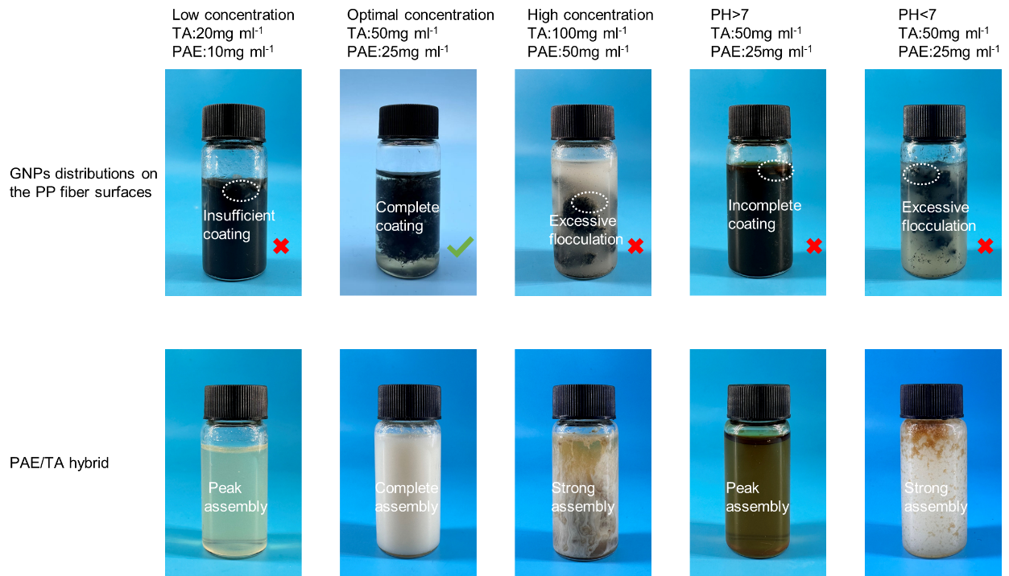
Fig. S1 The distribution of GNPs on the PP fiber surfaces and the state of PAE/TA hybrids under different conditions

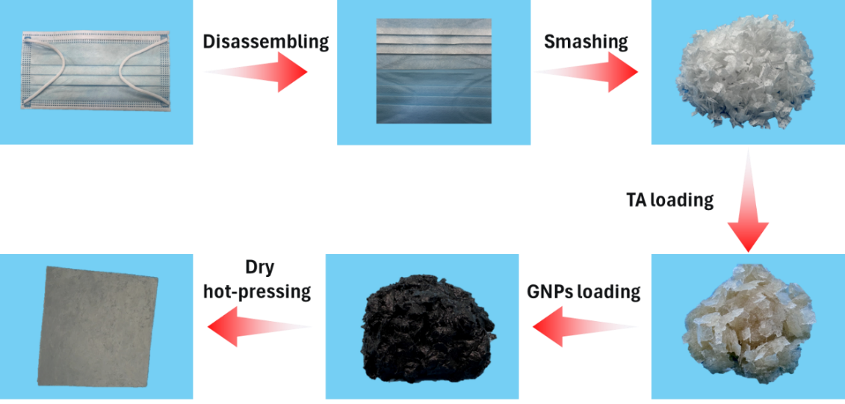
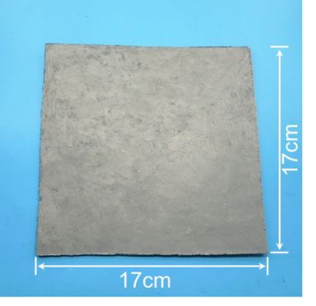
Fig. S2 The large-scale preparation process and photograph of PP@G nanocomposites (170 mm×170 mm)

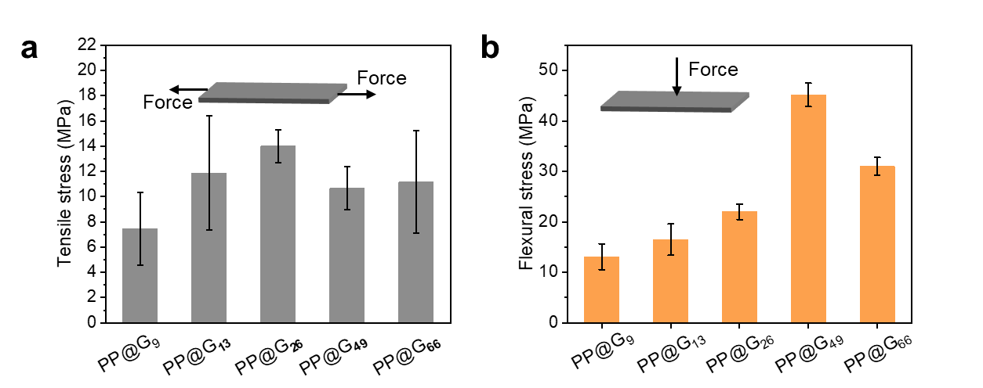
Fig. S3 a Tensile and b flexural stress of as-prepared PP@G nanocomposites with different GNP content

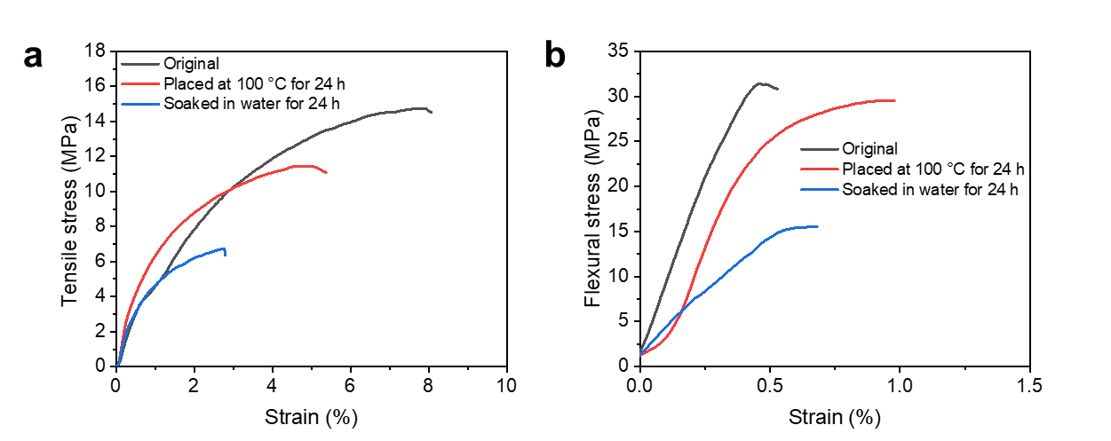
Fig. S4 The variations of a the tensile and b the flexural stress-strain curves of as-prepared PP@G nanocomposites under extreme conditions

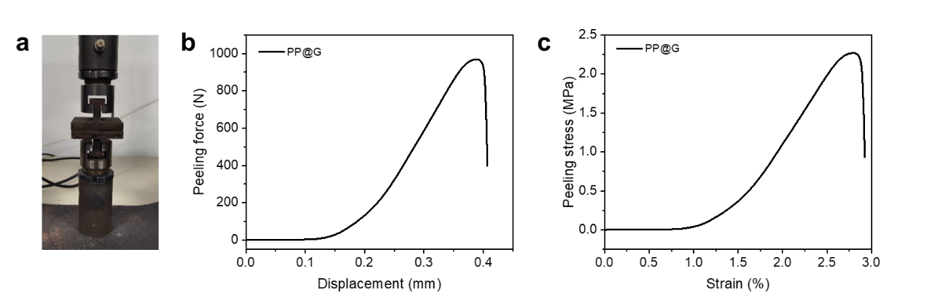
Fig. S5 a Photograph of the peeling process of the as-prepared PP@G nanocomposites, along with the corresponding b force-displacement and c stress-strain curves

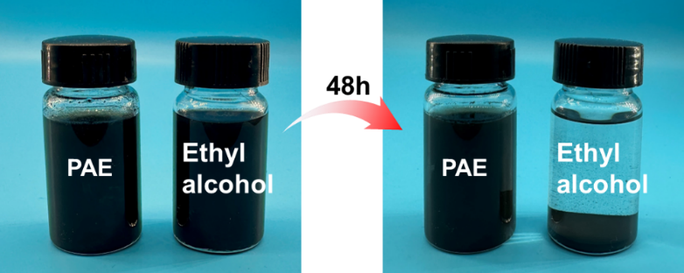
Fig. S6 Dispersions of GNPs in Ethyl alcohol solution, and aqueous PAE solution before and after being allowed to stand for 48 h

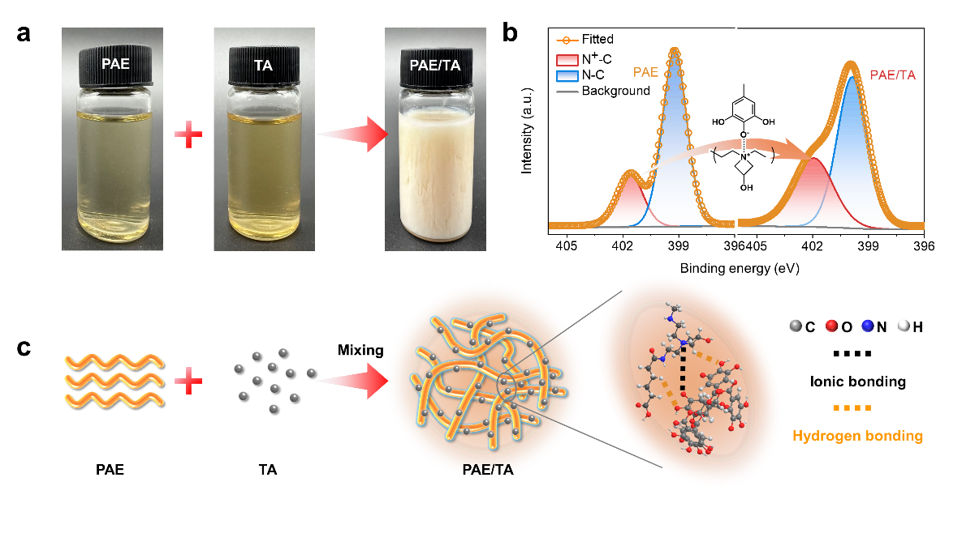
Fig. S7 Schematic illustration of interactions between PAE and TA

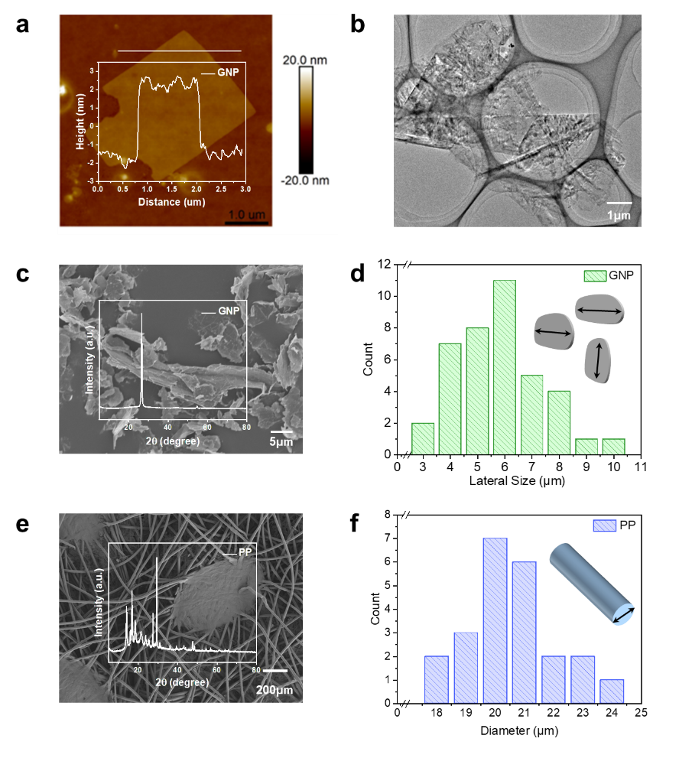
Fig. S8 a AFM image and corresponding thickness measuring curve, b typical TEM image, c SEM image, XRD, d and lateral size distributions of GNPs. e SEM image, XRD and f Diameter distributions of waste mask PP fibers
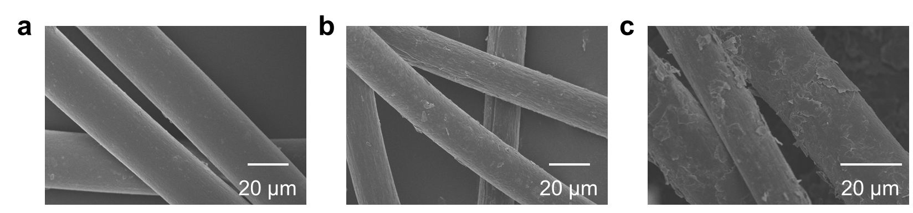
Fig. S9 a SEM image of waste mask PP fibers, b PP@TA and c PP@G
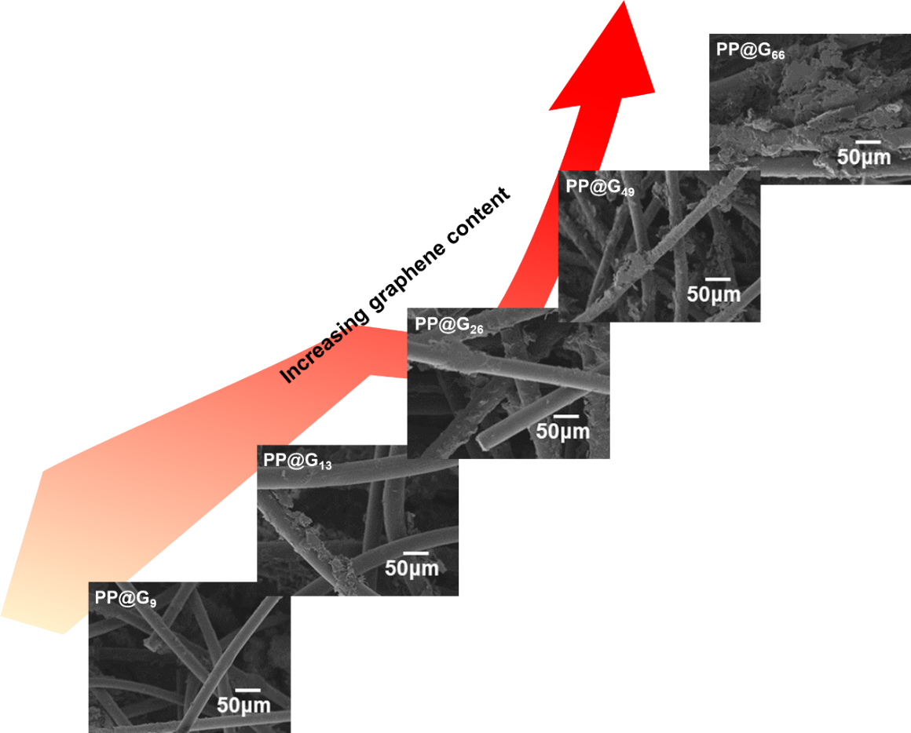
Fig. S10 SEM images of the PP@GNPs powders with different GNP contents

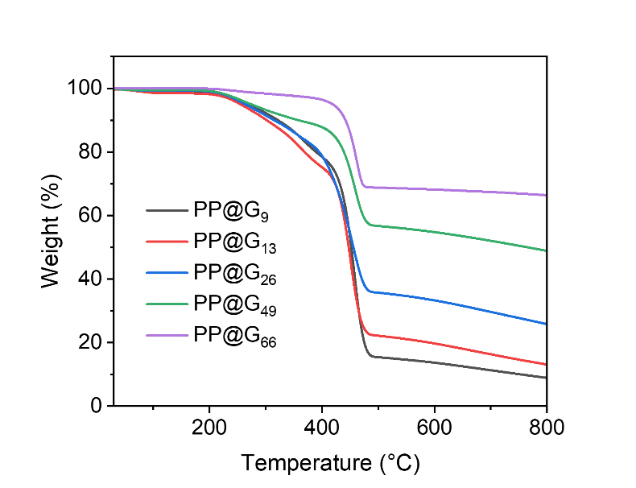
Fig. S11 TGA curves of as-prepared PP@G nanocomposites with different GNP contents at nitrogen atmosphere
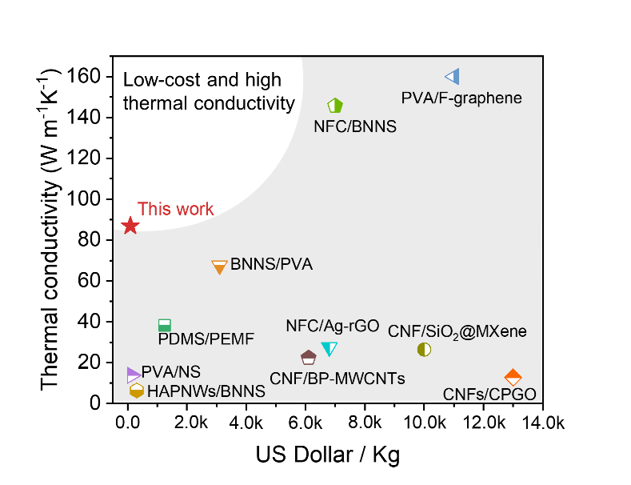
Fig. S12 Comparisons of thermal conductivity and production cost of as-developed PP@G₆₆ nanocomposites and previously reported heat-dissipating materials [S1-S10]
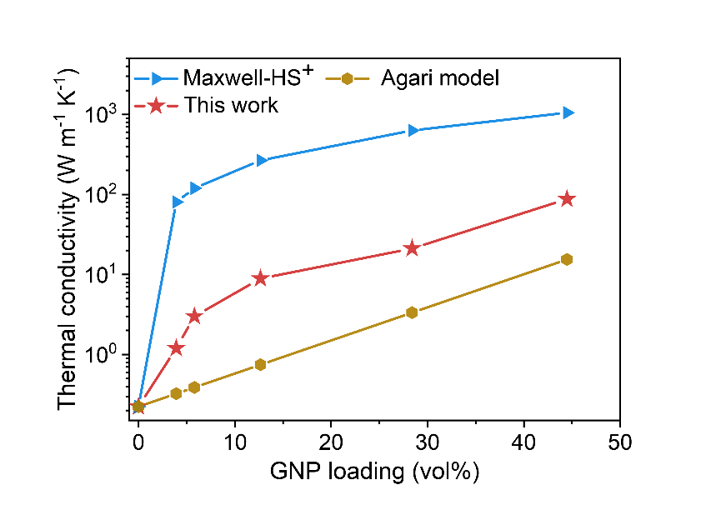
Fig. S13 Comparison of experimental TC values of as-prepared PP@G nanocomposites and those predicted using Agari and Maxwell-HS⁺ models for different GNP contents
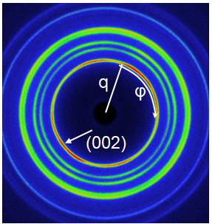
Fig. S14 2D WAXS pattern of as-prepared PP@G nanocomposites
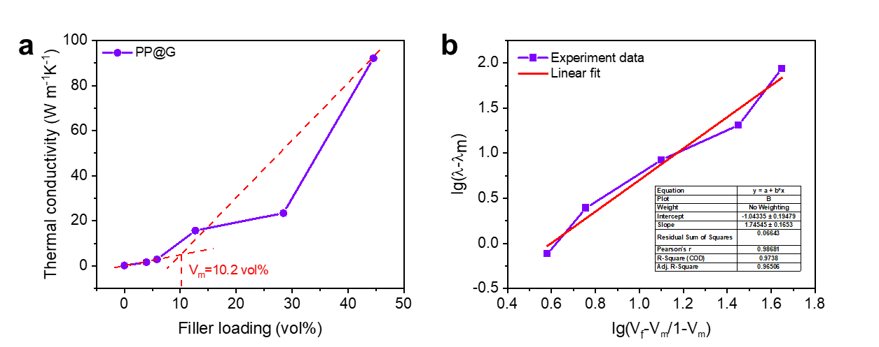
Fig. S15 a The tangent process of the experimental data for as-developed PP@G nanocomposites to obtain Vc; and b the fitting process by the Foygel model
Here, the Foygel theory was applied to calculate the interfacial thermal resistance at the filler/filler interface, which is expressed as follows：
$λ−λ_{m}=K_{0}$) ^{α}
$$R_{c}=\frac{1}{{K_{0}L\left(V_{m}\right)}^{α}}$$
In this context, λ and λ_{m} denote the thermal conductivity of as-developed PP@G₆₆ nanocomposites and PP matrix, respectively. K₀ refers to a pre-exponential factor ratio that is associated with the contact between GNPs and the topology of the percolation cluster. α represents conductivity exponent, while V_{f} indicates the critical percolation threshold of the fillers. R_{c} is the thermal contact resistance between the GNPs, and L signifies the lateral size of the GNPs. For the PP@G composites we developed, fitting the thermal conductivity yielded a calculated R_{c} value of 72,000 K W⁻¹ (Fig. S17). Furthermore, the R_{c} values from other previously reported thermal conductive polymer composites with random and 3D networked nanofiller structures were determined using the same methodology.

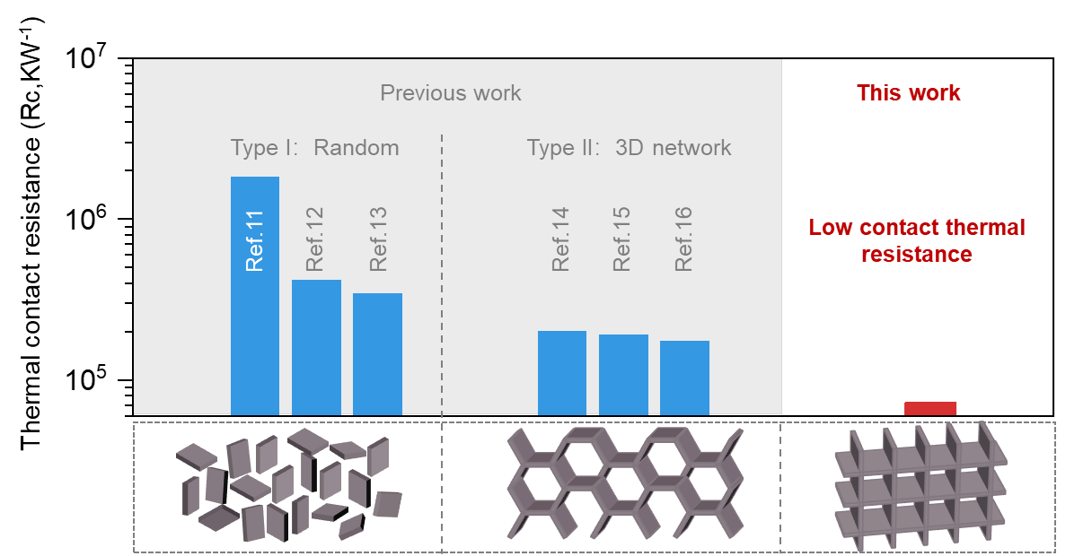
Fig. S16 Comparison of R_{c} values calculated using the Foygel model in this work with those of previously reported thermal conductive polymer composites with two types of filler distributions [S11-S16]
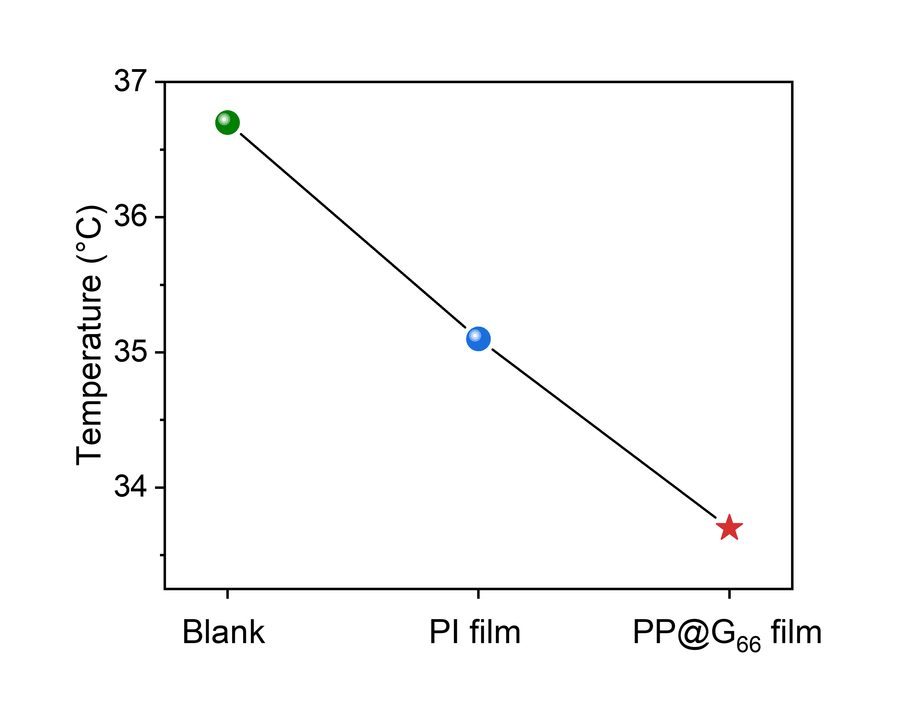
Fig. S17 The back temperatures of the smartphone using different heat dissipation films after high-load operation for 10 minutes

Fig. S18 The comparison of experimental and theoretical EMI SE values for as-prepared PP@G₆₆ nanocmposites (300 µm thickness)

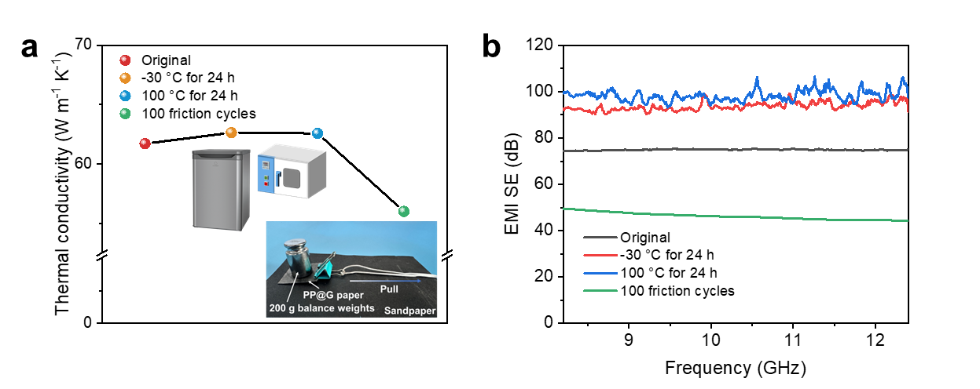
Fig. S19 Changes in a TC and b EMI SE of the PP@G nanocomposites under different conditions

Table S1 Environmental impact of using 1 kg of PP for the preparation of PP@G and landfilling
Impact category | Preparation of PP@G | Landfill of PP | Reference unit
Fossil fuel depletion | -3.47 | 10.80315574 | MJ surplus
Global warming | -0.351 | 2.527030755 | kg CO₂ eq
Carcinogenics | 3.64E-09 | 8.84082E-08 | CTUh
Acidification | 0.000375 | 0.00884379 | kg SO₂ eq
Ecotoxicity | 1.02 | 7.813904035 | CTUe
Smog | 0.0149 | 0.113794478 | kg O₃ eq
Eutrophication | 0.000804 | 0.003387112 | kg N eq
Ozone depletion | 1.61E-08 | 6.57458E-08 | kg CFC-11 eq
Non carcinogenics | 7.17E-08 | 1.69754E-07 | CTUh
Respiratory effects | 0.000504 | 0.00082594 | kg PM2.5 eq
Table S2 Comparisons of thermal conductivity and fabrication cost of PP@G₆₆ nanocomposites and previously reported heat-dissipating materials
 | Fillers | Matrix types | Contents (wt.%) | Thermal conductivity  (W m⁻¹ K⁻¹) | Fabrication cost  (Dollar/kg)
Previously  reported | F-graphene | PVA | 93 | 61.3 | 11000 ± 550
Previously  reported | BNNS | NFC | 50 | 145.7 | 7000 ± 350
Previously  reported | BNNS | PVA | 83 | 67.6 | 3100 ± 155
Previously  reported | BNNS | HAPNWs | 30 | 6.4 | 310 ± 15.5
Previously  reported | BP-MWCNTs | CNF | 20 | 22.38 | 6100 ± 305
Previously  reported | PEMF | PDMS | 55.08 | 38.27 | 1250 ± 62.5
Previously  reported | NS | PVA | 10 | 13.8 | 150 ± 7.5
Previously  reported | Ag-rGO | NFC | 9.6 | 27.55 | 6800 ± 340
Previously  reported | SiO₂@MXene | CNF | 97.5 | 26.4 | 10000 ± 500
Previously  reported | CPGO | CNFs | 70 | 12.75 | 13000 ± 650
Previously  reported | GNPs | PVA | 60.01 | 82.4 | 258 ± 12.9
This work | GNP | PP | 66 | 87 | 90±5
Table S3 Comparison of TC for PP@G nanocomposites using the steady-state heat flow method (ASTM D5470) and the laser flash method (out-of-plane)
GNP content (wt%) | Thermal conductivity (W m⁻¹ K⁻¹)
GNP content (wt%) | The steady-state  heat flow method | the laser flash method  (out-of-plane)
9 | 0.3 | 0.3
13 | 0.6 | 0.4
26 | 1.6 | 0.5
49 | 3.1 | 1.8
66 | 3.1 | 3.4
Table S4 Summary of thermal conductivity models of composites
Models | Effective TC equation
Agari | $$logλ=Vk_{2}logλ_{f}+\left(1−V\right)log\left(k_{1}λ_{m}\right)$$
Maxwell-HS⁺ | $$λ=λ_{f}\frac{2λ_{f}+λ_{m}−2\left(1−V\right)\left(λ_{f}−λ_{m}\right)}{2λ_{f}+λ_{m}+\left(1−V\right)\left(λ_{f}−λ_{m}\right)}$$
* In the above model, λ represents the effective thermal conductivity of composites, λ_{m} represents the thermal conductivity of matrix in the composite, λ_{f} represents the thermal conductivity of filler in the composite, and V represents the volume fraction of the filler. In the Agari model, K₁ is an indicator that measures the influence of filler on the secondary structure of the polymer matrix, such as crystallinity, crystal size, etc., and it is related to the changes in the thermal conductivity of the polymer matrix. K₂ measures the ease with which filler form conducting chains.
Table S5 Comparisons of in-plane specific TCE along the preferred direction of heat transfer between as-prepared PP@G₆₆ nanocomposites and other polyolefin composites filled with two types of nanofiller structure. λ_{m}: Thermal conductivity of matrix; λ: Thermal conductivity of composites; CNTs: Carbon nanotubes
Fillers |  | Matrix | λ_{m} | λ | Content (wt%) | Specific TCE | Refs.
 |  | Matrix | (W m⁻¹ K⁻¹) |  | Content (wt%) | Specific TCE | Refs.
Type I：  Random） | Boron nitride + CNTs | PE | 0.38 | 1.79 | 50 | 7 | [36]
Type I：  Random） | Boron nitride | PP | 0.18 | 0.72 | 29 | 10 | [37]
Type I：  Random） | CNTs | PP | 0.2 | 0.55 | 16 | 11 | [38]
Type I：  Random） | Graphene | PP | 0.2 | 0.67 | 15 | 16 | [39]
Type I：  Random） | Graphene | PE | 0.3 | 2.91 | 40 | 22 | [40]
Type II：  3D network | Graphene | PP | 0.2 | 0.86 | 16.7 | 20 | [41]
Type II：  3D network | Graphene | PE | 0.4 | 4.13 | 33 | 28 | [42]
Type II：  3D network | Graphene | PE | 0.33 | 1.84 | 10 | 46 | [43]
Type II：  3D network | Graphene | PP | 0.22 | 1.53 | 10 | 60 | [43]
Type II：  3D network | Graphene | PP | 0.74 | 1.58 | 1.83 | 63 | [44]
This work | Graphene | PP | 0.2 | 87 | 66 | 660 | /
Table S6 Comparisons of the EMI shielding performance of PP@G nanocomposites with other EMI composite materials
Type | Materials | Thickness  (mm) | EMI SE  (dB) | SMI SE/t  (dB cm⁻¹) | Refs.
Metal-based | Copper | 3.1 | 90 | 290.3 | [52]
Metal-based | Stainless steel | 4 | 89 | 222.5 | /
Metal-based | Ni fiber/PES | 2.85 | 58 | 203.5 | [53]
Metal-based | Ni filaments | 2.85 | 87 | 305.3 | [53]
Metal-based | AgNW/PI | 5 | 35 | 70 | [54]
All carbon  materials | CNT sponge | 0.24 | 20 | 833.3 | [55]
All carbon  materials | CNT/Graphene | 1 | 27 | 270 | [56]
All carbon  materials | rGO | 2.5 | 45.1 | 180.4 | [67]
CNT based | CNTs/PC | 2.1 | 39 | 185.7 | [57]
CNT based | MWCNTs/PS | 2 | 30 | 150 | [58]
CNT based | SWCNTs/PS | 1.2 | 18.5 | 154.2 | [59]
CNT based | MWCNTs/WPU | 2.3 | 35 | 152.17 | [60]
CNT based | MWCNTs/ABS | 1.1 | 40 | 363.6 | [61]
CNT based | MWCNT/GF/PDMS | 15 | 75 | 50 | [62]
CNT based | MWCNT-based composite paper | 0.6 | 56 | 933.3 | [63]
MXene based | MXene/PVA | 0.3 | 21 | 700 | [64]
MXene based | MXene/PS | 2 | 62 | 310 | [65]
MXene based | MXene/wax | 1 | 76.1 | 761 | [66]
rGO based | rGO/PS | 2.5 | 45.1 | 180.4 | [67]
rGO based | rGO/PU | 20 | 19.9 | 9.95 | [68]
rGO based | rGO/PDMS | 1 | 30 | 300 | [73]
rGO based | rGO/PMMA | 0.24 | 19 | 791.7 | [75]
rGO based | rGO/PEI | 2.3 | 12.8 | 55.7 | [69]
rGO based | rGO/Fe₃O₄/PEI | 25 | 18 | 7.2 | [70]
rGO based | rGO/PEDOT | 0.8 | 70 | 875 | [71]
Graphene-  based | Graphene/PEDOT:PS S | 1.5 | 91.9 | 612.7 | [72
Graphene-  based | Graphene/PDMS | 1 | 20 | 200 | [73]
Graphene-  based | Graphene/PS | 2 | 29 | 145 | [74]
Graphene-  based | Graphene/PMMA | 2.4 | 19 | 79.2 | [75]
Graphene-  based | Graphene/PI | 0.8 | 19 | 237.5 | [76]
This work | GNP/PP | 0.8 | 88 | 1100 | /
This work | GNP/PP | 0.5 | 69 | 1380 | /
This work | GNP/PP | 0.3 | 57 | 1900 | /
Table S7 Comparisons of comprehensive performance of our strategy and previously reported thermal conductive electromagnetic shielding composites
EMI SE | EMI SE/t | Thermal Conductivity  (W m⁻¹ K⁻¹) | Cost ($/kg) | Scalability (mm) | Environmental  benefits | Refs.
(dB cm⁻¹)
67.86 | 339.3 | / | / | 17.5×17.5 | / | [S17]
61.4 | 245.6 | 2.187 | / | 21×21 | / | [S18]
/ | / | 69.74 | / | 10×10 | / | [S19]
/ | / | 67.6 | 310 ± 155 | 44×44 | / | [S20]
88 | 1100 | 87 | 90 ± 5 | 170×170  (>150) | 1.Reduce waste plastic pollution;  2. Reduce the generation of micro(nano)plastics | This  work
Supplementary References
- L. Cheng, J. Feng, Flexible and fire-resistant all-inorganic composite film with high in-plane thermal conductivity. Chem. Eng. J. 398, 125633 (2020). https://doi.org/10.1016/j.cej.2020.125633
- Y. Gao, F. Müller-Plathe, Increasing the thermal conductivity of graphene-polyamide-6, 6 nanocomposites by surface-grafted polymer chains: calculation with molecular dynamics and effective-medium approximation. J. Phys. Chem. B 120(7), 1336–1346 (2016). https://doi.org/10.1021/acs.jpcb.5b08398
- Z. Qu, K. Wang, C.-A. Xu, Y. Li, E. Jiao et al., Simultaneous enhancement in thermal conductivity and flame retardancy of flexible film by introducing covalent bond connection. Chem. Eng. J. 421, 129729 (2021). https://doi.org/10.1016/j.cej.2021.129729
- D. Suh, C.M. Moon, D. Kim, S. Baik, Ultrahigh thermal conductivity of interface materials by silver-functionalized carbon nanotube phonon conduits. Adv. Mater. 28(33), 7220–7227 (2016). https://doi.org/10.1002/adma.201600642
- Q. Yan, W. Dai, J. Gao, X. Tan, L. Lv et al., Ultrahigh-aspect-ratio boron nitride nanosheets leading to superhigh in-plane thermal conductivity of foldable heat spreader. ACS Nano 15(4), 6489–6498 (2021). https://doi.org/10.1021/acsnano.0c09229
- S. Yang, B. Xue, Y. Li, X. Li, L. Xie et al., Controllable Ag-rGO heterostructure for highly thermal conductivity in layer-by-layer nanocellulose hybrid films. Chem. Eng. J. 383, 123072 (2020). https://doi.org/10.1016/j.cej.2019.123072
- Y. Zhan, B. Nan, Y. Liu, E. Jiao, J. Shi et al., Multifunctional cellulose-based fireproof thermal conductive nanocomposite films assembled by in situ grown SiO₂ nanoparticle onto MXene. Chem. Eng. J. 421, 129733 (2021). https://doi.org/10.1016/j.cej.2021.129733
- Y. Zhang, C. Lei, K. Wu, Q. Fu, Fully organic bulk polymer with metallic thermal conductivity and tunable thermal pathways. Adv. Sci. 8(14), 2004821 (2021). https://doi.org/10.1002/advs.202004821
- Y. Zhuang, K. Zheng, X. Cao, Q. Fan, G. Ye et al., Flexible graphene nanocomposites with simultaneous highly anisotropic thermal and electrical conductivities prepared by engineered graphene with flat morphology. ACS Nano 14(9), 11733–11742 (2020). https://doi.org/10.1021/acsnano.0c04456
- H. Zhu, Y. Li, Z. Fang, J. Xu, F. Cao et al., Highly thermally conductive papers with percolative layered boron nitride nanosheets. ACS Nano 8(4), 3606–3613 (2014). https://doi.org/10.1021/nn500134m
- Y. Seki, B. Avci, S. Uzun, N. Kaya, M. Atagur et al., The using of graphene nano-platelets for a better through-plane thermal conductivity for polypropylene. Polym. Compos. 40(S2), E1320–E1328 (2019). https://doi.org/10.1002/pc.24979
- M. Saeidijavash, J. Garg, B. Grady, B. Smith, Z. Li et al., High thermal conductivity through simultaneously aligned polyethylene lamellae and graphene nanoplatelets. Nanoscale 9(35), 12867–12873 (2017). https://doi.org/10.1039/C7NR04686C
- F. Tarannum, R. Muthaiah, R.S. Annam, T. Gu, J. Garg, Effect of alignment on enhancement of thermal conductivity of polyethylene-graphene nanocomposites and comparison with effective medium theory. Nanomaterials 10(7), 1291 (2020). https://doi.org/10.3390/nano10071291
- F. Xiao, F. Weng, D. Guo, E. Koranteng, H. Zhou et al., Preparation and characterization of thermosetting wood flour composite material with high biomass content. Polym. Compos. 42(9), 4822–4830 (2021). https://doi.org/10.1002/pc.26192
- W. Guo, G. Chen, Fabrication of graphene/epoxy resin composites with much enhanced thermal conductivity via ball milling technique. J. Appl. Polym. Sci. 131(15), 40565 (2014). https://doi.org/10.1002/app.40565
- C.-C. Teng, C.M. Ma, C.-H. Lu, S.-Y. Yang, S.-H. Lee et al., Thermal conductivity and structure of non-covalent functionalized graphene/epoxy composites. Carbon 49(15), 5107–5116 (2011). https://doi.org/10.1016/j.carbon.2011.06.095
- Q. Guo, H. Tian, Y. Cheng, S. Wang, Z. Li et al., Structural-functional integrated graphene-skinned aramid fibers for electromagnetic interference shielding. ACS Nano 18(49), 33566–33575 (2024). https://doi.org/10.1021/acsnano.4c11782
- S. Shi, Y. Jiang, H. Ren, S. Deng, J. Sun et al., 3D-printed carbon-based conformal electromagnetic interference shielding module for integrated electronics. Nano-Micro Lett. 16(1), 85 (2024). https://doi.org/10.1007/s40820-023-01317-w
- Z. Ma, J. Wang, Z. Hao, J. Dai, X. Zhu et al., Novel graphene-epoxy composite with aligned architecture and ultrahigh thermal conductivity. Adv. Funct. Mater. 35(2), 2412534 (2025). https://doi.org/10.1002/adfm.202412534
- Q. Yan, W. Dai, J. Gao, X. Tan, L. Lv et al., Ultrahigh-aspect-ratio boron nitride nanosheets leading to superhigh in-plane thermal conductivity of foldable heat spreader. ACS Nano 15(4), 6489–6498 (2021). https://doi.org/10.1021/acsnano.0c09229

