Supporting Information for
Efficient Thermally-Evaporated Near-Infrared Perovskite Light-Emitting Diodes via Phase Regulation
Siwei He^{1,#}, Lanxin Qin^{2,#}, Zhengzheng Liu^{3,*}, Jae-Wook Kang⁴, Jiajun Luo^{2,*}, Juan Du^{1,*}
¹School of Physics and Optoelectronic Engineering, Hangzhou Institute for Advanced Study, University of Chinese Academy of Sciences, Hangzhou 310024, P. R. China.
²Wuhan National Laboratory for Optoelectronics (WNLO) and School of Optical and Electronic Information, Huazhong University of Science and Technology (HUST), 1037 Luoyu Road, Wuhan, Hubei 430074, P. R. China
³State Key Laboratory of High Field Laser Physics and CAS Center for Excellence in Ultra-Intense Laser Science, Shanghai Institute of Optics and Fine Mechanics, Chinese Academy of Sciences, Shanghai 201800, P. R. China
⁴Department of Flexible and Printable Electronics, LANL-JBNU Engineering Institute-Korea, Jeonbuk National University, Jeonju 54896, Republic of Korea.
#Siwei He and Lanxin Qin contributed equally to this work.
*Corresponding authors. E-mail: du@ucas.ac.cn (Juan Du); luojiajun@hust.edu.cn (Jiajun Luo); liuzhengzheng@siom.ac.cn (Zhengzheng Liu)
S1 Digital images of perovskite thin films
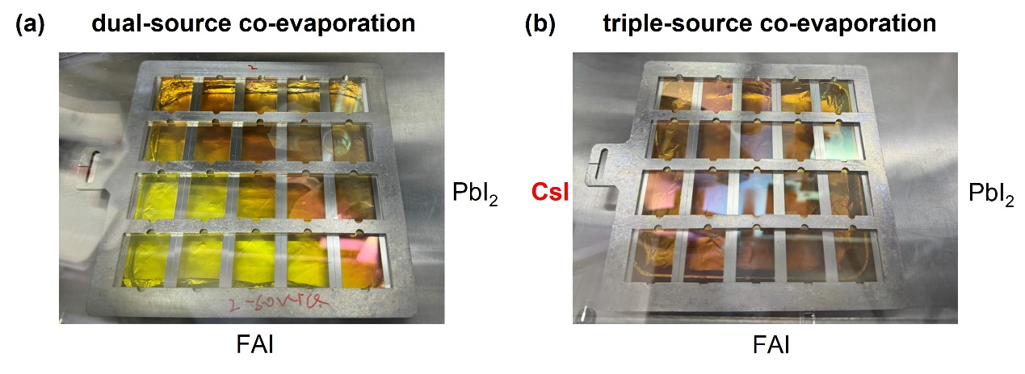
Fig. S1 Photographs of as-deposited (a) FAPbI₃ via dual-source co-evaporation, and (b) FACsPbI₃ via triple-source co-evaporation

S2 TRPL analysis
The PL lifetime decay curves of perovskite films were fitted using bi-exponential function through Equation S1:
$I=\sum_{n}{A_{n}exp\left(\frac{−t}{τ_{n}}\right)}n=1,2,3…$ (S1)
The average PL lifetime (τ_{avg}) can be determined via Equation S2:
$τ_{avg}=\frac{\sum_{n}{A_{n}τ_{n}^{2}}}{\sum_{n}{A_{n}}τ_{n}}n=1,2,3…$ (S2)

Table S1 PL decay lifetime of FAPbI₃ and FACsPbI₃ based on bi-exponential decay fitting of TRPL spectra
Samples | A₁ | τ₁  (ns) | A₂ | τ₂  (ns) | τ_{avg}  (ns)
FAPbI₃ | 0.41 | 8.50 | 0.10 | 68.83 | 48.55
FACsPbI₃ | 1.90 | 4.84 | 0.18 | 80.37 | 51.02
S3 XPS analysis

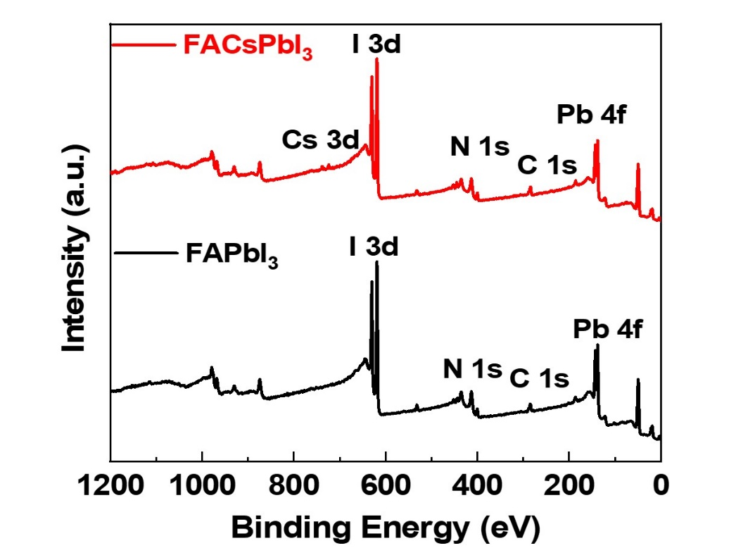
Fig. S2 Overall XPS spectra of FAPbI₃ and FACsPbI₃ thin film
S4 UPS analysis

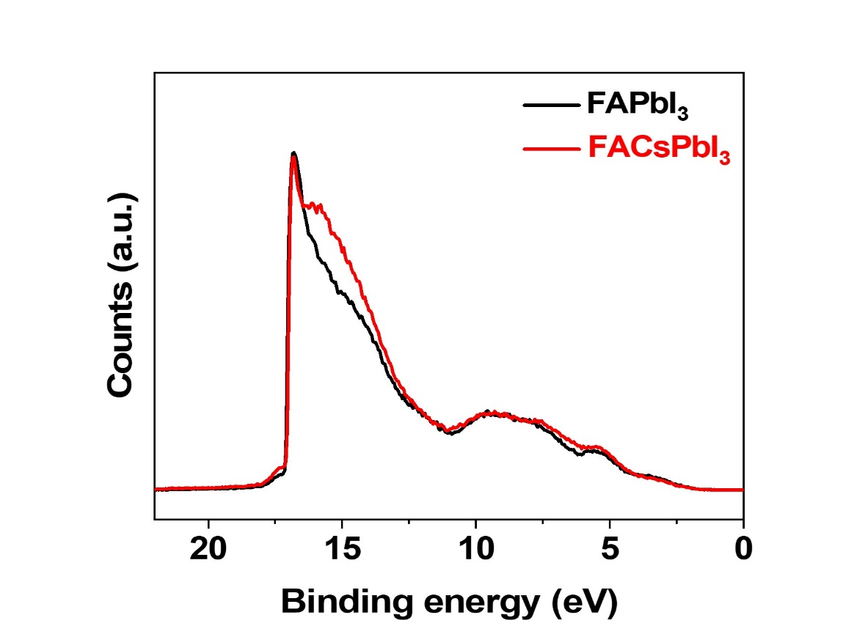
Fig. S3 UPS spectra of FAPbI₃ and FACsPbI₃ thin films
The valence band maximum (E_{VBM}) of the perovskite films were calculated using Equation S3:
E_{VBM} = hν - (E_{cut-off} - E_{onset}) (S3)
where hν is the ultraviolet radiation energy (21.22 eV).
The Fermi levels of the perovskite films were calculated using Equation S4:
E_{Fermi} =hv - E_{cut-off} (S4)
The conduction band minimum (E_{CBM}) of the perovskite films were calculated using Equation S5:
E_{CBM} = E_{VBM} - E_{g} (S5)
Table S2 Detailed band energy derived from UPS spectra for FAPbI₃ and FACsPbI₃ thin films
Samples | E_{cut-off} [eV] | E_{on-set}  [eV] | E_{VBM} [eV] | E_{Fermi} [eV] | E_{g}  [eV] | E_{CBM} [eV]
FAPbI₃ | 17.11 | 1.58 | -5.69 | -4.11 | 1.60 | -4.09
FACsPbI3 | 17.06 | 1.50 | -5.66 | -4.16 | 1.54 | -4.12

S5 Morphologies

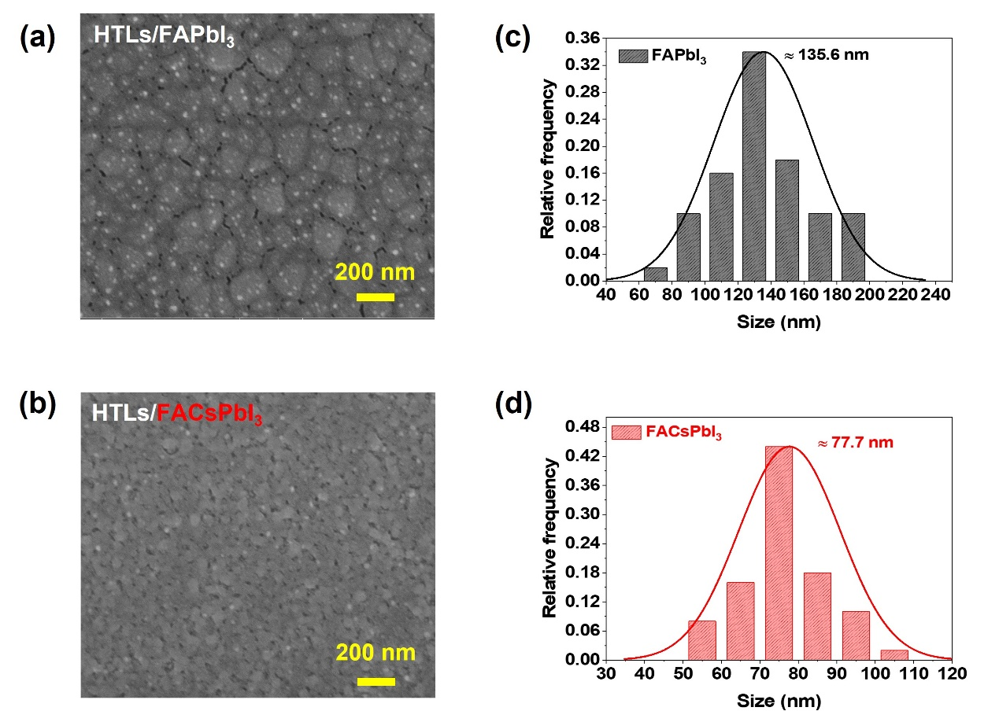
Fig. S4 FE-SEM images of (a) FAPbI₃ and (b) FACsPbI₃. The crystal size distribution of (c) FAPbI₃, and (d) FACsPbI₃ deposited on PEDOT:PSS/TFB hole transport layer
S6 FIB images

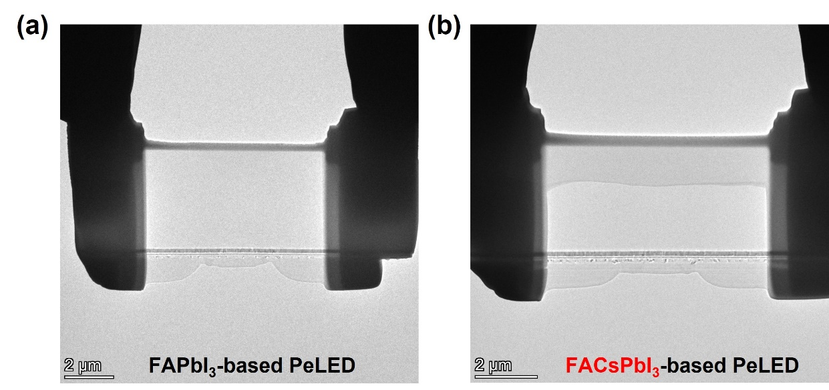
Fig. S5 FIB images of the FAPbI₃ and FACsPbI₃ for the characterization of STEM
S7 Cross-sectional and EDS images

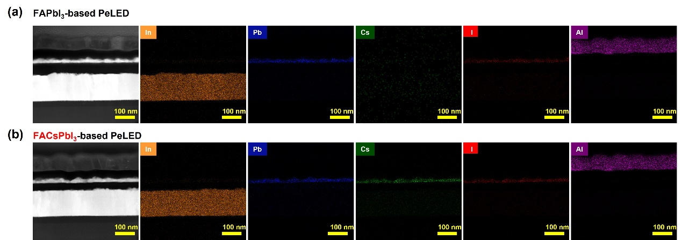
Fig. S6 Cross-sectional image and EDS spectra of (a) FAPbI₃-based, and (b) FACsPbI₃-based PeLEDs
S8 EQE and wavelength peak distribution

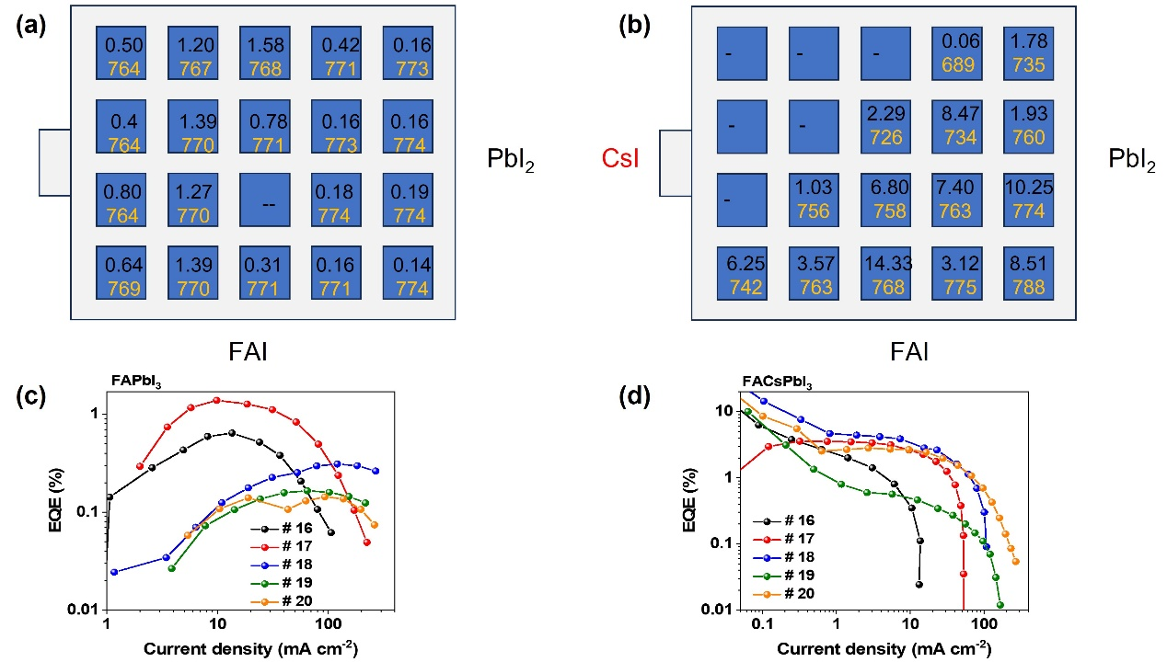
Fig. S7 EQE values (black, upper data) and wavelength peaks (yellow, lower data) for (a) FAPbI₃ via dual-source co-evaporation, and (b) FACsPbI₃ via triple-source co-evaporation. EQE-current density from the fourth row (denoted as #16-20) for (c) FAPbI₃-based and (d) FACsPbI₃-based devices

S9 SCLC analysis
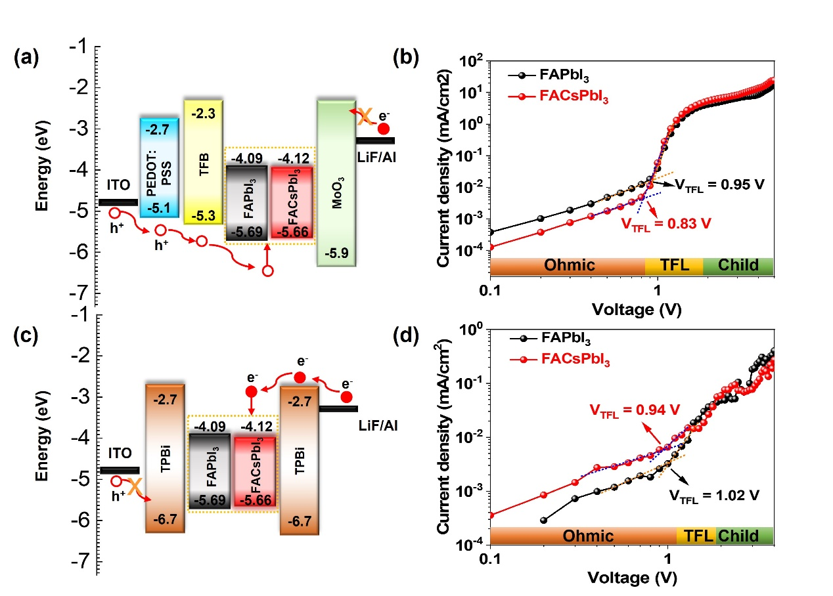
Fig. S8 (a) Energy band diagram, and (b) current density-voltage curves for the hole-only devices based on FAPbI₃ and FACsPbI₃. (c) Energy band diagram, and (d) current density-voltage curves based on FAPbI₃ and FACsPbI₃
Table S3 Performance of the state-of-the-art NIR-PeLEDs
Deposition method of perovskite | Perovskite | Device structure | EL  (nm) | EQE  (%) | Radiance  (W sr-1 m-2) | Year | Refs.
Thermal evaporation | FACsPbI₃ | ITO/PEDOT:PSS/ TFB/Pe/TPBi/LiF/Al | 770 | 10.25 | 2.64 | 2024 | This work
Thermal evaporation | MAPbI₃ | ITO/PEDOT:PSS/poly-TPD/Pe/PCBM/Ba/Ag | 765 | 0.04 | 0.084 | 2014 | [S1]
Thermal evaporation | MAPbI₃ | ITO/PEDOT:PSS/poly-TPD/Pe/PCBM/Ba/Ag | 765 | 0.06 | N.A. | 2015 | [S2]
Thermal evaporation | MAPbI₃ | ITO/MeO-TPD:F4TCNQ/MeO-TPD/Pe/Bphen/Bphen:Cs/Ag | 768 | 0.35 | 4.2 | 2016 | [S3]
Thermal evaporation | MAPbI₃ | ITO/ C₆₀/Pe/ TaTm /Au | 760 | 1.92 | 4.1 | 2018 | [S4]
Solution-based process | MAPbI_{3-x}Cl_{x} | ITO/TiO2/Pe/F8/MoO3/Ag | 754 | 0.76 | 13.2 | 2014 | [S5]
Solution-based process | FPMAI-MAPb_{0.6}Sn_{0.4}I₃ | ITO/Poly-TPD/Pe/TPBi/LiF/Al | 917 | 5.0 | 2.7 | 2018 | [S6]
Solution-based process | Cs_{0.17}FA_{0.83}PbI_{2.5}Br_{0.5} | ITO/ZnO/PEIE/Pe/TFB/MoO3/Au | 800 | 17.4 | 965 | 2020 | [S7]
Solution-based process | KI-MAPb_{0.8}Sn_{0.2}I₃ | ITO/Poly-TPD/Pe/TPBi/LiF/Al | 868 | 9.6 | 0.025 | 2022 | [S8]
Solution-based process | PEAI-FAPbI₃ QDs | ITO/PEDOT:PSS/VB-FNPD/Pe/CN-T2T/LiF/Al | 772 | 15.4 | 128.1 | 2022 | [S9]
Solution-based process | SFB10-FAPbI₃ | ITO/ZnO/PEIE/Pe/TFB/MoOx/Au | 803 | 22.8 | 278.9 | 2022 | [S10]
Solution-based process | Yb³⁺ :CsPb(Cl_{1-x}Br_{x})₃ QDs | ITO/PEDOT:PSS/Poly-TPD/PVK/Pe/TPBi/Liq/Al | 990 | 7.7 | NA | 2023 | [S11]
Solution-based process | MSPE-FAPbI₃ | ITO/ZnO/PEIE/Pe/Poly-TPD/MoOx/Au | 800 | 23.8 | > 3200 | 2023 | [S12]
Solution-based process | Yb³⁺:CsPb(Cl_{1−x}Br_{x})₃ QDs | ITO/PEDOT:PSS/poly-TPD/PVK/Pe/PO-T2T/Liq/Al | 990 | 8.5 | 52.5 | 2024 | [S13]
Solution-based process | CsSnI₃ | ITO/PEDOT:PSS/Pe/TPBi/LiF/Al | 948 | 2.63 | 226 | 2024 | [S14]

Supplementary References
[S1] L. Gil-Escrig, G. Longo, A. Pertegás, C. Roldán-Carmona, A. Soriano et al, Efficient photovoltaic and electroluminescent perovskite devices. Chem. Comm. 51, 569–571 (2015). https://doi.org/10.1039/c4cc07518h
[S2] L. Gil-Escrig, A. Miquel-Saempere, M. Sessolo, H.J. Bolink, Mixed iodide-bromide methylammonium lead perovskite-based diodes for light emission and photovoltaics. J. Phys. Chem. Lett. 6, 3743–3748 (2015). https://doi.org/10.1021/acs.jpclett.5b01716
[S3] A. Genco, F. Mariano, S. Carallo, V.L.P. Guerra, S. Gambino et al, Fully vapor-deposited heterostructured light-emitting diode based on organo-metal halide perovskite. Adv. Electron Mater. 2, 1500325 (2016). https://doi.org/10.1002/aelm.201500325
[S4] B. Dänekamp, N. Droseros, F. Palazon, M. Sessolo, N. Banerji et al, Efficient photo- and electroluminescence by trap states passivation in vacuum-deposited hybrid perovskite thin films. ACS Appl. Mater. Interfaces 10, 36187–36193 (2018). https://doi.org/10.1021/acsami.8b13100
[S5] Z.K. Tan, R.S. Moghaddam, M.L. Lai, P. Docampo, R. Higler et al, Bright light-emitting diodes based on organometal halide perovskite. Nat. Nanotechnol. 9 687–692 (2014). https://doi.org/10.1038/nnano.2014.149
[S6] W. Qiu, Z. Xiao, K. Roh, N.K. Noel, A. Shapiro et al, Mixed lead–tin halide perovskites for efficient and wavelength-tunable near-infrared light-emitting diodes. Adv. Mater. 31, 1806105 (2019). https://doi.org/10.1002/adma.201806105
[S7] Y.H. Jia, S. Neutzner, Y. Zhou, M. Yang, J.M.F. Tapia et al, Role of excess FAI in formation of high-Efficiency FAPbI₃-based light-emitting diodes, Adv. Funct. Mater. 30, 1906875 (2020). https://doi.org/10.1002/adfm.201906875
[S8] H. Yu, W. Chen, Z. Fang, L. Ding, B. Cao et al, Alkalis-doping of mixed tin-lead perovskites for efficient near-infrared light-emitting diodes, Sci. Bull. (Beijing) 67, 54–60 (2022). https://doi.org/10.1016/j.scib.2021.07.021
[S9] Z.L. Tseng, L.C. Chen, L.W. Chao, M.J. Tsai, D. Luo et al, Aggregation control, surface passivation, and optimization of device structure toward near-infrared perovskite quantum-dot light-emitting diodes with an EQE up to 15.4%, Adv. Mater. 34, 2109785 (2022). https://doi.org/10.1002/adma.202109785
[S10] B. Guo, R. Lai, S. Jiang, L. Zhou, Z. Ren et al, Ultrastable near-infrared perovskite light-emitting diodes, Nat. Photonics 16, 637–643 (2022). https://doi.org/10.1038/s41566-022-01046-3
[S11] Y.J. Yu, C. Zou, W.S. Shen, X. Zheng, Q.S. Tian et al, Efficient near-infrared electroluminescence from lanthanide-doped perovskite quantum cutters, Angew. Chem. Int. Ed. 62, 2302005 (2023). https://doi.org/10.1002/anie.202302005
[S12] Y. Sun, L. Ge, L. Dai, C. Cho, J. Ferrer Orri et al, Bright and stable perovskite light-emitting diodes in the near-infrared range, Nature 615, 830–835 (2023). https://doi.org/10.1038/s41586-023-05792-4
[S13] J.L. Pan, W.S. Shen, S.N. Li, Z. Da Zhang, F. Zhao et al, Polarity-mediated antisolvent control enables efficient lanthanide-based near-Infrared perovskite LEDs, Nano Lett. 24, 2765–2772 (2024). https://doi.org/10.1021/acs.nanolett.3c04586
[S14] F. Yuan, G. Folpini, T. Liu, U. Singh, A. Treglia et al, Bright and stable near-infrared lead-free perovskite light-emitting diodes, Nat. Photonics 18, 170–176 (2024). https://doi.org/10.1038/s41566-023-01351-5

