Supporting Information for
Aramid Nanofiber/MXene-Reinforced Polyelectrolyte Hydrogels for Absorption-Dominated Electromagnetic Interference Shielding and Wearable Sensing
Jinglun Guo ¹, Tianyi Zhang ¹, Xiaoyu Hao ¹, Shuaijie Liu ¹, Yuxin Zou ¹, Jinjin Li ², Wei Wu ², Liming Chen ^{3,} *, Xuqing Liu ^{1,} *
¹ Center of Advanced Lubrication and Seal Materials, State Key Laboratory of Solidification Processing, Northwestern Polytechnical University, Xi’an, 710072, P. R. China
² National Key Laboratory of Scattering and Radiation, Beijing Institute of Environmental Features, Beijing, 100854, P. R. China
³ Department of Physics and Astronomy, The University of Manchester, Oxford Road, Manchester, M13 9PL, UK
*Corresponding authors. E-mail: xqliu@nwpu.edu.cn (Xuqing Liu); liming.chen@manchester.ac.uk (Liming Chen)
Supplementary Figures and Tables
Fig. S1 Schematic diagram of the fabrication of Ti₃C₂T_{x} MXene. a The main synthesis procedures of delaminated Ti₃C₂T_{x} MXene. b The structural change of Ti₃AlC₂ MAX before and after the acid treatment

Fig. S2 a XPS survey spectra of Ti₃AlC₂ MAX and Ti₃C₂T_{x} MXene. The high-resolution XPS spectra of b Ti 2p, c C 1s, d O 1s and e F 1s in MXene
As depicted in Fig. S2a, Al element signals faded accompanied by the appearence of F element in the survey spectrum of Ti₃C₂T_{x} MXene compared with that of Ti₃AlC₂ MAX, indicating that the successful removal of Al atoms from Ti₃AlC₂ MAX and the formation of -F groups. The high resoltion spectra of Ti 2p, C 1s, O 1s and F 1s in MXene were shown in Fig. S2b-e.
Fig. S3 Raman spertrum of MXene
The peak at 197.7 cm⁻¹ was assigned to the typical out-of-plane (A_{1g}) vibrations of Ti atoms in the outer layer along with carbon and surface groups^{[1]}. Further, the broad peaks in the region of 230~470 cm⁻¹ was designated as in-plane (E_{g}) modes of surface groups attached to Ti atoms [S1, S2]. The peak region between 530 cm⁻¹ and 765 cm⁻¹ was associated mostly with carbon vibrations (both E_{g} and A_{1g}) [S1].

Fig. S4 Atomic structures of deprotonation and reprotonation in aramid fibers

Fig. S5 a XPS survey spectrum of ANF. The high-resolution XPS spectra of b C 1s, c N 1s and d O 1s in ANF
The survey spetrum manifested that ANF was composed of C, N and O elements. The peaks of C 1s at 287.8 eV, N 1s at 402.0 eV and O 1s at 531.0 eV were assigned to -CO-NH- group.

Fig. S6 Raman spertrum of ANF
The peak at 1568 cm⁻¹ was associated with the coupled C-N in-plane deformation and C-N stretching modes [S3]. The absorption peak located at 1609 cm⁻¹ was related to the C=C stretching band of the benzene ring of ANF [S4].

Fig. S7 Zeta potential of a ANF, b MXene and c ANF/Mxene

Fig. S8 Hydrodynamic size of a ANF, b MXene and c ANF/MXene

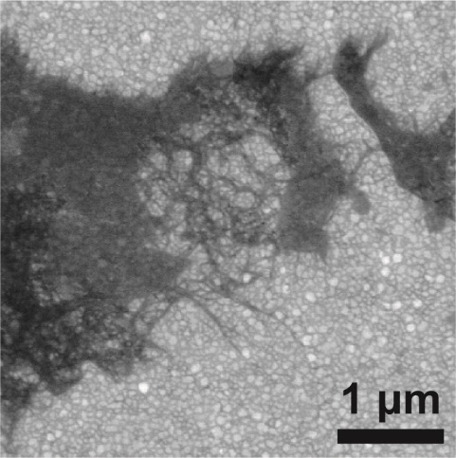
Fig. S9 SEM image of ANF/Mxene

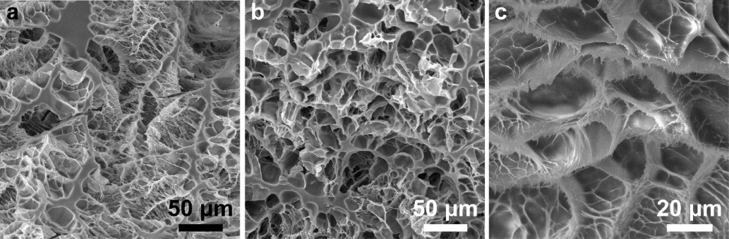
Fig. S10 SEM images of a A₀M₀PC, b A₀M_{1.5}PC and c A₅M₀PC

Fig. S11 FTIR spectra (TR mode) of A₀M₀PC, A₅M₀PC, A₀M_{1.5}PC and A₅M_{1.5}PC hydrogels
After incorporating ANF and MXene, the peak at 1644 cm⁻¹ shifted to 1632 cm⁻¹, i.e. red shift. It indicated the formation of hydrogen bondings near amide groups.

Fig. S12 FTIR spectra (ATR mode) of Water, A₀M₀PC, and Dry-A₀M₀PC hydrogels
The spectral profile of pure water was analyzed to characterize hydrogen bonding interactions in free water (FW) molecules, establishing reference peaks for subsequent analytical procedures. A broad and intense O-H stretching vibration peak observed at ~3300 cm⁻¹ arose from the formation of an intermolecular hydrogen-bonding network in FW. The A₀M₀PC hydrogel exhibited a markedly broadened O-H stretching band with a redshift to ~3250 cm⁻¹, superimposed with the N-H vibration (~3300 cm⁻¹) originating from chitosan (CS). Water molecules formed multiple hydrogen bondings with polar functional groups (-OH, -NH₂, -SO₃H) within the polymer matrix. The underlying interaction mechanisms involved: (i) strong hydrogen bonding between chitosan’s -OH and -NH₂ groups with water molecules, inducing spectral broadening and shifting; (ii) reinforced hydrogen-bonding networks through N-H···O interactions between acrylamide’s (AM’s) -CONH₂ and water molecules. The freeze-dried hydrogel (Dry-A₀M₀PC) demonstrated significant attenuation in O-H peak intensity due to the removal of FW, partial or complete elimination of IW, and partial extraction of bound water (BW). While the predominant removal of water molecules led to partial dissociation of the hydrogen-bonding network, inherent vibration peaks of the polymer matrix became discernible in the spectral profile. Overall, water molecules formed multiple hydrogen bondings via the O-H groups with the -OH and -NH₂ in CS, the -CONH₂ in AM, and the -SO₃H in AMPS, collectively establishing a dynamic cross-linked network. However, IW served as a transitional water molecule, exhibiting binding strength with the polymer matrix that was intermediate between that of FW and BW. Therefore, it remains challenging to precisely differentiate IW, FW, and BW based on FTIR test results. Nevertheless, the FTIR analyses still provides a vital characterization tool for investigating interactions between water molecules and the polymer matrix.
Fig. S13 Rheological properties of A₀M₀PC and A₅M_{1.5}PC hydrogels. a The variations of viscosity with frequency. b The loss tangent at different frequencies
The viscosity of A₅M_{1.5}PC hydrogel was always higher than that of A₀M₀PC hydrogel at all frequencies, indicating that the addition of ANF and MXene could improve the viscosity of the hydrogel matrix. The viscosity of both A₀M₀PC and A₅M_{1.5}PC hydrogel was dramatically descended with the frequency. It could be explained by the fracture of the hydrogel network. The loss tangent (tanδ) of both A₀M₀PC and A₅M_{1.5}PC hydrogel was below 0.2 at all frequencies, suggesting that the elasticity was dominant in the viscoelastic hydrogels with the strong molecular interaction. Moreover, ANF and MXene further enhanced the elasticity.
Fig. S14 Raman spectra of A₅M_{1.5}PC hydrogel in different spots
Fig. S15 Water content of A₀M₀PC, A₅M₀PC, A₀M_{1.5}PC and A₅M_{1.5}PC hydrogels
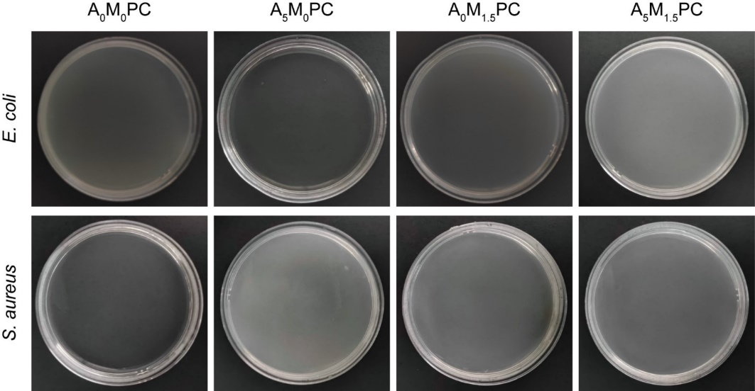
Fig. S16 Antibacterial activity of A₀M₀PC, A₅M₀PC, A₀M_{1.5}PC and A₅M_{1.5}PC hydrogels
Fig. S17 Average tensile stress of a A₅M_{0.5}PC, A₅M₁PC and A₅M_{1.5}PC as well as b A₀M₀PC, A₀M_{1.5}PC and A₅M₀PC hydrogels. Average elongation at break of c A₅M_{0.5}PC, A₅M₁PC and A₅M_{1.5}PC as well as d A₀M₀PC, A₀M_{1.5}PC and A₅M₀PC hydrogels
Fig. S18 Tensile toughness of A₀M₀PC, A₅M₀PC, A₀M_{1.5}PC and A₅M_{1.5}PC hydrogels
Fig. S19 Average compressive stress of A₀M₀PC, A₅M₀PC, A₀M_{1.5}PC and A₅M_{1.5}PC hydrogels
Fig. S20 Average adhesion stress of A₅M_{1.5}PC hydrogel to different substrates
Fig. S21 Uniaxial tensile strain-stress curves of A₅M_{1.5}PC, HM-A₅M_{1.5}PC and HT-A₅M_{1.5}PC
Under elevated temperatures, accelerated dehydration in hydrogels led to progressive rigidity through flexibility loss. Partial water depletion enhanced tensile strength but reduced fracture elongation. Strain-stress curves demonstrated non-monotonic progression with oscillatory patterns during stretching, attributed to modulus mismatch between rapidly dehydrated surface layers and hydrated internal regions exposed through mechanical extension.
Under high-humidity conditions, hydrogel specimens absorbed ambient moisture, exhibiting slight volumetric expansion and structural relaxation. This phenomenon led to near-zero stress levels during the initial strain phase of the stress-strain curve.
Therefore, based on the mechanical performance testing under extreme temperature and humidity conditions outlined above, the synthesized hydrogel materials in this study are recommended for application in environments with moderate thermal and hygroscopic parameters.
Fig. S22 EMI SE_{T} curves of a A₀M₀PC, b A₅M₀PC, c A₀M_{1.5}PC and d A₅M_{1.5}PC hydrogels with different thicknesses in the X-band range
Fig. S23 Average EMI SE_{R}, SE_{A} and SE_{T} of a A₀M₀PC, b A₅M₀PC, c A₀M_{1.5}PC and d A₅M_{1.5}PC hydrogels with different thicknesses in the X-band range
Fig. S24 Average EMI SE_{R} and SE_{A} as well as the percentage of SE_{A} relative to SE_{T} (marked as red numbers) of a A₀M₀PC, b A₅M₀PC, c A₀M_{1.5}PC and d A₅M_{1.5}PC hydrogels with different thicknesses in the X-band range

Fig. S25 Average EMI SE_{R}, SE_{A} and SE_{T} of A_{x}M_{y}PC hydrogels with a 2 mm, b 4 mm and c 6 mm in the X-band range
Fig. S26 Average power coefficient of A_{x}M_{y}PC hydrogels in the X-band range
Fig. S27 a ε" of A_{x}M_{y}PC hydrogels and b ε_{c}" and ε_{p}" of A₅M_{1.5}PC hydrogel in the X-band range
The classical Debye theoretical model was employed to calculate polarization loss and conductive loss values, thereby quantifying the impact of electromagnetic wave attenuation mechanisms. Given the non-magnetic nature of the hydrogel materials in this study, the initial analysis focused on filler effects on the imaginary dielectric constant (ε") (Fig. S27a). The polyelectrolyte hydrogels containing solely insulative ANF fillers (A₅M₀PC) exhibited higher ε" values compared to the filler-free counterparts (A₀M₀PC), yet remained lower than those incorporating exclusively MXene fillers (A₀M_{1.5}PC). Notably, the hydrogels with combined ANF/MXene fillers (A₅M_{1.5}PC) demonstrated a more pronounced ε" enhancement than the formulations containing individual filler components. The underlying mechanism stemed from distinct loss pathways: Insulative ANF primarily enhanced polarization loss through interfacial polarization and ionic path modulation, while highly conductive MXene surpassed ANF’s performance via conductive loss coupled with interfacial polarization. The synergistic incorporation of both fillers introduced multi-scale interfacial coupling and facilitated localized optimization of conductive networks, thereby achieving cooperative enhancement in electromagnetic dissipation capabilities.
The subsequent analysis based on the Debye model elucidated the loss mechanisms within the A₅M_{1.5}PC hydrogel (Fig. S27b). Polarization loss predominated over conductive loss, attributed to twofold origins. First, ANF acted as insulating spacers impeding direct contact between MXene nanosheets, suppressing conductive percolation network formation—thereby reducing overall conductivity and ultimately diminishing conductive loss. Furthermore, the coexistence of ANF and MXene introduced multi-interfacial zones that amplified heterogeneous interfacial polarization effects. These findings underscore the critical role of interfacial engineering in multiphase composite hydrogels for regulating high-frequency dielectric loss.

Table S1 Comparison of the ratio of EMI SE_{A} to SE_{T} between this work and other references
SE_{R}/(dB) | SE_{A}/(dB) | SE_{T}/(dB) | SE_{A}/SE_{T} | Sample | References
3.3 | 62.5 | 65.8 | 94.98% | PVA/EGaInSn-8Ni | [S5]
0.23 | 24.03 | 24.26 | 99.05% | M_{0.9}F₃CP-Gly/P | [S6]
8.8 | 25.0 | 33.8 | 73.96% | PGMCCa | [S7]
0.8 | 62.8 | 63.6 | 98.74% | POG | [S8]
5.9 | 30.8 | 36.7 | 83.92% | CG6 | [S9]
3.2 | 38.1 | 41.3 | 92.25% | PAM/PVA₆/LiCl₃ | [S10]
9 | 57 | 66 | 86.36% | AgNWs-MS-based hydrogels (∼20 wt % PVA) | [S11]
8.2 | 21.8 | 30 | 72.67% | C/M-10 | [S12]
4.3 | 34.4 | 38.7 | 88.89% | PMP3-SSD | [S13]
4.9 | 25.4 | 30.3 | 83.83% | PVA/PAA-PEDOT:PSS-TA | [S14]
7.726 | 41.774 | 49.5 | 84.39% | PAAm-PHEMAA/CMC-Fe³⁺-MXene | [S15]
2.97 | 51.17 | 54.14 | 94.51% | A₅M_{1.5}PC | This work

Fig. S28 Average EMI SE_{R}, SE_{A} and SE_{T} of A₅M_{1.5}PC hydrogel with a 2 mm, b 4 mm, c 6 mm and d 8 mm thickness after elongation in the X-band range

Fig. S29 Average EMI SE_{T} of a A₀M₀PC, b A₅M₀PC and c A₀M_{1.5}PC hydrogels with different thicknesses after elongation in the X-band range

Fig. S30 Comparison of EMI SE_{T} curves of Dry-A₅M_{1.5}PC and A₅M_{1.5}PC hydrogel with a 2 mm and b 8 mm thickness in the X-band range

Fig. S31 Comparison of EMI SE_{T} curves of Frozen-A₅M_{1.5}PC and A₅M_{1.5}PC hydrogel with a 2 mm and b 8 mm thickness in the X-band range
Fig. S32 Comparison of EMI SE between Dry-A₅M_{1.5}PC and Frozen-A₅M_{1.5}PC in the thickness of 2 mm and 8 mm: a EMI SE_{R}, 2 mm, b EMI SE_{A}, 2 mm, c EMI SE_{T}, 2 mm, d EMI SE_{R}, 8 mm, e EMI SE_{A}, 8 mm, f EMI SE_{T}, 8 mm
Fig. S33 Average EMI SE of A₅M_{1.5}PC and HM-A₅M_{1.5}PC in the X-band range
The hydrogel was placed in a sealed environment with a humidifier for 3 h to test the changes in EMI SE. The hydrogel absorbed moisture, leading to increased EMI SE_{T} and SE_{R}.
Fig. S34 Average EMI SE of A₅M_{1.5}PC and HT-A₅M_{1.5}PC in the X-band range
The hydrogel was treated in an oven at 40 °C for 4 h, resulting in partial moisture loss, and decreased EMI SE_{T} and SE_{A}. The increased EMI SE_{R} was attributed to the reduced presence of polarizable small water molecules.
Fig. S35 EMI a SE_{R} and b SE_{A} curves of A₀M₀PC, A₅M₀PC, A₀M_{1.5}PC and A₅M_{1.5}PC hydrogels in the THz-band range

Fig. S36 a Transmissivity and b reflectivity of A₀M₀PC, A₅M₀PC, A₀M_{1.5}PC and A₅M_{1.5}PC hydrogels in the THz-band range

Fig. S37 Ionic conductivity of A₀M₀PC, A₅M₀PC, A₀M_{1.5}PC and A₅M_{1.5}PC hydrogels

Fig. S38 The changes in relative resistance of A₅M_{1.5}PC hydrogels in the strain range of a 1%~5% and b 10%~100% as well as c different stretching velocities
Fig. S39 Body motion monitering of a bending of wrist joint and b pronunciation of ‘flexible’
Supplementary References
- Sarycheva, Y. Gogotsi, Raman spectroscopy analysis of the structure and surface chemistry of Ti₃C₂T_{x} MXene. MXenes. Jenny Stanford Publishing, (2023)., pp 333–355 https://doi.org/10.1201/9781003306511-16
- J. Isailović, A. Oberlintner, U. Novak, M. Finšgar, F.M. Oliveira et al., Study of chitosan-stabilized Ti₃C₂T _{x} MXene for ultrasensitive and interference-free detection of gaseous H₂O₂. ACS Appl. Mater. Interfaces 15(26), 31643–31651 (2023). https://doi.org/10.1021/acsami.3c05314
- Yang, L. Wang, M. Zhang, J. Luo, X. Ding, Timesaving, high-efficiency approaches to fabricate aramid nanofibers. ACS Nano 13(7), 7886–7897 (2019). https://doi.org/10.1021/acsnano.9b02258
- J. Wang, Y. Lin, A. Mohamed, Q. Ji, H. Jia, High strength and flexible aramid nanofiber conductive hydrogels for wearable strain sensors. J. Mater. Chem. C 9(2), 575–583 (2021). https://doi.org/10.1039/D0TC02983A
- Zhao, Z. Bai, H. Lv, Z. Yan, Y. Du et al., Self-healing liquid metal magnetic hydrogels for smart feedback sensors and high-performance electromagnetic shielding. Nanomicro Lett. 15(1), 79 (2023). https://doi.org/10.1007/s40820-023-01043-3
- Y. He, J. Chen, Y. Qian, Y. Wei, C. Wang et al., Organohydrogel based on cellulose-stabilized emulsion for electromagnetic shielding, flame retardant, and strain sensing. Carbohydr. Polym. 298, 120132 (2022). https://doi.org/10.1016/j.carbpol.2022.120132
- R. Zhang, D. Xie, C. Zhang, Z. Xu, Y. Fang et al., A highly stretchable, self-adhesive, anti-freezing, and highly sensitive dual-network conductive hydrogel sensor for multifunctional electronic skin. J. Mater. Chem. A 11(45), 24608–24617 (2023). https://doi.org/10.1039/D3TA04980A
- L. Meng, S. Yang, Y. Ma, Y. Zou, Y. Zhang et al., Porous polypyrrole nanotube-based organohydrogels: versatile materials for robust electromagnetic interference shielding in harsh environments. Chem. Eng. J. 479, 147643 (2024). https://doi.org/10.1016/j.cej.2023.147643
- R. Yin, C. Zhang, J. Shao, Y. Chen, A. Yin et al., Integration of flexible, recyclable, and transient gelatin hydrogels toward multifunctional electronics. J. Mater. Sci. Technol. 145, 83–92 (2023). https://doi.org/10.1016/j.jmst.2022.10.047
- S. Yuan, T. Dai, X. Jiang, H. Zou, P. Liu, Transparent and environmentally adaptive semi-interpenetrating network hydrogels for electromagnetic interference shielding. ACS Appl. Polym. Mater. 5(10), 8406–8414 (2023). https://doi.org/10.1021/acsapm.3c01381
- Y. Yang, N. Wu, B. Li, W. Liu, F. Pan et al., Biomimetic porous MXene sediment-based hydrogel for high-performance and multifunctional electromagnetic interference shielding. ACS Nano 16(9), 15042–15052 (2022). https://doi.org/10.1021/acsnano.2c06164
- Y. Bai, S. Bi, W. Wang, N. Ding, Y. Lu et al., Biocompatible, stretchable, and compressible cellulose/MXene hydrogel for strain sensor and electromagnetic interference shielding. Soft Mater. 20(4), 444–454 (2022). https://doi.org/10.1080/1539445x.2022.2081580
- T.-Y. Zhu, W.-J. Jiang, S. Wu, Z.-J. Huang, Y.-L. Liu et al., Multifunctional MXene/PEDOT: PSS-based phase change organohydrogels for electromagnetic interference shielding and medium-low temperature infrared stealth. ACS Appl. Mater. Interfaces 16(12), 15372–15382 (2024). https://doi.org/10.1021/acsami.4c01001
- Z. Zhou, W. Yuan, X. Xie, A stretchable and adhesive composite hydrogel containing PEDOT: PSS for wide-range and precise motion sensing and electromagnetic interference shielding and as a triboelectric nanogenerator. Mater. Chem. Front. 6(22), 3359–3368 (2022). https://doi.org/10.1039/D2QM00690A
- K. Fan, K. Li, L. Han, Z. Yang, J. Yang et al., Multifunctional double-network Ti₃C₂T_{x} MXene composite hydrogels for strain sensors with effective electromagnetic interference and UV shielding properties. Polymer 273, 125865 (2023). https://doi.org/10.1016/j.polymer.2023.125865

