Supporting Information for
Mixed-Dimensional Nanowires/Nanosheet Heterojunction of GaSb/Bi₂O₂Se for Self-Powered Near-Infrared Photodetection and Photocommunication
Guangcan Wang¹, Zixu Sa¹, Zeqi Zang¹, Pengsheng Li¹, Mingxu Wang¹, Bowen Yang¹, Xiaoyue Wang¹, Yanxue Yin¹, and Zai-xing Yang^{1,}*
¹ School of Physics, State Key Laboratory of Crystal Materials, Shandong University, Jinan 250100, P. R. China
*Corresponding author. E-mail: zaixyang@sdu.edu.cn (Zai-xing Yang)
Supplementary Figures and Tables
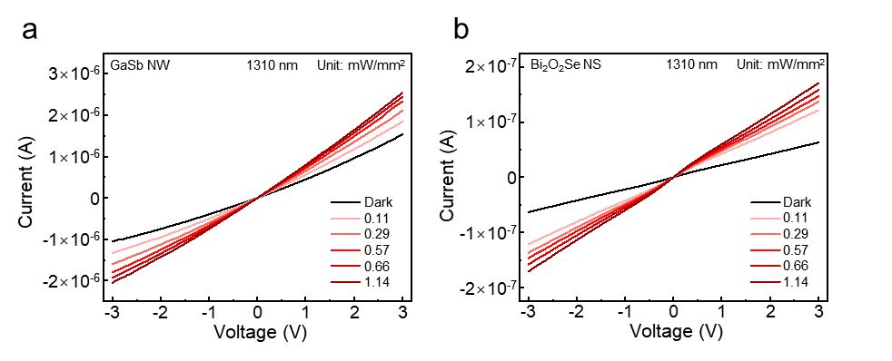
Fig. S1 I-V characteristics of the as-fabricated GaSb NW (a) and Bi₂O₂Se NS (b) photodetectors under the illumination of 1310 nm laser with various light intensities

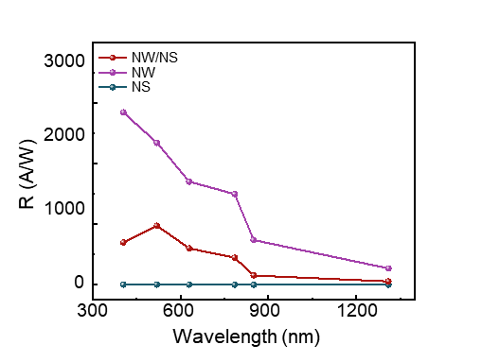
Fig. S2 Responsivity of the NW, NS and NW/NS mixed-dimensional heterojunction photodetector under the different wavelengths with -3 V bias
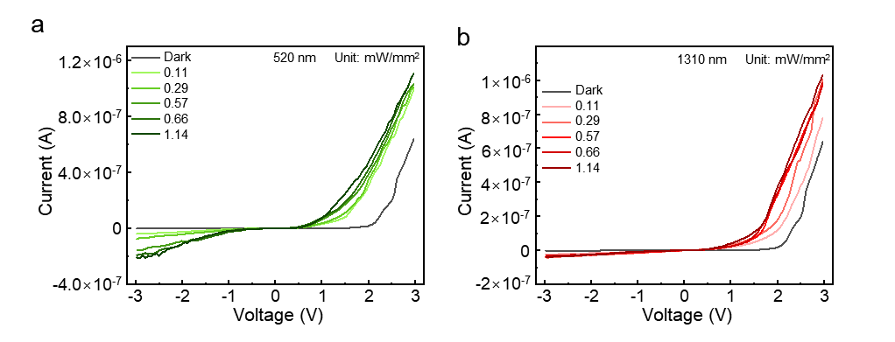
Fig. S3 Photodetection behavior of NW/NS mixed-dimensional heterojunction photodetector. a I-V characteristics of the NW/NS mixed-dimensional heterojunction photodetector under the illumination of 520 nm laser with various light intensities. b I-V characteristics of the NW/NS mixed-dimensional heterojunction photodetector under the illumination of 1310 nm laser with various light intensities
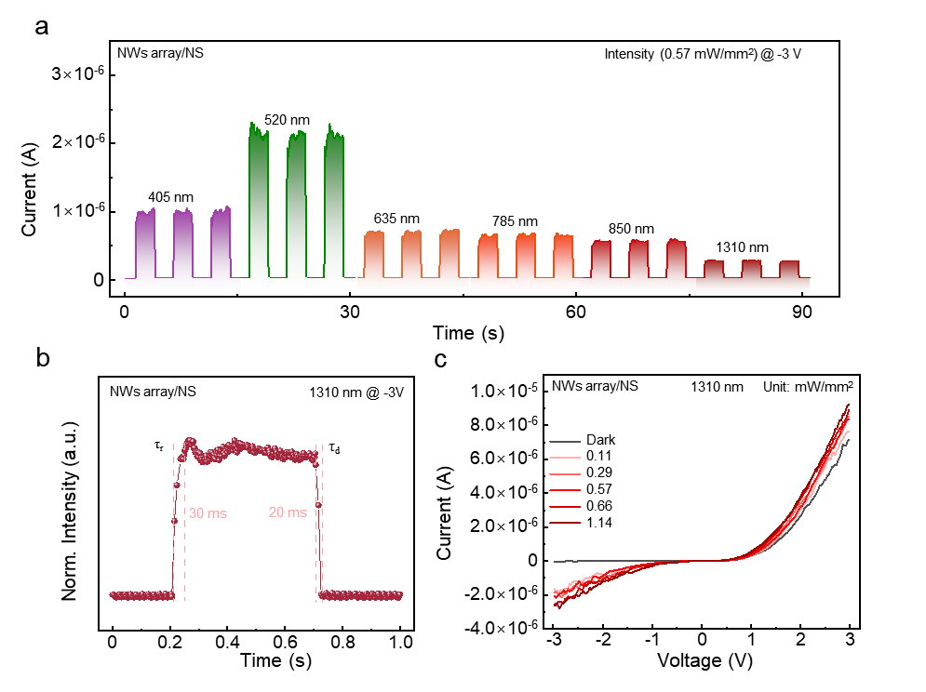
Fig. S4 Photodetection behaviors of the NWs array/NS mixed-dimensional heterojunction. a Broad spectrum photodetection performance of the NWs array/NS mixed-dimensional heterojunction photodetector under -3V bias. b Response time of the NWs array/NS mixed-dimensional heterojunction photodetector under -3V bias. c I-V characterization of the NWs array/NS mixed-dimensional heterojunction photodetector in dark and light conditions
Table S1 I_{dark} and response time comparison between this work and other photodetectors previously reported in the literatures
Marerials | Response time (ms) | I_{dark} (A) | References
GaSb | 11/16 | 4×10⁻⁷ | [49]
GaSb | 2/2 | 2×10⁻¹² | [13]
GsSb | 4.5/212 | 3.5×10⁻⁷ | [48]
Bi₂O₂Se | 39/63 | 1×10⁻⁴ | [51]
Bi₂O₂Se | 6/20 | 1×10⁻⁹ | [50]
Bi₂O₂Se | 117/58 | 1×10⁻¹⁰ | [52]
Bi₂O₂Se NW/MoSe₂ NS | 0.38/0.35 | 1×10⁻¹² | [53]
Te NW/CdS NS | 35/45 | 1×10⁻⁸ | [54]
Te NW/MoSe₂ NS | 100/100 | 4×10⁻¹² | [56]
Se NW/InSe NS | 30/37 | 3.8×10⁻¹⁴ | [55]
Notes. The references are in line with Figure 3g.

