Supporting Information for
Regulating the Coordination Environment of H₂O in Hydrogel Electrolyte for a High Environment-Adaptable and High-Stability Flexible Zn Devices
Jianghe Liu^{1,2}, Qianxi Dang², Jodie Yuwono³, Shilin Zhang³, Zhixin Tai^{1,}*, Zaiping Guo³, Yajie Liu^{1,}*
¹ Advanced Energy Storage Materials and Technology Research Center, Guangdong-Hong Kong Joint Laboratory for Carbon Neutrality, Jiangmen Laboratory of Carbon Science and Technology, Jiangmen, Guangdong 529199, P. R. China
² Shenzhen Key Laboratory of Advanced Materials, School of Materials Science and Engineering, Harbin Institute of Technology, Shenzhen, Guangdong 518055, P. R. China
³ School of Chemical Engineering, Faculty of Sciences, Engineering and Technology, University of Adelaide, Adelaide, SA, 5005 Australia.
*Corresponding authors. E-mail: liuyajie@hkustgz-jcl.ac.cn (Yajie Liu); taizhixin@hkustgz-jcl.ac.cn (Zhixin Tai)
Supplementary Figures and Tables
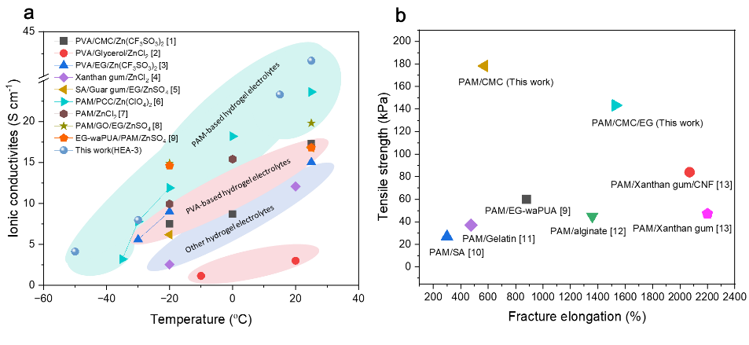
Fig. S1 a Wide-temperature ionic conductivities of various reported Zn-ion hydrogel electrolytes [S1-S9], b Mechanical properties of PAM-based hydrogel [S9-S13]
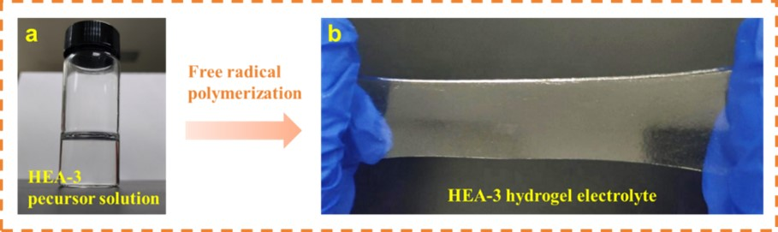
Fig. S2 Optical photograph of (a) HEA-3 pecursor solution; (b) HEA-3 hydrogel electrolyte membrane
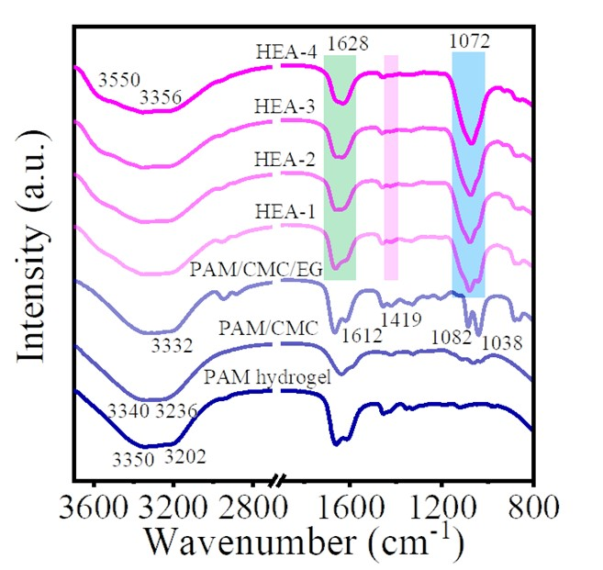
Fig. S3 FTIR spectrum of the PAM, PAM/CMC, PAM/CMC/EG, and high environmentally adaptable hydrogel electrolytes (HEA-1, HEA-2, HEA-3, HEA-4)
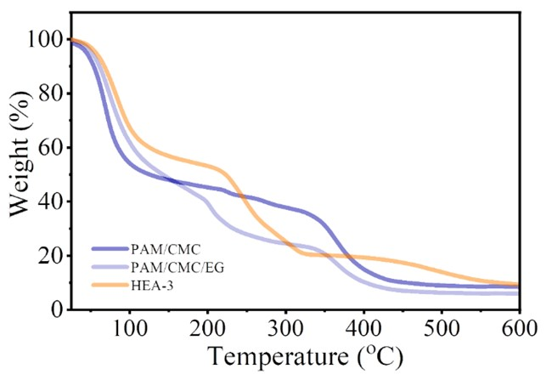
Fig. S4 TGA curves of PAM/CMC, PAM/CMC/EG, and HEA-3 at a test range form 25 to 600 ºC
For the HEA-3 gel electrolyte, the weight loss in the temperature range of 100-220 ^{ο}C can be attributed to the volatilization of ethylene glycol. The mass loss in the range 220-330 ^{ο}C results from the decomposition of Zn(ClO₄)₂ salt and the carbonization of CMC, while the mass loss in the temperature range 400-570 ^{ο}C is associated with the decomposition of the PAM.

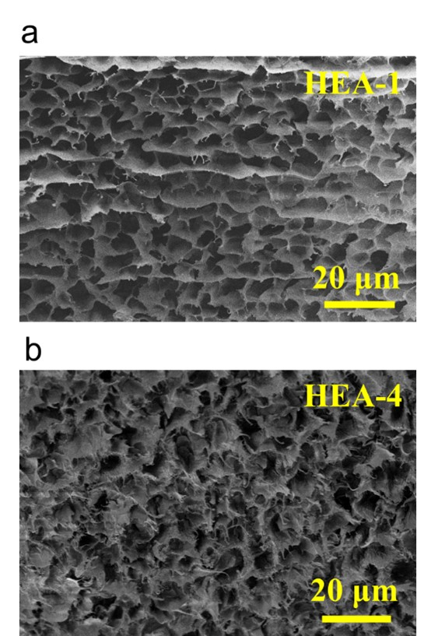

Fig. S5 SEM images of a HEA-1 and b HEA-4 hydrogel electrolytes
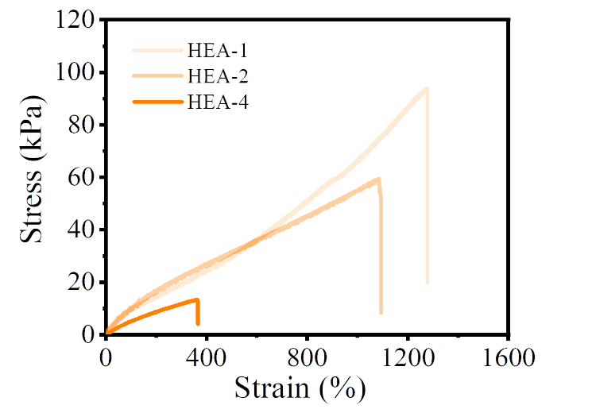
Fig. S6 Strain-stress curves of the HEA-1, HEA-2 and HEA-4 hydrogel electrolytes
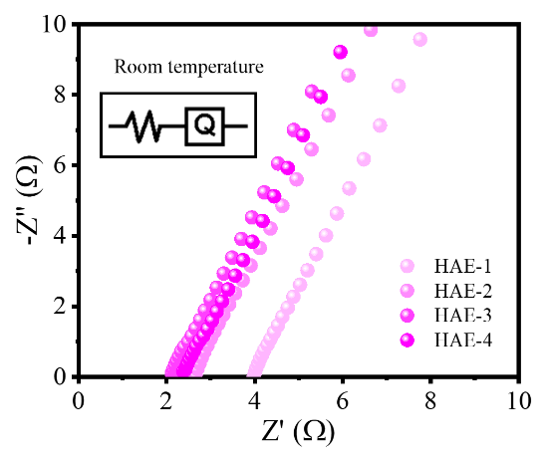
Fig. S7 EIS plots of HEA hydrogel electrolytes measured at room temperature, with the corresponding equivalent circuit shown in the inset
The EIS plots of hydrogel electrolytes consistently feature a high-frequency real-axis intercept corresponding to bulk ionic resistance (R_{b}), followed by a linear low-frequency response reflecting distributed capacitive behavior at electrode-electrolyte interfaces. The equivalent circuit (inset) incorporates R_{b} in series with a constant phase element (Q), which models non-ideal double-layer dynamics and interfacial heterogeneity [S14, S15].
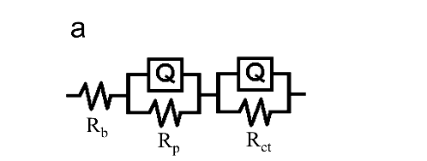
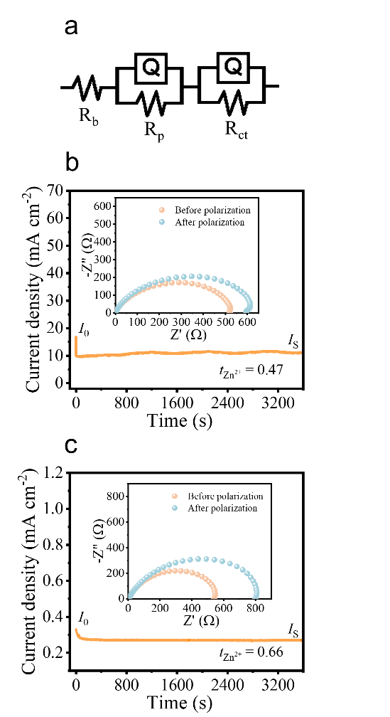
Fig. S8 a the equivalent circuit model of Zn||Zn symmetric cell, and DC polarization curve of the cells with b Zn(ClO₄)₂ (aq) and c Zn(ClO₄)₂+EG electrolyte at room temperature (the inset shows the EIS plots of the corresponding Zn||Zn symmetric cell before and after polarization).
In the equivalent circuit, in the high-frequency region, the value of the first intersection between the impedance spectrum and the Z-axis represents the bulk resistance (R_{b}) of the electrolyte. The first semicircle can be expressed by a parallel combination of the charge transfer resistor (R_{ct}) and a constant phase element (Q). The second semicircle can be represented by a parallel combination of the passivating layer resistor (R_{p}) and another constant phase element (Q) [S16]. 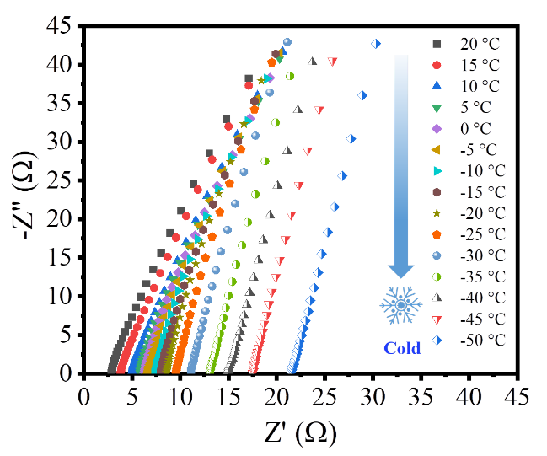
Fig. S9 EIS plots of the HEA-3 hydrogel electrolyte at different temperatures
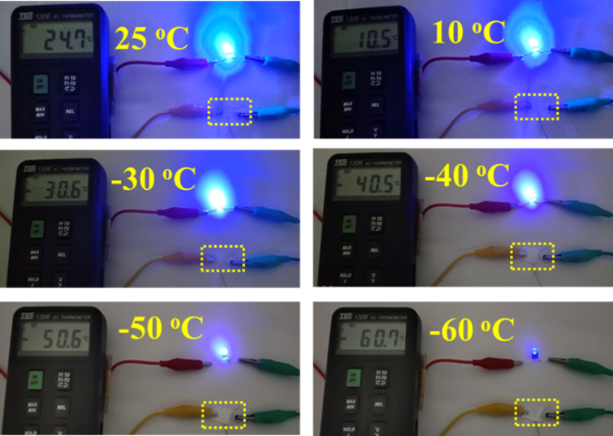

Fig. S10 Low-temperature ionic conduction ability of the HEA-3 hydrogel electrolyte

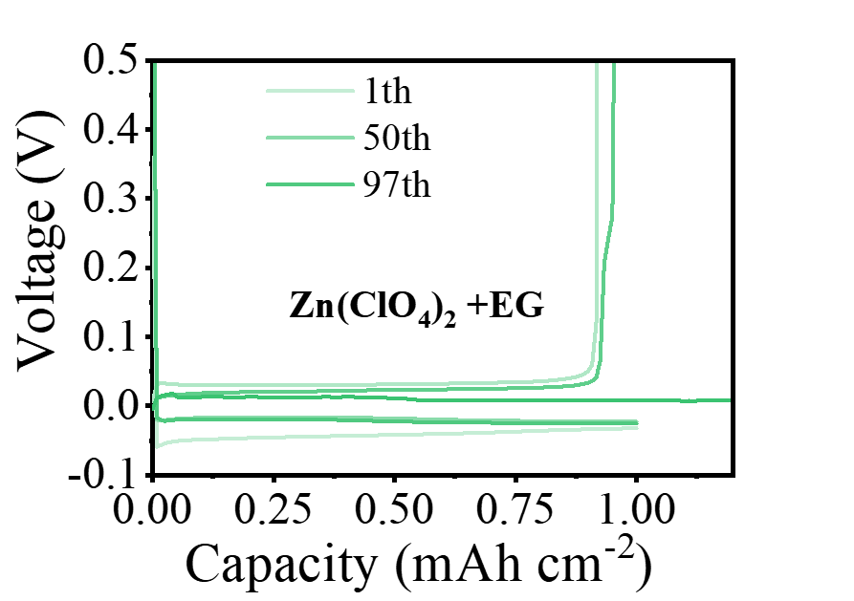
Fig. S11 Capacity-voltage curves in the Zn(ClO₄)₂+EG electrolyte at different cycles at a current density of 1 mA cm⁻² with a fixed capacity of 1 mAh cm⁻²
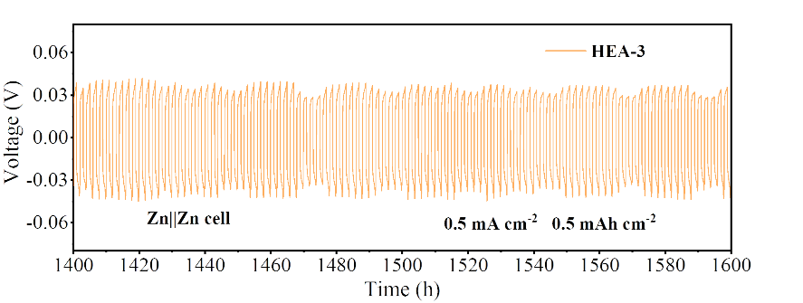
Fig. S12 Magnification of the GCD curve of Zn||Zn cell with HEA-3 electrolytes at a current density of 0.5 mA cm⁻² with a fixed plating capacity of 0.5 mAh cm⁻²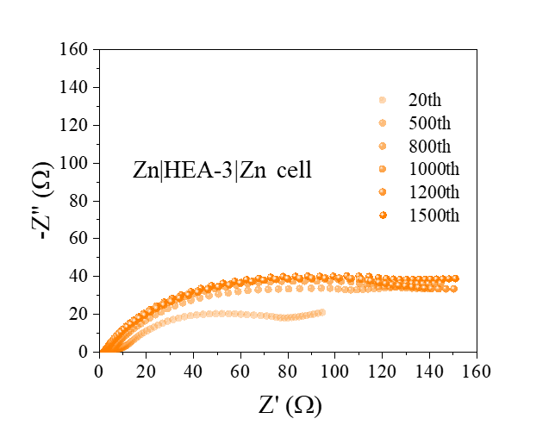
Fig. S13 EIS plots of Zn|HEA-3|Zn symmetric cell after different cycles under GCD cycling (a current density of 1 mA cm⁻² with a fixed capacity of 1 mAh cm⁻²) .
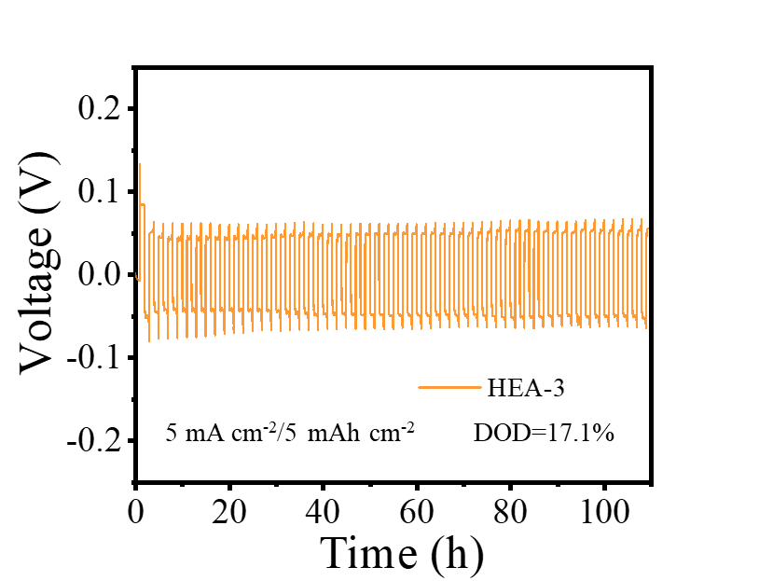

Fig. S14 Room temperature cycling performance of Zn|HEA-3|Zn cell w at a current density of 5 mA cm⁻² with a fixed plating capacity of 5 mAh cm⁻²
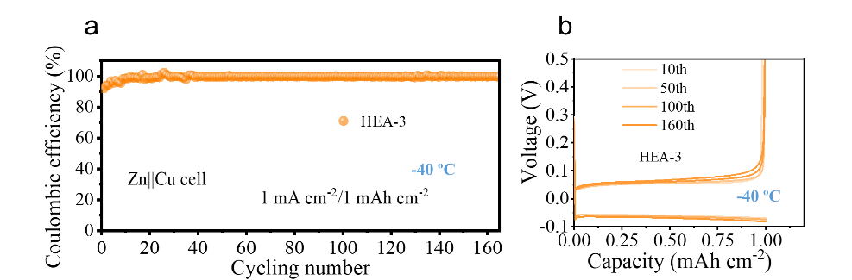
Fig. S15 a Cycling performance of Zn|HEA-3|Cu cell at -40 ºC, and b corresponding capacity-voltage curves at different cycles at a current density of 1 mA cm⁻² with a fixed capacity of 1 mAh cm⁻²
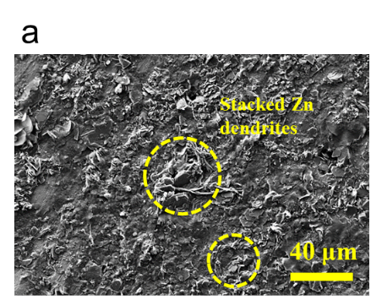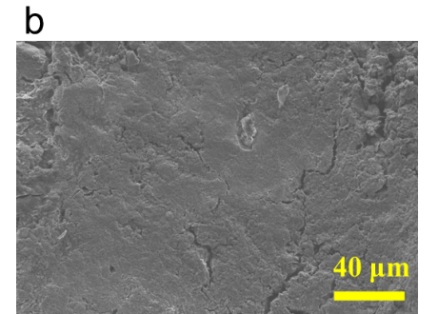
Fig. S16 SEM images of cycled Zn anode of Zn||Cu cell in a aqueous electrolyte and b HEA-3 hydrogel electrolyte, under a current density of 1 mA cm⁻² at room temperature

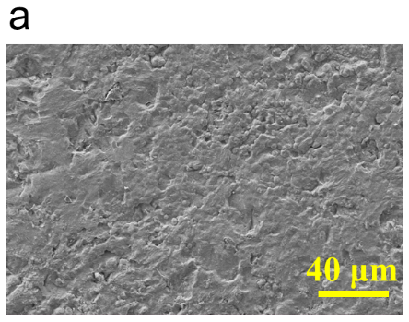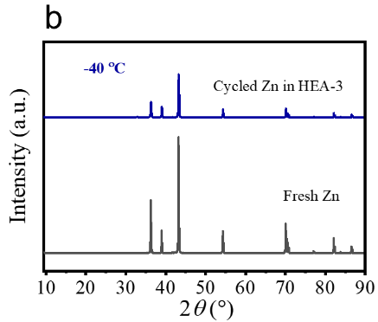
Fig. S17 a SEM images and b XRD pattern of cycled Zn anode surface in HEA-3 electrolyte at -40 ºC

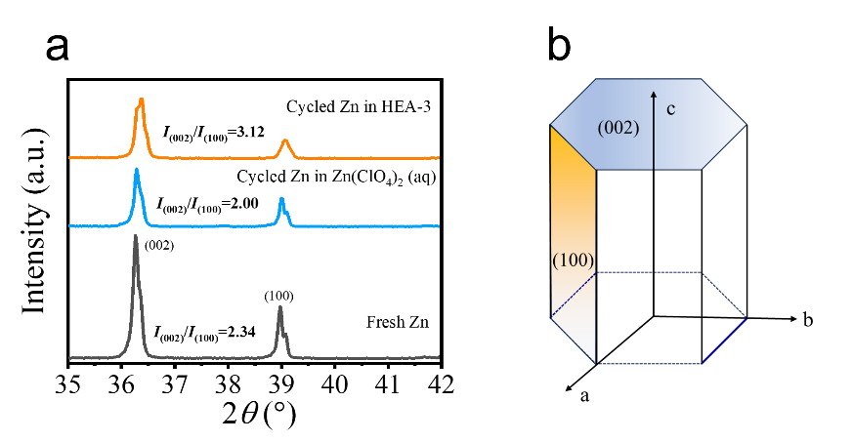
Fig. S18 a XRD pattern of cycled Zn anodes in different electrolytes at room temperature. b Illustration of hexagonal structure of Zn
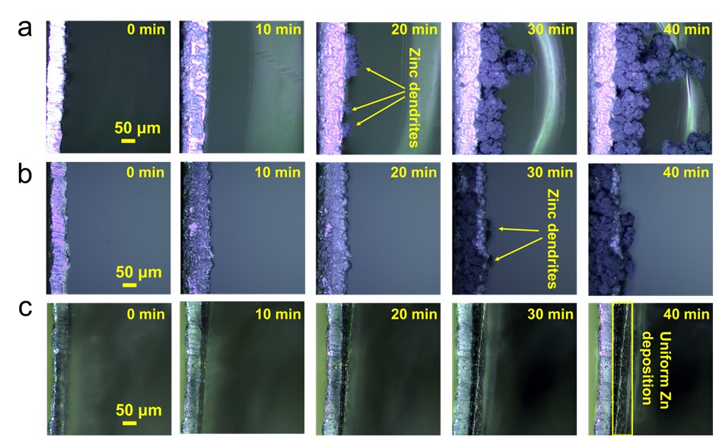

Fig. S19 In-situ observation of Zn plating in Zn||Zn symmetric cell with a Zn(ClO₄)₂ (aq) electrolyte, b Zn(ClO₄)₂+EG electrolytes, c HEA-3 electrolyte (current density: 5 mA cm⁻²; scale bars: 50 µm)

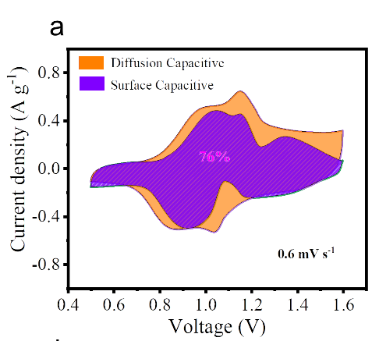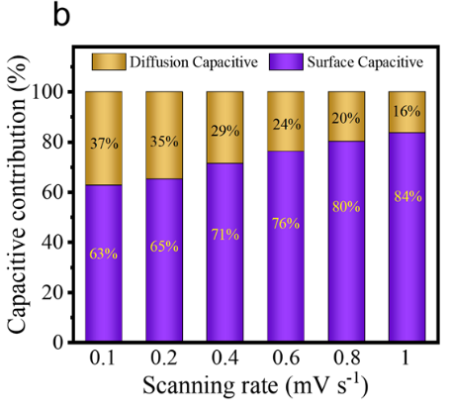
Fig. S20 a Diffusion contribution and capacitive contribution at 0.6 mV s⁻¹. b Normalized capacity contribution at different scan rates
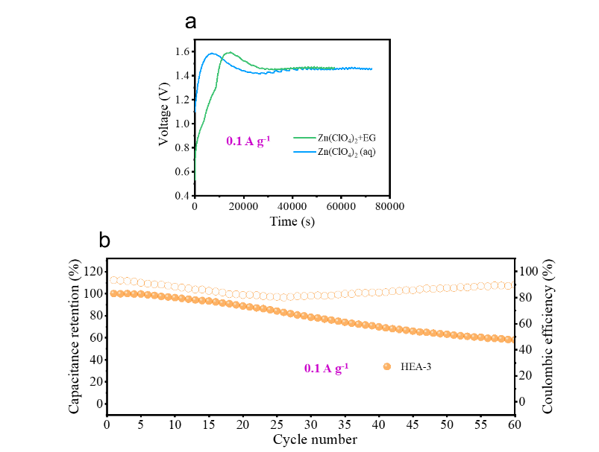
Fig. S21 a GCD curves of Zn||PANI device with the Zn(ClO₄)₂ (aq) electrolyte and Zn(ClO₄)₂ (aq)+EG electrolyte at 0.1 A g⁻¹ at room temperature. b Cycling performance of Zn||PANI device with HEA-3 electrolyte at 0.1 A g⁻¹ at room temperature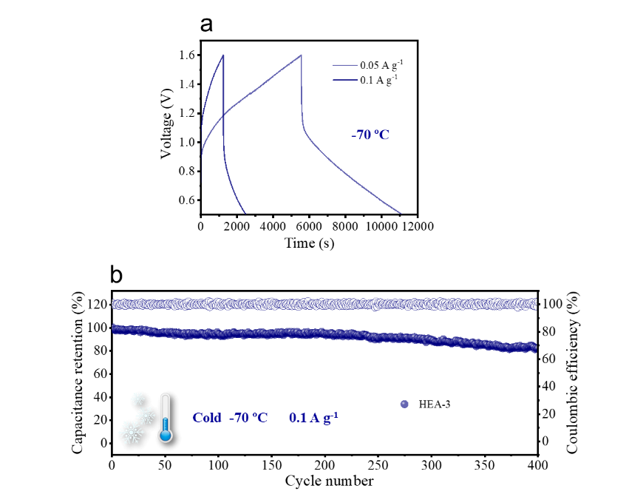
Fig. S22 a GCD curves of Zn||PANI devices with different current densities at -70 ºC. b Cycling performance of Zn||PANI devices with a current density of 0.1 A g⁻¹ at -70 ºC

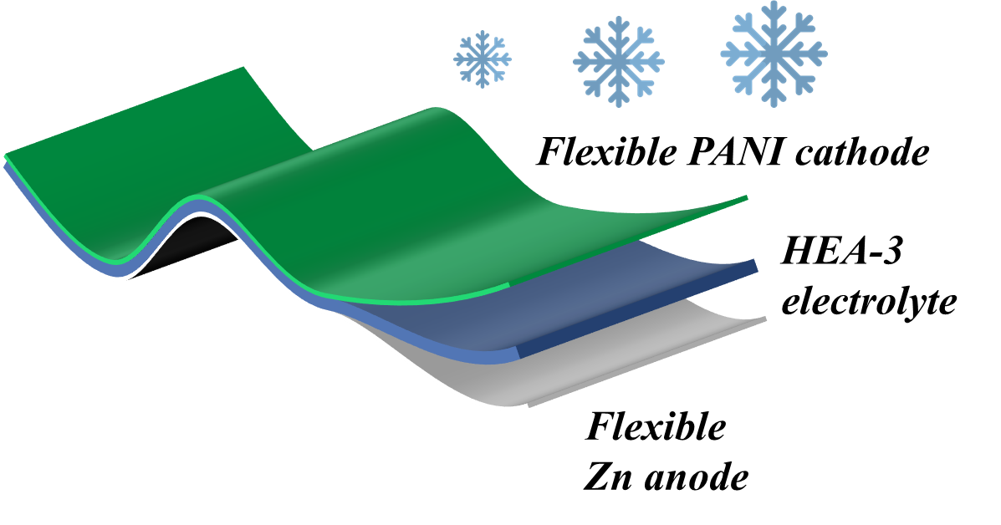
Fig. S23 Schematic diagram of flexible Zn||PANI device

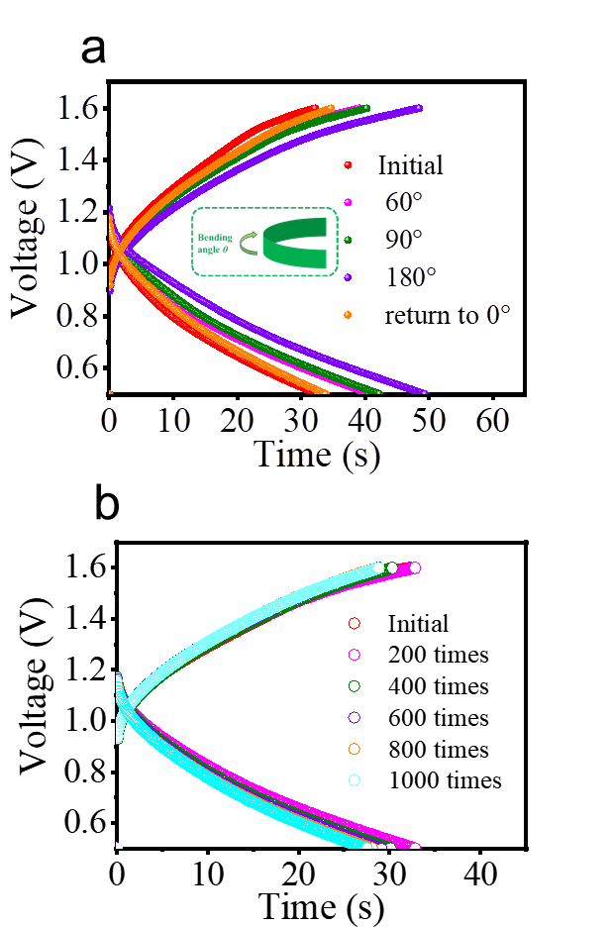
Fig. S24 a GCD curves of flexible device under different bending conditions; b GCD curves of flexible device for various bending times at a bending angle of 180º

Table S1 Comparison of low temperature performance of anti-freezing gel electrolyte and Zn-based devices
System | electrolyte | Ionic conductivity /mS cm⁻¹ | Low temperature performance |  |  | Refs
System | electrolyte | Ionic conductivity /mS cm⁻¹ | capacity | Cyclig number | Working temperature (ºC) | Refs
Zn||AC | PVA/MMT/  Zn(ClO₄)₂ | —— | 110 F g⁻¹ | 10000 | -20 | [S17]
Zn||AC | PAMPS/PAAm/EG/ZnCl₂/NH₄Cl | 1  (-30 ) | 48 F g⁻¹ | 5500 | -30 | [S18]
AC||δ-MnO₂ | PVA/glycerol/  Zn(Cl)₂ | 0.21  (-50 °C) | 8 mAh g⁻¹ | 100 | -30 | [S2]
Zn||δ-MnO₂ | PAM/EG/ GO/ZnSO₄/  MnSO₄ | 14.9  (-20 °C ) | 183.2 mAh g⁻¹ | 1000 | -20 | [S8]
Zn||PANI | PAM/ZnCl₂ | 9.93  (-20 °C) | 0.616 mAh cm⁻² | 100 | -20 | [S7]
Zn||PANI | PAMPS/PAM/EG/ZnCl₂/NH₄Cl | 1.62  (-30 ºC) | 59.7 mAh g⁻¹ | 1500 | -30 | [S19]
Zn||PANI | PVA/EG/ZnCl₂/  NH₄Cl | 2.89  (-30 ºC) | 58.8 mAh g⁻¹ | 150 | -20 | [S20]
Zn||PANI | PAM/CMCS/  Zn(ClO₄)_{2/} | 7.8  (-30 °C) | 123 mAh g⁻¹ | 2500 | -30 | [S21]
Zn||Au-CNT-PANI | PAM/EG  Zn(OTf)₂ | —— | 160.3 mAh g⁻¹ | 600 | -20 | [S22]
Zn@CC||GNP | PVA/EG/Zn(CF₃SO₃)₂ | 5.6  (-30 °C) | 202.8 F g⁻¹  (133.5 mAh g⁻¹) | 30000 | -20 | [S3]
Zn@CC||PANI | HEA-3 | 7.97  (-30 °C)  4.12  (-50 °C) | 244.8 F g⁻¹/  (109.2 mAh g⁻¹)  96.9 F g⁻¹ | 30000  400 | -40  -70 | This work
Table S2 Comparison of the room temperature cycling stability of the reported Zn(ClO₄)₂-based electrolyte system
Electrolyte system | Zn||Zn cell  (current density/plating density) | Zn||Zn cell Cycling life | DOD | Coulombic efficiency of half-cell | Refs
Sulfolane/  Zn(ClO₄)₂·6H₂O | 0.2 mA cm⁻²/0.1 mAh cm⁻²  0.5 mA cm⁻²/0.5 mAh cm⁻² | 1000 h  800 h | —— | 98% | [S23]
Succinonitrile/  Zn(ClO₄)₂·6H₂O | 0.05 mA cm⁻²/0.5 mAh cm⁻² | 800 h | —— | 98.4% | [S24]
NaClO₄/H₂O/  Zn(ClO₄)₂ | 0.2 mA cm⁻²/0.2 mAh cm⁻² | 1000 h | —— | 98.2% | [S25]
Adiponitrile/H₂O/Zn(ClO₄)₂ | 0.5 mA cm⁻²/0.5 mAh cm⁻²  1 mA cm⁻²/1 mAh cm⁻² | 265 h  155 h | 0.85%  1.71% | 62.92% | [S26]
β-cyclodextrin/H₂O/Zn(ClO₄)₂ | 1 mA cm⁻²/1 mAh cm⁻²  5 mA cm⁻²/5 mAh cm⁻² | 1000 h  140h | 1.71%  30% | 97.6% | [S27]
NaClO₄·H₂O/H₂O/Zn(ClO₄)₂·6H₂O | 0.5 mA cm⁻²/0.25 mAh cm⁻² | 3500 h | 0.43% | 98.3% | [S28]
HEA-3 | 1 mA cm⁻²/1 mAh cm⁻²  5 mA cm⁻²/5 mAh cm⁻² | 1700 h  >110 h | 3.42%  17.1% | 99.4% | This work
Table S3 Comparison of low temperature performance of Zn||Zn cells with different electrolytes
Electrolyte system | Current density  (mA cm⁻²) | Cumulative capacity  (mAh cm⁻²) | Temperature (ºC) | Refs
2 M ZnSO₄ (40 vol%EG+60vol% H₂O) | 2 | 160 | -20 | [S29]
4 M Zn(BF₄)₂ (aq) | 0.5 | 750 | -30 | [S30]
GG/SA/EG | 0.2 | 40 | -20 | [S17]
3M Zn(ClO₄)₂ (aq) | 0.5 | 200 | -30 | [S31]
CSAM-C | 1 | 1000 | -30 | [S5]
ZL-PAAm | 1 | 100 | -20 | [S32]
2 M Zn(CF₃SO₃)₂ (aq) | 0.2 | 80 | -30 | [S33]
Zn(CF₃SO₃)₂/methanol (Me56) | 1 | 200 | -20 | [S34]
ZS/GL/AN | 0.2 | 100 | -20 | [S35]
HEA-3 | 1 | 1400 | -40 | This work
Supplementary References
- X. Zhu, C. Ji, Q. Meng, H. Mi, Q. Yang et al., Freeze-Tolerant Hydrogel Electrolyte with High Strength for Stable Operation of Flexible Zinc-Ion Hybrid Supercapacitors. Small 18, (2022) 2200055. https://doi.org/10.1002/smll.202200055
- Y. Jiang, K. Ma, M. Sun, Y. Li, J. Liu, All-Climate Stretchable Dendrite-Free Zn-Ion Hybrid Supercapacitors Enabled by Hydrogel Electrolyte Engineering. Energy & Environmental Materials 6, (2023) e12357. https://doi.org/10.1002/eem2.12357
- J. Liu, Z. Khanam, S. Ahmed, T. Wang, H. Wang, S. Song, Flexible Antifreeze Zn-Ion Hybrid Supercapacitor Based on Gel Electrolyte with Graphene Electrodes. ACS Appl. Mater. Interfaces 13, 16454–16468 (2021). https://doi.org/10.1021/acsami.1c02242
- Y. Wang, Y. Chen, A flexible zinc-ion battery based on the optimized concentrated hydrogel electrolyte for enhanced performance at subzero temperature. Electrochim. Acta 395, 139178 (2021). https://doi.org/10.1016/j.electacta.2021.139178
- J. Wang, Y. Huang, B. Liu, Z. Li, J. Zhang et al., Flexible and anti-freezing zinc-ion batteries using a guar-gum/sodium-alginate/ethylene-glycol hydrogel electrolyte, Energy Storage Materials 41, 599-605 (2021). https://doi.org/10.1016/j.ensm.2021.06.034
- S. Huang, L. Hou, T. Li, Y. Jiao, P. Wu, Antifreezing Hydrogel Electrolyte with Ternary Hydrogen Bonding for High-Performance Zinc-Ion Batteries, Adv. Mater. 34, e2110140 (2022). https://doi.org/10.1002/adma.202110140
- Y. Liu, X. Zhou, Y. Bai, R. Liu, X. Li et al., Engineering integrated structure for high-performance flexible zinc-ion batteries, Chemical Engineering Journal 417, 127955 (2021). https://doi.org/10.1016/j.cej.2020.127955
- Y. Quan, M. Chen, W. Zhou, Q. Tian, J. Chen, High-Performance Anti-freezing Flexible Zn-MnO₂ Battery Based on Polyacrylamide/Graphene Oxide/Ethylene Glycol Gel Electrolyte, Frontiers in Chemistry 8, 603 (2020). https://doi.org/10.3389/fchem.2020.00603
- F. Mo, G. Liang, Q. Meng, Z. Liu, H. Li et al., A flexible rechargeable aqueous zinc manganese-dioxide battery working at −20 °C. Energ. Environ. Sci. 12, 706-715 (2019). https://doi.org/10.1039/C8EE02892C
- H. Wang, J. Liu, S. Ahmed, T. Wang, S. Song, Freeze-tolerant gel electrolyte membrane for flexible Zn-ion hybrid supercapacitor. Journal of Energy Storage 56, 105923 (2022). https://doi.org/10.1016/j.est.2022.105923
- M. Qiu, H. Liu, B. Tawiah, H. Jia, S. Fu, Zwitterionic triple-network hydrogel electrolyte for advanced flexible zinc ion batteries. Composites Communications 28, 100942 (2021). https://doi.org/10.1016/j.coco.2021.100942
- Z. Liu, D. Wang, Z. Tang, G. Liang, Q. Yang et al., A mechanically durable and device-level tough Zn-MnO₂ battery with high flexibility, Energy Storage Materials 23, 636-645 (2019),.
- B. Wang, J. Li, C. Hou, Q. Zhang, Y. Li, H. Wang, Stable Hydrogel Electrolytes for Flexible and Submarine-Use Zn-Ion Batteries, ACS Appl. Mater. Inter. 12, 46005-46014 (2020). https://doi.org/10.1021/acsami.0c12313
- C. Nusrath Unnisa, S. Chitra, S. Selvasekarapandian, S. Monisha, G. Nirmala Devi, V. Moniha et al., Development of poly(glycerol suberate) polyester (PGS)–PVA blend polymer electrolytes with NH4SCN and its application Ionics 24, 1979-1993 (2018). https://doi.org/10.1007/s11581-018-2466-x
- A.S. Samsudin, M.A. Saadiah, Ionic conduction study of enhanced amorphous solid bio-polymer electrolytes based carboxymethyl cellulose doped NH₄Br, Journal of Non-Crystalline Solids 497, 19-29 (2018). https://doi.org/10.1016/j.jnoncrysol.2018.05.027
- L. Li, J. Wang, P. Yang, S. Guo, H. Wang et al., Preparation and characterization of gel polymer electrolytes containing N-butyl-N-methylpyrrolidinium bis(trifluoromethanesulfonyl) imide ionic liquid for lithium ion batteries, Electrochim. Acta 88, 147-156 (2013). https://doi.org/10.1016/j.electacta.2012.10.018
- G. Yang, J. Huang, X. Wan, Y. Zhu, B. Liu et al., A low cost, wide temperature range, and high energy density flexible quasi-solid-state zinc-ion hybrid supercapacitors enabled by sustainable cathode and electrolyte design Nano Energy 90, 106500 (2021). https://doi.org/10.1016/j.nanoen.2021.106500
- H. Wang, X. Li, D. Jiang, S. Wu, W. Yi, et al., Organohydrogel electrolyte-based flexible zinc-ion hybrid supercapacitors with dendrite-free anode, broad temperature adaptability and ultralong cycling life. J. Power Sources 528, 231210 (2022). https://doi.org/10.1016/j.jpowsour.2022.231210
- X. Li, H. Wang, X. Sun, J. Li, Y.-N. Liu, Flexible Wide-Temperature Zinc-Ion Battery Enabled by an Ethylene Glycol-Based Organohydrogel Electrolyte. ACS Applied Energy Materials 4, 12718-12727 (2021). https://doi.org/10.1021/acsaem.1c02433
- Z. Cong, W. Guo, P. Zhang, W. Sha, Z. Guo, et al., Wearable Antifreezing Fiber-Shaped Zn/PANI Batteries with Suppressed Zn Dendrites and Operation in Sweat Electrolytes, Acs Appl. Mater. Inter. 13, 17608-17617 (2021). https://doi.org/10.1021/acsami.1c02065
- S. Huang, L. Hou, T. Li, Y. Jiao, P. Wu, Antifreezing Hydrogel Electrolyte with Ternary Hydrogen Bonding for High-Performance Zinc-Ion Batteries. Adv. Mater. 34, 2110140 (2022). https://doi.org/10.1002/adma.202110140
- X. Jin, L. Song, C. Dai, H. Ma, Y. Xiao et al., A self-healing zinc ion battery under -20 °C. Energy Storage Materials 44, 517-526 (2022). https://doi.org/10.1016/j.ensm.2021.11.004
- X. Lin, G. Zhou, M.J. Robson, J. Yu, S.C.T. Kwok et al., Hydrated Deep Eutectic Electrolytes for High-Performance Zn-Ion Batteries Capable of Low-Temperature Operation. Adv Funct Mater 32, 2109322 (2022). https://doi.org/10.1002/adfm.202109322
- W. Yang, X. Du, J. Zhao, Z. Chen, J. Li et al., Hydrated Eutectic Electrolytes with Ligand-Oriented Solvation Shells for Long-Cycling Zinc-Organic Batteries. Joule 4, 1557-1574 (2020). https://doi.org/10.1016/j.joule.2020.05.018
- Y. Zhu, J. Yin, X. Zheng, A.-H. Emwas, Y. Lei et al., Concentrated dual-cation electrolyte strategy for aqueous zinc-ion batteries. Energ Environ Sci 14, 4463-4473 (2021). https://doi.org/10.1039/D1EE01472B
- G. Liu, Y. Tang, Y. Wei, H. Li, J. Yan et al., Hydrophobic Ion Barrier-Enabled Ultradurable Zn (002) Plane Orientation towards Long-Life Anode-Less Zn Batteries. Angewandte Chemie International Edition 63, e202407639 (2024). https://doi.org/10.1002/anie.202407639
- M. Qiu, P. Sun, Y. Wang, L. Ma, C. Zhi et al., Anion-Trap Engineering toward Remarkable Crystallographic Reorientation and Efficient Cation Migration of Zn Ion Batteries. Angewandte Chemie International Edition 61, e202210979 (2022). https://doi.org/10.1002/anie.202210979
- Y.-S. Li, L.-S. Geng, B.-M. Zhang, Z.-H. Wei, H. Fan et al., Concentrated perchlorate-based electrolyte facilitates Zn anode-compatible in situ solid electrolyte interphase. Rare Metals 44, 950-960 (2025). https://doi.org/10.1007/s12598-024-02972-7
- N. Chang, T. Li, R. Li, S. Wang, Y. Yin, et al. An aqueous hybrid electrolyte for low-temperature zinc-based energy storage devices. Energ Environ Sci 13, 3527-3535 (2020). https://doi.org/10.1039/d0ee01538e
- T. Sun, X. Yuan, K. Wang, S. Zheng, J. Shi et al., An ultralow-temperature aqueous zinc-ion battery. J. Mater. Chem. A 9, 7042-7047 (2021). https://doi.org/10.1039/d0ta12409e
- S. Gao, B. Li, H. Tan, F. Xia, O. Dahunsi et al., High-Energy and Stable Subfreezing Aqueous Zn–MnO2 Batteries with Selective and Pseudocapacitive Zn-Ion Insertion in MnO₂. Adv. Mater. 34, 2201510 (2022). https://doi.org/10.1002/adma.202201510
- M. Zhu, X. Wang, H. Tang, J. Wang, Q. Hao et al., Antifreezing Hydrogel with High Zinc Reversibility for Flexible and Durable Aqueous Batteries by Cooperative Hydrated Cations. Adv. Funct. Mater. 30, 1907218 (2020). https://doi.org/10.1002/adfm.201907218
- Q. Zhang, K. Xia, Y. Ma, Y. Lu, L. Li et al., Chaotropic Anion and Fast-Kinetics Cathode Enabling Low-Temperature Aqueous Zn Batteries, ACS Energy Lett. 6, 2704-2712 (2021). https://doi.org/10.1021/acsenergylett.1c01054
- W. Xu, C. Liu, S. Ren, D. Lee, J. Gwon, et al., A cellulose nanofiber–polyacrylamide hydrogel based on a co-electrolyte system for solid-state zinc ion batteries to operate at extremely cold temperatures. J. Mater. Chem. A 9, 25651-25662 (2021). https://doi.org/10.1039/D1TA08023G
- T.T. Wei, Y.K. Ren, Z.Q. Li, X.X. Zhang, D.H. Ji et al., Bonding interaction regulation in hydrogel electrolyte enable dendrite-free aqueous zinc-ion batteries from -20 to 60 ºC. Chemical Engineering Journal 434, 134646 (2022). https://doi.org/10.1016/j.cej.2022.134646

