Supporting Information for
Binder-Free Immobilization of Photocatalyst on Membrane Surface for Efficient Photocatalytic H₂O₂ Production and Water Decontamination
Zhen-Yu Hu ^{1,2,4}, Tian Liu ^{1,2,3}*,Yu-Ru Yang^{1,2}, Alicia Kyoungjin An^{4,5,}*, Kim Meow LIEW ^{2,5}, Wen-Wei Li ^{1,2,}*
¹ State Key Laboratory of Advanced Environmental Technology, Department of Environmental Science and Engineering, University of Science and Technology of China, Hefei 230026, P. R. China
² SEEM Innovation Center, Suzhou Institute for Advanced Research, University of Science & Technology of China, Suzhou 215123, P. R. China
³ School of Resources and Environmental Engineering, Hefei University of Technology, Hefei 230009, P. R. China
⁴ School of Energy and Environmental, City University of Hong Kong, Hong Kong SAR 999077, P. R. China
⁵ Department of Chemical and Biological Engineering, Hong Kong University of Science and Technology, Hong Kong SAR, P. R. China
⁶ Department of Architecture and Civil Engineering, City University of Hong Kong, Hong Kong SAR 999077, P. R. China
* Corresponding authors. E-mail: liutian123@ustc.edu.cn (Tian Liu); alicia.kjan@ust.hk (Alicia Kyoungjin An); wwli@ustc.edu.cn (Wen-Wei Li)
S1 Multi- Physics Simulation Method
The oxygen concentration distribution over the SSPM and MEPM were analyzed using COMSOL Multiphysics 6.2. The geometric model was constructed as a 100×100×100 um cubic domain, with the membrane represented as a porous medium. Catalyst particles were modeled as octahedral structures (1-2 um in diameter), randomly deposited on the membrane outer surface for SSPM or uniformly dispersed within the membrane matrix for MEPM. A physics-controlled mesh with boundary layer refinement was applied near catalysts and interfaces to resolve steep concentration gradients. The oxygen distribution in a solution was simulated using the Dilute Species Transport module in COMSOL. The governing equation for dilute species transport is:
∇·J_{i} + u·∇c_{i} = R_{i}, where J_{i} = -D_{i}∇c_{i}
were J_{i} refers to species flux, u is fluid velocity field, c_{i} is the concentration of the species, R_{i} is Reaction term; D_{i} is the Diffusion coefficient. The diffusion term is calculated using Fick’s first law, where the flux (J_{i}) divided by the concentration gradient (∇c_{i}) equals the diffusion coefficient (D_{i}).

Table S1 BET surface areas of the pristine PVDF, SSPM and SUPM
 | Pristine PVDF | SSPM | SUPM
Surface area (m²/g) | 18.1 | 6.47 | 17.9
Table S2 Summary of recently reported materials for H₂O₂ photosynthesis
Photocatalyst | Reaction solution | Light source | H₂O₂ yield  (μmol g⁻¹ h⁻¹) | Refs.
DE7-M | Pure water | λ ≥ 420 nm | 221.6 | [S1]
NiSAPs-PuCN | Pure water | λ ≥ 420 nm | 342.2 | [S2]
CoOx-NvCN | Pure water | AM 1.5G | 367.8 | [S3]
CNW03 | Pure water | λ ≥ 420 nm | 556 | [S4]
MIL-125-R7 | Benzyl alcohol solution | λ ≥ 420 nm | 1000 | [S5]
SA-TCPP | Pure water | λ ≥ 420 nm | 1150 | [S6]
PM-carbon dots-3 | Pure water | λ ≥ 420 nm | 1340 | [S7]
TPB-DMTP-COF | Pure water with tris-phase reactor | λ ≥ 420 nm | 2882 | [S8]
Hz-TP-BT-COF | Pure water | λ ≥ 420 nm | 6500 | [S9]
This work | Pure water | AM 1.5G | 7700 | -
Table S3 The cost of raw materials for fabricating 1 g CoO_{x}/Mo:BiVO₄/Pd
Reagent | Dosage  (g or mL) | Unit price  (USD/g or USD/mL) | Total price  (USD)
K₂CO₃ | 0.349 | 0.009 | 0.003
V₂O₅ | 0.758 | 0.134 | 0.101
K₂MoO₄ | 0.001 | 0.825 | 0.001
Bi(NO₃)₃ | 1.617 | 0.005 | 0.001
Ethanol | 9.667 | 0.011 | 0.111
Co(NO₃)₂ | 0.003 | 0.042 | 0.000127
NaPdCl₄ | 0.004 | 54.319 | 0.217
NaIO₃ | 0.5 | 0.265 | 0.133
Total | - | - | 0.574

Table S4 The energy consumption for fabricating 1 g catalyst or 1 m² catalytic sheet
 | Program | Energy consumption (kW·h) | Energy price (USD/kW·h) | Cost of energy consumption (USD)
Preparing catalyst | Water bath | 5.95 | 0.085 | 0.506
Preparing catalyst | Muffle furnace | 6.933 | 0.085 | 0.589
Preparing catalyst | Xenon lamp | 0.7 | 0.085 | 0.06
Preparing catalyst | Total | 13.583 | 0.085 | 1.155
Preparing SSPM | Water bath | 3.15 | 0.085 | 0.268
Preparing SSPM | Membrane coating machine | 0.208 | 0.085 | 0.018
Preparing SSPM | Vacuum filtration | 0.09 | 0.085 | 0.008
 | Total | 3.448 |  | 0.294
Preparing MEPM | Water bath | 3.15 | 0.085 | 0.268
Preparing MEPM | Membrane coating machine | 0.208 | 0.085 | 0.018
Preparing MEPM | Total | 3.358 | 0.085 | 0.286
Table S5 The cost of material and energy consumption for preparing 1 m² photocatalytic membrane
Sheet type | Reagent |  | Dosage  (g, mL or kW·h) | Unit price  (USD/g, USD/mL or kW·h) | Total price  (USD)
SSPM | CoO_{x}/Mo:BiVO₄/Pd |  | 1.861 | 0.574 | 1.068
SSPM | PVDF |  | 30.707 | 0.154 | 4.729
SSPM | DMF |  | 193.552 | 0.008 | 1.593
SSPM | Ethanol |  | 10 | 0.011 | 0.115
SSPM | Energy consumption | for catalyst | 25.277 | 0.085 | 2.149
 | Energy consumption | for SSPM | 3.448 | 0.085 | 0.294
 | Total |  | - | - | 9.948
MEPM | CoO_{x}/Mo:BiVO₄/Pd |  | 5.864 | 0.574 | 3.365
MEPM | PVDF |  | 29.387 | 0.154 | 4.526
MEPM | DMF |  | 175.658 | 0.008 | 1.446
MEPM | Ethanol |  | 0 | 0.011 | 0
MEPM | Energy consumption | for catalyst | 79.65 | 0.085 | 6.77
MEPM | Energy consumption | for MEPM | 3.358 | 0.085 | 0.286
MEPM | Total |  | - | - | 16.392

Supplementary Figures
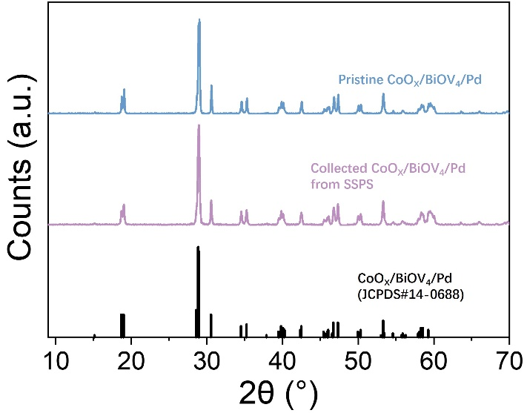
Fig. S1 XRD pattern of the pristine CoO_{x}/Mo:BiVO₄/Pd particles and those collected from SSPM. The XRD pattern is in good agreement with JCPDS standard card #14-0688, corresponding to monoclinic sheelite BiVO₄

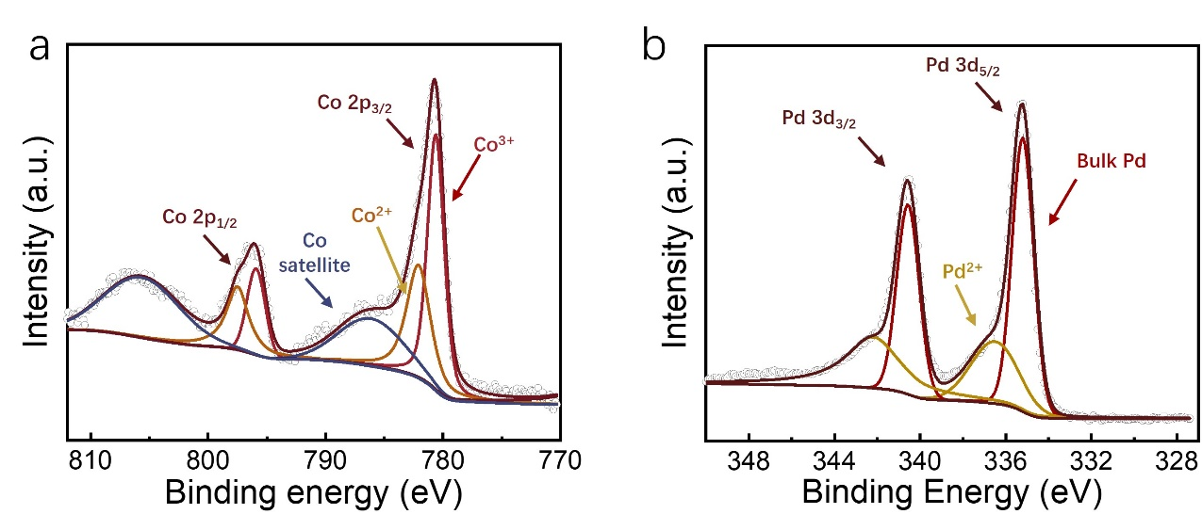

Fig. S2 (a) Co 2p XPS spectra of CoO_{x}/Mo:BiVO₄. (b) Pd 3d XPS spectra of Mo:BiVO₄/Pd. The area of Co 2p_{3/2} peak is twice that of Co 2p_{1/2} peak and the binding energies of Co³⁺ and Co²⁺ are 780.6 and 781.6 eV, respectively. The area of Pd 3p_{5/2} peak is 1.5 times that of Pd 2p_{3/2} peak and the binding energies of bulk Pd and Pd²⁺ are 335.1 and 337.0 eV, respectively

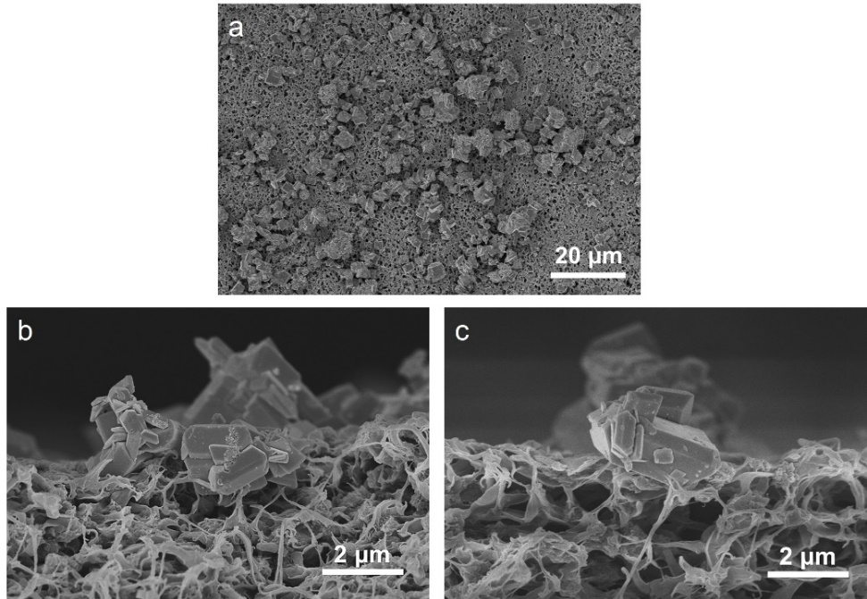
Fig. S3 (a) SEM images of the distribution state of particulate catalyst on the SSPM surface. (b) and (c) the high resolution of SEM images of particulate catalyst bounded by PVDF fibers
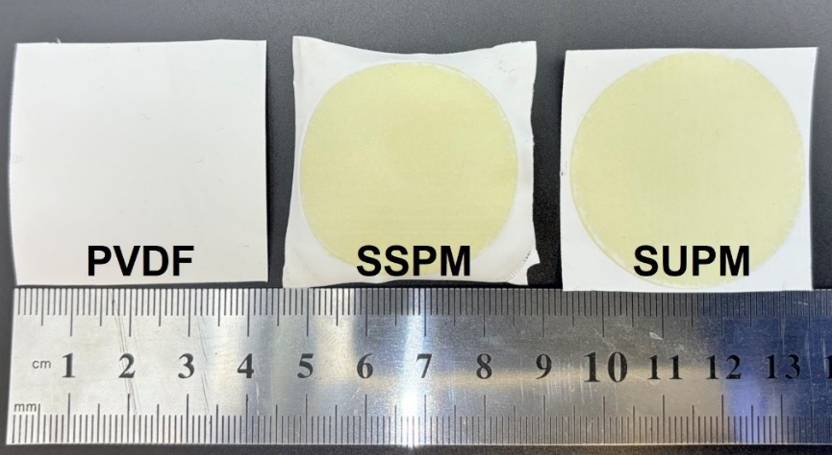
Fig. S4 The shape comparison of pristine PVDF (left), SSPM (middle) and SUPM (right)
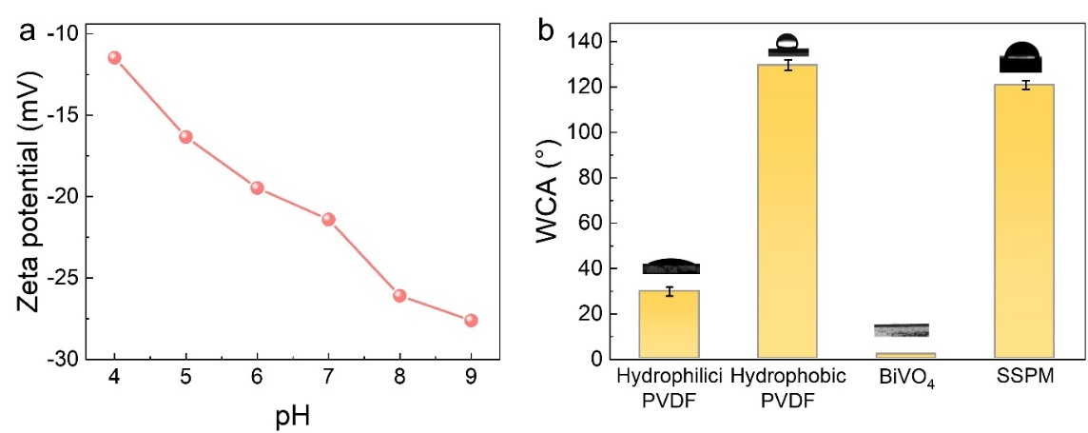
Fig. S5 (a) The surface potential of SSPM under different pH solutions. (b) The water contact angle of hydrophilic PVDF, hydrophobic PVDF, catalyst powder and SSPM
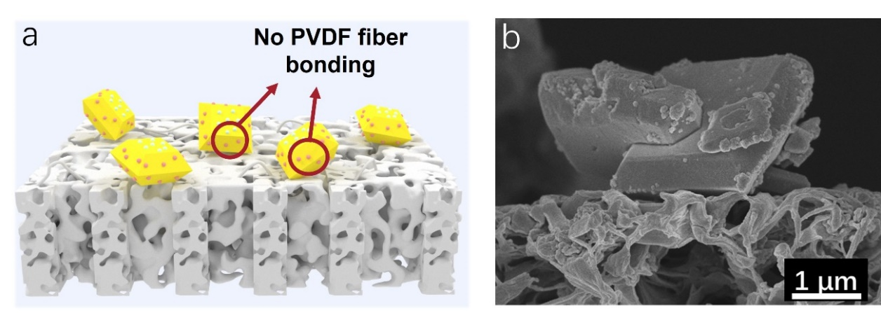
Fig. S6 (a) Schematic diagram of the SUPM. (b) SEM image of SUPM showing lack of catalyst binding to the PVDF fibers
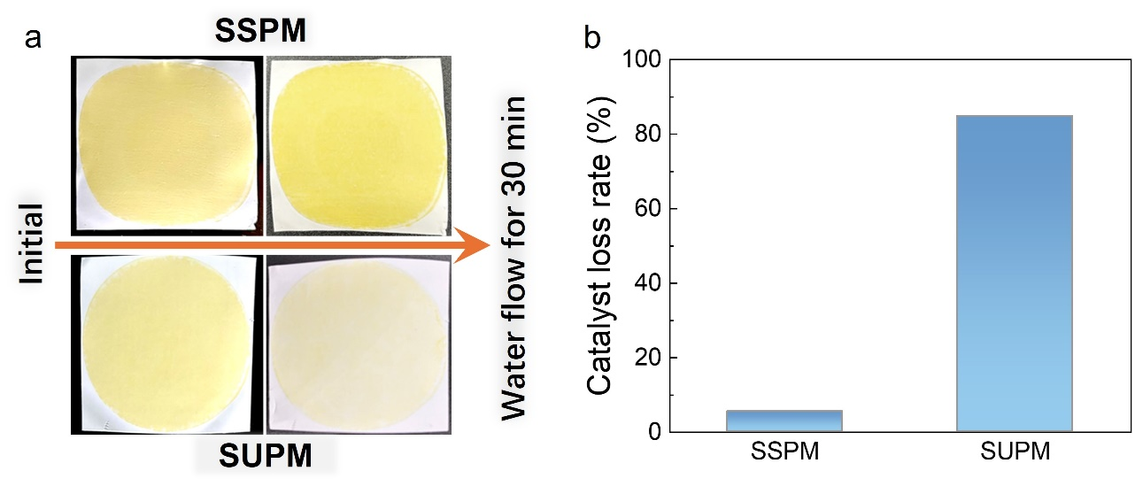
Fig. S7 (a) Photographs of SSPM and SUPM before and after cross flowing. (b) Catalyst loss rate of SSPM and SUPM after water cross flowing
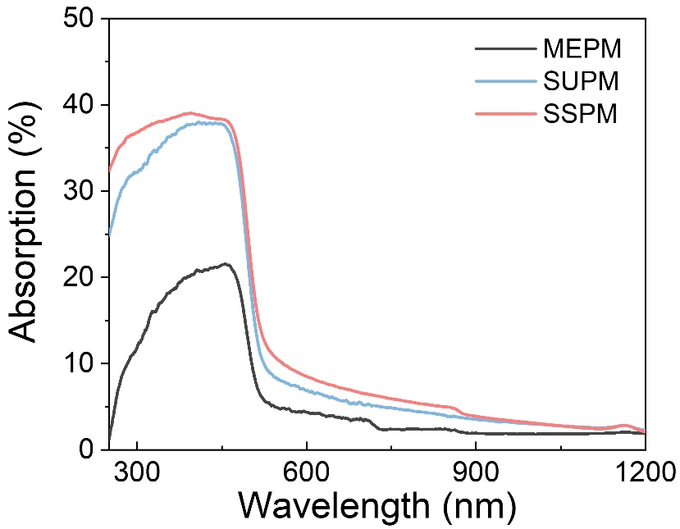
Fig. S8 UV-vis absorption spectra (250 -1200 nm) of different photocatalytic membranes
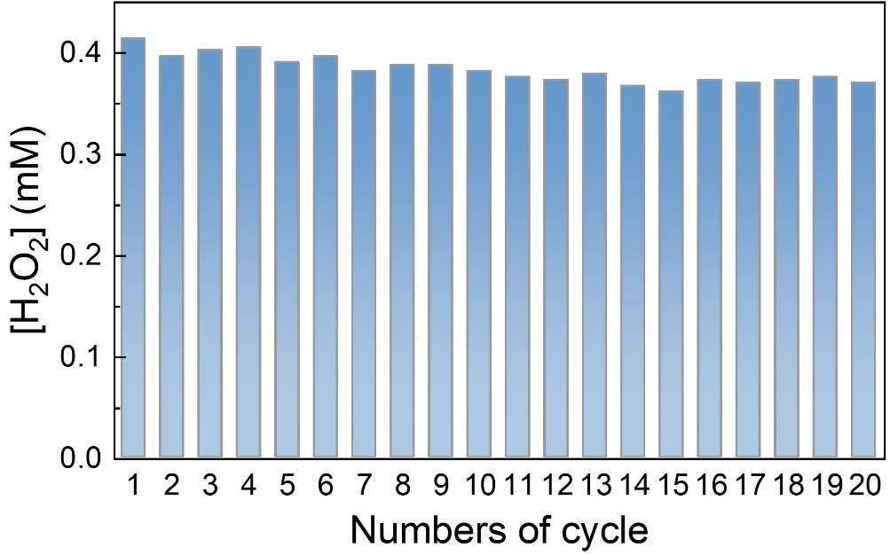
Fig. S9 The activity performance of SSPM in 20-cyclic experiment

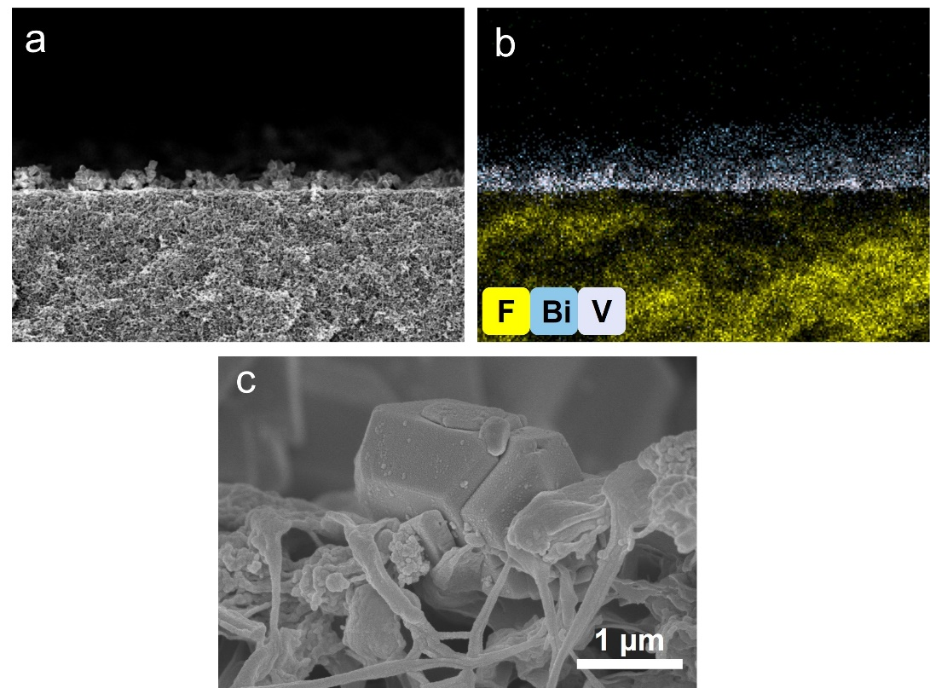

Fig. S10 SEM image (a) EDS mapping (b) and high-resolution SEM image of the SSPM after cyclic experiment

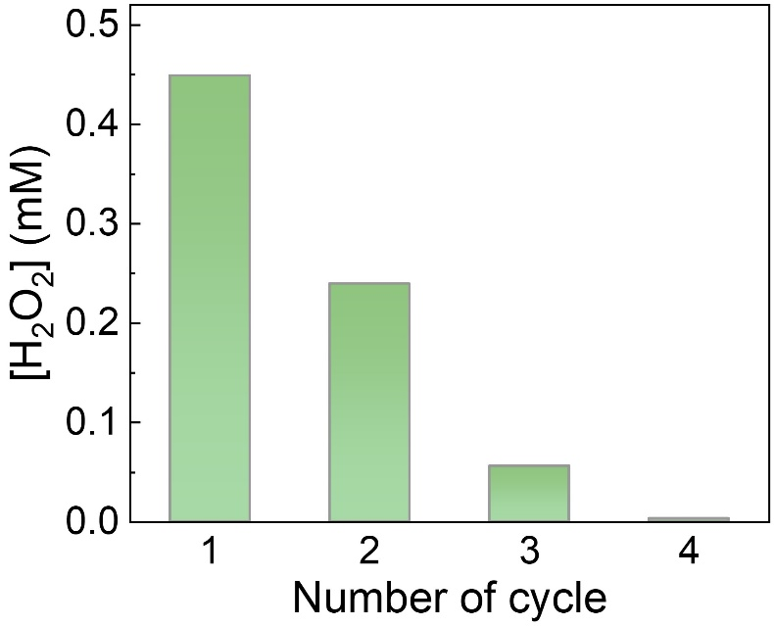
Fig. S11 The cyclic activity of powder photocatalytic. The initial experiment contains: 10 mg CoO_{x}/Mo:BiVO₄/Pd, 30 mL DI water saturated with O₂; Xenon lamp solar simulator with AM 1.5G filter, 100 mW/cm²

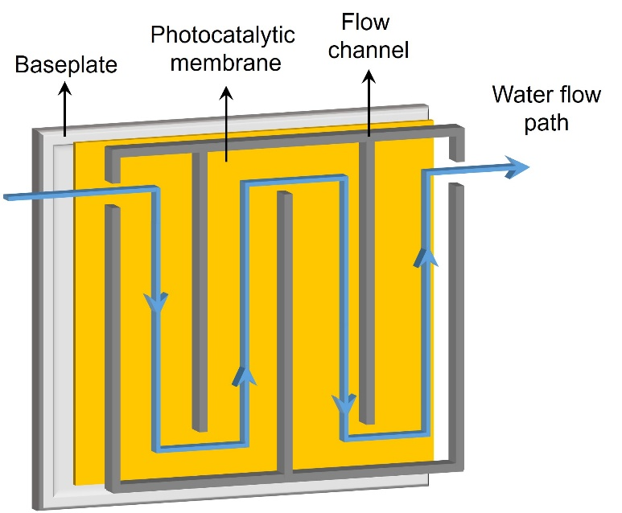
Fig. S12 Illustration of the structure and water flow pattern of the membrane cell, which consisted of baseplate, photocatalytic membrane and flow channel. The membrane was placed on the baseplate and water flew by the membrane surface and through the serpentine channel
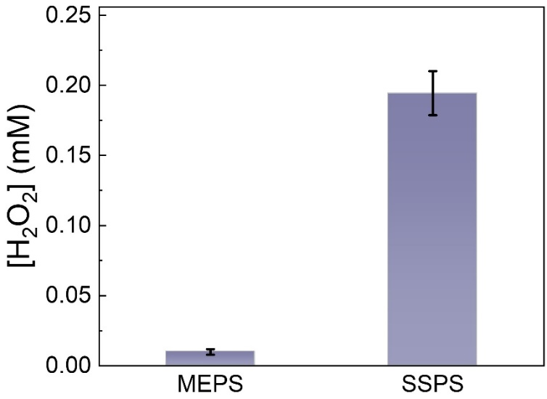
Fig. S13 H₂O₂ generated by MEPM and SSPM in flow reactor at water flow velocity of 0.2 mL/min
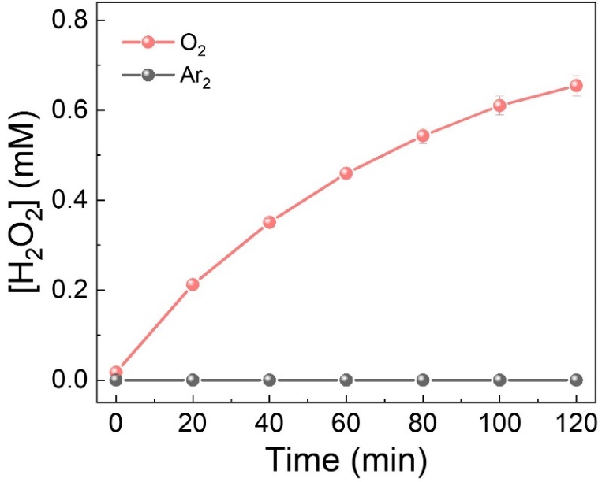
Fig. S14 H₂O₂ photosynthesis performance of SSPM under O₂ and Ar₂ purging
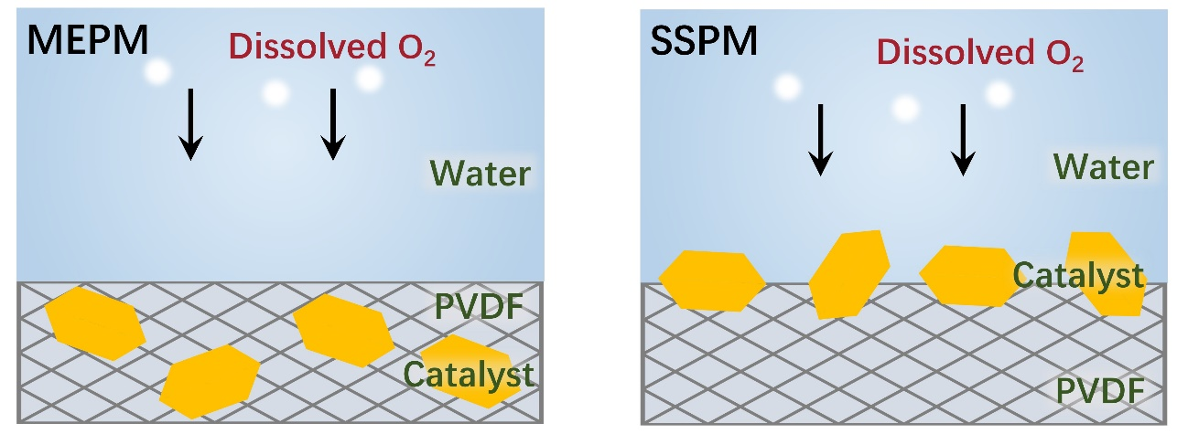
Fig. S15 Simulation model of O₂ distribution comprised a free water phase and a porous PVDF substrate. The catalyst was positioned within the substrate for the MEPM and on its surface for the SSPM as shown in the schematic
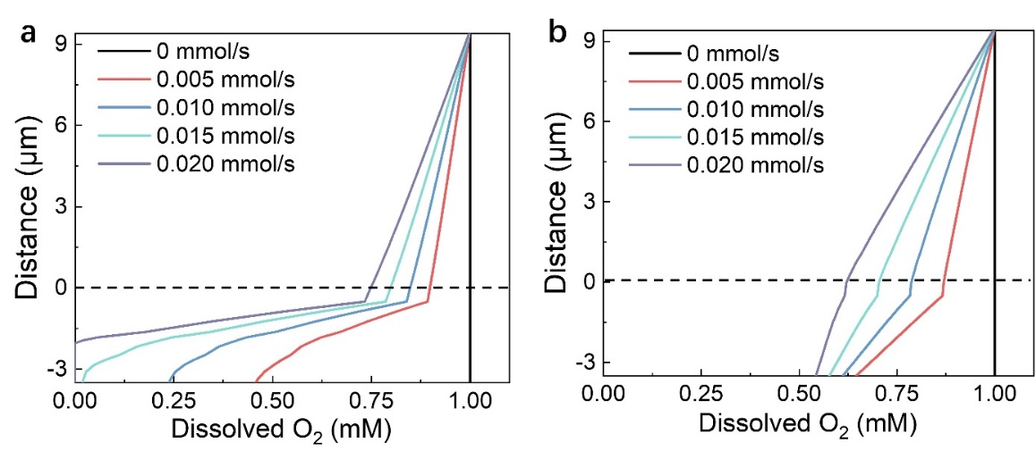
Fig. S16 O₂ concentration profile with the Y-axis under different O₂ consumption rate in (a) MEPM and (b) SSPM simulated models
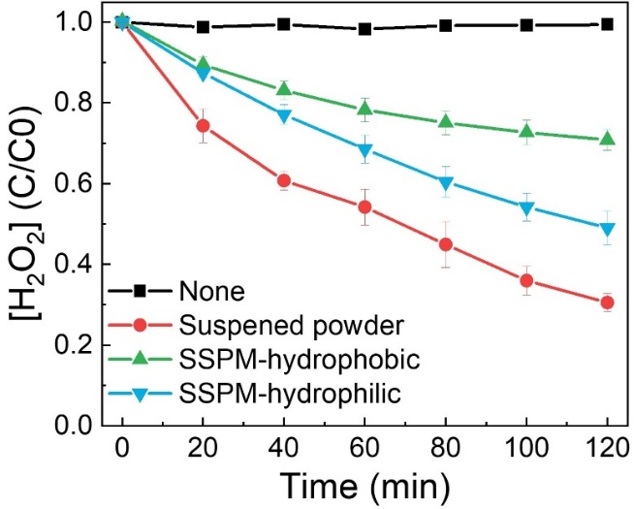
Fig. S17 The rates of H₂O₂ decomposition over blank control, powder suspension, surface bonded sheet with hydrophobic substrate, surface bonded sheet with hydrophilic substrate. The experiment group contains: 2 mg CoOx/Mo:BiVO₄/Pd, 30 mL, 1 Mm H₂O₂ solution saturated with N₂; Xenon lamp solar simulator, 100 mW/cm², AM 1.5G
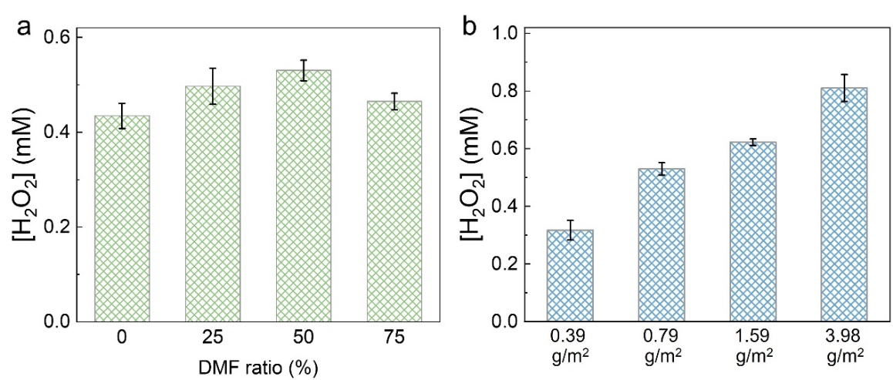
Fig. S18 The photocatalytic performance of SSPM with different DMF/ethanol ratio (a) and catalyst loading amounts (b). The optimized DMF/ethanol ratio and catalyst loading amount were 50 % and 3.98 g/m², respectively
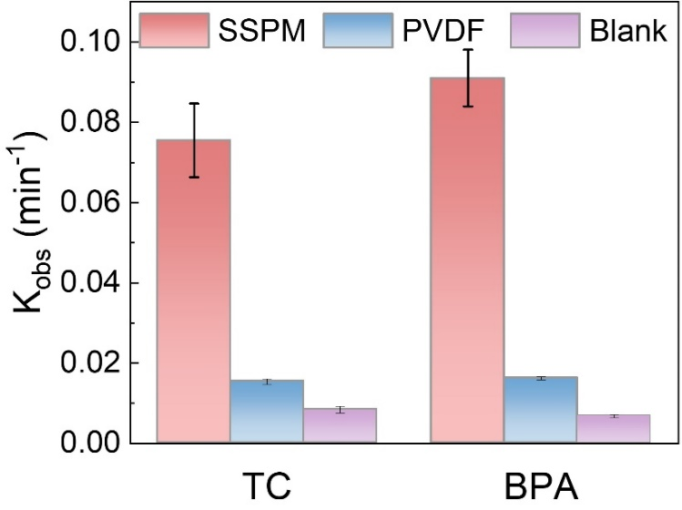
Fig. S19 The pollutant degradation rates of different photocatalytic membranes under UV light
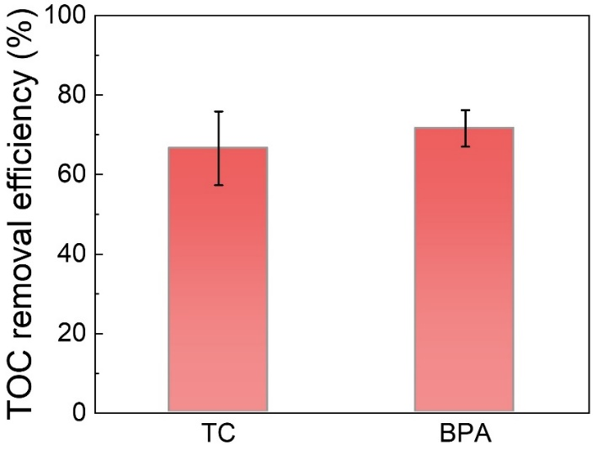
Fig. S20 TOC removal efficiency of TC and BPA by UV/SSPM treatment in 3 hours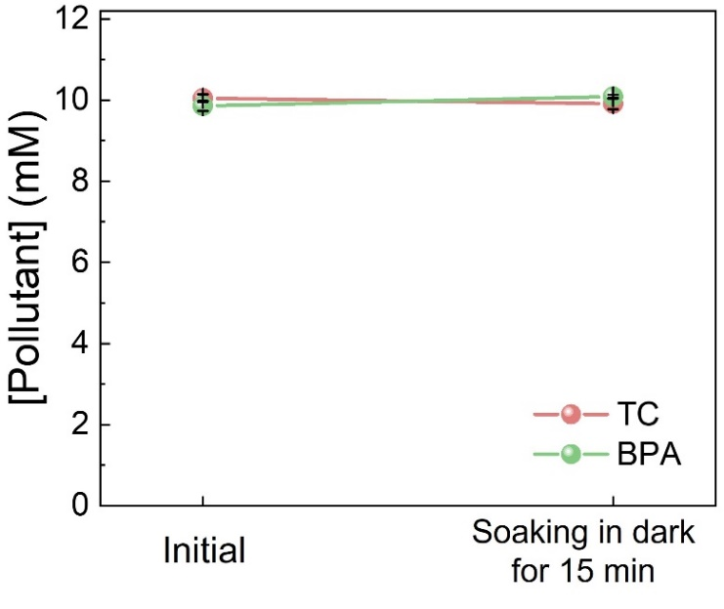
Fig. S21 The pollutants (TC and BPA) concentration changes when SSPM soaking under dark conditions
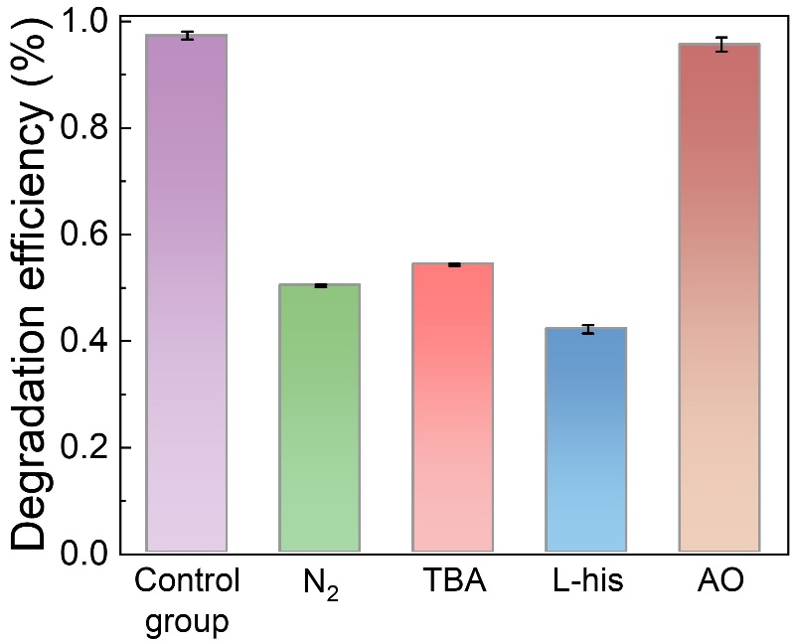
Fig. S22 The effect of scavengers (N₂, TBA, L-his and AO) in pollutant degradation experiments ([BPA] = 10 mg/L)
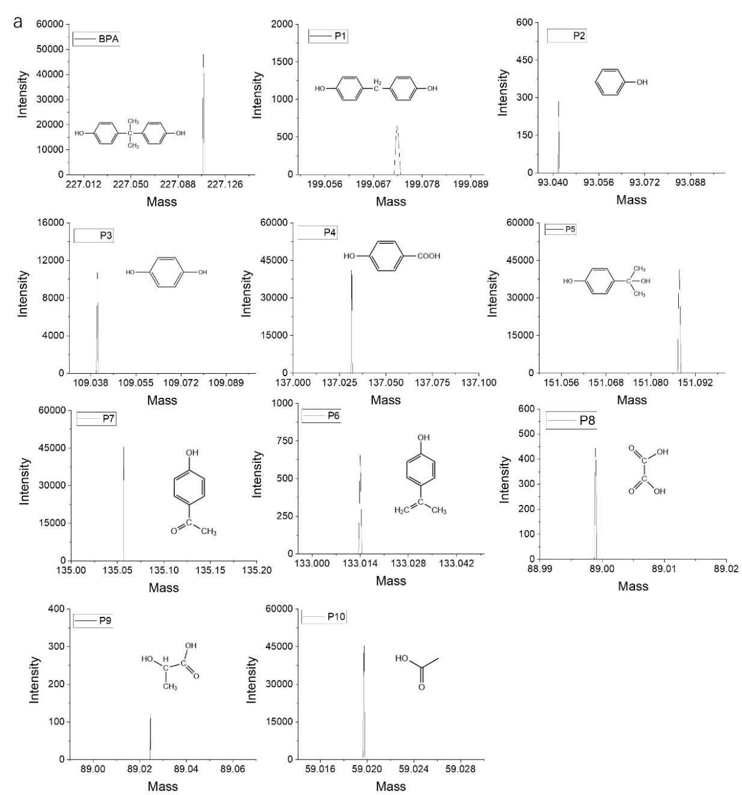

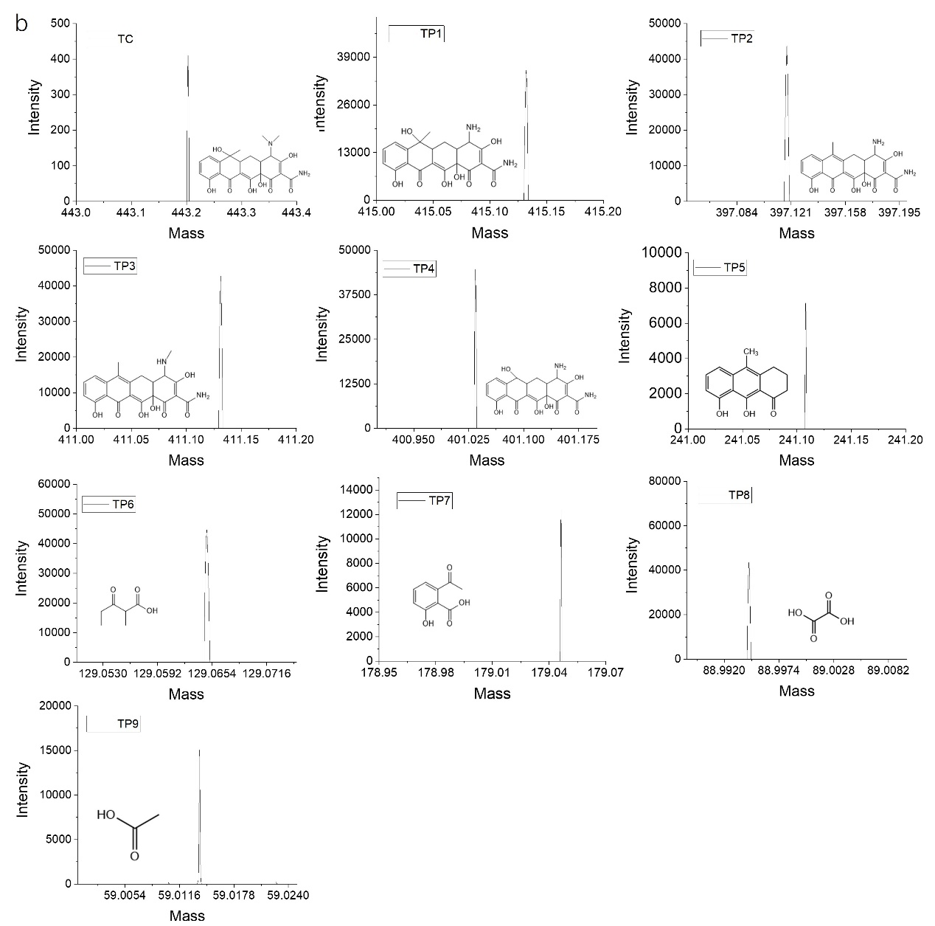
Fig. S23 The mass spectra of (a) BPA and its intermediates; (b) TC and its intermediate
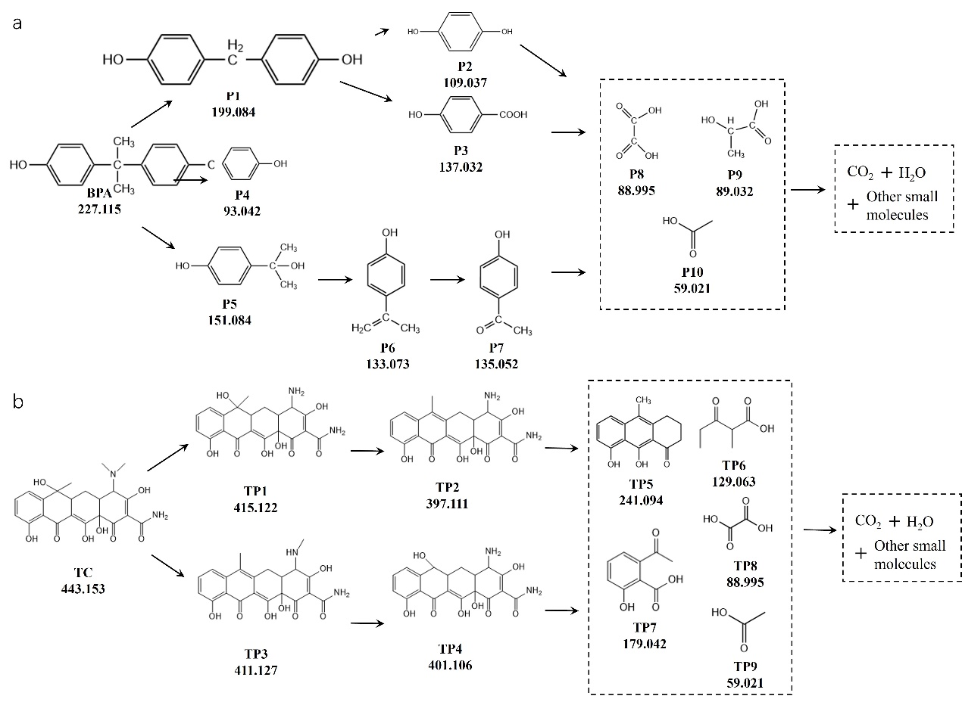
Fig. S24 The proposed mechanism for the transformation of (a) BPA and (b) TC based on the degradation intermediates detected

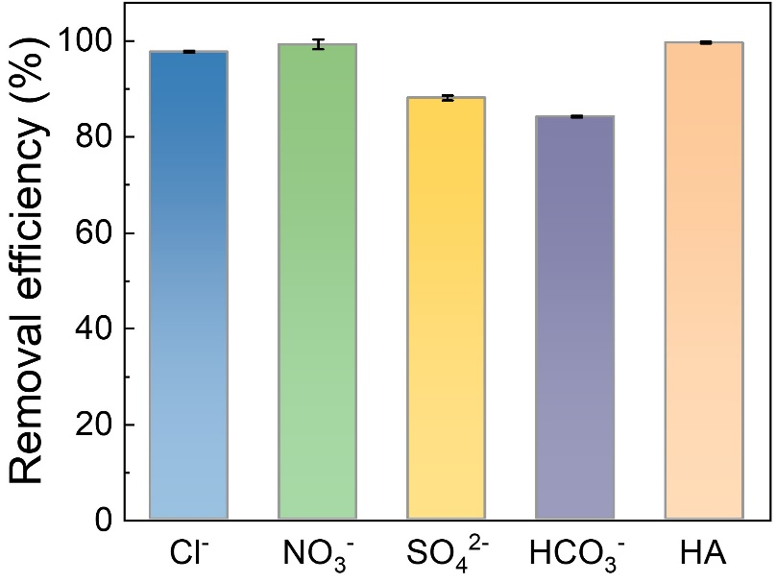
Fig. S25 The influence of interference components (Cl⁻, NO₃⁻, SO₄²⁻, HCO₃⁻ and humic acid) on pollutant degradation

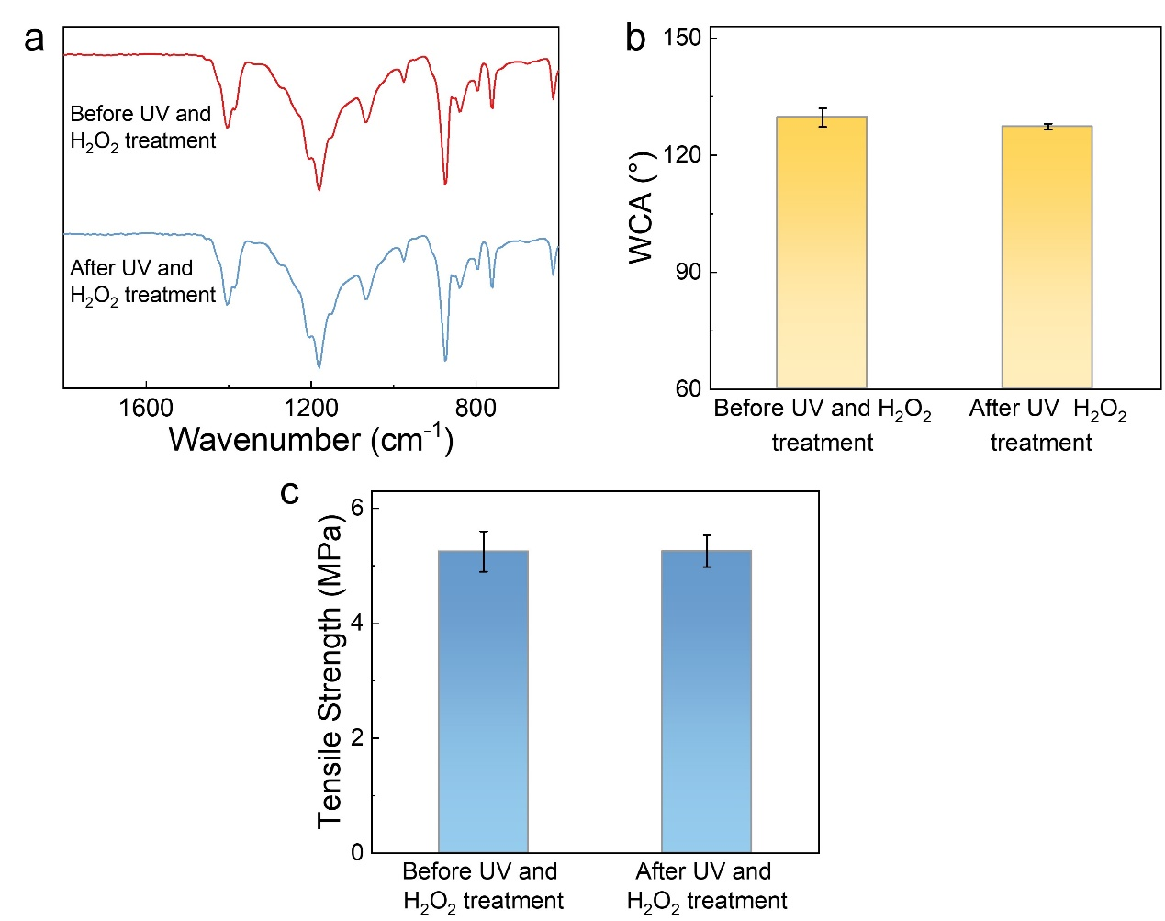
Fig. S26 (a) FTIR spectra of SSPM before and after UV-H₂O₂ treatment. (b) The water contact angle (WCA) of SSPM before and after UV-H₂O₂ treatment. (c) The tensile strength of SSPM before and after UV-H₂O₂ treatment

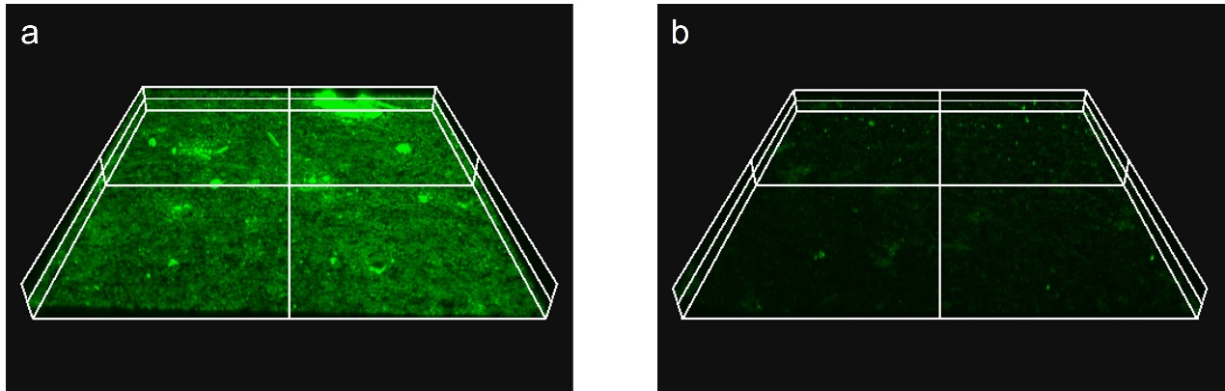
Fig. S27 The visual membrane surface fouling of PVDF and SSPM membrane. The membrane worked in the lake water for 24 hours and was characterized by Confocal laser scanning microscopy (CLSM)

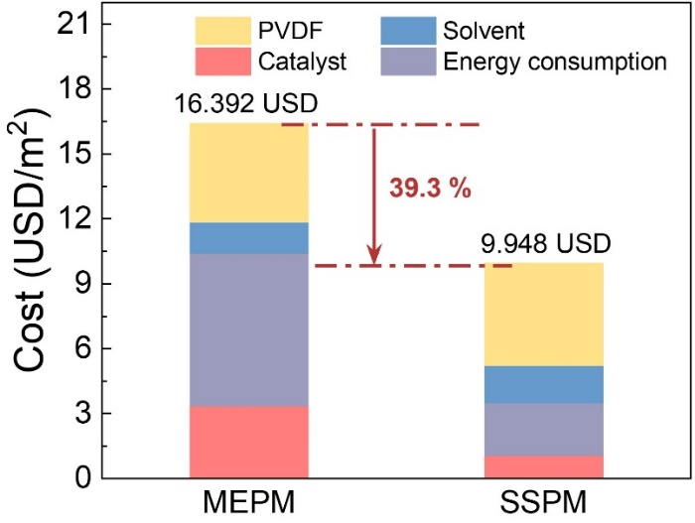
Fig. S28 The estimated costs for fabricating preparing MEPM and SSPM with each component cost of the photocatalytic sheets, which the SSPM cost (9.948 USD/m² ) was 39.3 % lower than MEPS (16.392 USD/m²). The solvent contained the used DMF and ethanol for preparing catalytic sheet
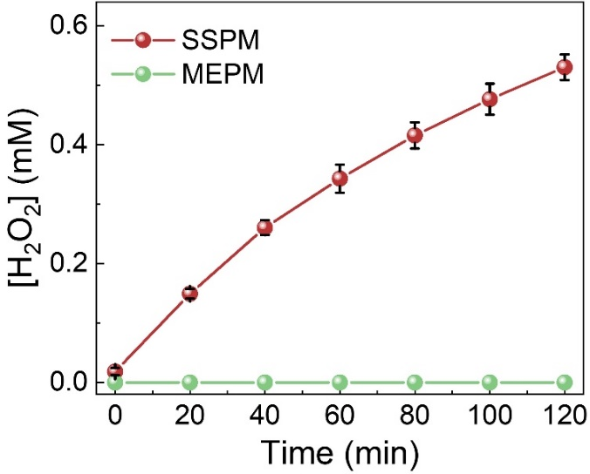
Fig. S29 The photocatalytic performance of SSPM and MEPM in dry state
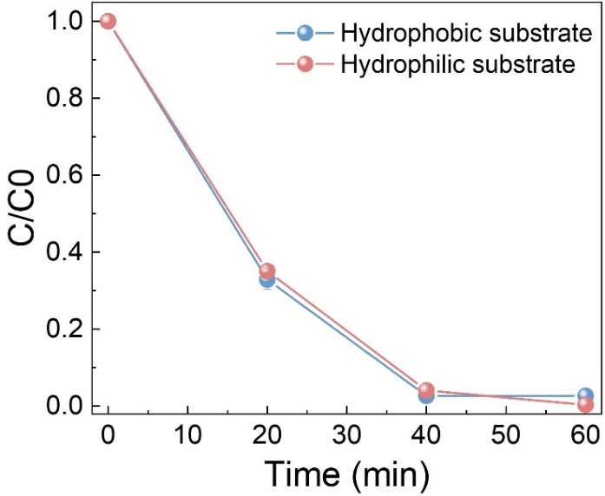
Fig. S30 The pollutant removal (BPA) performance of SSPM with hydrophobic and hydrophilic substrates. The initial pollutant concentration was 10 mg/L
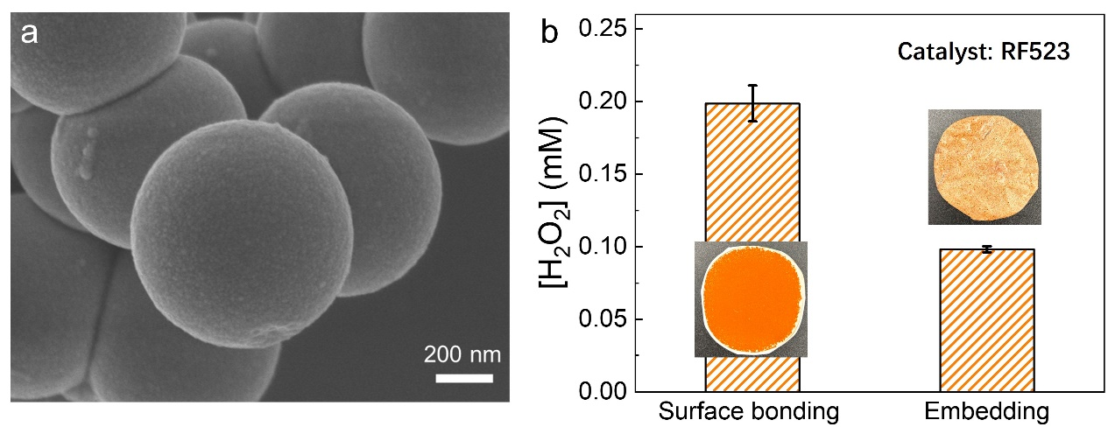
Fig. S31 (a) The SEM of RF 523 catalyst particulate. (b) The photocatalytic performance of RF523 in surface bonded and embedded sheets. The insert photos are surface bonded and embedded with RF523 respectively. Experiment condition: 2 mg RF523, 30 mL DI water saturated with O₂; Xenon lamp solar simulator, 100 mW/cm², AM 1.5G, reaction time is 2h
Supplementary References
- L. Liu, M.-Y. Gao, H. Yang, X. Wang, X. Li et al., Linear conjugated polymers for solar-driven hydrogen peroxide production: the importance of catalyst stability. J. Am. Chem. Soc. 143(46), 19287–19293 (2021). https://doi.org/10.1021/jacs.1c09979
- X. Zhang, H. Su, P. Cui, Y. Cao, Z. Teng et al., Developing Ni single-atom sites in carbon nitride for efficient photocatalytic H₂O₂ production. Nat. Commun. 14(1), 7115 (2023). https://doi.org/10.1038/s41467-023-42887-y
- J. Hou, K. Wang, X. Zhang, Y. Wang, H. Su et al., Synergistic defect sites and CoO_{x} nanoclusters in polymeric carbon nitride for enhanced photocatalytic H₂O₂ production. ACS Catal. 14(14), 10893–10903 (2024). https://doi.org/10.1021/acscatal.4c00334
- C. Feng, J. Luo, C. Chen, S. Zuo, Y. Ren et al., Cooperative tungsten centers in polymeric carbon nitride for efficient overall photosynthesis of hydrogen peroxide. Energy Environ. Sci. 17(4), 1520–1530 (2024). https://doi.org/10.1039/D3EE03032F
- Y. Isaka, Y. Kawase, Y. Kuwahara, K. Mori, H. Yamashita, Two-phase system utilizing hydrophobic metal–organic frameworks (MOFs) for photocatalytic synthesis of hydrogen peroxide. Angew. Chem. Int. Ed. 58(16), 5402–5406 (2019). https://doi.org/10.1002/anie.201901961
- Y. Zhang, C. Pan, G. Bian, J. Xu, Y. Dong et al., H₂O₂ generation from O₂ and H₂O on a near-infrared absorbing porphyrin supramolecular photocatalyst. Nat. Energy 8(4), 361–371 (2023). https://doi.org/10.1038/s41560-023-01218-7
- Q. Wu, J. Cao, X. Wang, Y. Liu, Y. Zhao et al., A metal-free photocatalyst for highly efficient hydrogen peroxide photoproduction in real seawater. Nat. Commun. 12(1), 483 (2021). https://doi.org/10.1038/s41467-020-20823-8
- L. Li, L. Xu, Z. Hu, J.C. Yu, Enhanced mass transfer of oxygen through a gas–liquid–solid interface for photocatalytic hydrogen peroxide production. Adv. Funct. Mater. 31(52), 2106120 (2021). https://doi.org/10.1002/adfm.202106120
- R. Liu, Y. Chen, H. Yu, M. Položij, Y. Guo et al., Linkage-engineered donor–acceptor covalent organic frameworks for optimal photosynthesis of hydrogen peroxide from water and air. Nat. Catal. 7(2), 195–206 (2024). https://doi.org/10.1038/s41929-023-01102-3

