Supporting Information for
Metal-Support Interaction Induced Electron Localization in Rationally Designed Metal Sites Anchored MXene Enables Boosted Electromagnetic Wave Attenuation
Xiao Wang^{1#}, Gaolei Dong^{2#}, Fei Pan¹, Cong Lin², Bin Yuan¹, Yang Yang¹*, Wei Lu¹*
¹Shanghai Key Lab of D&A for Metal-Functional Materials, School of Materials Science & Engineering, Tongji University, Shanghai 201804, People’s Republic of China
²College of Materials Science and Engineering, Fuzhou University, Fuzhou 350108, People’s Republic of China
# Xiao Wang and Gaolei Dong contributed equally to this work.

*Corresponding authors. E-mail: yangyang_@tongji.edu.cn (Yang Yang); weilu@tongji.edu.cn (Wei Lu)

S1 Corresponding formula in manuscript
One Debye relaxation process corresponds to one semicircle (Cole-Cole semicircle) in accordance with Debye theory:
${\left(ε'−\frac{ε_{s}+ε_{∞}}{2}\right)}^{2}+$ (S1)
$ε_{s}$ and $ε_{∞}$ stand for the static dielectric constant, the dielectric constant at infinite frequency, respectively.
$∁_{0}=μ\text{(μ')\} ^ \{-2\} \{f\} ^ \{-1}$ (S2)
According to Debye theory, the relatively complex permittivity imaginary part (ε") could be divided into conduction loss (ε_{c″}) and polarization loss (ε_{p″}) as following equations:

$ε\text{= \{ωτ left (\{ε\} rsub \{s\} - \{ε\} rsub \{∞\} right )\} over \{1+ \{ω\} ^ \{2\} \{τ\} ^ \{2\}\} + \{σ\} over \{ω \{ε\} rsub \{0\}\} = \{ε\} rsub \{p\} rsup \{}+ε_{c}^{}$ (S3)
$ε_{c}^{\text{\} = \{σ\} over \{ω \{ε\} rsub \{0\}}}$ (S4)
where $ω$ is angular frequency, $ε_{s}$ is static dielectric constant, 𝜏 is polarization relaxation time, $ε_{0}$is the permittivity of free space (8.85×10⁻¹² F/m), $ε_{∞}$ is relative permittivity at high frequency and 𝜎 is electrical conductivity.
Based on the transmission line theory, the reflection loss (RL) of absorbers is calculated by the complex permittivity ($ε_{r}$) and complex permeability ($μ_{r}$) by the following equations:
$Z_{0}=\sqrt{\frac{μ_{0}}{ε_{0}}}$ (S5)
$Z_{}=Z_{0}{\left(\frac{μ_{r}}{ε_{r}}\right)}^{\frac{1}{2}}tanh\left[j\left(\frac{2πfd}{c}\right){\left(ε_{r}μ_{r}\right)}^{\frac{1}{2}}\right]$ (S6)
$RL\left(dB\right)=20log\left|\frac{Z_{}−Z_{0}}{Z_{}+Z_{0}}\right|$ (S7)
where $Z_{}$ and$Z_{0}$ are the input impedance of absorbent and impedance of free space, 𝑓, 𝑑 and 𝑐 stand for the frequency, thickness of absorbers and velocity of light, respectively.
The attenuation constant (α) can be calculated through:
$α=\frac{\sqrt{2}πf}{c}×\sqrt{\left(μ^{″}ε^{″}−μ'ε'\right)+\sqrt{{\left(μ″ε″−μ'ε'\right)}^{2}+{\left(μ″ε″+μ'ε'\right)}^{2}}}$ (S8)
The specific reflection loss (SRL) values can be described as:
S𝑅𝐿_{min}=𝑅𝐿/ (𝑓𝑖𝑙𝑙𝑒𝑟𝑙𝑜𝑎𝑑𝑖𝑛𝑔 × 𝑙𝑎𝑦𝑒𝑟 𝑡h𝑖𝑐𝑘𝑛𝑒𝑠𝑠) (S9)
The Debye model can be used to express the dielectric polarization process in the following：
$ε^{'}=ε_{∞}+\frac{ε_{s}−ε_{∞}}{1+{\left(2πfτ\right)}^{2}}$ (S10)
${ε_{p}}^{″}=ε^{″}−ε_{c}^{\text{\} = \{\{ε\} rsub \{s\} - \{ε\} rsub \{∞\}\} over \{1+ \{left (2πfτ right )\} ^ \{2\}\} ∙ left (2πfτ right }}$ (S11)
where ε_{s}, ε∞, f and τ are the static permittivity, the permittivity when the frequency is infinity, the frequency and the relaxation time, respectively.
$$t_{m}=\frac{nλ}{4}=\frac{nc}{4f_{m}\sqrt{\left|ε_{r}∥μ_{r}\right|}}\left(S12\right)$$
where d_{m} and f_{m} stand for the matching thickness and the matching frequency.
S2 Supplementary Figures
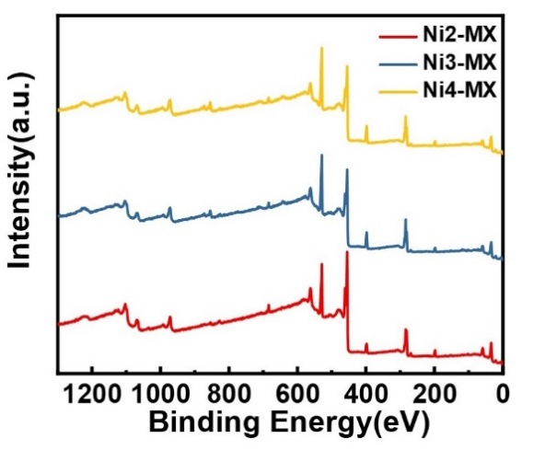
Fig. S1 XPS survey scan spectra
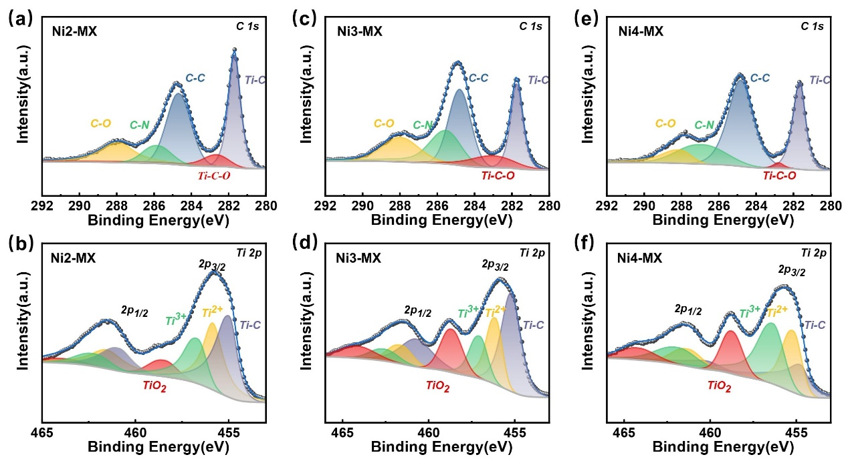
Fig. S2 XPS survey scan spectra of Ti 2p and C1s
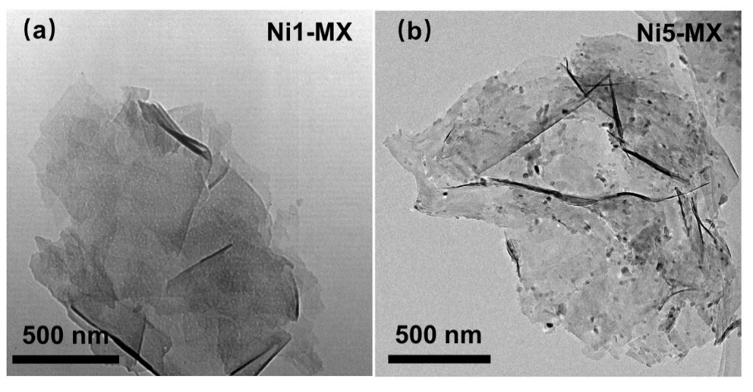
Fig. S3 TEM image of Ni-MX
Fig. S4 The size distribution diagram of Ni3-MX

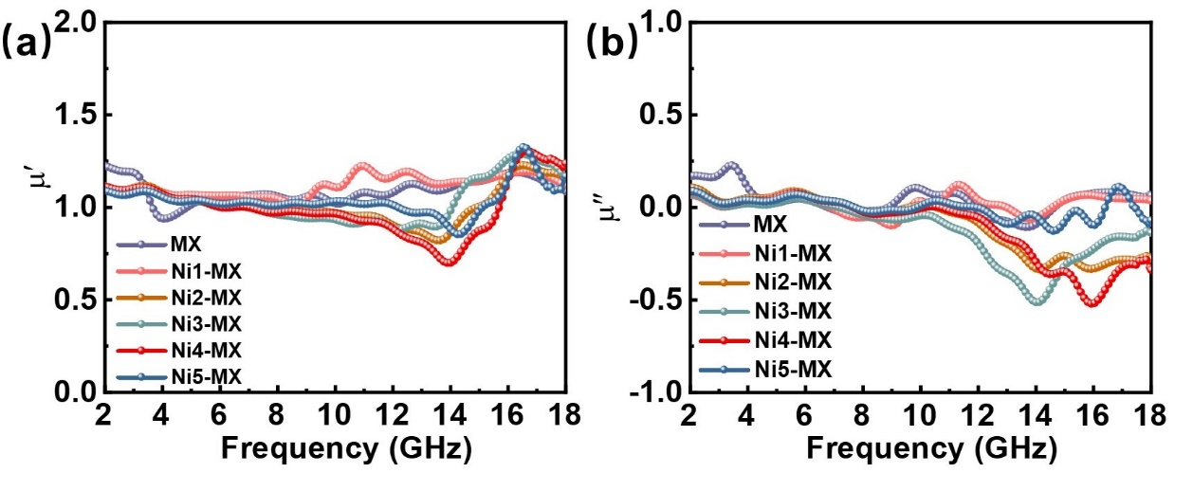
Fig. S5 μʹ and μʺ of the Ni-MX

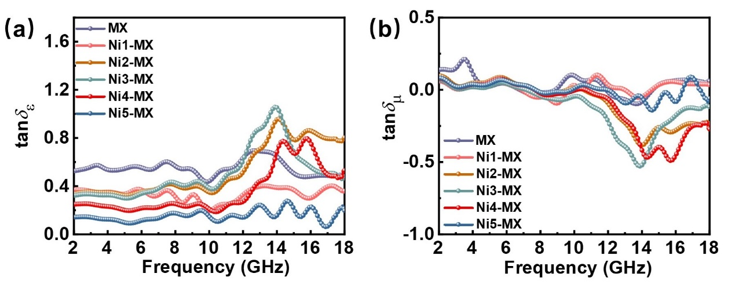
Fig. S6 $tan⁡δ_{ε}$ $tan⁡δ_{μ}$ of the Ni-MX

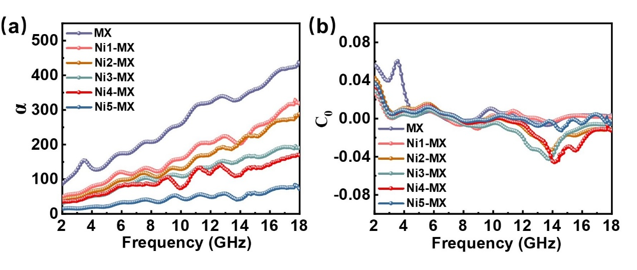
Fig. S7 α and C₀ of the he Ni-MX
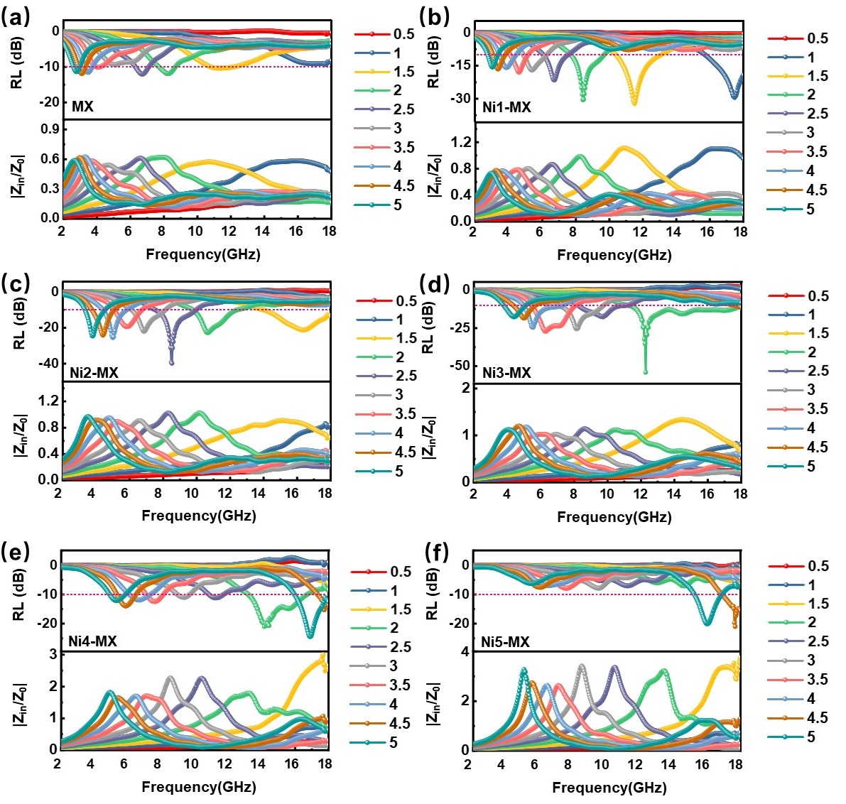
Fig. S8 2D RL and |Z_{in}/Z₀| of the he Ni-MX
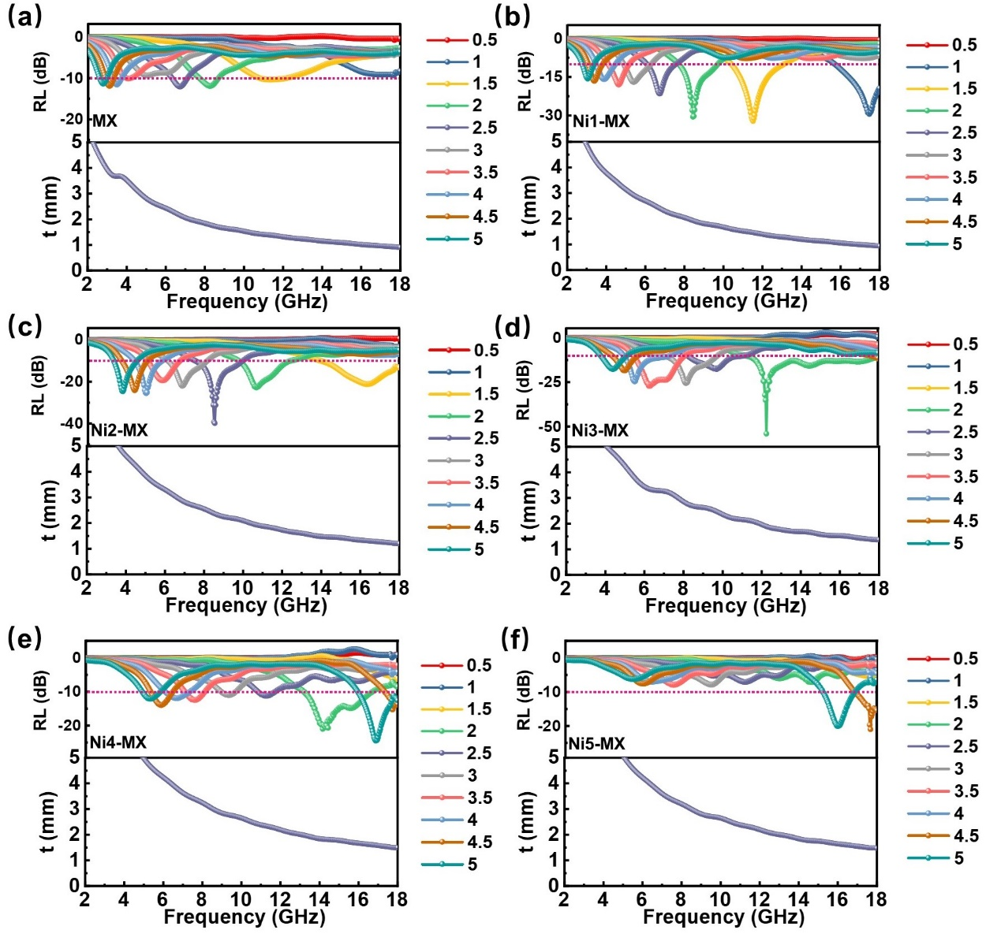
Fig. S9 The quarter-wavelength thickness of Ni-MX
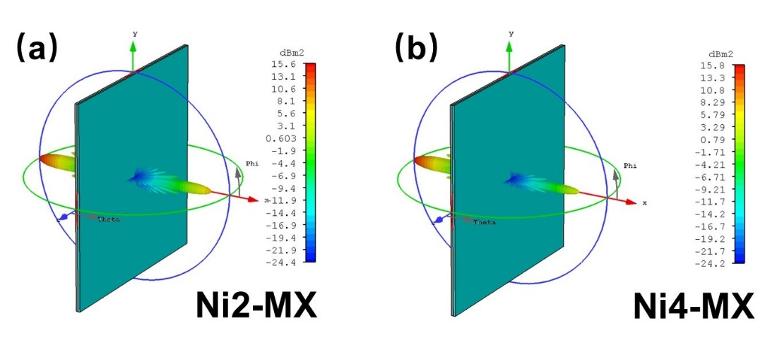
Fig. S10 RCS of the he Ni-MX

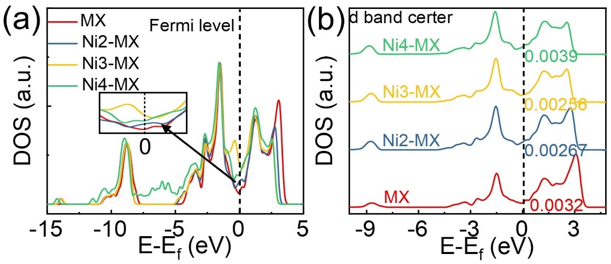
Fig. S11 DOS of the Ni-MX
Fig. S12 The work function of MX
Fig. S13 Cole-Cole plot of the Ni-MX
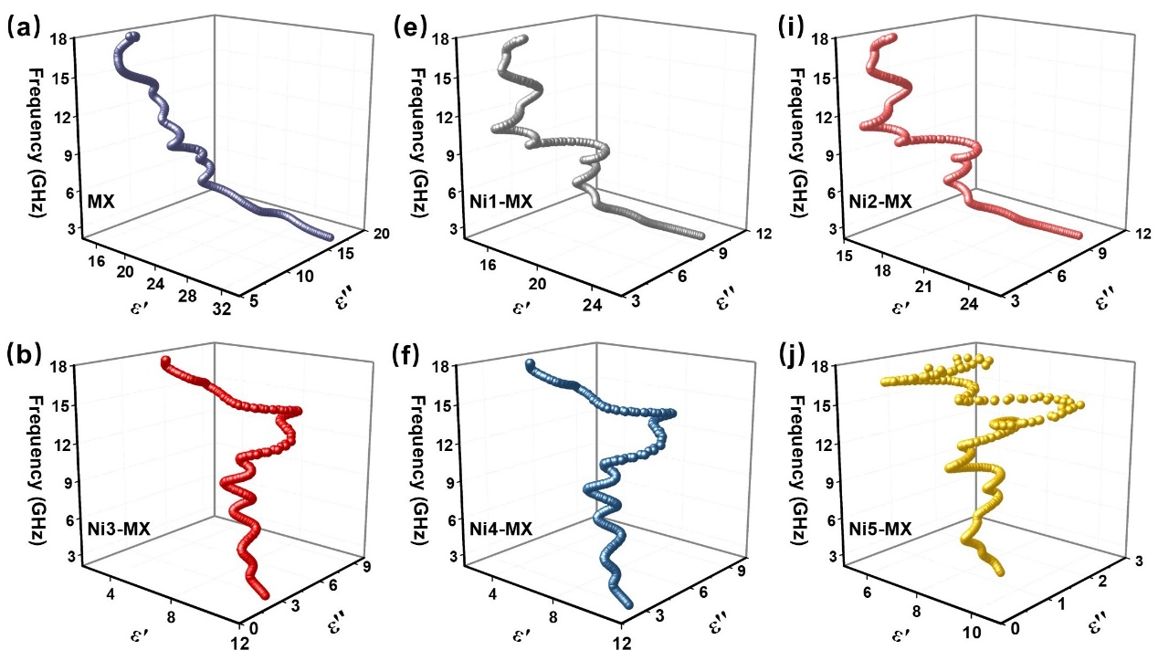
Fig. S14 The 3D Cole-Cole plot of the Ni-MX
Fig. S15 The quarter-wavelength thickness of Ni-MX

