Supporting Information for
Ultrahigh Dielectric Permittivity of a Micron-Sized Hf_{0.5}Zr_{0.5}O₂ Thin-Film Capacitor after Missing of a Mixed Tetragonal Phase
Wen Di Zhang¹, Bing Li², Wei Wei Wang³, Xing Ya Wang³, Yan Cheng^{4,}* and An Quan Jiang^{1,}*
¹ College of Integrated Circuits and Micro/Nano Electronics Innovation, Fudan University, Shanghai 200433, P. R. China
² Center for Transformative Science, ShanghaiTech University, Shanghai 201210, P. R. China
³ Shanghai Advanced Research Institute, Chinese Academy of Sciences, Shanghai 201204, P. R. China
⁴ Key Laboratory of Polar Materials and Devices (MOE), Department of Electronics, East China Normal University, Shanghai 200241, P. R. China
*Corresponding authors. E-mail: aqjiang@fudan.edu.cn (An Quan Jiang); ycheng@ee.ecnu.edu.cn (Yan Cheng)
Supplementary Figures
3.85 μm
1 μm
30 μm
10 μm
b
a

Fig. S1 Capacitor size. a b Planar SEM photographs of top electrodes for state-of-the-art HZO capacitors
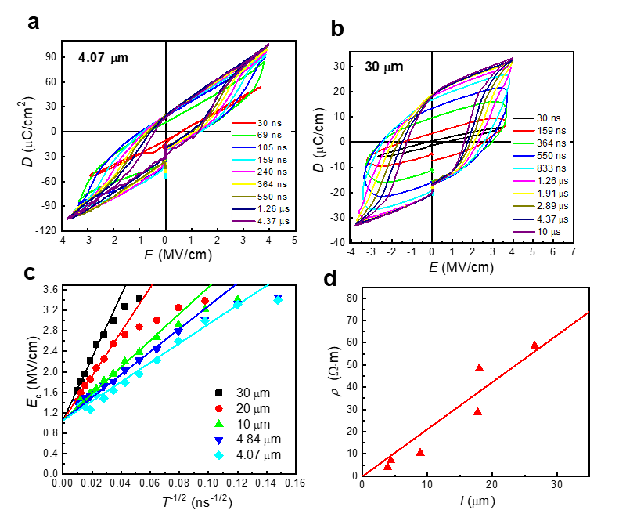
Fig. S2 D-E hysteresis loops of size-scaled capacitors. a b D-E hysteresis loops at different periodicities for two ferroelectric capacitors in different diameters. c E_{c}-T^{-1/2} dependences of the capacitors of various diameters. The solid lines are the linear fits of the data according to Eq. S1. d The ρ-l dependence fitted by the solid line according to Eq. S2.
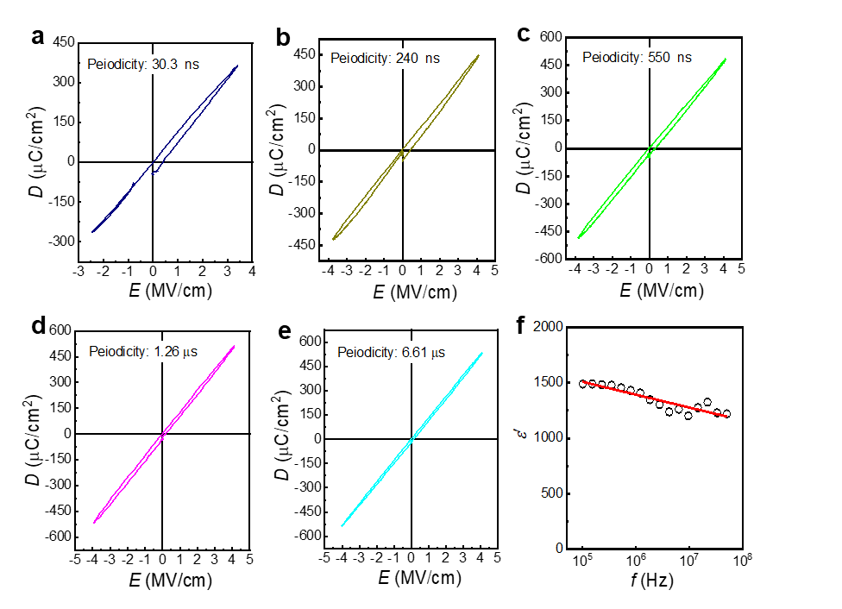
Fig. S3 Ultrahigh dielectric permittivity. a-e D-E hysteresis loops at different periodicities for the capacitor in the diameter of 3.85 μm when ferroelectricity disappears. f High frequency dependence of dielectric permittivity calculated from the slopes of the loops
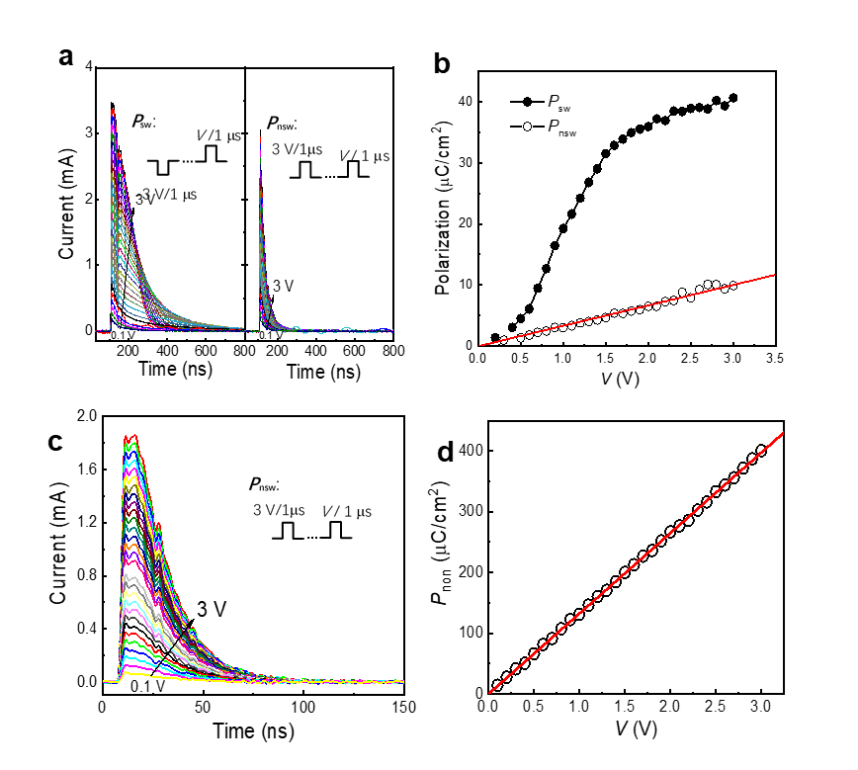
Fig. S4 Domain switching current transients. a Switching/nonswitching current transients versus time with increasing V from 0.1 to 3 V in steps of 0.1 V for a ferroelectric capacitor in the diameter of 30 μm using the pulse sequences sketched in the insets. b Voltage dependences of switching/nonswitching polarizations (P_{sw} and P_{non}) in a. c Nonswitching current transients versus time for a nonferroelectric capacitor in the diameter of 3.85 μm with increasing V from 0.1 to 3 V in steps of 0.1 V using the pulses sequence sketched in the inset. d Voltage dependence of P_{non} in c fitted by the solid line
a
b
c
Fig. S5 Size-scaling effect on storing charge density. a Cycling number dependences of maximum charge densities at 1.2 V for the sized-scaled capacitors after poling using the pulses sketched in the inset when using square fatigue pulses of ±1.2 V/50 ns at a repetition frequency of 10 MHz. b D-E hysteresis loops for the capacitors of various diameters after fatigue when characterized at 10 MHz. c Cycling number dependences of remanent polarization (P_{r}) for the sized-scaled capacitors when using square fatigue pulses of ±4 V/500 ns at a repetition frequency of 1 MHz. The inset figure shows D-E hysteresis loops after different fatigue cycles for a small capacitor in the diameter of 5.23 μm until the occurrence of dielectric breakdown, where the parenthetic value shows the zoom-in dielectric displacement.
-1.2 V/50 ns
1.2 V /50 ns
TiN
Fig. S6 Dielectric loss for the ultrahigh-ε′ capacitor. a DC voltage dependences of the dielectric loss at different frequencies for a nonferroelectric capacitor in the diameter of 3.85 μm. b Oscillating voltage dependences of the capacitance at different frequencies.
b
a

Fig. S7 Leakage current densities of size-scaled capacitors. a Electric field dependences of leakage current density for the capacitors of various diameters fitted by the solid lines according to Eq. S3. b The n-J_{edge} dependence for the edging area fitted by the solid line

a
b
b
a
c
Fig. S8 XRD patterns. a Synchrotron in-plane grazing-incidence diffraction pattern for a large-area TiN/HZO/TiN capacitor using a synchrotron radiation source at a wavelength of 0.6887 Å. b c Synchrotron X-ray micro-diffraction patterns of small capacitors in diameters of 4.07 μm and 3.85 μm with/without ferroelectricity, respectively, using a synchrotron radiation source at a wavelength of 0.6209 Å. From solid and dashed line fits of the peaks using the Gaussian function, we calculated area ratios of 0.76:0.24, 0.87:0.13 and 1:0 for O (111) and T (011) reflections with increasing dielectric permittivities from 24 to 1466, respectively.
b
a

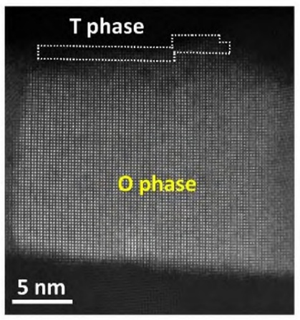
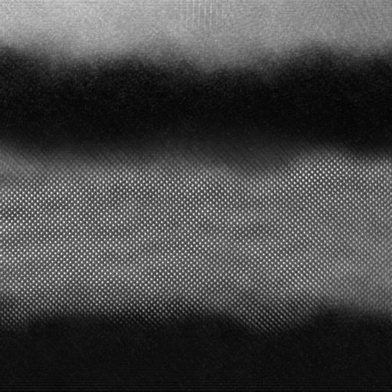
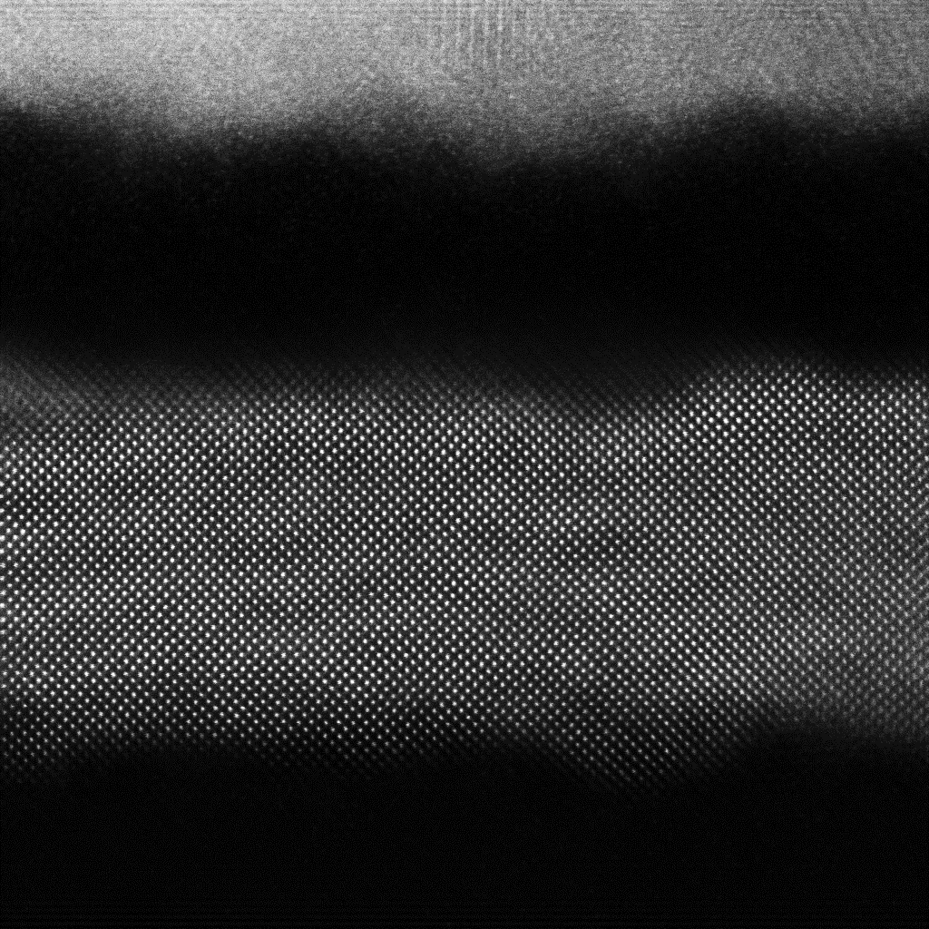
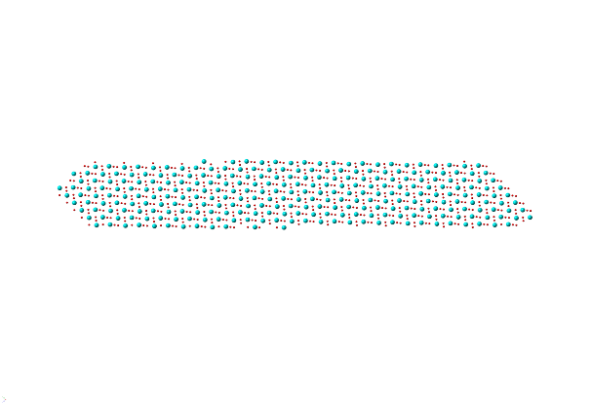
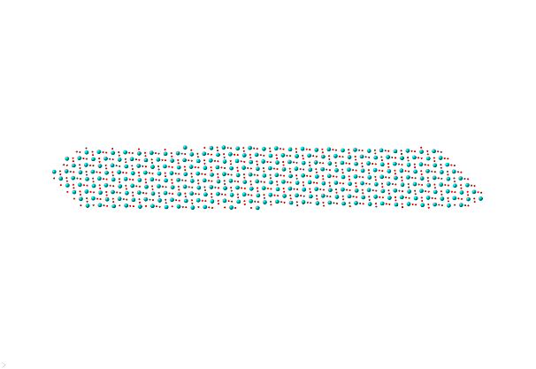
Supplementary Results and Discussion
Fig. S10 Phase structure. a The typical O grain affiliated with a thin layer of the T phase near the top electrode within a large-area TiN/HZO/TiN capacitor when ε′ =24. The data were adapted from Ref. 5. b The HAADF-STEM image of a typical O-phase grain within the ultrahigh-ε′ TiN/HZO/TiN capacitor without ferroelectricity. The inset shows the atomic modeling of the O [010] orientation
b
a
O phase
5 nm
x
O [010]
1 nm
Fig. S9 XRD patterns. a b Synchrotron X-ray micro-diffraction patterns of two capacitors in diameters of 4.07 μm and 3.85 μm with/without ferroelectricity, respectively, using a synchrotron radiation source at a wavelength of 0.6209 Å
Note S1 Effect of the TiN resistance on the domain switching speed
Continuous Hf_{0.5}Zr_{0.5}O₂ thin films were grown by ALD at 200 °C on a Si substrate coated with 10-nm-thick TiN bottom electrodes. After etching of the top electrodes. The thermal annealing process was performed at 550°C for 30 s in a N₂ atmosphere to enable crystallization of the HZO. Near-edge implantation of the oxygen vacancies occurs during etching. The capacitor sizes were determined by reactive ion etching of top electrodes (W/TiN) after ultraviolet photolithography patterning of the Cr shallow masks and were calibrated carefully from SEM photographs, as shown in Fig. S1a, b. Figure S2a, b shows D-E hysteresis loops at different periodicities for two ferroelectric capacitors of various diameters (l). the coercive field (E_{c}) enlarges with either the reduction of T or the increase in l. This is due to the partial oxidation of TiN top electrode in contact with HZO during thermal crystallization that increases the electrode resistivity (ρ_{on}) [S1]. E_{c} determined in the D-E hysteresis loop can be described in the form of [S2]
(S1)
where E_{c0} is the intrinsic coercive field independent of T and l, E_{a} is the amplitude of the applied electric field, and P_{r} is the remanent polarization. Figure S2c shows E_{c}−T^{-1/2} dependences for the capacitors of various l. All plots are almost linear and converge into E_{c0} = 1.06 MV/cm as T^{-1/2}→0, as shown by the solid line fits of the data. From the slopes of linear fits, we estimated ρ_{on} against l with the assumption of E_{a} = 4 MV/cm, and P_{r} = 17 μC/cm², as plotted in Fig. S2d. ρ_{on} reduces almost linearly against l in the form of [S2]:
(S2)
where R_{on} is the resistance of the interfacial layer. From the solid-line fit of the data, we estimated R_{on} = 2.11 MΩ. Figure S3c shows the separate plots of D-E hysteresis loops and dielectric dispersion at different periodicities for the capacitor in the diameter of 3.85 μm in main text of Fig. 1e more clearly.
Note S2 Domain switching current transients versus time
From positive-up-negative-down (PUND) testing, it is possible to measure domain switching and nonswitching current transients versus time under different applied voltages for a ferroelectric capacitor in Fig. S4a, c using the pulse sequences sketched in the insets. After time integration of the current transient, we got voltage dependences of switching and nonswitching polarizations (P_{sw} and P_{non}), as plotted in Fig. S4b, d, and 2P_{r} = P_{sw}-P_{non}. For a nonferroelectric capacitor when l = 3.85 μm, the two current transients of P_{sw} and P_{non} are nearly the same, as shown in Fig. S4c. Meantime, its P_{non}−V dependence is linear, as shown in Fig. S4d. From the slope of a linear fit, we derived that ε′ = 1490, roughly in agreement with the measurement of an impedance analyser in Fig. 1a. Figure S5a shows the fatigue number dependences of maximum charge densities for the size-scaled capacitors using square fatigue pulses of ±1.2 V/50 ns at a repetition frequency of 10 MHz. Though the storing charge density increases from 3.2 to 18 μC/cm² upon downscaling of the ferroelectric capacitor size from 33.5 to 4.5 μm, they are much lower than 185 μC/cm² of a nonferroelectric capacitor in the diameter of 3.85 μm in Fig. 1f. The charge densities of all ferroelectric capacitors keep constant against the fatigue number, and all domains become unswitched at +/-1.2 V, as implied from the linear D-E hysteresis loops in Fig. S5b. Once the fatigue voltage increases up to 4 V, the dielectric breakdown occurs when N = 10⁷−10⁸ among the ferroelectric capacitors in the diameters of 5.23-20.1 μm in Fig. S5c before the occurrence of ultrahigh ε′ transition. This highlights the advantage of ultrahigh ε′ transition within a virgin 3.85 μm-sized capacitor without requirement of high-field cycling.
Note S3 Voltage-independent ultrahigh ε′
In most ferroelectrics, both ε′ and tanδ have nonlinear dependence of either the amplitude of the applied AC voltage (V_{osc}) or the DC voltage (V) due to domain-wall pinning and depinning by homogeneously and inhomogeneously distributed oxygen vacancies (Fig. 2a) [S3, S4]. Figure S6a, b shows tanδ−V and C−V_{osc} dependences at different frequencies for a nonferroelectric capacitor when l = 3.85 μm, respectively, where C depends less on either V or V_{osc}. These observations confirm the ferroelectric-to-nonferroelectric transition.
Note S4 Leakage currents in HZO capacitors
Figure S7a shows the electric field dependences of leakage current density for the capacitors of various diameters. The total leakage current density comprises leakage currents from near-edge and central areas that both obey the power laws in the form of
(S3)
where J_{edge} and J_{center} are constants and n and m are the coefficients. After solid line fits of the data in Fig. S7a, we found that n from the edging area ranges from 0.48 to 0.84 with the reduction of l from 30 to 3.85 μm and can be fitted by the relationship of n ∝ J_{edge}^{-0.092}, as shown by the solid-line fit of the data in Fig. S7b. In comparison, the leakage current density from the central area is nearly constant with m = 8.1 for all capacitors in the diameters of 4.05−30 μm when r₀ << l.
Note S5 Phase structure
Figure S8 (a)-(c) are interplanar spacing scanning XRD patterns transformed from Fig. 3a-c in main text. From these patterns, it understood that both O (111) and T (011) lattices expand by 0.68 % in the etched HZO capacitors. This lattice expansion could be correlated to the reduced capping effect of top electrodes in small capacitors and near-edge ion injection that creates more oxygen vacancies. Figure S9a, b shows synchrotron X-ray micro-diffraction patterns of two capacitors in diameters of 4.07 μm and 3.85 μm, respectively. It seems that the phase structure of the ferroelectric capactor is the mixture of O, T and M phases. But the T phase disappears from the latter nonferroelectric capacitor (Fig. 8c) when the ultrahigh ε′ transition occurs.
In a ferroelectric HZO capacitor, a thin T-phase layer affliated to the O grain was always found at the top interface with the thickness ranging from 0.75 nm to 1 nm, as shown in Fig. S10a [S5]. The low-ε′ T phase in series with the ultrahigh-ε′ O phase can reduce the overall permittivity by one to two orders of magnitude. In contrast, the T layer disappears from the nonferroelectric capacitor after the occurrence of ultrahigh ε′ transition. Figure S10b show the typical STEM-HAADF image of the [010] O grain within the central area in Fig. 4a (Area 2), where there is no interfacial T phase, in agreement with the XRD observation in Fig. 3c.
Supplementary References
- W. Hamouda, A. Pancotti, C. Lubin, L. Tortech, C. Richter et al., Physical chemistry of the TiN/Hf_{0.5}Zr_{0.5}O₂ interface. J. Appl. Phys. 127(6), 064105 (2020). https://doi.org/10.1063/1.5128502
- W.D. Zhang, A.Q. Jiang, Size-scaling effect on domain switching time and coercive field of TiN/Hf_{0.5}Zr_{0.5}O₂/TiN thin-film capacitors. IEEE Trans. Electron Devices 70(12), 6324–6328 (2023). https://doi.org/10.1109/TED.2023.3325417
- L.M. Garten, S. Trolier-McKinstry, The field induced E31, f piezoelectric and Rayleigh response in barium strontium titanate thin films. Appl. Phys. Lett. 105(13), 132905 (2014). https://doi.org/10.1063/1.4897299
- C. Filipič, A. Levstik, Z. Kutnjak, Analytical behavior of dielectric nonlinearity in PbMg_{1/3}Nb_{2/3}O₃relaxor ferroelectric. Ferroelectrics 257(1), 63–68 (2001). https://doi.org/10.1080/00150190108016282
- Y. Cheng, Z. Gao, K.H. Ye, H.W. Park, Y. Zheng et al., Reversible transition between the polar and antipolar phases and its implications for wake-up and fatigue in HfO₂-based ferroelectric thin film. Nat. Commun. 13(1), 645 (2022). https://doi.org/10.1038/s41467-022-28236-5

