Supporting Information for
Chirality-Induced Suppression of Singlet Oxygen in Lithium–Oxygen Batteries with Extended Cycle Life
Kyunghee Chae,¹ Youngbi Kim,² Yookyeong Oh,¹ Hosik Hahn,³ Jaehyun Son,⁴ Youngsin Kim,³ Hyuk-Joon Kim,³ Hyun Jeong Lee,¹ Dohyub Jang,⁵ Jooho Moon,^{4,}* Kisuk Kang,^{3,}* Jeong Woo Han,^{3,}* Filipe Marques Mota,^{6,}* Dong Ha Kim^{1,7,8,9,10,}*
¹Department of Chemistry and Nanoscience, Ewha Womans University, 52 Ewhayeodae-gil, Seodaemun-gu, Seoul 03760, Republic of Korea
²Department of Chemical Engineering, Pohang University of Science and Technology (POSTECH), Pohang 37673, Republic of Korea
³Department of Materials Science and Engineering Seoul National University, 1 Gwanak-ro, Gwanak-gu, Seoul 08826, Republic of Korea
⁴Department of Materials Science and Engineering, Yonsei University, 50 Yonsei-ro Seodaemun-gu, Seoul 03722, Republic of Korea
⁵Chemical and Biological Integrative Research Center, Korea Institute of Science and Technology (KIST), 5 Hwarang-ro 14-gil, Seongbuk-gu, Seoul 02792, Republic of Korea
⁶Department of Chemistry, School of Natural Sciences, University of Lincoln, Brayford Pool, Lincoln LN6 7TS, United Kingdom
⁷College of Medicine, Ewha Womans University, 25, Magokdong-ro 2-gil, Gangseo-gu, Seoul 07804, Republic of Korea
⁸Gradutate Program in Innovative Biomaterials Convergence, 52 Ewhayeodae-gil, Seodaemun-gu, Ewha Womans University, Seoul 03760, Republic of Korea
⁹Basic Sciences Research Institute (Priority Research Institute), Ewha Womans University, Seoul 03760, Republic of Korea
¹⁰Nanobio • Energy Materials Center (National Research Facilities and Equipment Center), Ewha Womans University, Seoul 03760, Republic of Korea
*Corresponding authors. E-mail: jmoon@yonsei.ac.kr (Jooho Moon); matlgen1@snu.ac.kr (Kisuk Kang); jwhan98@snu.ac.kr (Jeong Woo Han); FMarquesMota@lincoln.ac.uk (Filipe Marques Mota); dhkim@ewha.ac.kr (Dong Ha Kim)
S1 Supplementary Method
S1. 1 Electrochemical linear sweep voltammetry
Linear sweep voltammetry (LSV) tests of Co₃O₄/CP electrodes were performed using typical three-electrode system with an electrochemical workstation (SP150) at room temperature. A graphite rod and Ag/AgCl were used as the counter and the reference electrodes, respectively. The described setup was used to investigate both OER and ORR profiles in 1 M KOH aqueous solution at a scan rate of 20 mV s⁻¹, with as-prepared electrodes in each N₂- and O₂-saturated electrolyte.
S1.2 Acid-based titration
Inside the Ar-filled glove box, spent cathodes along with the soaked pieces of Celgard, microfiber separators, and stainless-steel meshes were directly placed into vials containing 5 mL of deionized water and gently shaken for a few minutes. A complete dissolution and reaction of present DC products with H₂O were assumed as Li₂O₂ + 2H₂O → H₂O₂ + 2LiOH. During the acid-base titration process to examine the formation of Li₂O₂, possible side reactions with atmospheric CO₂ could lead to the formation of Li₂CO₃, potentially affecting the accuracy of the results. To minimize this effect, all titrations were conducted inside an Ar-filled glovebox to prevent CO₂ exposure. The extracted solution was titrated immediately (within 5 minutes of Li₂O₂ extraction) using a freshly prepared 5 mM HCl aqueous solution as the titrant (LiOH + HCl = LiCl + H₂O). Titration was performed dropwise under gentle stirring until the phenolphthalein indicator (20 μL, 1% in EtOH) changed color, indicating the neutralization of OH⁻ species. To ensure reproducibility, at least three separate titrations were conducted for each sample, and the average Li₂O₂ yield was reported with standard deviation. Calibration was confirmed using a known LiOH standard (Fig. S9), and blank control titration were performed with fresh electrolyte-exposed separators and cathodes without cycling to confirm the absence of background alkalinity contributions.
S1.3 UV-vis analysis
UV-vis absorption spectra were recorded with a UV–Vis Varion 5000 spectrometer with a wavelength rate of 300-500 nm. TEGDME electrolytes containing 20 mM DMA were used as the original solution. After discharge and recharge for 1 hour at 0.08 mA cm⁻², spent cathodes along with the soaked pieces of Celgard, microfiber separators, and stainless-steel meshes were diluted with TEGDME. Then, UV absorption spectra were recorded.
S2 Supplementary Figures and Tables
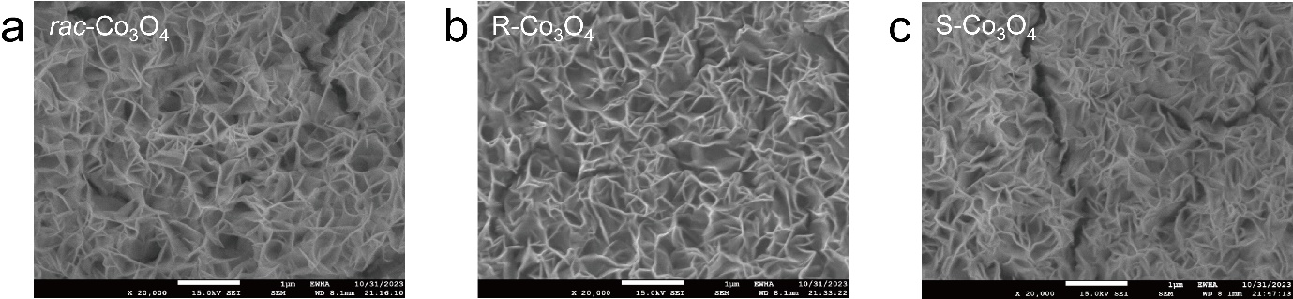
Fig. S1 SEM images of (a) rac-Co₃O₄ NS/ITO, (b) R-Co₃O₄ NS/ITO and (c) S-Co₃O₄ NS/ITO substrates
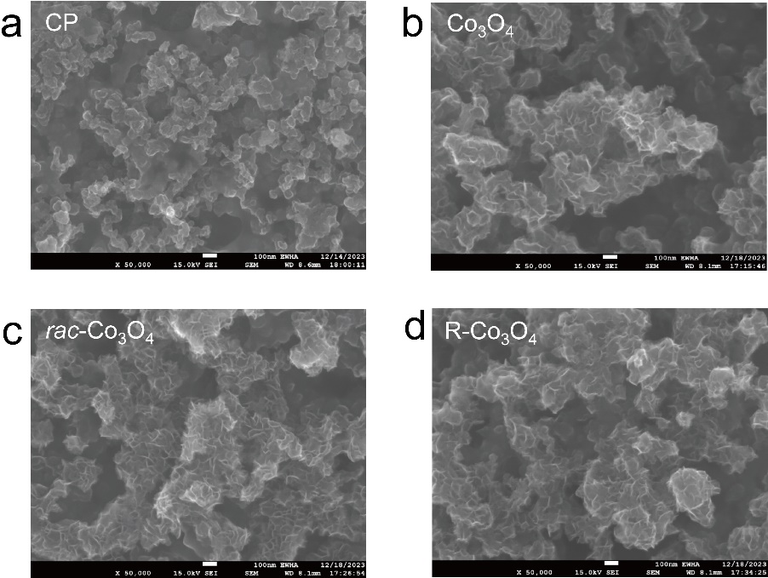
Fig. S2 SEM images of (a) bare carbon paper (CP), (b) Co₃O₄ NS/CP, (c) rac-Co₃O₄ NS/CP, and (d) R-Co₃O₄ NS/CP
Fig. S3 Dynamic light scanning (DLS) size distribution of (a) rac-Co₃O₄ NS, (b) R-Co₃O₄ NS, and (c) S-Co₃O₄ NS

Fig. S4 AFM height images of electrodeposited Co₃O₄ nanosheets on ITO substrates. (a) rac-Co₃O₄/CP and (b) R-Co₃O₄/CP

Fig. S5 XPS spectra of Co₃O₄ NS/CP, rac-Co₃O₄ NS/CP and R-Co₃O₄ NS/CP. All samples show deconvoluted Co²⁺ and Co³⁺ peaks along with their satellite features, confirming the typical mixed-valence nature of spinel Co₃O₄. The calculated Co²⁺/Co³⁺ ratios were 1.44 for Co₃O₄/CP, 1.46 for rac-Co₃O₄/CP, and 1.43 for R-Co₃O₄/CP, indicating consistent chemical states across samples
Fig. S6 CD spectra of (rac/R/S)-Co₃O₄ NS on an ITO substrate with (a) 1 mM, (b) 5 mM, and (c) 10 mM of (rac/R/S)-BINOL
Fig. S7 I-V curves of (a) rac-Co₃O₄/CP, (b) R-Co₃O₄/CP and (c) S-Co₃O₄/CP electrodes in the range of -3.0 to +3.0 V. The CoCr tip was magnetized along the north (gray) or south (green) orientation. The average I-V curve recorded over 30 scans at different points is shown. Spin polarization percentage (SP%) as a function of applied bias of (d) rac-Co₃O₄/CP, (e) R-Co₃O₄/CP and (f) S-Co₃O₄/CP electrodes
Fig. S8 (a) OER LSV curves of CP and (rac/R/S)-Co₃O₄/CP electrodes in the N₂-saturated 1 M KOH electrolyte. (b) ORR LSV curves of CP and (rac/R/S)-Co₃O₄/CP electrodes in O₂-saturated 1 M KOH electrolyte (subtracting the voltammograms in N₂). Scan rate is 20 mV s⁻¹
Fig. S9 Acid-base titration calibration curve with phenolphthalein indicator

To quantify the Li₂O₂ formed during the first discharge process, we conducted acid-base titration experiments following a 5-hour discharge at a current density of 0.8 mA cm^{–2}, with a total capacity of 4 mAh/cm². This titration process is based on the reaction of lithium peroxide (Li₂O₂) with water, which produces lithium hydroxide (LiOH), as shown in the reaction:
Li₂O₂ + 2H₂O → H₂O₂ + 2LiOH
Here, the relationship between LiOH and Li₂O₂ follows a 2:1 molar ratio. The resulting LiOH can then be titrated using a standardized hydrochloric acid (HCl) solution, which reacts with LiOH to form lithium chloride (LiCl) and water.
For theoretical calculations, based on a 5-hour discharge at a capacity of 0.4 mAh cm^{–2} and an electrode surface area of 1.25668 cm², the total discharge capacity is 0.5067 mAh (or 0.000507 Ah). This corresponds to 18.9 µmol of LiOH, given the two-electron transfer required for Li₂O₂ formation. Therefore, after 5 hours of discharge, the theoretical amount of Li₂O₂ produced should be 9.45 µmol, generating 18.9 µmol of LiOH in the titration process.

Fig. S10 Galvanostatic profiles of Li–O₂ batteries with CP, Co₃O₄ NS/CP and R-Co₃O₄ NS/CP at 0.08 mA cm⁻² for (a) 1st cycle, (b) 2nd cycle and (c) 5th cycle
Fig. S11 Cyclic voltammetry (CV) curves of (a) CP, (b) rac-Co₃O₄/CP, and (c) R-Co₃O₄/CP electrodes measured before and after 10 discharge/recharge galvanostatic cycles at a scan rate of 0.1 mV s⁻¹ in the voltage range of 2.0-4.8 V vs. Li⁺/Li. The 10-cycle test was conducted at a current density of 0.08 mA cm⁻² using a fixed charge/discharge time of 10 hours per cycle. (d) Overlaid CV profiles after cycling, demonstrating the superior catalytic stability of R-Co₃O₄/CP, which retains higher ORR and OER current densities compared to rac-Co₃O₄/CP and CP, indicating enhanced durability under prolonged cycling

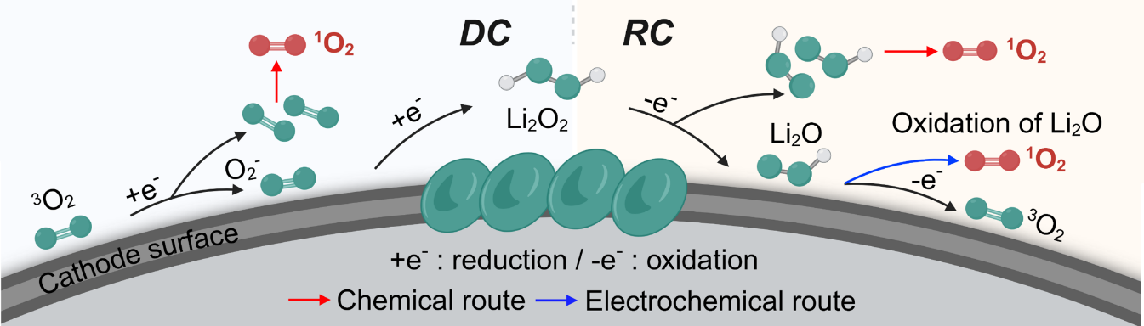
Fig. S12 Schematic generation of ¹O₂ during discharge and charge processes
Fig. S13 UV-vis absorption spectrum of DMA in TEGDME with CP, Co₃O₄/CP and (rac/R)-Co₃O₄/CP electrodes after discharge (a) and recharge (b) for 1 hour at 0.08 mA cm⁻²
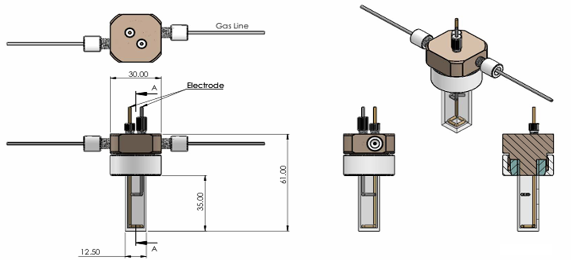
Fig. S14 Schematic diagram of operando PL cell design

Fig. S15 Excitation and emission spectra of 9,10-dimethylanthracene in 1.0 M LiTFSI in TEGDME. The emission was recorded from 400-600 nm with λ_{ex}= 378nm

Fig. S16 Partial density of states (PDOS) for Co 3d orbitals in (a) rac-Co₃O₄ NS/CP and (b) R-Co₃O₄ NS/CP
Fig. S17 Partial density of states (PDOS) for O 2p orbitals in (a) rac-Co₃O₄ NS/CP and (b) R-Co₃O₄ NS/CP
Fig. S18 The computed geometries of bare, Li, LiO₂*, Li₂O₂*, and 2Li₂O₂* at the rac-Co₃O₄ NS/CP cathode
Fig. S19 The computed geometries of bare, Li, LiO₂*, Li₂O₂*, and 2Li₂O₂* at the R-Co₃O₄ NS/CP cathode
Table S1 Summary of ICP-OES results and relative standard deviation values (RSD, %)
Sample name | Co 238.892 nm |  | Sample weight (g)
Sample name | Conc. (wt%) | RSD | Sample weight (g)
rac-Co₃O₄/CP | 5.274 | 1.579 | 0.0128
R-Co₃O₄/CP | 5.006 | 2.190 | 0.0138
S-Co₃O₄/CP | 6.149 | 0.797 | 0.0133

