Supporting Information for
Superelastic and Washable Micro/Nanofibrous Sponges Based on Biomimetic Helical Fibers for Efficient Thermal Insulation
Fengjin Yang¹, Zhifei Wang¹, Wei Zhang¹, Sai Wang¹, Yi-Tao Liu¹, Fei Wang^{1,} *, Roman A. Surmenev³, Jianyong Yu¹, Shichao Zhang¹, and Bin Ding^{1, 2}
¹ Innovation Center for Textile Science and Technology, College of Textiles, Donghua University, Shanghai 200051, P. R. China
² School of Materials Science and Engineering, Shanghai University of Engineering Science, Shanghai 201620, P. R. China
³ Physical Materials Science and Composite Materials Center, Research School of Chemistry & Applied Biomedical Sciences, National Research Tomsk Polytechnic University, Tomsk 634050, Russia
*Corresponding author. E-mail: feiwang@dhu.edu.cn (Fei Wang)
S1 Supplementary Figures
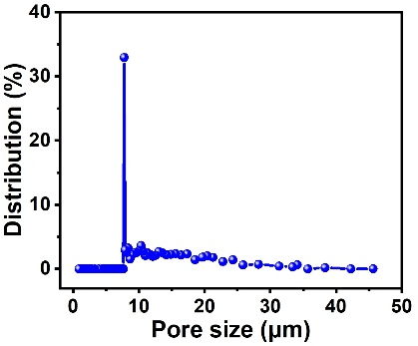
Fig. S1 Pore size distribution of MNFS prepared at the LiCl concentration of 0.004 wt% and AC concentration of 40 wt%

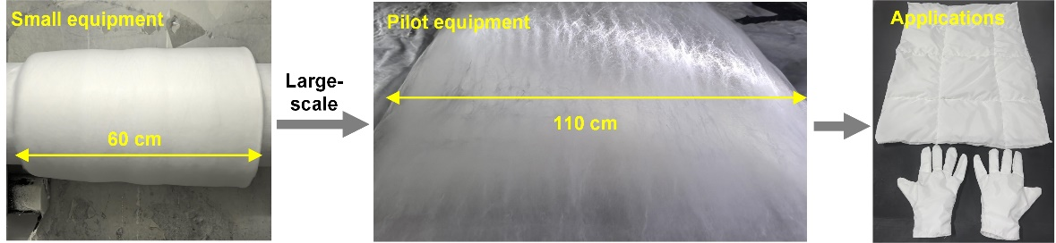
Fig. S2 The scalability of our strategy
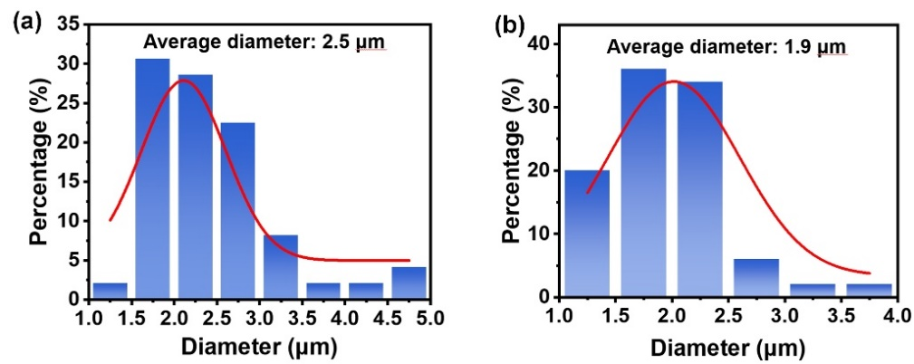
Fig. S3 Diameter distribution diagram of PVDF fibers. Diameter of fibers prepared by solution containing LiCl content at a 0 wt% and b 0.004 wt%
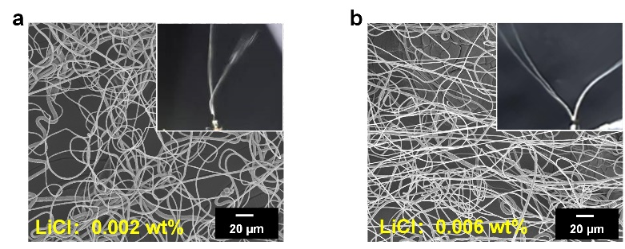
Fig. S4 SEM images of the fibers prepared from PVDF solution with the LiCl content of a 0.002 wt% and b 0.006 wt%. The insets present the optical photos of the jets.
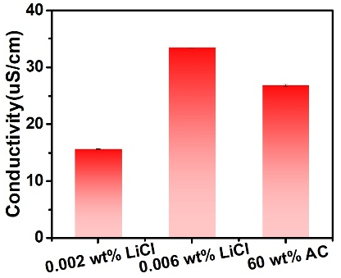
Fig. S5 Conductivity of PVDF solution with different concentration of LiCl (0.002 and 0.006 wt%) and AC (60 wt%)
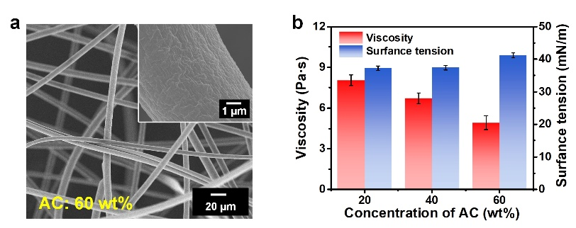
Fig. S6 a SEM images of the fibers prepared from PVDF solution with acetone concentration of 60 wt%. The insets present the SEM images of surface mophology of the single fiber. b Surface tension and viscosity of PVDF solution with different AC concentration (20, 40, and 60 wt%).
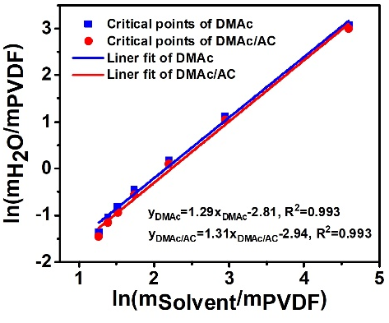
Fig. S7 Linearized cloud point plots of the PVDF/DMAc/H₂O and PVDF/DMAc/AC/H₂O system
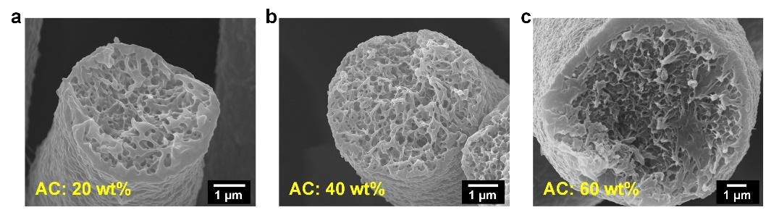
Fig. S8 Cross-section images of porous structures under different concentration of AC. a 20, b 40, and c 60 wt%.
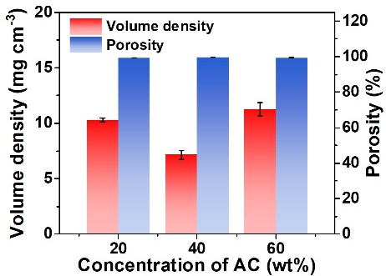
Fig. S9 The porosity and volume density of fiber assemblies prepared from the solution with different AC concentration.
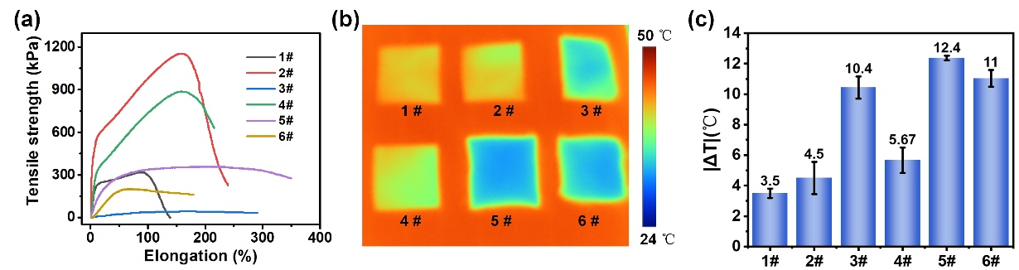
Fig. S10 Mechanical and thermal insulation performance of fibrous assemblies prepared under different concentration of LiCl and AC. a Elongation and tensile strength of fibrous assemblies. b IR images of fibrous assemblies placed on a heating stage (50 ℃). c Temperature difference (|ΔT |) between the sample surface and the stage
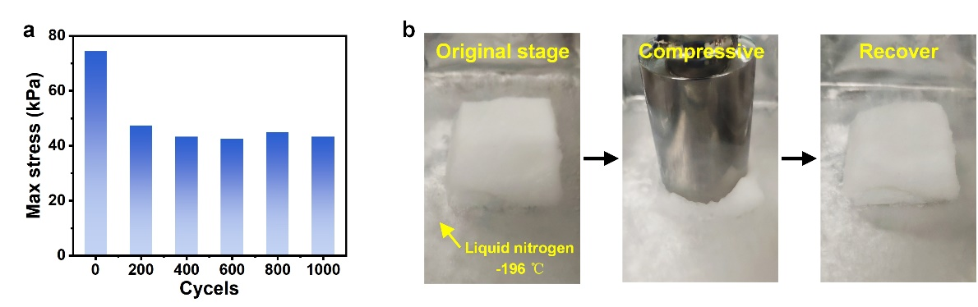
Fig. S11 a Max stress of MNFS under different cycles with strain of 50%. b Presentation showing that MNFS could maintain resilience in liquid nitrogen

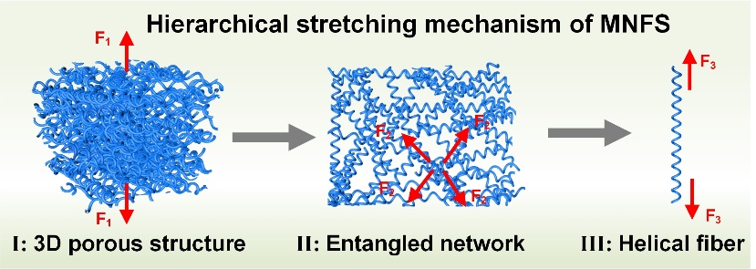
Fig. S12 The tensile fracture mechanism of MNFS

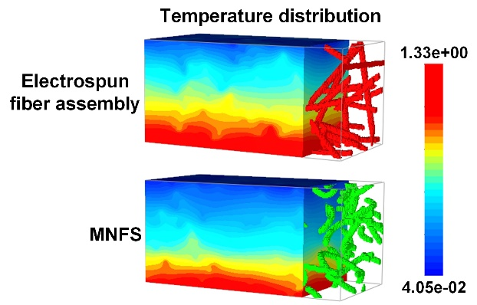
Fig. S13 The thermal transfer behavior models of electrospun fiber assembly and MNFS

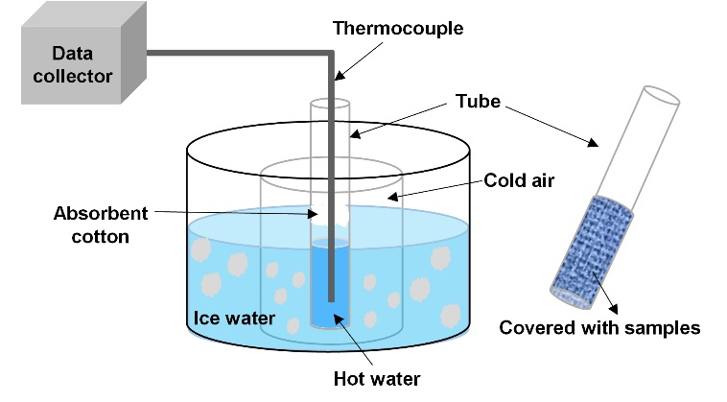
Fig. S14 Schematic illustration of the set-up for thermal insulation test
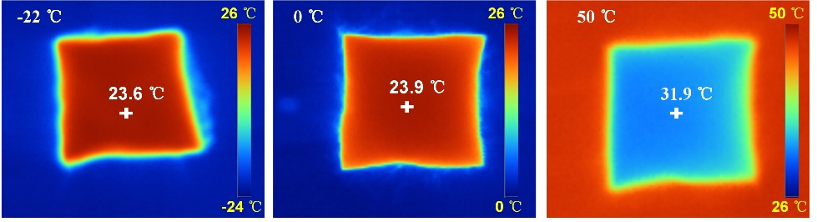
Fig. S15 Thermal insulation performance of MNFS under different temperature conditions
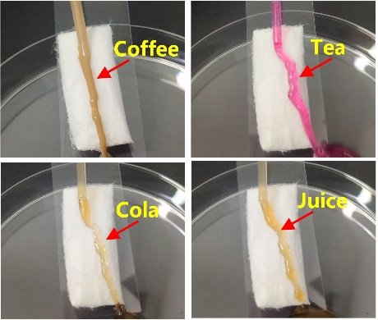
Fig. S16 Photographs showing the liquid-repellent properties of the MNFS
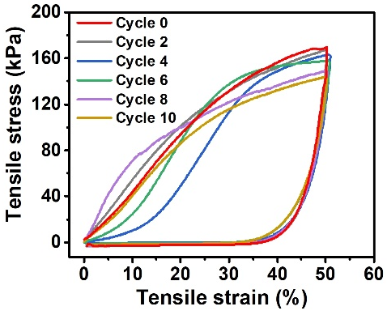
Fig. S17 Tensile stress-strain of MNFS under various washing cycles
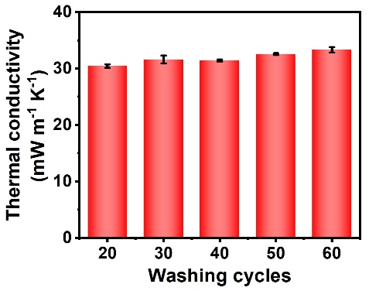
Fig. S18 Thermal conductivity of MNFS under various washing cycles
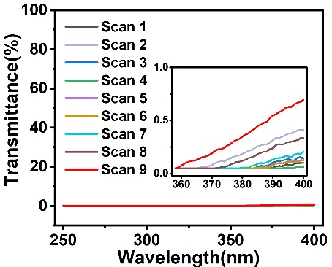
Fig. S19 The ultraviolet transmittance of MNFS

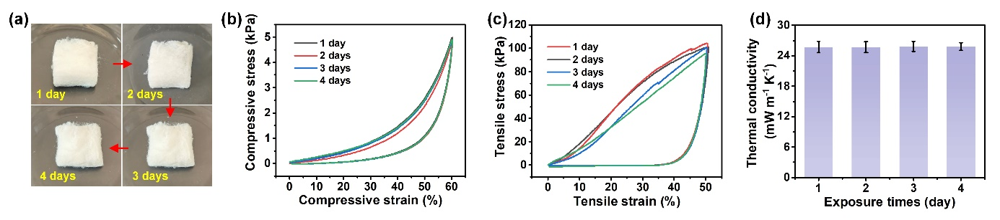
Fig. S20 The reliability and durability of MNFS. a morphology, b Compressive stress-strain, c Tensile stress-strain, and d thermal conductivity of MNFS under different exposure times
S2 Supplementary Tables
Table S1 The conductivity of the solution with different LiCl concentration and AC content
LiCl  [wt%] | AC  [wt%] | DMAc  [wt%] | Conductivity  [μS/cm]
0 | 20 | 80 | 6.5±0.02
0.002 | 20 | 80 | 15.6±0.05
0.004 | 20 | 80 | 25.0±0.17
0.006 | 20 | 80 | 33.5±0.1
0.004 | 40 | 60 | 26.3±0.16
0.004 | 60 | 40 | 26.8±0.2

Table S2 The comparison of the density, thermal conductivity, and mechanical properties for the commercial and reported thermal insulating materials
Component | Synthesis strategy |  | Density  [mg cm⁻³] |  | Thermal  conductivity  [mW m⁻¹ K⁻¹] | Tensile strength [kPa] | Compressive  strength  [kPa] |  | Reference
Commercial Cotton |  | / |  | 27.6 | 46.31 | 16.6 (50% strain) | 8.74 (70% strain) | Self testing
Commercial Polyester |  | / |  | 10.4 | 42.33 | 10.8 (50% strain) | 6.25 (80% strain) | Self testing
PI |  | Freeze-drying |  | 26 | 30.06 | 160 (25% strain) | ~160 (90% strain) | [1]
CNF/PPy/PU |  |  |  | 140-160 | 52-56 | None | None | [2]
Carbon/SiO₂  @CNTs |  |  |  | 40 | ~48 | None | 17.65 (75% strain) | [3]
SiBCN/SiC |  |  |  | 142 | 52 | None | None | [4]
Sodium alginate/ Al₂O₃ |  |  |  | 53 | 27.2 | None | 2100 (80% strain) | [5]
PPS |  |  |  | 6.4 | 28 | 8 (25% strain) | ~120 (95% strain) | [6]
BSiTa-PA |  | Ambient pressure drying |  | 180 | 49.6 | None | 768.7 (30% strain) | [7]
Zircon |  | Airflow- assisted spinning |  | 20 | 26 | 42.4 (18.5% strain) | ~90 (95% strain) | [8]
Polyimide |  |  |  | 50 | 37 | None | 15 (80% strain) | [9]
Yttria-stabilized zirconia |  |  |  | 65 | 21 | None | ~5 (50% strain) | [10]
Mullite |  | Electrospinning |  | 8 | 20 | 3.5 (20% strain) | ~3.7 (80% strain) | [11]
Zirconia-silica |  | Off-axial electrospinning |  | 8 | 24.6 | ~45 (150% strain) | 35 (90% strain) | [12]
PVDF |  | Multiple-jet electrospinning |  | 7.1 | 24.85 | 216 (200% strain) | 27 (80% strain) | This work
Table S3 The UV-resistance performance of MNFS
 | UPF | T(UVA)/% | T(UVB)/%
Number of Scans | 9 | 9 | 9
Mean | 1937.06 | 0.09 | 0.05%
STD | 89.45 | 0.05% | 0.00%
COV | 4.62% | 57.51% | 0.00%
Table S4 Performance requirement for difference application scenarios
Application scenarios | Component | Project | Index requirements |  | References
Aerospace | Cargo insulated containers | Working environments | Temperature (-30-45℃), relative humidity (100%) |  | GB/T 18433-2023
Transportation | Refrigerated trailers | Thermal conductivity (25℃)/[mW m⁻¹ K⁻¹] | ≤24 |  | GB/T 40363-2021
Building insulation | External Wall Insulation Modules | Thermal conductivity (25℃)/[mW m⁻¹ K⁻¹] | Grade 024 | ≤24 | GB/T 30595-2024
Building insulation | External Wall Insulation Modules | Thermal conductivity (25℃)/[mW m⁻¹ K⁻¹] | Grade 030 | ≤30 | GB/T 30595-2024
Building insulation | External Wall Insulation Modules | Thermal conductivity (25℃)/[mW m⁻¹ K⁻¹] | Grade 034 | ≤34 | GB/T 30595-2024
S3 Supplementary Captions for Movies S1 to S2
Movie S1: Demonstration of tensile fracture process of single helical fiber.
Movie S2: Demonstration of tensile and recovery process of single helical fiber.
Supplementary References
- Y. Pan, J. Zheng, Y. Xu, X. Chen, M. Yan et al., Ultralight, highly flexible in situ thermally crosslinked polyimide aerogels with superior mechanical and thermal protection properties via nanofiber reinforcement. J. Colloid Interface Sci. 628, 829–839 (2022). https://doi.org/10.1016/j.jcis.2022.07.144
- Y. Wang, L. Chen, H. Cheng, B. Wang, X. Feng et al., Mechanically flexible, waterproof, breathable cellulose/polypyrrole/polyurethane composite aerogels as wearable heaters for personal thermal management. Chem. Eng. J. 402, 126222 (2020). https://doi.org/10.1016/j.cej.2020.126222
- X. Wang, Y. Yuan, X. Sun, R. Qiang, Y. Xu et al., Lightweight, flexible, and thermal insulating carbon/SiO₂@CNTs composite aerogel for high-efficiency microwave absorption. Small 20(30), 2311657 (2024). https://doi.org/10.1002/smll.202311657
- J. Jiang, L. Yan, Y. Xue, J. Li, C. Zhang et al., Lightweight and thermally insulating polymer-derived SiBCN/SiCnw ceramic aerogel with enhanced electromagnetic wave absorbing performance. Chem. Eng. J. 482, 148878 (2024). https://doi.org/10.1016/j.cej.2024.148878
- H. Xu, C. Liu, W. Guo, N. Li, Y. Chen et al., Sodium alginate/Al₂O₃ fiber nanocomposite aerogel with thermal insulation and flame retardancy properties. Chem. Eng. J. 489, 151223 (2024). https://doi.org/10.1016/j.cej.2024.151223
- Y. Yu, C. Xu, Z. Hu, H. Xiang, J. Zhang et al., Industrial scale sea-island melt-spun continuous ultrafine fibers for highly comfortable insulated aerogel felt clothing. Adv. Mater. 36(52), 2414731 (2024). https://doi.org/10.1002/adma.202414731
- Z. Niu, F. Qu, F. Chen, X. Ma, B. Chen et al., Multifunctional integrated organic-inorganic-metal hybrid aerogel for excellent thermal insulation and electromagnetic shielding performance. Nano-Micro Lett. 16(1), 200 (2024). https://doi.org/10.1007/s40820-024-01409-1
- J. Guo, S. Fu, Y. Deng, X. Xu, S. Laima et al., Hypocrystalline ceramic aerogels for thermal insulation at extreme conditions. Nature 606(7916), 909–916 (2022). https://doi.org/10.1038/s41586-022-04784-0
- Y. Liu, X. Pan, Z. Zhou, Y. Xiao, H. Mei et al., Ultralight and elastic polyimide microtube aerogel via airflow-induced spinning. Adv. Mater. 2503499 (2025). https://doi.org/10.1002/adma.202503499
- L. Su, J. Lu, H. Zhang, X. Li, J. Wang et al., An ultralight all-fiber-structure sponge with thermal and electromagnetic integrated insulation property. J. Am. Ceram. Soc. 107(9), 5993–6003 (2024). https://doi.org/10.1111/jace.19902
- X. Chang, X. Cheng, X. Yin, R. Che, J. Yu et al., Multimode thermal gating based on elastic ceramic-carbon nanowhisker/nanofiber aerogels by strain engineering strategy. ACS Nano 19(10), 10421–10432 (2025). https://doi.org/10.1021/acsnano.5c00125
- S. Dang, J. Guo, Y. Deng, H. Yu, H. Zhao et al., Highly-buckled nanofibrous ceramic aerogels with ultra-large stretchability and tensile-insensitive thermal insulation. Adv. Mater. 37(4), 2415159 (2025). https://doi.org/10.1002/adma.202415159

