Supporting Information for
Lithium-Ion Dynamic Interface Engineering of Nano-Charged Composite Polymer Electrolytes for Solid-State Lithium-Metal Batteries
Shanshan Lv¹, Jingwen Wang¹, Yuanming Zhai², Yu Chen¹, Jiarui Yang¹, Zhiwei Zhu¹, Rui Peng¹, Xuewei Fu¹*, Wei Yang¹ and Yu Wang¹*
¹ College of Polymer Science and Engineering, National Key Laboratory of Advanced Polymer Materials, Sichuan University, Chengdu 610065, P. R. China
² Analytical & Testing Center, Sichuan University, Chengdu 610065, P. R. China
*Corresponding authors. E-mail: xuewei.fu@scu.edu.cn (Xuewei Fu); yu.wang3@scu.edu.cn (Yu Wang)
Supplementary Figures and Tables
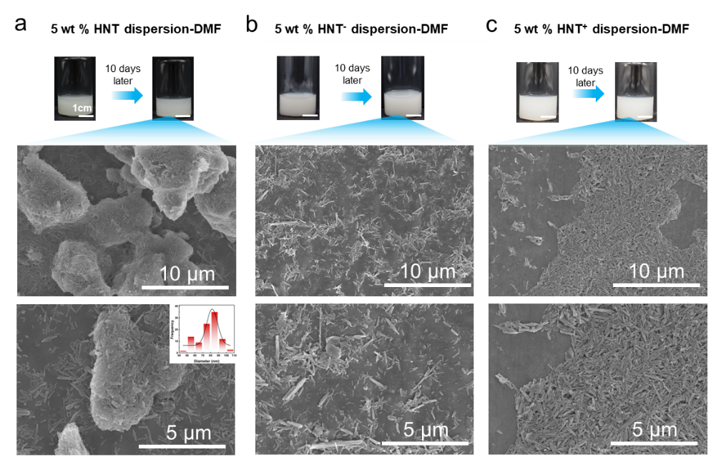
Fig. S1 SEM images of (a) HNT, (b) HNT⁻and (c) HNTs⁺

Fig. S2 Zeta potential curves of HNTs, HNTs⁻ and HNTs⁺
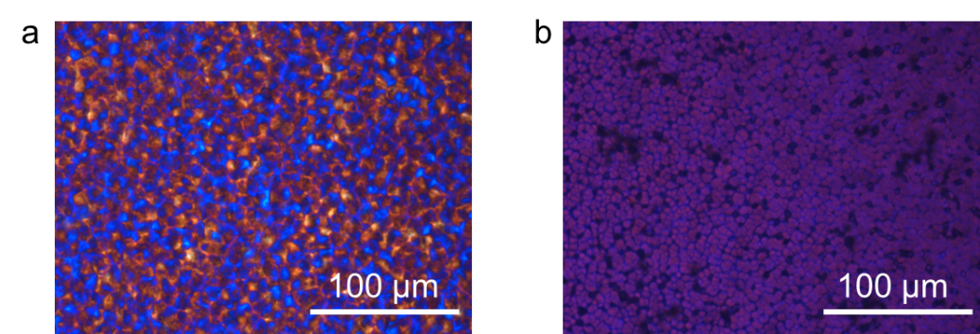
Fig. S3 Polarized optical microscopy images of (a) PVDF and (b) PVDF electrolyte
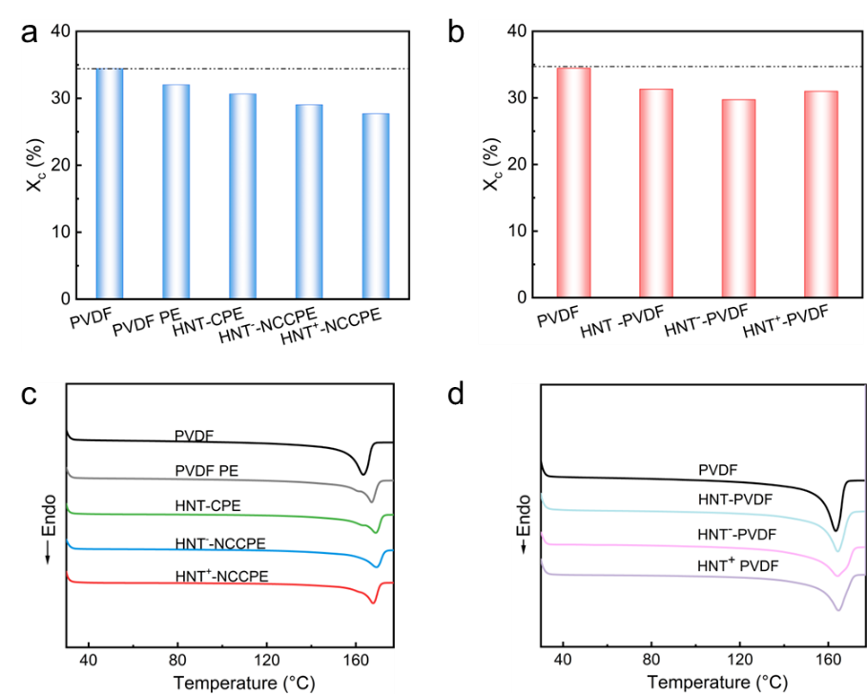
Fig. S4 (a) Crystallinity degree of PVDF-based electrolytes. (b) Crystallinity degree of PVDF-based films without LiTFSI. DSC curves of (c) PVDF-based electrolytes and (d) PVDF-based films without LiTFSI
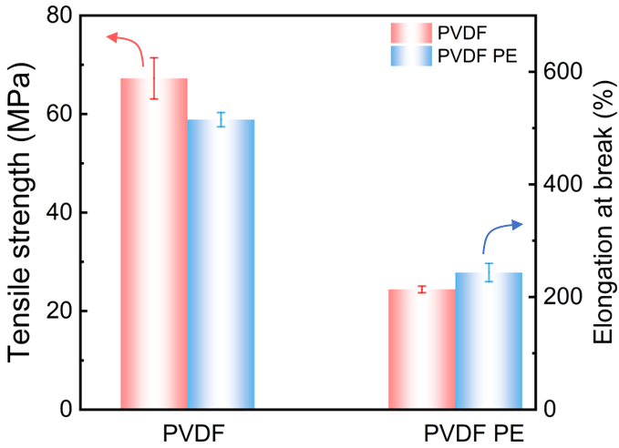
Fig. S5 Tensile strength and elongation at break of PVDF and PVDF electrolyte
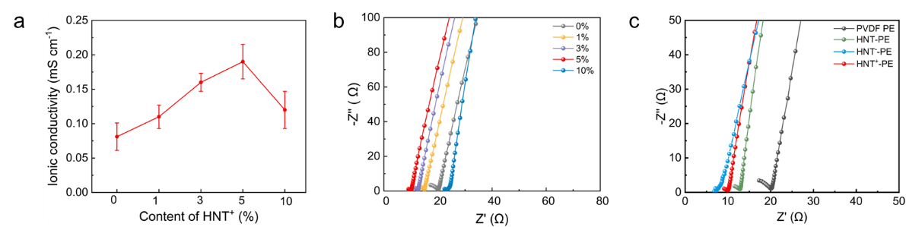
Fig. S6 (a) Ionic conductivity of HNT⁺-NCCPE with different contents of HNTs⁺. (b) EIS spectra of HNT⁺-NCCPE with different contents of HNTs⁺. (c) EIS spectra of different electrolytes

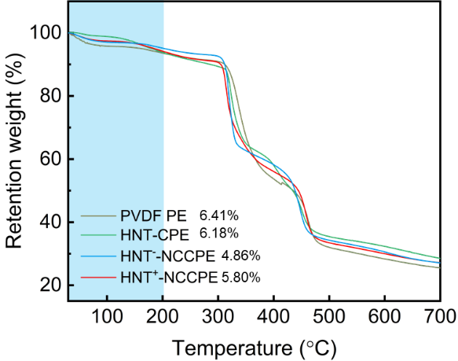
Fig. S7 TGA curves of PVDF-based electrolytes
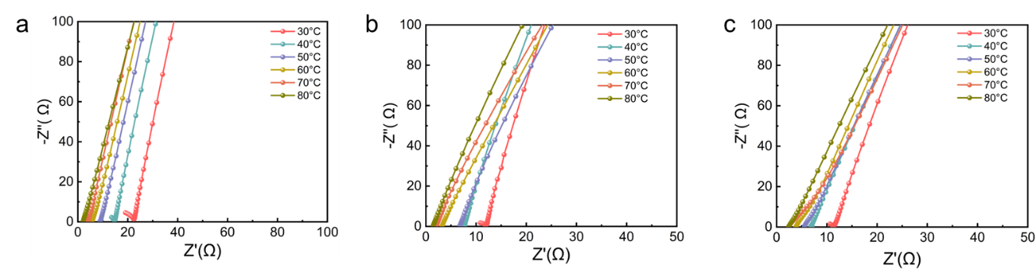
Fig. S8 EIS spectra of (a) PVDF electrolyte, (b) HNT-CPE, and (c) HNT⁺-NCCPE under varying temperatures

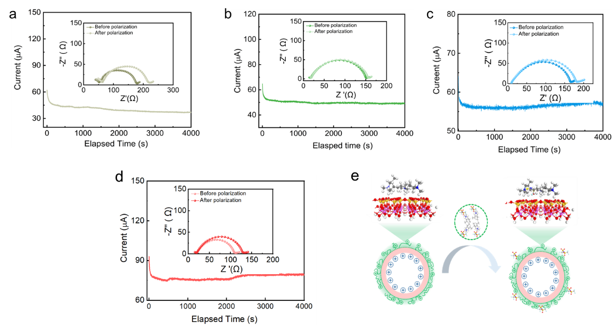
Fig. S9 Current-time curves and EIS spectra before and after the polarization of Li||Li symmetric cells with (a) PVDF electrolyte, (b) HNT-CPE, (c) HNT⁻-NCCPE, and (d) HNT⁺-NCCPE. (e) Illustration of the anchored TFSI⁻ by HNT⁺

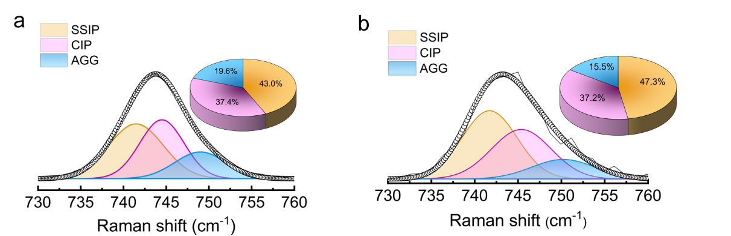
Fig. S10 Raman spectra of (a) PVDF electrolyte and (b) HNT-CPE

Fig. S11 LSV curves of various PVDF-based electrolytes
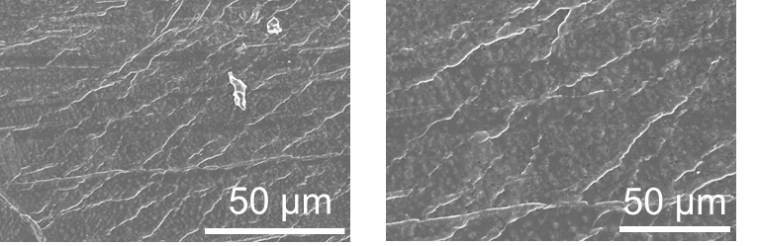
Fig. S12 SEM images of fresh lithium metal
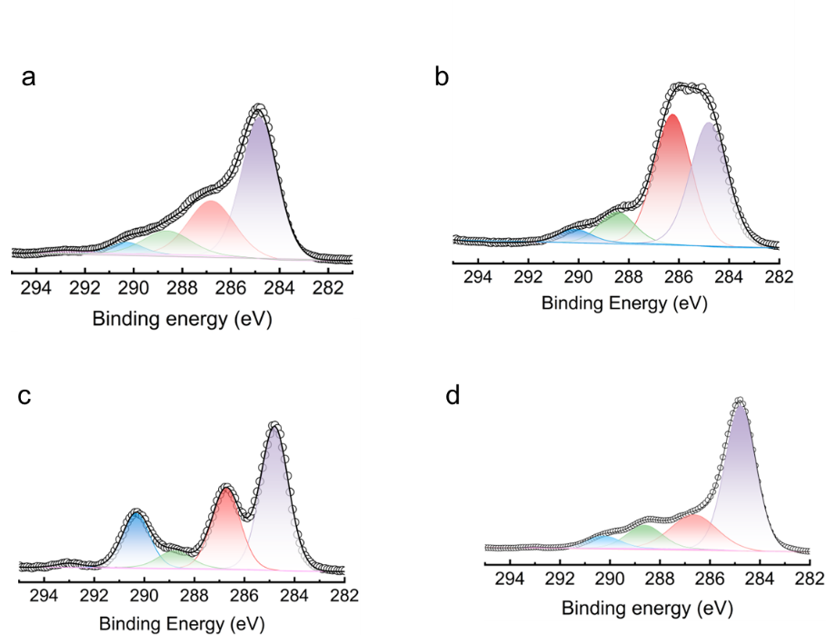
Fig. S13 C1s spectra of cycled lithium metal with (a) PVDF electrolyte, (b) HNT-CPE, (c) HNT⁻-NCCPE and (d) HNT⁺-NCCPE
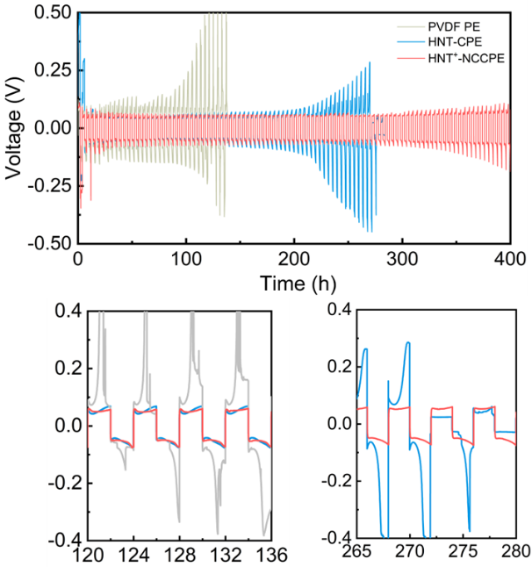
Fig. S14 Galvanostatic cycling profiles of Li||Li symmetric cells with PVDF electrolyte, HNT-CPE and HNT⁺-NCCPE

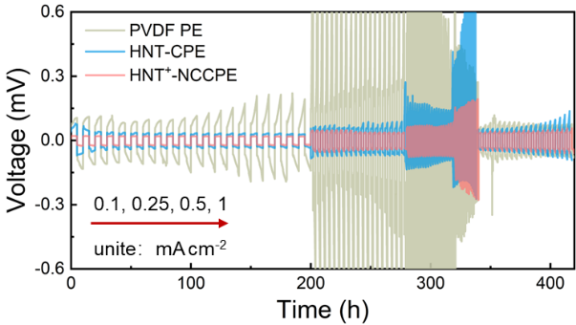

Fig. S15 Critical current density (CCD) profiles of Li||Li symmetric cells with PVDF electrolyte, HNT-CPE, and HNT⁺-NCCPE

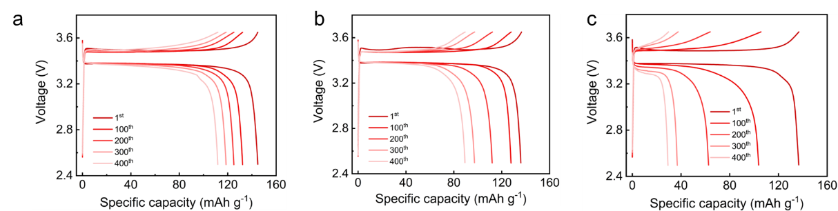
Fig. S16 Charge-discharge voltage profiles of LFP||Li cell with (a) HNT⁺-NCCPE, (b) HNT-CPE and (c) PVDF electrolyte at 0.5C

Fig. S17 Rate capability of LFP||Li cells with PVDF electrolyte, HNT-CPE and HNT⁺-NCCPE

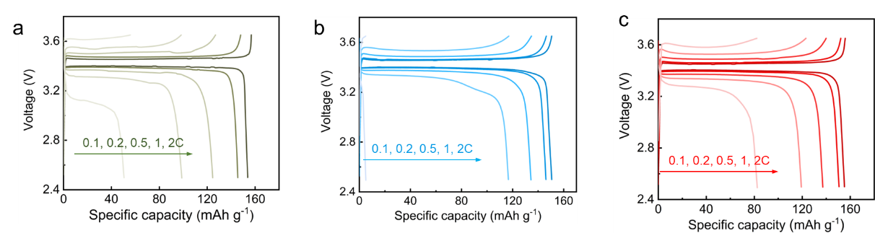
Fig. S18 Charge-discharge voltage profiles of LFP||Li cell with (a) PVDF electrolyte, (b) HNT-CPE and (c) HNT⁺-NCCPE
Fig. S19 Charge-discharge voltage profiles of NCM811||Li cell with PVDF electrolyte at 0.5 C
Fig. S20 Cycling stability of the NCM811|HNT⁺-NCCPE|Li cell at 0.5C in the voltage range of 2.8-4.4 V
Fig. S21 Charge-discharge voltage profiles of NCM811|HNT⁺-NCCPE|Li cell at 2.8-4.4 V
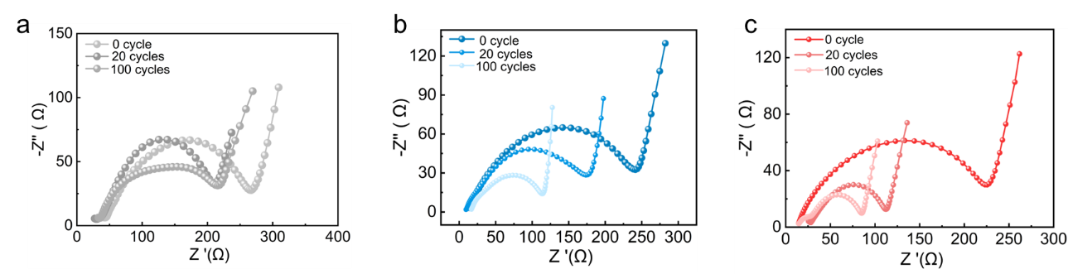
Fig. S22 Nyquist plots of the NCM811||Li half-cells after cycling with (a) PVDF electrolyte, (b) HNT-CPE, (c) HNT⁺-NCCPE
Table S1 The p-values and confidence intervals of mechanical strength of various electrolytes
Sample | H₀-Strength  (MPa) | p-value | confidence intervals
HNT-PVDF | 34.70 | 0.36 | [34.57, 35.01]
HNT-CPE | 19.13 | 0.57 | [19.04, 19.18]
HNT--PVDF | 45.87 | 0.88 | [44.98, 46.89]
HNT--NCCPE | 48.39 | 0.97 | [47.67, 49.09]
HNT+-PVDF | 45.09 | 0.18 | [45.02, 45.39]
HNT+-NCCPE | 32.46 | 0.30 | [31.84, 32.68]
Table S2 Comparison of Li⁺ transference number ($t_{{Li}^{+}}$) and mechanical strength of PVDF-based composite solid electrolytes
PVDF-based electrolyte | $$t_{{Li}^{+}}$$ | Strength (MPa) | References
h-PAN@MOF  /PVDF/LiFSI | 0.48 | 20.84 | Energy Environ. Sci., 2024,17, 8274-8283 [S1]
PVDF/PVA@STO/LiFSI | 0.43 | 8.02 | Energy Environ. Sci., 2025,18, 3730-3739 [S2]
PDOL@ZnO/PVDF-HFP | 0.59 | 15.8 | Adv. Energy Mater. 2025, 2501379 [S3]
BTO-MS HNFs/PVDF | 0.61 | 1.90 | Adv. Energy Mater. 2025, 15, 2405220 [S4]
F-PVDF | 0.69 | 6.3 | Adv. Mater. 2025, 2504419 [S5]
PI-PVDF-VS | 0.52 | 8.2 | Angew. Chem. Int. Ed. 2025, e202423227 [S6]
[EMIM][TFSI]@LZSP-PVDF | 0.81 | ≈11 | J. Am. Chem. Soc. 2024, 146, 10, 6591-6603 [S7]
BTO–LLTO-PVDF | 0.57 | 2.11 | Nat. Nanotechnol.2023 18, 602–610 [S8]
HNT⁺-NCCPE | 0.86 | 32.46 | This work
Table S3 Comparison of Li||Li symmetric battery performance
Electrolyte | Performance | References
PVDF/LiTFSI/LLZTO@PDA | 0.1 mA cm⁻²-0.1 mAh cm⁻² for 1000 h | Adv. Energy Mater. 2023, 13, 220437737 [S9]
PVDF/LiTFSI-LiDFOB-LiBF4 | 0.25 mA cm⁻²-0.25 mAh cm⁻² for 270 h | J. Am. Chem. Soc. 2023,145, 47, 25632-2564233 [S10]
PVDF/LiTFSI/DMIm | 0.1 mA cm⁻²-0.05 mAh cm⁻² for 800 h | Angew. Chem. Int. Ed.  2022, 61, e20220507536 [S11]
P(VDF-TrFE-CTFE)  /(Pyr13-TFSI) | 0.1 mA cm⁻²-0.05 mAh cm⁻² for 1500 h | Angew. Chem. Int. Ed.  2023, 62, e20230024338 [S12]
PVDF-HFP-LiTFSI-Fluorinated graphene | 0.2 mA cm⁻²-0.1 mAh cm⁻² for 500 h | Adv. Energy Mater. 2022, 2200967 [S13]
PVDF-HFP-LiTSI-(La_{0.7}Sr_{0.3})_{0.97}TiO₃ | 0.2 mA cm⁻²-0.1 mAh cm⁻² for 480 h | Adv. Mater. 2025, 37, 2419782 [S14]
P(VDF-TrFE-CTFE)-LiTFSI | 0.05 mA cm⁻² 0.05 mA cm⁻² for 1200 h | Energy Environ. Sci., 2021, 14, 6021–6029 [S15]
P(VDF-TrFE-CTFE)-LiFSI | 0.1 mA cm⁻² 0.1 mA cm⁻²  for 1200 h | Adv. Energy Mater. 2023, 2203888 [S16]
PVDF-HFP/LiTFSI | 0.3 mA cm⁻²-0.15 mAh cm⁻² for 300 h | Angew Chem Int Ed 2021; 60: 12931-1294038 [S17]
PEO-LiTFSI-BMI-Br | 0.3 mA cm⁻² for 500 h | Adv. Energy Mater. 2023, 13, 2301674 [S18]
β-zeolite-DBDPE-  LiTFSI-PVDF | 0.1 mA cm⁻²-5500 h | Small 2025, 21, 2406200 [S19]
PVDF-LiTFSI-LiDFOB-BTO | 0.2 mA cm⁻²-0.1 mAh cm⁻² for 5000 h | ACS Nano 2025, 19, 3, 3197–3209 [S20]
HNT⁺-NCCPE | 0.2 mA cm⁻²-0.2 mAh cm⁻² for 700 h | This work
HNT⁺-NCCPE | 0.25 mA cm⁻²-0.25 mAh cm⁻² for 400 h | This work
Table S4 Comparison of solid-state battery performance
Electrolyte | Areal Capacity  (mAh cm⁻²) |  | Current density (mA cm⁻²) | Cathode  material | Cycle number | References
PVDF/LiClO₄/  LLZTO |  | 0.342 | 0.1 | LCO | 120 | J Am Chem Soc 2017;139: 13779-13785 [S21]
PVDF/LiFSI |  | 0.504 | 0.15 | LCO | 200 | Adv Mater 2019; 31: 1806082 [S22]
PVDF-HFP/LiTFSI |  | 0.378 | 0.075 | NCM532 | 200 | Angew Chem Int Ed 2021; 60: 12931-1294038 [S17]
PVDF-HFP/LiTFSI/SiO₂ |  | 0.935 | 0.187 | LFP | 400 | Adv Mater 2022; 34: e220557546 [S23]
PVDF-HFP/LiTFSI/Fluorinated graphene |  | 0.342 | 0.342 | NCM622 | 300 | Adv Energy Mater 2022; 12: 2200967 [S13]
VEC/MASTFSILi/SN |  | 0.255 | 0.255 | LFP | 400 | Adv Mater 2022; 34:  e2202143 [S24]
IL/VEC/OFHDODA/LiTFSI |  | 0.187 | 0.099 | NCM532 | 200 | Nat Commun 2023; 14: 2301 [S25]
PVDF-HFP-LiTSI-(La_{0.7}Sr_{0.3})_{0.97}TiO₃ |  | 0.45 | 0.53 | LFP | 130 | Adv. Mater. 2025, 37, 2419782 [S14]
COF/LiClO₄ |  | 0.17 | 0.17 | LFP | 750 | Nat Commun 2022; 13: 2031 [S26]
HNT⁺-NCCPE |  | 0.45 | 0.26 | LFP | 400 | This work
Table S5 Comparison of electrochemical performance of various electrolytes
Sample | CE | CCD (mA cm⁻²) | Rct (after 100 cycles) | Capacity retention
PVDF PE | 80.75 ± 1.95% | 0.1 | 219 | 20.97%
HNT-CPE | 84.05 ± 1.40% | 0.5 | 135 | 65.03%
HNT⁺-NCCPE | 91.93±0.68% | 1 | 84 | 78.62%
Supplementary References
- Y. Ma, Y. Qiu, K. Yang, S. Lv, Y. Li et al., Competitive Li-ion coordination for constructing a three-dimensional transport network to achieve ultra-high ionic conductivity of a composite solid-state electrolyte. Energy Environ. Sci. 17(21), 8274–8283 (2024). https://doi.org/10.1039/D4EE03134B
- Y. Ma, L. Chen, Y. Li, B. Li, X. An et al., Mesoscale polymer regulation for fast-charging solid-state lithium metal batteries. Energy Environ. Sci. 18(8), 3730–3739 (2025). https://doi.org/10.1039/d5ee00203f
- H. Gao, Y. Zhou, K. Wang, B. Li, S. Wang et al., An in situ polymerized solid-state electrolyte for uniform lithium deposition via the piezoelectric effects. Adv. Energy Mater. 15(28), 2570123 (2025). https://doi.org/10.1002/aenm.202570123
- J. Shan, R. Gu, J. Xu, S. Gong, S. Guo et al., Heterojunction ferroelectric materials enhance ion transport and fast charging of polymer solid electrolytes for lithium metal batteries. Adv. Energy Mater. 15(18), 2405220 (2025). https://doi.org/10.1002/aenm.202405220
- X. Han, J. Lu, Q. Zou, H. Wang, M. Chen et al., Salt-segregated solid polymer electrolytes for high-rate solid-state lithium batteries. Adv. Mater. 37(24), e2504419 (2025). https://doi.org/10.1002/adma.202504419
- Z. Yang, B. Yang, S. Wang, J. Qian, Z. Hou et al., Multivariate distribution structured anisotropic inorganic polymer composite electrolyte for long-cycle and high-energy all-solid-state lithium metal batteries. Angew. Chem. Int. Ed. 64(30), e202423227 (2025). https://doi.org/10.1002/anie.202423227
- L. Zhu, J. Chen, Y. Wang, W. Feng, Y. Zhu et al., Tunneling interpenetrative lithium ion conduction channels in polymer-in-ceramic composite solid electrolytes. J. Am. Chem. Soc. 146(10), 6591–6603 (2024). https://doi.org/10.1021/jacs.3c11988
- P. Shi, J. Ma, M. Liu, S. Guo, Y. Huang et al., A dielectric electrolyte composite with high lithium-ion conductivity for high-voltage solid-state lithium metal batteries. Nat. Nanotechnol. 18(6), 602–610 (2023). https://doi.org/10.1038/s41565-023-01341-2
- Y. Xu, K. Wang, X. Zhang, Y. Ma, Q. Peng et al., Improved Li-ion conduction and (electro)chemical stability at garnet-polymer interface through metal-nitrogen bonding. Adv. Energy Mater. 13(14), 2204377 (2023). https://doi.org/10.1002/aenm.202204377
- M. Li, H. An, Y. Song, Q. Liu, J. Wang et al., Ion–dipole-interaction-induced encapsulation of free residual solvent for long-cycle solid-state lithium metal batteries. J. Am. Chem. Soc. 145(47), 25632–25642 (2023). https://doi.org/10.1021/jacs.3c07482
- X. Pei, Y. Li, T. Ou, X. Liang, Y. Yang et al., Li–N interaction induced deep eutectic gel polymer electrolyte for high performance lithium-metal batteries. Angew. Chem. Int. Ed. 61(31), e202205075 (2022). https://doi.org/10.1002/anie.202205075
- J.-F. Liu, Z.-Y. Wu, F.J. Stadler, Y.-F. Huang, High dielectric poly(vinylidene fluoride)-based polymer enables uniform lithium-ion transport in solid-state ionogel electrolytes. Angew. Chem. Int. Ed. 62(26), e202300243 (2023). https://doi.org/10.1002/anie.202300243
- P. Zhai, Z. Yang, Y. Wei, X. Guo, Y. Gong, Two-dimensional fluorinated graphene reinforced solid polymer electrolytes for high-performance solid-state lithium batteries. Adv. Energy Mater. 12(42), 2200967 (2022). https://doi.org/10.1002/aenm.202200967
- Y.-L. Liao, X.-L. Wang, H. Yuan, Y.-J. Li, C.-M. Xu et al., Ultrafast Li-rich transport in composite solid-state electrolytes. Adv. Mater. 37(10), e2419782 (2025). https://doi.org/10.1002/adma.202419782
- Y.-F. Huang, T. Gu, G. Rui, P. Shi, W. Fu et al., A relaxor ferroelectric polymer with an ultrahigh dielectric constant largely promotes the dissociation of lithium salts to achieve high ionic conductivity. Energy Environ. Sci. 14(11), 6021–6029 (2021). https://doi.org/10.1039/D1EE02663A
- Y.-F. Huang, J.-P. Zeng, S.-F. Li, C. Dai, J.-F. Liu et al., Conformational regulation of dielectric poly(vinylidene fluoride)-based solid-state electrolytes for efficient lithium salt dissociation and lithium-ion transportation. Adv. Energy Mater. 13(15), 2203888 (2023). https://doi.org/10.1002/aenm.202203888
- W. Liu, C. Yi, L. Li, S. Liu, Q. Gui et al., Designing polymer-in-salt electrolyte and fully infiltrated 3D electrode for integrated solid-state lithium batteries. Angew. Chem. Int. Ed. 60(23), 12931–12940 (2021). https://doi.org/10.1002/anie.202101537
- E. Kim, H. Jamal, I. Jeon, F. Khan, S.-E. Chun et al., Functionality of 1-butyl-2, 3-dimethylimidazolium bromide (BMI-Br) as a solid plasticizer in PEO-based polymer electrolyte for highly reliable lithium metal batteries (adv. energy mater. 47/2023). Adv. Energy Mater. 13(47), 2370192 (2023). https://doi.org/10.1002/aenm.202370192
- H. Lim, M.S. Chae, H. Jamal, F. Khan, I. Jeon et al., Triple-layered noncombustible PEO-based solid electrolyte for highly safe lithium-metal batteries. Small 21(14), e2406200 (2025). https://doi.org/10.1002/smll.202406200
- Y. Zhang, H. Liu, F. Liu, S. Zhang, M. Zhou et al., Dual-anion-rich polymer electrolytes for high-voltage solid-state lithium metal batteries. ACS Nano 19(3), 3197–3209 (2025). https://doi.org/10.1021/acsnano.4c09953
- X. Zhang, T. Liu, S. Zhang, X. Huang, B. Xu et al., Synergistic coupling between Li_{6.75}La₃Zr_{1.75}Ta_{0.25}O₁₂ and poly(vinylidene fluoride) induces high ionic conductivity, mechanical strength, and thermal stability of solid composite electrolytes. J. Am. Chem. Soc. 139(39), 13779–13785 (2017). https://doi.org/10.1021/jacs.7b06364
- X. Zhang, S. Wang, C. Xue, C. Xin, Y. Lin et al., Self-suppression of lithium dendrite in all-solid-state lithium metal batteries with poly(vinylidene difluoride)-based solid electrolytes. Adv. Mater. 31(11), 1806082 (2019). https://doi.org/10.1002/adma.201806082
- T. Zhang, J. Li, X. Li, R. Wang, C. Wang et al., A silica-reinforced composite electrolyte with greatly enhanced interfacial lithium-ion transfer kinetics for high-performance lithium metal batteries. Adv. Mater. 34(41), 2205575 (2022). https://doi.org/10.1002/adma.202205575
- K. Wen, C. Xin, S. Guan, X. Wu, S. He et al., Ion–dipole interaction regulation enables high-performance single-ion polymer conductors for solid-state batteries. Adv. Mater. 34(32), 2202143 (2022). https://doi.org/10.1002/adma.202202143
- L. Tang, B. Chen, Z. Zhang, C. Ma, J. Chen et al., Polyfluorinated crosslinker-based solid polymer electrolytes for long-cycling 4.5 V lithium metal batteries. Nat. Commun. 14(1), 2301 (2023). https://doi.org/10.1038/s41467-023-37997-6
- J. Li, J. Qi, F. Jin, F. Zhang, L. Zheng et al., Room temperature all-solid-state lithium batteries based on a soluble organic cage ionic conductor. Nat. Commun. 13(1), 2031 (2022). https://doi.org/10.1038/s41467-022-29743-1

