Supporting Information for
Moisture-Resistant Scalable Ambient-Air Crystallization of Perovskite Films via Self-Buffered Molecular Migration Strategy
Mei Yang¹, Weidong Zhu^{1*}, Laijun Liang¹, Wenming Chai¹, Xiaomeng Wu^{2*}, Zeyang Ren¹, Long Zhou³, Dazheng Chen¹, He Xi³, Chunfu Zhang ^{1*}, Jincheng Zhang¹, Yue Hao¹
¹State Key Laboratory of Wide-Bandgap Semiconductor Devices and Integrated Technology, Xidian University, Xi'an 710071, P. R. China
²School of Electronic Engineering, Xi’an Shiyou University, Xi’an 710065, P. R. China
³School of Advanced Materials and Nanotechnology, Xidian University, Xi’an 710126, P. R. China
*Corresponding authors. E-mail: wdzhu@xidian.edu.cn (Weidong Zhu); xmwudz@xsyu.edu.cn (Xiaomeng Wu); cfzhang@xidian.edu.cn (Chunfu Zhang)
Supplementary Figures and Tables
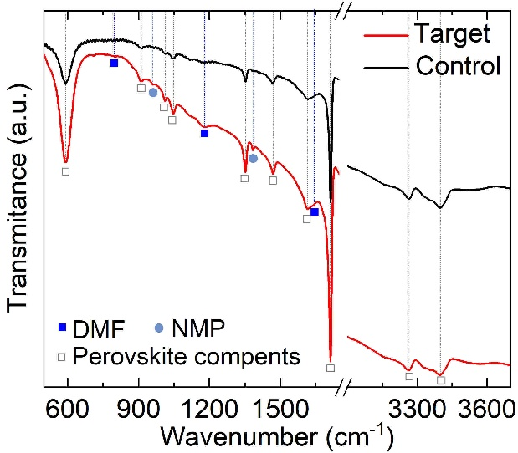
Fig. S1 FTIR spectra of control and target intermediate-phase films after being exposed to ambient air for about 120 min

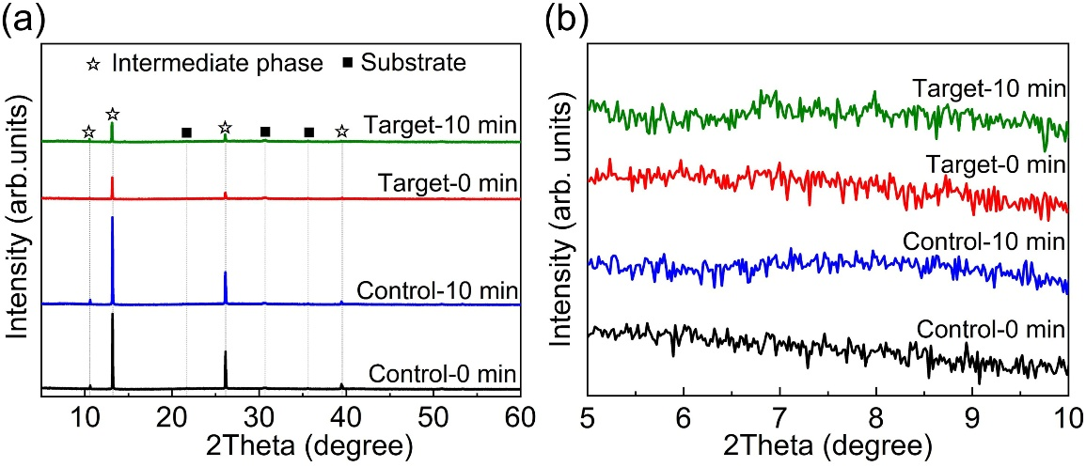
Fig. S2 a XRD patterns and b the magnified results in the range 2θ = 5°–10° for the control and target intermediate-phase films just exposure to ambient air (Conrol-0 min and Control-10 min) and exposed for 10 min (Target-0 min and Target-10 min)
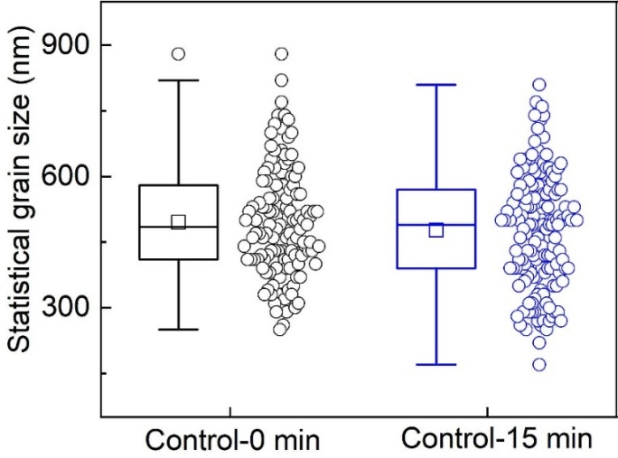
Fig. S3 Statistical grain sizes of control and target perovskite films obtained with 0- and 15-min ambient-air exposure
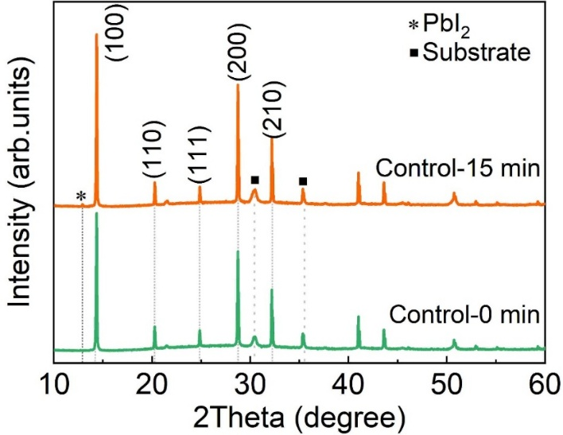
Fig. S4 XRD patterns of the control perovskite films obtained with 0- and 15-min ambient-air loading and prepared in ambient air with RH of below 20%
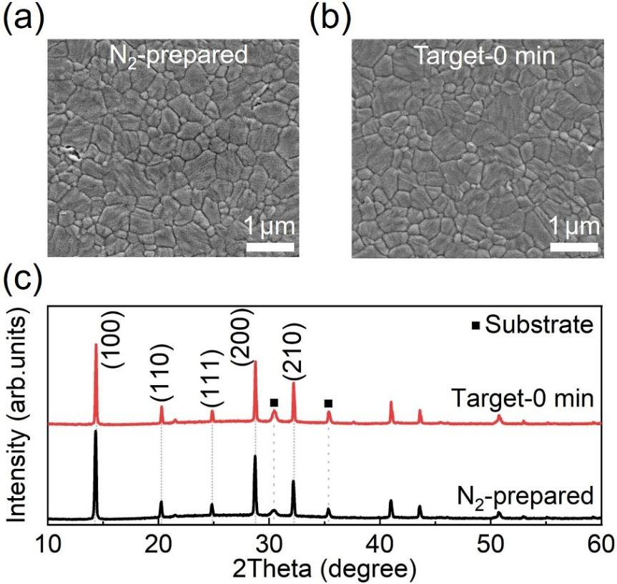
Fig. S5 SEM images of a the perovskite film produced in glovebox (labeled as N₂-preapred) and b the target perovskite film prepared with 0-min ambient-air exposure. c The corresponding XRD patterns
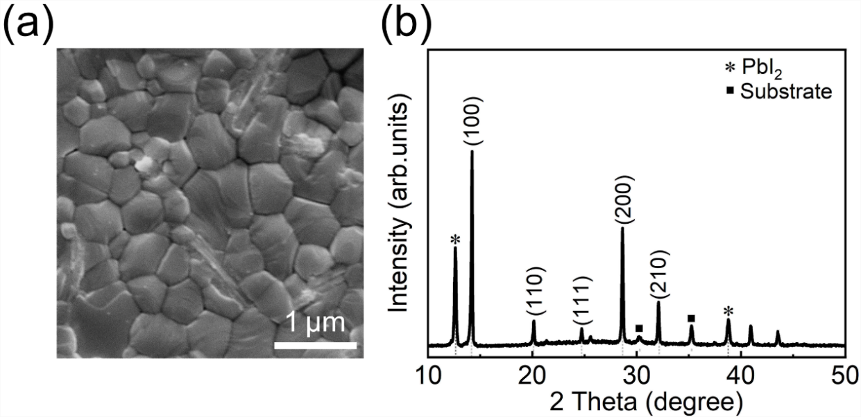
Fig. S6 a SEM image and b XRD pattern of perovskite film prepared by use of pure IPA solvent and with 0 min ambient-air exposure before annealing

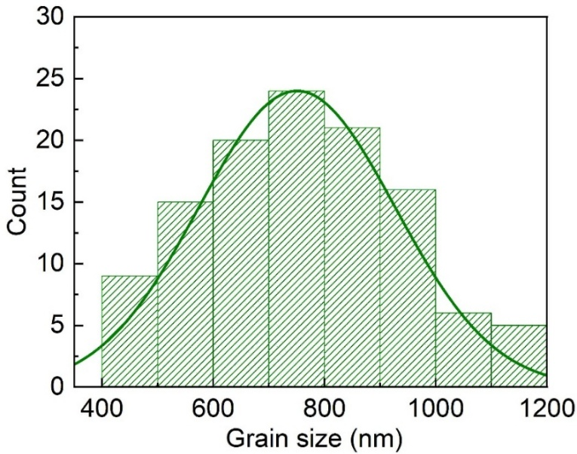
Fig. S7 Statistical grain sizes for the target sample obtained with 15-min ambient-air exposure

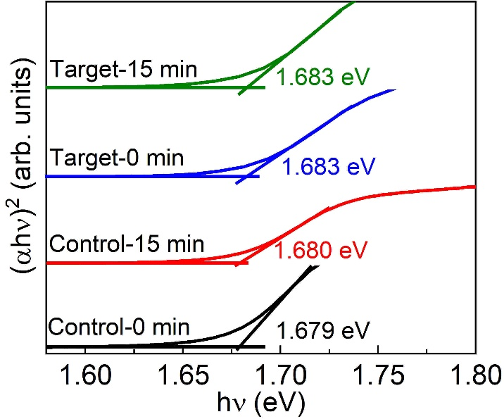
Fig. S8 Tauc plots derived from the absorption spectra of the control and target perovskite films obtained with 0- and 15-min ambient exposure

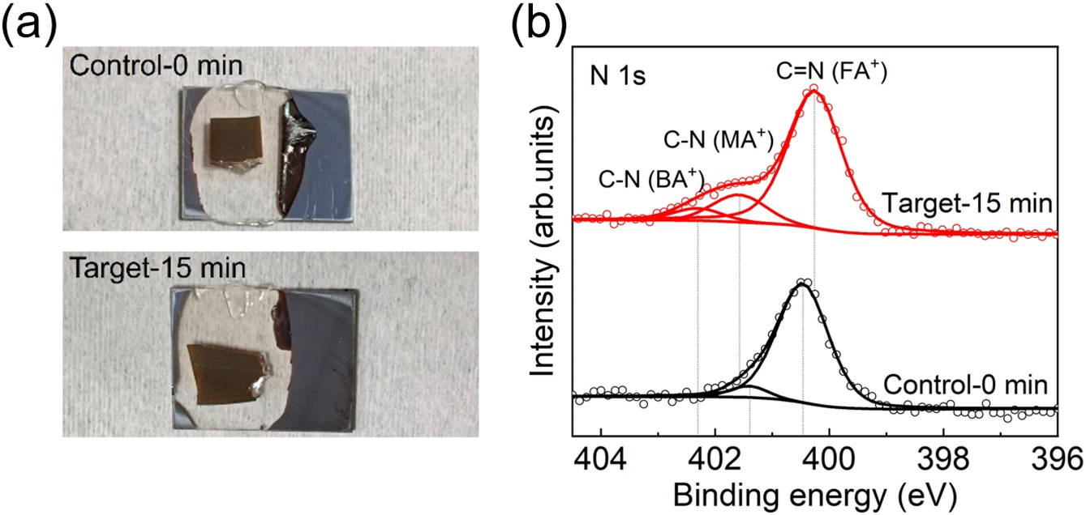

Fig. S9 a Photographs and b core-level N 1s spectra of the delaminated control-0 min and target-15min films

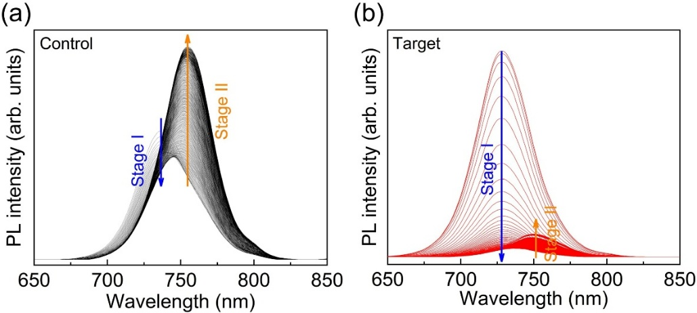

Fig. S10 Re-plotted in-situ PL spectra for a control and b target intermediate-phase films exposed to ambient air with RH of 60-80%
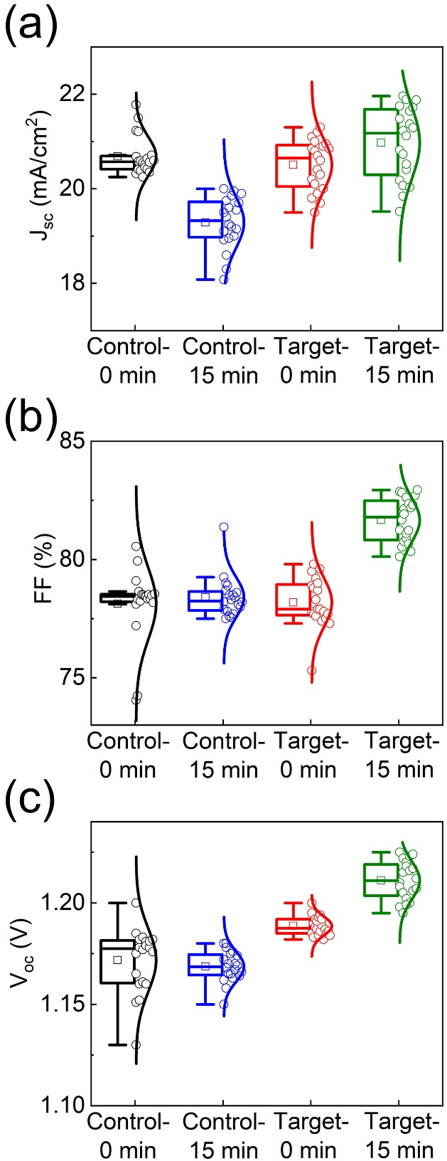

Fig. S11 Statistical a J_{sc}s, b FFs, and c V_{oc}s for 20 individual control and target PSCs fabricated with 0- and 15-min ambient-air exposure

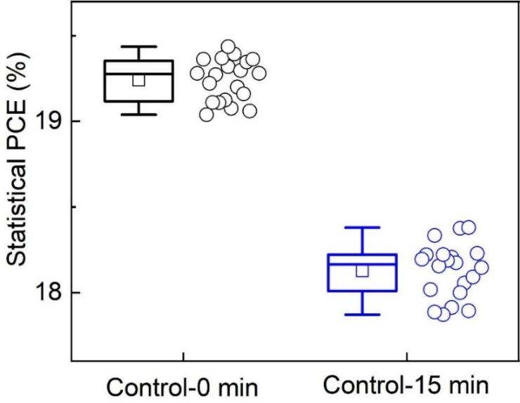
Fig. S12 Statistical RS PCEs for the control PSCs fabricated with 0- and 15-min ambient-air exposure. During the device fabrication process, the RH of ambient air was controlled to 30~40%

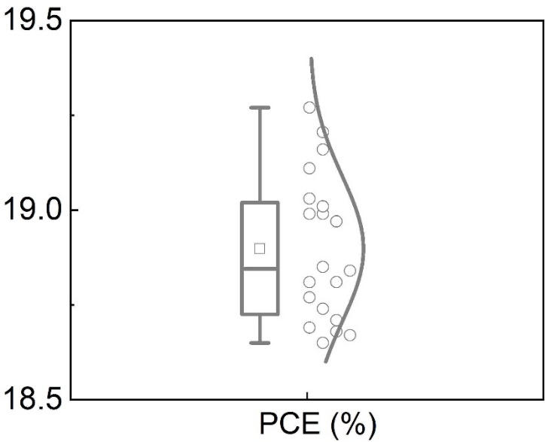
Fig. S13 Statistical RS PCEs for the PSCs fabricated in glovebox and with coating of BABr layer

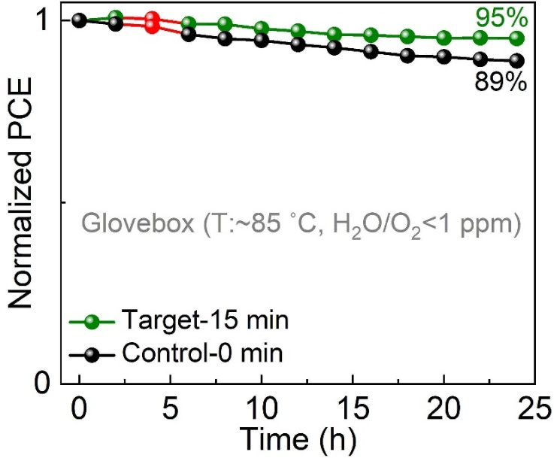
Fig. S14 Thermal stability test results measured at ~85 ℃ and glovebox (H₂O/O₂ < 1ppm) for the control PSC (0-min ambient-air exposure) and target PSC (15-min ambient-air exposure)
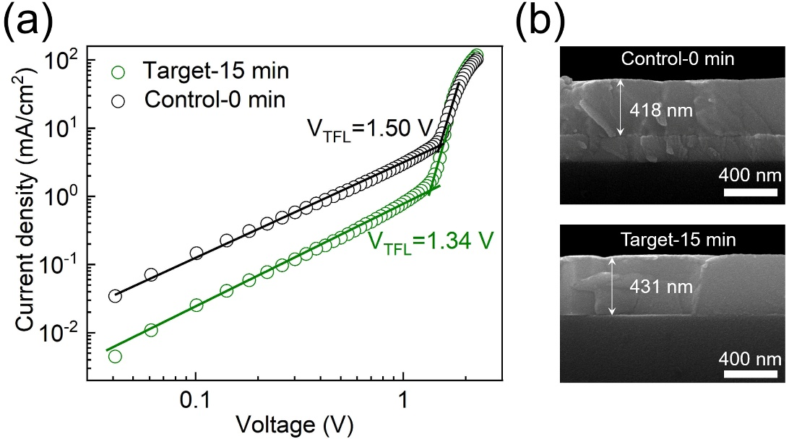
Fig. S15 a SCLC analysis of hole-transport-only devices (ITO/NiO_{x}/perovskite/Spiro-OMeTAD/Ag) based on the control film (0-min ambient-air exposure) and target film (15-min ambient-air exposure). b Cross-sectional SEM images of control film (0-min ambient-air exposure) and target film (15-min ambient-air exposure)
From Fig. S15(a), the trap-filled limit voltages (V_{TFL}s) were determined to 1.50 and 1.34 V for control film (0-min ambient-air exposure) and target film (15-min ambient-air exposure), respectively. The trap density (N_{t}) can be correlated with the V_{TFL} by following N_{t}=2V_{TFL}ε_{r}ε₀/eL², for which L is the thickness of perovskite film that can be determined from the cross-sectional SEM images in Fig. S15(b), ε₀ stands for the vacuum permittivity (8.8542×10⁻¹⁴ F/m), ε_{r} represents the relative dielectric constant of perovskite film (32), and e is the elementary charge (1.602×10⁻¹⁹ C). In this manner, the trap densities were determined to 3.04×10¹⁶ and 2.55×10¹⁶ cm⁻³ for the control film (0-min ambient-air exposure) and target film (15-min ambient-air exposure), respectively.

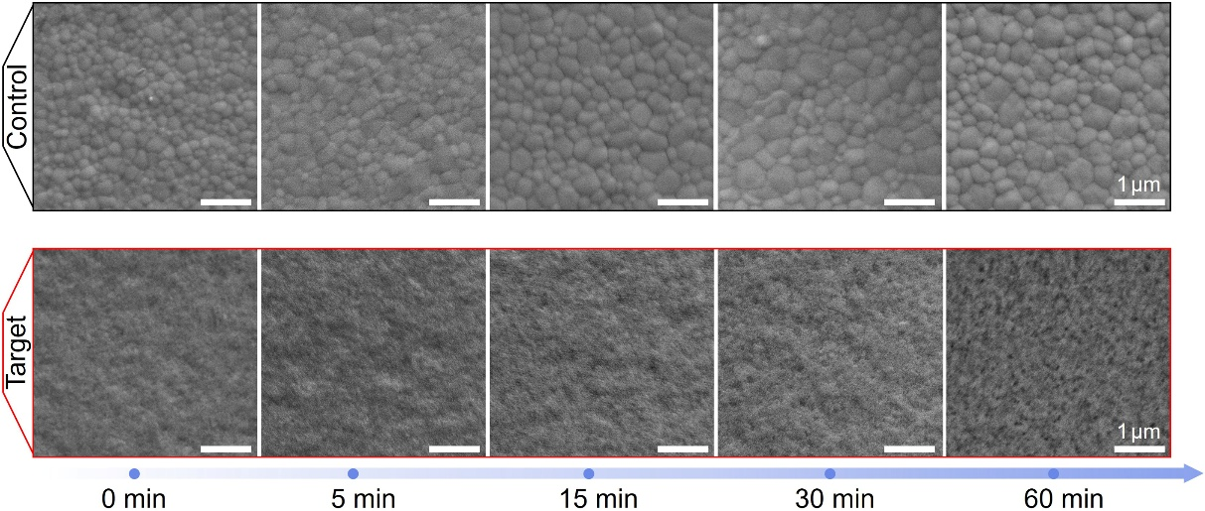
Fig. S16 SEM images of the 1.53 eV-bandgap intermediate-phase films with the ambient-air exposure duration of 0, 5, 15, 30, and 60 min

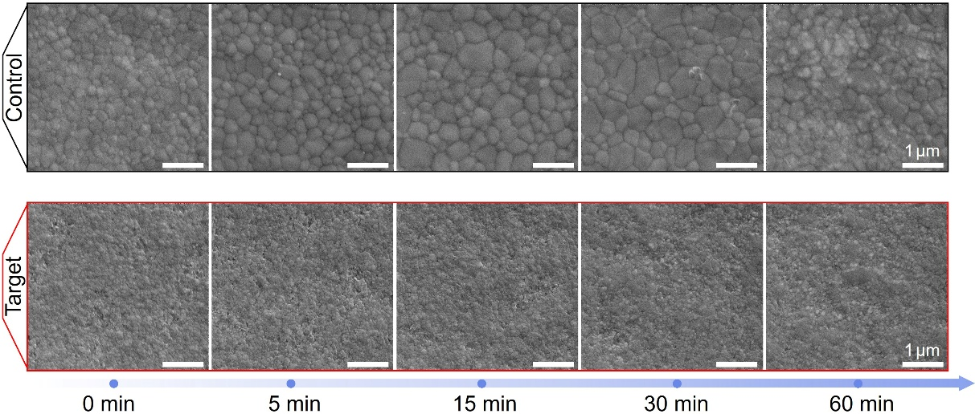
Fig. S17 SEM images of the 1.77 eV-bandgap intermediate-phase films with the ambient-air exposure duration of 0, 5, 15, 30, and 60 min
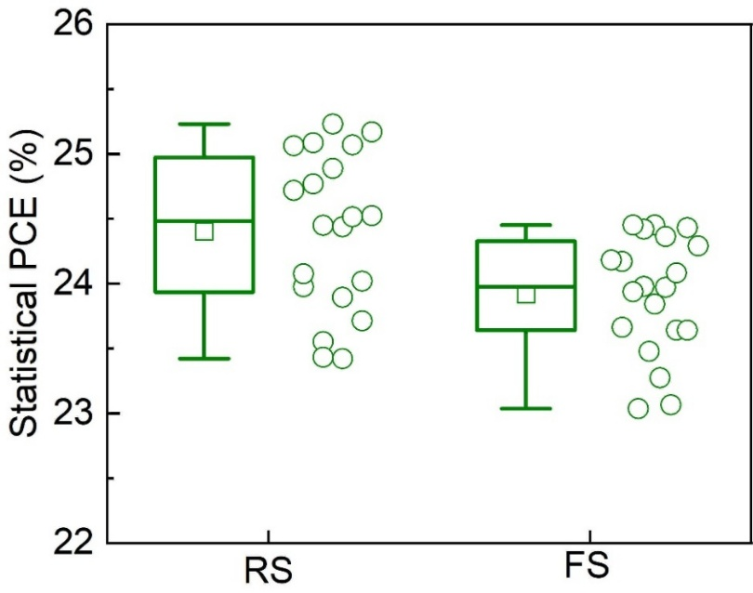
Fig. S18 Statistical RS and FS PCEs for the target PSCs based on 1.53 eV-bandgap perovskite films

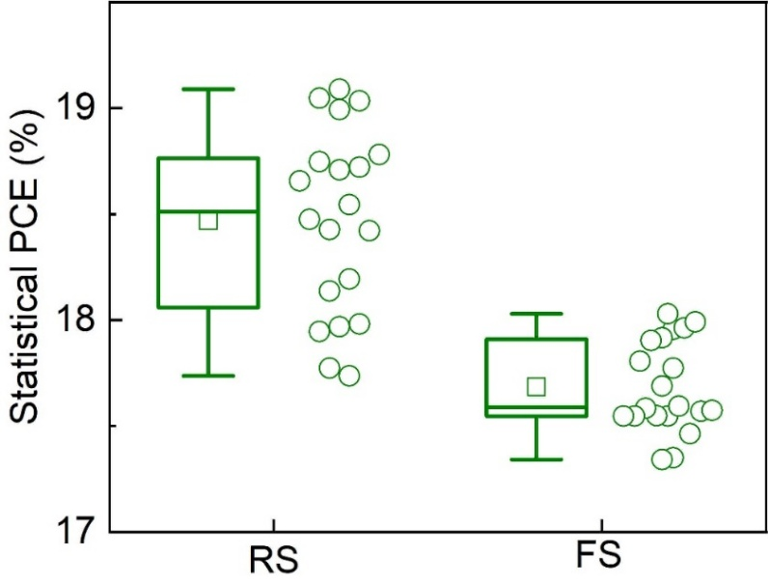
Fig. S19 Statistical RS and FS PCEs for the target PSCs based on 1.77 eV-bandgap perovskite films
Table S1 Photovoltaic performance parameters recorded under RS for best-performing control and target PSCs fabricated with 0- and 15-min ambient-air exposure
Samples | J_{sc} (mA/cm²) | Voltage (V) | FF (%) | PCE (%)
Control-0 min | 20.54 | 1.180 | 78.26 | 18.97
Control-15 min | 19.31 | 1.176 | 79.09 | 17.96
Target-0 min | 20.37 | 1.191 | 78.58 | 19.06
Target-15 min | 20.96 | 1.231 | 82.16 | 21.20
Table S2 Photovoltaic performance parameters recorded under RS for the best-performing PSCs assembled with different shielding layers and 30-min ambient-air exposure
Samples | V_{oc} (V) | J_{sc}(mA/cm²) | FF (%) | PCE (%)
Target-30 min MACl | 1.222 | 21.43 | 80.97 | 21.20
Target-30 min CF₃PEACl | 1.200 | 21.47 | 82.06 | 21.14
Target-30 min PEACl | 1.214 | 21.93 | 79.24 | 21.09
Target-30 min CF₃PEABr | 1.194 | 21.32 | 79.21 | 20.16
Target-30 min OABr | 1.160 | 21.69 | 79.85 | 20.09
Table S3 Summary of the historical RS PCEs, J_{sc}s, V_{oc}s, and FFs of the n-i-p structured PSCs based on 1.68 eV-bandgap perovskite films prepared in N₂-atomopshere and ambient air
Preparation atmosphere | V_{oc} (V) | J_{sc} (mA/cm²) | FF (%) | PCE (%) | Publication  year | Refs
Ambient air | 1.220 | 22.00 | 82.3 | 22.09 | 2025 | This work
Ambient air | 1.2 | 22.72 | 80.3 | 21.9 | 2024 | [S1]
Ambient air | 1.139 | 20.73 | 78.7 | 18.59 | 2024 | [S2]
Ambient air | 1.255 | 20.31 | 79.0 | 20.08 | 2023 | [S3]
Ambient air | 1.2 | 20.68 | 81.87 | 20.32 | 2022 | [S4]
Ambient air | 1.22 | 20.38 | 77.22 | 19.24 | 2021 | [S5]
N₂ atmosphere | 1.22 | 21.27 | 79.2 | 20.55 | 2025 | [S6]
N₂ atmosphere | 1.282 | 22.43 | 81.2 | 23.35 | 2024 | [S7]
N₂ atmosphere | 1.212 | 22.52 | 83.13 | 22.69 | 2024 | [S8]
N₂ atmosphere | 1.214 | 20.49 | 82.49 | 20.34 | 2024 | [S9]
N₂ atmosphere | 1.249 | 20.31 | 81.25 | 20.61 | 2024 | [S10]
N₂ atmosphere | 1.21 | 21.8 | 77.3 | 20.4 | 2024 | [S11]
N₂ atmosphere | 1.25 | 21.85 | 77.66 | 21.12 | 2023 | [S12]
N₂ atmosphere | 1.17 | 21.81 | 81.90 | 20.90 | 2023 | [S13]
N₂ atmosphere | 1.22 | 20.6 | 76.9 | 19.3 | 2023 | [S14]
N₂ atmosphere | 1.256 | 20.43 | 78.71 | 20.2 | 2022 | [S15]
N₂ atmosphere | 1.233 | 20.5 | 71.6 | 18.1 | 2022 | [S16]
N₂ atmosphere | 1.195 | 19.95 | 78.2 | 18.64 | 2021 | [S17]
Supplementary References
- T. Dong, L. Tan, Z. Li, J. Li, H. Li et al., Enhanced efficiency and intrinsic stability of wide-bandgap perovskite solar cells through dimethylamine-based cation engineering. Chem. 31(4), e202403527 (2025). https://doi.org/10.1002/chem.202403527
- T. Yang, D. Huang, Z. Wang, F. Li, J. Gong et al., Manipulating wide-band-gap perovskite compositions via Br sources for highly efficient perovskite/silicon tandem solar cells. ACS Appl. Energy Mater. 7(14), 5755–5764 (2024). https://doi.org/10.1021/acsaem.4c00822
- X. Zhang, X. Li, L. Tao, Z. Zhang, H. Ling et al., Precise control of crystallization and phase-transition with green anti-solvent in wide-bandgap perovskite solar cells with open-circuit voltage exceeding 1.25 V. Small 19(22), 2208289 (2023). https://doi.org/10.1002/smll.202208289
- X. Sun, Z. Shao, Z. Li, D. Liu, C. Gao et al., Highly efficient CsPbI3/Cs_{1-x}DMAxPbI3 bulk heterojunction perovskite solar cell. Joule 6(4), 850–860 (2022). https://doi.org/10.1016/j.joule.2022.02.004
- B. Chen, P. Wang, R. Li, N. Ren, Y. Chen et al., Composite electron transport layer for efficient N-I-P type monolithic perovskite/silicon tandem solar cells with high open-circuit voltage. J. Energy Chem. 63, 461–467 (2021). https://doi.org/10.1016/j.jechem.2021.07.018
- X. Chen, Z. Yuan, S. Fan, X. Feng, X. Sun et al., Enhanced light transmittance of electron transport layer through bilayer SnO₂ for high-performance semitransparent perovskite solar cells. ChemSusChem 18(11), e202402582 (2025). https://doi.org/10.1002/cssc.202402582
- Q. Ye, W. Hu, J. Zhu, Z. Cai, H. Zhang et al., Suppressing charge recombination in a methylammonium-free wide-bandgap perovskite film for high-performance and stable perovskite solar cells. Energy Environ. Sci. 17(16), 5866–5875 (2024). https://doi.org/10.1039/D4EE00666F
- D. Ding, Y. Yao, P. Hang, C. Kan, X. Lv et al., Visualizing the structure-property nexus of wide-bandgap perovskite solar cells under thermal stress. Adv. Sci. 11(29), 2401955 (2024). https://doi.org/10.1002/advs.202401955
- J. Shen, X. Ge, Q. Ge, N. Li, Y. Wang et al., Improvement of photovoltaic performance of perovskite solar cells by synergistic modulation of SnO₂ and perovskite via interfacial modification. ACS Appl. Mater. Interfaces 16(19), 24748–24759 (2024). https://doi.org/10.1021/acsami.4c03595
- H. Yang, K. Wu, H. Guo, J. Wei, J. Guo et al., Crystallinity control and strain release in wide-bandgap perovskite film via seed-induced growth for efficient photovoltaics. ACS Appl. Mater. Interfaces 16(32), 42566–42576 (2024). https://doi.org/10.1021/acsami.4c08445
- S. Zhang, J. Wang, N. Kalasariya, P. Dally, C. Deger et al., Mitigating buried-interface energy losses through multifunctional ligands in n–i–p perovskite/silicon tandem solar cells. ACS Energy Lett. 9(9), 4633–4644 (2024). https://doi.org/10.1021/acsenergylett.4c01841
- Z. Li, X. Li, X. Feng, X. Chen, J. Chen et al., Strain control of mixed-halide wide-bandgap perovskites for highly efficient and stable solar cells. Sol. RRL 7(22), 2300615 (2023). https://doi.org/10.1002/solr.202300615
- X. Niu, N. Li, Z. Cui, L. Li, F. Pei et al., Anion confinement for homogeneous mixed halide perovskite film growth by electrospray. Adv. Mater. 35(45), 2305822 (2023). https://doi.org/10.1002/adma.202305822
- J. Zhao, A.S.R. Chesman, J. Yan, L.J. Sutherland, J. Jasieniak et al., Precursor engineering of lead acetate-based precursors for high-open-circuit voltage wide-bandgap perovskite solar cells. ACS Appl. Mater. Interfaces 15(15), 18800–18807 (2023). https://doi.org/10.1021/acsami.2c22179
- J. Tao, Z. Yu, X. Liu, J. Xue, J. Shen et al., A facile strategy to adjust SnO₂/perovskite interfacial properties for high-efficiency perovskite solar cells. J. Mater. Chem. C 10(21), 8414–8421 (2022). https://doi.org/10.1039/D2TC00818A
- Z. Su, D. Xu, Q. Ma, K. Gao, C. Zhang et al., Atomic layer deposited ZnO–SnO₂ electron transport bilayer for wide-bandgap perovskite solar cells. Sol. RRL 7(3), 2201026 (2023). https://doi.org/10.1002/solr.202201026
- X. Cui, P. Wang, B. Shi, Y. Zhao, X. Zhang, Insights into the effect of bromine-based organic salts on the efficiency and stability of wide bandgap perovskite. Nano Sel. 2(3), 615–623 (2021). https://doi.org/10.1002/nano.202000183

