Supporting Information for
Gas Phase Construction of Compact Capping Layers for High-Performance Halide Perovskite X-Ray Detectors
Bin Zhang^{1, 2,} †, Chuanyun Hao^{1,} †, Shoufeng Zhang^{3,} †, Bin Xue¹, Xiangfan Xie¹, Shengqiao Zeng¹, Bin Yang¹, Fang Xu¹, Hui Li¹, Xin’an Zhang¹, Zhang Qu¹, Kaihang Ye⁴, Guangda Niu^{5, 6}, Wallace C. H. Choy⁷, Kezhou Fan⁸, Kam Sing Wong⁸, Lei Yan², Xingzhu Wang^{2,} *, Shuang Xiao^{1,} *, Cangtao Zhou¹
¹ Shenzhen Key Laboratory of Ultraintense Laser and Advanced Material Technology, Center for Intense Laser Application Technology (iLaT) and College of Engineering Physics, Shenzhen Technology University, Shenzhen 518118, P. R. China
² Engineering and Research Center for Integrated New Energy Photovoltaics & Energy Storage Systems of Hunan Province and School of Electrical Engineering, University of South China, Hengyang 421001, P. R. China
³ School of Electrical Engineering, Guangxi University of Science and Technology, Liuzhou 545006, P. R. China
⁴ Institute for Sustainable Transformation School of Chemical Engineering and Light Industry, Guangdong University of Technology, Guangzhou 510006, P. R. China
⁵ Research Institute of Huazhong University of Science and Technology in Shenzhen, Shenzhen 518052, P. R. China
⁶ Wuhan National Laboratory for Optoelectronics, Huazhong University of Science and Technology, Wuhan 430074, P. R. China
⁷ Department of Electrical and Electronic Engineering, The University of Hong Kong, Pokfulam Road, Hong Kong SAR, P. R. China
⁸ Department of Physics and William Mong Institute of Nano Science and Technology, The Hong Kong University of Science and Technology, Clear Water Bay, Kowloon, Hong Kong S.A.R., P. R. China
†Bin Zhang, Chuanyun Hao, and Shoufeng Zhang contributed equally to this work.
*Corresponding authors. E-mail: 2022000041@usc.edu.cn (Xingzhu Wang); xiaoshuang@sztu.edu.cn (Shuang Xiao)
DFT Calculations
The first-principles calculations were performed using the Vienna Ab initio Simulation Package (VASP, version5.4.4) [S1, S2] with standard projector augmented-wave (PAW) method and the exchange-correlation functional for generalized gradient approximation (GGA) in PBE format [S1]. The energy cut-off was set as 450 eV with energy convergence criterion of 10⁻⁵ eV and force converged accuracy of 0.01 eV/Å. A 233 k-points mesh was set in the Brillouin zone for all DFT calculations. The DFT-D3(Grimme 2006) [S2] was used to describe the vdW-interaction of organic-inorganic interfaces. The post-processing of the energy calculations was obtained by VASPKIT toolkit.
Supplementary Figures and Tables
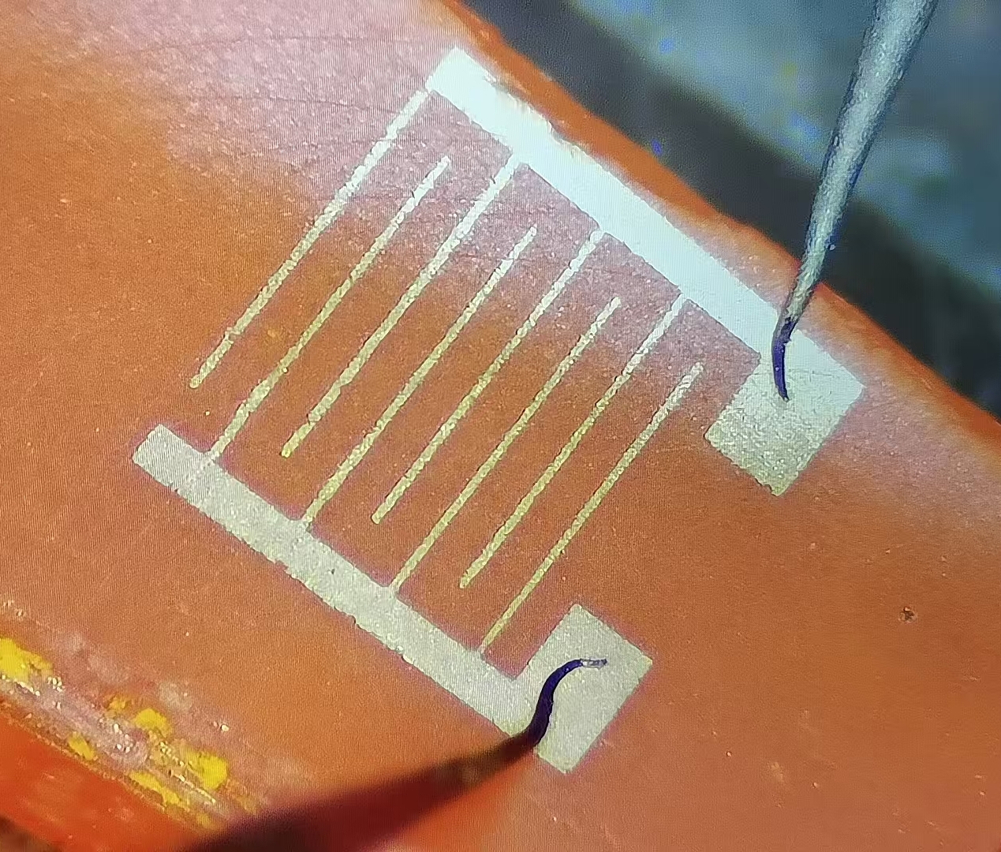
Fig. S1 The photograph of the X-ray detector with lateral electrodes
Fig. S2 Schematic illustration of the X-ray response speed measurement

Scheme S1 The schematic structure of propylamine (PA) and 1,6-hexanediamine (HDA)
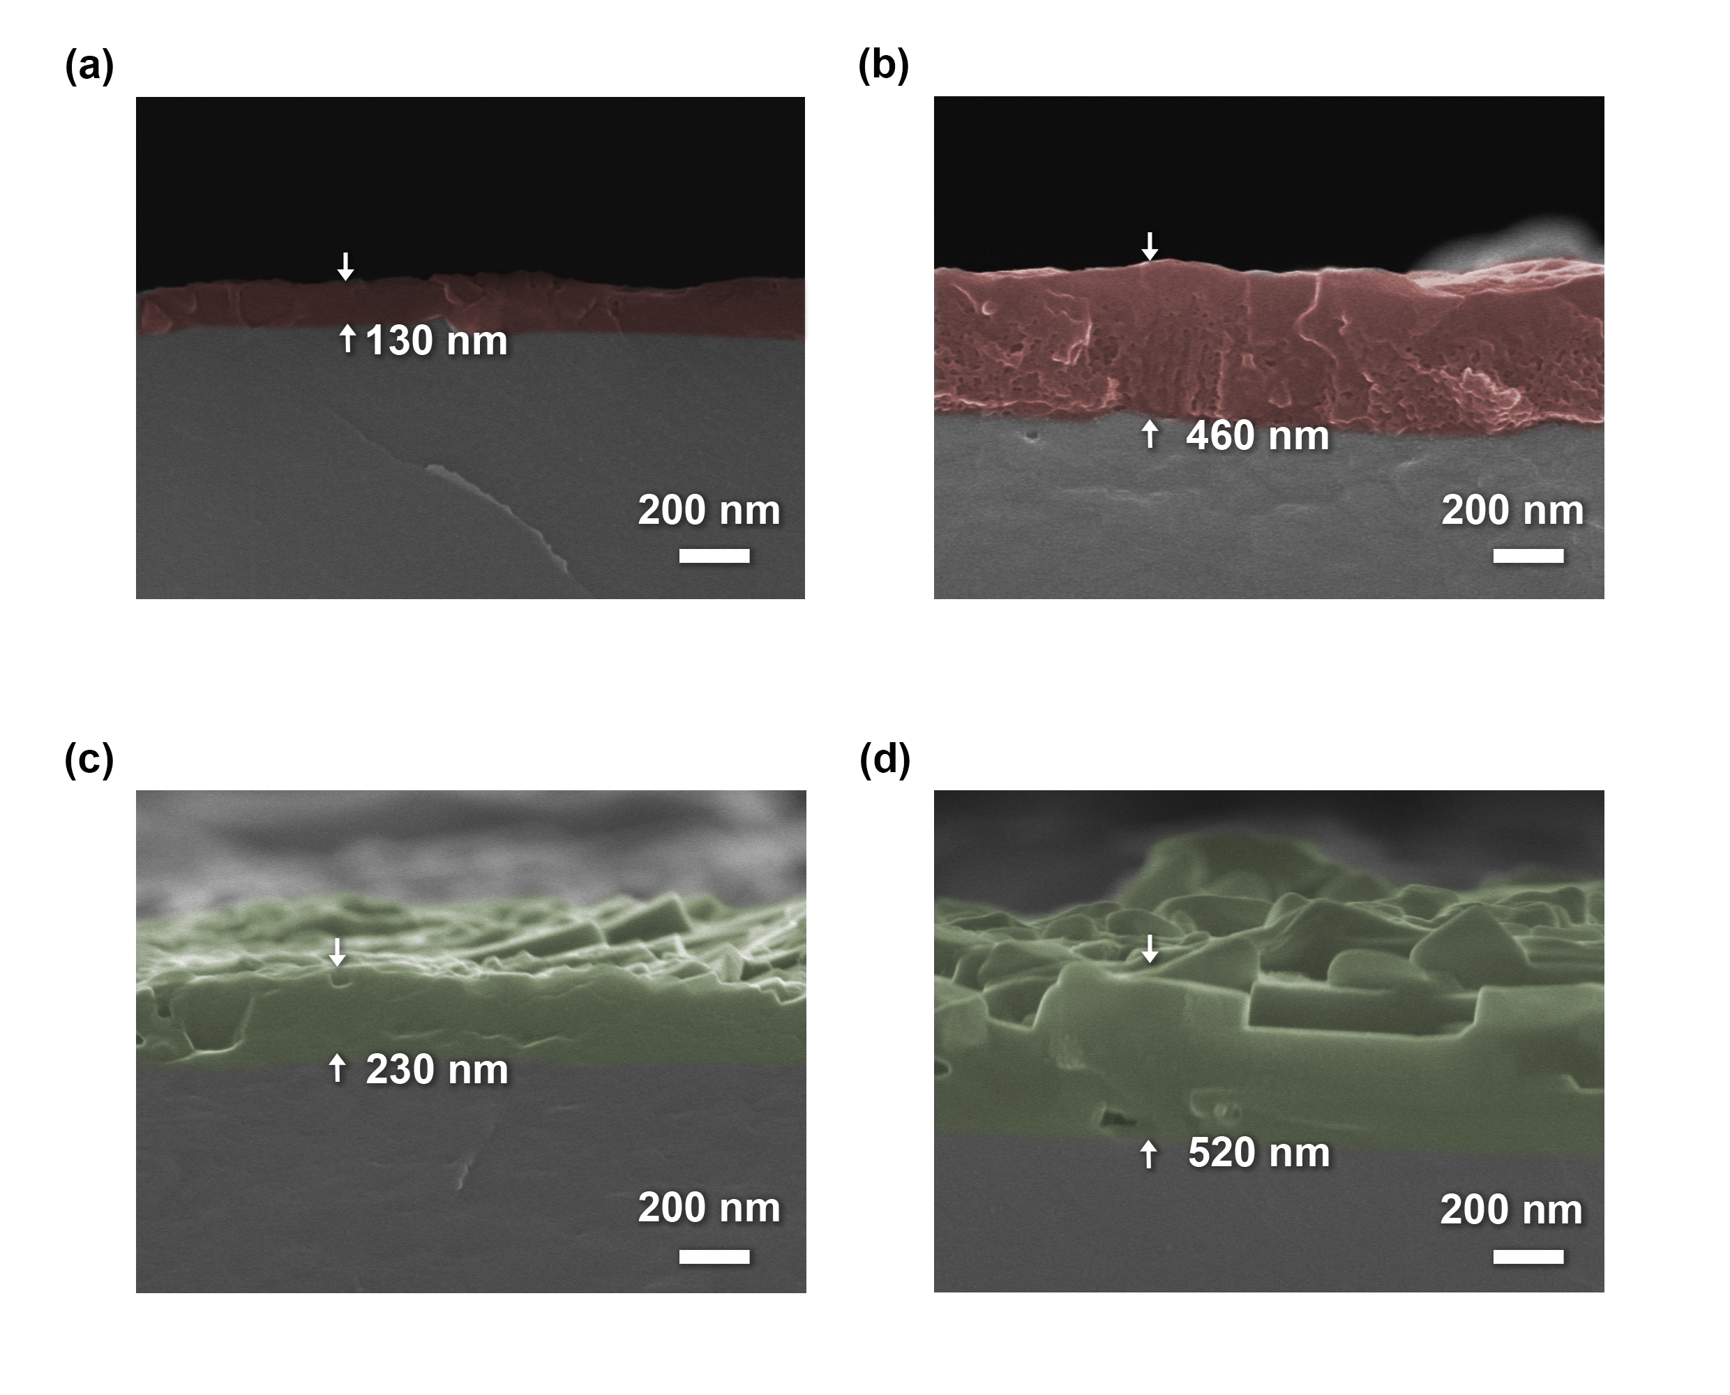
Fig. S3 Side-view scanning electron microscope (SEM) images of the MAPbBr₃ single crystal with the (PA)₂PbBr₄ capping layers: (a) 130 nm (PA)₂PbBr₄ capping layer (PA 130) and (b) 460 nm (PA)₂PbBr₄ capping layer (PA 460). (PA)₂PbBr₄ capping layers are in red. SEM images of the MAPbBr₃ single crystal with the (HDA)PbBr₄ capping layers: (c) 230 nm (HDA)PbBr₄ capping layer (HDA 230) and (d) 520 nm (HDA)PbBr₄ capping layer (HDA 520). (HDA)PbBr₄ capping layers are in green

Fig. S4 Sensitivity of devices with varying 2D perovskite layer thicknesses. (a) (PA)₂PbBr₄ capping devices: PA 130, PA 300, PA 460 denote 2D perovskite (PA)₂PbBr₄ thicknesses of 130 nm, 300 nm, and 460 nm, respectively. (b) (HDA)PbBr₄ capping devices: HDA 230, HDA 450, HDA 520 correspond to 2D perovskite thicknesses of 230 nm, 450 nm, and 520 nm, respectively

Fig. S5 Elements molar ratios of Br/Pb alone the cross-section of (a) the (PA)₂PbBr₄ capping and (b) (HDA)PbBr₄ capping samples
Fig. S6 Top-view atomic force microscopy (AFM) height images of (a) Ctrl, (b) (PA)₂PbBr₄ capping, and (c) (HDA)PbBr₄ capping samples
Fig. S7 Taut plots of (a) Ctrl, (b) (PA)₂PbBr₄ capping, (c) (HDA)PbBr₄ capping samples. The thicknesses of the two-dimensional perovskites (PA)₂PbBr₄ and (HDA)PbBr₄ are both less than 500 nm. Compared with the several-millimeter-thick three-dimensional perovskite MAPbBr₃, their influence on the UV-Vis spectroscopy test is basically negligible. Therefore, the displayed 2.13 eV bandgap corresponds to that of the three-dimensional perovskite MAPbBr₃
Fig. S8 Steady-state photoluminescence of (PA)₂PbBr₄ capping and (HDA)PbBr₄ capping samples
Fig. S9 Schematic band alignment of (a) the MAPbBr₃-(PA)₂PbBr₄ heterojunction and (b) the MAPbBr₃-(HDA)PbBr₄ heterojunction, which show the energy levels of materials at equilibrium. The energy drop at interfaces are highlighted by red circles
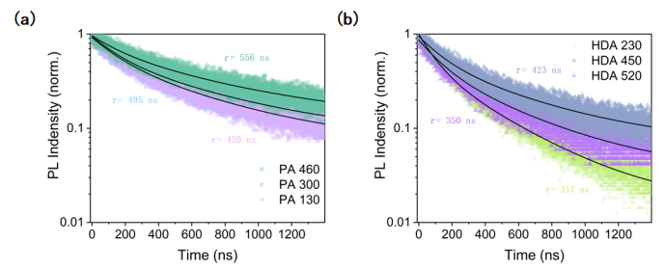
Fig. S10 TRPL of heterostructures with varying 2D perovskite layer thicknesses. (a) (PA)₂PbBr₄ capping samples: PA 130, PA 300, PA 460 denote 2D perovskite (PA)₂PbBr₄ thicknesses of 130 nm, 300 nm, and 460 nm, respectively. (b) (HDA)PbBr₄ capping samples: HDA 230, HDA 450, HDA 520 correspond to 2D perovskite thicknesses of 230 nm, 450 nm, and 520 nm

Fig. S11 Space charge limited current (SCLC) of (a) Ctrl, (b) (PA)₂PbBr₄ capping, and (c) (HDA)PbBr₄ capping samples

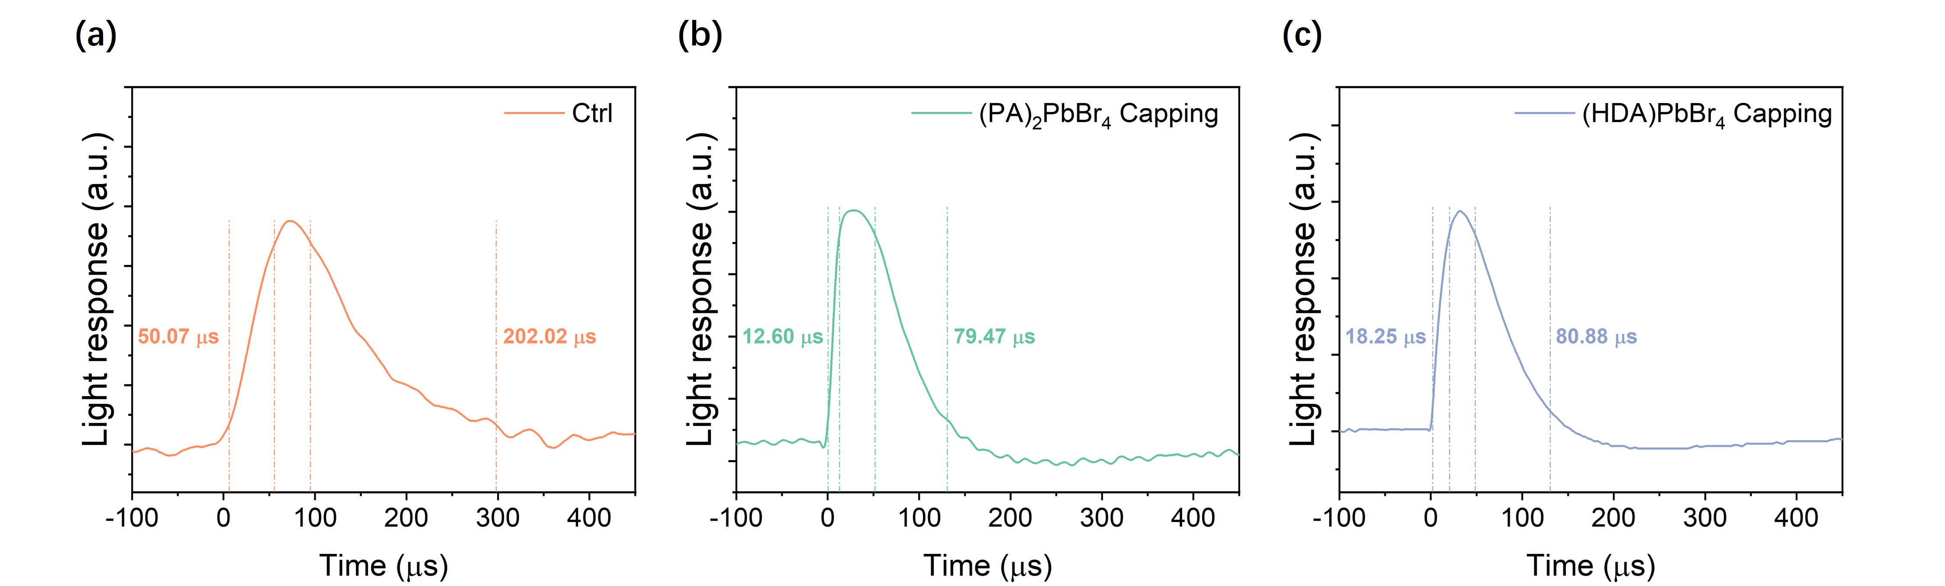
Fig. S12 The Time-Resolved Photocurrent Decay curves of (a) Ctrl, (b) (PA)₂PbBr₄ capping, and (c) (HDA)PbBr₄ capping samples. The electric field for measurements was 267 V mm⁻¹

Fig. S13 (a) The current-time (I-t) curve of the Ctrl device under X-ray dose rates ranging from 74.7 to 616.6 μGy_{air} s⁻¹. I-t curves of (b) the (PA)₂PbBr₄ capping and (c) the (HDA)PbBr₄ capping devices under X-ray dose rates ranging from 1.3 to 10.7 μGy_{air} s⁻¹

Fig. S14 Sensitivity of Ctrl, (PA)₂PbBr₄ capping, and (HDA)PbBr₄ capping samples under different electric fields. The dose rate of X-ray for measurements of the Ctrl sample was 5111.11 μGy_{air} s⁻¹. The dose rate of X-ray for measurements of the (PA)₂PbBr₄ capping and (HDA)PbBr₄ capping samples was 86.11 μGy_{air} s⁻¹
Fig. S15 Relative X-ray absorption (blue curve) and mass attenuation coefficient (red curve) of MAPbBr₃ in the 1 eV ~ 100 keV energy range. The relative X-ray absorption coefficient (𝜖) was directly obtained from μ_{P} by applying the relationship: 𝜖 = 1 – exp(–μ_{P}·ρd). By considering a photon energy E_{ph} = 5.73 keV, which is the most probable energy in the case of a Cu-target X-ray tube, the mass attenuation coefficient is μ_{P} = 3.78 cm² •g⁻¹, corresponding to a relative X-ray absorption 𝜖 = 83.2% for a 1.5 mm-thick crystal. At the same photon energy (5.73 keV), the mass attenuation coefficient of dry air [5] is μ = 9.92 cm² g⁻¹. Finally, being the bandgap energy E_{g} = 2.13 eV, the estimated electron-hole pair creation energy is E_{i} = 2 × 2.13 + 1.43 = 5.69 eV.
By inserting all the numerical values into the S_{t} equation we obtain:
$$S_{t}=\frac{eμ_{P}ρd}{μE_{i}}=16.5 μC·{Gy_{air}}^{-1}·{cm}^{-2}$$

Fig. S16 The long-term dark current drift of (a) Ctrl, (b) (PA)₂PbBr₄ capping, and (c) (HDA)PbBr₄ capping samples under an electric field of 267 V mm⁻¹
Table S1 Performance comparison of perovskite-based X-ray detectors
Materials | Electric field  (V mm⁻¹) | X-ray  energy  (kVp) | Sensitivity  (μC·Gy_{air}⁻¹·cm⁻²) | LoD  (μGy_{air} s⁻¹) | Response time  (ms) | References
MAPbBr₃ | 0.1 | 50 | 80 | 0.5 | 0.73 | [S6]
MAPbBr₃ | 2.67 | 40 | 7275 | 0.67 | / | [S7]
MAPbBr₃ | 7.1 | 40 | 2181 | 0.48 | / | [S8]
FAPbI₃ | 80 | 70 | 4.15 × 10⁵ | 0.001 | 0.214 | [S9]
MA_{0.42}FA_{0.58}PbI₃ | 71 | 22 | 1.16 × 10⁶ | 0.037 | 20000 | [S10]
Cs_{0.05}FA_{0.9}MA_{0.05}PbI₃ | 200 | 59.3 | 1.5 × 10⁴ | / | 0.235 | [S11]
CsPbI₂Br | 125 | 50 | 1.48 × 10⁵ | 0.28 | / | [S12]
CsPbBr₃ | 21 | 50 | 5.57 × 10⁴ | 0.215 | 92 | [S13]
(BDA)PbI₄ | 310 | 40 | 242 | 0.43 | 7.3 | [S14]
2D layered  (NH₄)₃Bi₂I₉ | 10 | 50 | 8200 | 0.055 | 80 | [S15]
MA₃Bi₂I₉ | 60 | 40 | 1947 | 0.083 | 23 | [S16]
MAPbBr₃ - MAPbI₃ | 80 | 40 | 3.98 × 10⁵ | 0.012 | 1.5 | [S17]
MAPbI₃ - (PEA)₂MA₃Pb₄I₁₃ | 33.3 | 70 | 1.95 × 10⁴ | 0.48 | / | [S18]
MAPbBr₃ -(PA)₂PbBr₄ | 267 | 60 | 2.22 × 10⁴ | 0.13 | 0.240 | This work
MAPbBr₃ -(HDA)PbBr₄ | 267 | 60 | 1.79 × 10⁴ | 0.56 | 0.269 | This work
Supplementary References
- G. Kresse, J. Furthmüller, Efficiency of ab-initio total energy calculations for metals and semiconductors using a plane-wave basis set. Comput. Mater. Sci. 6(1), 15–50 (1996). https://doi.org/10.1016/0927-0256(96)00008-0
- G. Kresse, J. Furthmüller, Efficient iterative schemes for ab initio total-energy calculations using a plane-wave basis set. Phys. Rev. B 54(16), 11169–11186 (1996). https://doi.org/10.1103/physrevb.54.11169
- J. Perdew, K. Burke, M. Ernzerhof, Generalized gradient approximation made simple. Phys. Rev. Lett. 77(18), 3865–3868 (1996). https://doi.org/10.1103/PhysRevLett.77.3865
- S. Grimme, J. Antony, S. Ehrlich, H. Krieg, A consistent and accurate ab initio parametrization of density functional dispersion correction (DFT-D) for the 94 elements H-Pu. J. Chem. Phys. 132(15), 154104 (2010). https://doi.org/10.1063/1.3382344
- J. H. Hubbell, S. M. Seltzer, X-Ray Mass Attenuation Coefficients, NIST Standard Reference Database 126 (NISTIR 5632), accessed: October, 2023.
https://dx.doi.org/10.18434/T4D01F
- H. Wei, Y. Fang, P. Mulligan, W. Chuirazzi, H.-H. Fang et al., Sensitive X-ray detectors made of methylammonium lead tribromide perovskite single crystals. Nat. Photonics 10(5), 333–339 (2016). https://doi.org/10.1038/nphoton.2016.41
- D. Liu, L. Jiang, X. Jiang, X. Sun, G. Zhang et al., Interface-tension-assisted temperature-gradient crystallization of high-quality MAPbBr₃ perovskite single crystals with low defect densities. ACS Appl. Mater. Interfaces 15(49), 57846–57855 (2023). https://doi.org/10.1021/acsami.3c13614
- Z. Zhu, W. Li, W. Deng, W. He, C. Yan et al., Controllable metastable growth of perovskite single crystals for highly sensitive X-ray detection. J. Mater. Chem. C 10(17), 6837–6845 (2022). https://doi.org/10.1039/D2TC00235C
- D. Chu, B. Jia, N. Liu, Y. Zhang, X. Li et al., Lattice engineering for stabilized black FAPbI₃ perovskite single crystals for high-resolution X-ray imaging at the lowest dose. Sci. Adv. 9(35), eadh2255 (2023). https://doi.org/10.1126/sciadv.adh2255
- W.-G. Li, X.-D. Wang, Y.-H. Huang, D.-B. Kuang, Ultrasound-assisted crystallization enables large-area perovskite quasi-monocrystalline film for high-sensitive X-ray detection and imaging. Adv. Mater. 35(31), 2210878 (2023). https://doi.org/10.1002/adma.202210878
- Y. He, J. Song, M. Li, K. Sakhatskyi, W. Li et al., Perovskite computed tomography imager and three-dimensional reconstruction. Nat. Photon. 18(10), 1052–1058 (2024). https://doi.org/10.1038/s41566-024-01506-y
- W. Qian, X. Xu, J. Wang, Y. Xu, J. Chen et al., An aerosol-liquid-solid process for the general synthesis of halide perovskite thick films for direct-conversion X-ray detectors. Matter 4(3), 942–954 (2021). https://doi.org/10.1016/j.matt.2021.01.020
- W. Pan, B. Yang, G. Niu, K.-H. Xue, X. Du et al., Hot-pressed CsPbBr₃ quasi-monocrystalline film for sensitive direct X-ray detection. Adv. Mater. 31(44), 1904405 (2019). https://doi.org/10.1002/adma.201904405
- Y. Shen, Y. Liu, H. Ye, Y. Zheng, Q. Wei et al., Centimeter-sized single crystal of two-dimensional halide perovskites incorporating straight-chain symmetric diammonium ion for X-ray detection. Angew. Chem. Int. Ed. 59(35), 14896–14902 (2020). https://doi.org/10.1002/anie.202004160
- R. Zhuang, X. Wang, W. Ma, Y. Wu, X. Chen et al., Highly sensitive X-ray detector made of layered perovskite-like (NH₄)₃Bi₂I₉ single crystal with anisotropic response. Nat. Photonics 13(9), 602–608 (2019). https://doi.org/10.1038/s41566-019-0466-7
- Y. Liu, Z. Xu, Z. Yang, Y. Zhang, J. Cui et al., Inch-size 0D-structured lead-free perovskite single crystals for highly sensitive stable X-ray imaging. Matter 3(1), 180–196 (2020). https://doi.org/10.1016/j.matt.2020.04.017
- X. Zhang, D. Chu, B. Jia, Z. Zhao, J. Pi et al., Heterointerface design of perovskite single crystals for high-performance X-ray imaging. Adv. Mater. 36(3), 2305513 (2024). https://doi.org/10.1002/adma.202305513
- X. Xu, W. Qian, J. Wang, J. Yang, J. Chen et al., Sequential growth of 2D/3D double-layer perovskite films with superior X-ray detection performance. Adv. Sci. 8(21), 2102730 (2021). https://doi.org/10.1002/advs.202102730

