Supporting Information for
Ammonia Borane All-In-One Modification Strategy Enables High-Performance Perovskite Solar Cells
Jiaxin Ma^{1,2}, Cong Shao^{1,2}, Yirong Wang^{2,3}, Guosheng Niu^{1,2}, Kaiyi Yang^{1,2}, Yao Zhao⁴, Fuyi Wang^{2,4}, Zongxiu Nie^{2,4}, and Jizheng Wang^{1,2}*
¹ Beijing National Laboratory for Molecular Sciences CAS Key Laboratory of Organic Solids, Institute of Chemistry, Chinese Academy of Sciences, Beijing 100190, P. R. China
² School of Chemical Sciences, University of Chinese Academy of Sciences, Beijing 100049, P. R. China
³ CAS Key Laboratory of Engineering Plastics, Institute of Chemistry, Chinese Academy of Sciences, Beijing, P. R. China
⁴ Beijing National Laboratory for Molecular Sciences, National Centre for Mass Spectrometry in Beijing, CAS Key Laboratory of Analytical Chemistry for Living Biosystems, Chinese Academy of Sciences, Beijing, P. R. China
* Corresponding author. E-mail: jizheng@iccas.ac.cn (Jizheng Wang)
Supplementary Figures and Tables
$${NH}_{3}∙{BH}_{3}+2H_{2}O→{{NH}_{4}}^{+}+{{BO}_{2}}^{-}+3H_{2}$$

Fig. S1 The hydrolysis chemical equation of ammonium borane.

Fig. S2 O 1s XPS spectra of the SnO₂ and SnO₂/BNH₆ films after oxygen plasma treatment

Fig. S3 J-V curves of the devices with no treatment or post treatment by oxygen plasma

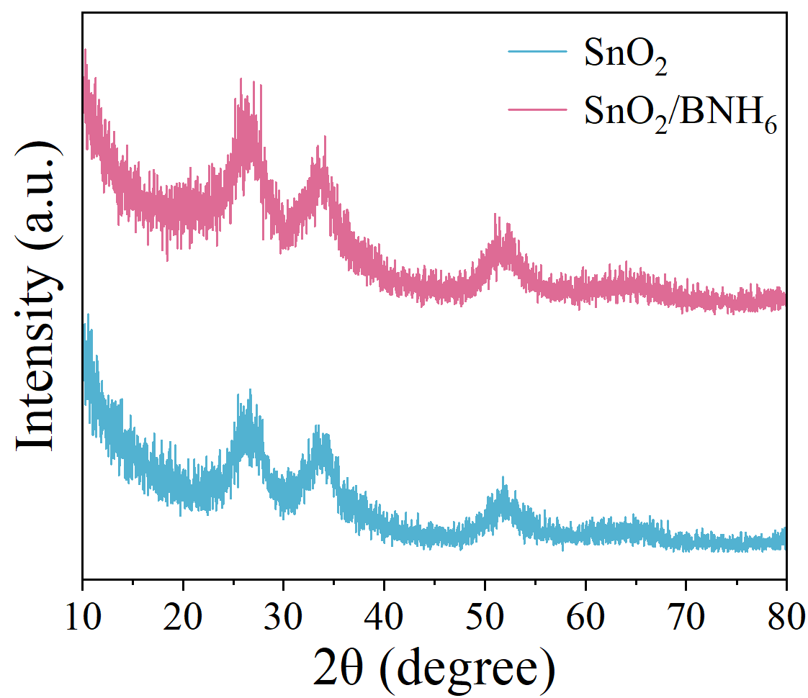
Fig. S4 XRD spectra of the SnO₂ and the SnO₂/BNH₆ films

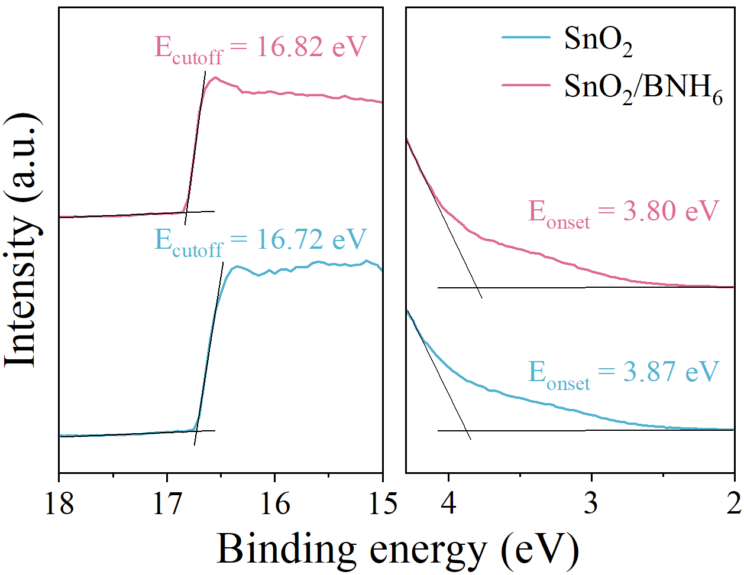
Fig. S5 UPS spectra of the SnO₂ and SnO₂/BNH₆ films

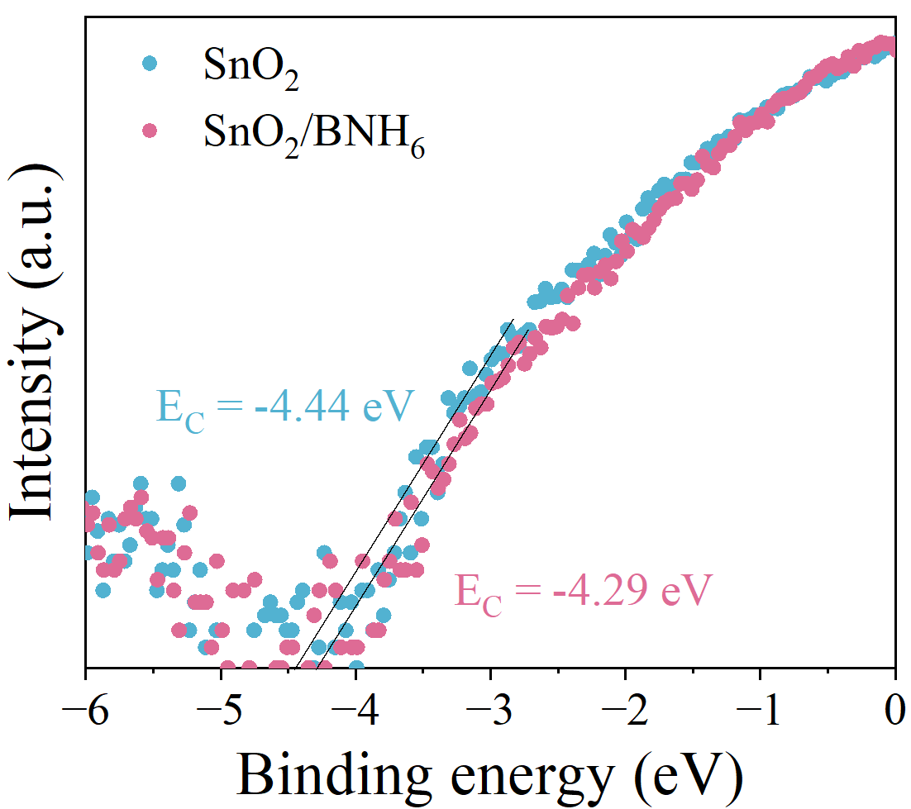
Fig. S6 LEIPS spectra of the SnO₂ and SnO₂/BNH₆ films

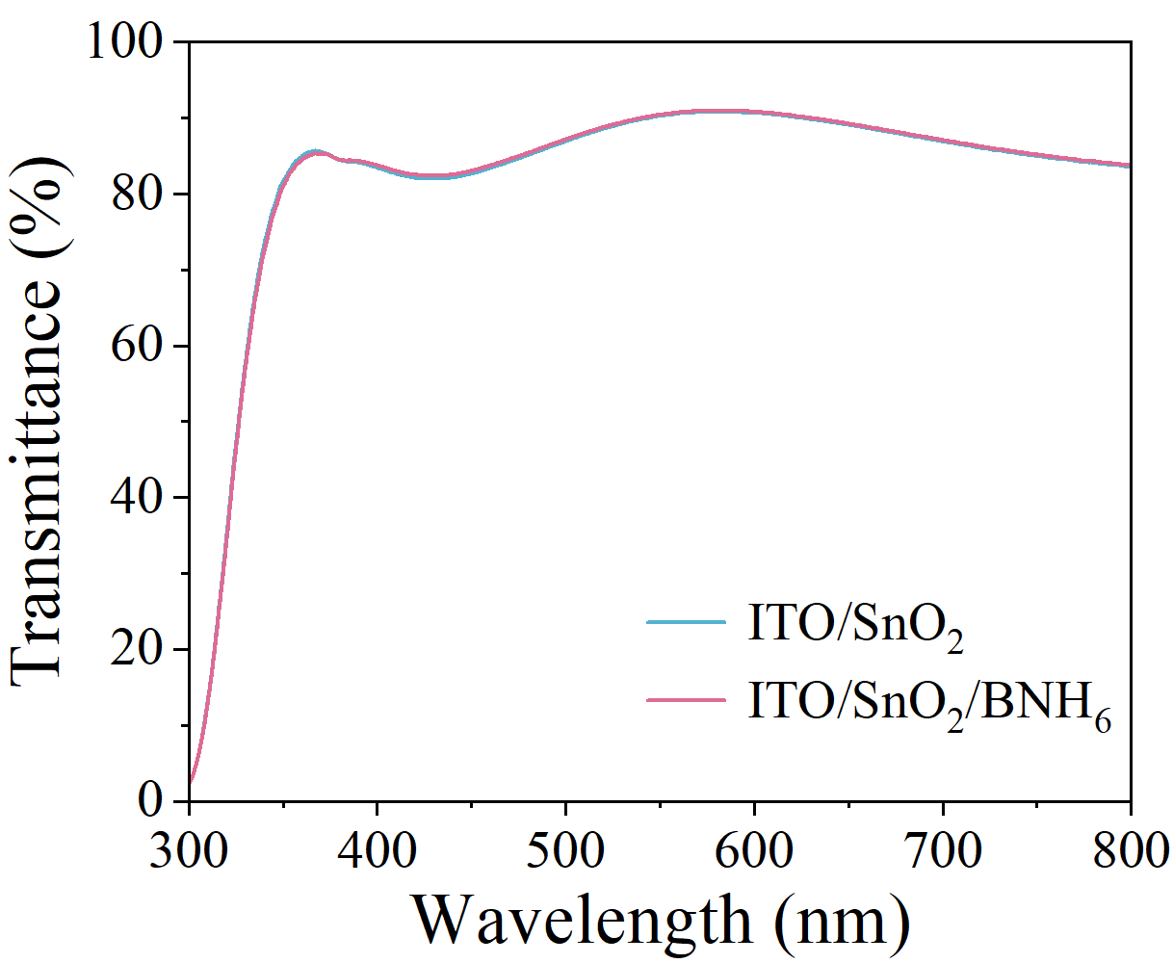
Fig. S7 The transmittance spectra of the SnO₂ and SnO₂/BNH₆ films

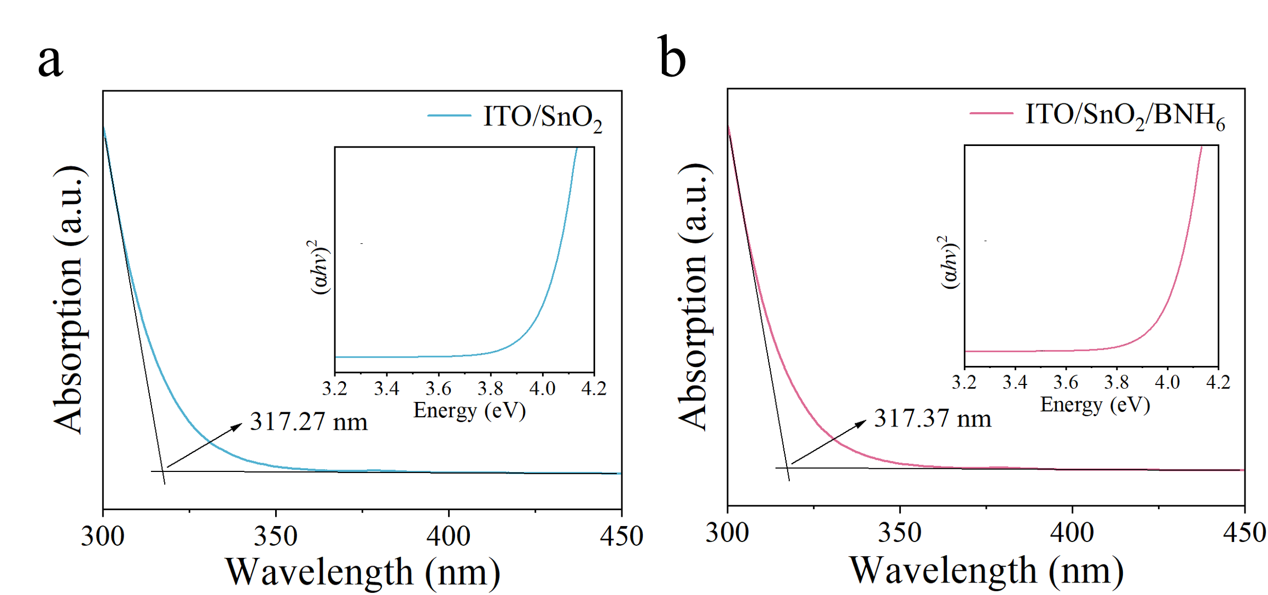
Fig. S8 UV-vis absorption spectra of the (a) SnO₂ and (b) SnO₂/BNH₆ films, the insets are Tauc plots of corresponding films

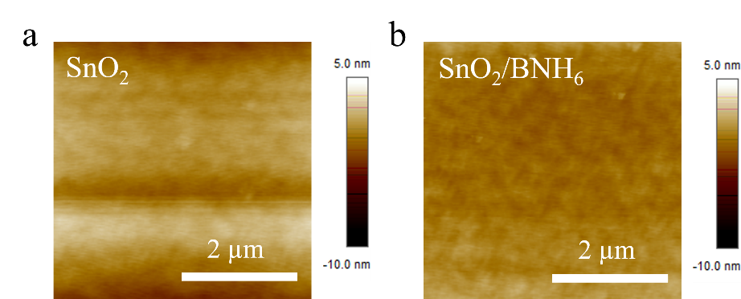
Fig. S9 AFM images of the (a) SnO₂ film and (b) SnO₂/BNH₆ film

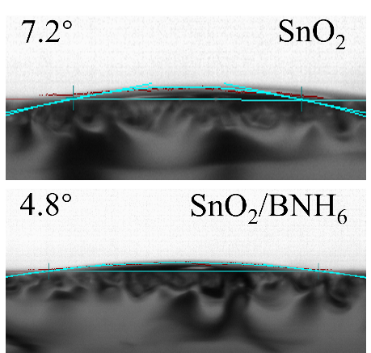
Fig. S10 Contact angles of perovskite precursor solutions on the SnO₂ and SnO₂/BNH₆ films

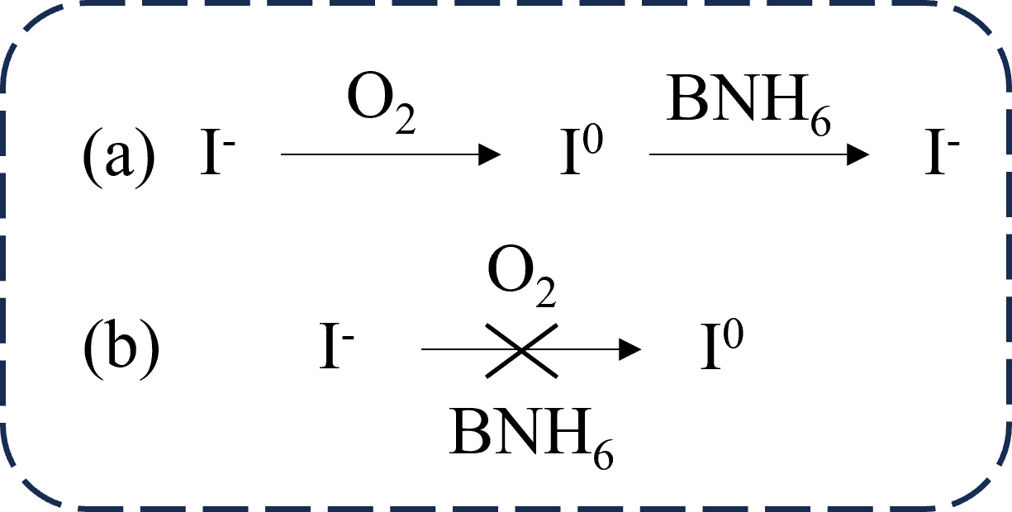

Fig. S11 Chemical reaction expression of I⁰ and I⁻

Fig. S12 Ion chromatography of the concentrations of I⁻ at different times with and without BNH₆

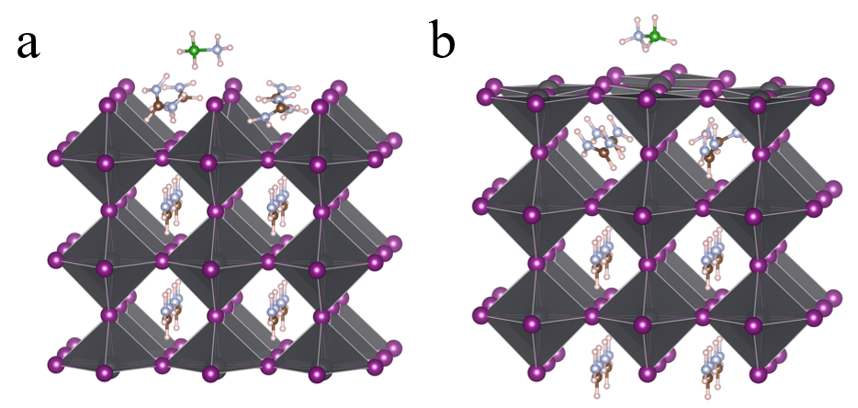
Fig. S13 Supercell constructed for DFT calculations, in which BNH₆ molecules are adsorbed on the FAPbI₃ (001) surface via (a) FAI and (b) PbI₂ terminations, respectively

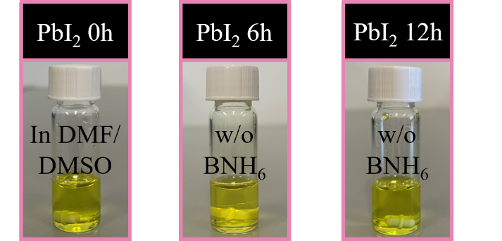
Fig. S14 The color change process of pristine PbI₂ solution

Fig. S15 FTIR spectra of PbI₂, BNH₆, and PbI₂ with BNH₆ films

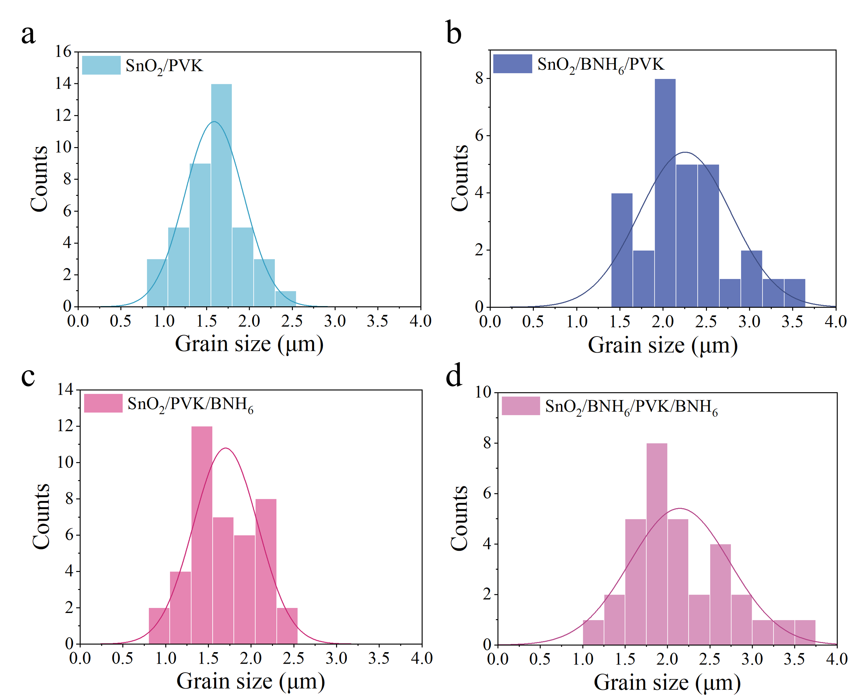
Fig. S16 Distribution histogram of crystal grain sizes of the perovskite films: (a) SnO₂/PVK, (b) SnO₂/BNH₆/PVK, (c) SnO₂/PVK/BNH₆ and (d) SnO₂/BNH₆/PVK/BNH₆

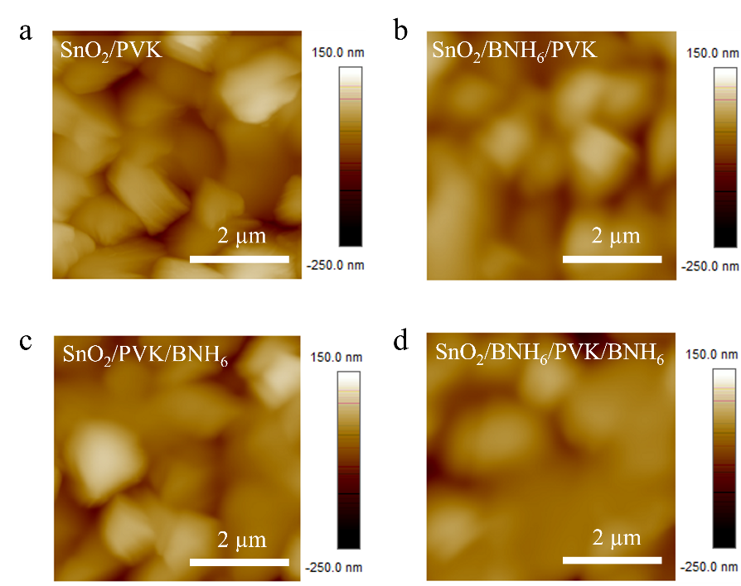
Fig. S17 AFM surface images of the perovskite films: (a) SnO₂/PVK, (b) SnO₂/BNH₆/PVK, (c) SnO₂/PVK/BNH₆, and (d) SnO₂/BNH₆/PVK/BNH₆

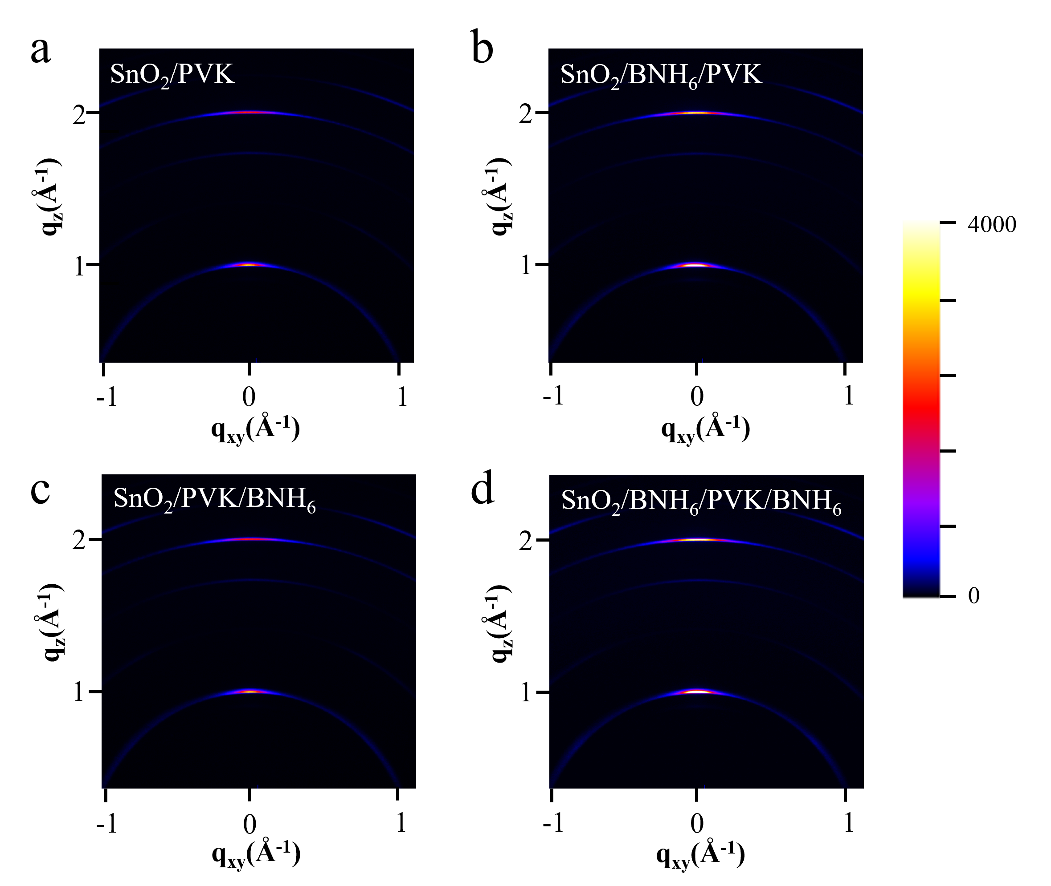
Fig. S18 2D-XRD images of the perovskite films: (a) SnO₂/PVK, (b) SnO₂/BNH₆/PVK, (c) SnO₂/PVK/BNH₆, and (d) SnO₂/BNH₆/PVK/BNH₆

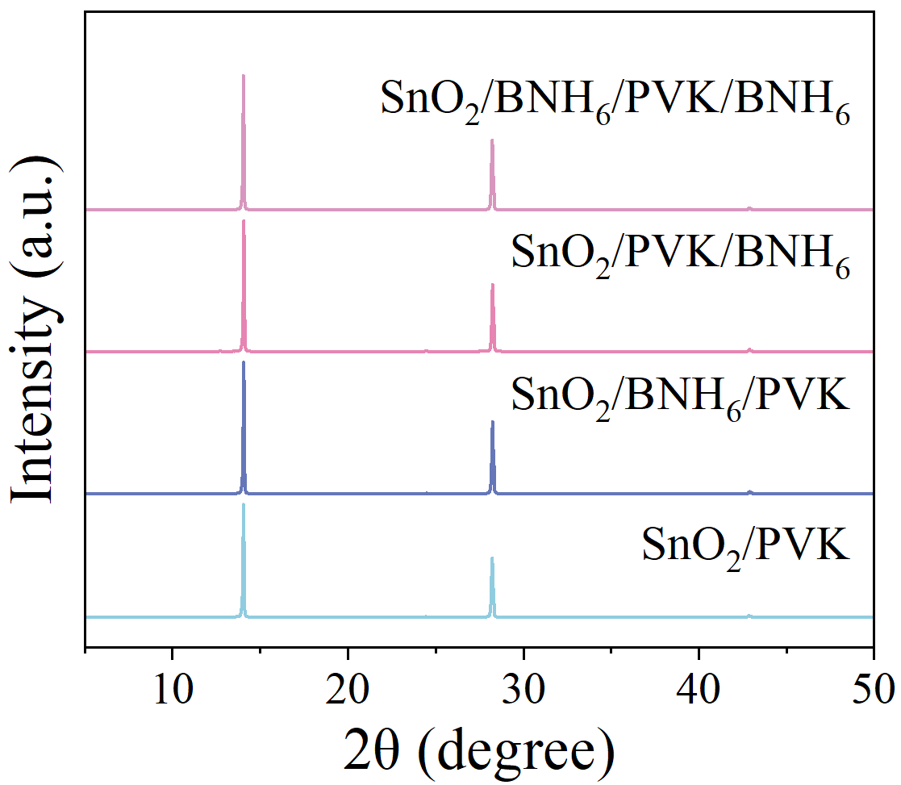
Fig. S19 XRD images of the SnO₂/PVK, SnO₂/BNH₆/PVK, SnO₂/PVK/BNH₆ and SnO₂/BNH₆/PVK/BNH₆ films

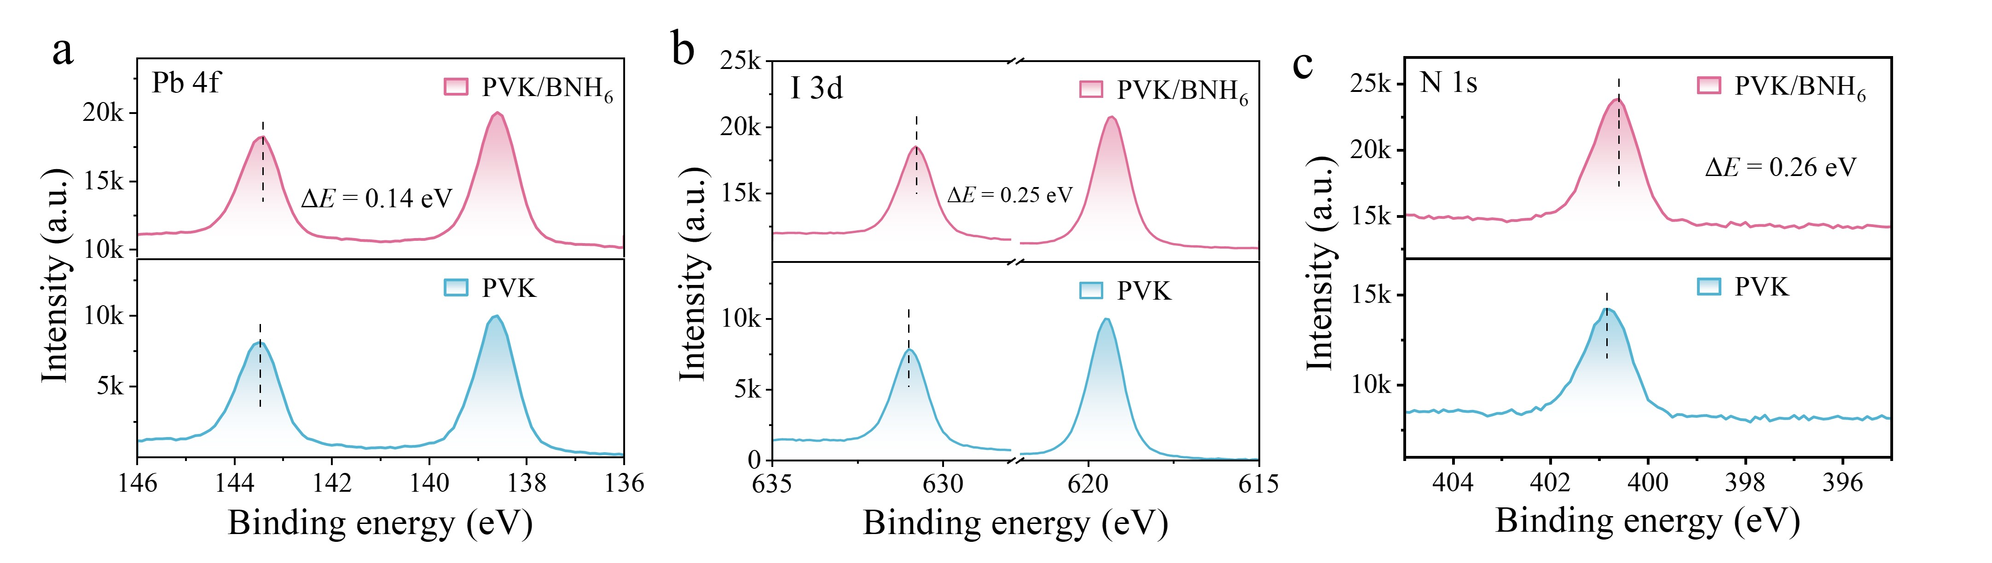
Fig. S20 XPS spectra of the PVK and PVK/BNH₆ films. (a) Pb 4f, (b) I 3d, (c) N 1s

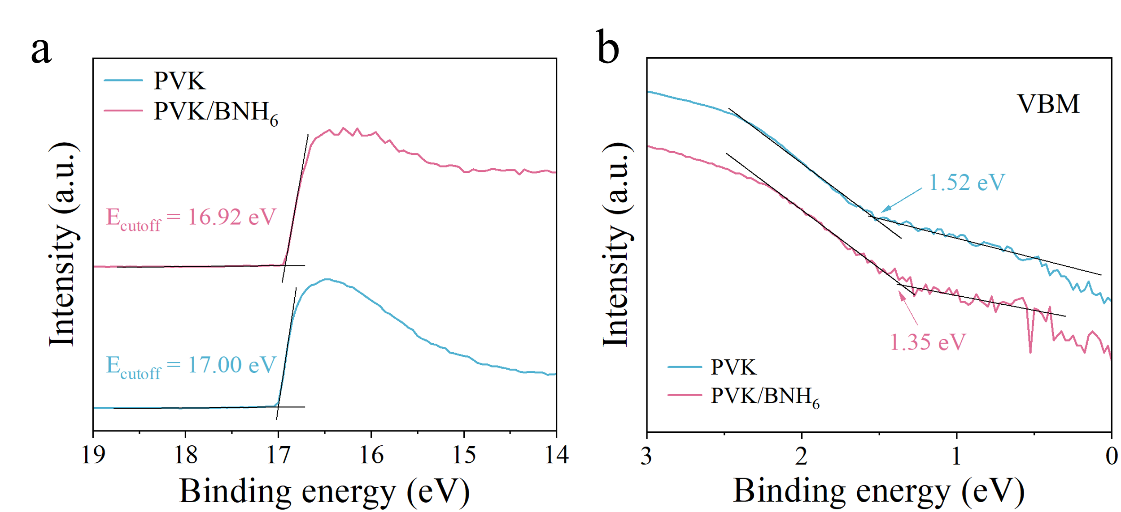
Fig. S21 UPS spectra of the PVK and PVK/BNH₆ films

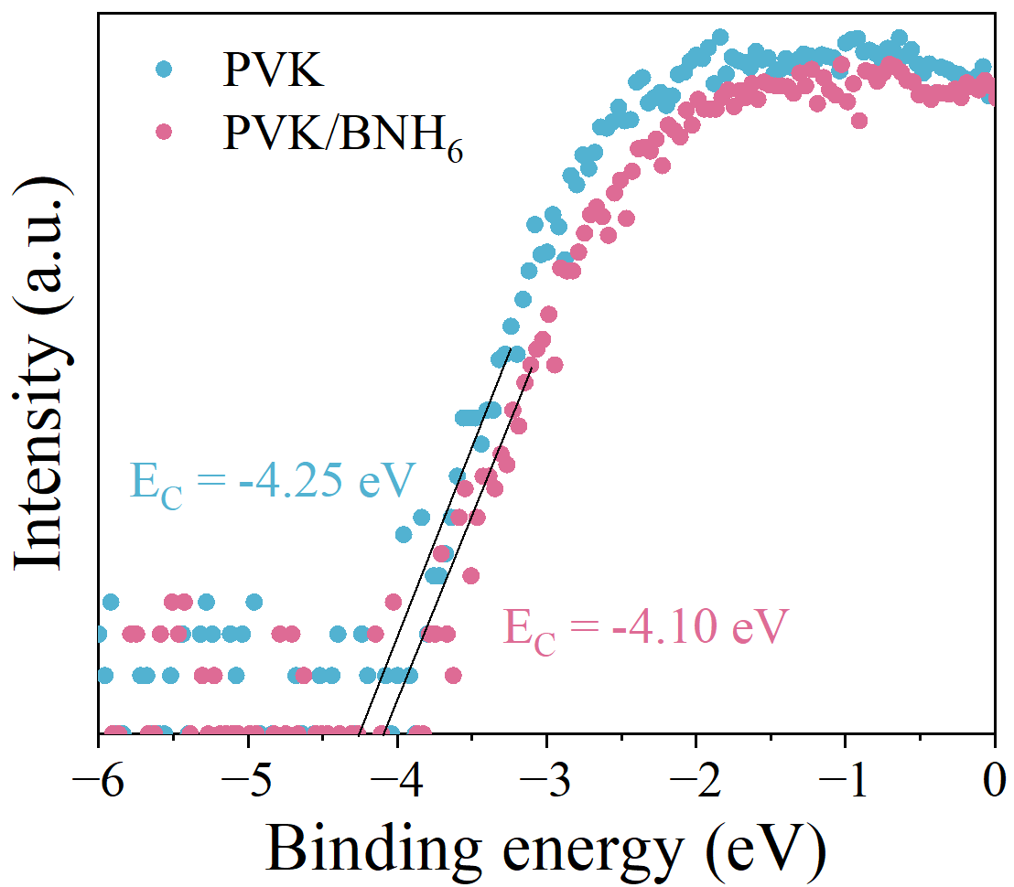
Fig. S22 LEIPS spectra of the PVK and PVK/BNH₆ films
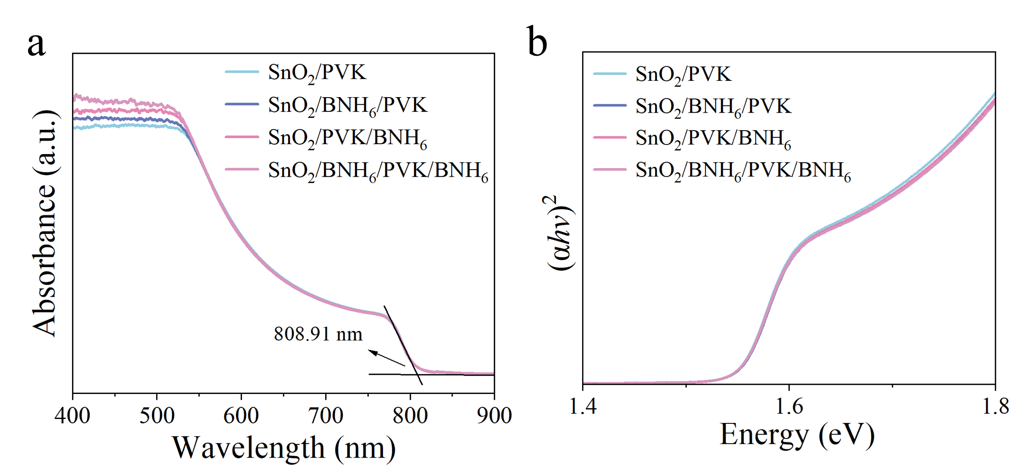
Fig. S23 (a) UV-vis absorption spectra and (b) Tauc plots of the SnO₂/PVK, SnO₂/BNH₆/PVK, SnO₂/PVK/BNH₆ and SnO₂/BNH₆/PVK/BNH₆ films
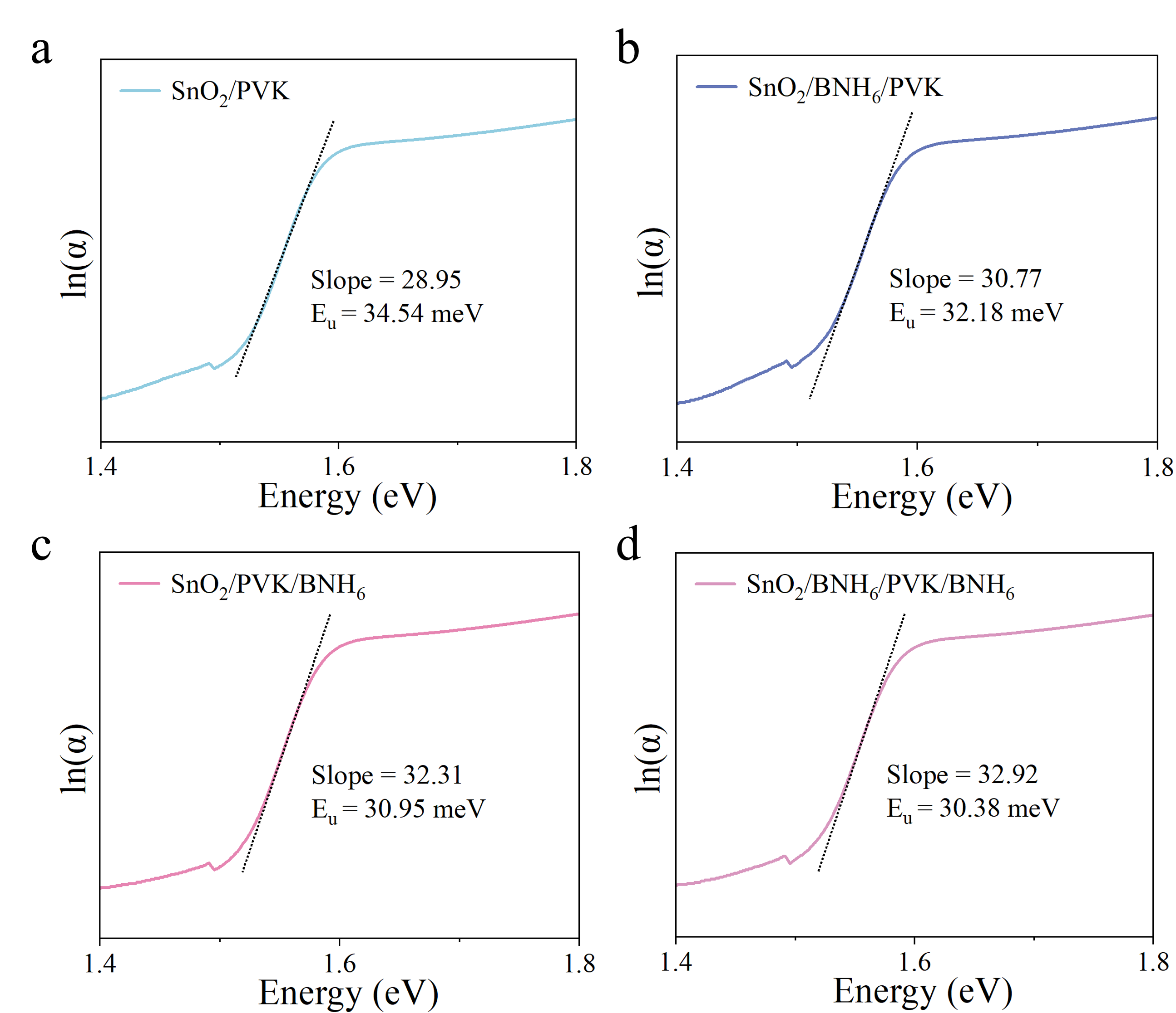
Fig. S24 Urbach energy obtained from the (a) SnO₂/PVK, (b) SnO₂/BNH₆/PVK, (c) SnO₂/PVK/BNH₆ and (d) SnO₂/BNH₆/PVK/BNH₆ films
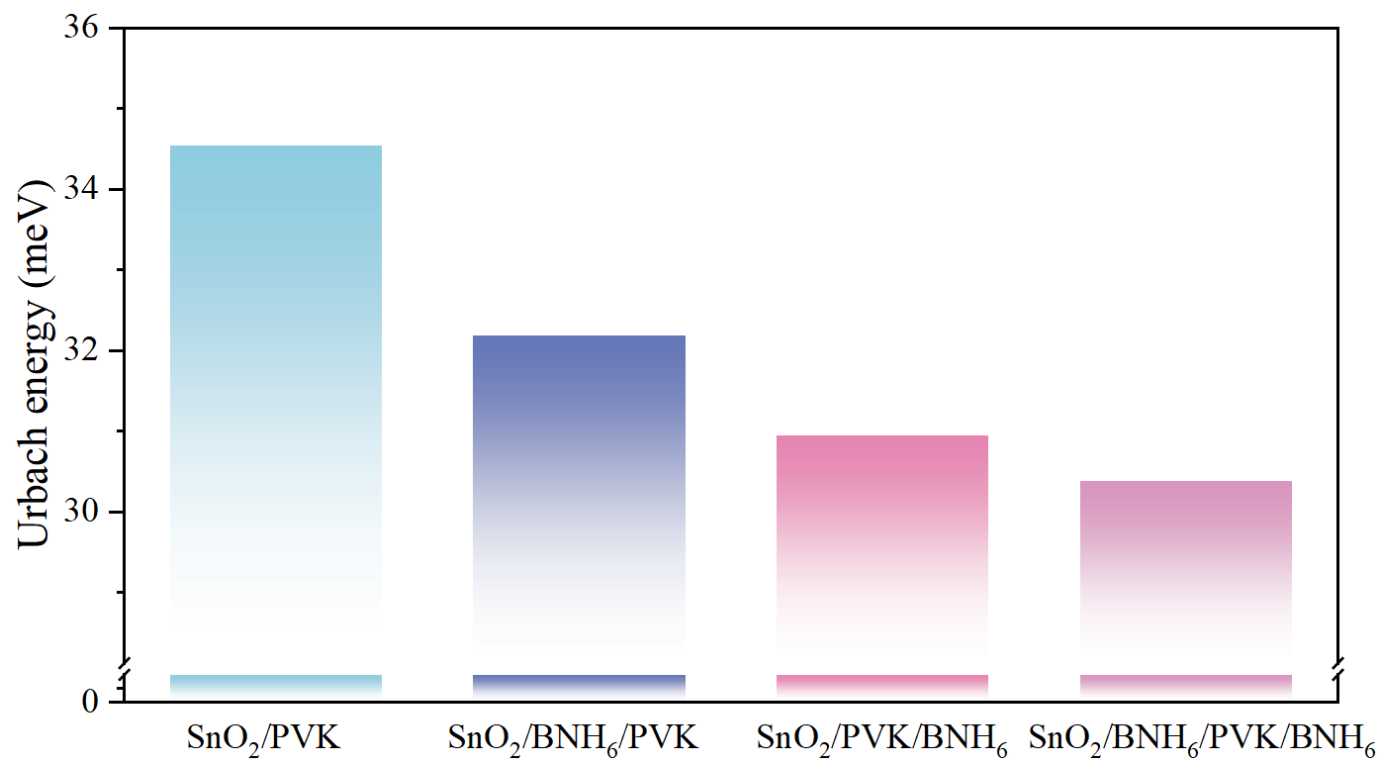
Fig. S25 Urbach energy calculated from the SnO₂/PVK, SnO₂/BNH₆/PVK, SnO₂/PVK/BNH₆ and SnO₂/BNH₆/PVK/BNH₆ films
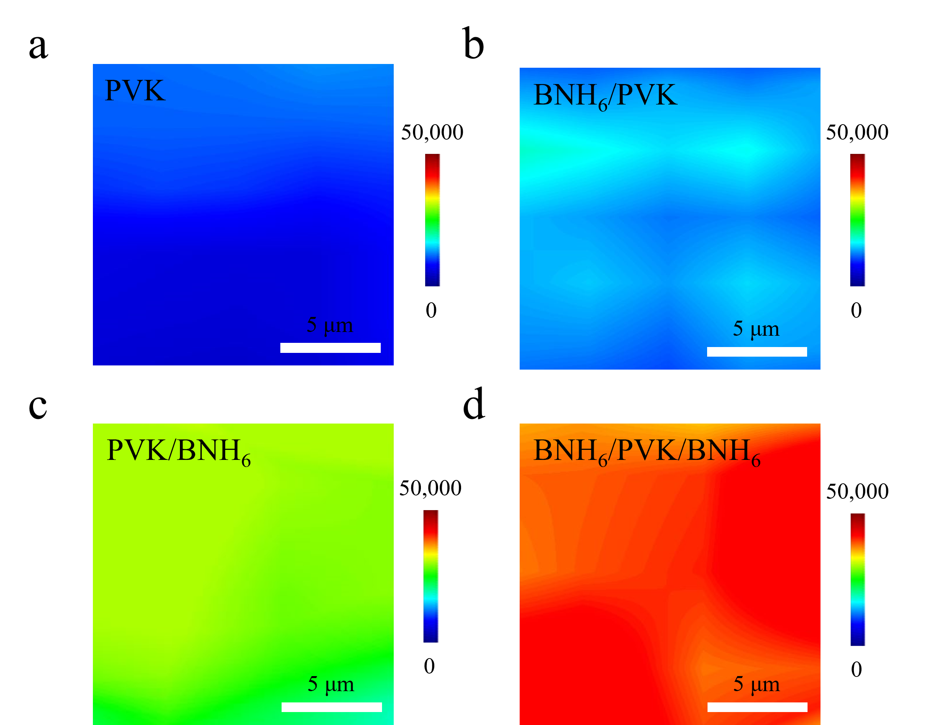
Fig. S26 PL mapping of the (a) PVK, (b) BNH₆/PVK, (c) PVK/BNH₆ and (d) BNH₆/PVK/BNH₆ films
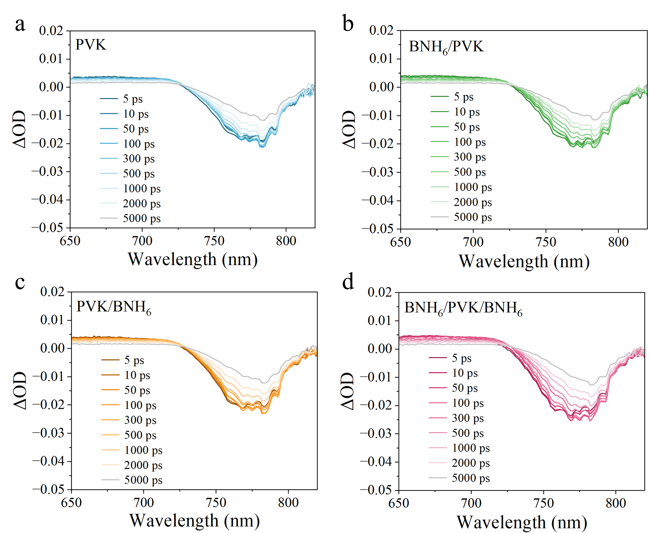
Fig. S27 Time-resolved transient absorption of the (a) PVK, (b) BNH₆/PVK, (c) PVK/BNH₆ and (d) BNH₆/PVK/BNH₆ films at different probe delay times

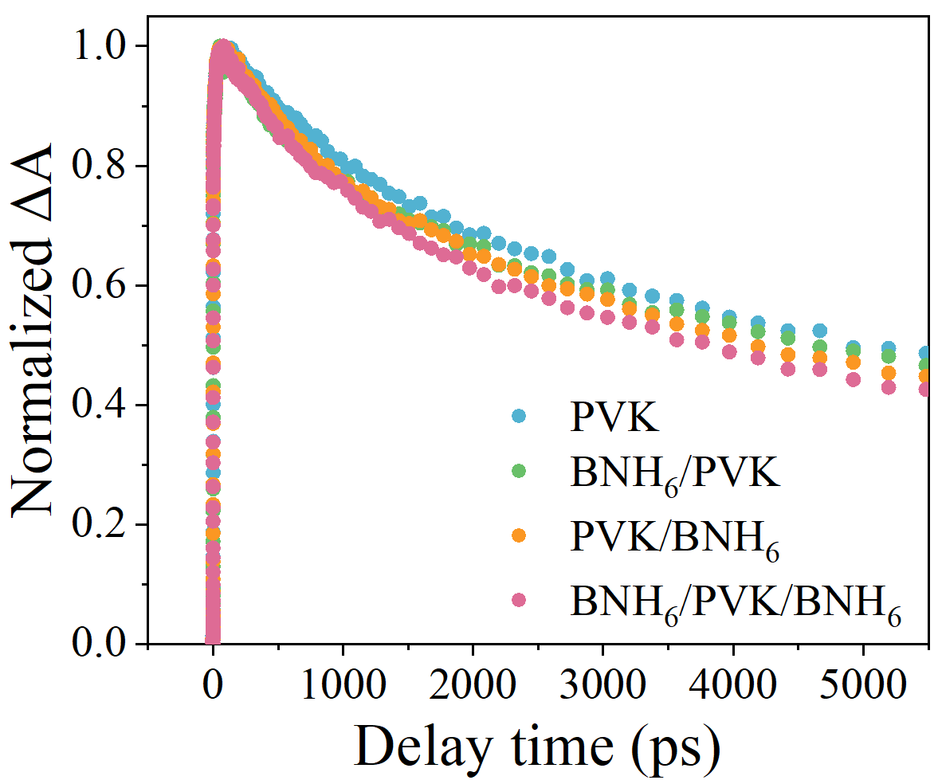
Fig. S28 The decay kinetics of the corresponding GSB peaks
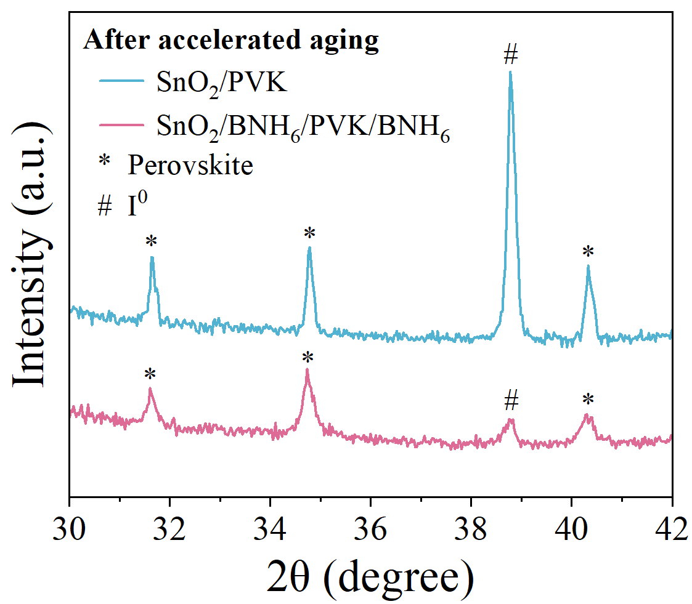
Fig. S29 XRD spectra of the SnO₂/PVK and SnO₂/BNH₆/PVK/BNH₆ films after accelerated aging
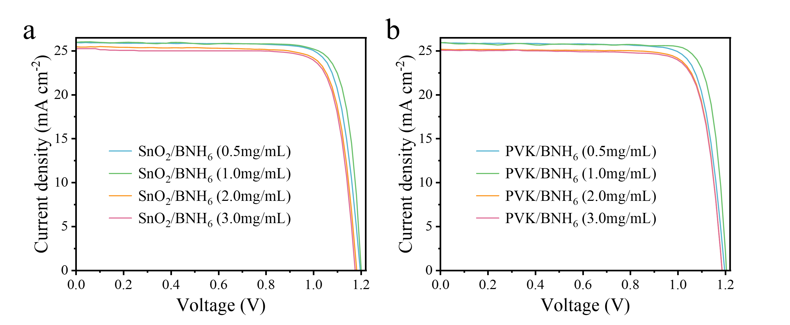
Fig. S30 Optimal J-V curves of the PSCs measured in the reverse scan direction using different concentrations of BNH₆. The BNH₆ solution (0.5, 1.0, 2.0 and 3.0 mg/mL) coated at the buried and upper interface of perovskite was prepared by dissolving 0.5, 1.0, 2.0 and 3.0 mg BNH₆ in 1 mL deionized water and 1 mL IPA, respectively. The other device preparation processes remain unchanged.

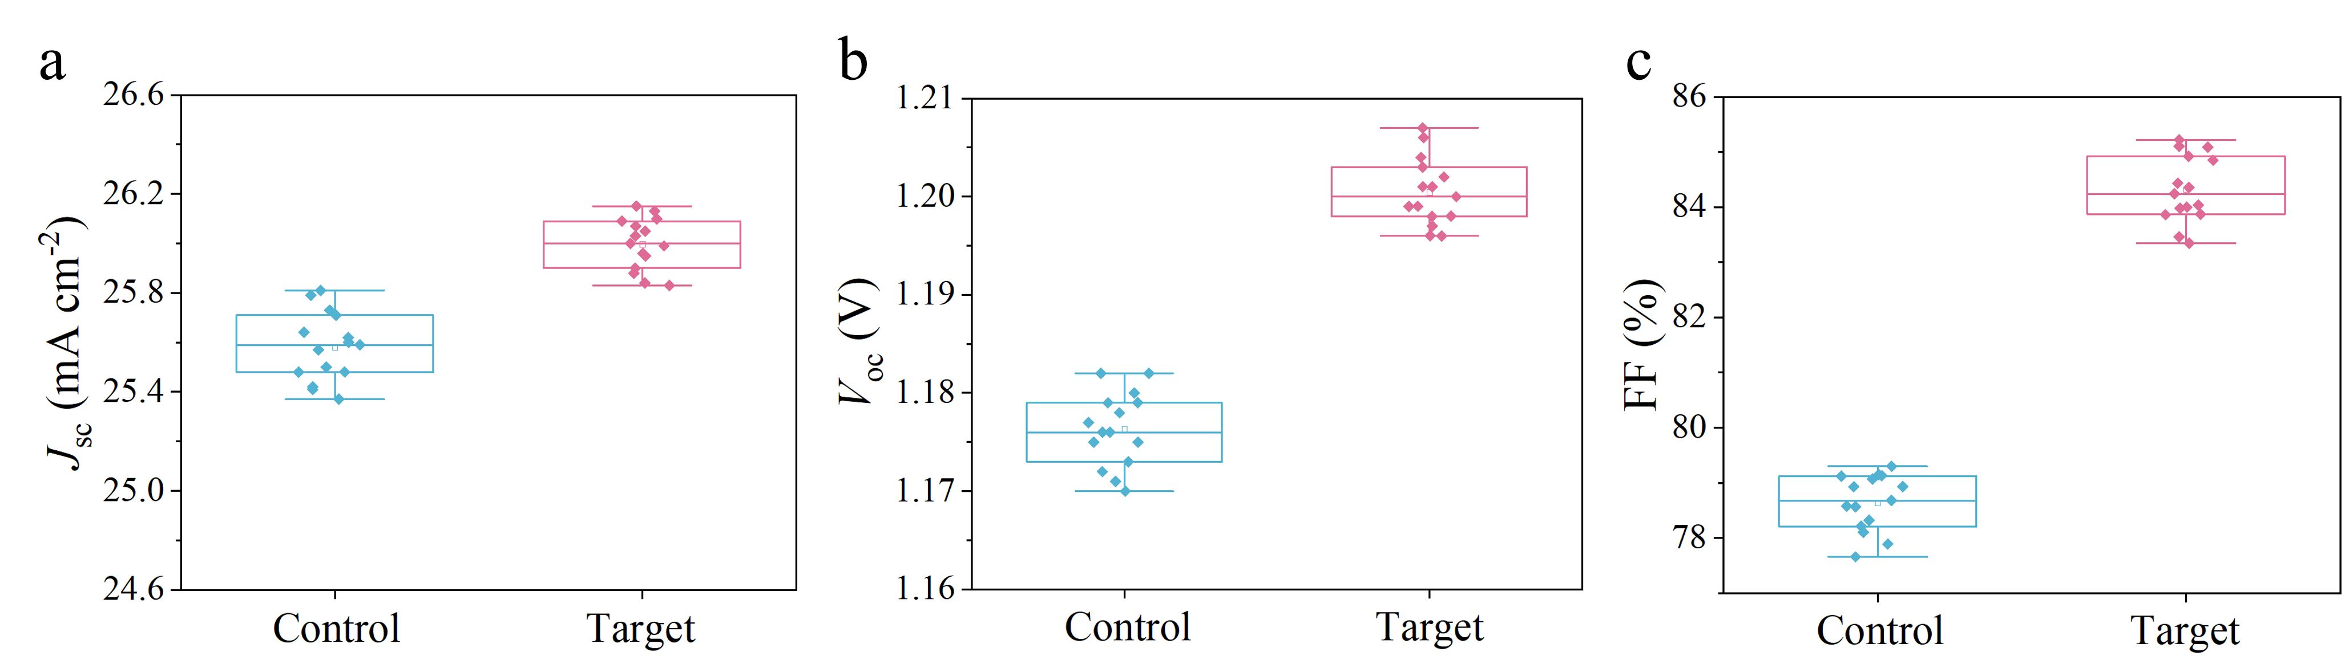
Fig. S31 Statistical device data based on 15 devices for (a) J_{sc}, (b) V_{oc} and (c) FF

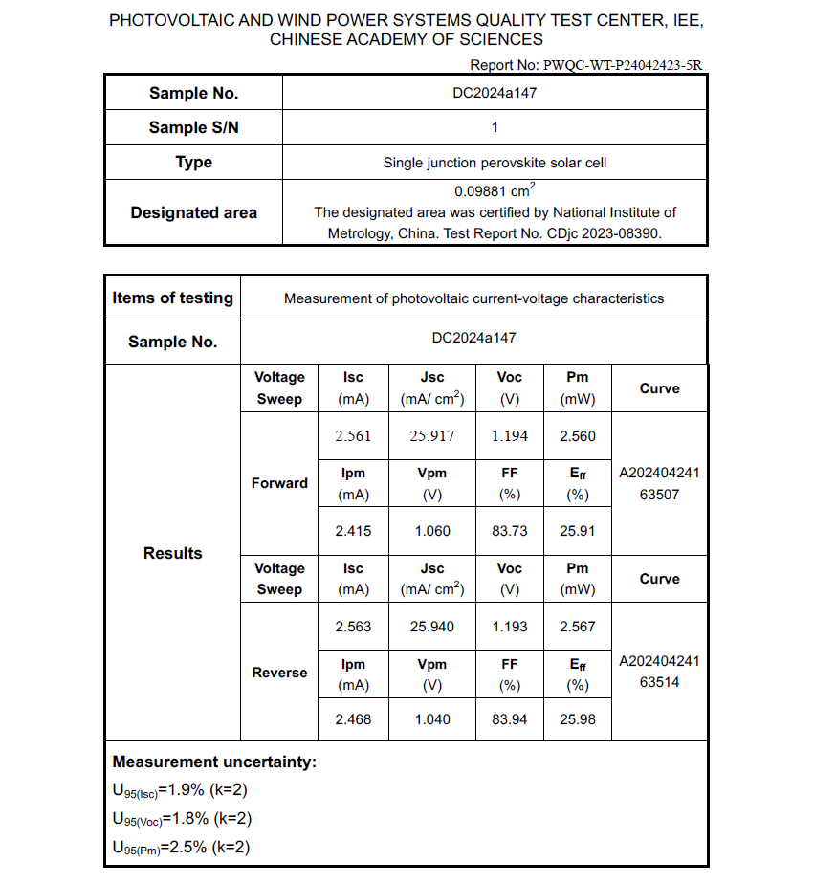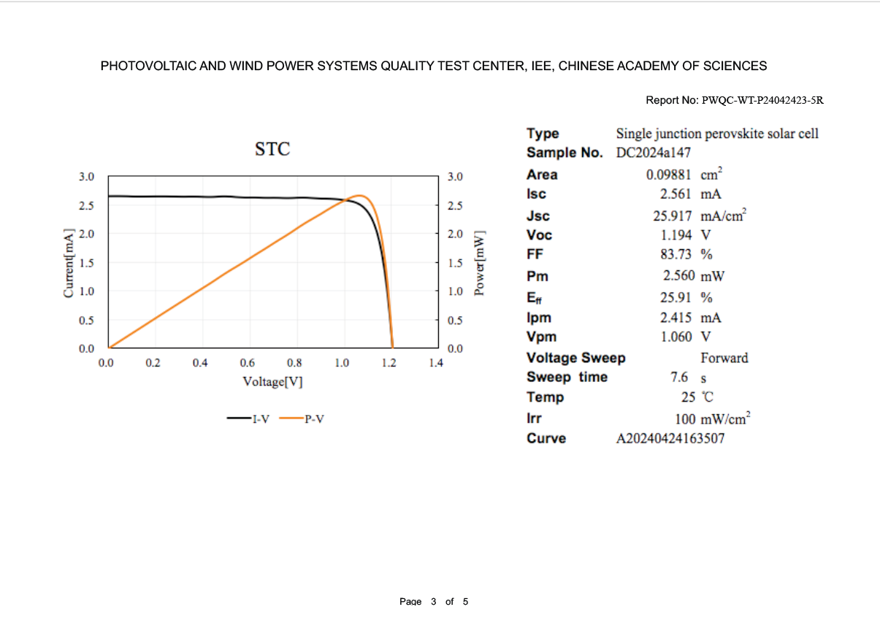
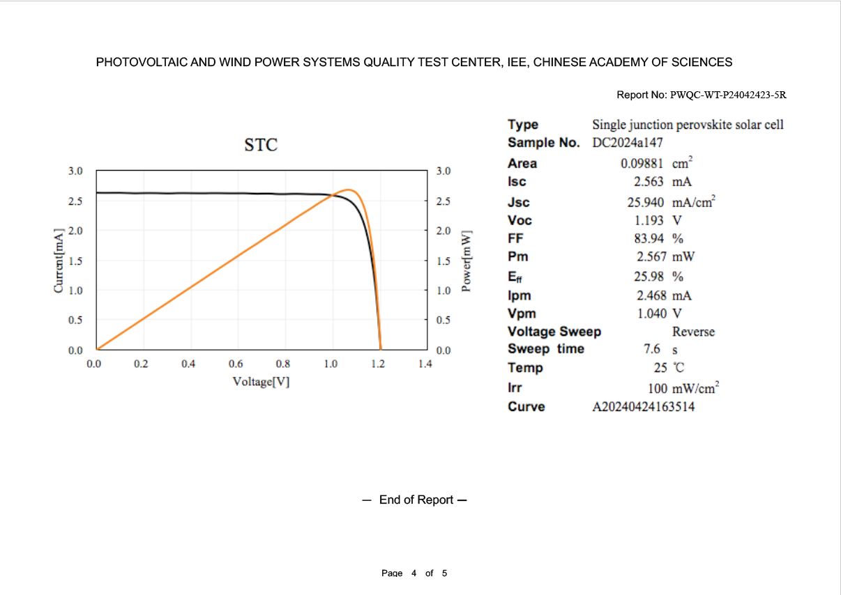
Fig. S32 Certification of PSC from Institute of Electrical Engineering Chinese Academy of Sciences

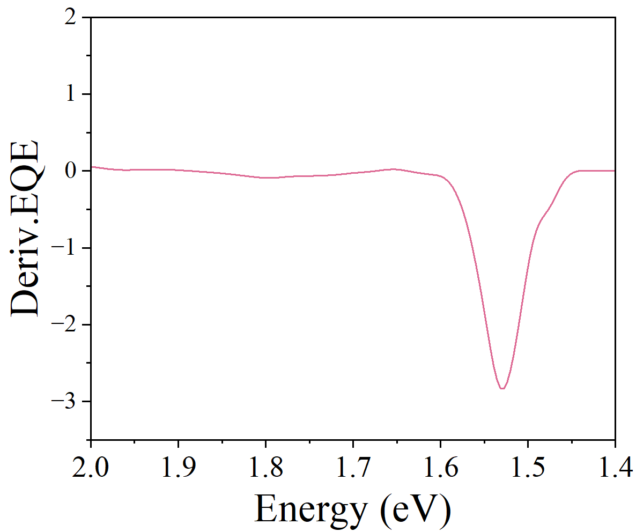
Fig. S33 Analysis of perovskite bandgap from the EQE spectrum by taking its derivative spectrum
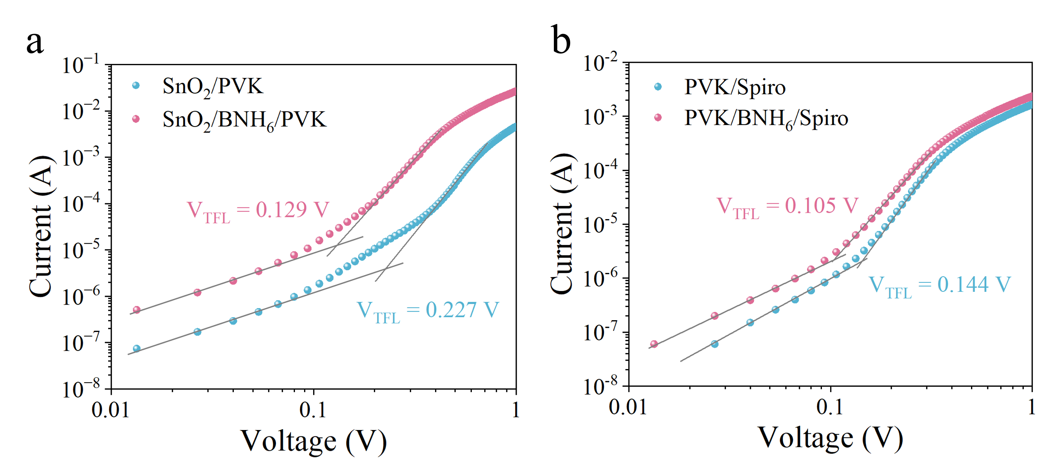
Fig. S34 Dark I-V curves of (a) the electron-only devices and (b) the hole-only devices with and without BNH₆

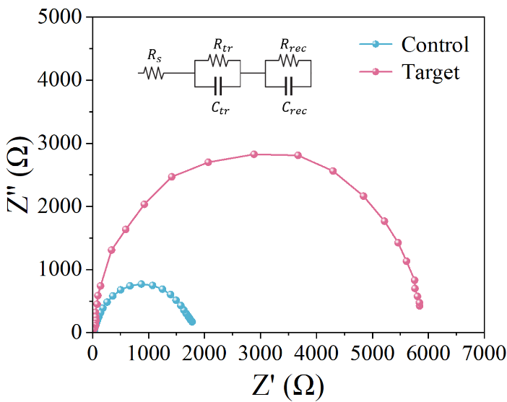
Fig. S35 Nyquist plots of the control and target devices (Inset: Equivalent circuit model)

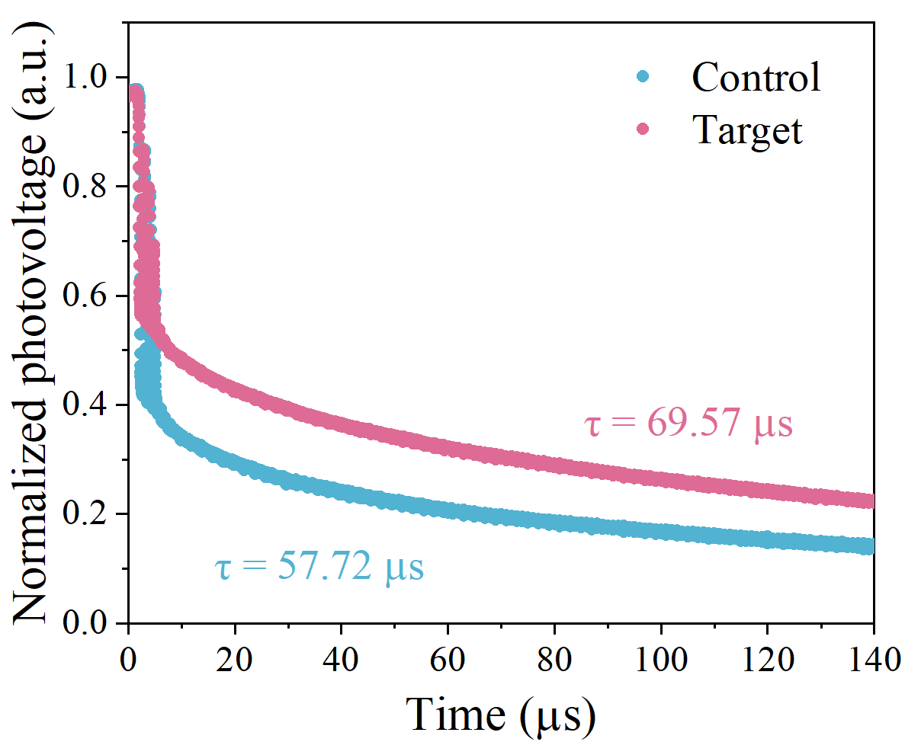
Fig. S36 TPV of the control and target devices

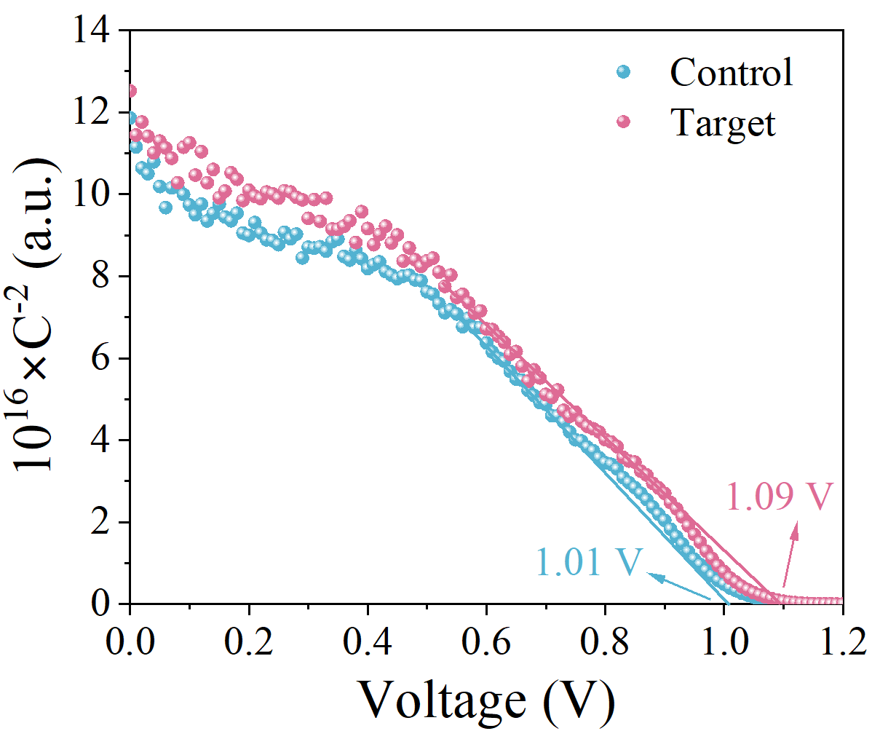
Fig. S37 Mott-Schottky plots of the control and target devices

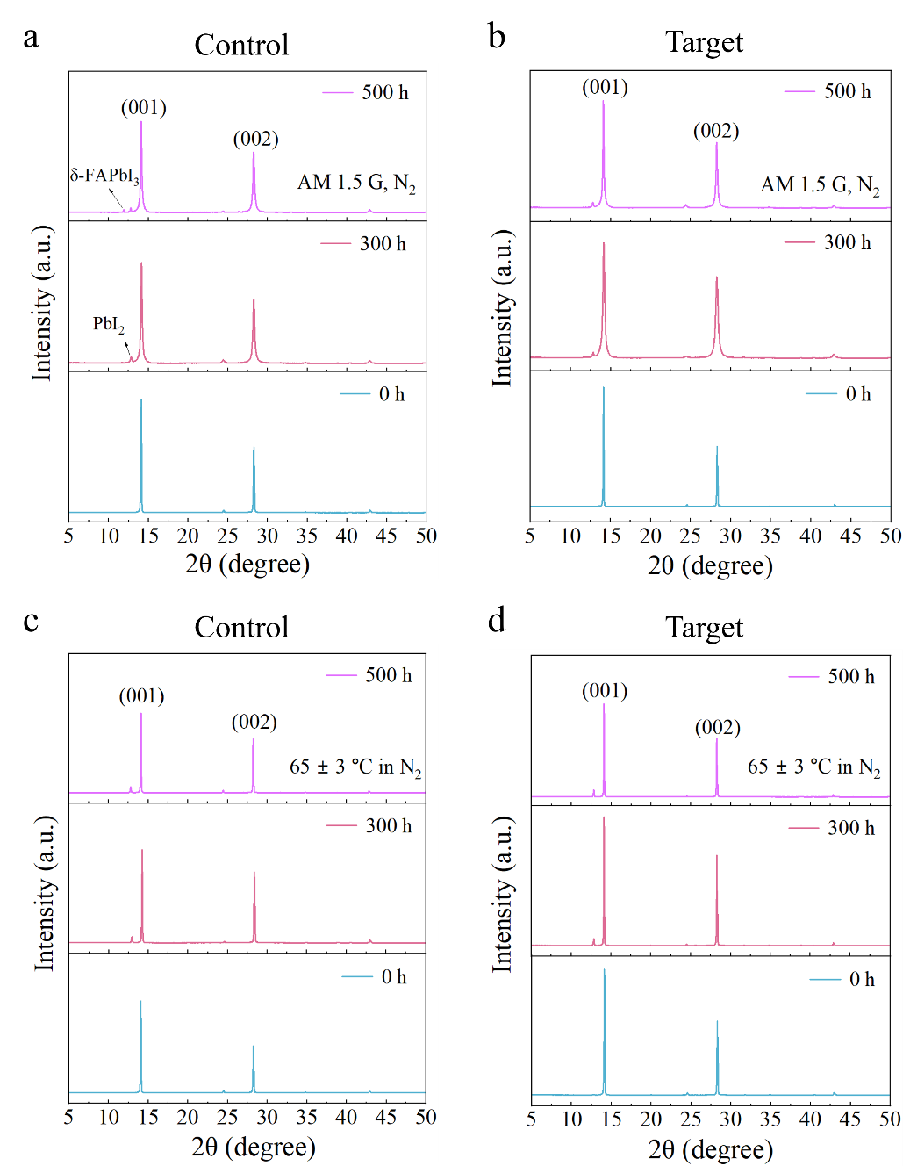
Fig. S38 Time evolution of XRD patterns of the (a) control and (b) target device under AM 1.5 G illumination with N₂ atmosphere, (c) control and (d) target device under 65 ± 3 °C heat with N₂ atmosphere
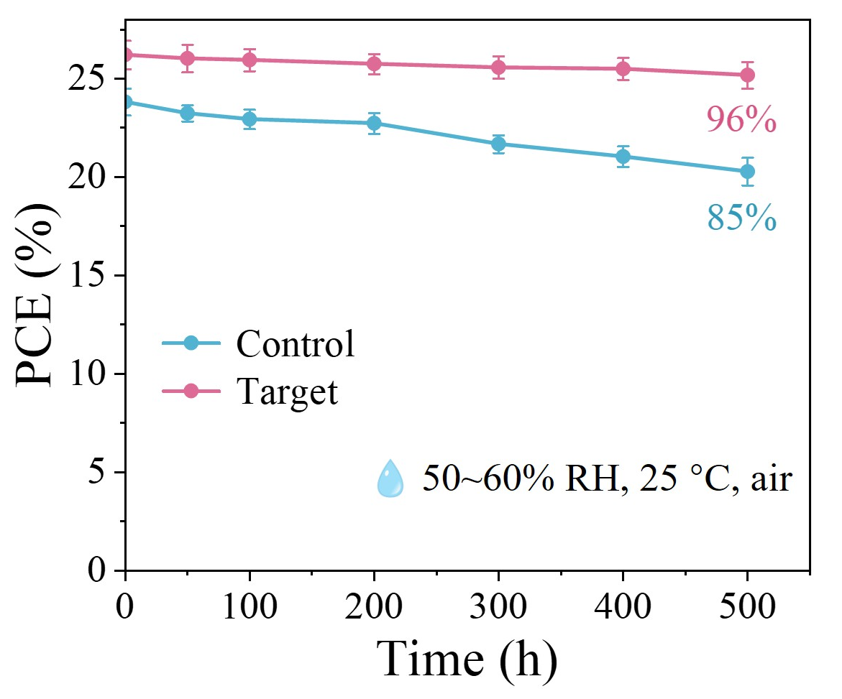
Fig. S39 Long-term stability of the unencapsulated control and target devices stored under ambient air conditions (50~60% RH, 25 °C)

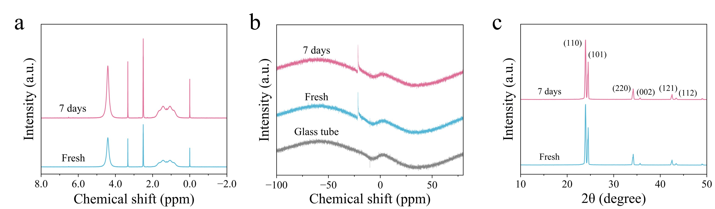
Fig. S40 (a) ¹H NMR , (b) ¹¹B NMR and (c) XRD spectra of fresh BNH₆ and BNH₆ under accelerated conditions for 7 days. The characteristic peaks of BNH₆ remained essentially unchanged after aging, confirming its robust chemical stability and indicating that BNH₆ would not compromise device performance
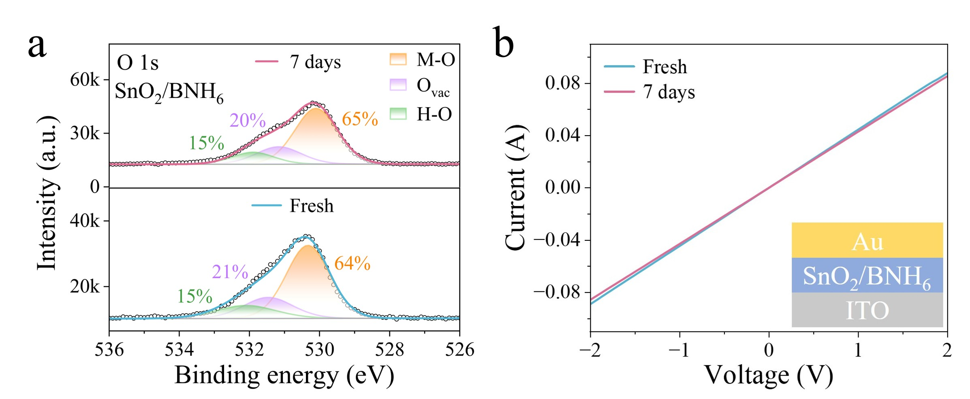
Fig. S41 (a) O 1s XPS and (b) the electrical conductivity spectra of the SnO₂/BNH₆ film under accelerated conditions for 7 days. No noticeable changes in the O 1s XPS characteristic peaks were observed after aging. And the electrical conductivity measurements of BNH₆/SnO₂ films before and after aging showed negligible variation, further verifying the robustness of the BNH₆/SnO₂ interface under accelerated conditions
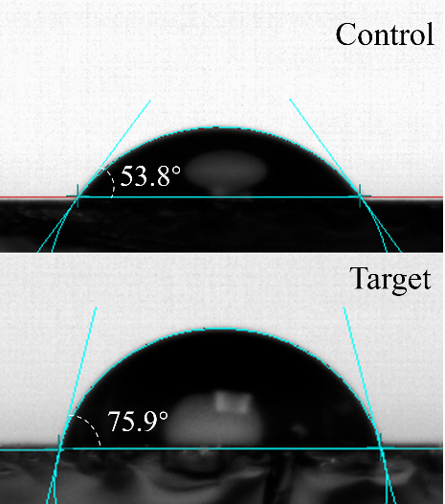
Fig. S42 Contact angles of the control and target films

Table S1 Summary of photovoltaic performance of the effective interface modification strategies
Additive | Configuration | PCE  (%) | Certified PCE  (%) | Reference
C₆₀-SAM | p-i-n | 17.3 | na | ACS Nano 12, 12701-12709 (2014)
C3-SAM | n-i-p | 15.67 | na | J. Am. Chem. Soc. 137, 2674-2679 (2015)
2D PVSK | n-i-p | 20.64 | 19.77 | Nat. Commun. 9, 3021 (2018)
DPPP | n-i-p | 24.5 | na | Science 379, 690-694 (2023)
HP | n-i-p | 23.68 | na | Adv. Mater. 32, 2003990 (2020)
CPI | n-i-p/p-i-n | 24.3/26.0 | na | Science 384, 878-884 (2024)
CBz-PAI | n-i-p | 24.7 | na | Nat. Energy 8, 515-525 (2023)
3TPYMB | p-i-n | 25.76 | na | Nat. Photon. 19, 28-35 (2025)
CPMAC | p-i-n | 26.1 | na | Science 288, 964-968 (2025)
TMPU/TMFS | n-i-p | 23.11 | na | Chem. Eng. J. 469, 143790 (2023)
AMP/ mF-PEAI and PDI | p-i-n | 25.35 | 24.87 | Adv. Energy Mater. 14, 2304486 (2024)
BNH₆/BNH₆ | n-i-p | 26.43 | 25.98 | This work

Table S2 Best photovoltaic parameters of PSCs with no treatment or post treatment by oxygen plasma measured in reverse scan directions under standard AM 1.5 illumination (100 mW cm⁻²)
 | Samples | V_{oc}  (V) | J_{sc}  (mA cm⁻²) | FF  (%) | PCE  (%)
No treatment | SnO₂ | 1.171 | 25.53 | 78.08 | 23.34
No treatment | SnO₂/BNH₆ | 1.198 | 25.86 | 82.40 | 25.53
Post  treatment | SnO₂ | 1.176 | 25.57 | 78.56 | 23.62
Post  treatment | SnO₂/BNH₆ | 1.198 | 25.96 | 82.42 | 25.63

Table S3 Parameters of the TRPL spectroscopy based on different samples
Samples | A₁ | τ₁ (ns) | A₂ | τ₂ (ns) | τ_{ave} (ns)
PVK | 158.92 | 147.28 | 748.22 | 1978.11 | 1949.61
BNH₆/PVK | 120.56 | 1196.47 | 750.33 | 3365.35 | 3248.15
PVK/BNH₆ | 161.68 | 621.38 | 1108.05 | 7010.56 | 6928.98
BNH₆/PVK/BNH₆ | 163.98 | 1000.00 | 1119.16 | 9273.37 | 9144.68

Table S4 Best photovoltaic parameters of PSCs using different concentrations of BNH₆ measured in reverse scan directions under standard AM 1.5 illumination (100 mW cm⁻²)
SnO₂/BNH₆ | Concentration  (mg mL⁻¹) | V_{OC}  (V) | J_{SC}  (mA cm⁻²) | FF  (%) | PCE  (%)
SnO₂/BNH₆ | 0.5 | 1.196 | 25.93 | 81.16 | 25.18
SnO₂/BNH₆ | 1.0 | 1.198 | 25.96 | 82.42 | 25.63
SnO₂/BNH₆ | 2.0 | 1.181 | 25.47 | 80.45 | 24.20
SnO₂/BNH₆ | 3.0 | 1.174 | 25.21 | 80.80 | 23.92
PVK/BNH₆ | 0.5 | 1.197 | 25.90 | 80.67 | 25.00
PVK/BNH₆ | 1.0 | 1.203 | 25.91 | 83.51 | 26.03
PVK/BNH₆ | 2.0 | 1.185 | 25.16 | 81.13 | 24.19
PVK/BNH₆ | 3.0 | 1.185 | 25.05 | 80.77 | 23.98

Table S5 Photovoltaic parameters of control and target devices measured in reverse and forward scan directions under standard AM 1.5 illumination (100 mW cm⁻²)
 | Scan Directions | V_{OC}  (V) | J_{SC}  (mA cm⁻²) | FF  (%) | PCE  (%)
Control | RS | 1.176 | 25.57 | 78.56 | 23.62
Control | FS | 1.171 | 25.55 | 77.26 | 23.12
Target | RS | 1.206 | 26.05 | 84.12 | 26.43
Target | FS | 1.201 | 25.99 | 83.67 | 26.12

Table S6 Parameters from SCLCs of the electron-only devices and of the hole-only devices
 | SnO₂/PVK | SnO₂/BNH₆/PVK | PVK/Spiro | PVK/BNH₆/Spiro
V_{TFL} (V) | 0.227 | 0.129 | 0.136 | 0.119
Trap  density(cm⁻³) | 2.7910‧10¹⁵ | 1.5861‧10¹⁵ | 1.7705‧10¹⁵ | 1.2910‧10¹⁵
Trap densities were calculated using the V_{TFL} from SCLC measurements, and the equation $N_{traps}=2ε_{0}ε_{r}V_{TFL}/(qL^{2})$, where the ε₀ is the vacuum permittivity, ε_{r} (47) is the relative dielectric constant of FAPbI₃, q is the elementary charge, and L (650 nm) is the thickness of the perovskite films, respectively.

Table S7 EIS fitting parameters of the control and target PSCs
Device | R_{s} (Ω) | R_{rec} (Ω)
Control | 33.28 | 1618
Target | 29.65 | 5699

