Supporting Information for

High-Performance Cu-Based Liquid Thermocells Enabled by Thermosensitive Crystallization and Etched Carbon Cloth Electrode
Wei Fang¹, Zeping Ou¹, Yifan Wang¹, Zhe Li¹, Qian Huang¹, Pengchi Zhang ¹, Xinzhe Li¹, Yujie Zheng¹, Lijun Hu², Chen Li^{1,3}, Jianyong Ouyang⁴, Kuan Sun¹*
¹ MOE Key Laboratory of Low-grade Energy Utilization Technologies and Systems, School of Energy & Power Engineering, Chongqing University, Chongqing 400044, P. R. China
² Hunan Key Laboratory for the Design and Application of Actinide Complexes, School of Chemistry and Chemical Engineering, University of South China, Hengyang, Hunan 421001, P. R. China
³ Sibley School of Mechanical and Aerospace Engineering, Cornell University, Ithaca, New York 14853, United States
⁴ Department of Materials Science & Engineering, National University of Singapore, Singapore 117574, Singapore

*Corresponding author. E-mail: kuan.sun@cqu.edu.cn (Kuan Sun)

Note S1 Theoretical analysis of the S_{e} for the Cu-based thermocell
For a liquid thermocell using CuCl/CuCl₂ as redox couple, the reversible reactions can be symbolically described as follows:
${\text{Cu}}^{\text{2+}} \text{+}{ \text{e}}^{\text{‒}} \text{↔} {\text{Cu}}^{\text{+}} \left(\text{S1}\right)$
When a temperature difference (ΔT) is applied to this LTC, the resulting electrochemical redox potential difference (ΔE) drives the aforementioned reaction to spontaneously occur in the reverse direction, generating a cell voltage (ΔV) and allowing electrons to flow through the external circuit. This phenomenon is commonly referred to as the thermogalvanic effect. The thermopower S_{e} represents the dependence of the potential difference (ΔE) on the temperature difference (ΔT). Thus, S_{e} can be expressed as [S1, S2]:
$${\text{S}}_{\text{e}} \text{=} \frac{\text{∆V}}{\text{∆T}} \text{=} \frac{\text{∆}\text{S}}{\text{nF}} \left(\text{S2}\right)$$
where ΔS is the entropy change for the redox reaction, n is the number of electrons transferred in the redox reaction, and F is Faraday’s constant.
To enhance the S_{e} of this thermocell system, the ΔS must be highly boosted. In general, the ΔS only takes into account the solvent-structural entropy of Cu⁺ and Cu²⁺. Besides, the concentration ratio difference (ΔC_{r}) of [Cu²⁺]/[Cu⁺] also can lead to a ΔS, but its value is generally nearly zero in a thermodynamically stable state. Nonetheless, Zhou's work offered a novel approach by introducing a thermosensitive crystallization process, which effectively regulates the concentration of the targeted ions through temperature control [S3, S4]. Here, we analyze the potential for enhancing the S_{e} by regulating the ΔC_{r} of [Cu²⁺]/[Cu⁺].
According to the Nernst equation, the equilibrium potential (E) of the abovementioned redox reaction can be expressed as:
$$\text{E} \text{=}{ \text{E}}^{\text{0}} \text{+} \frac{\text{RT}}{\text{nF}}\text{ln}{\frac{{\text{α}}_{{\text{Cu}}^{\text{2+}}}}{{\text{α}}_{{\text{Cu}}^{\text{+}}}}} \left(\text{S3}\right)$$
where E⁰ is the standard potential, and R is the ideal gas constant. The activity (αi) is defined as the product of the activity coefficient (γ_{i}) and concentration ([i]) (α_{i} = γ_{i}×[i]). Thus, Eq. (S3) can be written:
$$\text{E} \text{=}{ \text{E}}^{\text{0}} \text{+} \frac{\text{RT}}{\text{nF}} \left[\text{ln}{\frac{{\text{γ}}_{{\text{Cu}}^{\text{2+}}}}{{\text{γ}}_{{\text{Cu}}^{\text{+}}}}} \text{+}\text{ln}{\frac{\left[{\text{Cu}}^{\text{2+}}\right]}{\left[{\text{Cu}}^{\text{+}}\right]}}\right] \left(\text{S4}\right)$$
In general, S_{e} is calculated by:
$${\text{S}}_{\text{e}} \text{=} \frac{{\text{E}}_{\text{hot}}\text{-}{\text{E}}_{\text{cold}}}{{\text{T}}_{\text{hot}}\text{-}{\text{T}}_{\text{cold}}} \left(\text{S5}\right)$$
where the subscripts “hot” and “cold” indicate that the corresponding variables pertain to the hot and cold sides of the LTC, respectively. By substituting Eq. (S4) into Eq. (S5), S_{e} can be finally written as the sum of two terms:
$${\text{S}}_{\text{e}}\text{=}\frac{\text{R}}{\text{F∆T}}\left[{\text{T}}_{\text{hot}}\text{ln}{\frac{{\text{(}{\text{γ}}_{{\text{Cu}}^{\text{2+}}}\text{)}}_{\text{hot}}}{{\text{(}{\text{γ}}_{{\text{Cu}}^{\text{+}}}\text{)}}_{\text{hot}}}}\text{-}{\text{T}}_{\text{cold}}\text{ln}{\frac{{\text{(}{\text{γ}}_{{\text{Cu}}^{\text{2+}}}\text{)}}_{\text{cold}}}{{\text{(}{\text{γ}}_{{\text{Cu}}^{\text{+}}}\text{)}}_{\text{cold}}}}\right]\text{+}\frac{\text{R}}{\text{F∆T}}\left[{\text{T}}_{\text{hot}}\text{ln}{\frac{{\left[{\text{Cu}}^{\text{2+}}\right]}_{\text{hot}}}{{\left[{\text{Cu}}^{\text{+}}\right]}_{\text{hot}}}}\text{-}{\text{T}}_{\text{cold}}\text{ln}{\frac{{\left[{\text{Cu}}^{\text{2+}}\right]}_{\text{cold}}}{{\left[{\text{Cu}}^{\text{+}}\right]}_{\text{cold}}}}\right] \left(\text{S6}\right)$$
whereas the first term containing the activity coefficient (γ) is considered to be dominated by the solvent-dependent difference in entropy between the redox couple; the second term is only related to the concentrations of Cu⁺ and Cu²⁺, which is defined as temperature-dependent concentration ratio difference ΔC_{r}.
Generally, the concentration ratio [Cu²⁺]/[Cu⁺] is approximately consistent for the hot and cold sides, equaling to the initial concentration of the used electrolyte. Hence, the second term in Eq. (S6) is nearly zero. Clearly, if the concentration ratio [Cu²⁺]/[Cu⁺] at the hot side is much larger than that at the cold side, the value of the second term in Eq. (S6) could be highly boosted, and thereby contributed a giant S_{e}. According to our experimental S_{e} value for the pristine electrolyte (Fig. 2e), the value of the first term in Eq. (S6) is approximately considered to be 1.47 mV K^{–1} in following calculations. We establish a Cu²⁺ concentration gradient using the ammonium sulfate (NH₄)₂SO₄ to induce thermosensitive crystallization. Specifically, (NH₄)₂SO₄ addition causes Cu²⁺ to crystallize on the cold side (top), precipitating due to gravity and subsequently redissolving on the hot side (bottom). This creates a Cu²⁺ concentration gradient, lower near the cold electrode and higher near the hot electrode (Fig. 1). As shown in the Figure S11, Supporting Information, we demonstrate the potential for regulating the open-circuit voltage (V_{oc}, namely S_{e}×ΔT) by the concentration ratio [Cu²⁺]/[Cu⁺] at the cold and hot side (T_{h} and T_{c} are 60 and 20 ℃, respectively). Furthermore, based on the measured concentration ratio [Cu²⁺]/[Cu⁺] at different temperature (Figure S10, Supporting Information), the simulated V_{oc} values for the TC-LTC are also calculated, exhibiting a near consistence with the experimental values (Fig. 2e).

Note S2 Analysis of cuprous and copper ion content by UV-vis spectra
In this work, the strategy of thermosensitive crystallization is adopted to enhance S_{e}. Specifically, thermosensitive crystallization at the cold electrode and dissolution process at the hot electrode induce a persistent concentration gradient of redox ions by adding (NH₄)₂SO₄. Therefore, the detection of Cu²⁺ ion and Cu⁺ ion content to analyze the change of concentration ratio [Cu²⁺]/[Cu⁺] is very critical. In 3 M Cl‒ environment, the absorption peak of Cu⁺ ion appears at 274 nm, while that of Cu²⁺ ion appears at 250 nm [S5] (Fig. S8). When the solution contains Cu²⁺ and Cu⁺ ions at the same time, there are two absorption peaks at 250 nm and 270 nm. The UV absorption spectra of 0.4 M CuCl₂ and 0.15 M CuCl are superimposed in the range of 210~400 nm, which is similar to the UV absorption spectra containing both 0.4 M CuCl₂ and 0.15 M CuCl in the solution (Fig. S8, dashed line). This suggests that the shift of Cu⁺ absorption peak in the solution containing Cu²⁺ is caused by the superposition of Cu²⁺ absorption band. Obviously, when the solution contains Cu²⁺ and Cu⁺ ions at the same time, the characteristic peak intensity of Cu²⁺ is inevitably affected by Cu⁺, and vice versa. Therefore, the content of Cu²⁺ and Cu⁺ ions cannot be calculated directly according to the intensity of characteristic peak.
According to Lambert-Beer's law, absorbance A = KCL, where K is the molar absorption coefficient; C is the concentration of detection solution; L is the thickness of the transmittance layer. Moreover, absorbance is additive [S6], at the same wavelength A = A₁ + A₂ + A₃ + …… In order to resolve the concentration from the intensity at characteristic peak, we select the absorption intensity at 250 nm and 274 nm in the UV absorption spectra to analyze the copper ion content. Firstly, we obtain the UV absorption spectra of the solution with known Cu²⁺ (Cu⁺) concentration, and fit the relationship between the absorbance intensity at 250 nm and 274 nm and concentration of Cu²⁺ (Cu⁺) (Fig. S9). It can be seen that there is a good linearity between the absorbance intensity and concentration, with a correlation coefficient R of at least 0.998. Next, for unknown solutions containing X₁ M CuCl and X₂ M CuCl₂, the absorbance of this UV absorption spectra at 250 nm and 274 nm is A₂₅₀, A₂₇₄, respectively. The Cu²⁺ and Cu⁺ ion concentration in solution can be obtained by solving the following binary first order equation:

$$\text{2.77 }{\text{X}}_{\text{1}} \text{+} \text{0.058} \text{+} \text{3.87 }{\text{X}}_{\text{2}} \text{+} \text{0.072} \text{=}{ \text{A}}_{\text{250}}$$
$\text{7.93 }{\text{X}}_{\text{1}} \text{+} \text{0.018} \text{+} \text{2.52 }{\text{X}}_{\text{2} }\text{+} \text{0.054} \text{=}{ \text{A}}_{\text{274}}$ (S7)

Note S3 Mechanism of etching carbon cloth by KOH activation
KOH activation method is widely used in broad fields to increase the specific surface area of carbon material. The activation mechanism has not been well understood because of the complexity due to the large number of variables in both the experimental parameters and the reactivity of different precursors used. In a general view, the reaction of carbon and KOH starts with solid–solid reactions and then proceeds via solid–liquid reactions including the reduction of potassium (K) compound to form metallic K [S7], the oxidation of carbon to form carbon oxide and carbonate, and other reactions among various active intermediates.
Based on previous research [S8-S10], three main activation mechanisms for KOH activation of carbon are concluded which have been widely accepted: (a) Etching the carbon framework by the redox reactions between various potassium compounds as chemical activating reagents with carbon as shown:
$$\text{6KOH} \text{+} \text{2C} \text{→ 2K} \text{+} \text{3}{\text{H}}_{\text{2}} \text{+} \text{2}{\text{K}}_{\text{2}}{\text{CO}}_{\text{3}} \text{(S8)}$$
$${\text{K}}_{\text{2}}{\text{CO}}_{\text{3}} \text{+} \text{2C} \text{→} \text{2K} \text{+} \text{3CO } \left(\text{S9}\right)$$
$$\text{C} \text{+} {\text{K}}_{\text{2}}\text{O} \text{→} \text{2K} \text{+} \text{CO } \text{ (S10)}$$
called chemical activation, is responsible for generating the pore network; (b) the formation of H₂O ($\text{2}\text{KOH}\text{ → }{\text{K}}_{\text{2}}\text{O + }{\text{H}}_{\text{2}}\text{O}$) and CO₂ ($\text{CO + }{\text{H}}_{\text{2}}\text{O → }{\text{H}}_{\text{2}}\text{ + C}{\text{O}}_{\text{2}}$ and ${\text{K}}_{\text{2}}{\text{CO}}_{\text{3}}\text{ → }{\text{K}}_{\text{2}}\text{O + C}{\text{O}}_{\text{2}}$) in the activation system positively contributes to the further development of the porosity through the gasification of carbon as shown:
$$\text{C + }{\text{H}}_{\text{2}}\text{O → }{\text{H}}_{\text{2}}\text{ + CO } \text{ (S}\text{11}\text{)}$$
$$\text{C + C}{\text{O}}_{\text{2}}\text{ → }\text{2}\text{CO} \text{(S}\text{12}\text{)}$$
namely physical activation; (c) the as-prepared metallic K (Eqs. (8-10)), efficiently intercalating into the carbon lattices of the carbon matrix during the activation, results in the expansion of the carbon lattices [S11]. After the removal of the intercalated metallic K and other K compounds by washing, the expanded carbon lattices cannot return to their previous nonporous structure and thus the high microporosity.
The development of large specific surface area and high porosity in KOH-activated carbons is the result of the synergistic, comprehensive actions including chemical activation, physical activation, and carbon lattice expansion by the metallic K intercalation. In our research, this activation mechanism is also applicable to the etching process of carbon cloth. After soaking in 1 M KOH solution and annealing at a suitable time at 600 ℃, microporous structures can be etched on the surface of carbon cloth fibers (Fig. S20), which will further increase the specific surface area of carbon cloth. When the carbon cloth is annealed at 600 ℃ for 5 h without KOH soaking, a small number of micropores will appear on the surface of the carbon cloth fiber (Fig. S21), which may be caused by gasification of carbon.

Supplementary Figures and Tables
Fig. S1 Schematic sectional drawing illustrating the assembly process of the LTC device in four steps: (1) Preparing all parts and assembling the cell frame; (2) Injecting the electrolyte to fill the cell; (3) Sealing the cell using nano transparent double-sided tape; (4) Horizontally placing the cell for testing. The temperature difference in the LTC is achieved by positioning a heater on one side and a thermoelectric cooler with a water-cooled plate on the opposite side. The water-cooled plate effectively cools the thermoelectric cooler through water circulation, helping maintain the cold side of the LTC at 20 °C. The cross-sectional area of the cell is 3.24 cm², with an electrode separation of 1.2 cm.
Fig. S2 a The open-circuit voltage of the 0.4 M Fe(CN)₆^{3‒}/Fe(CN)₆^{4‒} LTC across a temperature difference (ΔT) ranging from 0 to 40 K. The 0.4 M Fe(CN)₆^{3‒}/Fe(CN)₆^{4‒} system, with a thermopower S_{e} of approximately ‒1.4 mV K^{–1[12]}, serves as a benchmark for thermocells. To verify the accuracy of our experimental device, we tested the 0.4 M Fe(CN)₆^{3‒}/Fe(CN)₆^{4‒} system using our experimental setup. Within the temperature range of 0 to 40 K, the measured S_{e} was ‒1.38 mV K^{–1}, confirming the reliability of our testing apparatus. b Short-circuit current density (J_{sc}) of 0.4 M Fe(CN)₆^{3‒}/Fe(CN)₆^{4‒} LTC versus time over about 12 h short-circuit operation at a ΔT = 40 K

Fig. S3 a Photographs of electrolytes comprising 0.15 M CuCl/CuCl₂ in 0.9 M NH₄Cl solution with and without the addition 0.1 M HCl. The results indicate that the addition of a small amount of HCl inhibits hydrolysis and enhances dissolution. b Open-circuit voltage of the LTC device as a function of temperature difference (ΔT) from 0 to 40 K

Fig. S4 a Photographs of electrolytes including 0.15 M CuCl and different amount of CuCl₂ in 0.9 M NH₄Cl and 0.1 M HCl solutions with 3 M (NH₄)₂SO₄ added. An increase in the CuCl₂ content corresponds to a greater amount of precipitate produced. b The corresponding S_{e} as a funciton of CuCl₂ concentration. The S_{e} reaches its maximum value when the CuCl₂ concentration is 0.4 M.

Fig. S5 Thermogalvanic properties of the selected pristine electrolyte for the LTC. The pristine electrolyte comprises 0.15 M CuCl, 0.4 M CuCl₂, 0.9 M NH₄Cl, and 0.1 M HCl. a Open-circuit voltage of this LTC as a function of ΔT ranging from 0 to 40 K. b Short-circuit current density (J_{sc}) versus time over a 12 h short-circuit operation. The J_{sc} do not fluctuate, indicating excellent stability of the LTC.
Fig. S6 Cyclic voltammetry (CV) curves scanned at 10 mV s⁻¹ for (a) 2 mM K₃Fe(CN)₆/K₄Fe(CN)₆ in 1 M KCl aqueous solution and (b) 2 mM CuCl/CuCl₂ in 0.9 M NH₄Cl + 0.1 M HCl aqueous solution. Both the working electrode and the opposing electrode are graphite electrodes, and reference electrode is Ag/AgCl electrode.

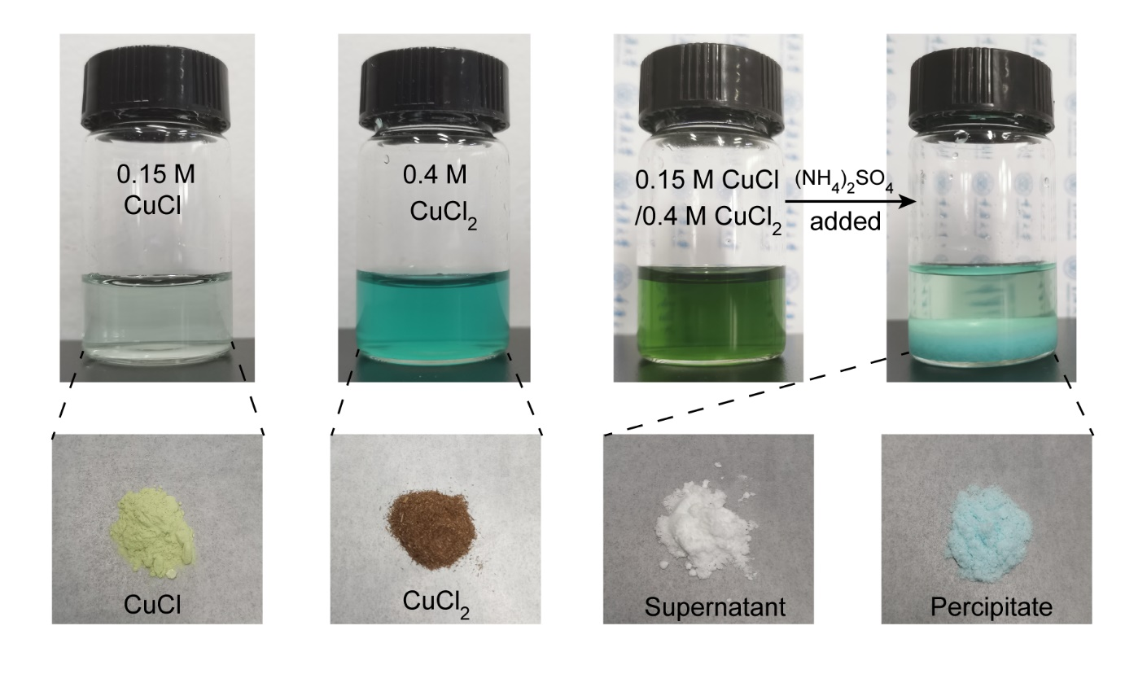
Fig. S7 Photographs of the electrolytes (top row), left to right: 0.15 M CuCl, 0.4 M CuCl₂, 0.15 M CuCl/0.4 M CuCl₂ and 0.15 M CuCl/0.4 M CuCl₂ + 4 M (NH₄)₂SO₄ in 0.9 M NH₄Cl solution with 0.1 M HCl. The bottom row shows the corresponding dried powders obtained through vacuum drying. CuCl appears as a white powder; however, upon exposure to moisture in the air, it slightly oxidizes and takes on a light yellow color. The dried powders from the supernatant are white, indicating a very low content of Cu²⁺ ions.

Fig. S8 a N 1s XPS spectra for pure (NH₄)₂SO₄ and the dried powders from the supernatant and precipitate in the (NH₄)₂SO₄ added electrolyte. b FTIR spectra for pure (NH₄)₂SO₄ and dried powders from the supernatant and precipitate in the (NH₄)₂SO₄ added electrolyte

Fig. S9 UV-vis absorption spectra of Cu⁺ or/and Cu²⁺ in different aqueous solutions. The dashed line represents the superposition of the UV-Vis absorption spectra under 0.15 M CuCl and 0.4 M CuCl₂ conditions. It is evident that the dashed line closely matches the UV-Vis absorption spectrum of the solution containing 0.15 M CuCl + 0.4 M CuCl₂ at the absorption band. This observation suggests that the shift of the Cu⁺ absorption peak in the presence of Cu²⁺ is attributable to the superposition of the Cu²⁺ absorption band.

Fig. S10 Cuprous chloride and copper chloride scale measurement. a UV-vis absorption spectra for CuCl solutions with a gradient of concentration. b Linear fit between CuCl content and absorbance at 250 nm and 274 nm. c UV-vis absorption spectra for CuCl₂ solution with a gradient of concentration. d Linear fit between CuCl₂ content and absorbance at 250 nm and 274 nm
Fig. S11 a Schematic representation of the in-situ method for measuring redox species concentration in TC-LTC using a solution containing 0.15 M CuCl/0.4 M CuCl₂, 0.1 M HCl, 0.9 M NH₄Cl, and 4 M (NH₄)₂SO₄. (b-e) UV-Vis spectra of solution at cold and hot electrode in TC-LTC under different temperature difference. The extracted solution samples were diluted ~ 350 times for UV-Vis analysis. The temperature at the cold electrode is controlled at about 293 K (20 ℃).
Fig. S12 Simulated V_{oc} of the TC-LTC depending on the concentration ratio of [Cu²⁺]/[Cu⁺] at the two electrodes. The temperatures at the cold and hot electrodes were 293 and 333 K, respectively. This simulation is based on Eq. (S6) in Note S1
Fig. S13 a Photographs of the 0.15 M CuCl/0.4 M CuCl₂ electrolyte with different amount of (NH₄)₂SO₄. b UV-Vis spectra of CuCl and CuCl₂ in electrolyte with different amount of (NH₄)₂SO₄. c Concentrations of Cu⁺ and Cu²⁺ in electrolyte with different amount of (NH₄)₂SO₄. These concentrations are calculated from the corresponding UV-Vis spectra. When the concentration of (NH₄)₂SO₄ exceeded 4 M, the Cu⁺ content began to decrease, suggesting that the increase in the precipitation content after the addition of more than 4 M (NH₄)₂SO₄ came from concomitant Cu⁺ crystallization.

Fig. S14 Plot of measured V_{oc} versus ΔT for the TC-LTC with different amounts of added (NH₄)₂SO₄
Fig. S15 a Chemical structures of ammonium (NH₄⁺), tetramethylammonium (Tma⁺), and guanidinium (Gdm⁺). b UV-Vis spectra of the electrolyte containing different cation additives

Fig. S16 Plot of measured solubility versus temperature for (NH₄)₂Cu(SO₄)₂∙6H₂O, K₂Cu(SO₄)₂∙6H₂O, and (Tma)₂Cu(SO₄)₂∙H₂O

Fig. S17 UV-Vis spectra at increasing temperatures following the addition of a (NH₄)₂SO₄, b K₂SO₄, and c (Tma)₂SO₄. d Plot of the concentration ratio of [Cu²⁺]/[Cu⁺] versus temperature for the electrolyte with various additive, which was calculated from the corresponding UV-Vis spectrum by the Lambert-Beer law

Fig. S18 Plot of measured V_{oc} versus ΔT for the TC-LTC with different cation additives

Fig. S19 Diagram of the carbon cloth etching process. The cut carbon cloth is immersed in a 1 M KOH solution for 24 hours, concurrently heated at 70 °C. After immersion, the carbon cloth is removed and rinsed three times with deionized water to eliminate excess KOH. The etched carbon cloth is then obtained by annealing at 600 °C for varying durations in a tube furnace and subsequently cleaned

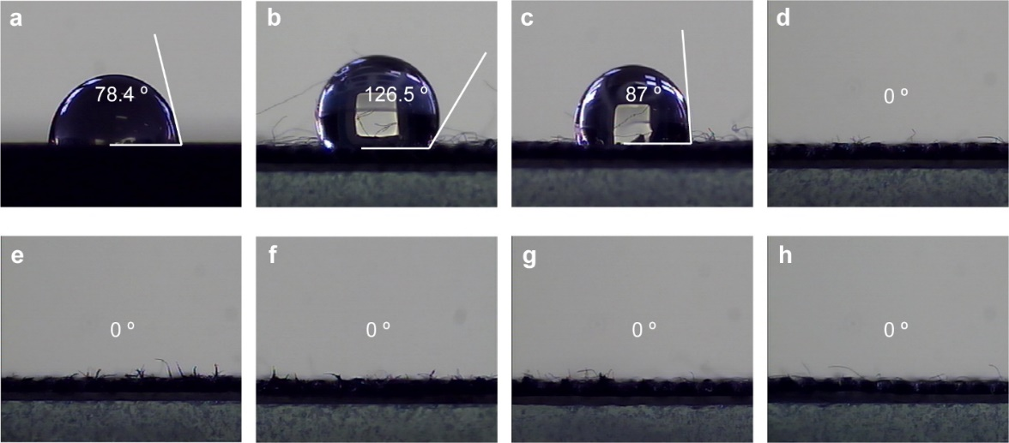
Fig. S20 Photographs of water drops on three different electrodes. a Graphite sheet; b untreated carbon cloth; c treated carbon cloth soaked in 1 M KOH; d carbon cloth annealed for 5 h without soaking in 1 M KOH; and carbon cloth annealed at 600 ℃ for e 1 h, f 3 h, g 5 h, and h 7 h after soaking in 1 M KOH
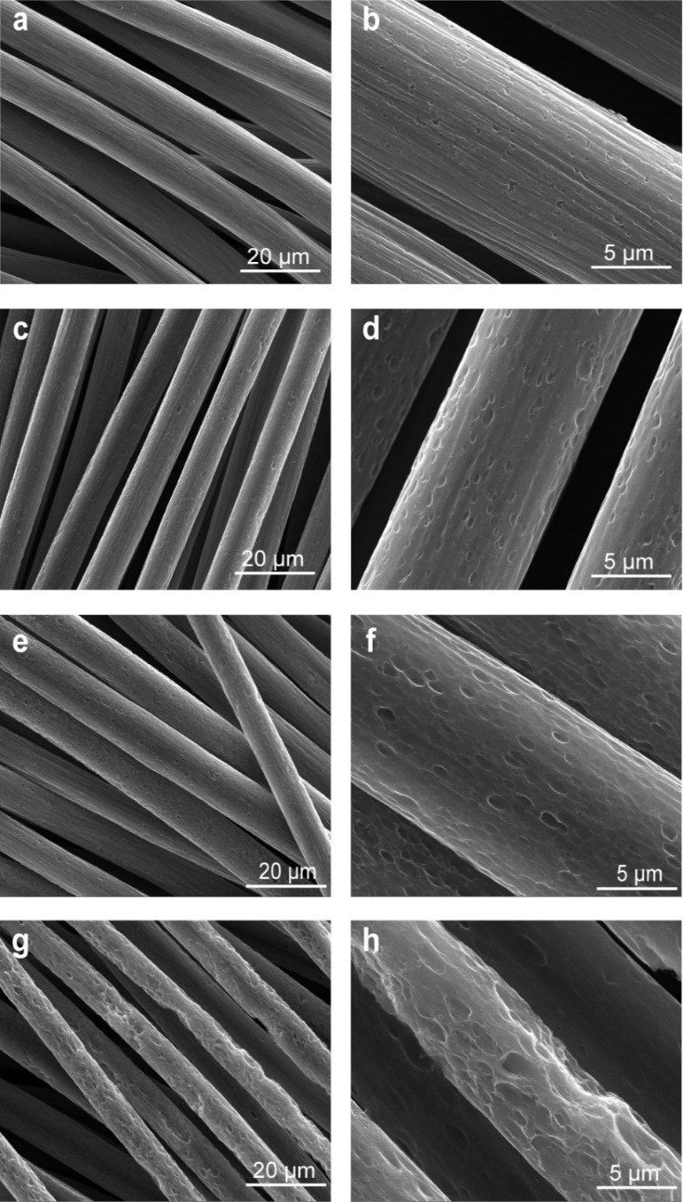
Fig. S21 SEM images of the surface of carbon cloth electrodes with increasing annealing times, 1 h (a, b), 3 h (c, d), 5 h (e, f), 7 h (g, h)

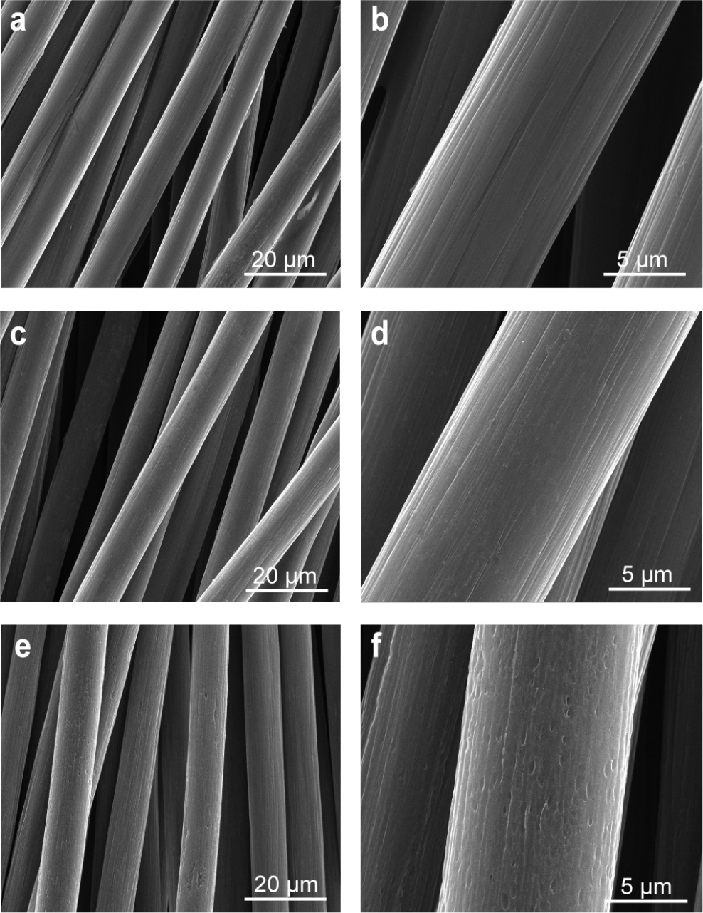
Fig. S22 SEM images of the surface of (a, b) untreated carbon cloth, (c, d) alkalized carbon cloth, and (e, f) carbon cloth annealed at 600 ℃ for 5 h without KOH immersion

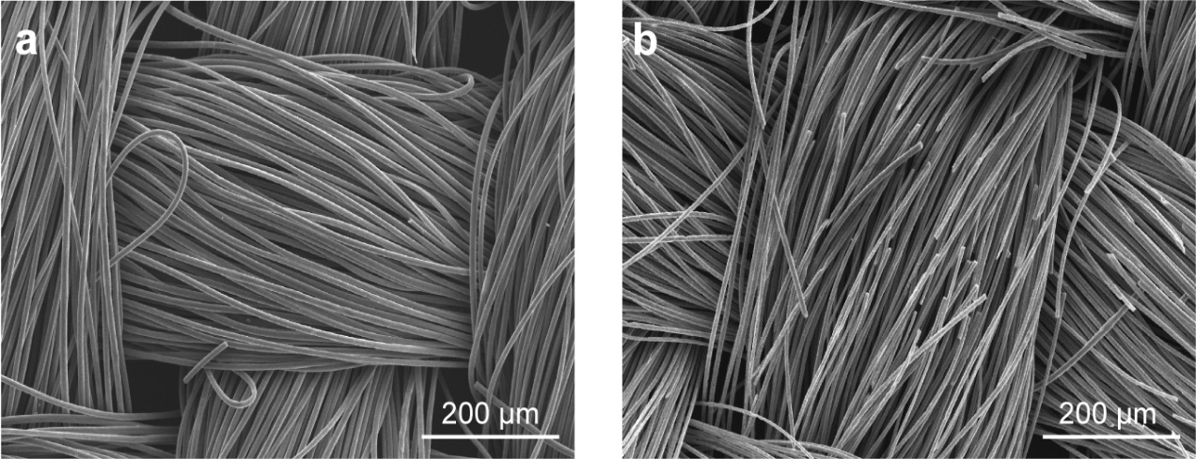
Fig. S23 SEM images of the surface of carbon cloth annealed at 600 ℃ for a 5 h and b 7 h

Fig. S24 Current-voltage and power-voltage curves for LTC with carbon cloth electrodes annealed at 600 ℃ for different times

Fig. S25 (a, c) Current-voltage curves for the LTC and TC-LTC at different values of ΔT, and their corresponding power densities (b, d) with CC-Alkali+A

Table S1 Summary of recently reported intrinsic n-type TECs
Redox  couple | Electrolyte | Electrode |  | Se  (mV K⁻¹) | P_{max} (ΔT)⁻²  (mW m⁻² K⁻²) | Refs.
$${\text{Fe(CN)}}_{\text{6}}^{\text{3-/4-}}$$ | 0.4 M ${\text{Fe(CN)}}_{\text{6}}^{\text{3-/4-}}$ | Pt |  | 1.44 | 0.592 | [S13]
$${\text{Fe(CN)}}_{\text{6}}^{\text{3-/4-}}$$ | 0.4 M ${\text{Fe(CN)}}_{\text{6}}^{\text{3-/4-}}$ | Activated carbon cloth |  | 1.40 | 1.80 | [S14]
$${\text{Fe(CN)}}_{\text{6}}^{\text{3-/4-}}$$ | 0.4 M ${\text{Fe(CN)}}_{\text{6}}^{\text{3-/4-}}$ in methanol/water | SWNT |  | 2.90 | 0.64 | [S15]
$${\text{Fe(CN)}}_{\text{6}}^{\text{3-/4-}}$$ | 0.4 M ${\text{Fe(CN)}}_{\text{6}}^{\text{3-/4-}}$with guanidinium/ urea added | Graphite |  | 4.2 | 1.1 | [S1]
$${\text{Fe(CN)}}_{\text{6}}^{\text{3-/4-}}$$ | 0.4 M ${\text{Fe(CN)}}_{\text{6}}^{\text{3-/4-}}$with guanidinium added | Carbon fiber |  | 3.73 | 7.08 | [S3]
Fe^{2+/3+} | 0.5 M Fe^{2+/3+}-Cl | Pt |  | 1.04 | 0.256 | [S13]
Fe^{2+/3+} | 0.2 M Fe^{2+/3+}-NO₃ + 1 M H NO₃ | Au |  | 1.38 | 0.163 | [S16]
Fe^{2+/3+} | 0.8 M Fe^{2+/3+}-ClO₄ | DWCNT sheet |  | 1.65 | 0.41 | [S17]
Fe^{2+/3+} | 0.8 M Fe^{2+/3+}-ClO₄ + 1 M HClO₄ | Carbon cloth |  | 1.50 | 1.19 | [S18]
Fe^{2+/3+} | 0.8 M Fe^{2+/3+}-ClO₄ | Fe-N-C coated carbon cloth |  | 1.64 | 1.92 | [S19]
I‒/I₃‒ | 5 mM I‒/I₃‒ with methylcellulose | Graphite |  | 9.62 | 0.36 | [S20]
I‒/I₃‒ | 0.4 M I‒/I₃‒ with CsCl added | Graphite |  | 1.2 | 0.296 | [S21]
I‒/I₃‒ | 2.5 mM KI₃, 10 mM KI, 0.2 M KCl | Pt wire mesh |  | 1.97 | 0.0147 | [S22]
Cu/Cu²⁺ | 0.7 M CuSO₄ + 0.1 M H₂SO₄ | Cu foil |  | 0.70 | 0.0012 | [S23]
Cu/Cu²⁺ | 0.7 M CuSO₄ + 0.1 M H₂SO₄ with ethylenediamine and (NH₄)₂SO₄ added | Cu foil |  | 2.12 | 0.676 | [S24]
Cu/Cu²⁺ | 1.2 M CuSO₄ + 0.1 M H₂SO₄ with (NH₄)₂SO₄ added | 3D multi-structured Cu |  | 1.66 | 0.71 | [S4]
$${\text{Co(bpy)}}_{\text{3}}^{\text{2+/3+}}$$ | 0.025 M Co(bpy)₃^{2+/3+} in [EMIM][NTf₂] | Pt |  | 1.60 | 0.028 | [S25]
$${\text{Co(bpy)}}_{\text{3}}^{\text{2+/3+}}$$ | 0.05 M Co(SAR)(OTf)_{4/5} in DMSO with HOTf | Pt |  | 2.04 | 0.011 | [S26]
$${\text{Co(bpy)}}_{\text{3}}^{\text{2+/3+}}$$ | 0.1 M Co(bpy)₃(NTf₂)_{2/3} in MPN | Pt |  | 1.92 | 0.102 | [S27]
CuCl/CuCl₂ | 0.15MCuCl/0.4M CuCl₂ in 0.1 M HCl and 0.9 M LiCl with (NH₄)₂SO₄ added | Graphite | 2.93 |  | 3.968 | This work

Table S2 Summary of data of various thermoelectric materials, reported in the literatures and this work, used for CPM estimation
Type | Material | Temperature  (K) | Material CPM  ($ W−1) | Reference
LTCs | 0.15MCuCl/0.4M CuCl₂ in 0.1 M HCl and 0.9 M LiCl with (NH₄)₂SO₄ added | 333 | 1.17 | This work
LTCs | K₃Fe(CN)₆/K₄Fe(CN)₆/GdmCl solution | 318 | 1.56 | [S3]
OTECs | PEDOT | RT | 116.96 | [S28]
OTECs | CNTs | 310 | 133.57 | [S29]
ITECs | Bi₂Te₃ | 333 | 1979.18 | [S30]
ITECs | Mg_{3.2}Bi_{1.498}Sb_{0.5}Te_{0.002} | 325 | 53.79 | [S31]
ITECs | PbTe | 380 | ~2155.31 | [S32]
ITECs | SnSe | 320 | ~336.55 | [S33]
Material CPM: the Cost-Performance Metric (CPM) is simply calculated from the maximum device performance (P_{max}) and the corresponding raw material cost (C_{m}) by: CPM=C_{m}/P_{max}
Supplementary Movie S1 TC-LTC module to power electronic devices at ΔT = 40 K

Supplementary References
- J. Duan, G. Feng, B. Yu, J. Li, M. Chen et al., Aqueous thermogalvanic cells with a high Seebeck coefficient for low-grade heat harvest. Nat. Commun. 9(1), 5146 (2018). https://doi.org/10.1038/s41467-018-07625-9
- S. Sahami, M.J. Weaver, Entropic and enthalpic contributions to the solvent dependence of the thermodynamics of transition-metal redox couples. J. Electroanal. Chem. Interfacial Electrochem. 122, 171–181 (1981). https://doi.org/10.1016/S0022-0728(81)80148-9
- B. Yu, J. Duan, H. Cong, W. Xie, R. Liu et al., Thermosensitive crystallization-boosted liquid thermocells for low-grade heat harvesting. Science 370(6514), 342–346 (2020). https://doi.org/10.1126/science.abd6749
- B. Yu, H. Xiao, Y. Zeng, S. Liu, D. Wu et al., Cost-effective n-type thermocells enabled by thermosensitive crystallizations and 3D multi-structured electrodes. Nano Energy 93, 106795 (2022). https://doi.org/10.1016/j.nanoen.2021.106795
- D. D. Davis, K. L. Stevenson, C. R. Davis, Photooxidation of dichloro- and trichlorocuprate(Ⅰ) ions in acid solution. J. Am. Chem. Soc. 100(17), 5344-5349 (1978). https://doi.org/10.1021/ja00485a015
- A. Müllertz, Y. Perrie, T. Rades, UV/Vis spectrophotometry and UV imaging. Springer (2016). https://doi.org/doi.org/10.1007/978-1-4939-4029-5_1
- D. Lozano-Castelló, J.M. Calo, D. Cazorla-Amorós, A. Linares-Solano, Carbon activation with KOH as explored by temperature programmed techniques, and the effects of hydrogen. Carbon 45(13), 2529–2536 (2007). https://doi.org/10.1016/j.carbon.2007.08.021
- J. Wang, S. Kaskel, KOH activation of carbon-based materials for energy storage. J. Mater. Chem. 22(45), 23710 (2012). https://doi.org/10.1039/c2jm34066f
- Z. Zhang, J. Xi, H. Zhou, X. Qiu, KOH etched graphite felt with improved wettability and activity for vanadium flow batteries. Electrochim. Acta 218, 15–23 (2016). https://doi.org/10.1016/j.electacta.2016.09.099
- H. Wang, Q. Gao, J. Hu, High hydrogen storage capacity of porous carbons prepared by using activated carbon. J. Am. Chem. Soc. 131(20), 7016–7022 (2009). https://doi.org/10.1021/ja8083225
- J. Romanos, M. Beckner, T. Rash, L. Firlej, B. Kuchta et al., Nanospace engineering of KOH activated carbon. Nanotechnology 23(1), 015401 (2012). https://doi.org/10.1088/0957-4484/23/1/015401
- J. Duan, B. Yu, L. Huang, B. Hu, M. Xu et al., Liquid-state thermocells: Opportunities and challenges for low-grade heat harvesting. Joule 5(4), 768–779 (2021). https://doi.org/10.1016/j.joule.2021.02.009
- K. Kim, S. Hwang, H. Lee, Unravelling ionic speciation and hydration structure of Fe(III/II) redox couples for thermoelectrochemical cells. Electrochim. Acta 335, 135651 (2020). https://doi.org/10.1016/j.electacta.2020.135651
- L. Zhang, T. Kim, N. Li, T.J. Kang, J. Chen et al., High power density electrochemical thermocells for inexpensively harvesting low-grade thermal energy. Adv. Mater. 29(12), 1605652 (2017). https://doi.org/10.1002/adma.201605652
- T. Kim, J.S. Lee, G. Lee, H. Yoon, J. Yoon et al., High thermopower of ferri/ferrocyanide redox couple in organic-water solutions. Nano Energy 31, 160–167 (2017). https://doi.org/10.1016/j.nanoen.2016.11.014
- M.A. Buckingham, F. Marken, L. Aldous, The thermoelectrochemistry of the aqueous iron(ii)/iron(iii) redox couple: significance of the anion and pH in thermogalvanic thermal-to-electrical energy conversion. Sustain. Energy Fuels 2(12), 2717–2726 (2018). https://doi.org/10.1039/c8se00416a
- L. Hwan, Y. Jung, K. Hyeon, Y. Jae, K. June, Stacked double-walled carbon nanotube sheet electrodes for electrochemically harvesting thermal energy. Carbon 147, 559–565 (2019). https://doi.org/10.1016/j.carbon.2019.03.033
- W. Li, C. Gao, J. Ma, J. Qiu, S. Wang, Simultaneous enhancement of thermopower and ionic conductivity for N-type Fe(III/II) thermocell. Mater. Today Energy 30, 101147 (2022). https://doi.org/10.1016/j.mtener.2022.101147
- S.-M. Jung, S.-Y. Kang, B.-J. Lee, J. Lee, J. Kwon et al., Fe─N─C electrocatalyst for enhancing Fe(II)/Fe(III) redox kinetics in thermo-electrochemical cells. Adv. Funct. Mater. 33(45), 2304067 (2023). https://doi.org/10.1002/adfm.202304067
- Y. Han, J. Zhang, R. Hu, D. Xu, High-thermopower polarized electrolytes enabled by methylcellulose for low-grade heat harvesting. Sci. Adv. 8(7), eabl5318 (2022). https://doi.org/10.1126/sciadv.abl5318
- H. Wang, X. Zhuang, W. Xie, H. Jin, R. Liu et al., Thermosensitive-CsI₃-crystal-driven high-power I⁻/I₃⁻ thermocells. Cell Rep. Phys. Sci. 3(3), 100737 (2022). https://doi.org/10.1016/j.xcrp.2022.100737
- H. Zhou, T. Yamada, N. Kimizuka, Supramolecular thermo-electrochemical cells: enhanced thermoelectric performance by host–guest complexation and salt-induced crystallization. J. Am. Chem. Soc. 138(33), 10502–10507 (2016). https://doi.org/10.1021/jacs.6b04923
- A.M. Bates, B. Zickel, S. Krebs, S. Mukherjee, N.D. Schuppert et al., Analytical study and experimental validation of copper II sulfate and potassium ferri/ferrocyanide thermocells using Onsager flux equations. J. Energy Resour. Technol. 139(4), 042003 (2017). https://doi.org/10.1115/1.4036045
- M. Wu, S. Hao, L. Qi, Y. Shi, W. Yang et al., An N-type thermogalvanic cell with a high temperature coefficient based on the Cu/Cu(en)₂₂+ redox couple. ACS Appl. Mater. Interfaces 17(18), 26775–26783 (2025). https://doi.org/10.1021/acsami.5c03375
- P.F. Salazar, S.T. Stephens, A.H. Kazim, J.M. Pringle, B.A. Cola, Enhanced thermo-electrochemical power using carbon nanotube additives in ionic liquid redox electrolytes. J. Mater. Chem. A 2(48), 20676–20682 (2014). https://doi.org/10.1039/c4ta04749d
- K. Laws, M.A. Buckingham, M. Farleigh, M. Ma, L. Aldous, High Seebeck coefficient thermogalvanic cells via the solvent-sensitive charge additivity of cobalt 1, 8-diaminosarcophagine. Chem. Commun. 59(16), 2323–2326 (2023). https://doi.org/10.1039/d2cc05413b
- T.J. Abraham, D.R. MacFarlane, J.M. Pringle, High Seebeck coefficient redox ionic liquid electrolytes for thermal energy harvesting. Energy Environ. Sci. 6(9), 2639–2645 (2013). https://doi.org/10.1039/c3ee41608a
- G.-H. Kim, L. Shao, K. Zhang, K.P. Pipe, Engineered doping of organic semiconductors for enhanced thermoelectric efficiency. Nat. Mater. 12(8), 719–723 (2013). https://doi.org/10.1038/nmat3635
- Y. Nonoguchi, K. Ohashi, R. Kanazawa, K. Ashiba, K. Hata et al., Systematic conversion of single walled carbon nanotubes into n-type thermoelectric materials by molecular dopants. Sci. Rep. 3, 3344 (2013). https://doi.org/10.1038/srep03344
- S. LeBlanc, S.K. Yee, M.L. Scullin, C. Dames, K.E. Goodson, Material and manufacturing cost considerations for thermoelectrics. Renew. Sustain. Energy Rev. 32, 313–327 (2014). https://doi.org/10.1016/j.rser.2013.12.030
- J. Mao, H. Zhu, Z. Ding, Z. Liu, G.A. Gamage et al., High thermoelectric cooling performance of n-type Mg₃Bi₂-based materials. Science 365(6452), 495–498 (2019). https://doi.org/10.1126/science.aax7792
- J. Androulakis, C.-H. Lin, H.-J. Kong, C. Uher, C.-I. Wu et al., Spinodal decomposition and nucleation and growth as a means to bulk nanostructured thermoelectrics: enhanced performance in Pb(1-x)Sn(x)Te-PbS. J. Am. Chem. Soc. 129(31), 9780–9788 (2007). https://doi.org/10.1021/ja071875h
- L.-D. Zhao, S.-H. Lo, Y. Zhang, H. Sun, G. Tan et al., Ultralow thermal conductivity and high thermoelectric figure of merit in SnSe crystals. Nature 508(7496), 373–377 (2014). https://doi.org/10.1038/nature13184

