Supporting Information for
Nanoreactor-Structured Defective MoS₂: Suppressing Intercalation-Induced Phase Transitions and Enhancing Reversibility for Potassium-Ion Batteries
Chunrong Ma¹, Cyrus Koroni², Jiacheng Hu², Ji Qian³, Guangshuai Han^{4*}, and Hui Xiong^{2*}
¹ School of Mechanical and Electrical Engineering, Qingdao University, Qingdao 266071, P. R. China
² Micron School of Materials Science and Engineering, Boise State University, Boise, ID 83725, United States
³ Shandong Key Laboratory of Advanced Chemical Energy Storage and Intelligent Safety, Advanced Technology Research Institute, Beijing Institute of Technology, Jinan 250300, P. R. China
⁴ School of Automotive Studies, Tongji University, Shanghai 201804, P. R. China
*Corresponding authors. E-mail: 17666026@tongji.edu.cn (Guangshuai Han); clairexiong@boisestate.edu (Hui Xiong)
Supplementary Figures and Tables
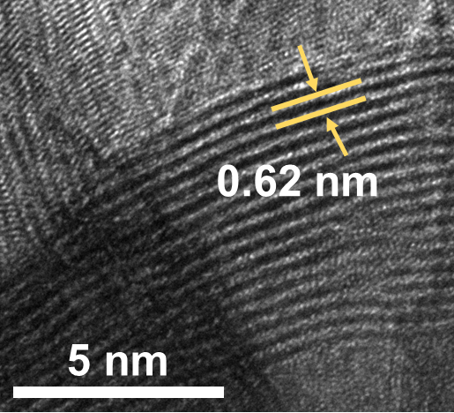
Fig. S1 TEM image of pure MoS₂


Fig. S2 HRTEM image of MoS₂@NC
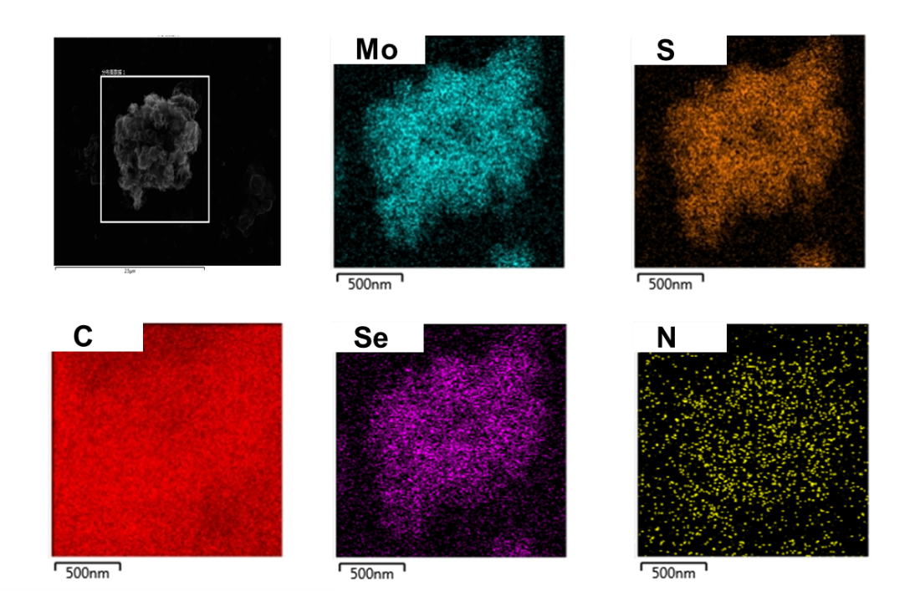
Fig. S3 Elemental mapping images of MoSSe@NC composite
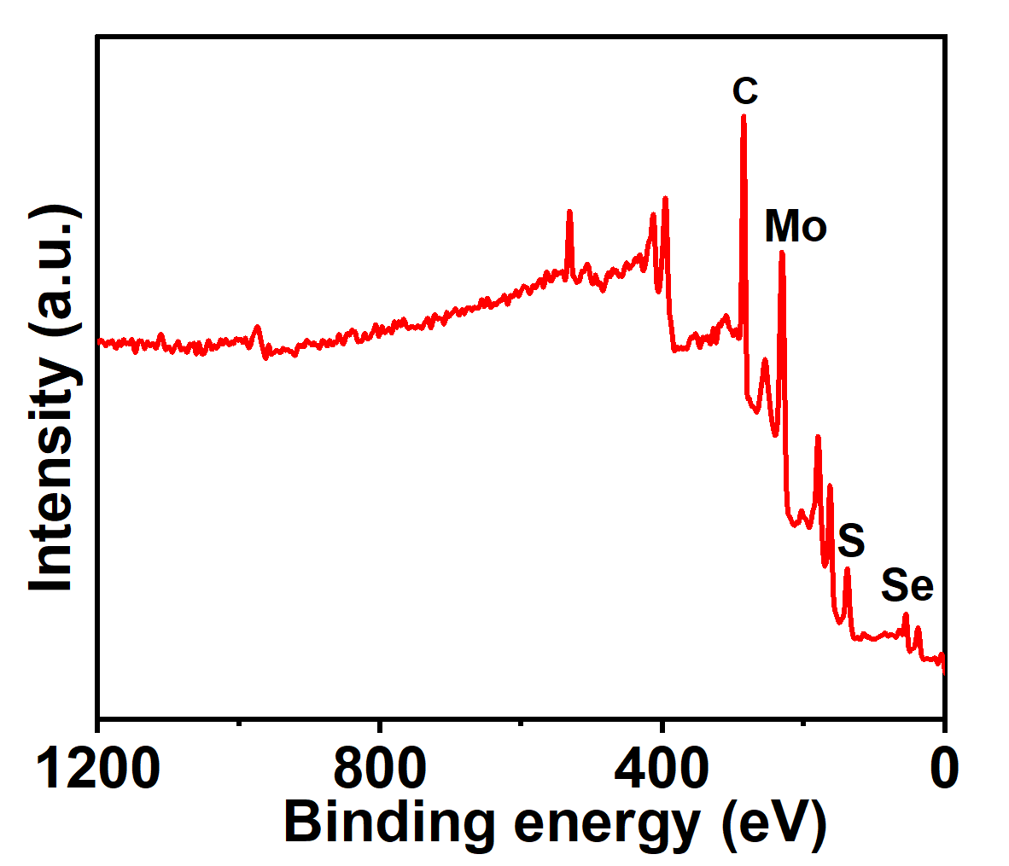
Fig. S4 XPS of MoSSe@NC composite

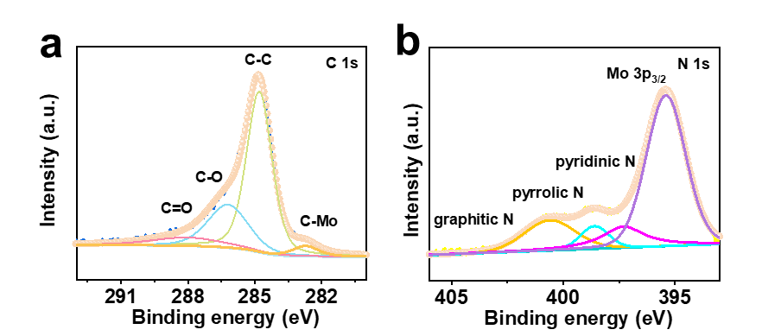
Fig. S5 XPS spectrum of a) C1s and b) N1s in the MoSSe@NC composite
Fig. S6 Raman spectra of CNT and MoSSe@NC
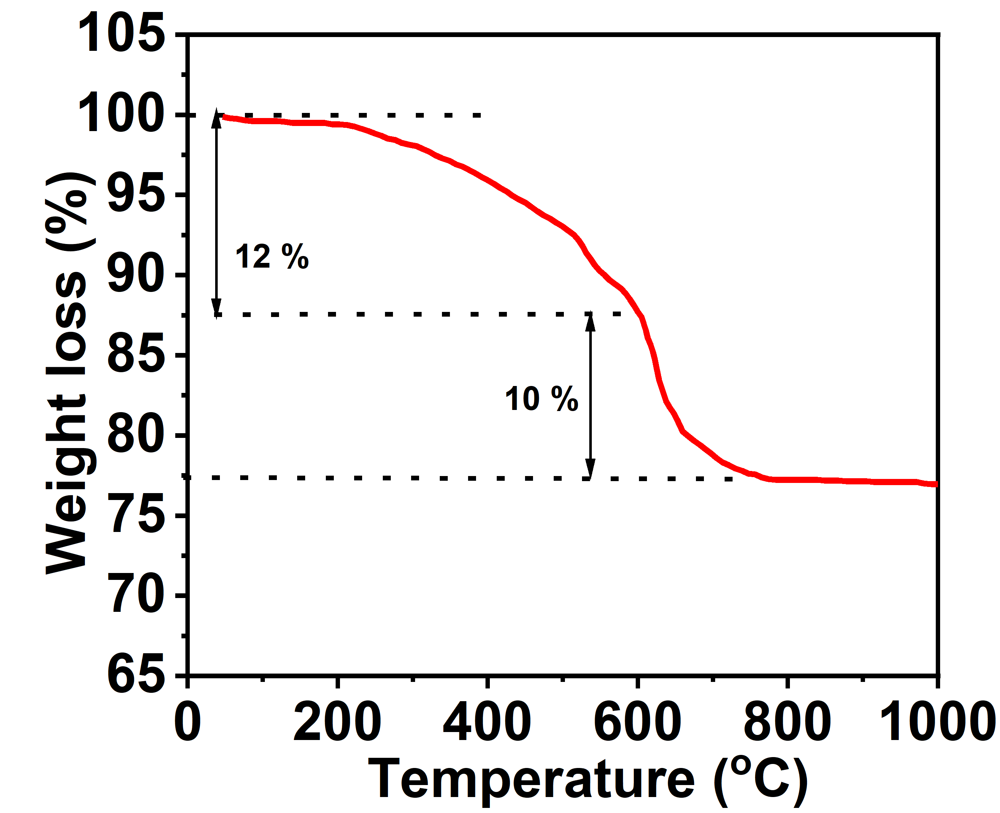
Fig. S7 TGA profiles of MoSSe@NC

Fig. S8 N₂ adsorption–desorption isotherm

Table S1 Comparison of initial Coulombic efficiency with MoS₂-based anode materials
Materials | Charge/discharge capacity  (mAh g⁻¹) | Current density (mA g⁻¹) | ICE | References
MoSSe@NC | 466 / 576 | 200 | 70% | Our work
the C-p-MoS₂/C | 666 / 963 | 50 | 69% | Adv. Funct. Mater. 2023, 33, 2207
1T’’’MoS₂ | 130 / 240 | 40 | 49% | Adv. Funct. Mater. 2023, 33, 23065
DWHNS Sn/MoS₂@C, | 445 / 903 | 100 | 49.2% | ACS Nano 2021, 15, 14125−1413
the MoS₂-on-NC | 304 / 760 | 200 | 40% | Adv. Mater. 2020, 32, 20009
TiNb₂O₆@MoS₂/C | 592 / 1180 | 100 | 51% | J. Mater. Chem. A, 2019, 7, 5760–5768

Table S2 Comparison of the electrochemical performance of the MoSSe@NC electrode with state-of-the-art MoS₂-based anodes reported in the literature
Materials | Rate/Capcity  (A g⁻¹/mAh g⁻¹) | Cycling performance | References
MoSSe@NC | 10 / 176 | 1000 cycles at 3A g⁻¹  92% capacity retention | Our work
1T/2H-MoS₂/NCNHP | 2 / 302 | 500 cycles at 1A g⁻¹  70% capacity retention | Small 2020,16, 2004178
1T’’’ MoS2 | 1 / 75 | 1400 cycles at 1A g⁻¹  95% capacity retention | Adv. Funct. Mater.2023, 33,2306550
MoSSe | 5 / 275 | 1000 cycles at 2A g⁻¹  75% capacity retention | ACS Nano 2019, 13, 11843-11852
Fe₉S₁₀@MoS₂@C | 5 / 95 | 50 cycles at 2A g⁻¹  80% capacity retention | Energy Storage Materials 24 (2020) 208–219
MoS1.5Se0.5-NC | 5 / 210 | 490 cycles at 5A g⁻¹  70% capacity retention | Adv. Energy Mater. 2020, 10, 1904162
CTMG | 5 / 186 | 380 cycles at1A g⁻¹  65% capacity retention | Adv. Funct. Mater. 2020, 30, 2001484
MoS₂/C | 1 / 175 | 300 cycles at1A g⁻¹  55% capacity retention | J. Mater. Chem. A, 2019, 7, 5760–5768

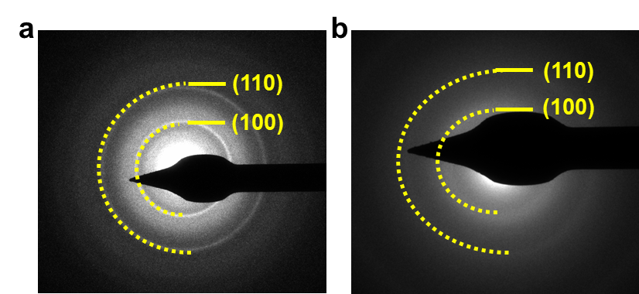
Fig. S9 SAED patterns of MoSSe@NC: (a) before cycling and (b) after 500 cycles

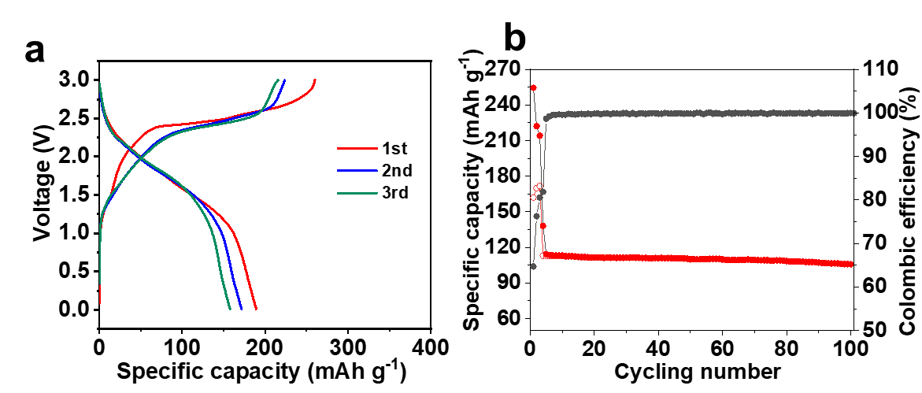
Fig. S10 (a) The charge-discharge profiles and (b) Cycling performance at 0.5 A g⁻¹ of full cell
The diffusion coefficient can be expressed as the following equation:
$D_{K+}=\frac{4}{π}{\left(\frac{m_{B}V_{M}}{M_{B}A}\right)}^{2}{\left(\frac{∆E_{s}}{τ\left(dE_{τ}\right)/d(\sqrt{τ})}\right)}^{2}$ ($τ≪L^{2}/D_{K+}$) (S1)
In this equation, τ(s) is the constant current flux time, m_{B} (g) is the active mass of the electrode, V_{M} (cm³ mol⁻¹) is the molar volume of the electrode, M_{B} (g mol⁻¹) is the molecular weight, A (cm²) is the surface area of the electrode, L (cm) is the thickness of the electrode, E_{S} (V) is the total change in cell voltage during a single step and Eτ (V) is the voltage change in the steady state during a single step.
If E versus $\sqrt{τ}$ shows a linear behavior during the current pulse, the equation can be transformed into:
$D_{K+}=\frac{4}{π}{\left(\frac{m_{B}V_{M}}{M_{B}A}\right)}^{2}{\left(\frac{∆E_{s}}{∆E_{t}}\right)}^{2}$ ($τ≪L^{2}/D_{K+}$) (S2)

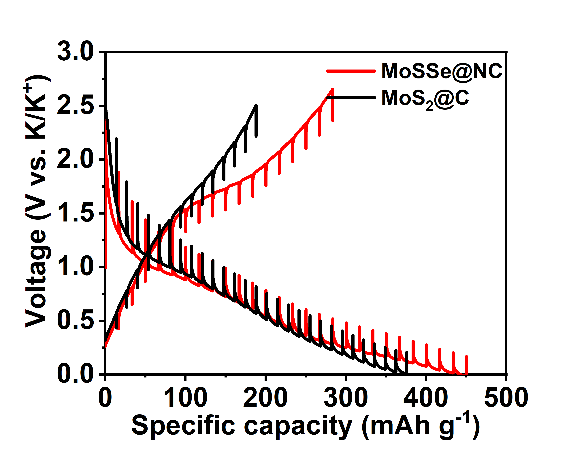
Fig. S11 GITT profiles of MoSSe@NC and MoS₂@NC composite

Fig. S12 EIS spectra of MoS₂@NC and MoSSe@NC
Fig. S13 The capacitive contribution in the total charge storage at 0.2 mV s⁻¹
Computational Method
Calculations were conducted by the Gaussian and the Vienna Ab initio Simulation Package (VASP). Projector-augmented-wave (PAW) potentials were used to consider the electron-ion interactions, whereas the electron exchange-correlation interactions were treated using the Perdew-Burke-Ernzerhof (PBE) exchange correlation functional in the scheme of generalized gradient approximation (GGA). For the substrate, a vacuum space of 15 Å placed between adjacent layers to avoid periodic interactions. All the atomic positions and lattice vectors fully optimized using a conjugate gradient algorithm to obtain the unstrained configuration. The Brillouin zone integration employed a gamma-centred 3 × 3 × 1 Monkhorst-Pack mesh of k points. The electron wavefunctions were expanded in a plane wave basis with kinetic energy cutoff of 500 eV. Atomic relaxation performed until the change in total energy was less than 1×10⁻⁵ eV, and maximum forces were smaller than 0.02 eV/Å.

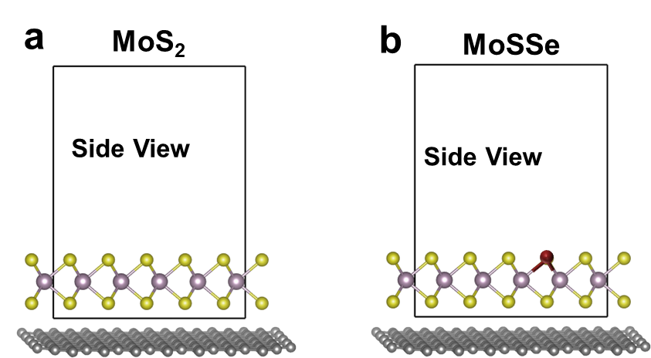

Fig. S14 the Strucutre of MoS₂@NC and MoSSe@NC

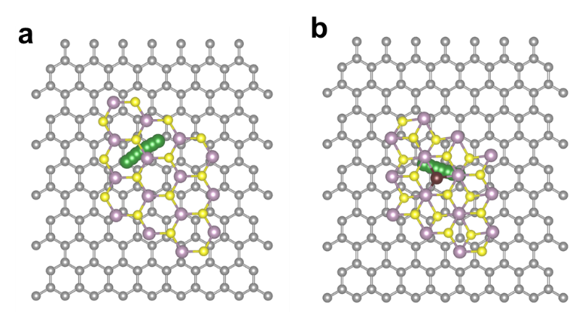
Fig. S15 The structural diffusion paths of K on MoSSe@NC and MoS₂@NC

