Supporting Information for
Vertical Interfacial Engineering in Two-Step-Processed Perovskite Films Enabled by Dual Interface Modification for High-Efficiency p-i-n Solar Cells
Wenhao Zhou^{1#}, Heng Liu^{2,3#}, Haiyan Li^{4#}, Weihai Zhang^{1,2},* Hui Li¹, Xia Zhou¹, Rouxi Chen⁵, Wenjun Zhang¹, Tingting Shi^{4,}*, Antonio Abate¹*, and Hsing-Lin Wang²*
¹ School of New Energy, Ningbo University of Technology, Ningbo, 315211, P. R. China
² Department of Materials Science and Engineering, Southern University of Science and Technology, Shenzhen, 518055, P. R. China
³ Institute of Materials, Henan Academy of Sciences, Zhengzhou, 450046, P. R. China
⁴ Siyuan Laboratory, Guangzhou Key Laboratory of Vacuum Coating Technologies and New Energy Materials, Department of Physics, Jinan University, Guangzhou, 510632, P. R. China
⁵ School of Innovation and Entrepreneurship, Southern University of Science and Technology, Shenzhen, 518055, P. R. China
#Wenhao Zhou, Heng Liu, and Haiyan Li contributed equally to this work.
*Corresponding authors. E-mail: zhangwh@nbut.edu.cn (Weihai Zhang); ttshi@jnu.edu.cn (Tingting Shi); antonio.abate@unina.it (Antonio Abate); wangxl3@sustech.edu.cn (Hsing-Lin Wang)
Supplementary Figures and Tables

Fig. S1 a Schematic structure of the regular n-i-p and inverted p-i-n devices. b J-V curves of the TSP n-i-p and p-i-n devices

Fig. S2 Exfoliation process of the perovskite film
Note: The detailed exfoliation process as follows: 1) The as-deposited perovskite films were encapsulated by dispensing a drop of UV-curable adhesive and then covered with a clean glass. 2) After encapsulating the sample, it was exposed to 365 nm UV light for 10 minutes to cure the UV-curable adhesive. 3) The ITO substrate was then gently peeled off to expose the bottom surface of the perovskite film for investigation.

Fig. S3 XPS C 1s and Pb 4f core spectra of the top and bottom sides of the TSP film
Fig. S4 Depth-profiled a I 3d and b Pb 4f core spectra of the TSP film with varying etching time
Note: The I/Pb ratio of the TSP perovskite film with different etching time can be estimated according to the equation: $N_{I}∕N_{Pb}=\left(A_{I}∕S_{I}\right)∕\left(A_{Pb}∕S_{Pb}\right)$, where $A_{I}$ and $A_{Pb}$ represent the I 3d and Pb 4f peak areas, respectively, and $S_{I}$ (5.337) and $S_{Pb}$ (6.968) denote the sensitivity factors for I and Pb. The detailed parameteres are summarized in Table S1.

Fig. S5 ¹⁹F NMR spectra of pure Sn(OTF)₂ and Sn(OTF)₂+PbI₂ samples in deuterated DMSO-d₆ solution
Note: The characteristic resonance signal of F in pure Sn(OTF)₂ reveals upshift of resonance peak for the Sn(OTF)₂+PbI₂ sample, verifying the interaction between -CF₃ groups and PbI₂.

Fig. S6 a, b XRD patterns and c, d SEM images of PbI₂ films deposited on bare NiO_{x} (control) and NiO_{x}/Sn(OTF)₂ (Sn(OTF)₂) substrates
Note: The inset photos suggest that the control-PbI₂ films exhibit a significantly faster color transition from semitransparent yellow to deep yellow compared to the Sn(OTF)₂-PbI₂ films. This visual observation directly suggests that the control-PbI₂ films undergo crystallization at a higher rate than the Sn(OTF)₂-PbI₂ films. Consistently, the corresponding XRD results reveal that under identical experimental conditions, the control-PbI₂ films display substantially stronger diffraction intensities relative to the Sn(OTF)₂-PbI₂ films, confirming the faster crystallization rate of the control-PbI₂ films. The SEM results suggest that the Sn(OTF)₂-PbI₂ film demonstrates a more mesoporous morphology than that of the control-PbI₂ film, indicating that Sn(OTF)₂ interlayer interact with PbI₂, thus retarding its crystallization. This more mesoporous PbI₂ film is beneficial for ammonium salt penetration, facilitating perovskite crystallization.
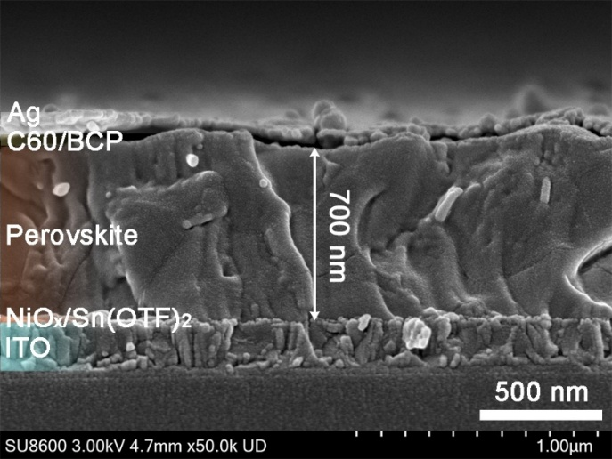
Fig. S7 Cross-sectional SEM image of the device
Note: According to the scale bar, the thickness of the perovskite film is approximately 700 nm.
Fig. S8 J-V curves obtained from reverse (V_{oc} to J_{sc}) and forward (J_{sc} to V_{oc}) scans for the a control, b Sn(OTF)₂, and c Sn(OTF)₂+PEA devices. d EQE spectra and e stabilized power outputs of the champion devices based on the control, Sn(OTF)₂, and Sn(OTF)₂+PEA films
Note: Hysteresis studies based on H-index: $HI={\left({PCE}_{reverse}-{PCE}_{forward}\right)}/{{PCE}_{reverse}}$, where PCE_{reverse} and PCE_{forward} are power conversion efficiency of devices for reverse and forward scan, respectively, reveal that Sn(OTF)₂+PEA device delivers the smallest HI value (1.9%) compared to the control (9.3%) and Sn(OTF)₂ (4.7%) devices, which is mainly attributed to a more favorable charge extraction environment within the Sn(OTF)₂+PEA device.

Fig. S9 Models and adsorption energies of SO₃-NiO_{x}(Ni), CF₃-NiO_{x}(Ni), SO₃-FAPbI₃(Pb), and CF₃-FAPbI₃(Pb), respectively

Fig. S10 SEM and AFM images of the bare NiO_{x} and NiO_{x}/Sn(OTF)₂ films. The scale bar is 1 μm. Statistical RMS values for different films. A total of 5 different random positions (5 × 5 μm² per position) for each sample were counted
Note: The Sn(OTF)₂ modification does not alter the morphology of NiO_{x} films. While, a reduction in RMS roughness from 5.29 ± 0.34 nm (bare NiO_{x}) to 4.76 ± 0.18 nm (NiO_{x}/Sn(OTF)₂) can be observed.
Fig. S11 Optical transmission spectra of the bare NiO_{x} and NiO_{x}/Sn(OTF)₂ films
Fig. S12 In-situ PL spectra of control and Sn(OTF)₂ perovskite films as a function of different annealing time
Fig. S13 GIXRD spectra of the control and Sn(OTF)₂ films acquired from the bottom surface

Fig. S14 Depth-profiled Pb 4f core spectra of the Sn(OTF)₂ film with varying etching time
Note: It can be seen that after 330 seconds of etching, the Pb 4f peak disappeared, indicating complete etching through the perovskite film. By combining the thickness (700 nm) measured via cross-sectional SEM with the etching duration, the etching rate was calculated to be 2.1 nm/s.

Fig. S15 UV-vis absorption spectra and Urbach energy of different perovskite film
Note: The Urbach energy was calculated from the UV-Vis absorption spectra with equation $\ln{α}=\ln{α_{0}}+\left({hv}/{E_{u}}\right)$, where α₀ is a constant, α is the absorption coefficient, hυ is the photon energy, and Eu is the Urbach energy. A smaller E_{u} is highly desirable for semiconductor devices, indicative of highly crystallized film with less impurities.
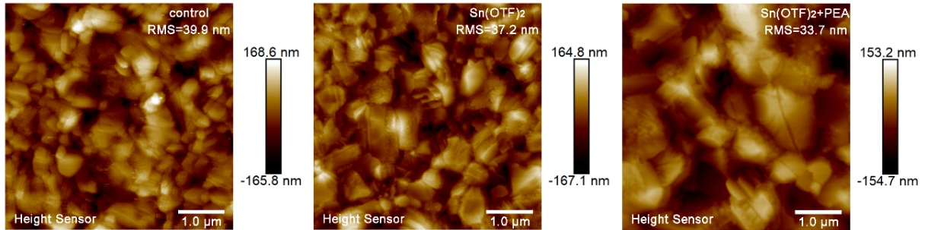
Fig. S16 AFM images of different perovskite films
Note: The RMS values of the control, Sn(OTF)₂ and Sn(OTF)₂+PEA films are 39.9, 37.2, and 33.7 nm, respectively. The Sn(OTF)₂+PEA film exhibits the smallest surface roughness, which is critical for achieving high device performance.
Fig. S17 Tauc’s plots of the FAPbI₃ and FASn_{0.1}Pb_{0.9}I₃ perovskite films
Note: The Tauc’s plots were derived from the UV-Vis absorption spectra with equation ${\left(αhν\right)}^{2}=A\left({hυ-E}_{g}\right)$, where α is the absorption coefficient, hυ is the photon energy, and E_{g} is the bandgap of the perovskite film. Accordingly, the bandgaps of the FAPbI₃ and FASn_{0.1}Pb_{0.9}I₃ perovskites were determined to be 1.55 and 1.45 eV, respectively.
Fig. S18 Energy level alignment plots of the a control, b Sn(OTF)₂, and c Sn(OTF)₂+PEA films

Fig. S19 J_{sc} response under different light intensities
Note: The Sn(OTF)₂+PEA device delivers a most ideal α value of 0.957 compared to the control (0.911) and Sn(OTF)₂ (0.946) devices, demonstrating improved charge carrier extraction efficiency.

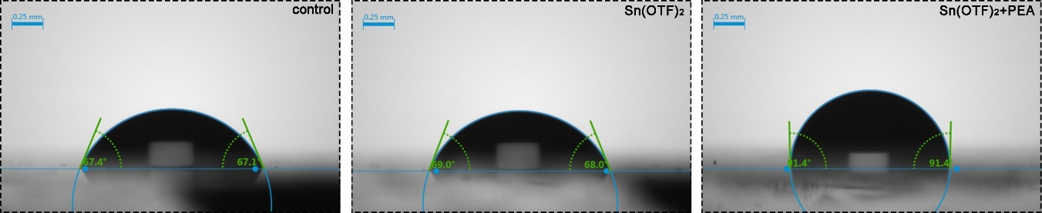
Fig. S20 The contact angle of control, Sn(OTF)₂, and Sn(OTF)₂+PEA films
Note: It can be seen that the Sn(OTF)₂+PEA film exhibits a contact angle of 91.4°, much larger than that of control (67.4°) and Sn(OTF)₂ (69°) films. The results suggest that after F-PEA post-treatment, the resulting Sn(OTF)₂+PEA film demonstrates a more hydrophobic surface, which is essential for the enhancement of long term stability of the resulting device.

Fig. S21 Sn 3d_{5/2} XPS core spectra derived from the bottom surface of the perovskite film as a function of ambient exposure time
Note: It can be seen that after 168 h exposure, the Sn⁴⁺/Sn²⁺ ratio only increased slightly from 14.1 to 21.0%. This slow oxidation rate indicates the Pb-Sn interlayer has strong ambient resilience. The mild increase aligns with the gradual degradation of unencapsulated perovskite films, which is unavoidable in ambient conditions but well-controlled here.

Fig. S22 J-V curves and corresponding photovoltaic parameters of the unencapsulated PSCs a function of ambient exposure time
Note: It can be seen that after 168 h exposure, the PCE of the device decreased slightly from 25.21%to 24.7%. The minor efficiency loss was primarily attributed to a small drop in FF (from 81.9% to 80.8%), not J_{SC} or V_{OC}. This confirms the interlayer’s energy level alignment function (critical for J_{SC} and V_{OC}) remains intact, and the decay stems from trivial bulk perovskite degradation, not interlayer failure.

Table S1 I/Pb ratio of the TSP perovskite film with different etching time
Etching time (s) | A_{I} | A_{Pb} | S_{I} | S_{Pb} | I/Pb ratio
0 | 1616816 | 824578 | 5.337 | 6.968 | 2.56
30 | 1624230 | 818762 | 5.337 | 6.968 | 2.59
60 | 1643074 | 812574 | 5.337 | 6.968 | 2.64
90 | 1678798 | 808763 | 5.337 | 6.968 | 2.71
120 | 1712927 | 801578 | 5.337 | 6.968 | 2.79
150 | 1728758 | 797538 | 5.337 | 6.968 | 2.83
Table S2 Photovoltaic parameters of champion PSCs based on different perovskite films
Device | Scan direction | Voltage (V) | Current density (mA cm-2) | FF (%) | PCE (%) | HI (%)
control | Forward | 1.06 | 23.9 | 73.1 | 18.6 | 9.3
control | Reverse | 1.11 | 24.4 | 75.7 | 20.5 | 9.3
Sn(OTF)₂ | Forward | 1.14 | 25.4 | 77.5 | 22.5 | 4.7
Sn(OTF)₂ | Reverse | 1.14 | 25.2 | 81.8 | 23.6 | 4.7
Sn(OTF)₂+PEA | Forward | 1.18 | 26 | 81.5 | 25.1 | 1.9
Sn(OTF)₂+PEA | Reverse | 1.18 | 26.1 | 82.8 | 25.6 | 1.9
Table S3 Conductivity of bare NiO_{x} and NiO_{x}/Sn(OTF)₂ films
Sample | Thickness (nm) | Area (cm²) | slope | Conductivity (S·cm⁻¹)
NiO_{x} | 40 | 0.04 | 0.2 | 210⁻⁵
NiO_{x}/Sn(OTF)₂ | 40 | 0.04 | 0.26 | 2.610⁻⁵
Note: The conductivity of the films were calculated according to the equation: σ=D/(SR), where σ is the conductivity, D is the film thickness, S is the effective area, and R is the resistance. Based on the I-V curve, R can be extracted as 1/slope.
Table S4 UPS parameters of the bare NiO_{x} and NiO_{x}/Sn(OTF)₂ films
Sample | E_{cutoff} (eV) | E_{onset} (eV) | VBM (eV) | E_{F} (eV)
NiO_{x} | 16.60 | 0.71 | 5.33 | 4.62
NiO_{x}/Sn(OTF)₂ | 16.43 | 0.68 | 5.47 | 4.79
Table S5 Fitted TRPL parameters of the different perovskite films
Perovskite | A₁ | τ₁ (ns) | A₂ | τ₂ (ns) | τ_{ave} (ns)
control | 0.406 | 181.45 | 0.473 | 386.8 | 327.9
Sn(OTF)₂ | 0.59 | 240.5 | 0.256 | 792.4 | 565.2
Sn(OTF)₂+PEA | 0.696 | 337.13 | 0.225 | 1140 | 756.6
Note: The fitting biexponential decay function was $y=y_{0}+A_{1}exp\left(-\frac{t}{τ_{1}}\right)+A_{2}exp\left(-\frac{t}{τ_{2}}\right)$.
Table S6 UPS parameters of the control perovskite film with different etching depths
Depth [nm] | E_{cutoff} (eV) | E_{onset} (eV) | VBM (eV) | E_{g} (eV) | CBM (eV) | E_{F} (eV)
700 | 16.4 | 1.02 | -5.84 | 1.55 | -4.29 | 4.82
600 | 16.43 | 0.99 | -5.78 | 1.55 | -4.23 | 4.79
500 | 16.46 | 0.95 | -5.71 | 1.55 | -4.16 | 4.76
400 | 16.46 | 0.88 | -5.64 | 1.55 | -4.09 | 4.76
300 | 16.45 | 0.82 | -5.59 | 1.55 | -4.04 | 4.77
200 | 16.47 | 0.77 | -5.52 | 1.55 | -3.97 | 4.75
100 | 16.5 | 0.76 | -5.48 | 1.55 | -3.93 | 4.72
0 | 16.53 | 0.73 | -5.42 | 1.55 | -3.87 | 4.69
Table S7 UPS parameters of the Sn(OTF)₂ perovskite film with different etching depths
Depth [nm] | E_{cutoff} (eV) | E_{onset} (eV) | VBM (eV) | E_{g} (eV) | CBM (eV) | E_{F} (eV)
700 | 16.45 | 0.77 | -5.54 | 1.45 | -4.09 | 4.77
600 | 16.43 | 0.81 | -5.6 | 1.55 | -4.05 | 4.79
500 | 16.42 | 0.84 | -5.64 | 1.55 | -4.09 | 4.8
400 | 16.41 | 0.86 | -5.67 | 1.55 | -4.12 | 4.81
300 | 16.41 | 0.85 | -5.66 | 1.55 | -4.11 | 4.81
200 | 16.4 | 0.84 | -5.66 | 1.55 | -4.11 | 4.82
100 | 16.41 | 0.81 | -5.62 | 1.55 | -4.07 | 4.81
0 | 16.4 | 0.76 | -5.58 | 1.55 | -4.03 | 4.82
Table S8 UPS parameters of the Sn(OTF)₂+PEA perovskite film with different etching depths
Depth [nm] | E_{cutoff} (eV) | E_{onset} (eV) | VBM (eV) | E_{g} (eV) | CBM (eV) | E_{F} (eV)
700 | 16.47 | 0.78 | -5.53 | 1.45 | -4.08 | 4.75
600 | 16.42 | 0.81 | -5.61 | 1.55 | -4.06 | 4.80
500 | 16.42 | 0.85 | -5.65 | 1.55 | -4.10 | 4.80
400 | 16.41 | 0.86 | -5.67 | 1.55 | -4.12 | 4.81
300 | 16.41 | 0.87 | -5.68 | 1.55 | -4.13 | 4.81
200 | 16.4 | 0.88 | -5.70 | 1.55 | -4.15 | 4.82
100 | 16.39 | 0.91 | -5.74 | 1.55 | -4.19 | 4.83
0 | 16.38 | 0.95 | -5.79 | 1.55 | -4.24 | 4.84
Table S9 SCLC parameters for different perovskite films
Perovskite | Dielectric factor | Vacuum permittivity (F m⁻¹) | Thickness (nm) | Elementary charge | V_{TFL} (V) | Trap density (cm⁻³)
control | 48 | 8.85×10⁻¹² | 700 | 1.6×10⁻¹⁹ | 0.64 | 6.91×10¹⁵
Sn(OTF)₂ | 48 | 8.85×10⁻¹² | 700 | 1.6×10⁻¹⁹ | 0.47 | 5.07×10¹⁵
Sn(OTF)₂+PEA | 48 | 8.85×10⁻¹² | 700 | 1.6×10⁻¹⁹ | 0.39 | 4.21×10¹⁵
Note: The trap density of the perovskite films can be calculated through the following equation:
$N_{t}=\frac{{2V}_{TFL}ε_{r}ε_{0}}{{eL}^{2}}$ (S1)
where ε_{r} is the relative dielectric constant of perovskite, which is approximately 48, ε₀ is the vacuum permittivity, e is the elementary charge, and L is the thickness of the perovskite film, which is approximately 700 nm. Accordingly, the defect density was determined to be 6.91×10¹⁵, 5.07×10¹⁵, and 4.21×10¹⁵ cm⁻³ for the control, Sn(OTF)₂, and Sn(OTF)₂+PEA films, respectively.

