Supporting Information for
Strong yet Flexible TiC-SiC Fibrous Membrane with Long–Time Ultrahigh Temperature Resistance for Sensing in Extreme Environment
Tianyue Yang¹, Yan Shen¹, Yangzhong Zhao¹, Zhongqian Zhao¹, Xue Zhou¹, Qianji Chen¹, Xujing Wang¹, Yanzi Gou¹*
¹Science and Technology on Advanced Ceramic Fibers and Composites Laboratory, College of Aerospace Science and Engineering, National University of Defense Technology, Changsha 410073, P. R. China
*Corresponding author. E-mail: y.gou2012@hotmail.com (Yanzi Gou)
S1 Experimental part
S1.1 Elemental composition analysis
The oxygen content of SiC fibrous membranes was measured by EMGA-820 oxygen and nitrogen analyzer. The carbon content was measured by EMIA-320V2 carbon-sulfur analyzer. The content of silicon element was determined by melting the sample with strong alkali for colorimetric analysis. Analysis of titanium content by Inductively Coupled Plasma Optical Emission Spectrometer (ICP-OES, Thermo ICP 6300).
S1.2 Mechanical Strength Test
The mechanical properties of the TiC-SiC fibrous membrane were quantified by Testometric Micro 350 tensile tester. The gauge length and width of the membrane specimens were 25 mm and 3 mm, respectively. The loading rate was 1 mm·min⁻¹. The thickness was tested by using a digital fabric thickness gauge (YG141D, China).
The stress (σ) was calculated by the following equation:
σ=F/(W×D)
Where the F, W and D are the load, width and the thickness of the fibrous membrane, respectively.
S1.3 Finite element analogy
A finite element analysis software was used, and a microstructure generation algorithm based on Voronoi polygons was adopted to finally establish TiC-SiC composite model. The fiber diameter is 500 nm and the length is 30 μm. Typical uniaxial tensile boundary conditions were used to simulate the overall stress-strain response during the tensile process. The displacement control method was used for loading, and the maximum strain was set to 0.5. A fracture stop criterion was also set: once the principal strain exceeds the critical value, the element will fail, and the simulation will automatically enter the termination process.
S1.4 Molecular Dynamics Simulations
Molecular dynamics simulations were performed using LAMMPS 2024 to study the structural and mechanical properties of SiC and TiC-SiC systems. The initial atomic structures were obtained from the crystallographic information file (CIF) of SiC downloaded from a crystallographic database. SiC system: The interatomic interactions were modeled using the Tersoff potential, which accurately describes covalent bonding in SiC. TiC-SiC system: A hybrid potential combining the Tersoff potential for SiC and the Lennard-Jones (LJ) potential for Ti interactions was employed to capture the mixed bonding nature. The parameters for the hybrid potential were combined appropriately within LAMMPS. The system was first equilibrated at room temperature (298 K) using a timestep of 1 fs (0.001 ps). The thermal treatment followed a multi-stage process: Heating under an NPT ensemble (constant number of particles, pressure, and temperature) to 2073 K over 1 ns. Holding at 2073 K under an NVT ensemble (constant number of particles, volume, and temperature) for 1 ns to stabilize the high-temperature phase. Cooling back to 298 K under an NPT ensemble over 1 ns to obtain the relaxed pre-stretch configuration. The equilibrated model was further equilibrated at 298 K under NPT conditions for 1 ns with the same timestep. Subsequent uniaxial tensile deformation was applied at a strain rate of 0.005 Å/ps. Applying the elongation under an NVT ensemble for 200 ps to monitor the mechanical response at constant volume and temperature. Data analysis and visualization of atomic configurations and deformation behavior were conducted using OVITO software, enabling detailed structural interpretation and presentation of results.
Supplementary Figures and Tables
Fig. S1 The synthetic route of PTCS precursor

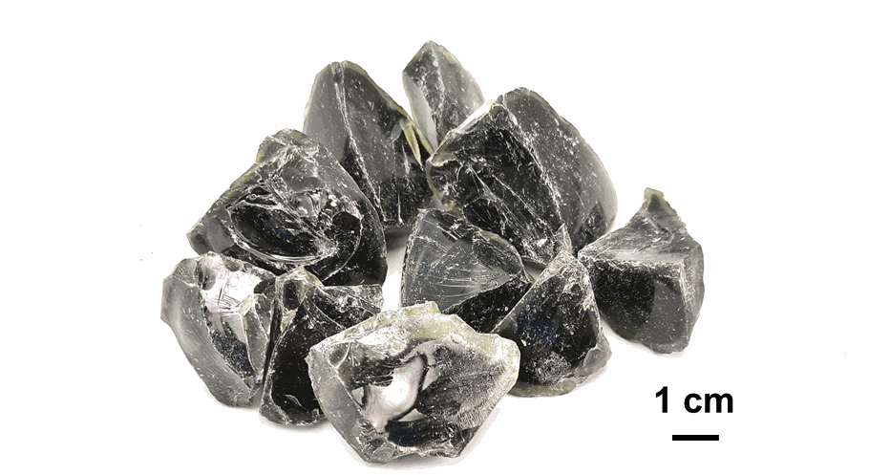
Fig. S2 The optical photo of PTCS
Fig. S3 FTIR spectra of the PTCS precursors
Table S1 The Elemental composition and molecular weight of PTCS precursors
Sample | Si content (wt%) | C content (wt%) | O content (wt%) | Ti content (wt%) | M_{w}  (g/mol) | M_{n}  (g/mol)
PTCS-1 | 57.8 | 40.33 | 1.50 | 0.32 | 5300 | 1600
PTCS-2 | 57.1 | 40.02 | 2.05 | 0.80 | 7300 | 2100
PTCS-3 | 55.9 | 39.91 | 2.73 | 1.40 | 10700 | 2400

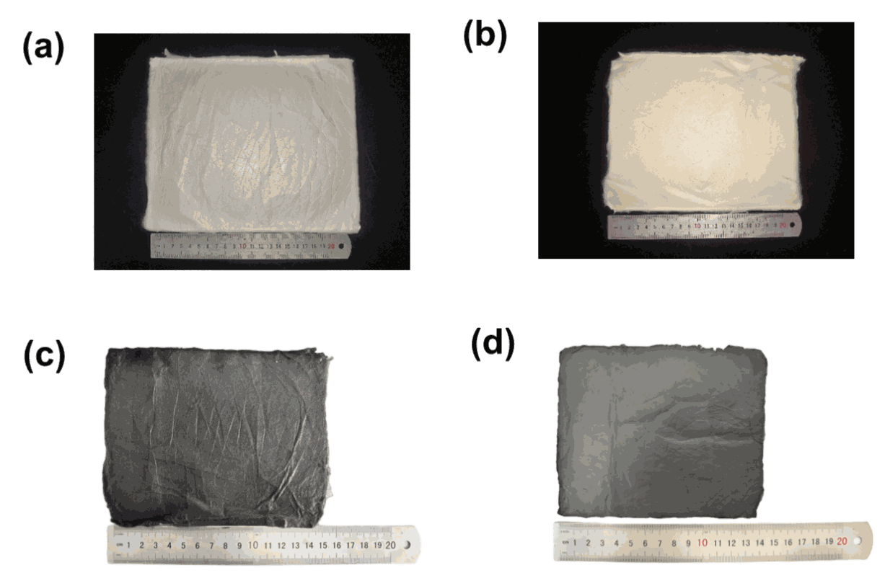
Fig. S4 Optical photograph of membrane consisted of (a) PTCS green fibrous membrane, (b) cured fibrous membrane, (c) Si-Ti-C-O fibrous membrane, (d) TiC-SiC fibrous membrane
The influence of spinning voltage on fiber formation was investigated. When the environmental humidity was 50% and the liquid pushing speed was 2.5 ml/h, three spinning voltage parameters were set as: 16 kV, 20 kV, and 24 kV. At a voltage of 16 kV, the fibers showed a beaded shape, indicating that the fibers were not sufficiently stretched. When the voltage was increased to 20 kV, the fibers still contained spindles. As the voltage increased to 24 kV, the fibers were fully stretched during the spinning process, and the spindles disappeared. When the voltage was further increased, a discharge phenomenon occurred at the needle tip, making spinning impossible. Therefore, 24 kV was finally selected as the optimal spinning voltage.
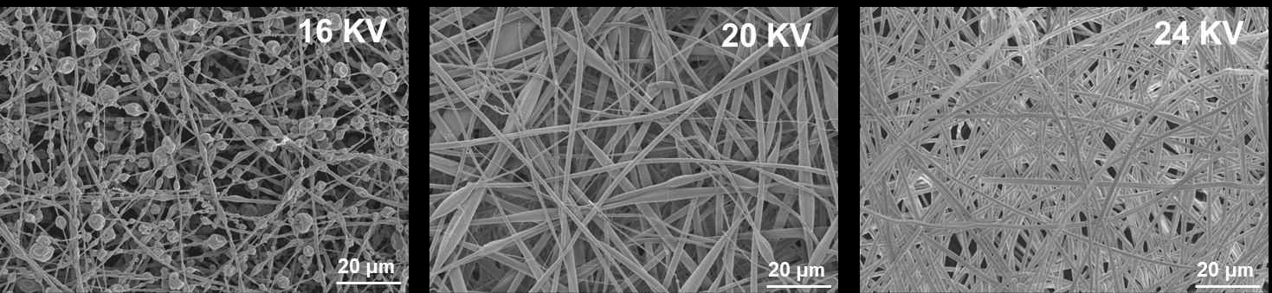
Fig. S5 SEM images of PTCS fibrous membranes obtained with different spinning voltage
During the electrospinning process, the spinning rate was determined by the syringe pushing speed. When the environmental humidity was 50%, the pushing speed was 2.5 ml/h, and the spinning voltage was 24 kV, three pushing speeds were set as: 1.5 ml/h, 2.0 ml/h, and 2.5 ml/h. The experiment showed that when the solution pushing speed was too low, the speed at which the spinning solution accumulates at the needle tip was lower than the jet ejection speed, resulting in intermittent ejection of the solution at the spinneret, unstable spinning, and discontinuous fibers. When the solution pushing speed increased to 2.0 ml/h, a stable Taylor cone formed at the needle tip, and the jet was fully stretched and refined in the electric field, resulting in fibers with small and uniform diameters. When the solution pushing speed increased to 2.5 ml/h, the ejection became unstable, and the fiber diameters increased and became non-uniform.
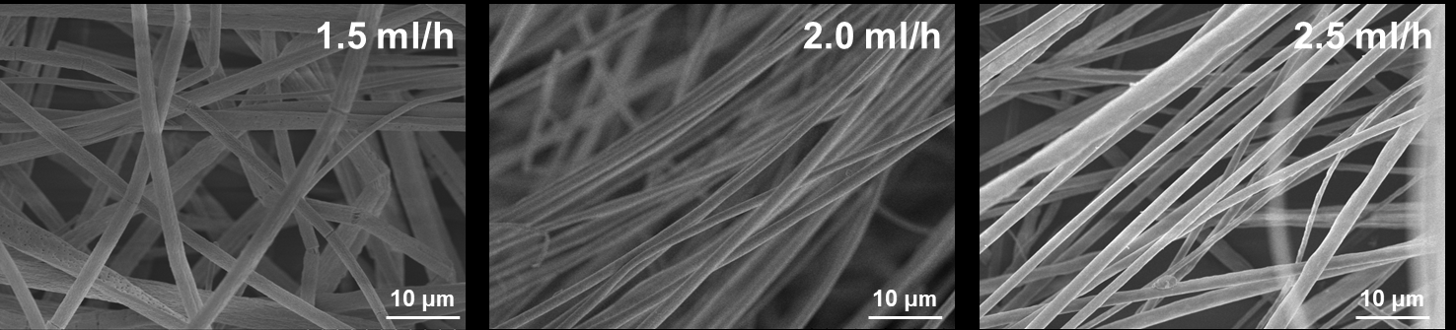
Fig. S6 SEM images of PTCS fibrous membranes obtained with different pushing speeds
Further regulation was carried out around the spinning humidity, and the humidity was controlled at 20%, 40%, and 60% respectively. When the humidity was 60%, the shape of the fibers was irregular, and a large number of pores appeared on the surface. This is because in a high - humidity environment, the volatilization of the solvent was inhibited, and the surface tension of the spinning solution decreased, resulting in an increase in the fiber diameter. Moreover, as the solvent volatilization took away part of the heat, the temperature of the surface of the polymer solution jet was lower than the ambient temperature. Therefore, small droplets would be deposited on the surface of the jet. After the fibers hardened, pores would be left where the small droplets were located. When the humidity was 40%, the defects on the fiber surface were significantly reduced; when the humidity was reduced to 20%, the fiber surface was smooth with no obvious defects. When the humidity was further reduced, the solution solidified rapidly at the spinneret, causing the spinneret to clog and making normal spinning impossible. Therefore, the spinning experiment was finally carried out with the ambient humidity controlled at 20%.
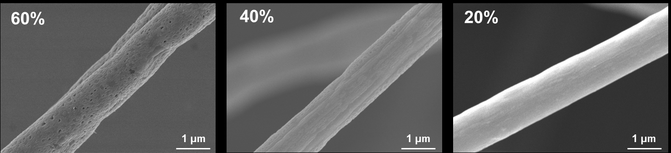
Fig. S7 SEM images of PTCS fibrous membranes obtained with different humidity

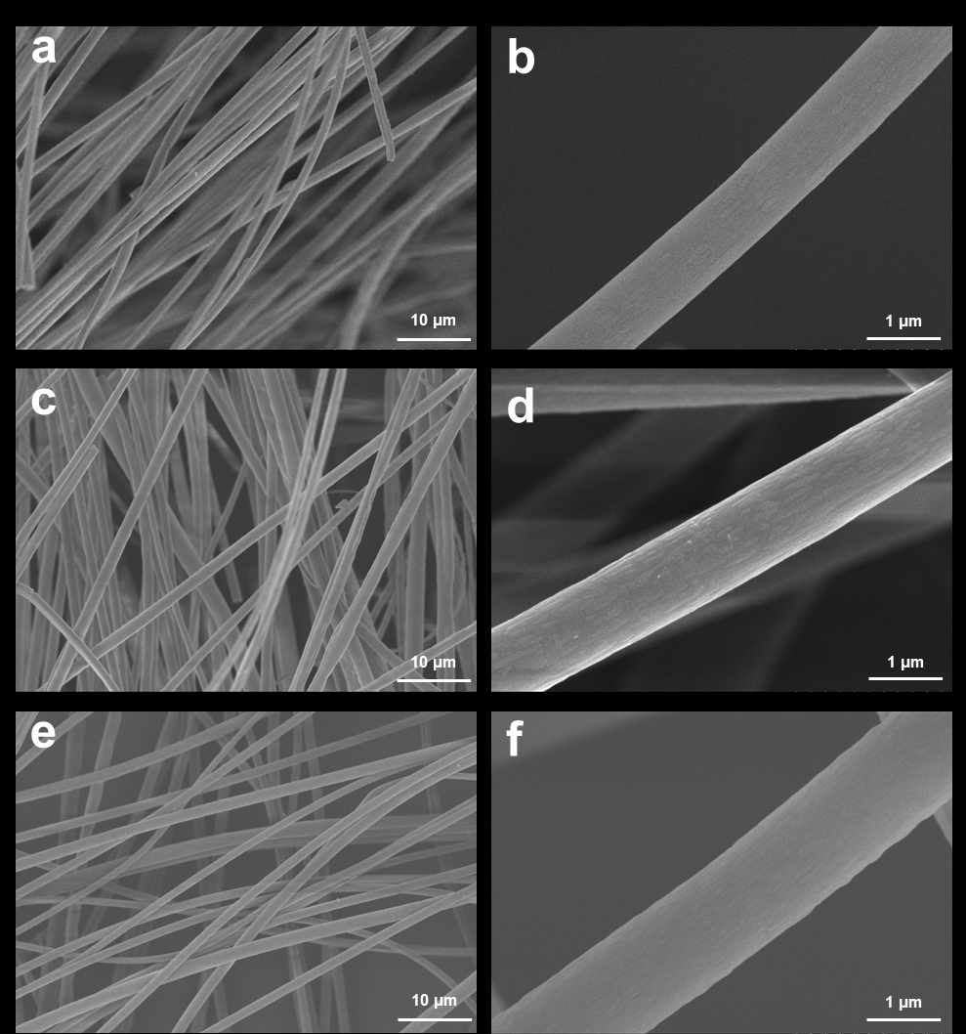
Fig. S8 The SEM images of PTCS fibrous membranes: (a-b) PTCS-1, (b-c) PTCS-2, (c-d) PTCS-3
Fig. S9 FTIR spectra of the PTCS fibrous membranes

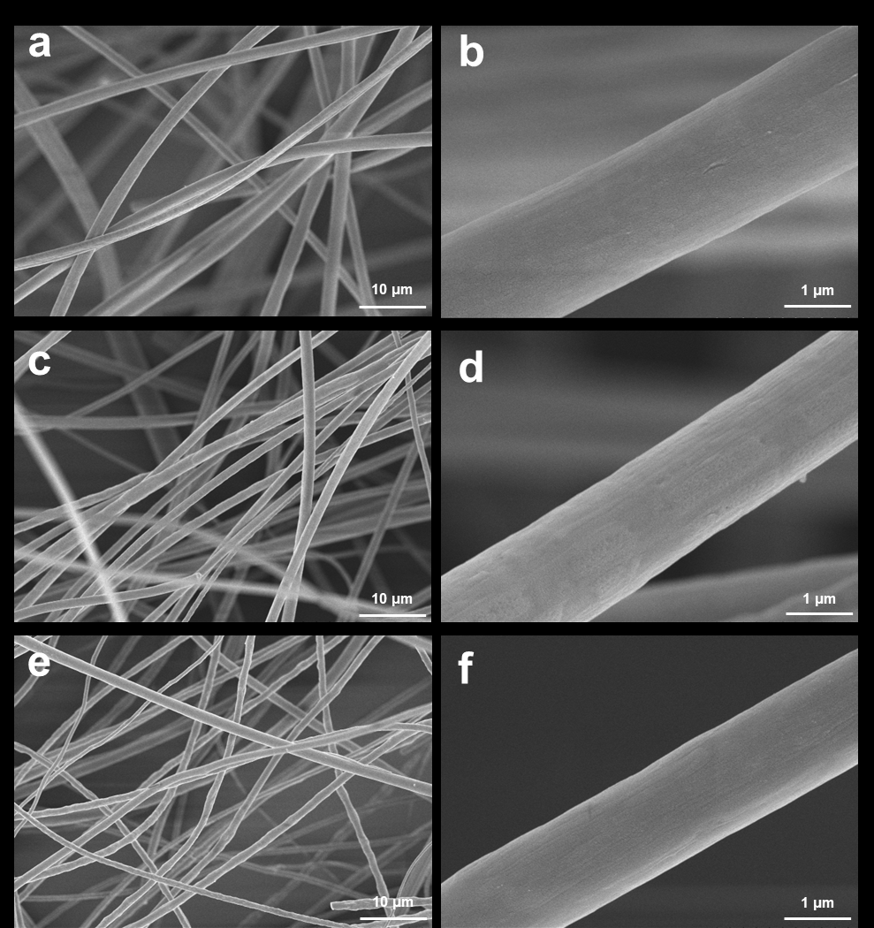
Fig. S10 The SEM images of AC-PTCS fibrous membranes: (a-b) AC-PTCS-1, (c-d) AC-PTCS-2, (e-f) AC-PTCS-3
Fig. S11 FTIR spectra of the AC-PTCS fibrous membranes
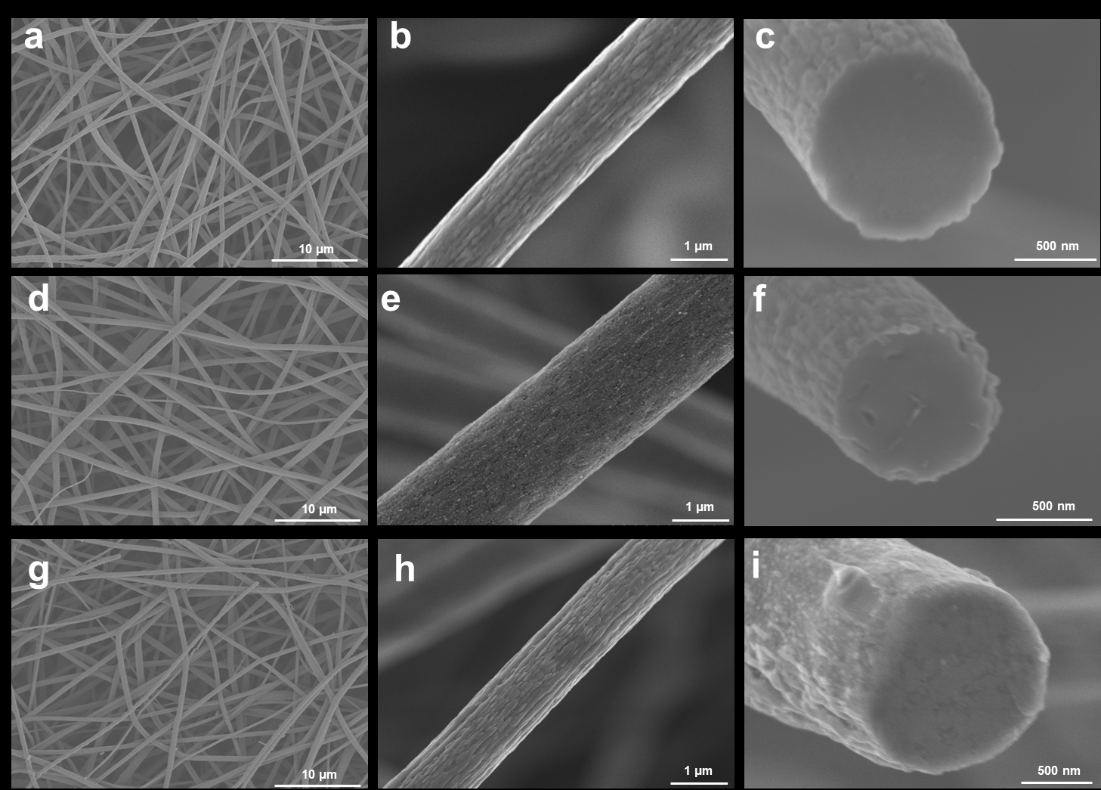
Fig. S12 The SEM images of Si-Ti-C-O fibrous membranes: (a-c) Si-Ti-C-O-1, (d-f) Si-Ti-C-O-2, (g-i) Si-Ti-C-O-3

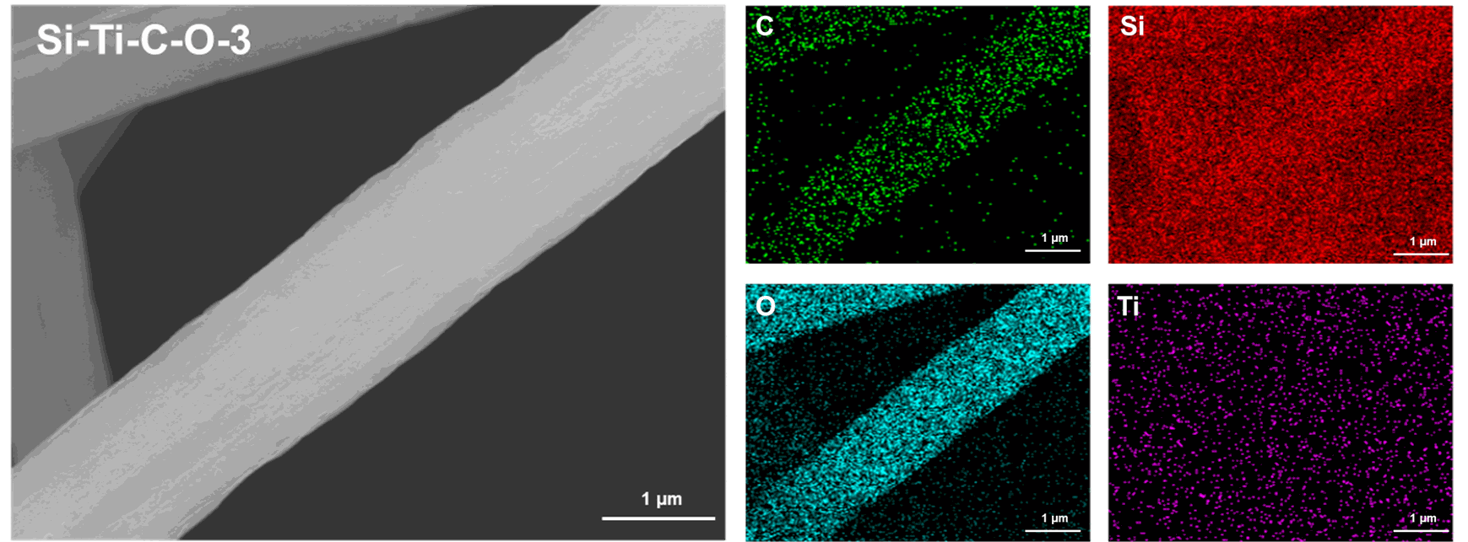
Fig. S13 Elemental mappings of the Si-Ti-C-O-3 fiber
Table S2 The elemental content of Si-Ti-C-O-3 fibrous membrane obtained by SEM-EDS
Element | Si | C | O | Ti
Content (wt%) | 39.85 | 20.74 | 36.96 | 1.99

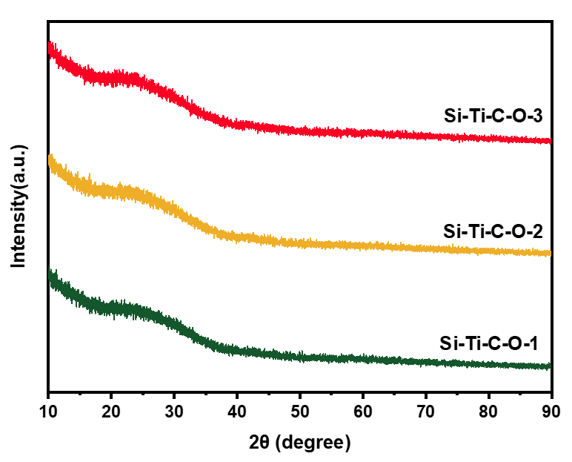
Fig. S14 XRD curves of Si-Ti-C-O fibrous membranes
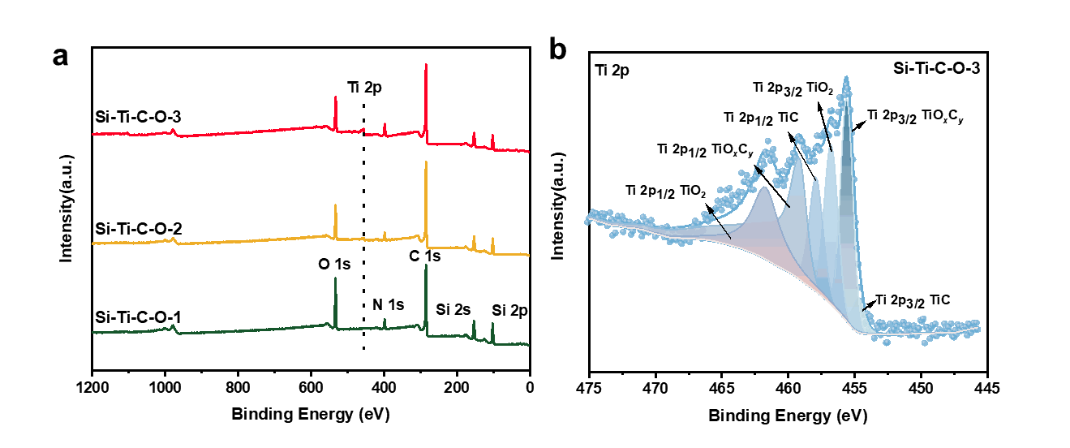
Fig. S15 (a) XPS spectra of Si-Ti-C-O fibrous membranes, and (b) Ti 2p spectra of Si-Ti-C-O-3 fibrous membranes
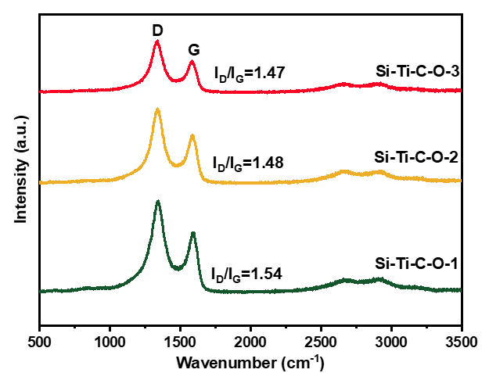
Fig. S16 Raman spectra of Si-Ti-C-O fibrous membranes

Table S3 The elemental composition of Si-Ti-C-O fibrous membranes
Membrane | Si (wt%) | Ti (wt%) | C (wt%) | O (wt%)
Si-Ti-C-O-1 | 56.17 | 0.47 | 34.98 | 4.26
Si-Ti-C-O-2 | 58.15 | 1.09 | 35.57 | 3.04
Si-Ti-C-O-3 | 52.69 | 2.04 | 30.29 | 2.93
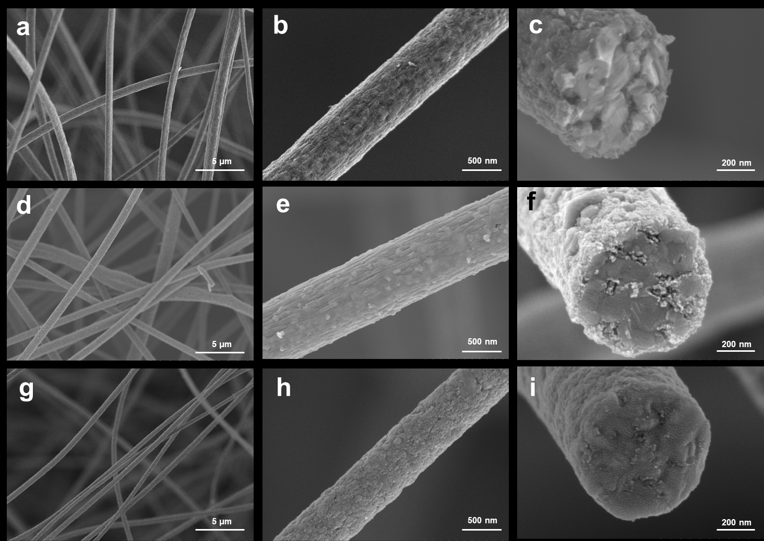
Fig. S17 SEM images of TiC-SiC fibrous membranes: (a-c) TiC-SiC-1, (d-f) TiC-SiC-2, (g-i) TiC-SiC-3
Fig. S18 XRD curves of TiC-SiC fibrous membranes
The peaks at 1348 and 1585 cm⁻¹ correspond to the D and G peaks of free carbon, respectively. The I_{D}/I_{G} radio (the intensity ratio of D peak versus G peak) of Si-Ti-C-O ﬁbers and TiC-SiC ﬁbers are estimated as 1.54 and 0.76, respectively, suggesting that the degree of graphitization of carbon increased after the high-temperature sintering.
Fig. S19 Raman spectra of TiC-SiC fibrous membranes
Fig. S20 XPS spectra of TiC-SiC fibrous membranes
Table S4 The elemental composition of TiC-SiC fibrous membranes
Membrane | Si (wt%) | Ti (wt%) | C (wt%) | O (wt%)
TiC-SiC-1 | 48.62 | 0.50 | 39.02 | 0.34
TiC-SiC-2 | 51.80 | 1.06 | 39.86 | 0.32
TiC-SiC-3 | 49.82 | 1.95 | 39.76 | 0.39
According to the C 1s spectrum fitting results, the peak at 284.8 eV is attributed to the sp2 bond of free carbon, the peak at 283.5 eV is attributed to the C-Si bond of SiC, the peak at 282.8 eV comes from the C signal of C-Ti, and the peak at 286.0 eV comes from the C signal of C-O, which could be attributed to the residual O element inside the fiber [S1-S4].
Fig. S21 C 1s spectrum of the TiC-SiC-3 fibrous membrane
Fig. S22 SAED pattern of the TiC-SiC fiber
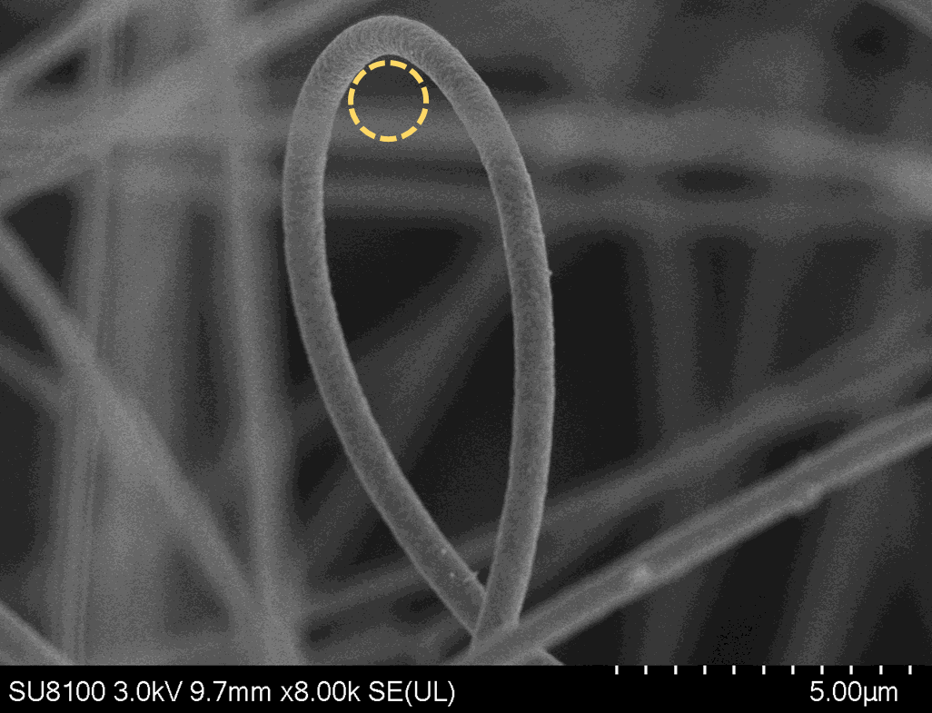
Fig. S23 SEM image of the bended single TiC-SiC fiber

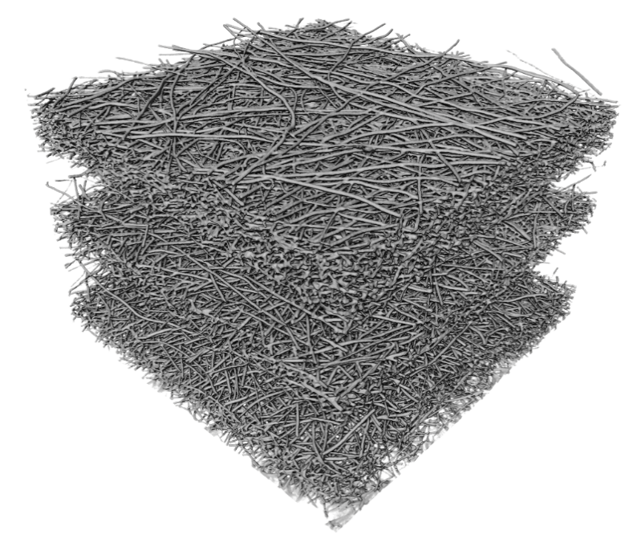
Fig. S24 The three-dimensional CT image reconstruction of TiC-SiC fibrous membrane

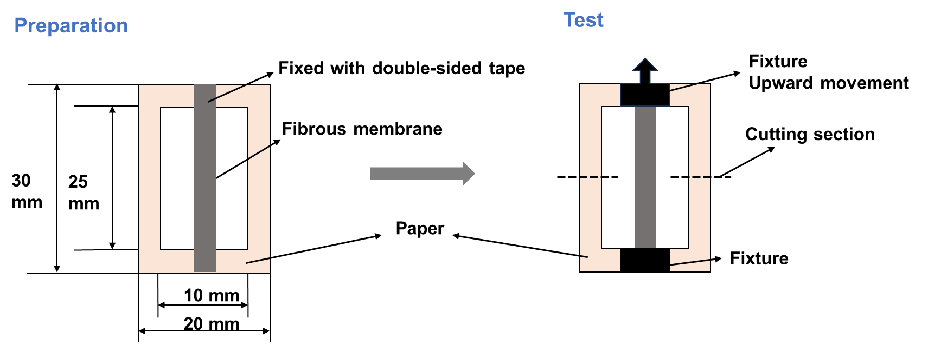
Fig. S25 Schematic of the mechanical property test for the fibrous membranes

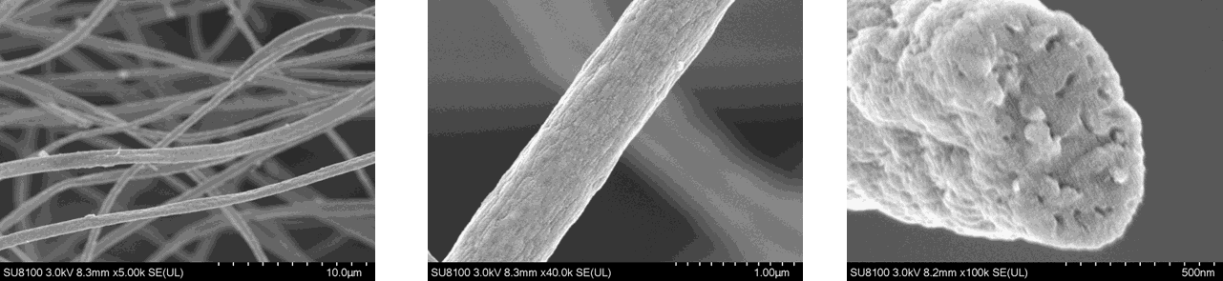
Fig. S26 SEM image of SiC fibrous membrane
Fig. S27 XRD pattern of SiC fibrous membrane

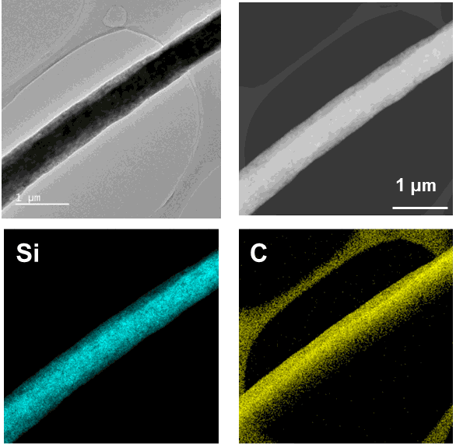
Fig. S28 TEM and elemental mapping images of the SiC fiber without Ti

Fig. S29 The average strength of different fibrous membranes

Fig. S30 The stress-strain curves of the mechanical tests for 5 times for the TiC-SiC-3 fibrous membrane

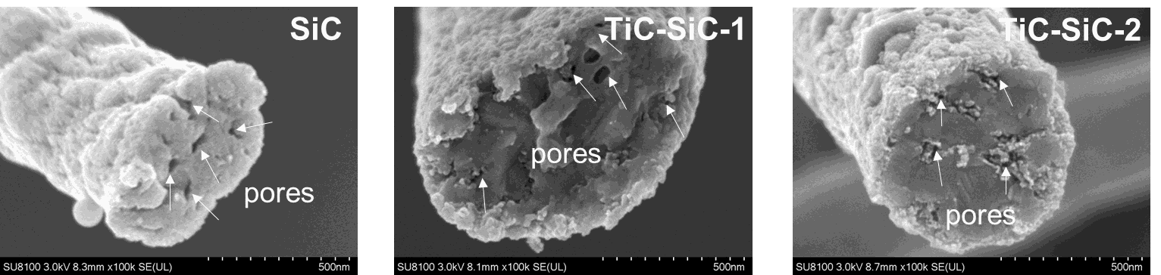
Fig. S31 SEM images of the cross section of the fibers in different membrane
Table S5 The specific surface area and pore volume of the fibers
Sample | BET Surface Area (m²/g) | Single point adsorption total pore volume of pores (cm³/g) | BJH Adsorption cumulative volume of pores (cm³/g) | BJH Desorption cumulative volume of pores (cm³/g)
SiC | 16.7611 | 0.039617 | 0.035449 | 0.038515
TiC-SiC-1 | 22.3529 | 0.048533 | 0.047291 | 0.048505
TiC-SiC-2 | 36.8877 | 0.194705 | 0.193978 | 0.193952
TiC-SiC-3 | 3.9719 | 0.024959 | 0.023256 | 0.024967

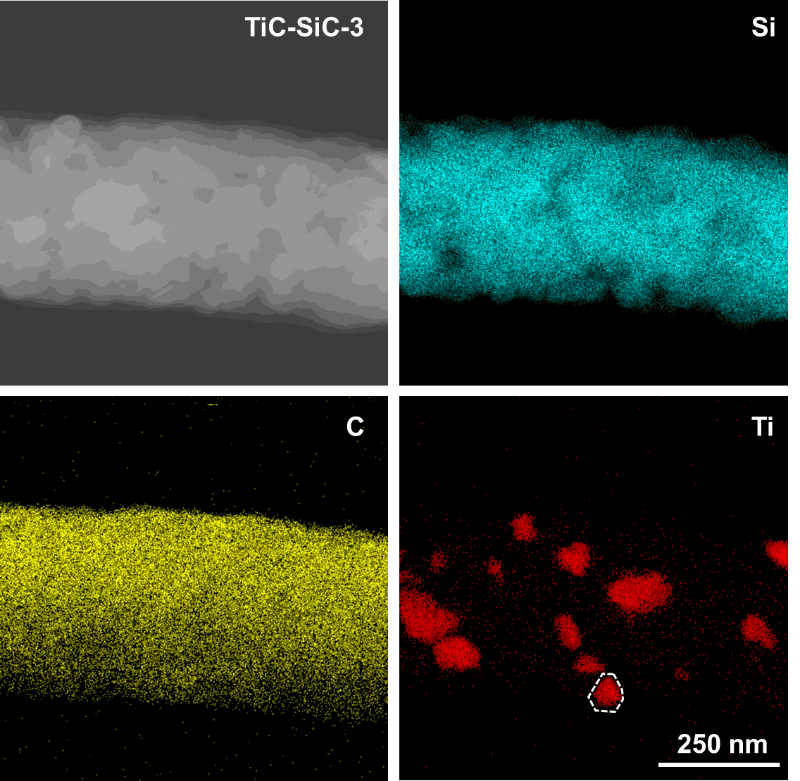
Fig. S32 Elemental mapping images of TiC-SiC-3 fiber
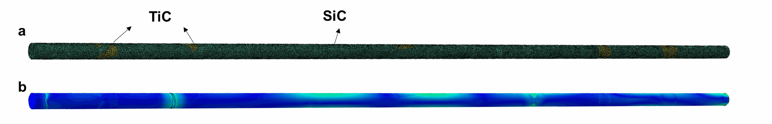
Fig. S33 (a) Model diagram of finite element analysis, (b) TiC-SiC fiber fracture stress distribution map
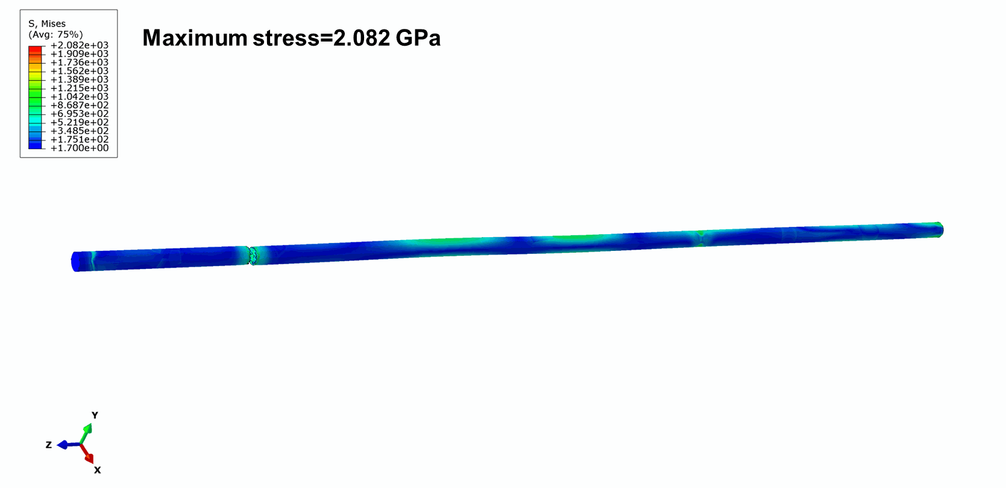
Fig. S34 Stress distribution of TiC-SiC fiber
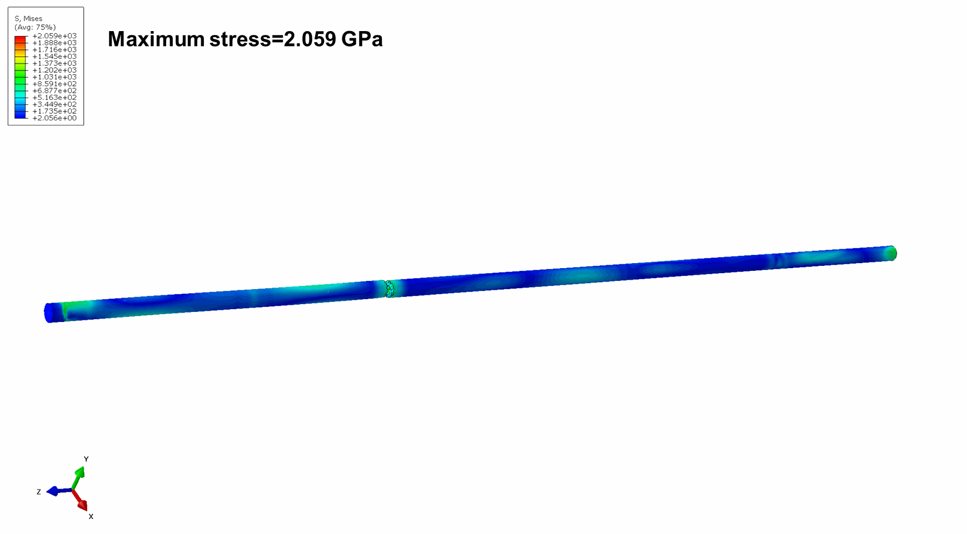
Fig. S35 Stress distribution of SiC fiber
Fig. S36 Fracture curves from molecular dynamics simulations

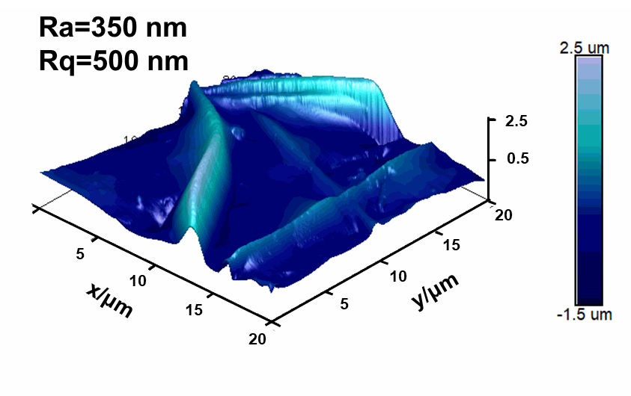
Fig. S37 AFM image of the surface of the SiC fibrous membrane

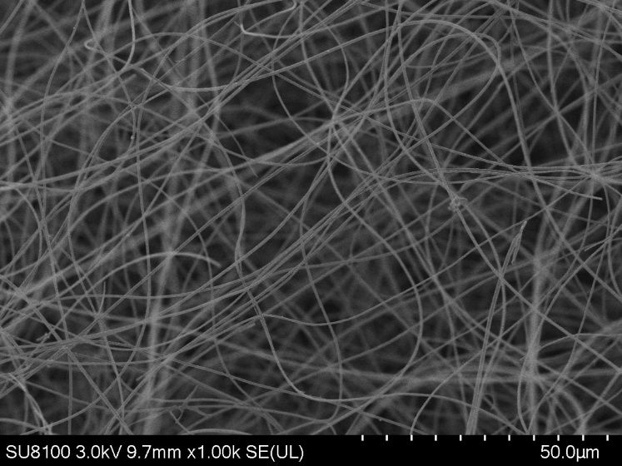
Fig. S38 SEM image of the TiC-SiC ultrafine fibers in the membrane
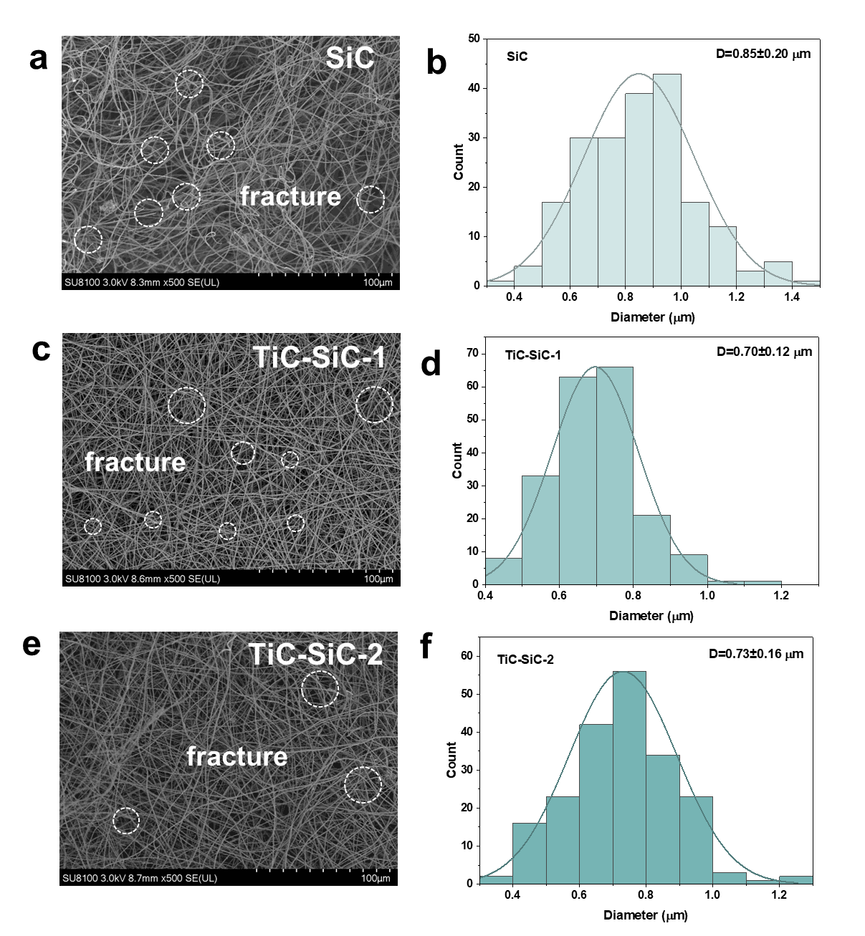
Fig. S39 SEM images and the statistics of diameter distribution: (a-b) SiC fibrous membrane, (c-d) TiC-SiC-1 fibrous membrane, (e-f) TiC-SiC-2 fibrous membrane

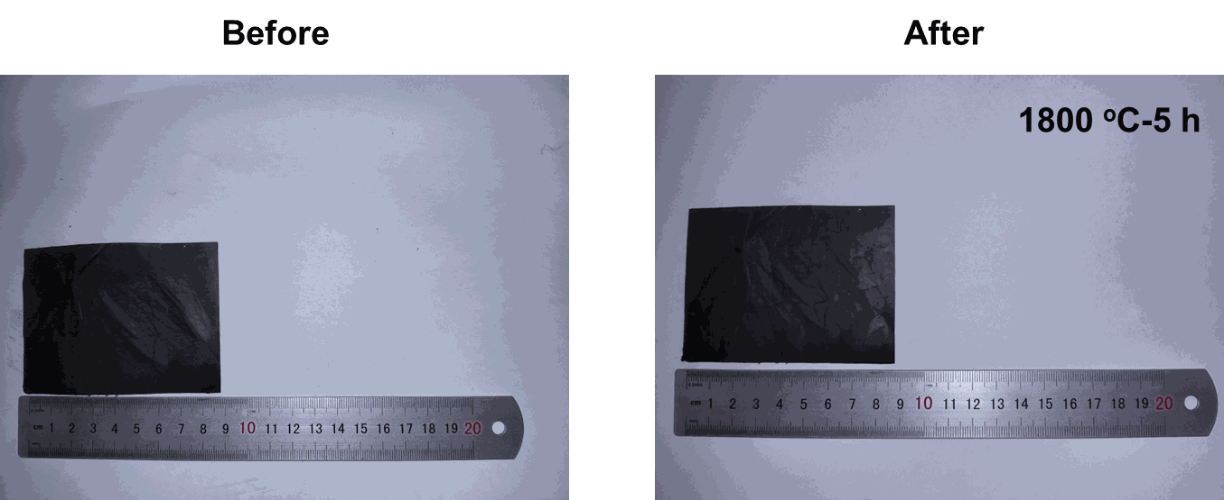
Fig. S40 Optical photograph of TiC-SiC fibrous membrane before and after being heated at 1800 ℃ for 5 h in argon atmosphere
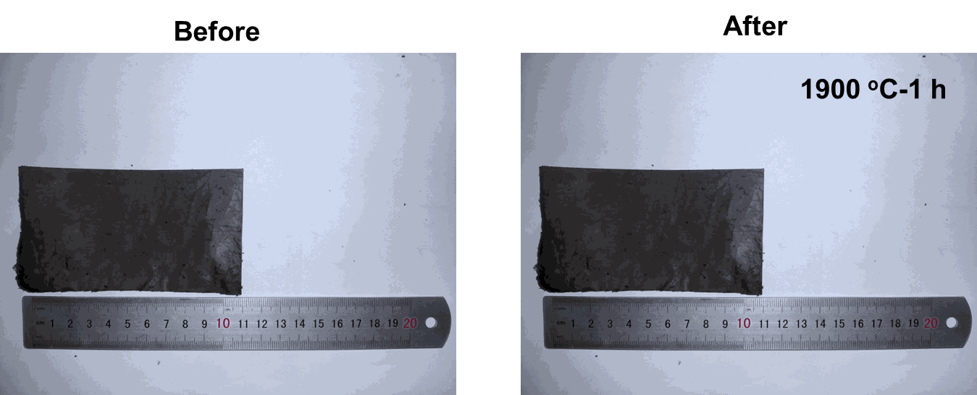
Fig. S41 Optical photograph of TiC-SiC fibrous membrane before and after being heated at 1900 ℃ for 1 h in argon atmosphere
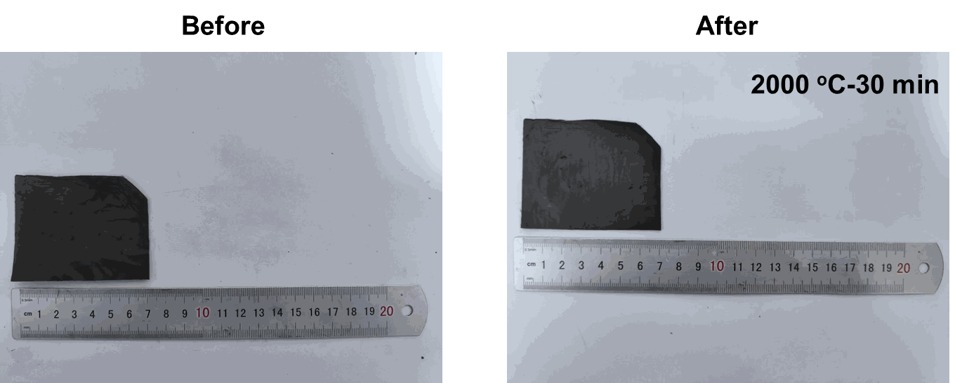
Fig. S42 Optical photograph of TiC-SiC fibrous membrane before and after being heated at 2000 ℃ for 30 min in argon atmosphere
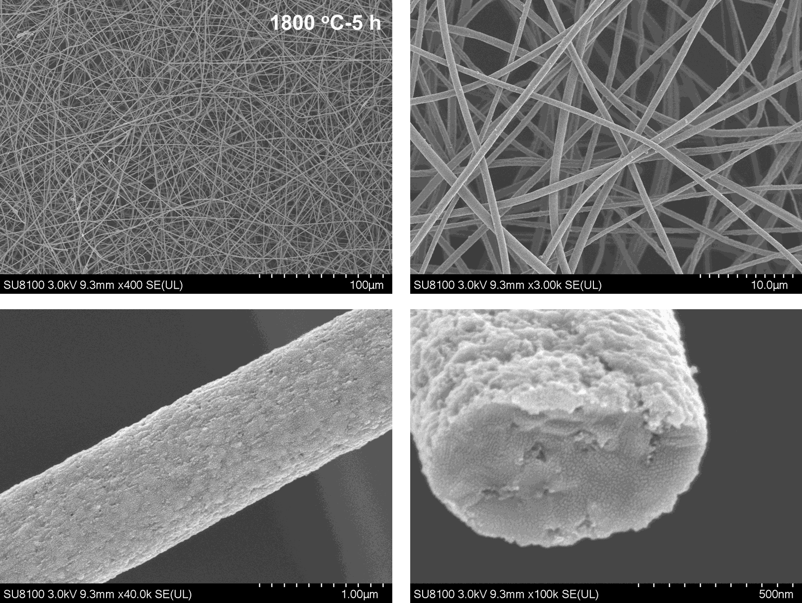
Fig. S43 SEM images of TiC-SiC fibrous membrane after heat treatment at 1800 ℃ for 5 h in argon atmosphere
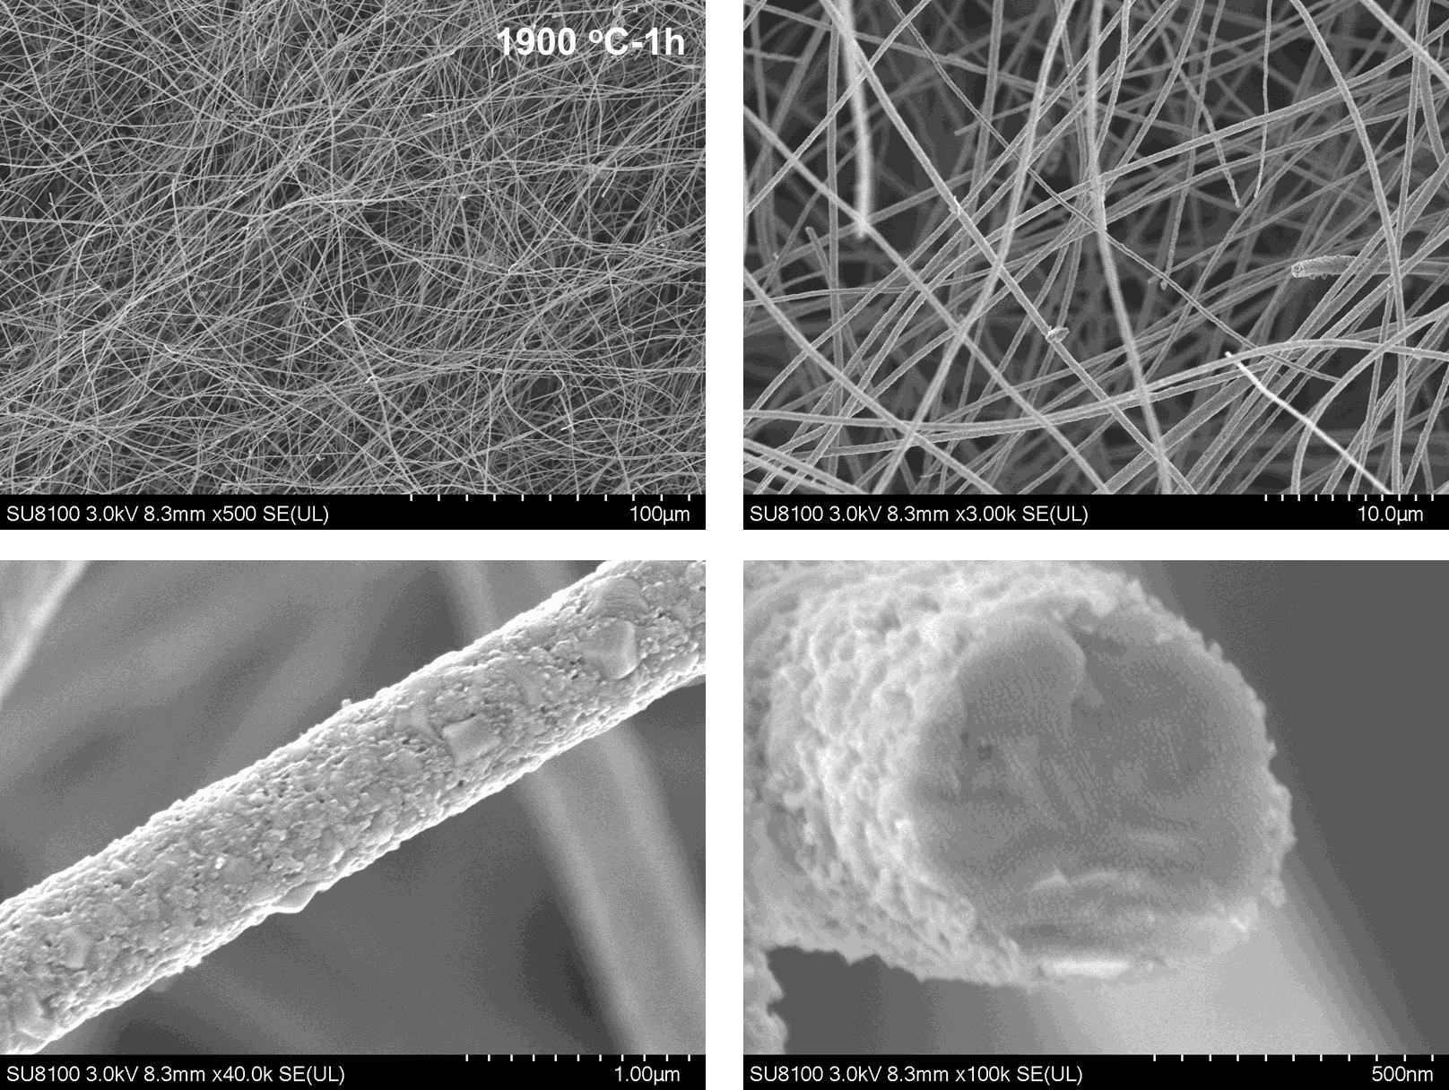
Fig. S44 SEM images of TiC-SiC fibrous membrane after heat treatment at 1900 ℃ for 1 h in argon atmosphere

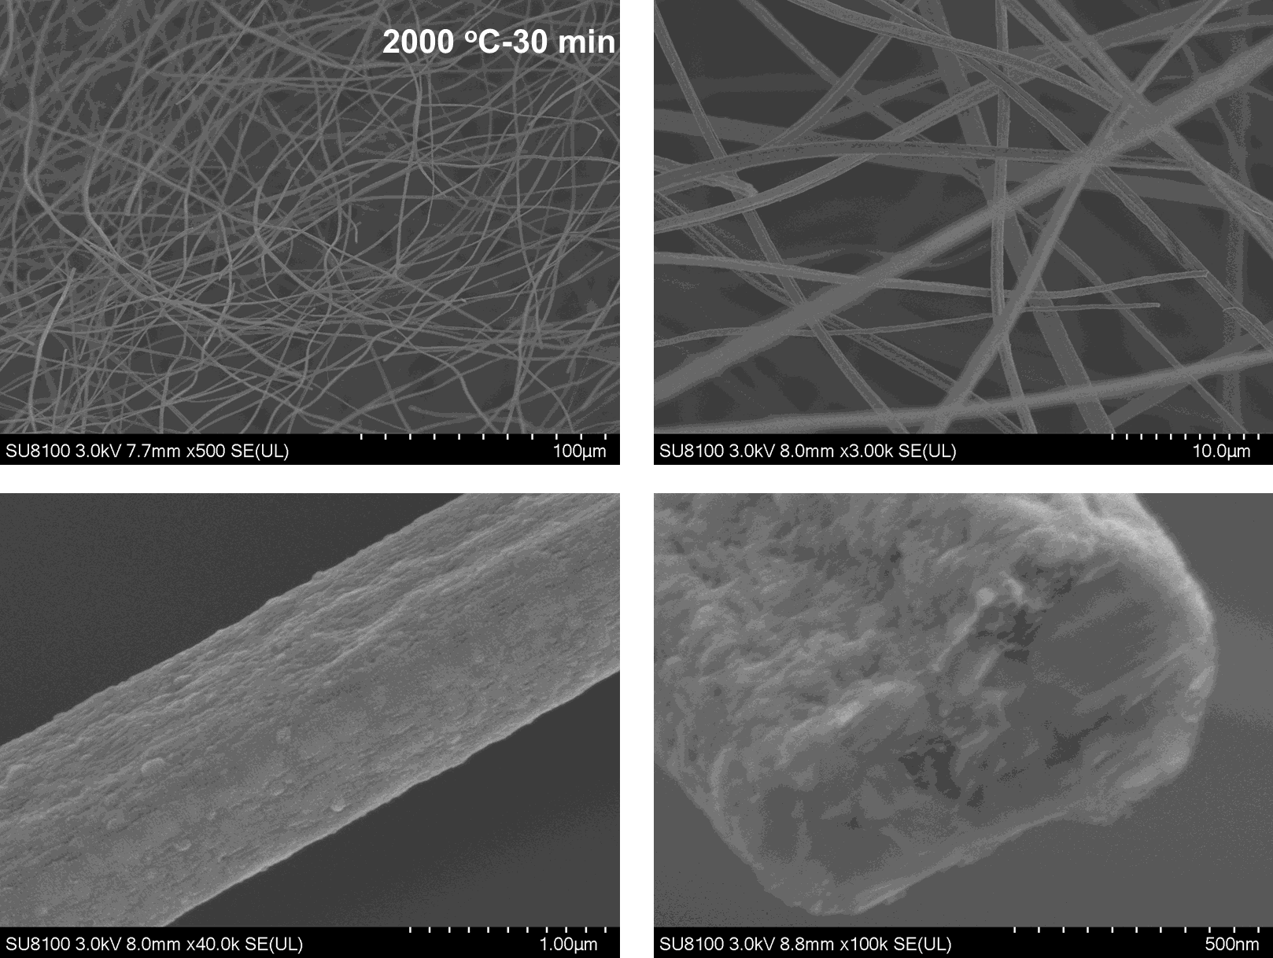
Fig. S45 SEM images of TiC-SiC fibrous membrane after heat treatment at 2000 ℃ for 30 min
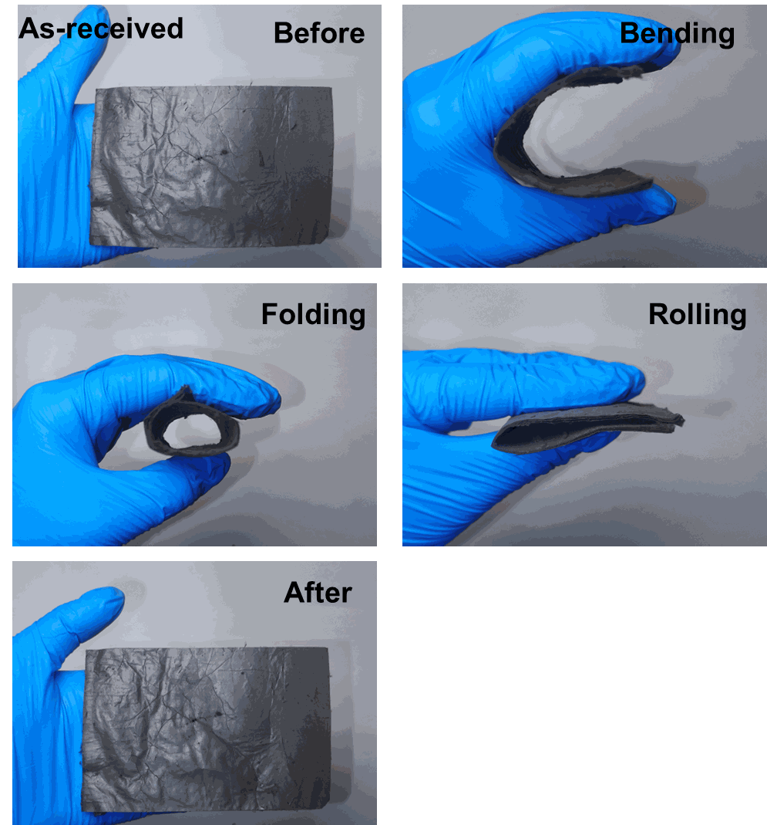
Fig. S46 Demonstration of the flexibility of the original TiC-SiC fibrous membrane
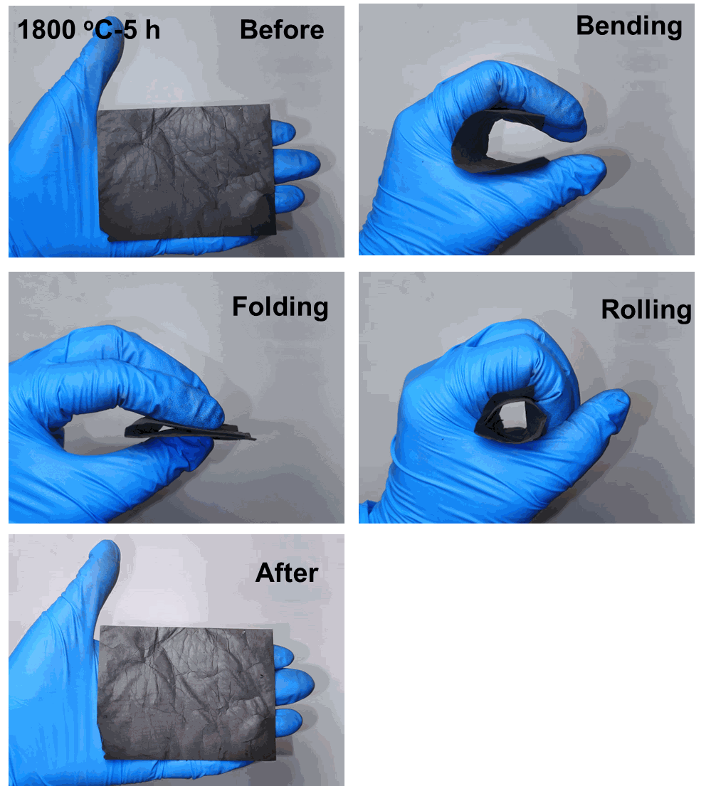
Fig. S47 Demonstration of the flexibility of the TiC-SiC fibrous membrane after heat treatment at 1800 ℃ for 5 h in argon atmosphere
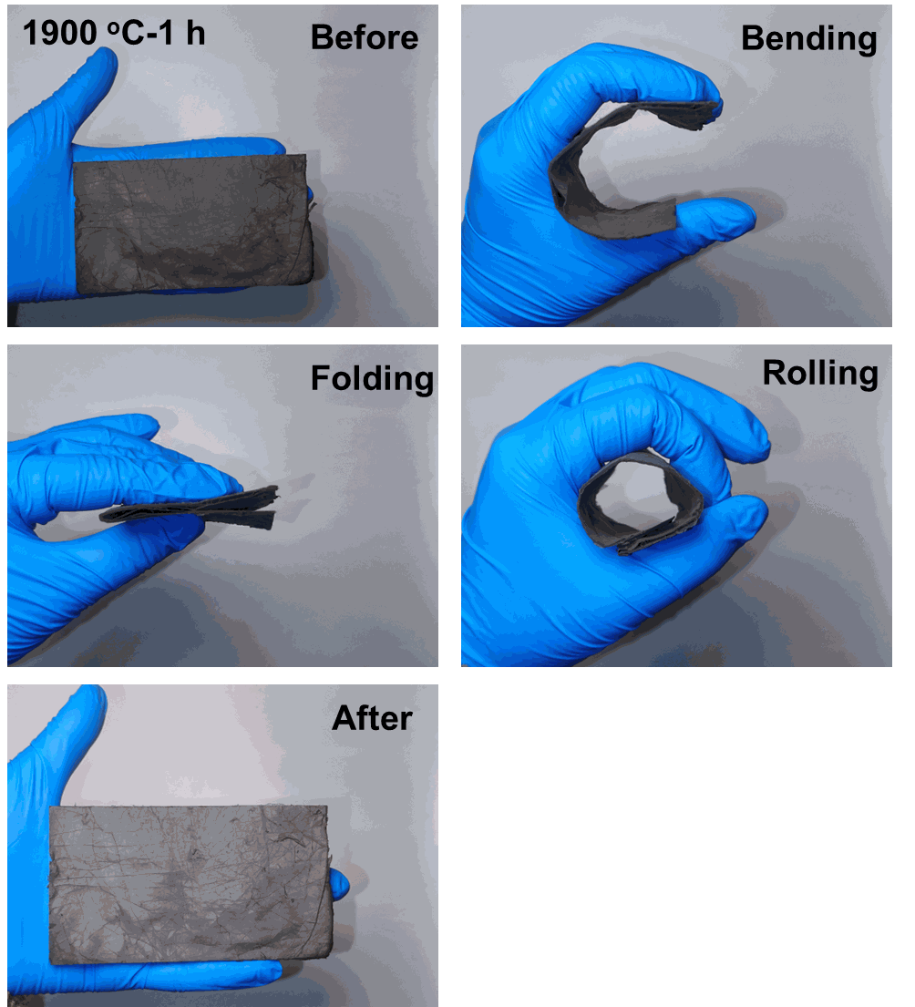
Fig. S48 Demonstration of the flexibility of the TiC-SiC fibrous membrane after heat treatment at 1900 ℃ for 1 h in argon atmosphere
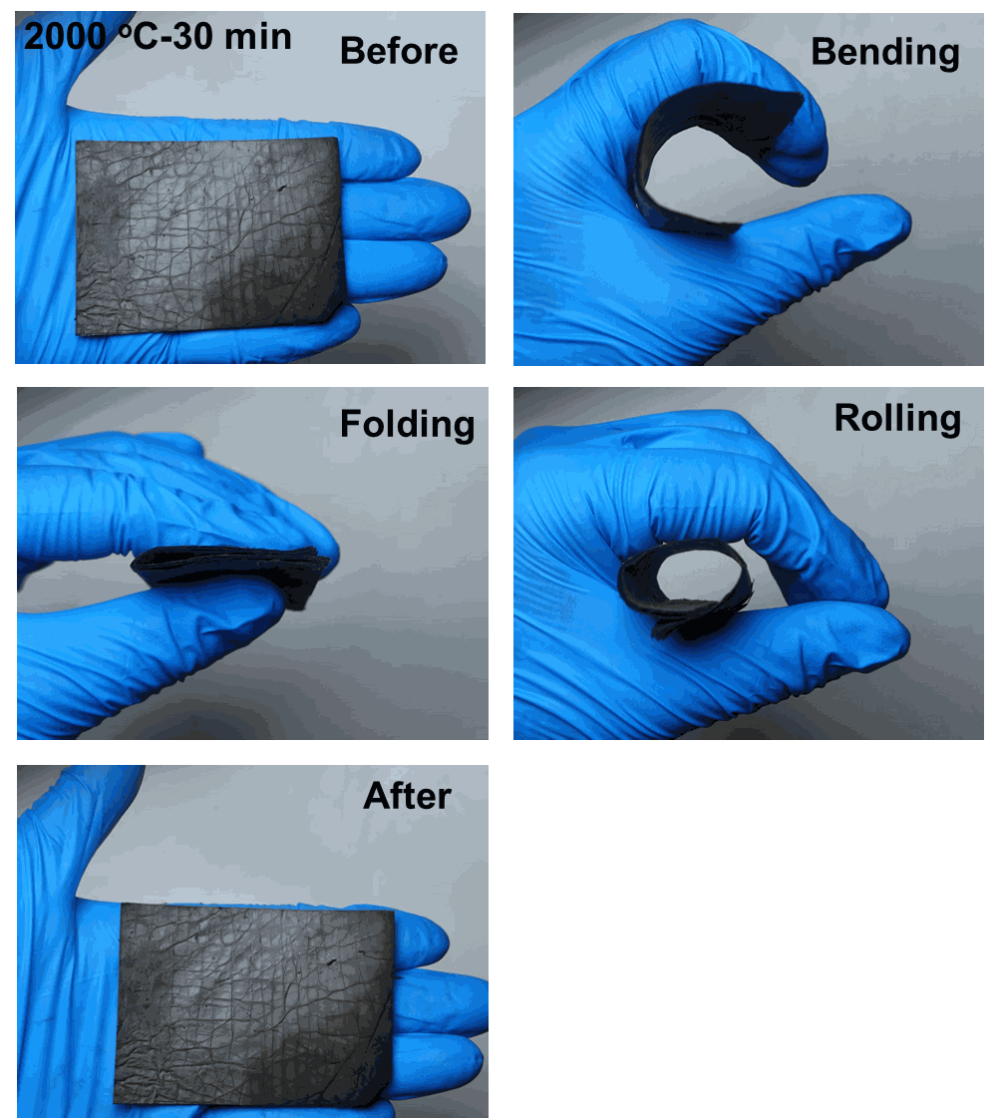
Fig. S49 Demonstration of the flexibility of the TiC-SiC fibrous membrane after heat treatment at 2000 ℃ for 30 min in argon atmosphere
Table S6 Comparison of maximum working temperature and tensile strength of TiC-SiC fibrous membranes and different membranes previously reported in literature
Materials | Max working Temperature (ºC) | Tensile strength (MPa) | Refs.
montmorillonite@ZrO₂-SiO₂ membranes | ~1000 | 1.83 | [S5]
TiO₂ nanofibrous membranes | 800 | 0.62 (Max) | [S6]
CNF-CNNS | 1700 | ~1.9 | [S7]
OUHS 3YSZ fibrous membranes | 1500 | ~3.5 (average) | [S8]
OUHS TiO₂ fibrous membranes | 1300 | ~1.2 | [S8]
OUHS HfO₂ fibrous membranes | 1500 | ~1.6 | [S8]
OUHS Al₂O₃ fibrous membranes | 1300 | ~2.0 | [S8]
OUHS Y₂O₃ fibrous membranes | 1400 | ~1.2 | [S8]
MgAl₂O₄ nanofibrous membranes | 1600 | 1.94 | [S9]
SiZrOC nanofibrous membranes | 1200 | 0.82 (Max) | [S10]
Ultrafine SiC fiber | 1900 | ~0.32 (Max) | [S11]
This work | 2000 | 2.1
It was noted that:
1.CNF-CNNS: 2D ceramic nanofibrous membranes with a crosslinked nanofiber network structure (Al₂O₃-SiO₂ nanofiber membrane)
2.OUHS: open ultrafast high-temperature sintering (heating/cooling rate = 10000 K min⁻¹)
3YSZ: 3 mol% yttria-stabilized zirconia
3.The maximum operating temperature of the OUHZ 3YSZ fiber membranes fibers were not explicitly provided, therefore the preparation temperature at its highest strength is selected.
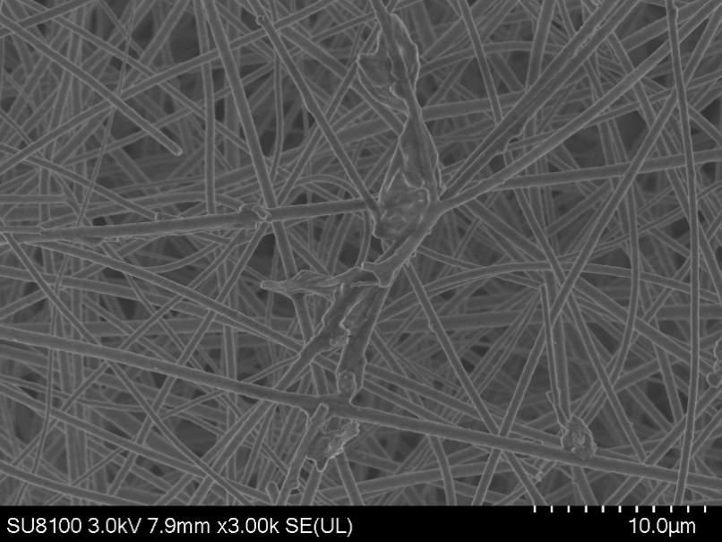
Fig. S50 SEM images of the TiC-SiC fibrous membrane after heat treatment at 1200 ℃ for 1 h in air atmosphere

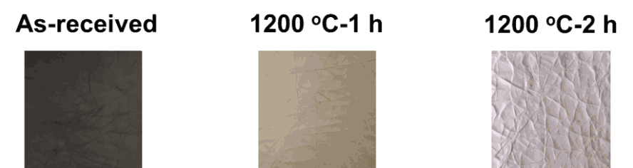
Fig. S51 Optical photos of the TiC-SiC fibrous membrane before and after oxidation at 1200 ºC in air

Fig. S52 The stress–strain curve of the TiC-SiC ultrafine fibrous membrane after oxidation at 1200 ℃ for 2 h

Fig. S53 XRD pattern of the TiC-SiC fibrous membrane treated at 1200 ℃ for 2 h in air
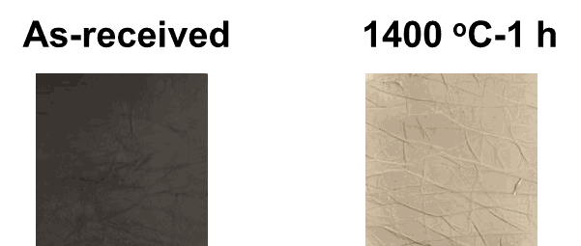
Fig. S54 Optical photos of the TiC-SiC fibrous membrane before and after oxidation at 1400 ℃ for 1 h in air
Fig. S55 XRD pattern of the TiC-SiC fibrous membrane treated at 1400 ℃ for 1 h in air
Fig. S56 The stress–strain curve of the TiC-SiC fibrous membrane after oxidation at 1400 ℃ for 1 h
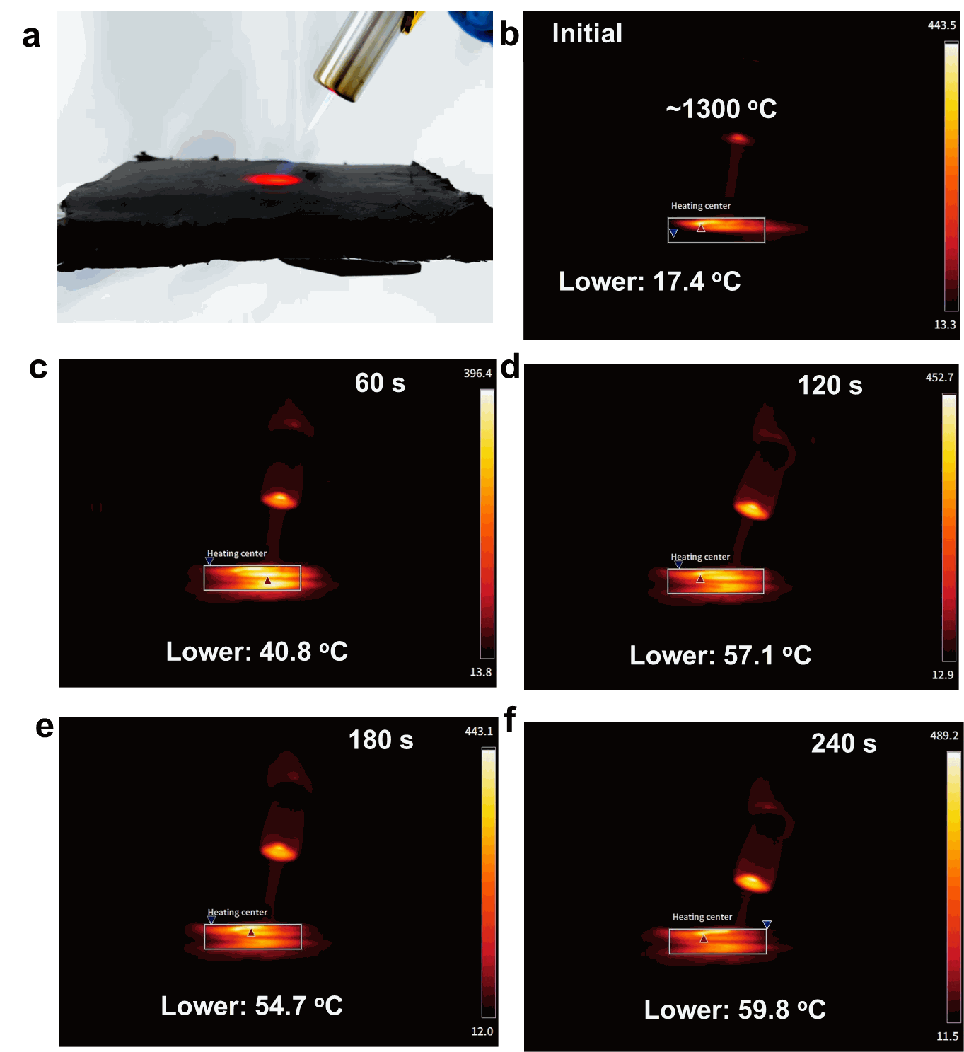
Fig. S57 Optical photos of (a) the device heated by butane flame and (b-f) infrared photos during the heating process
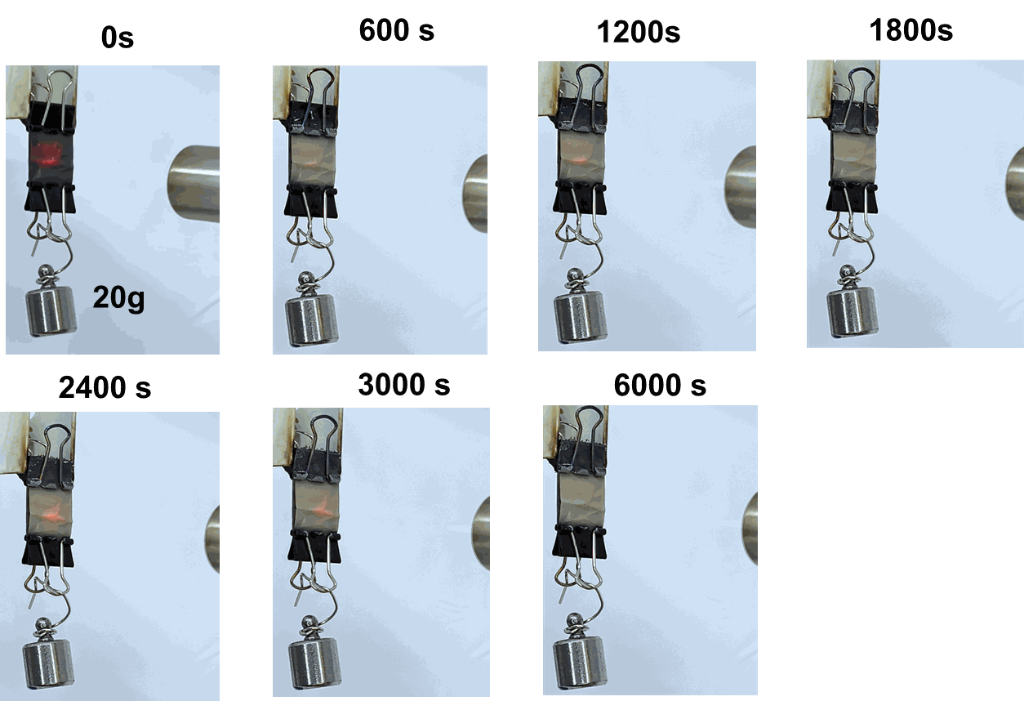
Fig. S58 Photos of the TiC-SiC ultrafine fibrous membrane (length: 3 cm, width: 1.5 cm, and weight: 0.0140 g) pulled by a weight of 20 g under continuous heating by the butane flame
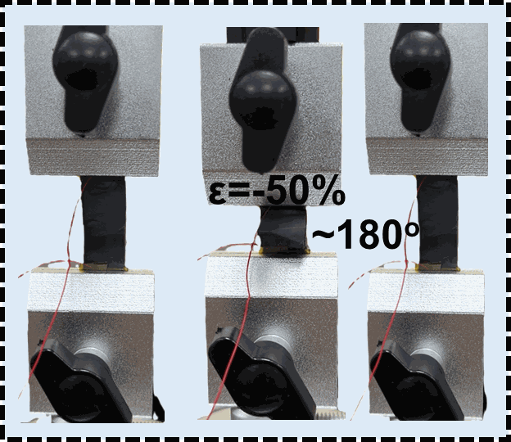
Fig. S59 Optical photos of the TiC-SiC fibrous membrane under bending process
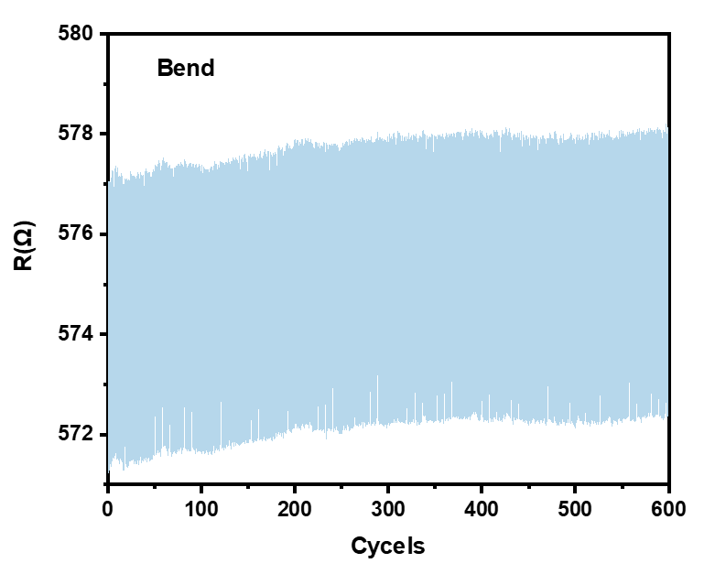
Fig. S60 Electric resistance–cycle responses of the TiC-SiC fibrous membrane under bending and relaxing
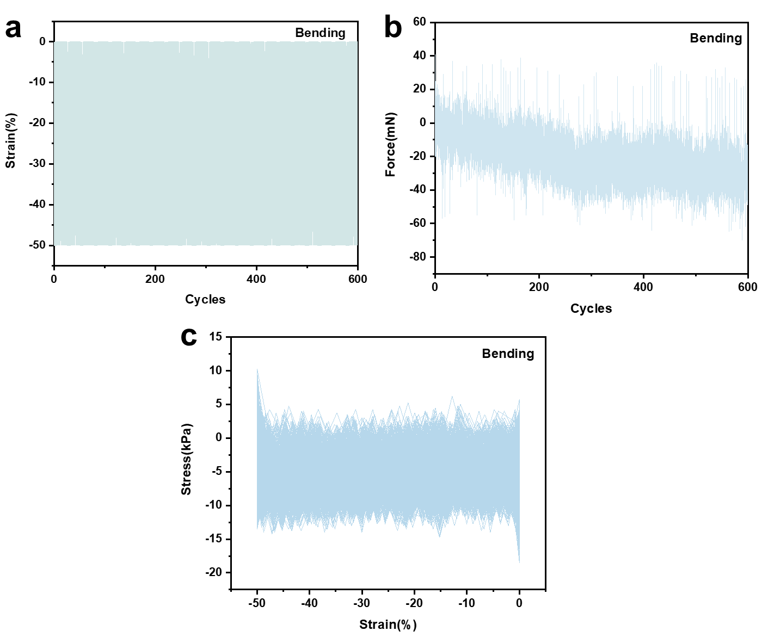
Fig. S61 The mechanical properties of the TiC-SiC fibrous membrane during bending process
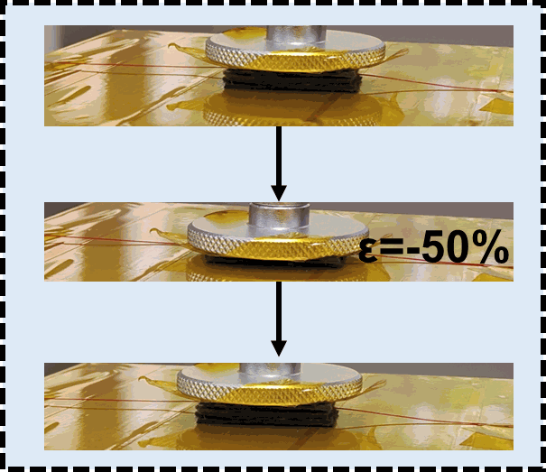
Fig. S62 Optical photos of the stacked TiC-SiC fibrous membranes under compression process
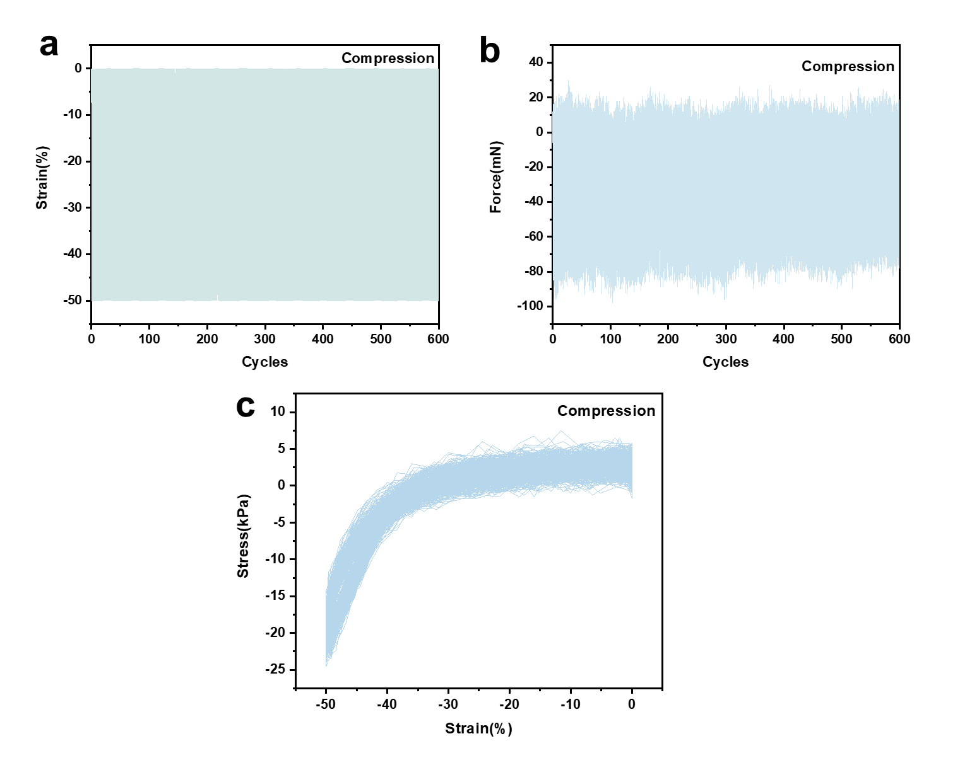
Fig. S63 The mechanical properties of the TiC-SiC fibrous membrane during compression process
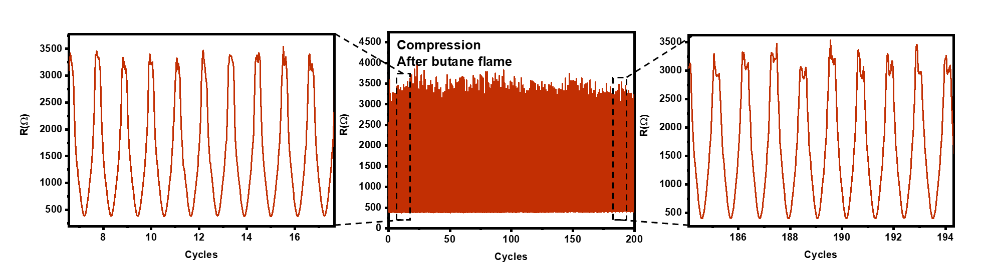
Fig. S64 Electric resistance–cycle responses of the stacked TiC-SiC fibrous membrane (after butane flame ablation for 60 s) under compression and relaxing
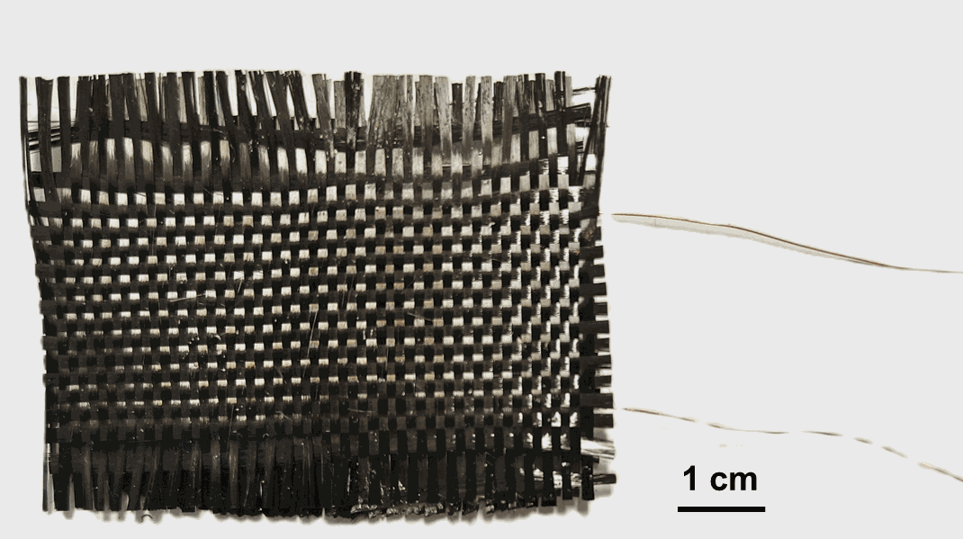
Fig. S65 Optical photos of sensor devices assembled by the TiC-SiC fibrous membranes
Table S7 Detailed data list of radar chart
Material | Tensile strength | Working temperature in Ar (°C) | Working time in Ar | Oxidation resistance | Pressure sensing performance | Refs.
Montmorillonite@ZrO₂-SiO₂ | 1.83 MPa | 1000 | ~10 min | ~1000 ºC | / | [S5]
SiC | / | 1800 | 60min | 1400 ºC | 100 cycles in room temperature | [S12]
SiC@SiO₂ | / | 600 | ~10min | 700 ºC | 1000 cycles at room temperature (ɛ=30%) | [S13]
SCNFM | 2.16 MPa | 700 | 120 min | / | / | [S14]
ZSNFA | ~1.8 MPa | 1100 | ~15 min | ~1300 | 1000 cycles  (800 ℃) | [S15]
TiO₂ | / | 370 | ~1 min | 1300 | 10000 cycles (room temperature)  5 cycles (370 ℃) | [S16]
This work | 2.1MPa | 1800 | 300 min | 1200:60 min  1300: 60min | 600 cycles (room temperature, ɛ=50%)  600 cycles (after butane blame, ɛ=50%)
It was noted that:
1.The stability of Submicron SiC fibers in the air was judged based on the fact that the mass increased 5.05 wt% according to TG.
2.The stability in the air of SiC@SiO₂ nanofiber aerogel was based on alcohol lamp flame reported in the literature.
3. SCNFM refers to SiO₂-carbon nanofiber membranes. The working temperature and time were selected based on the preparation temperature and time of membrane reported in the literature.
4. ZSNFA refers to ZrO₂-SiO₂ nanofiber aerogel.
5. In terms of pressure sensing performance, we comprehensively considered the combined factors of the number of cycles and the working temperature.
Supplementary References
- W. Zhao, X. Wang, M. Liu, Fabrication of in situ carbon coatings and their influence on mechanical properties of SiC fibers. Ceram. Int. 51(8), 10402–10414 (2025). https://doi.org/10.1016/j.ceramint.2024.12.473
- M. Sreemany, T.B. Ghosh, B.C. Pai, M. Chakraborty, XPS studies on the oxidation behavior of SiC particles. Mater. Res. Bull. 33(2), 189–198 (1998). https://doi.org/10.1016/S0025-5408(97)00222-5
- J.E. Oghenevweta, D. Wexler, A. Calka, Study of reaction sequences during MSR synthesis of TiC by controlled ball milling of titanium and graphite. Mater. Charact. 140, 299–311 (2018). https://doi.org/10.1016/j.matchar.2018.04.005
- L. Pang, P. Xiao, Z. Li, H. Luo, J. Zheng et al., Long-range uniform SiC(x)O(y) beaded carbon fibers for efficient microwave absorption. ACS Appl. Mater. Interfaces 15(25), 30815–30825 (2023). https://doi.org/10.1021/acsami.3c05029
- X. Mao, J. Hong, Y.-X. Wu, Q. Zhang, J. Liu et al., An efficient strategy for reinforcing flexible ceramic membranes. Nano Lett. 21(22), 9419–9425 (2021). https://doi.org/10.1021/acs.nanolett.1c02657
- Y. Zhang, S. Liu, J. Yan, X. Zhang, S. Xia et al., Superior flexibility in oxide ceramic crystal nanofibers. Adv. Mater. 33(44), 2105011 (2021). https://doi.org/10.1002/adma.202105011
- Z. Xu, Y. Liu, Q. Xin, J. Dai, J. Yu et al., Ceramic meta-aerogel with thermal superinsulation up to 1700 °C constructed by self-crosslinked nanofibrous network via reaction electrospinning. Adv. Mater. 36(32), 2401299 (2024). https://doi.org/10.1002/adma.202401299
- Y. Wang, W. Qin, Z. Chen, Z. Deng, D. Ma et al., Fine-grain high-performance densified oxide fibers produced by open ultrafast high-temperature sintering. Adv. Mater. 36(48), 2412139 (2024). https://doi.org/10.1002/adma.202412139
- X. Wang, Z. Zhu, Z. Guo, C. Mi, Z. Huang et al., Thermally insulating and wave-transparent magnesium aluminum spinel nanofibers applied from–196 to 1600 °C. Chem. Eng. J. 502, 157617 (2024). https://doi.org/10.1016/j.cej.2024.157617
- X. Zhang, B. Wang, N. Wu, C. Han, C. Wu et al., Flexible and thermal-stable SiZrOC nanofiber membranes with low thermal conductivity at high-temperature. J. Eur. Ceram. Soc. 40(5), 1877–1885 (2020). https://doi.org/10.1016/j.jeurceramsoc.2020.01.037
- J. Chen, Y. Zhang, D. Yan, Y. Gou, Flexible ultrafine nearly stoichiometric polycrystalline SiC fibers with excellent oxidation resistance and superior thermal stability up to 1900 °C. J. Eur. Ceram. Soc. 42(5), 1938–1946 (2022). https://doi.org/10.1016/j.jeurceramsoc.2021.12.049
- W. Kang, Y. Shen, T. Yang, Z. Zhao, Y. Gou, Multifunctional submicron SiC fibers for extreme environments: superior electromagnetic absorption and high-temperature performance. Adv. Funct. Mater. 35(7), 2415432 (2025). https://doi.org/10.1002/adfm.202415432
- L. Song, F. Zhang, Y. Chen, L. Guan, Y. Zhu et al., Multifunctional SiC@SiO₂ nanofiber aerogel with ultrabroadband electromagnetic wave absorption. Nanomicro Lett. 14(1), 152 (2022). https://doi.org/10.1007/s40820-022-00905-6
- H. Zhao, Z. Jian, J. Zhang, Y. Du, Z. Tang et al., Controllable preparation of carbon nanofiber membranes for enhanced flexibility and permeability. Carbon 229, 119496 (2024). https://doi.org/10.1016/j.carbon.2024.119496
- W. Xiao, L. Lu, Z. Xu, Y. Huang, Q. Zhuang et al., A superelastic ceramic aerogel for flexible pressure sensor in harsh environment. Compos. Part B Eng. 292, 112110 (2025). https://doi.org/10.1016/j.compositesb.2024.112110
- M. Fu, J. Zhang, Y. Jin, Y. Zhao, S. Huang et al., A highly sensitive, reliable, and high-temperature-resistant flexible pressure sensor based on ceramic nanofibers. Adv. Sci. 7(17), 2000258 (2020). https://doi.org/10.1002/advs.202000258

