Supporting Information for
Copper Single-Atoms Loaded on Molybdenum Disulphide Drive Bacterial Cuproptosis-Like Death and Interrupt Drug-Resistance Compensation Pathways
Wenqi Wang^{1, 2}, Xiaolong Wei³, Bolong Xu⁴, Hengshuo Gui³, Yan Yan⁵*, Huiyu Liu⁴*, Xianwen Wang^{1, 3}*
¹ College and Hospital of Stomatology, Anhui Medical University, Key Lab of Oral Diseases Research of Anhui Province, Hefei 230032, P. R. China
² School of Pharmaceutical Sciences, Anhui Medical University, Hefei 230032, P. R. China
³ School of Biomedical Engineering, Anhui Medical University, Hefei 230032, P. R. China
⁴ Beijing Advanced Innovation Center for Soft Matter Science and Engineering, State Key Laboratory of Organic‒Inorganic Composites, Bionanomaterials and Translational Engineering Laboratory, Beijing Key Laboratory of Bioprocess, Beijing Laboratory of Biomedical Materials, Beijing University of Chemical Technology, Beijing 100029, P. R. China
⁵ School of Chemistry & Chemical Engineering, Anhui University of Technology, Ma’anshan, Anhui 243002, P. R. China
*Corresponding authors. E-mail: xianwenwang@ahmu.edu.cn (Xianwen Wang); liuhy@mail.buct.edu.cn (Huiyu Liu); yanyan@ahut.edu.cn (Yan Yan)
Supplementary Figures and Table
Fig. S1 POD-like activity of MoS₂ at different H₂O₂ concentrations using a OPD and b TMB. POD-like activity at different MoS₂ concentrations using c OPD and d TMB

Fig. S2 Quantification of the GSH consumption capacity after different treatments

Fig. S3 Time-dependent GSH depletion of Cu SAs/MoS₂ at a concentration of 150 μg/mL using the DTNB probe

Fig. S4 Quantitative analysis of ROS in MRSA subjected to different treatments via DCFH-DA

Fig. S5 Quantitative analysis of ROS in E. coli subjected to different treatments via DCFH-DA

Fig. S6 Plate photographs and corresponding quantitative survival rates after treatment of a MRSA and b E. coli with different Cu SAs/MoS₂ concentrations

Fig. S7 Heatmap of differentially expressed genes identified via prokaryotic transcriptomics

Fig. S8 Heatmap of metabolomics differentially expressed metabolites
Fig. S9 Cu SAs/MoS₂ at different pH values in the ability to release Cu²⁺

Fig. S10 MIC of a MoS₂ and b Cu SAs/MoS₂ in MRSA

Fig. S11 Evolution of indirect drug resistance of MRSA to MoS₂, Cu SAs/MoS₂, vancomycin, and methicillin after 21 days of cultivation in liquid medium
Fig. S12 Detection of Cu²⁺ content in Cu SAs/MoS₂ using ICP‒OES

Fig. S13 Rates of inhibition of biofilms in each group. 1: control; 2: H₂O₂; 3: MoS₂ + H₂O₂; 4: Cu SAs/MoS₂ + H₂O₂

Fig. S14 Rates of disruption of biofilms in each group. 1: control; 2: H₂O₂; 3: MoS₂ + H₂O₂; 4: Cu SAs/MoS₂ + H₂O₂
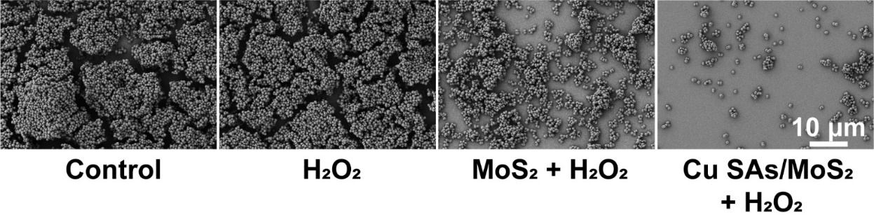
Fig. S15 SEM images after biofilm treatment
Fig. S16 Cell viability of a HaCaT, b HUVCE, c RAW, and d L929 cells exposed to different concentrations of Cu SAs/MoS₂
Fig. S17 Hemolysis test at different concentrations of the Cu SAs/MoS₂
Fig. S18 Assessment of the inflammatory microenvironment in macrophage culture

Fig. S19 POD-like and GSH-Px-like activities in the IM
Fig. S20 Cu SAs/MoS₂ was evaluated for the treatment of subcutaneous abscesses. a Schematic diagram of a subcutaneous abscess model of MRSA infection and its treatment. b Photos of the wound and plate photos of bacterial residues in the skin tissue on the seventh day. c Residual bacteria in wounds. d H&E staining, Masson staining, and Gemusa staining images of wounds after different treatments
Fig. S21 Cu SAs/MoS₂ was evaluated for the treatment of burn wounds infected with E. coli. a Schematic diagram of a burn wound model caused by E. coli infection and its treatment. b Twelve-day wound healing images and c wound healing area statistics. d Bacterial residues in skin tissue e H&E staining and Masson staining images of wounds after different treatments

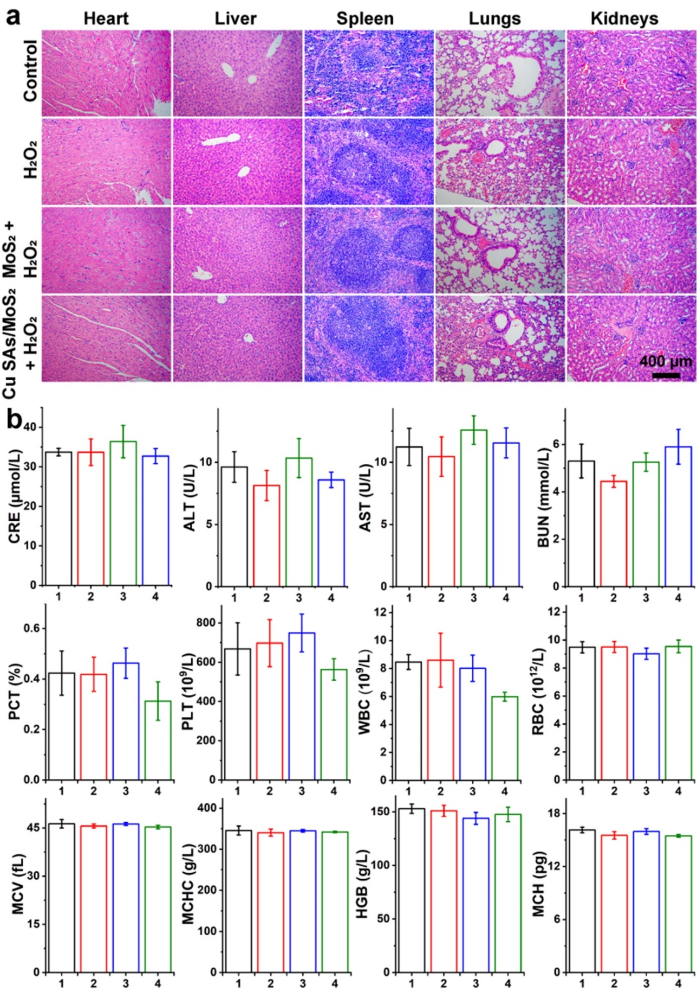
Fig. S22 In vivo biocompatibility assessment of Cu SAs/MoS₂. a H&E sections of major organs (heart, liver, spleen, lung, and kidney) of mice in different groups on day 12. b Routine blood and biochemical parameters of normal mice and other treatment groups on day 12.

Fig. S23 The concentrations of Cu²⁺ in the a blood and b-c organs (heart, liver, spleen, lungs and kidneys) were measured via ICP‒OES

Table S1 Fitting data extracted from the Cu SAs/MoS₂ FT-EXAFS
Sample | Shell | CNª | R(Å)^{b} | σ²(Å²)^{c} | ΔE⁰(eV)^{d} | R factor
Cu SAs/MoS₂ | Cu-S | 3.03 | 2.38 | 0.0109 | 3.8 | 0.0043
CNª, coordination number; ^{b}R, distance between absorber and backscatter atoms; ^{c}σ², Debye‒Waller factor to account for both thermal and structural disorders; ^{d}ΔE⁰, inner potential correction; R factor indicates the goodness of fit.

